Table S1 Permutational multivariate analysis of variance (PERMANOVA) of four biocolonization types
 |  | Df | Sums Of Sqs | Mean Sqs | F.Model | R² | Pr ( > F)
NR | Group_factor | 4 | 0.9884 | 0.2471 | 11.9725 | 0.8273 | 0.001
 | Residuals | 10 | 0.2064 | 0.0206 | - | 0.1727 | -
 | Total | 14 | 1.1948 | - | - | 1 | -
LR | Group_factor | 4 | 1.9999 | 0.4999 | 25.5938 | 0.9110 | 0.001
 | Residuals | 10 | 0.1954 | 0.0195 | - | 0.0890 | -
 | Total | 14 | 2.1953 | - | - | 1 | -
BS | Group_factor | 4 | 0.8040 | 0.2010 | 7.9801 | 0.7615 | 0.001
 | Residuals | 10 | 0.2519 | 0.0252 | - | 0.2385 | -
 | Total | 14 | 1.0559 | - | - | 1 | -
VS | Group_factor | 4 | 1.0103 | 0.2526 | 12.5232 | 0.8336 | 0.001
 | Residuals | 10 | 0.2017 | 0.0201 | - | 0.1664 | -
 | Total | 14 | 1.2121 | - | - | 1 | -
Table S2 Relative abundance of bacterial species on phylum level of NR biocolonization under different nitrogen addition treatments (means ± SD)
Bacteria phyla | N0/% | N1/% | N2/% | N3/% | N4/% | p Value
Cyanobacteria | 21.51±11.07b | 45.38±2.88a | 34.78±10.93ab | 45.24±5.34a | 53.42±6.47a | 0.006
Proteobacteria | 38.20±9.87a | 28.42±1.95ab | 34.21±8.12a | 19.08±3.10bc | 10.29±2.43c | 0.001
Actinobacteria | 16.83±3.08a | 7.45±0.54c | 13.34±2.43ab | 7.85±0.85c | 8.83±2.47bc | 0.001
Firmicutes | 4.03±1.87b | 5.09±0.21b | 7.11±2.00ab | 11.70±3.42a | 11.28±2.69a | 0.006
Chloroflexi | 3.51±1.66b | 2.88±0.46b | 3.11±0.96b | 6.09±1.11ab | 11.66±7.29a | 0.048
Acidobacteria | 5.69±1.67a | 3.39±0.55b | 2.78±0.17b | 2.78±0.17b | 1.47±0.34b | 0.002
Bacteroidetes | 2.86±0.67a | 1.30±0.15ab | 0.99±0.41b | 0.95±1.47b | 0.12±0.06b | 0.004
WPS-2 | 1.49±0.42a | 0.79±0.18a | 0.66±0.24a | 0.83±0.18a | 1.40±0.31a | 0.113
Planctomycetes | 1.32±0.57a | 1.34±0.26a | 0.56±0.18a | 1.19±0.65a | 0.58±0.16a | 0.096
Verrucomicrobia | 0.87±0.38b | 1.54±0.28a | 0.68±0.29b | 0.69±0.31b | 0.13±0.04b | 0.004
Patescibacteria | 0.98±0.25a | 1.12±0.16a | 0.57±0.09b | 0.54±0.04b | 0.50±0.17b | 0.002
Note: different lowercase letters indicated significant differences among nitrogen addition treatments (p < 0.05), values are means ± standard error.

Table S3 Relative abundance of bacterial species on phylum level of LR biocolonization under different nitrogen addition treatments (means ± SD)
Bacteria phyla | N0/% | N1/% | N2/% | N3/% | N4/% | p Value
Cyanobacteria | 45.35±7.60ab | 15.29±1.61c | 34.86±10.88b | 58.92±6.49a | 61.00±7.83a | 0.001
Proteobacteria | 12.58±3.11b | 20.58±1.01b | 34.07±8.03a | 23.39±3.70b | 17.34±3.51b | 0.002
Firmicutes | 26.09±2.78a | 21.12±0.55b | 7.11±1.98c | 8.93±1.89c | 11.07±2.44c | 0.001
Chloroflexi | 2.00±0.21b | 11.83±5.75a | 3.15±0.98b | 1.30±0.22b | 1.07±0.19b | 0.002
Acidobacteria | 0.38±0.07c | 1.36±0.35b | 2.80±0.83a | 1.12±0.09b | 1.58±0.27b | 0.001
Bacteroidetes | 0.39±0.10c | 3.01±0.27a | 0.99±0.42b | 1.09±0.27b | 0.23±0.07c | 0.001
Note: different lowercase letters indicated significant differences among nitrogen addition treatments (p < 0.05), values are means ± standard error.
Table S4 Relative abundance of bacterial species on phylum level of BS biocolonization under different nitrogen addition treatments (means ± SD)
Bacteria phyla | N0/% | N1/% | N2/% | N3/% | N4/% | p value
Actinobacteria | 43.42±3.01a | 30.31±1.43a | 43.41±2.74a | 44.14±7.52a | 40.35±8.65a | 0.055
Proteobacteria | 20.07±0.45b | 20.99±0.21ab | 23.86±1.56a | 22.48±1.33ab | 20.83±3.06ab | 0.093
Cyanobacteria | 5.27±1.16a | 7.92±3.23a | 9.23±2.23a | 3.98±0.31a | 8.56±1.96a | 0.043
Acidobacteria | 8.61±0.52a | 6.11±1.50b | 7.15±1.06ab | 5.32±0.43bc | 3.57±0.35c | 0.001
Chloroflexi | 7.47±0.64ab | 3.65±0.54c | 4.56±0.51bc | 8.67±2.52a | 6.05±0.54abc | 0.003
WPS-2 | 2.51±0.27b | 2.51±0.80b | 3.61±0.48b | 2.56±0.16b | 5.30±0.57a | 0.000
Bacteroidetes | 2.29±1.08b | 6.06±1.83a | 1.22±0.17b | 2.06±1.41b | 2.36±1.90b | 0.015
Patescibacteria | 1.45±0.04ab | 1.31±0.14b | 1.62±0.14ab | 1.53±0.12ab | 1.80±1.31a | 0.041
Note: different lowercase letters indicated significant differences among nitrogen addition treatments (p < 0.05), values are means ± standard error.

Table S5 Relative abundance of bacterial species on phylum level of VS biocolonization under different nitrogen addition treatments (means ± SD)
Bacteria phyla | N0/% | N1/% | N2/% | N3/% | N4/% | p value
Actinobacteria | 46.35±6.54a | 46.85±2.85a | 40.60±2.45ab | 28.32±2.42c | 36.35±4.33bc | 0.001
Proteobacteria | 28.74±3.16a | 24.27±0.30ab | 29.39±2.13a | 22.54±2.18b | 22.77±1.76ab | 0.012
Acidobacteria | 9.90±4.83a | 10.84±1.59a | 9.29±2.68a | 9.38±1.72a | 7.83±3.00a | 0.805
Firmicutes | 0.72±0.19b | 0.68±0.16b | 1.45±1.32b | 16.83±7.19a | 9.63±2.07a | 0.001
Chloroflexi | 3.54±1.22a | 4.24±0.05a | 5.21±1.58a | 5.05±1.40a | 5.44±1.11a | 0.335
Bacteroidetes | 1.60±0.19bc | 1.11±0.08c | 3.43±0.27b | 7.05±1.96a | 5.49±0.29a | 0.001
Note: different lowercase letters indicated significant differences among nitrogen addition treatments (p < 0.05), values are means ± standard error.
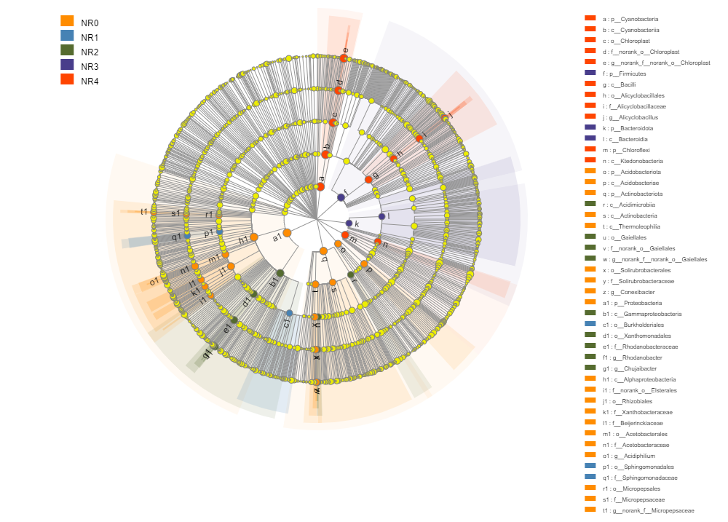
Figure S1 LEfSe analysis of bacterial species at various classification levels under different nitrogen addition in NR biocolonization. The branch diagram shows the statistical difference between N0-N4 treatments at LDA level > 4. Circles from different taxonomic represent taxa at that level. The circle from inside to outside represents the rank of classification from phylum to genus. Different nitrogen levels correspond to different colors, representing the microbial groups that play an important role in each group. The name of the taxon is shown on the right of the corresponding picture. The same below.
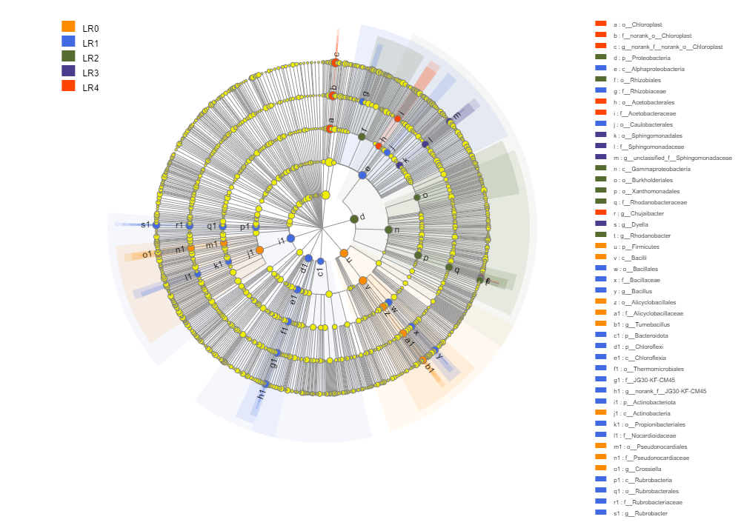
Figure S2 LEfSe analysis of bacterial species at various classification levels under different nitrogen addition in LR biocolonization.
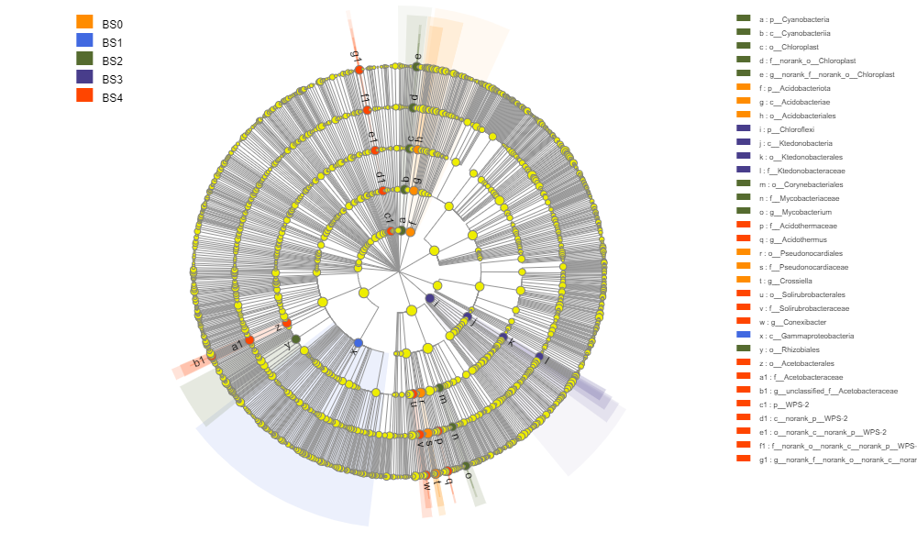
Figure S3 LEfSe analysis of bacterial species at various classification levels under different nitrogen addition in BS biocolonization.

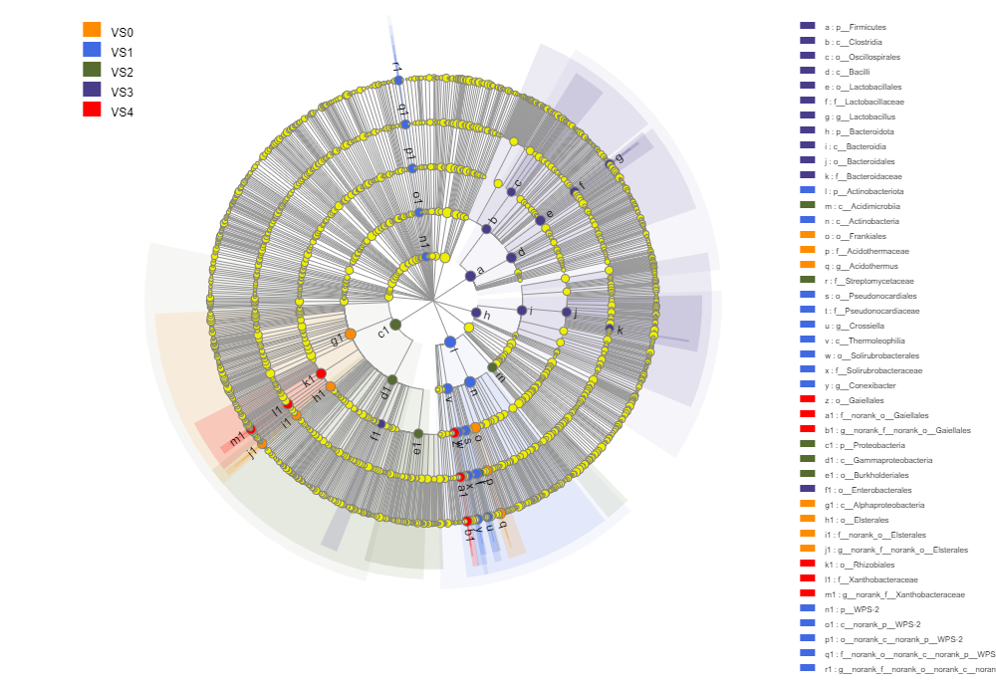
Figure S4 LEfSe analysis of bacterial species at various classification levels under different nitrogen addition in VS biocolonization.
Table S6 Multivariate direct gradient analysis based on linear models of four biocolonization types.
Biocolonization types | Environmental factors | RDA1 | RDA2 | r² | p_values
NR | TOC | 0.6298 | 0.7768 | 0.4363 | 0.042
 | TN | 0.9026 | 0.4306 | 0.7692 | 0.001
 | TP | -0.9635 | -0.2678 | 0.3291 | 0.093
 | DOC | -0.777 | -0.6295 | 0.1565 | 0.378
 | DON | 0.9353 | 0.3539 | 0.7186 | 0.001
 | AP | -0.5946 | -0.804 | 0.1218 | 0.472
 | pH | -0.9824 | -0.1867 | 0.4452 | 0.036
LR | TOC | -0.6416 | -0.767 | 0.7415 | 0.002
 | TN | -0.4903 | -0.8715 | 0.8426 | 0.001
 | TP | -0.9163 | 0.4004 | 0.6573 | 0.002
 | DOC | -0.7175 | -0.6966 | 0.7942 | 0.001
 | DON | 0.113 | -0.9936 | 0.9575 | 0.001
 | AP | -0.6816 | -0.7317 | 0.5761 | 0.01
 | pH | -0.746 | 0.666 | 0.8373 | 0.001
BS | TOC | -0.5118 | -0.8591 | 0.0611 | 0.705
 | TN | 0.9598 | 0.2806 | 0.0417 | 0.772
 | TP | -1 | 0.007 | 0.1097 | 0.495
 | DOC | 0.9749 | 0.2225 | 0.8023 | 0.001
 | DON | 0.9074 | 0.4203 | 0.9204 | 0.001
 | AP | 0.6115 | -0.7912 | 0.1623 | 0.352
 | pH | -0.9129 | -0.4082 | 0.4968 | 0.017
VS | TOC | 0.8323 | 0.5544 | 0.1645 | 0.348
 | TN | 0.9882 | -0.1533 | 0.6616 | 0.002
 | TP | -0.9927 | 0.1208 | 0.8178 | 0.001
 | DOC | -0.5484 | -0.8362 | 0.3788 | 0.057
 | DON | 0.9432 | 0.3322 | 0.6298 | 0.004
 | AP | 0.9858 | 0.168 | 0.6524 | 0.002
 | pH | 0.9738 | 0.2273 | 0.6274 | 0.003

