Supplementary File for Article:
An 8-week injury prevention exercise program combined with change-of-direction technique training reduces change-of-direction knee joint loading without compromising performance

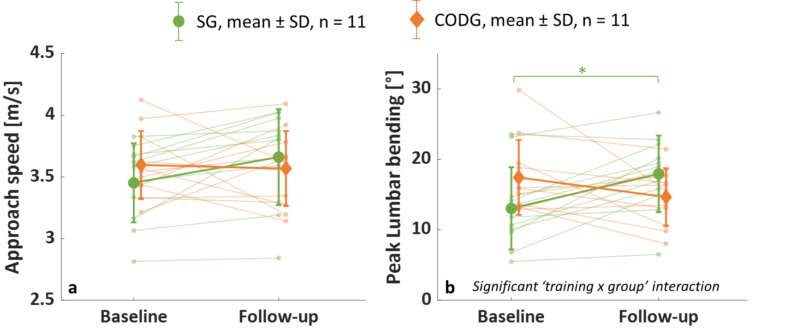
Supplementary Figure 1: COD kinematic results. COD approach speed (a) and peak lumbar bending (lateral trunk flexion towards the opposite than the intended movement direction) (b). SG – sprint group, CODG – change-of-direction group. Transparent data points indicate results for each individual. p-values correspond to within-group post-hoc comparisons.

