Correlates of preconception and pregnancy hair cortisol concentrations

SUPPLEMENTARY MATERIAL
Supplementary Figure 1. Histograms showing the right-skewed distribution of hair cortisol concentrations (HCC) (pg/mg), and its normalization after applying log-transformation (logHCC). LogHCC values were used for all analyses to fulfill model assumptions. HCC was measured at four time periods (pre-pregnancy, first trimester, second trimester, and third trimester; N range 835-1,734).

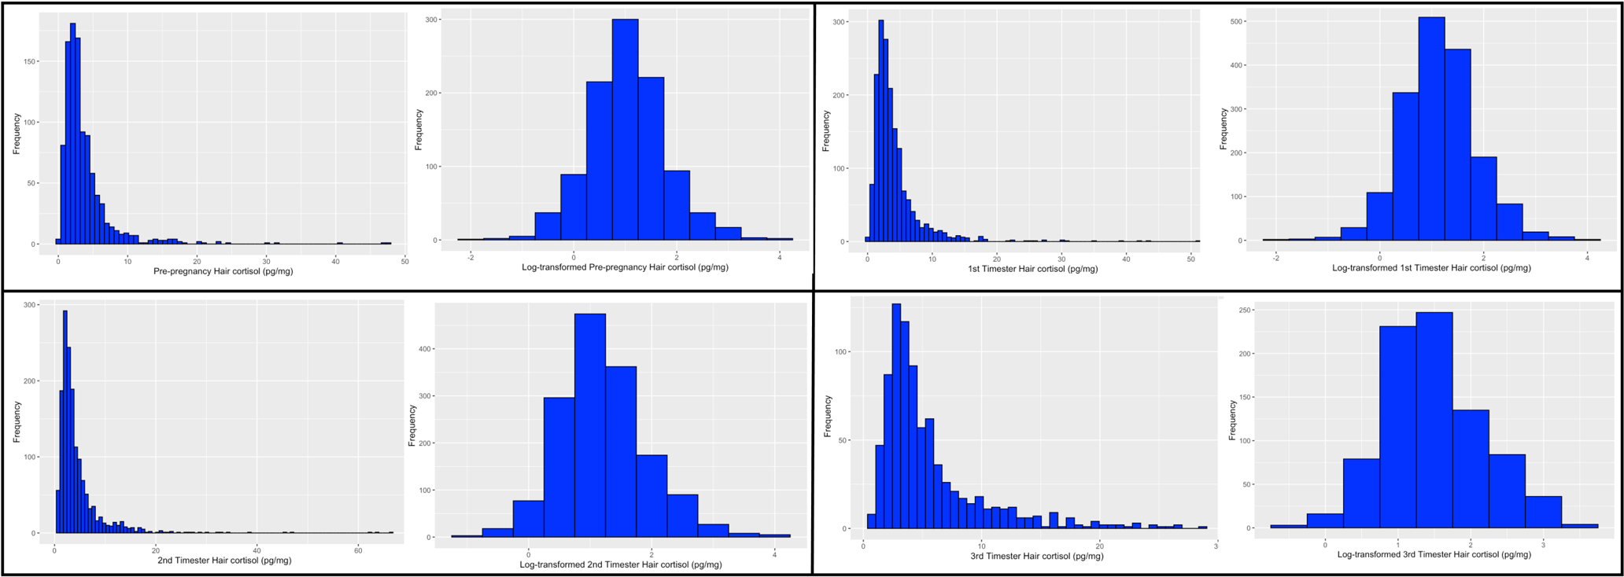

Supplementary Figure 2.
Distribution of log-transformed values of HCC (logHCC) according to maternal psychological variables at four time periods (pre-pregnancy, first, second, and third trimester) (N range 835-1,734). P-values assessing the mean difference in logHCC between groups were calculated using unpaired t-tests for symptoms of antenatal depression (PHQ-9 ≥ 10) and anxiety (GAD-7 ≥ 7). A one-way Analysis of Variance (ANOVA) was used to assess mean differences in logHCC across tertiles of the Perceived Stress Scale (PSS), reporting P-values for the pairwise comparisons of means based on the post-hoc Tukey-Kramer test. Results were considered significant at p < 0.05.
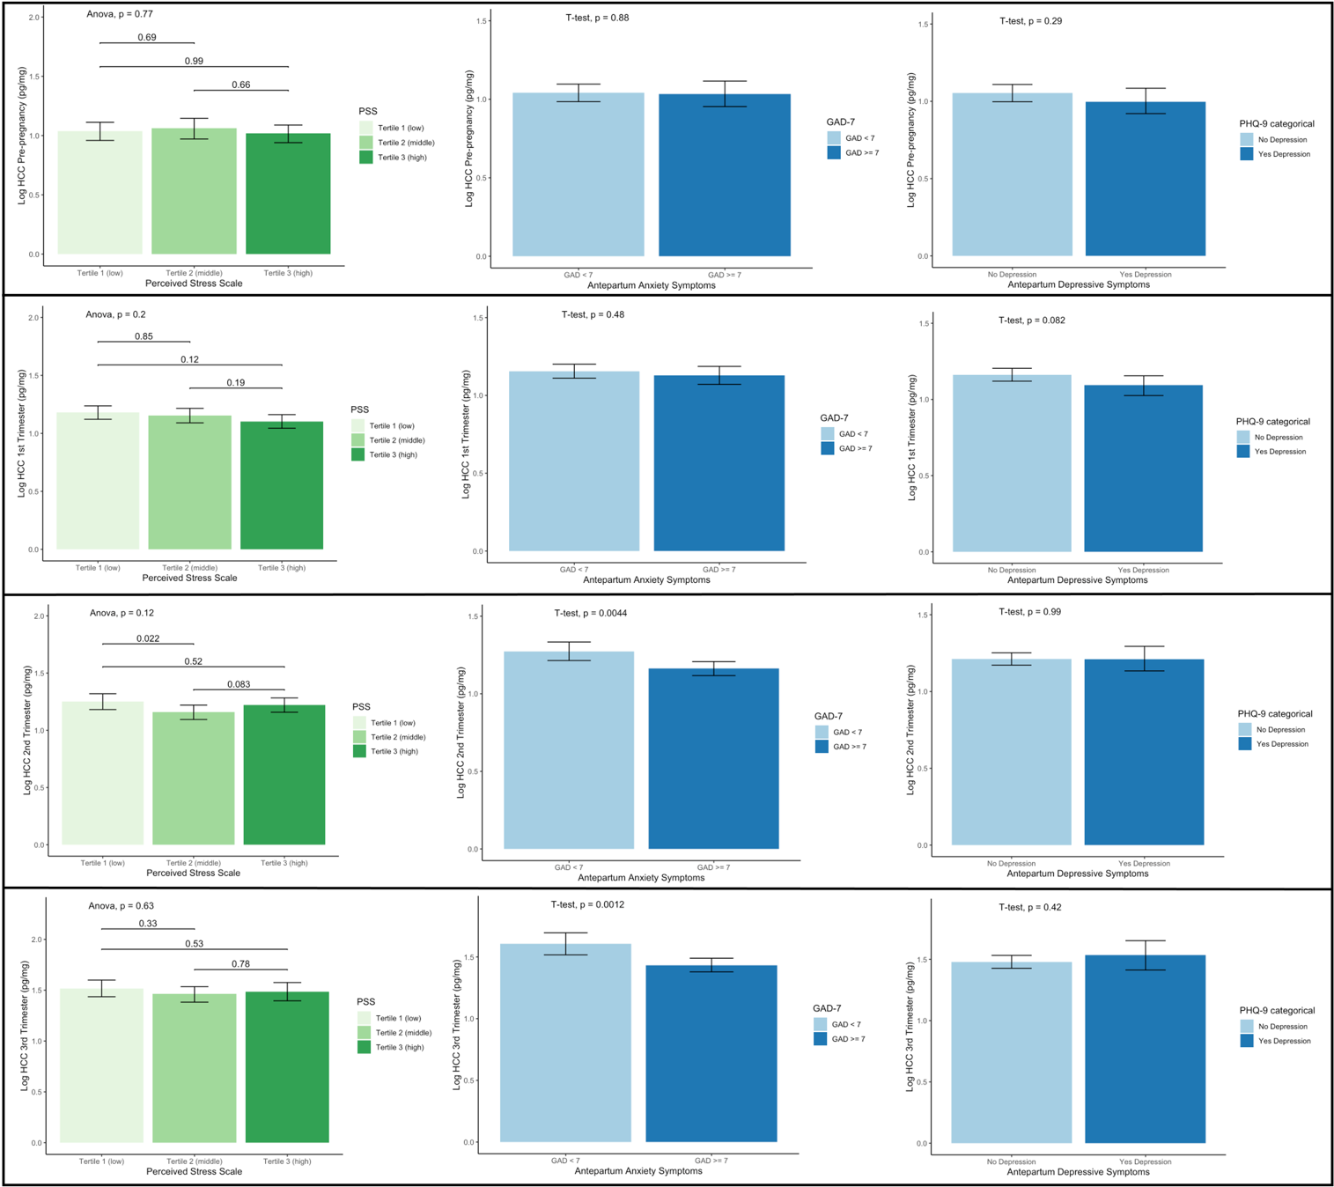

Supplementary Table 1. Pearson’s correlation coefficients and mean difference in logHCCs at four time periods (pre-pregnancy, first trimester, second trimester, and third trimester) (N range 694-1,022).
 | Pre-pregnancy |  | First Trimester |  | Second Trimester |  | Third Trimester
 | Mean difference  (95%CI) | r | Mean difference  (95%CI) | r | Mean difference  (95%CI) | r | Mean difference  (95%CI) | r
Pre-pregnancy | Ref. | 1.00 | 0.15 (0.11,0.19)*** | 0.62*** | — | — | — | —
First Trimester | 0.15  (0.11, 0.19)*** | 0.62 *** | Ref. | 1.00 | 0.21  (0.16, 0.25) *** | 0.65*** | — | —
Second Trimester | — | — | 0.2  (0.16, 0.25)*** | 0.65*** | Ref. | 1.00 | 0.35  (0.32, 0.39)*** | 0.70***
Third Trimester | — | — | — | — | 0.35  (0.32, 0.39)*** | 0.70*** | Ref. | 1.00
Note. LogHCC, log-transformed values of HCC. Differences in the mean of logHCCs were calculated using a paired t-test. ‘*’ p <0.05; ‘**’ p <0.01; ‘***’ p <0.001.

Supplementary Table 2. Regression estimates from stepwise fitted models between logHCCs and predictors. HCCs were assessed at four time periods (pre-pregnancy, first trimester, second trimester, and third trimester) (N range 766-1,636).
 | Pre-pregnancyª |  | First Trimesterª |  | Second Trimesterª |  | Third Trimesterª
 | β | 95% CI | β | 95% CI | β | 95% CI | β | 95% CI
Maternal age (years) | 0.007 | -0.002, 0.015 | 0.005 | -0.002, 0.011 | 0.004 | -0.002, 0.010 | 0.0002 | -0.008, 0.008
Gestational age at HCC collection  (weeks) | 0.013 | -0.011, 0.037 | -0.010** | -0.017, -0.002 | -0.008** | -0.015, -0.001 | 0.051*** | 0.029, 0.073
Pre-pregnant BMI (kg/m²) | 0.018*** | 0.005, 0.031 | 0.022*** | 0.012, 0.032 | 0.029*** | 0.019, 0.039 | 0.031*** | 0.020, 0.043
Difficulty accessing basic foods
No | Ref. |  | Ref. |  | Ref. |  | Ref.
Yes | 0.099* | -0.003, 0.202 | 0.074* | -0.003, 0.150 | 0.080* | -0.001, 0.161 | 0.172*** | 0.073, 0.271
Maternal education (years)
≤ 6 | Ref. |  | Ref. |  | Ref. |  | Ref.
7-12 | -0.119 | -0.498, 0.275 | -0.097 | -0.390, 0.194 | -0.003 | -0.278, 0.212 | 0.030 | -0.234, 0.293
> 12 | -0.156 | -0.543, 0.230 | -0.259* | -0.551, 0.033 | -0.184 | -0.430, 0.061 | -0.020 | -0.284, 0.245
Maternal Employment
Yes | Ref. |  | Ref. |  | Ref. |  | Ref.
No | 0.045 | -0.057, 0.147 | -0.006 | -0.081, 0.069 | 0.070* | 0.148, 0.007 | 0.172*** | 0.073, 0.271
Hair Dyeing
No | Ref. |  | Ref. |  | Ref. |  | Ref.
Yes | -0.001 | -0.153, 0.150 | 0.172*** | 0.053, 0.290 | 0.214*** | 0.093, 0.335 | 0.119* | -0.016, 0.254
Infant Sex
Male | Ref. |  | Ref. |  | Ref. |  | Ref.
Female | 0.098** | -0.004, 0.199 | 0.068* | -0.007, 0.143 | 0.057 | -0.020, 0.134 | -0.013 | -0.118, 0.091
PSS tertiles
Tertile 1 (low) | Ref. |  | Ref. |  | Ref. |  | Ref.
Tertile 2 (middle) | -0.019 | -0.142, 0.104 | -0.028 | -0.120, 0.064 | -0.068 | -0.161, 0.026 | 0.002 | -0.109, 0.112
Tertile 3 (high) | -0.033 | -0.158, 0.092 | -0.073 | -0.164, 0.018 | -0.029 | -0.123, 0.065 | 0.016 | -0.102, 0.133
GAD-7 ≥ 7
No anxiety | Ref. |  | Ref. |  | Ref. |  | Ref.
Anxiety | 0.017 | -0.092, 0.126 | -0.030 | -0.108, 0.048 | -0.073* | -0.155, 0.008 | 0.061 | -0.168, 0.046
PHQ-9 ≥ 10
No depression | Ref. |  | Ref. |  | Ref. |  | Ref.
Depression | -0.064 | -0.181, 0.053 | -0.114** | -0.200, -0.027 | -0.041 | -0.138, 0.055 | 0.016 | -0.105, 0.138
PHQ-9, 9-item Patient Health Questionnaire. GAD-7, 7-item Generalized Anxiety Disorder. PSS, Perceived Stress Scale. ‘*’ p <0.01; ‘**’ p <0.01; ‘***’ p <0.001. ª For each time period, a separate stepwise analysis was calculated for each distress facet (stress, anxiety, depression) independent from the other distress facets.

