Supplementary Materials

Lycorine (Lycoris radiata)-A unique natural medicine on breast cancer
Qinbing Xue^{a,1}, Bing Wang^{b}, Jie Feng^{a,1}, Chaoyu Liª, Miao Yu^{a,}*, Yan Zhao^{c,}*, Zheng Qi^{a,}*

ª Engineering Research Center for Medicine, Ministry of Education, Harbin University of Commerce, Harbin, China.
^{b} School of Food Engineering, Harbin University of Commerce, Harbin, China
^{c} Medical Imaging Department, The Fourth Affiliated Hospital of Harbin Medical University, Harbin, China

Corresponding author:
*Miao Yu and Zheng Qi
No. 138, Tongda Road, Daoli District, Harbin, 150076, China.
Tel.: +86-451-84866922; Fax: +86-451-84866922
E-mail: yumiao913@163.com; 18645039597@163.com; qizheng@hrbcu.edu.cn
¹ These authors contributed equally to this work.

Tables

Table S1 Instruments and manufacturers
Table S2 Reagents and manufacturers
Table S3 Inhibition rate of lycorine on proliferation of MCF-7 cells
Table S4 Primer sequences in PCR reaction system
Table S5 Effects of lycorine on tumor weights of S180 mice
Table S6 Classification and proportion of proteins in cell cycle arrest calculated by PCA analysis
Table S7 Correlation analysis between mitosis protein and relative abundance of genes
Table S8 Effect of cycle arrest on protein expressions induced by lycorine

Figures

Fig. S1 The certification of the human MCF-7 cell line, human hepatoma cell line HepG2, human breast carcinoma cell line MDA-MB-231, human gastric carcinoma cell line SGC-7901 and non-small cell lung cancer cell line A549 contrast result detected by National Infrastructure of Cell Line Resource
Fig. S2 1D-NMR spectra of lycorine
Fig. S3 Affidavit of approval of animal ethics and welfare
Fig. S4 Primer sequences in PCR reaction system
Fig.S5 Effect of MCF-7 cell cycle arrest on protein expressions induced by lycorine.

Table S1 Instruments and manufacturers
Instruments | Manufacturer
CO-150 incubator | SANYO Electric Co., Ltd.
EPED-E2 - 30TJ Laboratory Super pure Water Apparatus | Nanjing Yipu Yida Technology Development Co., Ltd.
CKX-41 - 32 inverted microscope | Olympus Corporation, Japan
One thousandth of Adventurer electronic balance | Ohous, USA
DK-8D electric-heated thermostatic waterbath | Shanghai Yiheng Technology Instrument Co., Ltd.
Standard PB-10 pH Meter | Sartorius, Germany
DL-CJ-1N Medical Super Cleaning Worktable | Beijing HDL apparatus Co., Ltd.
680 automatic microplate reader | Bio-Rad Laboratories, Inc.
Fluorescence microscope | Leica, Germany
Electrophoresis instrument DYY-7C | Beijing Liuyi Biotechnology Co., Ltd.
Vertical electrophoresis tank | Beijing Liuyi Biotechnology Co., Ltd.
TS-1000 Oscillator | Haimen Qilinbeier Instrument Manufacturing Co., Ltd.
Anke TDL80 - 2C Centrifuge | Shanghai Anting Scientific Instrument Factory
ImageQuant LAS500 Gel Imaging System | Shanghai Tanon Power Co., Ltd.
EPICS-XL Flowcytometer | Beckman Coulter, Inc., USA
Allegra 64R Tabletop High Speed Refrigerated Centrifuge | Beckman Coulter, Inc., USA
C-4040ZOOM Digital Camera | Olympus Corporation, Japan
Step One PlusTM Real-Time PCR system | Wcgene Biotech, Inc., Shanghai, China

Table S2 Reagents and manufacturers

Reagents | Manufacturer
RPMI-1640 culture powder (batch number: ab37672)  Dulbecco’s modified Eagle’s medium (batch number: ab37654) | Gibco Life Technologies, Inc., USA  Gibco Life Technologies, Inc., USA
Lycorine (batch number: L413074) | Shanghai Aladdin Biochemical Technology Co., Ltd.
Fetal bovine serum (batch number: 20160402a) | Corning Life Co., Ltd. New Zealand
Trypsin (batch number: 20150703) | Gibco Life Technologies, Inc., USA
DMSO (batch number: 20160204) | Tianjin Zhonghe Shengtai Chemical Co., Ltd.
MTT (batch number: 20151121) | Jiangsu Beyotime Institute of Biotechnology
Penicillin-Streptomycin Solution (100X) (batch number: C0222） | Jiangsu Beyotime Institute of Biotechnology
NaCl (batch number: bs130727) | Shanghai Chemical Reagent Company
KCl (batch number: bs130402) | Tianjin Corrine Chemical Sales Company
KH₂PO₄ (batch number: 20130301) | Weifang Hengfeng Chemical Co., Ltd.
Na₂HPO₄ (batch number: 20130517) | Shanghai Chemical Reagent Company
Propidium iodide (PI) (batch number: 20160102) | Sigma-Aldrich LLC., USA
Ethanol (95%) (batch number: 20160309) | Shandong Yinzhou Chemical Co., Ltd.
Triton-X-100 (batch number: 114-a) | Farco, Hung
Sodium Citrate (batch number: 20120317) | Beijing Chemical Reagent Company
Ribonuclease A (batch number: 20160304) | Beijing Chemical Reagent Company
NaHCO₃ (batch number: 20140508) | Tianjin BASF Chemical Trading Co., Ltd.
Saline (batch number: 20160414) | Harbin Triple Pharmaceutical Co., Ltd.
Crystal violet staining solution (batch number: C0121) | Shanghai Beyotime Biological Co.,Ltd.
Glycerol (batch number: 20130703)  Cyclophosphamide (batch number: S83332)  Vincristine (VCR) (batch number: B20160) | Shanghai Macklin Biochemical Technology Co., Ltd.  Shanghai Yuanye Biotechnology Co.,Ltd.  Shanghai Yuanye Biotechnology Co.,Ltd.
TriTris (batch number: 0479) | Sigma-Aldrich LLC., USA
Glycine (batch number: ST085) | Jiangsu Beyotime Institute of Biotechnology
BCA protein concentration determination kit (batch number: P0010S) | Jiangsu Beyotime Institute of Biotechnology
DAB Substrate Kit (batch number: P0203) | Beijing ZhongShan-Golden Bridge Biological Technology
Skimmed milk powder (batch number: CM0004) | Hefei Lanxu Biotechnology Co., Ltd.
Acrylamide (batch number: A012901) | Beijing Huamaike Biotechnology Co., Ltd.
IgG/HRP (batch number : ZDR-5306） | Jiangsu Beyotime Institute of Biotechnology
Rabbit Anti-β actin mAb (batch number : TA-09） | Jiangsu Beyotime Institute of Biotechnology
Rabbit Anti-Cyclin B1 antibody (batch number : bs-0572R） | Jiangsu Beyotime Institute of Biotechnology
Rabbit Anti-CDK1 antibody (batch number : bs-1341R） | Jiangsu Beyotime Institute of Biotechnology
Rabbit Anti-p21 antibody (batch number : bs-2687R） | Biosynthesis Biotechnology Co., Ltd.
Rabbit Anti-Aurora A antibody (batch number: bsm-52018R）  Rabbit Anti-Aurora B antibody (batch number : bs-22286R）  Rabbit Anti-p-H3 antibody (batch number : bs-3189R）  Rabbit Anti-PLK1 antibody (batch number : bsm-33865M）  Rabbit Anti-BRCA1 antibody (batch number : bs-20490R）  Rabbit Anti-STAT3 antibody (batch number : bsm-52235R）  Rabbit Anti-PAK1 antibody (batch number : bs-2277R）  Rabbit Anti-CAMK4 antibody (batch number : bs-6727R）  Rabbit Anti-PKA antibody (batch number : bs-3964R）  Rabbit Anti-ERK1/2 antibody (batch number : bsm-52259R） | Beijing Bioss Biotechnology Co., Ltd.  Beijing Bioss Biotechnology Co., Ltd  Beijing Bioss Biotechnology Co., Ltd  Beijing Bioss Biotechnology Co., Ltd  Beijing Bioss Biotechnology Co., Ltd  Beijing Bioss Biotechnology Co., Ltd  Beijing Bioss Biotechnology Co., Ltd  Beijing Bioss Biotechnology Co., Ltd  Beijing Bioss Biotechnology Co., Ltd  Beijing Bioss Biotechnology Co., Ltd
Rabbit Anti-BubR1 antibody (batch number : bs-5726R） | Biosynthesis Biotechnology Co., Ltd.
Color-coded Prestained Protein Marker (10-180 kDa (batch number: P0068） | Jiangsu Beyotime Institute of Biotechnology
Ponceau Staining Solution (batch number: P0022） | Jiangsu Beyotime Institute of Biotechnology
Ammonium persulfate (APS) (batch number: ST005) | Jiangsu Beyotime Institute of Biotechnology
Tween-20 (batch number: ST825) | Jiangsu Beyotime Institute of Biotechnology
PMSF (100mM) (batch number: ST506) | Jiangsu Beyotime Institute of Biotechnology
TEMED (batch number: ST728) | Jiangsu Beyotime Institute of Biotechnology
SDS (batch number: BOO0276) | Sigma-Aldrich LLC., USA
DTT (batch number: ST040) | Jiangsu Beyotime Institute of Biotechnology
Bromophenol Blue (batch number: B802654) | Shanghai Macklin Biochemical Technology Co., Ltd
Methanol (batch number: 20160509) | Guangzhou Yuebao Chemical Technology Co., Ltd.

Table S3 Inhibition rate of lycorine on proliferation of MCF-7 cells (n=6)

Groups | Concentration (μmol/L) | Optical density | Inhibitory rate (%)
Control | - | 1.355±0.07 | -
Lycorine | 1 | 1.187±0.13** | 14.9
 | 2 | 1.075±0.09** | 24.8
 | 4 | 0.974±0.16** | 33.7
 | 8 | 0.929±0.05** | 37.7
 | 16 | 0.777±0.04** | 51.2
 | 32 | 0.632±0.03** | 64.1
VCR | 0.625 | 0.892±0.05** | 52.7
Significant difference compared with control group, **P <0.01

Table S4 Primer sequences in PCR reaction system

ARGs | Forward primer | Reverse primer
ABL1 | TGGTCCCTTCCTTTTGTTAACGT | TATGCACACGCCACTTAGAAAAGA
ANAPC2 | TATGTTGCGCGGAGTCTTGTT | GAAGCACCCATACAGACGCTG
ATM | ATCTGCTGCCGTCAACTAGAA | GATCTCGAATCAGGCGCTTAAA
ATR | ACATTTGTGACTGGAGTAGAAGA | TCCACAATTGGTGACCTGGG
AURKA | TGGGTGGTCAGTACATGCTC | TGCATCCGACCTTCAATCATTTC
AURKB | CGCAGAGAGATCGAAATCCAG | AGATCCTCCTCCGGTCATAAAA
BCCIP | ACAGAACCAATAAGCCATGTGG | TGCAAACATTAACGCAGCTTTC
BCL2 | ATTGATGGGATCGTTGCCTTAT | TCCAATTCCTTTCGGATCTTTA
BIRC5 | TGGGAAGGGTTGTGAATGAG | CAGTTTGGCTTGCTGGTCTC
BRCA1 | GAAACCGTGCCAAAAGACTTC | CCAAGGTTAGAGAGTTGGACAC
BRCA2 | TGCCTGAAAACCAGATGACTATC | AGGCCAGCAAACTTCCGTTTA
CASP3 | TGGTTCATCCAGTCGCTTTGT | CCCGGGTAAGAATGTGCATAAA
CCNA2 | TGGAAAGCAAACAGTAAACAGCC | GGGCATCTTCACGCTCTATTT
CCNB1 | AATAAGGCGAAGATCAACATGGC | TTTGTTACCAATGTCCCCAAGAG
STMN1 | TCAGCCCTCGGTCAAAAGAAT | TTCTCGTGCTCTCGTTTCTCA
KIF2C | GAGAGCAAGCTGACACAGGT | CCTGGTGAGATCGTGGCAAT
KATNA1 | AGCACTCCCTTGAAAGCGG | GCGTTTTCTAGGTCCTGGTGA
CCNB2 | TGCTCTGCAAAATCGAGGACA | GCCAATCCACTAGGATGGCA
CCNC | CCTTGCATGGAGGATAGTGAATG | AAGGAGGATACAGTAGGCAAAGA
CCND1 | GCTGCGAAGTGGAAACCATC | CCTCCTTCTGCACACATTTGAA
CCND2 | CTGTCTCTGATCCGCAAGCAT | GGTGGGTACATGGCAAACTTAAA
CCND3 | TACCCGCCATCCATGATCG | AGGCAGTCCACTTCAGTGC
CCNE1 | AAGGAGCGGGACACCATGA | ACGGTCACGTTTGCCTTCC
CCNF | CACAAAGCATCCATATTGCACTG | TGGTCAGACATCCCTGATGAG
CCNG1 | GAGTCTGCACACGATAATGGC | GTGCTTGGGCTGTACCTTCA
CCNG2 | TCTCGGGTTGTTGAACGTCTA | GTAGCCTCAATCAAACTCAGCC
CCNH | AGGCACTTGAACAGATACTGGA | CCAATATGGGATAGCGGGTCT
CCNT1 | ACAACAAACGGTGGTATTTCACT | CCTGCTGGCGATAAGAAAGTT
CDC16 | CTTGAAGGACGAAAGTGGCTT | TTCCCGCGTAGAAGACAGATA
CDC20 | GCTTTGAACCTGAACGGTTTTG | TCTGGCGCATTTTGTGGTTTT
CDC25A | GTGAAGGCGCTATTTGGCG | TGGTTGCTCATAATCACTGCC
STAT3 | CAGCAGCTTGACACACGGTA | AAACACCAAAGTGGCATGTGA
ERK | TCACACAGGGTTCCTGACAGA | ATGCAGCCTACAGACCAAATATC
PAK1 | AGGGGAGTTTACGGGAATGC | TCTTCTGCTCCGACTTAGTGATA
CDC25C | TCTACGGAACTCTTCTCATCCAC | TCCAGGAGCAGGTTTAACATTTT
CDC34 | AACGAGCCCAACACCTTCTC | GTACTCCCGATCCTTCCCCT
CDC6 | TGTTCTCCTCGTGTAAAAGCC | GGGGAGTGTTGCATAGGTTGT
CDK1 | GGATGTGCTTATGCAGGATTCC | CATGTACTGACCAGGAGGGATAG
CDK2 | GTACCTCCCCTGGATGAAGAT | CGAAATCCGCTTGTTAGGGTC
CDK4 | TCAGCACAGTTCGTGAGGTG | GTCCATCAGCCGGACAACAT
CDK5R1 | AGAACAGCAAGAACGCCAAG | CGGCCACGATTCTCTTCCA
CDK5RAP1 | ATGGCTGCCAGATGAATGTGA | CTCTTGGAGGTTACTGGTCCG
CDK6 | CCAGATGGCTCTAACCTCAGT | AACTTCCACGAAAAAGAGGCTT
CDK7 | GGAGCCCCAATAGAGCTTATACA | TCCACACCTACACCATACATCC
CDK8 | GGGATCTCTATGTCGGCATGT | CACACCTTCCTATCAGCATGAG
CDKN1A | TGTCCGTCAGAACCCATGC | AAAGTCGAAGTTCCATCGCTC
CDKN1B | ATCACAAACCCCTAGAGGGCA | GGGTCTGTAGTAGAACTCGGG
CDKN2A | ATGGAGCCTTCGGCTGAC | GTAACTATTCGGTGCGTTGG
CAMK4 | GCCTCGTCCCGGATTACTG | TCCCCTTCTGTTTGCATCTGT
CDKN2B | GGGACTAGTGGAGAAGGTGC | CATCATCATGACCTGGATCGC
CDKN3 | AGCCGCCCAGTTCAATACAA | CCTGGAAGAGCACATAAACCG
CHEK1 | ATATGAAGCGTGCCGTAGACT | TGCCTATGTCTGGCTCTATTCTG
CHEK2 | TGAGAACCTTATGTGGAACCCC | ACAGCACGGTTATACCCAGC
CKS1B | TATTCGGACAAATACGACGACG | CGCCAAGATTCCTCCATTCAGA
CKS2 | TTCGACGAACACTACGAGTACC | GGACACCAAGTCTCCTCCAC
CUL1 | AGCCATTGAAAAGTGTGGAGAA | GCGTCATTGTTGAATGCAGACA
CUL2 | ACGACAATAAAAGCCGTGGTC | GGATAGGCCACACATAAAGCAT
CUL3 | TGTGGAGAACGTCTACAATTTGG | GCGCCTCTGTCTACGACTT
E2F1 | CATCCCAGGAGGTCACTTCTG | GACAACAGCGGTTCTTGCTC
E2F4 | CCTAGCTGTACGCCAGAAGC | TTTTTCTCGATTAGCCCGATACC
GADD45A | GGATGCCCTGGAGGAAGTG | CTTCGTACACCCCGACAGTGA
GTSE1 | CAGGGGACGTGAACATGGATG | ATGTCCAAAGGGTCCGAAGAA
HUS1 | GAATGCCAGGGCTTTGAAAATC | CACAATGCGGCTACTGCTTG
TPPP3 | TCCATTCCTGCGTCGTTCTG | TTCATCTCTTGCCCACTGGC
MAP2 | CTCAGCACCGCTAACAGAGG | CATTGGCGCTTCGGACAAG
MAPT | CCAAGTGTGGCTCATTAGGCA | CCAATCTTCGACTGGACTCTGT
KNTC1 | GAGAGAAGTGGCAACCTACATC | CGCCGATTTTCATCGTTAGCTTT
KPNA2 | GGCACTGTAAATTGGTCTGTTGA | CCTGGCAGCTTGAGTAGCTT
MAD2L1 | GTTCTTCTCATTCGGCATCAACA | GAGTCCGTATTTCTGCACTCG
MAD2L2 | ACCGCCCAGTGGAGAAATTC | CATCGCACACGCTGATCTT
MCM2 | ATGGCGGAATCATCGGAATCC | GGTGAGGGCATCAGTACGC
MCM3 | TCAGAGAGATTACCTGGACTTCC | TCAGCCGGTATTGGTTGTCAC
MCM4 | CACCACACACAGTTATCCTGTT | CGAATAGGCACAGCTCGATAGAT
MCM5 | AGCATTCGTAGCCTGAAGTCG | CGGCACTGGATAGAGATGCG
MDM2 | CAGTAGCAGTGAATCTACAGGGA | CTGATCCAACCAATCACCTGAAT
MKI67 | CGTCCCAGTGGAAGAGTTGT | CGACCCCGCTCCTTTTGATA
MNAT1 | AGCTCTGTATGAATACCAGCCA | AGTCTTCCTAGCATCTCAAGCTC
MRE11A | ATCGGCCTGTCCAGTTTGAAA | TGCCATCTTGATAGTTCACCCAT
NBN | GACTGGCGTTGAGTACGTTGT | TGATTTCGGCTGATCGACTGA
RAD1 | CTCAACAGTGGGGTAGGCAG | GGTGGGGATAAGGGACAAGC
DIAPH1 | CTTGCGGGATATGCCTCTG | AATGTTTGCACCCAACTGACA
RAC1 | GTGCAGACACTTGCTCTCCT | AATGGCAACGCTTCATTCGG
CDC42 | CCATCGGAATATGTACCGACTG | CTCAGCGGTCGTAATCTGTCA
RAD17 | ACACGCTCTTTACTCAGGGAA | AGCATATCCTCGGGCTTTGTT
RAD51 | CAACCCATTTCACGGTTAGAGC | TTCTTTGGCGCATAGGCAACA
RAD9A | CATTGACTCTTACATGATCGCCA | GCCAGGTGAAAGGGAAATGG
RB1 | TTGGATCACAGCGATACAAACT | AGCGCACGCCAATAAAGACA
RBBP8 | AGATCGGTTAAGAGCAGGCTT | TGCTGCCGGATATTTTCAAACT
RBL1 | TCGGATGATTGGGGATGACTT | GCACATAATCGCATTGGCAAAAA
RBL2 | TGAGCGAAAGCTACACGCTG | TCCCTTTGCTTACAGTTGGAAC
SERTAD1 | CTGGCTGTCTACTGGACGATG | TGGTGCCCAAAGTTCATTGTC
SKP2 | ATGCCCCAATCTTGTCCATCT | CACCGACTGAGTGATAGGTGT
TFDP1 | AGGGCCTACGGCATTTCTC | CTCGTCTGCCACTTCGTTGT
TFDP2 | CTGCCTACCAATTCTGCTCAG | CGCTTCTGCTTTATCCGTTCT
TP53 | GAGGTTGGCTCTGACTGTACC | TCCGTCCCAGTAGATTACCAC
WEE1 | TGAAGAGGCTGGATGGATGC | TTCTGCCCACGCAGAGAAAT
RHOA | GGAAAGCAGGTAGAGTTGGCT | GGCTGTCGATGGAAAAACACAT
CKAP5-A | TGTGGAAAGCAAGGTTAAGTGG | ACTCTGGGCTCTTTTCATCCT
PKA | AGCCCACTTGGATCAGTTTGA | GTTCCCGGTCTCCTTGTGT
ICIS | CCGGGGAGAGCTAGTCACT | CTGCTGGACGAATGCTTCA
CDC2 | GGATGTGCTTATGCAGGATTCC | CATGTACTGACCAGGAGGGATAG

Table S5 Effects of lycorine on tumor weights of S180 mice (n=10)

Group | Dose (mg/kg) | Tumor weigh (g) | Inhibition Rate (%)
Control | — | 1.15±0.11 | —
CTX | 10 | 0.49±0.08** | 56.84
Lycorine | 10 | 0.89±0.12** | 21.69
Lycorine | 20 | 0.78±0.17** | 32.07
Lycorine | 40 | 0.57±0.13** | 50.58
Significant difference compared with control group, **P <0.01

Table S6 Classification and proportion of proteins in cell cycle arrest calculated by PCA analysis

Proteins | PC1 (88.8%) | PC2 (6.4%) | PC3 (3.1%)
CyclinB1 | -1.78564 | -0.04188 | 0.01567
CDK1 | -3.8643 | -0.69761 | -0.01461
p21 | -3.03271 | 1.41814 | -0.48869
Aurora A | -1.14403 | -0.41752 | 0.09986
Aurora B | -2.40351 | -0.99334 | 0.1933
p-H3 | -5.08589 | -0.28909 | 0.34799
PLK1 | 0.38954 | -0.79803 | -0.21024
BRCA1 | 0.16248 | 0.52092 | 1.51571
BUBR1 | 0.11785 | 2.83211 | -0.39083
STAT3 | 7.72889 | -0.34553 | 0.0857
PAK1 | 5.42342 | 0.19241 | 1.08569
CAMK4 | 5.00192 | -0.24517 | -0.58637
PKA | 2.22545 | -0.53335 | -1.46269
EKR1 | -1.84439 | -0.21735 | -0.05468
ERK2 | -1.88909 | -0.38472 | -0.13583

Table S7 Correlation analysis between mitosis protein and relative abundance of genes

 | CyclinB1 | CDK1 | p21 | Aurora A | Aurora B | p-H3 | PLK1
CCNB2 | 0.270 | 0.051 | 0.064 | 0.484 | 0.205 | 0.495 | 0.936
CCNF | 0.076 | 0.010* | 0.014* | 0.185 | 0.057 | 0.239 | 0.688
CDC25C | 0.083 | 0.011* | 0.016* | 0.194 | 0.063 | 0.244 | 0.684
CDC6 | 0.234 | 0.032* | 0.044* | 0.473 | 0.172 | 0.497 | 0.863
CDC20 | 0.310 | 0.049* | 0.064* | 0.574 | 0.231 | 0.578 | 0.780
MRE11A | 0.590 | 0.153 | 0.180 | 0.873 | 0.467 | 0.827 | 0.595
RAD51 | 0.102 | 0.017* | 0.023* | 0.212 | 0.078 | 0.251 | 0.655
KIF2C | 0.001** | 0*** | 0*** | 0.001** | 0.001** | 0.002* | 0.003*
STMN1 | 0*** | 0*** | 0*** | 0.001** | 0.001** | 0.002* | 0.003*
KATNA1 | 0*** | 0*** | 0*** | 0*** | 0*** | 0.001** | 0.001**
MAP2 | 0.261 | 0.037* | 0.050 | 0.512 | 0.192 | 0.528 | 0.825
MAPT | 0.124 | 0.018* | 0.024* | 0.270 | 0.093 | 0.314 | 0.820
PAK1 | 0.034* | 0.004** | 0.006** | 0.096 | 0.027* | 0.150 | 0.490
Stat3 | 0.001** | 0*** | 0*** | 0.007 | 0.001** | 0.030* | 0.117
ERK | 0*** | 0*** | 0*** | 0.001** | 0*** | 0.001** | 0.001**
PKA | 0.035* | 0.004** | 0.006** | 0.103 | 0.028* | 0.162 | 0.531
CAMK4 | 0.010* | 0.001** | 0.002** | 0.034* | 0.008** | 0.074 | 0.271
ICIS | 0.049 | 0.006** | 0.008** | 0.133 | 0.038* | 0.190 | 0.591
AURKB | 0.009** | 0.001** | 0.002** | 0.033* | 0.008** | 0.076 | 0.282
CDC2 | 0.007** | 0.001** | 0.001** | 0.029* | 0.007** | 0.072 | 0.273
In each cell, the value indicates the P-value. Bold values indicate statistical significance (P＜0.05), * P＜0.05, ** P＜0.01, *** P＜0.001.

Table S7 Correlation analysis between mitosis protein and relative abundance of genes (continued table)

 | BRCA1 | BUBR1 | STAT3 | PAK1 | CAMK4 | PKA | EKR1 | ERK2
CCNB2 | 0.892 | 0.656 | 0.018* | 0.056 | 0.063 | 0.403 | 0.276 | 0.291
CCNF | 0.496 | 0.314 | 0.021* | 0.075 | 0.086 | 0.602 | 0.081 | 0.092
CDC25C | 0.499 | 0.320 | 0.023* | 0.082 | 0.094 | 0.621 | 0.089 | 0.100
CDC6 | 0.946 | 0.674 | 0.012* | 0.037* | 0.040* | 0.328 | 0.243 | 0.262
CDC20 | 0.954 | 0.776 | 0.011* | 0.035* | 0.038* | 0.297 | 0.318 | 0.337
MRE11A | 0.723 | 0.953 | 0.012* | 0.034* | 0.038* | 0.240 | 0.592 | 0.607
RAD51 | 0.491 | 0.328 | 0.032* | 0.110 | 0.129 | 0.692 | 0.107 | 0.117
KIF2C | 0.002** | 0.002** | 0.276 | 0.072 | 0.047* | 0.011* | 0.001** | 0.001**
STMN1 | 0.002** | 0.001** | 0.340 | 0.087 | 0.056 | 0.013* | 0.001** | 0.001**
KATNA1 | 0.001** | 0.001** | 0.095 | 0.023* | 0.015* | 0.004** | 0*** | 0***
MAP2 | 0.989 | 0.715 | 0.011* | 0.035* | 0.038* | 0.312 | 0.269 | 0.288
MAPT | 0.629 | 0.420 | 0.020* | 0.067 | 0.076 | 0.525 | 0.130 | 0.143
PAK1 | 0.317 | 0.187 | 0.026* | 0.095 | 0.110 | 0.755 | 0.038* | 0.045*
Stat3 | 0.046* | 0.024* | 0.039* | 0.171 | 0.206 | 0.761 | 0.002** | 0.003**
ERK | 0.002** | 0.001** | 0.252 | 0.063 | 0.041* | 0.010* | 0.001** | 0.001**
PKA | 0.346 | 0.203 | 0.022* | 0.083 | 0.094 | 0.701 | 0.039* | 0.047*
CAMK4 | 0.147 | 0.081 | 0.034* | 0.134 | 0.159 | 0.995 | 0.011* | 0.015*
ICIS | 0.403 | 0.244 | 0.022* | 0.081 | 0.092 | 0.664 | 0.054 | 0.063
AURKB | 0.152 | 0.082 | 0.031* | 0.123 | 0.144 | 0.963 | 0.011* | 0.014*
CDC2 | 0.141 | 0.076 | 0.029* | 0.116 | 0.135 | 0.956 | 0.009** | 0.012*
In each cell, the value indicates the P-value. Bold values indicate statistical significance (P＜0.05), * P＜0.05, ** P＜0.01, *** P＜0.001.

Table S8 Effect of cycle arrest on protein expressions induced by lycorine (n=3).

Proteins | Control | VCR | 7μmol/L | 14μmol/L | 28μmol/L
CyclinB1/β-Actin（%） | 0.52±0.01 | 0.38±0.00** | 0.41±0.01 | 0.38±0.01** | 0.36±0.01**
CDK1/β-Actin（%） | 0.33±0.04 | 0.23±0.04** | 0.28±0.01 | 0.25±0.01 | 0.18±0.02***
p21/β-Actin（%） | 0.16±0.02 | 0.18±0.02 | 0.25±0.01** | 0.38±0.03*** | 0.42±0.02***
Aurora A/β-Actin（%） | 0.65±0.03 | 0.47±0.01* | 0.51±0.01* | 0.41±0.01* | 0.35±0.00**
Aurora B/β-Actin（%） | 0.52±0.01 | 0.40±0.01* | 0.42±0.01* | 0.34±0.00** | 0.22±0.01***
STAT3/GADPH（%） | 1.65±0.05 | 1.25±0.06*** | 1.45±0.05 | 0.93±0.07*** | 0.82±0.03***
PAK1/GADPH（%） | 1.45±0.05 | 1.18±0.03** | 0.92±0.07*** | 0.81±0.03*** | 0.75±0.02***
CAMK4/GADPH（%） | 1.3±0.02 | 0.92±0.03* | 1.13±0.05 | 0.9±0.08* | 0.65±0.03**
PKA/GADPH（%） | 1.15±0.02 | 0.52±0.02*** | 0.85±0.03*** | 0.75±0.02*** | 0.5±0.04***
ERK1/GADPH（%） | 0.57±0.05 | 0.37±0.02* | 0.41±0.03 | 0.38±0.02* | 0.34±0.04**
ERK2/GADPH（%） | 0.62±0.02 | 0.36±0.02* | 0.40±0.05 | 0.37±0.03* | 0.33±0.02*
In each cell, the value indicates the P-value, * P＜0.05, ** P＜0.01, *** P＜0.001.

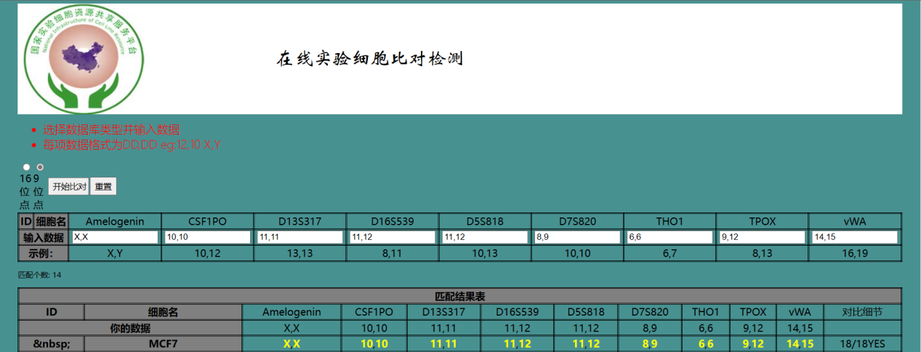
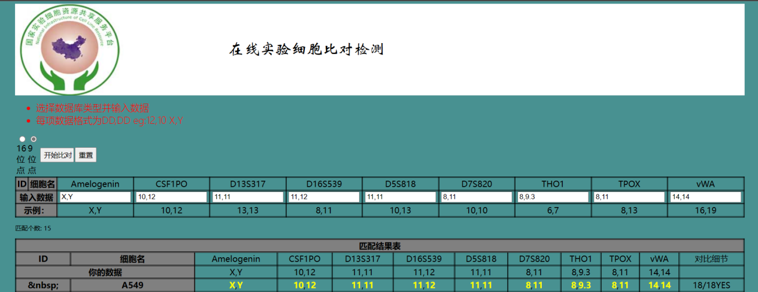
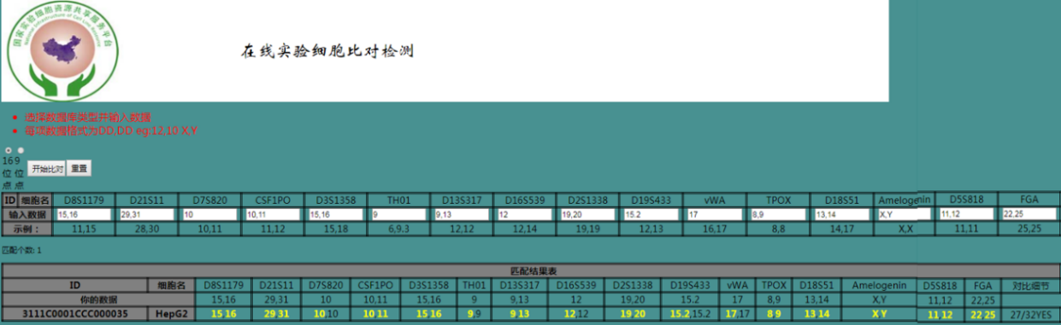
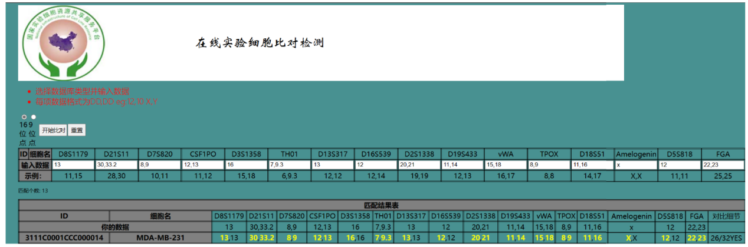

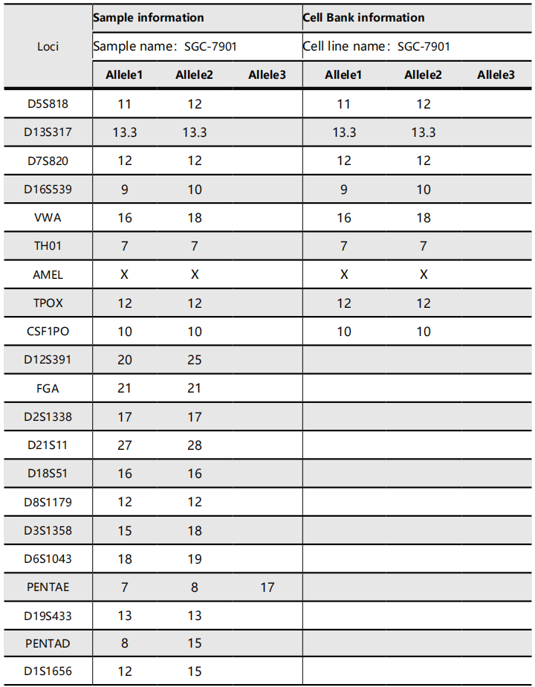

Fig. S1 The certification of the human MCF-7, A549, HepG2, MDA-MB-231, SGC-7901 cell contrast result detected by National Infrastructure of Cell Line Resource

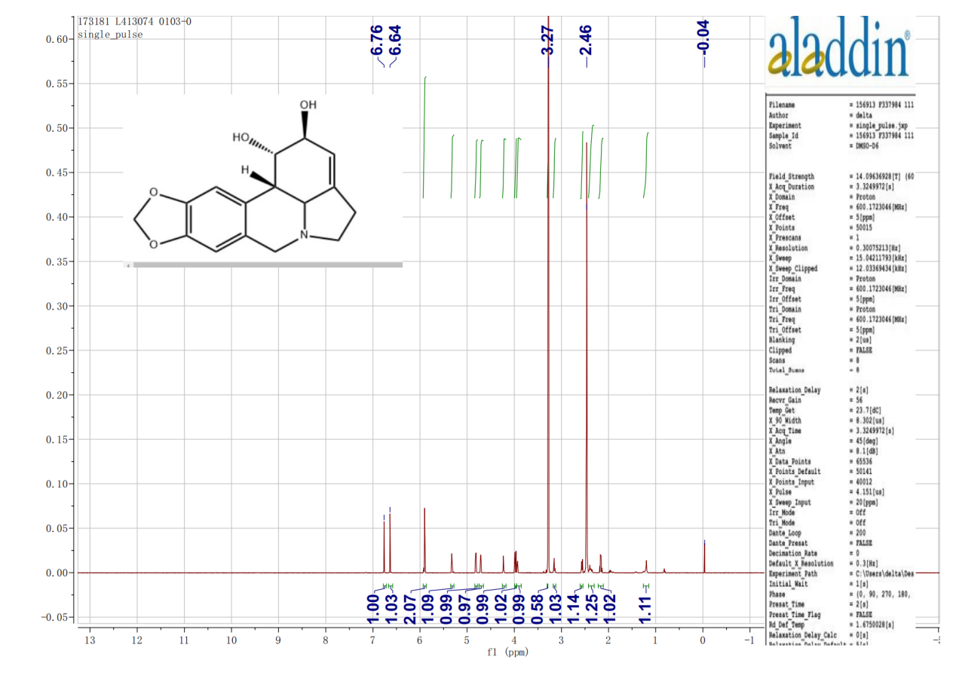
Fig. S2 1D-NMR spectra of lycorine.

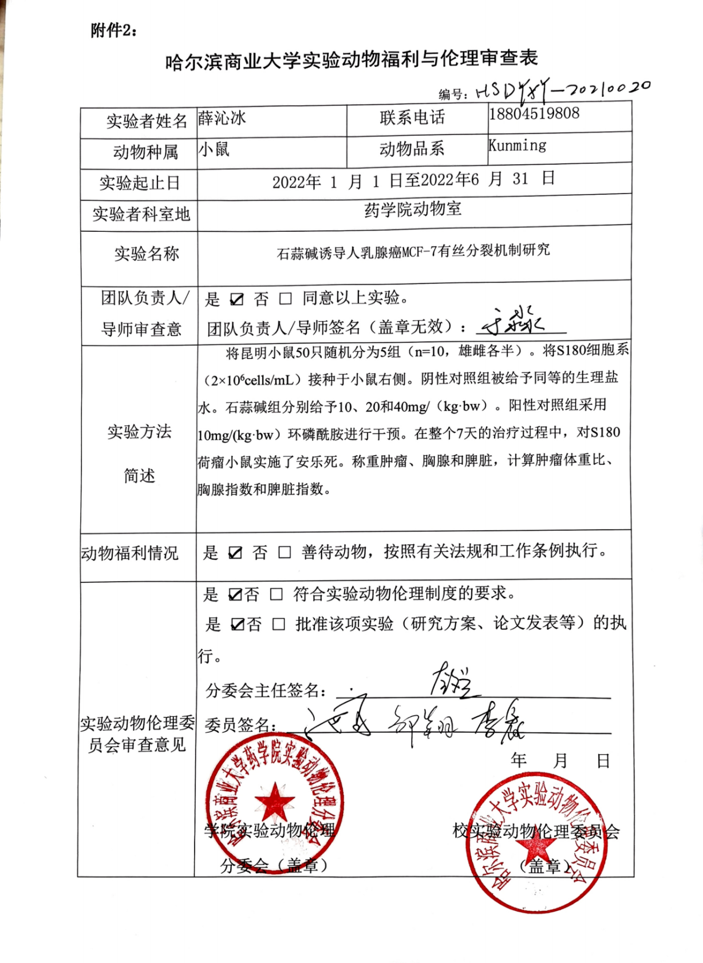
Fig. S3 Affidavit of approval of animal ethics and welfare

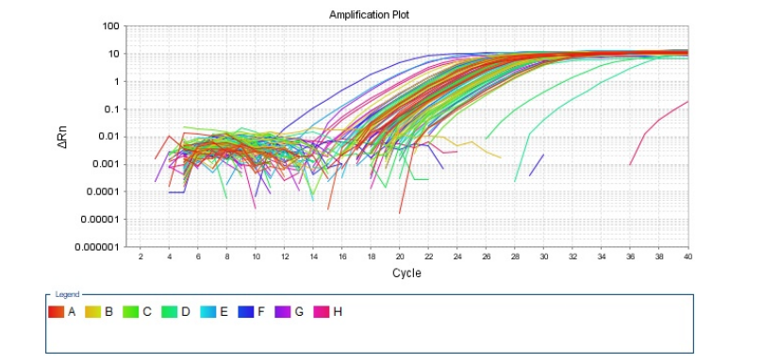

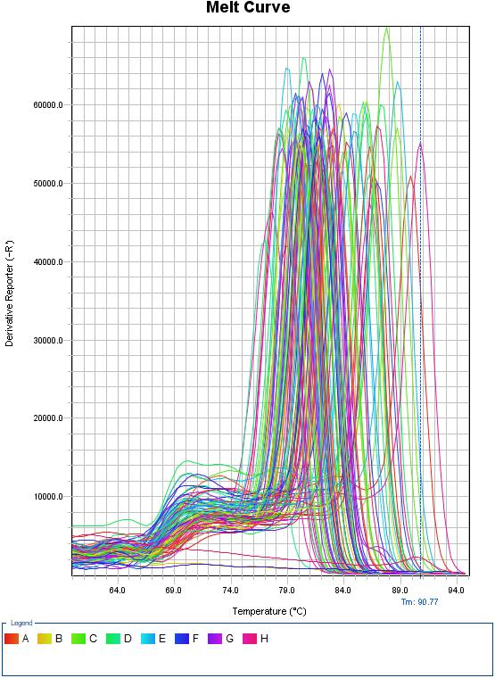

Fig. S4 Primer sequences in PCR reaction system.

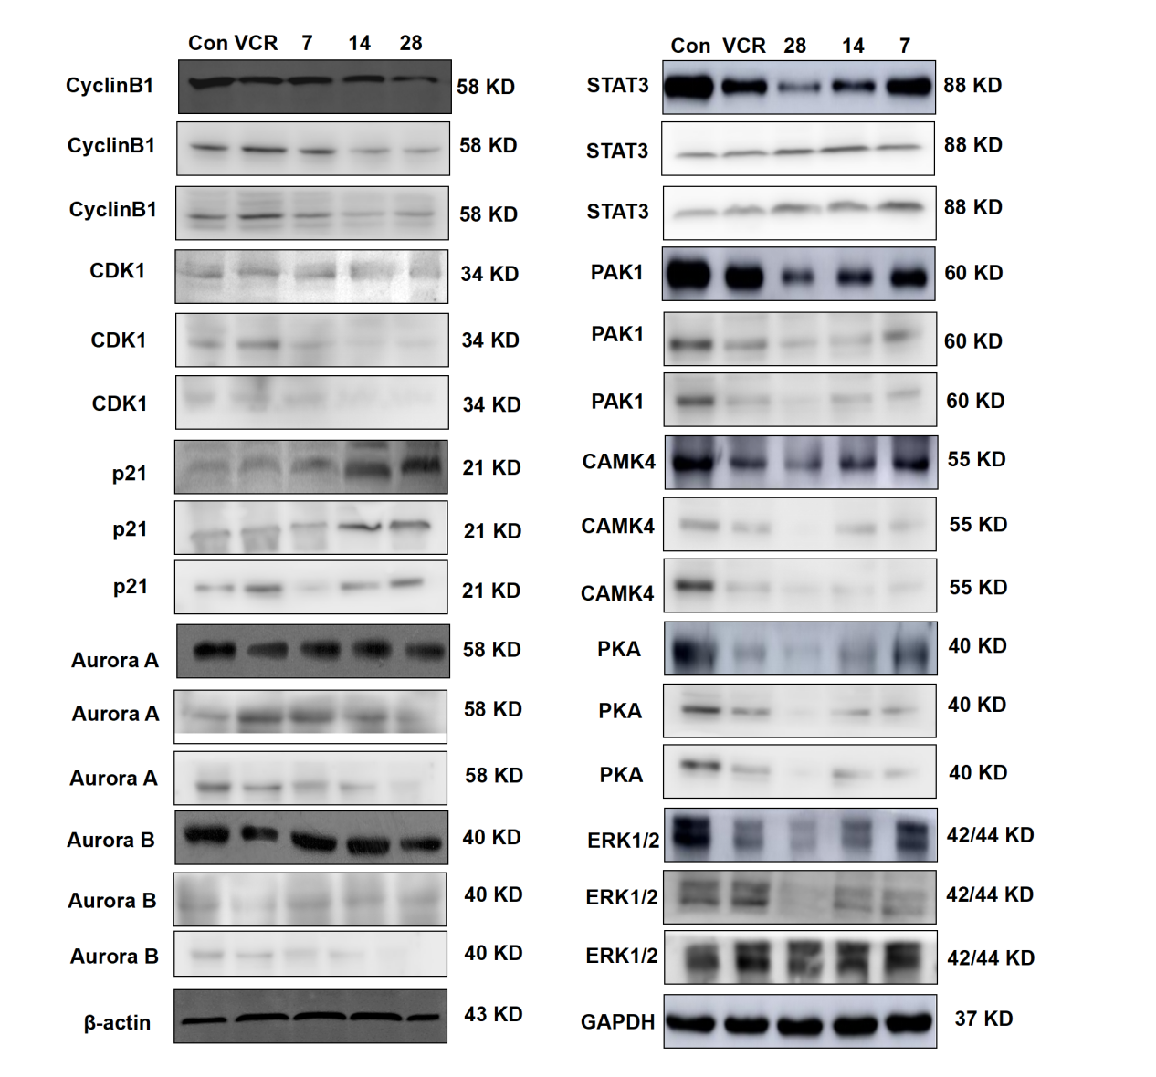
Fig.S5 Effect of MCF-7 cell cycle arrest on protein expressions induced by lycorine (n=3).

