Supplementary information document

Additional file 1: Study information sheet
Study title: Evaluation of the Malaria Case Surveillance System in KwaZulu-Natal Province, South Africa, 2022: A focus on DHIS2
Greetings: Good day, my name is Maxwell Mabona, a South African Field Epidemiology Training Programme resident and Master’s student from the University of the Witwatersrand medical school (School of Public Health).
Introduction: We are conducting a research study to evaluate the malaria case surveillance system (DHIS2) used in KwaZulu-Natal. This is in accordance with the World Health Organization, which recommends that a surveillance system should be reviewed periodically to determine whether the program activities are functioning effectively and they are achieving the desired outcomes. The study aims to see if the malaria case surveillance system (DHIS2) is meeting the goals underneath objective two of the National Malaria Elimination Strategic Plan (NMESP).
Invitation to Participate: We would like to invite you to participate in this research study. Your participation will involve answering an online short self-administered questionnaire designed to gather information for the study.
What is involved in the study: If you agree to take part in this study, you will be participating in a self-administered online questionnaire which will take about 15 minutes of your time. The questionnaire is targeting KwaZulu-Natal’s malaria program managers, case investigation officers, malaria information officers, environmental health practitioners, and data captures of the malaria case surveillance and reporting system.
Risks of being involved in the study: There are no foreseen risks involved in participating in this study.
Benefits of being in the study: There are also no direct individual benefits of being involved in the study. However, the overall benefits of the study are that the results will be used to make recommendations to strengthen and improve the surveillance system if needed. You will be given pertinent information on the study while involved in the project and after the results are available.
Participation is voluntary: Your participation in the survey is voluntary and there will be no negative consequences if you do not wish to participate. You are free to withdraw/drop out of the study at any time. You will not be required to provide a reason for withdrawing and any data you already provided will in default be destroyed, unless the you specifically consent to its retention. If you have any questions, do not hesitate to ask.
Reimbursements: Participation in the research will not cost you any money nor will they be any payments for participation.
Confidentiality: Responses will completely be confidential and anonymous. The results will not be linked to individual respondents. The data will be password-protected and only accessible to the principal researcher. All data collected in the course of the study will be securely retained for two (2) years, if a scientific publication arises from the study and six (6) years, if there is no publication. Thereafter it will be destroyed accordingly.
Anonymity: You will not be required to provide any personal or identifying information such as your name or identity number, responses will completely be anonymous.
Contact details of researchers:
Maxwell Mabona, MaxwellM@nicd.ac.za
033 940 2432 / 079 919 8332
Supervisor:
Mrs. Moshibudi Poncho Bapela, ponchob@nicd.ac.za / Poncho.Bapela@kznhealth.gov.za
033 940 2434
Outputs: The outputs of the research study will be an evaluation report. A copy of the participant information document, a summary of your responses, and the results of the study (evaluation report) once available is available upon request.
Contact details of HREC administrator and chair: This study has been approved by the Human Research Ethics Committee (Medical) of the University of the Witwatersrand, Johannesburg (“Committee”). A principal function of this Committee is to safeguard the rights and dignity of all human subjects who agree to participate in a research project and the integrity of the research.
If you have any concern over the way the study is being conducted, please contact the Chairperson of this Committee who is Professor Clement Penny, who may be contacted on telephone number 011 717 2301, or by e-mail on Clement.Penny@wits.ac.za. The telephone numbers for the Committee secretariat are 011 717 2700/1234 and the e-mail addresses are Zanele.Ndlovu@wits.ac.za and Rhulani.Mukansi@wits.ac.za
Thank you for reading this Study Information document.
Date: August 2022

Additional file 2: Participant/respondent Consent Form
Study title: Evaluation of the Malaria Case Surveillance System in KwaZulu-Natal Province, South Africa, 2022: A focus on DHIS2
Consent
I have been provided with a study information sheet that explains the nature and processes involved in this study; I was given time to read it, in the language I best understand. I was given time to ask any questions I wanted to and found any answers given to me to be reasonable and satisfactory. I believe I fully understand why the study is being conducted and what the intended outcomes will be. I understand that there will be no immediate benefit to me, should I agree to participate, nor will I receive any payment; conversely, participation will not cost me anything but my time. I understand that, even if I initially consent to take part in the study, I may subsequently withdraw at any time and would not be required to give any reasons. I have been given a range of contact details, listed below. If I require further information or become concerned about any aspect of this study, I am free to speak to any of these contacts.
I, therefore, give my consent to participate in this research study: No ☐ Yes ☐
Signature or mark: _______________________________
Date: __________________________________________
Place: _________________________________________

Additional file 3: Key Personnel Questionnaire
Evaluation of the Malaria Case Surveillance System in KwaZulu-Natal Province, South Africa, 2022: A focus on DHIS2
Date Survey was completed (DD/MM/YYYY): ____ ______ ________
Section 1- Socio-demographic details
- Please indicate your gender:
Male ☐ Female ☐
- What is your current position or occupation?
- Malaria Programme Manager ☐
- Case investigation officer ☐
- Malaria information officer ☐
- Environmental Health Practitioner ☐
- Data Capturer ☐
- Other ☐ Please specify____________________________
- Where are you normally working from?
- UMkhanyakude District ☐
- King Cetshwayo District ☐
- Zululand District ☐
- Provincial offices ☐
- Other District (Non-endemic) ☐
- Do you work in a malaria surveillance office/sentinel site?
Yes ☐ No ☐
If yes, please indicate the surveillance sentinel site:
Jozini ☐ Richards Bay ☐
- How long have you been using DHIS2 (in years)?
Less than 1 year ☐ 1-2 years ☐ 3-4 years ☐ 4-5 years ☐ >5years ☐
- Have you ever been trained on how to use DHIS2?
Yes ☐ No ☐
If yes, please indicate the number of times have you been trained on how to use DHIS2? ________
And if yes, please indicate the year you were last trained on DHIS2: (YYYY) _________
Section 2- System Attributes
Simplicity
- Is it simple to access and log into the DHIS2 system? Rate from 1 – 5
(1 = Strongly disagree, 2 = disagree, 3 = Neutral, 4 = Agree, 5 = Strongly agree)
___________________
- Do you consider the DHIS2 surveillance system interface simple to use? Rate from 1 – 5
(1 = Strongly disagree, 2 = disagree, 3 = Neutral, 4 = Agree, 5 = Strongly agree)
___________________
- Do you find it simple to share, transfer, enter, edit, and store data on DHIS2?
Yes ☐ No ☐ If no, please indicate the area that usually gives you a challenge (select all that apply):
- Entering data ☐
- Accessing data ☐
- Editing data ☐
- Sharing data ☐
- Transferring data ☐
- Saving/ storing data ☐
- Other ☐ Please briefly specify______________
- Are there aspects of the DHIS2 surveillance system interface that need improvement for it to be more user-friendly?
Yes ☐ No ☐ If yes, please indicate the aspect that should be improved (select all that apply):
- Logging in and out ☐
- Ease of navigation ☐
- Loading speed ☐
- Other ☐ Please briefly specify______________
- Do you find the case definitions/classifications (local case, imported case, locally imported case, indigenous case) easy to understand? Rate from 1 – 5
(1 = Strongly disagree, 2 = disagree, 3 = Neutral, 4 = Agree, 5 = Strongly agree)
___________________
- Do you ever find it challenging to classify a malaria case according to the case definition/classification?
Yes ☐ No ☐ If yes, please indicate the type of cases that usually give you a challenge classifying (select all that apply):
- Local cases ☐
- Imported cases ☐
- Locally imported cases ☐
- Indigenous cases ☐
- Other ☐ Please briefly specify______________
- Do you find it simple to access malaria cases on DHIS2 that were initially reported through the Notifiable Medical Conditions application (NMC App)? Rate from 1 – 5 (1 = Strongly disagree, 2 = disagree, 3 = Neutral, 4 = Agree, 5 = Strongly agree)
___________________
- Do you find it simple to access malaria cases on DHIS2 that were initially reported through the Malaria Connect notification system? Rate from 1 – 5
(1 = Strongly disagree, 2 = disagree, 3 = Neutral, 4 = Agree, 5 = Strongly agree)
___________________
- Do you find it simple to visualize malaria case data on DHIS2? (Through pivot tables, graphs, and maps) Rate from 1 – 5
(1 = Strongly disagree, 2 = disagree, 3 = Neutral, 4 = Agree, 5 = Strongly agree)
___________________
- Do you ever find it challenging to visualize malaria case data on DHIS2?
Yes ☐ No ☐ If yes, please indicate the common challenges (select all that apply):
- It is time-consuming ☐
- It is complicated/complex ☐
- It is not easy to understand the visualized data ☐
- Other ☐ Please briefly specify______________
- Do you find it simple to use the DHIS2 surveillance system to generate or help generate a malaria report/presentation? Rate from 1 – 5
(1 = Strongly disagree, 2 = disagree, 3 = Neutral, 4 = Agree, 5 = Strongly agree)
___________________
Acceptability
- How many days in a week do you log in and use the DHIS2 surveillance system?
- Zero (0) to one (1) day per week ☐
- Two (2) – four (4) days per week ☐
- Five (5) days per week ☐
- More than five (5) days per week ☐
- Do you perceive the DHIS2 surveillance system acceptable to you? Rate from 1 – 5 (1 = Strongly disagree, 2 = disagree, 3 = Neutral, 4 = Agree, 5 = Strongly agree)
___________________
- Are you willing to continue using the DHIS2 surveillance system? Rate from 1 – 5 (1 = Strongly disagree, 2 = disagree, 3 = Neutral, 4 = Agree, 5 = Strongly agree)
___________________
- Are you willing to continue providing accurate, consistent data into DHIS2? Rate from 1 – 5 (1 = Strongly disagree, 2 = disagree, 3 = Neutral, 4 = Agree, 5 = Strongly agree)
___________________
- Are you willing to continue providing complete, and timely data into DHIS2? Rate from 1 – 5 (1 = Strongly disagree, 2 = disagree, 3 = Neutral, 4 = Agree, 5 = Strongly agree)
___________________
- Are there factors that decrease the acceptability of the DHIS2 surveillance system?
Yes ☐ No ☐ If yes, please indicate which factors (select all that apply):
- Work overload ☐
- Lack of human resources ☐
- Data costs ☐
- The complexity of the system ☐
- Network problems ☐
- Other ☐ Please briefly specify______________
- There is adequate dissemination of aggregated malaria case data from Programme managers back to those that notify and input cases? Rate from 1 – 5 (1 = Strongly disagree, 2 = disagree, 3 = Neutral, 4 = Agree, 5 = Strongly agree)
___________________
- The DHIS2 surveillance system and other users involved in malaria surveillance acknowledge and appreciate my contributions to malaria surveillance? Rate from 1 – 5
(1 = Strongly disagree, 2 = disagree, 3 = Neutral, 4 = Agree, 5 = Strongly agree)
___________________
- Have you ever made suggestions/comments about improving data reporting into DHIS2?
Yes ☐ No ☐
If yes, was your suggestion taken? Yes ☐ No ☐
This completes the survey. Thank you very much for your participation.

Additional file 4: Secondary data management flow chart
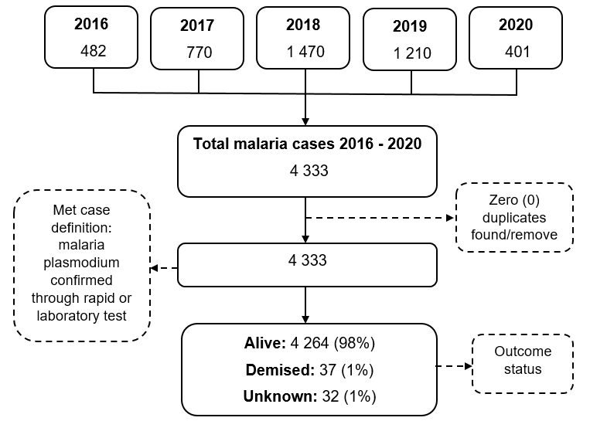
Figure S1: Flow chart depicting data management of malaria data retrieved from DHIS2, January 2016 to December 2020

