Supplemental Information

Figure S1. Drought and discharge affected NO₃⁻

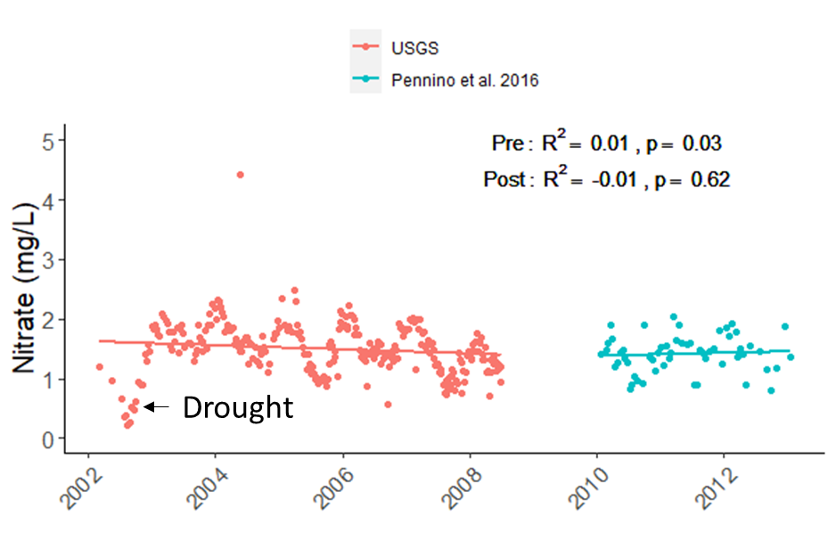

Figure S2. Peakflow, the discharge at which stormflow hydrograph is at its peak (m³/s) during the study period, calculated based on methods of Pennino et al. (2016).

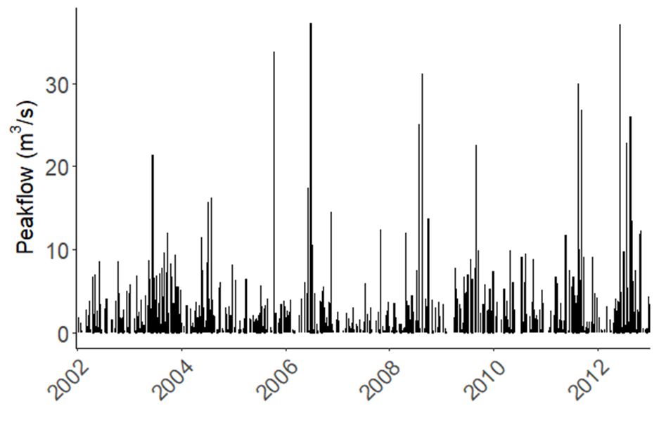

Figure S3. The average monthly Precipitation Flashiness Index: a) from 2002-2008 and b) from 2002-2012.

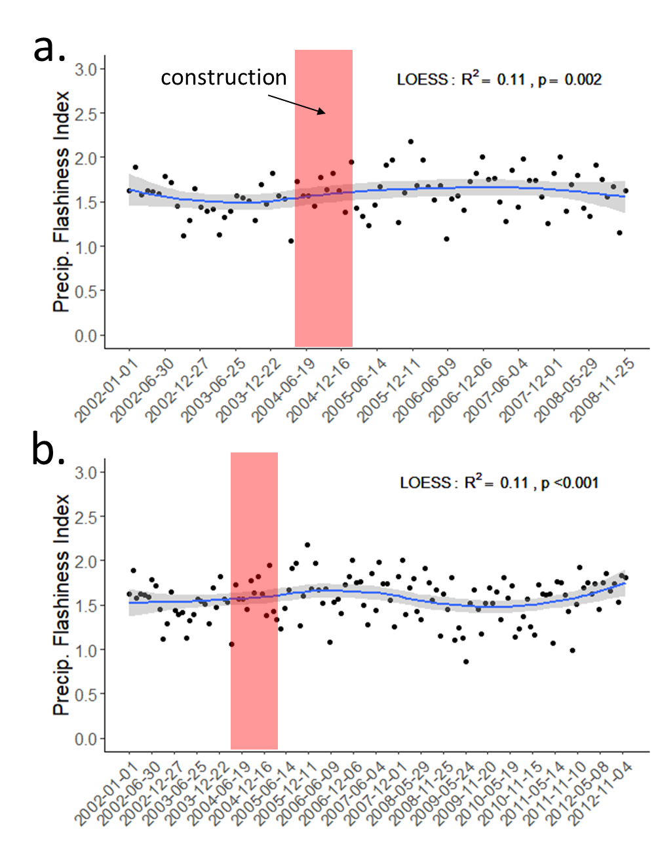

Figure S4. Precipitation Flashiness compared during pre- and post-restoration periods for (a) 2002-2008 and (b) 2002-2012.

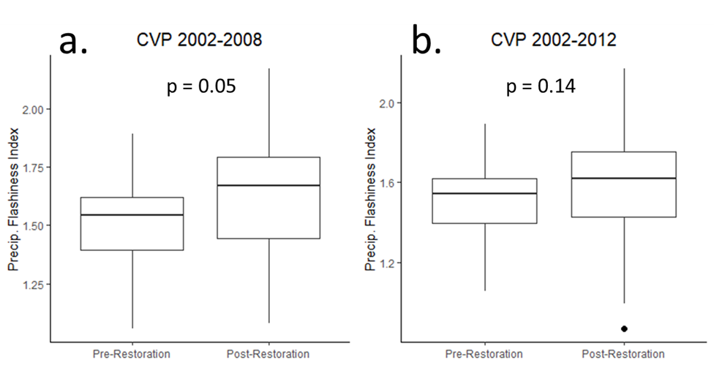
Figure S5a and b. Stream channel evolution after restoration. a: April 2006 is 14 months after the restoration. May 2014 is 9 years, 3 months after restoration. Note bank erosion and formation of gravel bar. Before and after photos were taken from approximately the same location. A tree, road, and house are identified in each photo for orientation. b: February 2021 is 16 years after restoration. Note bank erosion, exposed roots, and movement of cobble. Before and after photos were taken from approximately the same location. A barn and shed are identified in each photo for orientation. (Feb 2021 photo from R. Shedlock)

a

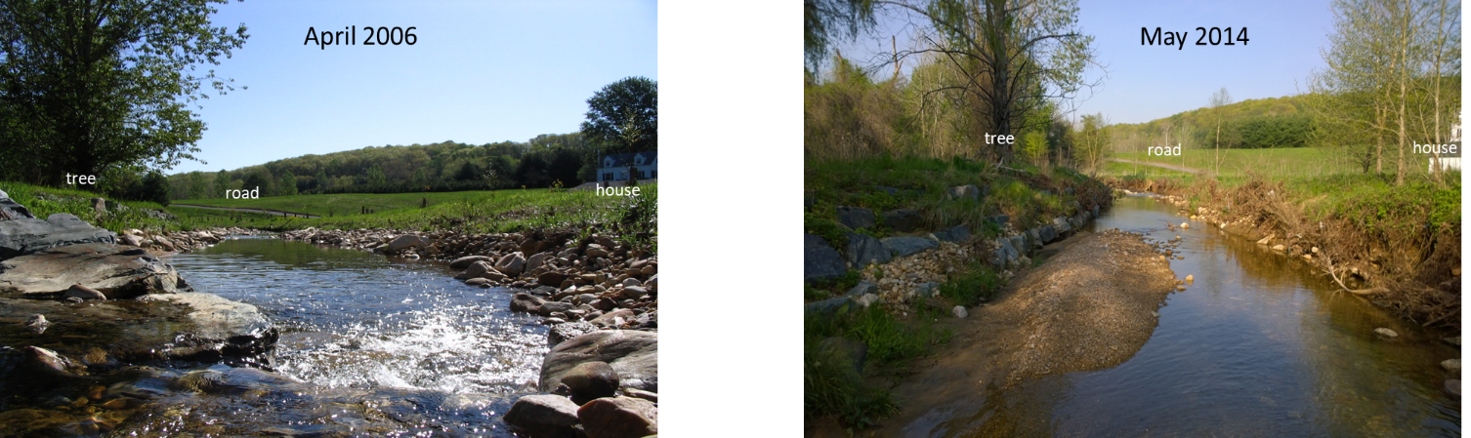

b

