Appendix 1: ML Algorithms in China’s Indsutrial applications
Model | 2016 | 2017 | 2018 | 2019 | 2020 | Total | %
BP | 11 | 35 | 21 | 20 | 8 | 95 | 27.38%
SVM | 23 | 17 | 19 | 15 | 11 | 85 | 24.50%
LR | 3 | 10 | 11 | 6 | 0 | 30 | 8.65%
Perceptron | 2 | 8 | 3 | 2 | 3 | 18 | 5.19%
RNN | 3 | 3 | 5 | 3 | 3 | 17 | 4.90%
RF | 0 | 5 | 3 | 0 | 5 | 13 | 3.75%
CNN | 0 | 0 | 4 | 6 | 1 | 11 | 3.17%
K-means | 2 | 1 | 1 | 1 | 6 | 11 | 3.17%
AdaBoost | 4 | 1 | 2 | 2 | 1 | 10 | 2.88%
Bayesian Network | 1 | 3 | 2 | 3 | 0 | 9 | 2.59%
KNN | 1 | 0 | 1 | 2 | 3 | 7 | 2.02%
Stepwise Regression | 0 | 3 | 0 | 2 | 0 | 5 | 1.44%
Naive Bayes | 0 | 2 | 1 | 1 | 1 | 5 | 1.44%
SOM | 0 | 1 | 1 | 2 | 0 | 4 | 1.15%
PLSR | 0 | 2 | 1 | 1 | 0 | 4 | 1.15%
Logistic Regression | 0 | 3 | 0 | 1 | 0 | 4 | 1.15%
LVQ | 1 | 2 | 0 | 0 | 0 | 3 | 0.86%
CART | 0 | 2 | 0 | 1 | 0 | 3 | 0.86%
Hierarchical Clustering | 0 | 1 | 1 | 0 | 0 | 2 | 0.58%
C4.5 | 0 | 1 | 0 | 1 | 0 | 2 | 0.58%
RBFN | 0 | 0 | 0 | 1 | 0 | 1 | 0.29%
LWL | 0 | 1 | 0 | 0 | 0 | 1 | 0.29%
Projection Pursuit | 0 | 1 | 0 | 0 | 0 | 1 | 0.29%
PCR | 0 | 0 | 0 | 1 | 0 | 1 | 0.29%
PLS | 1 | 0 | 0 | 0 | 0 | 1 | 0.29%
LDA | 0 | 0 | 0 | 1 | 0 | 1 | 0.29%
GBRT | 0 | 0 | 1 | 0 | 0 | 1 | 0.29%
Expectation Maximization | 0 | 0 | 0 | 1 | 0 | 1 | 0.29%
Ridge Regression | 0 | 0 | 1 | 0 | 0 | 1 | 0.29%
Sum | 52 | 117 | 91 | 82 | 48 | 347 | 100.00%

Appendix 2: Predictive Performance Assessment of ML Algorithms Between 2020 and 2023
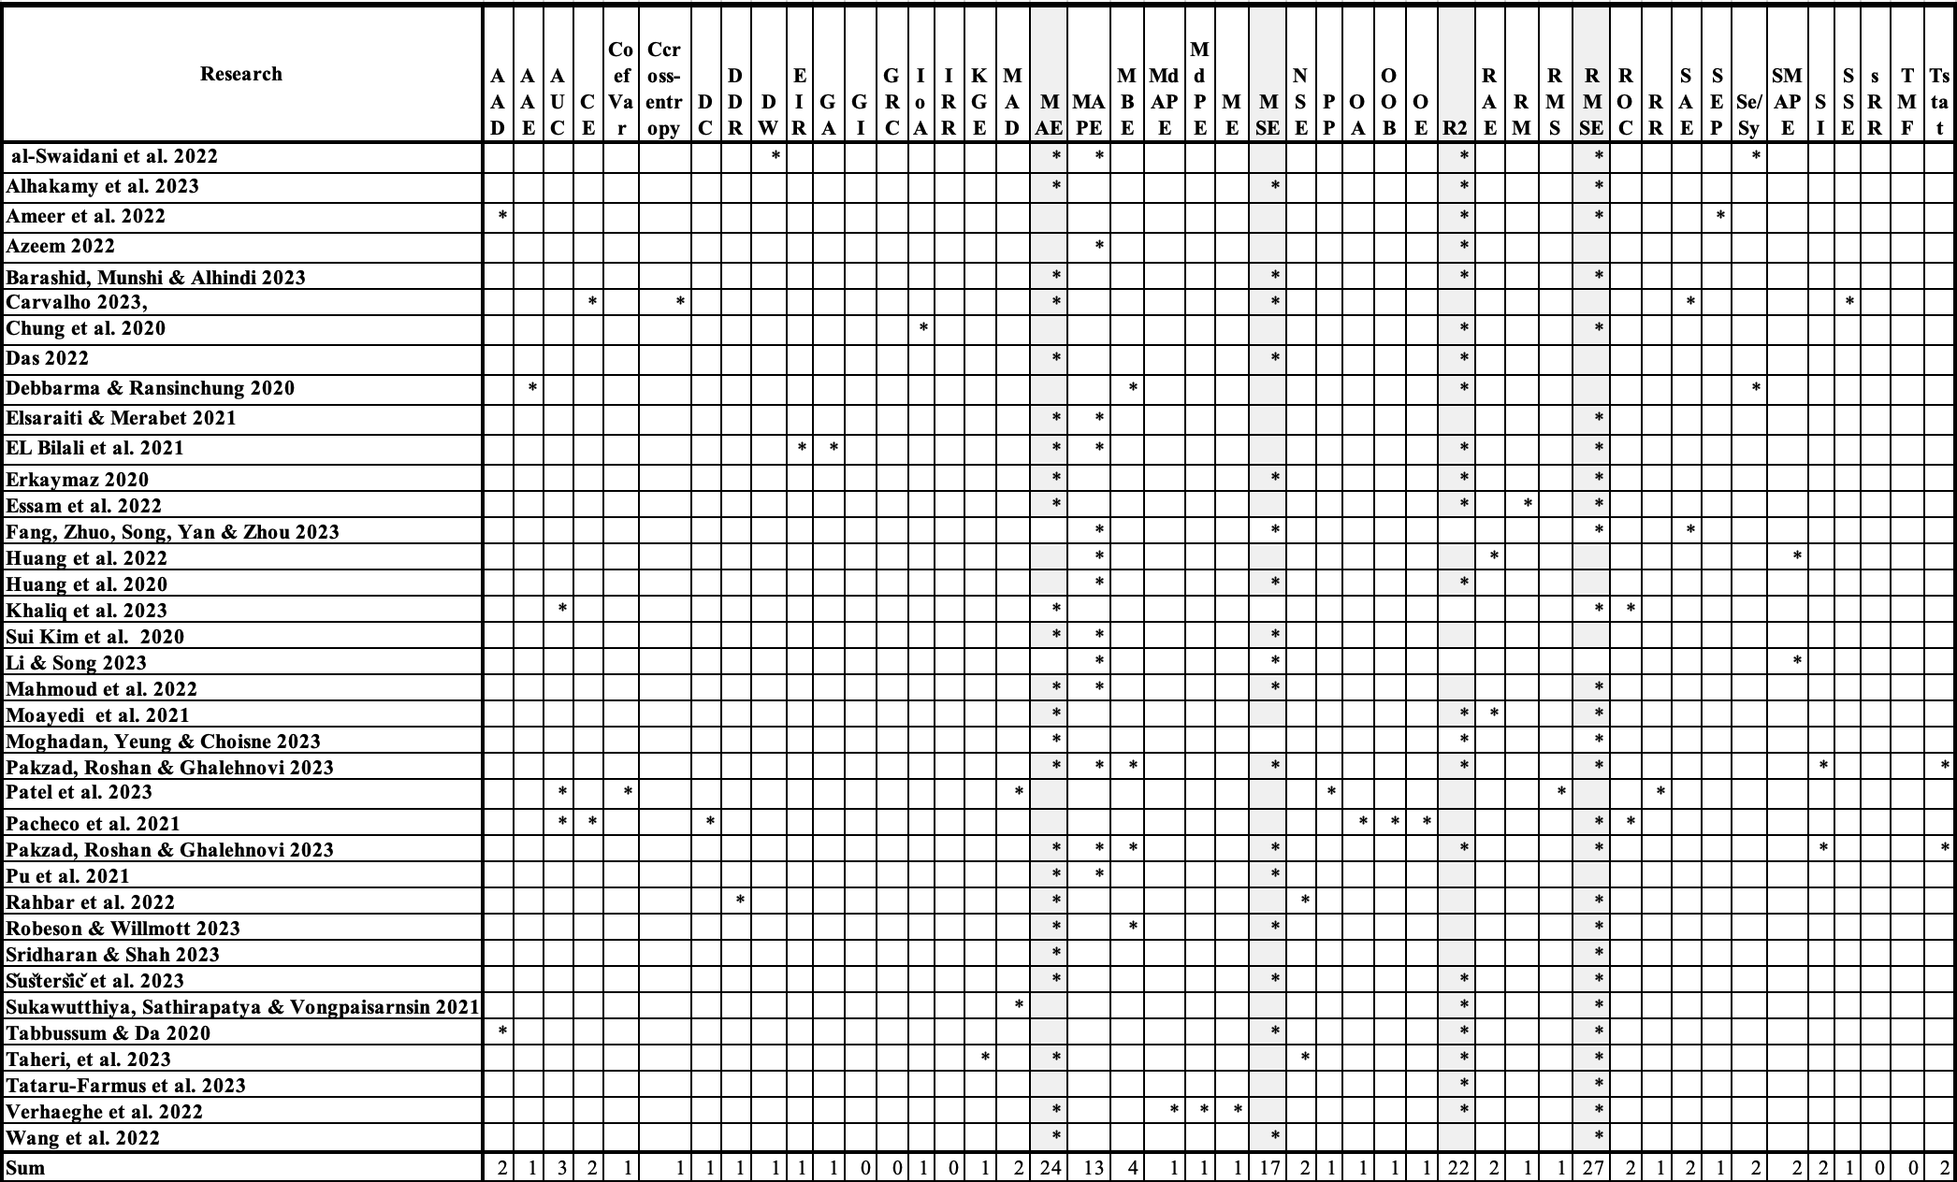

Appendix 3: Outcomes of Training and Testing

