Supporting information

Fabrication of O-enriched macroporous polymer for the efficient adsorption organic acid from aqueous solution
Yuli Fu ª, Hui Gong ^{b}, Shengpei Su ^{b}, Ting Lei ^{a, *}, Shihua Zhong ^{b, c, *}

ª State Key Laboratory of Powder Metallurgy, The Powder Metallurgy Research Institute, Central South University, Changsha 410083, China
^{b} College of Chemistry and Chemical Engineering, Open Foundation of National &
Local Joint Engineering Laboratory for New Petro-chemical Materials and Fine Utilization of Resources, Hunan Normal University, Changsha 410081, China
^{c} College of Chemistry and Chemical Engineering, Key Laboratory of the Assembly and Application of Organic Functional Molecules of Hunan Province, Hunan Normal University, Changsha 410081, China

__________
Corresponding Authors. *Shihua Zhong, E-mail: zhongshihua@hunnu.edu.cn; Ting Lei, E-mail: tlei@csu.edu.cn

1. Experimental section

1.1 Materials
Macroporous chloromethylated polystyrene (CMPS) was supplied by Jafron Biomedical Co., Ltd. (Guangdong, China), its S_{BET} was 78 m²/g, total pore volume (V_{total}) was 0.683 cm³/g, average pore size was 34.8 nm, and the chlorine content was 4.88 mmol/g. β-Cyclodextrin, Potassium iodide (KI), Sodium hydride (NaH), molecular sieve (5A), N,N-dimethylformamide (DMF), 95% ethanol, Salicylic acid (SA), Pyrogallic acid (PA), Galic acid (GA), phenolphthalein, nitrobenzene, silver nitrate (AgNO₃), Ammonium ferric sulfate (NH₄Fe(SO₄)₂), Ammonium thiocyanate (NH₄SCN), sodium hydroxide (NaOH), hydrochloric acid (HCl), tetrabutylammonium bromide, phenol (PHE), 2-naphthol (NAP), 1,1'-bi-2-naphthol (BNAP) purchased from Sinopharm Chemical Industry Co., Ltd. (Shanghai, China), were analytical agents and used without further purification.

1.2 Synthesis of β-CD-PS
60g β-CD was dissolved in 150 mL anhydrous (DMF), and 2g NaH was added under nitrogen atmosphere, after the reaction completely, 10 g CMPS of swelled in DMF overnight was added. Then, 0.5g KI was added to improve the nucleophilic properties. The temperature of the reaction system slowly adjusted to 60℃ for 24h with stirring, and got product polymer β-CD-PS. β-CD-PS was shaken and washed with deionized water, and stored in a wet state.

1.3 Characterization
The Fourier transform infrared spectroscopy (FT-IR) of polymers was subjected to measurement by KBr disk method using Nicolet 510P Fourier transform infrared spectroscopy (Thermo Nicolet Corporation, USA) in the range of 500-4000 cm⁻¹. Its resolution is 1.0 cm⁻¹. The pore structure of the polymer was determined by a nitrogen adsorption-desorption isotherm (77 K) using a Micromeritics ASAP 2020 Surface Area and Porosity Analyzer (Micromeritics Instrument Corporation, USA). Prior to measurement, a degassing process was carried out for 300 min at a nitrogen purge and degassing pretreatment temperature of 363 K. The BET surface area (S_{BET}) was calculated by the BET model including P/P₀=0.05-0.30, and the total pore volume was calculated (V_{total}) at P/P₀=0.99. The micropore area (S_{micro}) and micropore volume (V_{micro}) were determined by the Barrett-Joyner-Halenda (BJH) model, while the pore size distribution (PSD) was calculated by the non-local density functional theory (NLDFT) model. The contact angles (CA) of the polymers were measured by JC 2000D1 contact angle measuring instrument (Zhongchen, Shanghai). The X-ray photoelectron spectroscopy (XPS) of the samples was investigated on a Thermo ESCALAB 250Xi (ThermoFisher-VG Scientific, China) spectrometer with an Al K-alpha source. The chlorine content of the polymers was measured according to the Volhard method. The concentration of PHE, NAP, BNAP in aqueous solution and cyclohexane solutions was determined using a UV-2450 spectrophotometer.

1.4 Adsorption isotherm and adsorption kinetics
0.1 g wet polymers after absorbing the surface moisture with filter paper and put it into a dry 50 mL erlenmeyer flask with 25 mL adsorbate SA solution with its initial concentration at 100, 200, 300, 400, and 500 mg/L, respectively. Placed these flasks in a constant temperature oscillator at a certain temperature (298, 308 and 318 K), and shaken at 150 r/min for 24 h. The equilibrium concentration of SA aqueous solution was measured at the maximum adsorption wavelength (PHE: λ_{max} = 269 nm, NAP: λ_{max} =273 nm, BNAP: λ_{max} =285 nm, SA: λ_{max} =296 nm, PA: λ_{max} =266 nm, GA: λ_{max} =266 nm), then calculated the equilibrium adsorption capacity of the polymers on the adsorbate q_{e} (mg/g) according to the equation.
q_{e} = (C₀-C_{e})V/(W(1-x)). (Eq.1)
Where q_{e} is the equilibrium capacity (mg/g), C_{e} and C₀ are the equilibrium and initial concentration (mg/L), V is the solution volume (L), W and x (%) were the mass of wet polymers (g) and water content of the polymers, respectively. The adsorption isotherms of SA for each polymer at a certain temperature were plotted with C_{e} as the abscissa and q_{e} as the ordinate. The experimental process for the other five adsorbents (NAP, BNAP, PHE, PA, GA) is the same as above.
The operation of kinetic adsorption is as follows. 0.5 g wet polymers were accurately weighed and added to a 250 mL erlenmeyer flask and pipette 100 mL of adsorbate solutions with its initial concentration at 500 mg/L. Placed these flasks in a constant temperature oscillator at a 298K, and shaken at 150 r/min. Collected the solution at different time intervals, and measured the absorbance after diluting. Recorded the concentration and time (t) of sampling, and stopped sampling when the concentration does not change. Recorded the time when the adsorption reaches equilibrium, then calculated the q_{t} (mg/g).

1.5 Effect of initial pH on the adsorption capacity
About 0.1 g wet polymers was introduced into a sequence of 50 mL of erlenmeyer flasks with 25 mL a certain concentration of adsorbents aqueous solutions, respectively. Then the erlenmeyer flasks were settled and shaken in a thermostatic oscillator at a certain temperature for 24 h and 150 r/min speed sampling. The effects of initial pH values of the aqueous solutions on the adsorption performance for the polymers were conducted with 500 mg/L of adsorbents in the aqueous solution at 298 K, and the initial pH was set to be 3.0, 4.0, 5.0, 6.0, 7.0, 8.0, 9.0, 10.0 and 11.0, respectively. The initial pH of the solutions was adjusted by NaOH or HCl aqueous solutions.

1.6 Repeated adsorption and desorption experiments
About 0.05 g wet polymer was added into a 50 mL erlenmeyer flask, 25 mL adsorbents solution with an initial concentration of 500 mg/L was added. Placed the flask in a constant temperature oscillator at 298 K, and shaken at 150 r/min for 24 h. The equilibrium concentration of adsorbents solution was measured at the maximum adsorption wavelength (PHE: λ_{max} = 269 nm, NAP: λ_{max} =273 nm, BNAP: λ_{max} =285 nm, SA: λ_{max} =296 nm, PA: λ_{max} =266 nm, GA: λ_{max} =266 nm), and calculate the adsorption amount according to the formula Eq (1). After the adsorbed resin was desorbed with 100% (v/v) ethanol, washed with water and filtered. The above adsorption operation was repeated five times.

1.7 Effect of polymer content on adsorption capacity
A certain quality of wet polymer was added into a sequence of 50 mL of erlenmeyer flasks with 25 ml 500 mg/L of adsorbents aqueous solutions, respectively. The mass of wet polymers was 0.03, 0.05, 0.10, 0.20, 0.30, 0.40, 0.50, 0.60 and 0.70 g in the different erlenmeyer flasks. Then the erlenmeyer flasks were settled and shaken in a thermostatic oscillator at 298 K for 24 h. The above experiments study the adsorption effect of different polymers dosages on different adsorbents.

2. Characterization Supplementary Figure
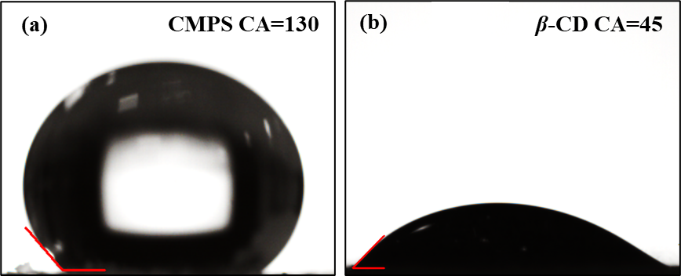
Figure S1 Contact angles of (a) CMPS, (b) β-CD-PS

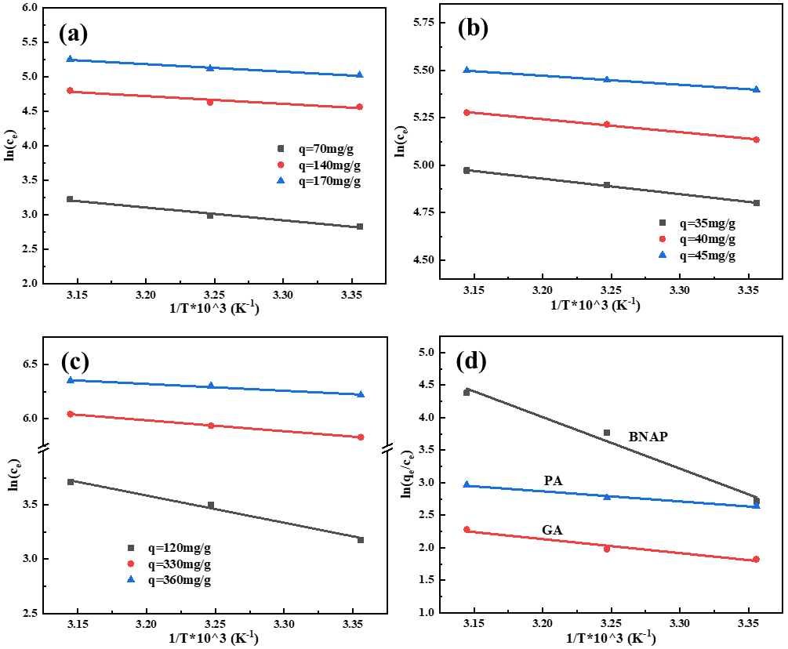
Figure S2 (a) Plot of ln(c_{e}) vs. 1000/T of NAP on the β-CD-PS and (b) PHE, (c) SA, (d) Plot of ln(q_{e}/c_{e}) vs. 1000/T of BNAP, PA, and GA on the β-CD-PS.

Table S1 Correlated parameters of the equilibrium data for the adsorption on β-CD-PS according to the Langmuir and Freundlich model
Adsorbate | Temperature | Langmuir model |  |  | Freundlich model
Adsorbate | Temperature | K_{L} /(L/mg) | q_{m} /(mg/g) | R² | K_{F} /(mg/g)((L/mg)^{1/n}) | n | R²
NAP | 298K | 1.46 ×10⁻² | 246.39 | 0.9800 | 17.65 | 2.24 | 0.9969
NAP | 308K | 1.26×10⁻² | 238.60 | 0.9793 | 15.05 | 2.17 | 0.9976
NAP | 318K | 7.4 ×10⁻³ | 232.56 | 0.9782 | 11.97 | 2.08 | 0.9977
PHE | 298K | 1.58 ×10⁻² | 56.71 | 0.9912 | 5.07 | 2.46 | 0.9951
PHE | 308K | 8.46×10⁻³ | 51.45 | 0.9968 | 2.13 | 1.94 | 0.9989
PHE | 318K | 5.66 ×10⁻³ | 46.86 | 0.9971 | 1.11 | 1.71 | 0.9981
SA | 298K | 1.176×10⁻² | 407.47 | 0.9698 | 41.20 | 2.84 | 0.9875
SA | 308K | 9.99×10⁻³ | 380.24 | 0.9844 | 34.54 | 2.76 | 0.9927
SA | 318K | 8.50×10⁻³ | 351.10 | 0.9773 | 27.21 | 2.62 | 0.9998
BNAP | 298K | 9.25×10⁻² | 243.43 | 0.9994 | 73.25 | 4.36 | 0.8823
BNAP | 308K | 2.03×10⁻¹ | 291.87 | 0.9973 | 101.55 | 4.38 | 0.8773
BNAP | 318K | 2.98×10⁻¹ | 320.75 | 0.9987 | 120.14 | 4.31 | 0.8698
PA | 298K | 3.56×10⁻² | 302.17 | 0.9943 | 71.31 | 4.19 | 0.9842
PA | 308K | 4.04×10⁻² | 309.42 | 0.9958 | 77.14 | 4.32 | 0.9832
PA | 318K | 5.42×10⁻² | 312.42 | 0.9951 | 87.08 | 4.59 | 0.9833
GA | 298K | 9.45×10⁻² | 218.67 | 0.9976 | 69.47 | 4.76 | 0.9325
GA | 308K | 9.57×10⁻² | 235.64 | 0.9985 | 68.48 | 4.30 | 0.9627
GA | 318K | 1.05×10⁻¹ | 254.40 | 0.9969 | 76.01 | 4.33 | 0.9380
Table S2 The adsorption thermodynamic parameters of β-CD-PS
Adsorbate | q  (mg/g) | ΔH  (kJ/mol) | ΔG (kJ/mol) |  |  | ΔS (J/(mol·K))
Adsorbate | q  (mg/g) | ΔH  (kJ/mol) | 298K | 308K | 318K | 298K | 308K | 318K
NAP | 70 | -15.42 | -5.55 | -5.56 | -5.50 | -33.13 | -12.56 | -11.84
NAP | 140 | -9.29 | -5.55 | -5.56 | -5.50 | -32.03 | -12.13 | -11.44
NAP | 170 | -9.08 | -5.55 | -5.56 | -5.50 | -31.21 | -11.93 | -11.26
PHE | 35 | -6.76 | -6.09 | -4.97 | -4.52 | -2.24 | 1.49 | 7.18
PHE | 40 | -5.65 | -6.09 | -4.97 | -4.52 | -5.82 | -2.22 | 3.29
PHE | 45 | -3.95 | -6.09 | -4.97 | -4.52 | -7.05 | -3.55 | 1.78
SA | 120 | -20.88 | -7.04 | -7.07 | -6.93 | -46.44 | -4.47 | 6.13
SA | 330 | -8.37 | -7.04 | -7.07 | -6.93 | -44.83 | -4.22 | 6.03
SA | 360 | -5.21 | -7.04 | -7.07 | -6.93 | -43.87 | -4.53 | 5.40

Table S3 The adsorption thermodynamic parameters of β-CD-PS
Adsorbate | ΔG (kJ/mol) |  |  | ΔH (kJ/mol) |  |  | ΔS (J/(mol·K))
Adsorbate | 298K | 308K | 318K | 298K | 308K | 318K | ΔS (J/(mol·K))
BNAP | -122.33 | -126.44 | -130.54 | 45.19 | 46.71 | 48.22 | 562.16
PA | -35.83 | -37.04 | -38.24 | 12.32 | 12.74 | 13.15 | 172.90
GA | -35.83 | -37.04 | -38.24 | 8.84 | 9.14 | 9.44 | 149.92

Table S4 Fitted parameters for the kinetics adsorption data on the polymers by pseudo-first-order rate and pseudo-second-order rate equations at 298 K
Adsorbate | Peudo-first-order |  |  | Peudo-second-order
Adsorbate | k₁ (min⁻¹) | q_{m}(mg/g) | R² | k₂ (g/(mg·min)) | q_{cal}(mg/g) | R²
BNAP | 2.63×10⁻³ | 214.40 | 0.9753 | 1.06×10⁻⁵ | 263.99 | 0.9820
NAP | 2.77×10⁻² | 143.34 | 0.9453 | 2.57×10⁻⁴ | 155.34 | 0.9865
PHE | 8.76×10⁻² | 55.26 | 0.9732 | 2.73×10⁻³ | 57.20 | 0.9974
SA | 9.34×10⁻² | 256.554 | 0.9710 | 5.83×10⁻⁴ | 269.62 | 0.9937
PA | 4.56×10⁻² | 319.47 | 0.9517 | 1.92×10⁻⁴ | 347.698 | 0.9851
GA | 9.42×10⁻² | 239.17 | 0.9455 | 5.73×10⁻⁴ | 254.65 | 0.9900

References
[1] Zhang F, Zhang S, Chen L, Liu Z, Qin J (2021) Utilization of bark waste of Acacia mangium: The preparation of activated carbon and adsorption of phenolic wastewater. Ind Crops Prod 160: 113157
[2] Wang Q, Yang Z (2016) Industrial water pollution, water environment treatment, and health risks in China. Environ. Pollut 218: 358-365
[3] Lu Y, Song S, Wang R, Liu Z, Meng J, Sweetman A, Jenkins A, Ferrier R, Li H, Luo W, Wang T (2015) Impacts of soil and water pollution on food safety and health risks in China. Environ Int 77: 5-15
[4] Wang Y, Shu Z, Zeng X, Kuang W, Huang J (2020) Fabrication of O-enriched HyperCross-Linked Polymers and Their Adsorption of Aniline from Aqueous Solution. Ind. Eng. Chem. Res 59: 11705-11712
[5] Wang X, Wang Y, Shu Z, Cao Y, Wang X, Zhou F, Huang J (2023) Phenolic hydroxyl-functionalized hyper-cross-linked polymers for efficient adsorptive removal of aniline. Sep. Purif. Technol 305: 122443
[6] Liu Z, Mu Q, Sun Y, Gao P, Yu Y, Gao J, Shi W, Wen X, Fei Z (2020) Effective adsorption of chloroanilines from aqueous solution by m-phenylenediamine modified hyper-cross-linked resin: Kinetic, equilibrium, and thermodynamic studies. Colloids Surf. A Physicochem. Eng. Asp 601: 124996
[7] Tian B, Hua S, Liu J (2020) Cyclodextrin-based delivery systems for chemotherapeutic anticancer drugs: A review. Carbohydr. Polym 232: 115805
[8] Amran F (2022) Muhammad Abbas Ahmad Zaini. Beta-cyclodextrin adsorbents to remove water pollutants-a commentar. Front Chem Sci Eng 16: 1407-1423
[9] Duan C, Wang J, Liu Q, Zhou Y, Zhou Y (2022) Efficient removal of Salbutamol and Atenolol by an electronegative silanized beta-cyclodextrin adsorbent. Sep. Purif. Technol 282: 120013

