Supplementary table 1 | Significant genes generated in Univariate Cox regression analysis.
Genes | HR | HR 95%CI (lower) | HR 95%CI (upper) | p-Value
LDHA | 1.757748 | 1.424095 | 2.169574 | 1.53E-07
VDAC1 | 1.88216 | 1.443658 | 2.453855 | 3.12E-06
GAPDH | 1.529894 | 1.279318 | 1.829549 | 3.65E-06
FUT4 | 1.779532 | 1.388108 | 2.28133 | 5.69E-06
HMMR | 1.417942 | 1.215227 | 1.654471 | 8.28E-06
SHC1 | 1.637556 | 1.308711 | 2.049031 | 1.79E-05
CDKN3 | 1.330225 | 1.159938 | 1.525511 | 4.11E-05
KRT8 | 1.420262 | 1.200052 | 1.680881 | 5.27E-05
ITGA6 | 1.278343 | 1.134811 | 1.440029 | 5.49E-05
CDX2 | 1.53924 | 1.239295 | 1.911781 | 6.67E-05
CCR2 | 0.669383 | 0.546527 | 0.819857 | 9.48E-05
SLC16A1 | 1.249293 | 1.116083 | 1.398401 | 0.000103
H2AX | 1.415099 | 1.179993 | 1.697048 | 0.00018
CD40LG | 0.603845 | 0.461527 | 0.790049 | 0.000216
HMGA2 | 1.259551 | 1.111598 | 1.427197 | 0.000248
CDK1 | 1.279061 | 1.1203 | 1.460322 | 0.000261
HSPA4 | 1.899768 | 1.347486 | 2.678409 | 0.000263
MKI67 | 1.281059 | 1.119653 | 1.465732 | 0.000294
TPI1 | 1.52738 | 1.215877 | 1.918688 | 0.000308
YWHAZ | 1.580515 | 1.228766 | 2.032955 | 0.000368
BIRC5 | 1.236694 | 1.097519 | 1.393518 | 0.000455
ITGB1 | 1.415424 | 1.16597 | 1.718247 | 0.000476
PVR | 1.435431 | 1.170411 | 1.760461 | 0.00052
MS4A1 | 0.793282 | 0.69488 | 0.905618 | 0.000558
F2 | 1.31412 | 1.119982 | 1.541911 | 0.000582
XRCC5 | 1.804921 | 1.288967 | 2.527403 | 0.000605
AURKA | 1.272422 | 1.107008 | 1.462553 | 0.000666
GLI2 | 1.634328 | 1.221883 | 2.185992 | 0.000954
TRIM28 | 1.542822 | 1.197357 | 1.98796 | 0.000979
HGF | 0.66544 | 0.521471 | 0.849156 | 0.001095
ADRB2 | 0.69432 | 0.55713 | 0.865294 | 0.001114
CAT | 0.726915 | 0.599514 | 0.881389 | 0.001151
BIRC3 | 1.227368 | 1.084868 | 1.388587 | 0.001153
CYCS | 1.419528 | 1.147521 | 1.75601 | 0.001222
EIF2S1 | 1.660374 | 1.219602 | 2.260445 | 0.001267
BTK | 0.735414 | 0.609346 | 0.887565 | 0.001311
CIITA | 0.764504 | 0.647769 | 0.902275 | 0.001432
HSPD1 | 1.416069 | 1.141494 | 1.75669 | 0.001553
CD1D | 0.65787 | 0.50698 | 0.85367 | 0.001613
EIF2AK3 | 0.5977 | 0.433608 | 0.823889 | 0.001651
IL1A | 1.262409 | 1.089635 | 1.462578 | 0.001835
TLR2 | 0.813199 | 0.713393 | 0.926968 | 0.001956
F2RL1 | 1.232924 | 1.079167 | 1.408588 | 0.002069
CCR6 | 0.106649 | 0.025367 | 0.44838 | 0.00215
CALM3 | 1.572264 | 1.18003 | 2.094874 | 0.002224
CD1C | 0.816329 | 0.715499 | 0.931368 | 0.002452
ITGB4 | 1.179983 | 1.060001 | 1.313545 | 0.002467
ANXA2 | 1.349932 | 1.110973 | 1.64029 | 0.002567
PANX1 | 1.497193 | 1.150688 | 1.94804 | 0.002667
PLAUR | 1.237587 | 1.076604 | 1.422641 | 0.002688
MMP14 | 1.234272 | 1.075186 | 1.416896 | 0.002799
ANK2 | 0.590274 | 0.417863 | 0.833823 | 0.002808
SYNE1 | 0.71996 | 0.580318 | 0.893204 | 0.002878
RAC1 | 1.54824 | 1.160316 | 2.065857 | 0.002947
CCR4 | 0.738681 | 0.603674 | 0.903881 | 0.003142
AGER | 0.891903 | 0.824756 | 0.964518 | 0.004058
CD22 | 0.747228 | 0.612156 | 0.912104 | 0.004085
HLA-DQA1 | 0.861826 | 0.77829 | 0.95433 | 0.004178
ADA | 1.311142 | 1.088683 | 1.579058 | 0.004307
XRCC6 | 1.607639 | 1.16303 | 2.222215 | 0.004388
TLR7 | 0.70139 | 0.54863 | 0.896683 | 0.004548
DMD | 0.643804 | 0.474385 | 0.873728 | 0.004616
PRKCZ | 0.757634 | 0.624649 | 0.918931 | 0.004826
ACTG1 | 1.488766 | 1.129586 | 1.962155 | 0.004895
MIF | 1.267275 | 1.076002 | 1.492549 | 0.005076
ITGAL | 0.798004 | 0.680817 | 0.935363 | 0.00525
PRKCB | 0.723094 | 0.575389 | 0.908715 | 0.005329
HLA-DPB1 | 0.860057 | 0.773348 | 0.956488 | 0.005345
NEUROD1 | 0.603214 | 0.407109 | 0.893784 | 0.005467
CD19 | 0.783365 | 0.658918 | 0.931316 | 0.005493
CD79A | 0.875211 | 0.79635 | 0.961882 | 0.005565
IL11 | 1.358815 | 1.092375 | 1.690243 | 0.005685
NEDD9 | 0.814093 | 0.703401 | 0.942204 | 0.005821
KIT | 0.873836 | 0.793425 | 0.962397 | 0.006004
CD69 | 0.806946 | 0.691674 | 0.94143 | 0.006241
SERPINE1 | 1.158432 | 1.04231 | 1.28749 | 0.006256
PDX1 | 1.250259 | 1.062997 | 1.47051 | 0.006486
DHFR | 1.466569 | 1.111873 | 1.934415 | 0.006729
TXN | 1.249809 | 1.062681 | 1.469889 | 0.007004
CR2 | 0.824418 | 0.716145 | 0.949059 | 0.007055
GATA4 | 1.503438 | 1.111552 | 2.033486 | 0.007072
CLEC7A | 0.821815 | 0.712075 | 0.948468 | 0.007184
HLA-DRA | 0.86901 | 0.784174 | 0.963025 | 0.007289
TNFRSF11A | 1.435556 | 1.102351 | 1.869479 | 0.007318
TOP2A | 1.163023 | 1.041213 | 1.299083 | 0.007324
SPN | 0.783344 | 0.654849 | 0.937052 | 0.007437
IRF4 | 0.79404 | 0.670453 | 0.940409 | 0.007451
FCER2 | 0.668333 | 0.496563 | 0.899522 | 0.007515
BCL2L1 | 1.369285 | 1.087587 | 1.723946 | 0.007586
HLA-DQB1 | 0.880655 | 0.801744 | 0.967333 | 0.007879
CD79B | 0.824222 | 0.714463 | 0.950843 | 0.0079
KITLG | 0.815173 | 0.700998 | 0.947945 | 0.007952
IL2 | 0.114462 | 0.022735 | 0.576276 | 0.008525
TH | 1.818499 | 1.152633 | 2.86903 | 0.009241
TNFRSF1A | 1.427122 | 1.091847 | 1.865351 | 0.009324
NRAS | 1.354858 | 1.076064 | 1.705883 | 0.009744
HR, hazard ratio; CI, confidence interval.

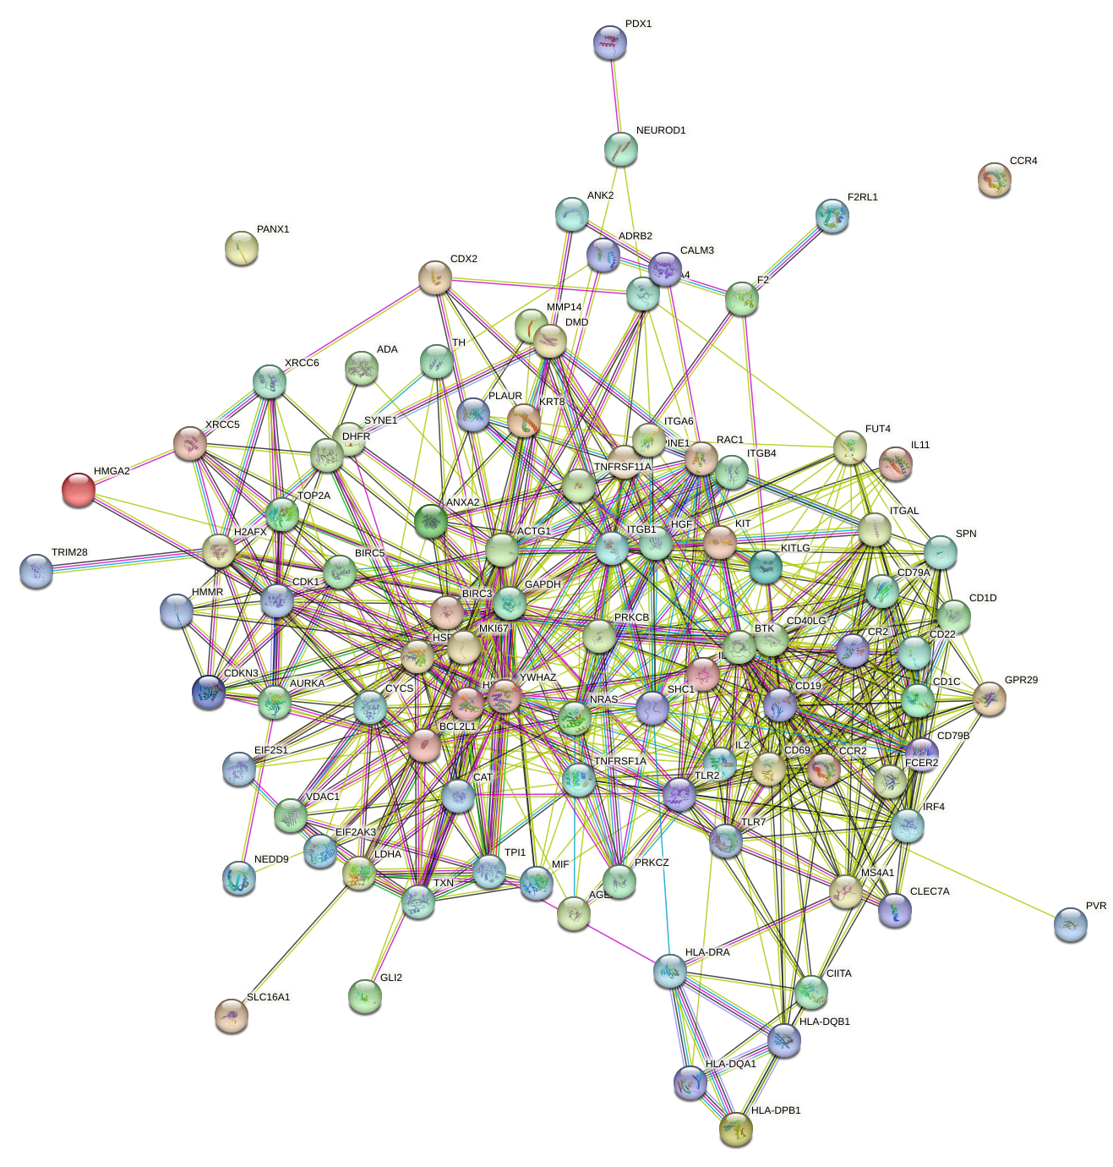
Supplementary Figure 1 | Protein–protein interactions among the ICDRGs.
Supplementary Figure 2 | Gene ontology analysis of the DEGs between the two clusters. (A) molecular function enrichment analysis of the differentially expressed genes, (B) cellular components enrichment analysis of the differentially expressed genes.

Supplementary Figure 3 | Risk scores, distribution of survival status of LUAD patient, and heatmaps of prognostic 11 prognostic genes in GSE13213 cohort (A), GSE37745 cohort (B), GSE50081 cohort (C), GSE42127 cohort (D).

Supplementary Figure 4 | Validation of the prognostic predictive ability of ICD signature in different clinical subgroups. Kaplan–Meier curves of overall survival in female (A), male (B), age＜65 (C), age≥65 (D), early stage (E) and advanced stage (F) patients based on risk score in TCGA LUAD cohort.

