Streptomyces chenzhouensis sp. nov., an endophytic actinobacterium from the root tissue of Cathaya argyrophylla
Ping Mo¹, Can Wu¹, Ruonan Han², Zhongyuan Chen¹,
Yushuang Luo¹, Peng Xie¹, Li Li^{1*}, Yun Wang^{1*}

¹Key Laboratory of Agricultural Products Processing and Food Safety in Hunan Higher Education, Science and Technology Innovation Team for Efficient Agricultural Production and Deep Processing at General University in Hunan Province, Hunan Provincial Key Laboratory for Health Aquaculture and Product Processing in Dongting Lake Area, Hunan Provincial Key Laboratory for Molecular Immunity Technology of Aquatic Animal Diseases, State Key Laboratory of Developmental Biology of Freshwater Fish, College of life and environmental sciences, Hunan University of Arts and Science, Changde 415000, Hunan Province, P.R. China.
²Animal Husbandry and Fisheries Affairs Center of Huaihua, Huaihua 418000, Hunan Province, P.R. China.
∗Correspondence:
Li Li, 191477713@qq.com; Yun Wang, wy2015@huas.edu.cn.

Fig. S1. Polar lipids composition of strain HUAS 5^{T}.
The plate dotted with sample was subjected to two-dimensional development, with the first solvent of chloroform-methanol-water (65:25:4, v/v/v) followed by the second solvent of chloroform-methanol-acetic acid-water (80:18:12:5, v/v/v/v).
Molybdophosphoric acid, molybdenum blue reagent, anisaldehyde and ninhydrin were used to detect total lipids, phospholipids, phosphatidylinositol mannosides and aminolipids respectively. A, Molybdophosphoric acid (for total lipids); B, Molybdenum blue reagent (for phospholipids); C, Anisaldehyde (for phosphatidylinositol mannosides); D, Ninhydrin (for aminolipids). phosphatidyl ethanolamine (PE), phospholipids glycerol (PG), phosphotidyl inositol (PI), phosphatidylinositol mannosides (PIM).

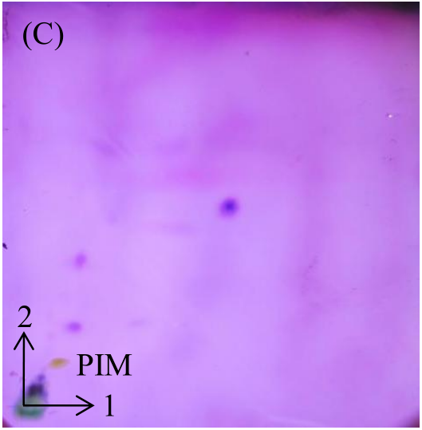
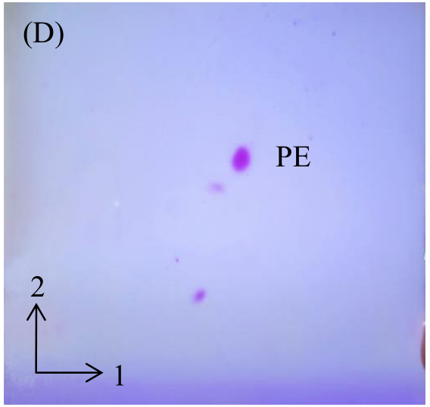
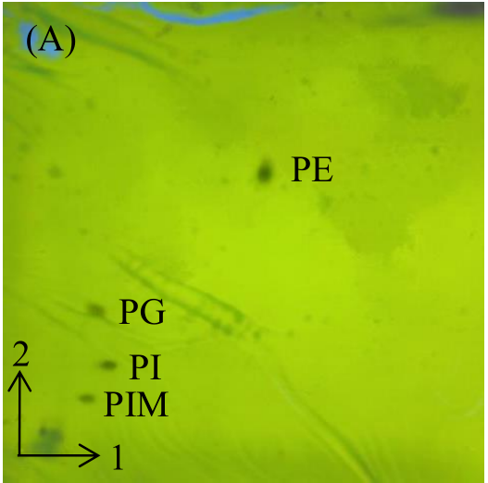
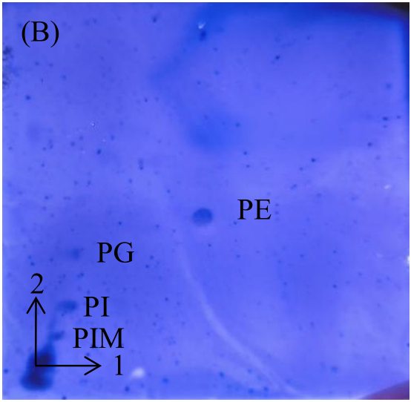
Fig. S1

Fig. S2 neighbor-joining phylogenetic tree based on 16S rRNA gene sequences showing the relationship between selected species of the genus Streptomyces. Mycobacterium tuberculosis H37Rv^{T} was used as an outgroup. Bootstrap percentages over 50% derived from 1,000 replications are showed at the node. Bar represents 0.0100.
Streptomyces jeddahensis G25^{T} (LOHS01000151)
Streptomyces tacrolimicus ATCC 55098^{T} (FN429653)
Streptomyces pilosus NBRC 12807^{T} (AB184161)
Streptomyces violaceus NRRL B-2867^{T} (KL569104)
Streptomyces prasinosporus NRRL B-12431^{T} (DQ026655)
Streptomyces thermocarboxydovorans DSM 44296^{T} (U94489)
Streptomyces thermospinosisporus AT10^{T} (AF333113)
Streptomyces fimbriatus NBRC 15411^{T} (AB184659)
Streptomyces griseomycini NBRC 12778^{T} (AB184137)
Streptomyces griseostramineus NBRC 12781^{T} (AB184140)
Streptomyces poonensis NBRC 13485^{T} (AB184437)
Streptomyces fumigatiscleroticus NBRC 12999^{T} (AB184248)
Streptomyces bullii C2^{T} (HE591384)
S. thermoviolaceus subsp. apingens DSM 41392^{T} (Z68095)
Streptomyces spectabilis NBRC 13424^{T} (AB184393)
Streptomyces viridosporus NRRL 2414^{T} (MSGP01000087)
Streptomyces chenzhouensis HUAS 5^{T} (OR237570)
Streptomyces kebangsaanensis SUK12^{T} (HM449824)
Streptomyces hirsutus NRRL B-2713^{T} (LIQT01000254)
Streptomyces prasinopilosus NRRL B-2711^{T} (LIRG01000283)
Mycobacterium tuberculosis H37Rv^{T} (NR 102810)
99
100
54
65
96
63
74
59
0.0100

Fig. S2

Fig.S3 maximum-parsimony phylogenetic tree based on 16S rRNA gene sequences showing the relationship between selected species of the genus Streptomyces. Mycobacterium tuberculosis H37Rv^{T} was used as an outgroup. Bootstrap percentages over 50% derived from 1,000 replications are showed at the node. Bar represents 20.
Streptomyces hirsutus NRRL B-2713^{T} (LIQT01000254)
Streptomyces prasinopilosus NRRL B-2711^{T} (LIRG01000283)
Streptomyces kebangsaanensis SUK12^{T} (HM449824)
Streptomyces chenzhouensis HUAS 5^{T} (OR237570)
Streptomyces viridosporus NRRL 2414^{T} (MSGP01000087)
Streptomyces prasinosporus NRRL B-12431^{T} (DQ026655)
Streptomyces pilosus NBRC 12807^{T} (AB184161)
Streptomyces violaceus NRRL B-2867^{T} (KL569104)
Streptomyces jeddahensis G25^{T} (LOHS01000151)
Streptomyces tacrolimicus ATCC 55098^{T} (FN429653)
Streptomyces fimbriatus NBRC 15411^{T} (AB184659)
Streptomyces thermospinosisporus AT10^{T} (AF333113)
Streptomyces griseomycini NBRC 12778^{T} (AB184137)
Streptomyces griseostramineus NBRC 12781^{T} (AB184140)
Streptomyces thermocarboxydovorans DSM 44296^{T} (U94489)
Streptomyces bullii C2^{T} (HE591384)
Streptomyces poonensis NBRC 13485^{T} (AB184437)
Streptomyces fumigatiscleroticus NBRC 12999^{T} (AB184248)
S. thermoviolaceus subsp. apingens DSM 41392^{T} (Z68095)
Streptomyces spectabilis NBRC 13424^{T} (AB184393)
Mycobacterium tuberculosis H37Rv^{T} (NR 102810)
99
59
92
98
76
65
61
20

Fig. S3

