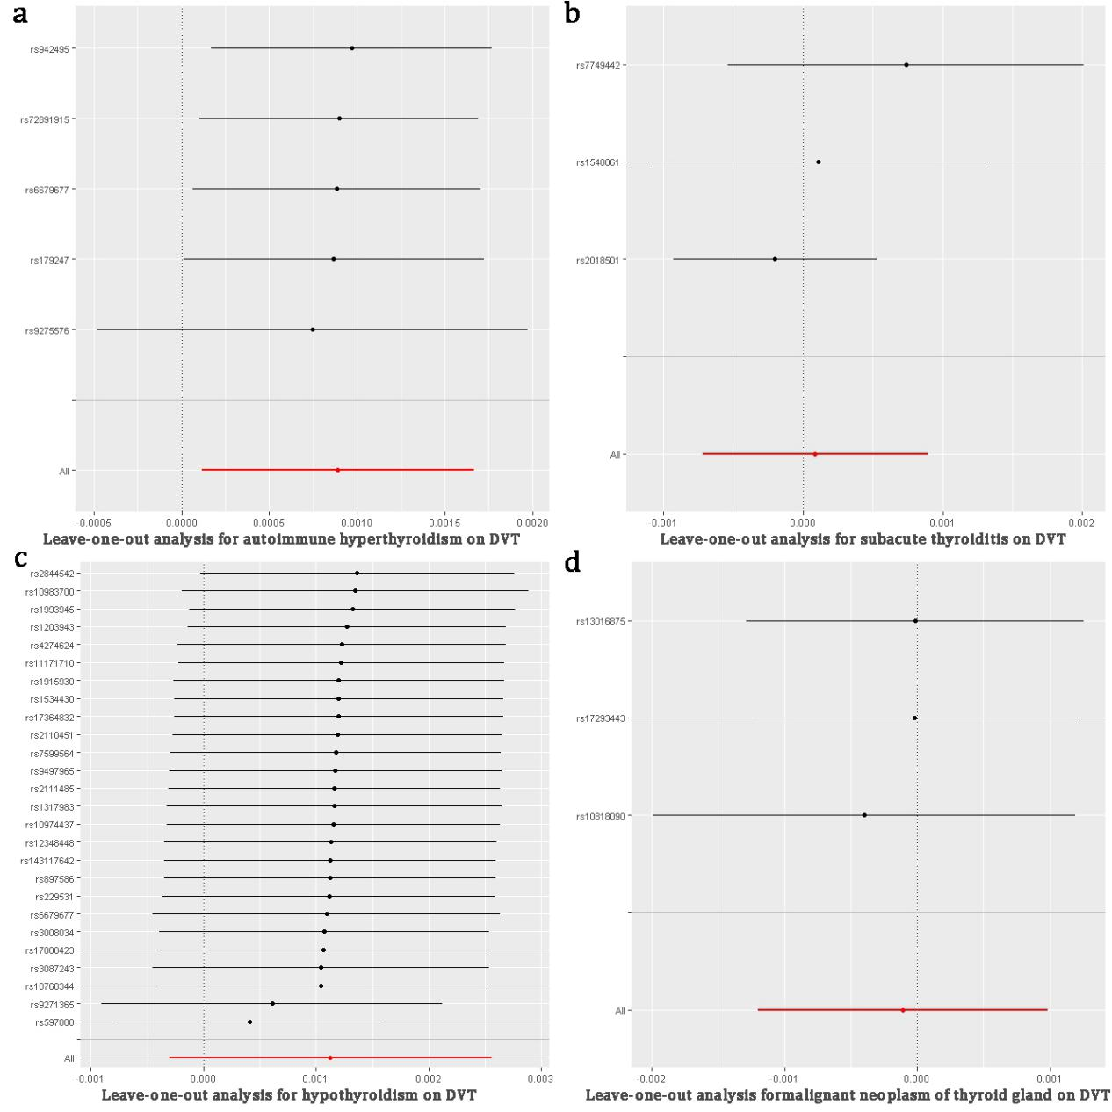
Figure S1. Leave-one-out sensitivity analysis for thyroid diseases on DVT

Autoimmune hyperthyroidism on DVT
SNP | b | se | p
rs179247 | 0.000867183 | 0.000437712 | 0.04757213
rs6679677 | 0.000884952 | 0.000418735 | 0.03456703
rs72891915 | 0.00089717 | 0.000404592 | 0.0265911
rs9275576 | 0.000746588 | 0.000626572 | 0.23344025
rs942495 | 0.000969907 | 0.000407785 | 0.01738441
All | 0.000890436 | 0.000395343 | 0.02430269
Subacute thyroiditis on DVT
SNP | b | se | p
rs1540061 | 0.000108883 | 0.000620315 | 0.8606648
rs2018501 | -0.000199085 | 0.000371829 | 0.5923591
rs7749442 | 0.000737815 | 0.000649634 | 0.2560652
All | 8.66314E-05 | 0.000411678 | 0.8333283
Hypothyroidism on DVT
SNP | b | se | p
rs10760344 | 0.001040578 | 0.000749614 | 0.16509116
rs10974437 | 0.001153369 | 0.0007547 | 0.12645104
rs10983700 | 0.001347148 | 0.000784674 | 0.08601115
rs11171710 | 0.001223493 | 0.000736902 | 0.09685039
rs1203943 | 0.00127289 | 0.000719299 | 0.07678971
rs12348448 | 0.001130736 | 0.000752905 | 0.13314069
rs1317983 | 0.001161723 | 0.000757566 | 0.12515397
rs143117642 | 0.001124928 | 0.000750202 | 0.13374389
rs1534430 | 0.001199823 | 0.000746186 | 0.10784808
rs17008423 | 0.001061885 | 0.000752071 | 0.15796503
rs17364832 | 0.001199711 | 0.000745999 | 0.10779256
rs1915930 | 0.001202127 | 0.000750413 | 0.10916592
rs1993945 | 0.001322031 | 0.000739418 | 0.07378641
rs2110451 | 0.001193364 | 0.000747702 | 0.11047954
rs2111485 | 0.00116378 | 0.000750807 | 0.12113216
rs229531 | 0.001114191 | 0.000753354 | 0.13914732
rs2844542 | 0.001365139 | 0.000711689 | 0.0550897
rs3008034 | 0.001072378 | 0.000749243 | 0.15234944
rs3087243 | 0.00104192 | 0.0007615 | 0.17123478
rs4274624 | 0.001230724 | 0.000744442 | 0.0982868
rs597808 | 0.000408923 | 0.000614412 | 0.50569766
rs6679677 | 0.001091251 | 0.000787096 | 0.1656169
rs7599564 | 0.001175163 | 0.000749057 | 0.11668144
rs897586 | 0.00112343 | 0.000752728 | 0.13557375
rs9271365 | 0.000608815 | 0.000771182 | 0.42984441
rs9497965 | 0.001170376 | 0.000753467 | 0.12034618
All | 0.001126647 | 0.000730977 | 0.12324629
Malignant neoplasm of thyroid gland on DVT
SNP | b | se | p
rs10818090 | -0.000398358 | 0.00081146 | 0.6234868
rs13016875 | -1.4744E-05 | 0.000649276 | 0.9818829
rs17293443 | -1.62949E-05 | 0.00062583 | 0.9792276
All | -0.000105765 | 0.000557104 | 0.8494277
Table S1. Single SNP effect in Leave-one-out sensitivity analysis

