Supporting Information for
Ultrasound-triggered and Glycosylation Inhibition-enhanced Tumor Piezocatalytic Immunotherapy
Wencheng Wu¹, Yinying Pu³, Jinhong Bing¹, Liang Wang¹, Mingqi Chen², Yucui Shen², Shuang Gao², Min Zhou²*, and Jianlin Shi¹*
¹Shanghai Institute of Ceramics, Chinese Academy of Sciences, Shanghai 200050 (P. R. China). Research Unit of Nanocatalytic Medicine in Specific Therapy for Serious Disease, Chinese Academy of Medical Sciences (2021RU012), Shanghai 200050, P. R. China. E-mail: jlshi@mail.sic.ac.cn.
²Digestive endoscopy center, Shanghai Fourth People's Hospital to Tongji University, Shanghai 200081, P. R. China. E-mail: crown_zhou@hotmail.com.
³Department of Medical Ultrasound, Shanghai Tenth People’s Hospital, Ultrasound Research and Education Institute, Tongji University Cancer Center, Tongji University School of Medicine, Shanghai 200072, P. R. China.
The supplementary information includes:
1. Supplementary Methods
2. Supplementary Figures (Fig. 1-18)

1. Supplementary Methods
Characterization. The hydrodynamic diameter of BFO in deionized water (pH 7.4) was measured by the Malvern Zetasizer Nano series (Nano ZS90). The morphology of BFO was observed under the transmission electron microscope (TEM, JEM-2100F). The powder X-ray diffraction (PXRD) was performed on a Rigaku diffractometer (SmartLab 9KW, Japan). After hydrogels were frozen at -80 °C overnight, the microstructure of gels was observed by cryo-scanning electron microscopy (Cryo-SEM) (SU8010, Japan). Piezoresponse force microscopic (PFM) measurements were characterized by an AFM (NTEGRA, NT-MDT, Russian) equipped with a ferroelectric test system. The element quantitative analysis of samples was conducted on inductively coupled plasma-optical emission spectrometry (ICP-OES, Agilent 725, Agilent Technologies, US). The electron paramagnetic resonance (EPR) characterization was performed on an electron paramagnetic resonance spectrometer (JEOL-FA200, JEOL, Japan). The confocal laser scanning microscope (CLSM) images were obtained on an FV1000 (Olympus Company, Japan). Flow cytometry analysis for cell-apoptosis analysis was conducted by a BD LSRFortessa flow cytometry (Becton, Dickinson and Company, USA). For electric measurement, the DBG was cast on ITO‐coated substrate with an electrode area of 16.5 cm² to form the film. The output voltage and current of the fabricated device were detected with a digital oscilloscope (Tektronix, 2 GHz) at the power levels of 120 W. Ultrasound detection was performed with a probe ultrasonograph (SCIENTZ, JY96-IIN) equipped with a plane wave transducer module (6 mm diameter tip, 20 KHz). The probe was fixed vertically at a distance of 1-2 cm from the device.
The finite element modeling (FEM) simulation of BFO. The simulation involved a dynamic 3D analysis of a piezoelectric device using the Piezoelectric Devices multiphysics interface. The model consists of BFO nanocrystals with a side length of 400 and a region of surrounding water (εr = 80). The other material parameters used in this simulation, such as density (ρ = 8344 kg/m³), elasticity matrix (cE), coupling matrix (eES), and relative permittivity (εr) of BFO nanocrystals are available as predefined material parameters in Comsol Multiphysics.
Cell experiment. Murine breast cancer 4T1 cell line was originally obtained from the Cell Bank of Shanghai Institutes for Biological Sciences, Chinese Academy of Sciences, and was cultured in the recommended medium and condition (DMEM medium with 10% FBS and 1% antibiotics (penicillinstreptomycin, 10000 U mL⁻¹) at 37 °C in a humidified atmosphere containing 5% CO₂).
GRP78 Western blot analysis. 4T1 cells were grown in a complete medium supplemented with treatments as indicated (2FDG 4mM 48h; Mannose 1mM 48h; Glucose 1mM 48h; DBG + US 48h). Cells were lysed in RIPA buffer with a protease inhibitor cocktail. Then, proteins were quantified through Pierce BCA Protein Assay Kit and denatured at 95°C for 5 min in Laemmli buffer with 150 mM DTT. After denaturation, an equal amount of proteins (30 µg) was loaded in 4 to 15% SDS-PAGE (Bio-Rad) and transferred to a 0.45 pore polyvinylidene difluoride filter. Polyclonal rabbit anti-GRP78 (1:1000 dilution overnight at 4 °C) and mouse monoclonal anti-vinculin (1:1000 dilution overnight at 4 °C) antibodies were used after saturation in 3% bovine serum albumin (BSA). After incubation with horseradish peroxidase (HRP)-linked secondary antibody (1:3000 dilution 1 hour at room temperature), Western Lightning Chemiluminescence Reagent Plus (PerkinElmer) was used for visualization. Images were acquired with ChemiDoc Touch Imaging System (Bio-Rad) and analyzed with ImageLab software (Bio-Rad).
Immunofluorescence. In this assay, four groups (non-treated cells as control, US, DBG, and DBG + US) were set. 4T1 cells were seeded in 12-well plates (1 × 104 cells/well) for 12 h. In DBG + US group, the cells were first treated with DBG at the BFO doses of 200 μg/mL for 8 h. After that, the cells were irradiated by US (1.0 MHz, 1.0 W/cm2, 50 % duty cycle) for 5 min and further incubation for 16 h. Then, tumor cells were washed with PBS and fixed in 4 % paraformaldehyde for 10 min. Immediately afterward, anti-CRT, anti-HMGB1, and anti-HSP70 were added to the cells and incubation for 4 h at room temperature, respectively. Finally, the cells were further incubated by FITC or APC-conjugated secondary antibody for CLSM observation, and the nuclei of 4T1 cells were stained with DAPI.
Tumor models. BALB/c mice (female, 4 weeks) were purchased from Beijing Vital River Laboratory Animal Technology Co. All animal experiment protocols were approved by the Laboratory Animal Center of Shanghai Tenth Peoples’ Hospital and complied with the policies of the National Ministry of Health. To establish the tumor-bearing mouse models, 4T1 cancer cells (2 × 10⁶ cells/mouse) were subcutaneously implanted into the normal BALB/c mice.
In vivo fluorescence imaging. To evaluate the in vivo release of BFO from DBG under US irradiation, free Cy5.5-BFO or Cy5.5-DBG was injected subcutaneously into 4T1 tumor-bearing BALB/c mice. On day 0, 3, 5, and 7, fluorescence imaging of Cy5.5-BFO or Cy5.5-DBG release was monitored by the IVIS imaging system (VISQUE Invivo Smart-LF, Korea). Likewise, for the assessment of 2-DG release, representative fluorescence imaging of DBG in which indocyanine green was used as a fluorescent surrogate for 2-DG was taken via the IVIS imaging system
RNA sequencing. Tumors were isolated from mice after 3 days of different treatments, and RNA was extracted using the HiPure Universal RNA Mini Kit (Magen Biotechnology Co. Ltd, China). RNA sequencing was performed using the Agilent Bioanalyzer 2100 system (Agilent Technologies, CA, USA) RNA Nano 6000 assay kit was used for RNA sequencing. ere identified by liquid mass spectrometry (LC-MS/MS) combined with a database search.

2. Supplementary Figures
Figure S1. a) TMB absorption spectra by adding 200 µg mL⁻¹ of BFO after US irradiation for varied durations. b) TMB absorption spectra by adding 200 µg mL⁻¹ of BFO after US irradiation with different power intensities for 5 min.

Figure S2. ESR spectra of O₂¹ trapped by TEMP in different systems.
Figure S3. The 2-DG release from DBG with or without US irradiation.

Figure S4. a) Confocal fluorescence images and b) flow cytometry analysis of DCFH-DA stained cancer cells after various treatments.
Figure 5. Flow cytometry analysis of BMDCs and BMMs after different treatments in the transwell system.

Figure S6. Levels of various cytokines in treated BMDCs and BMMs suspensions measured by the ELISA method.
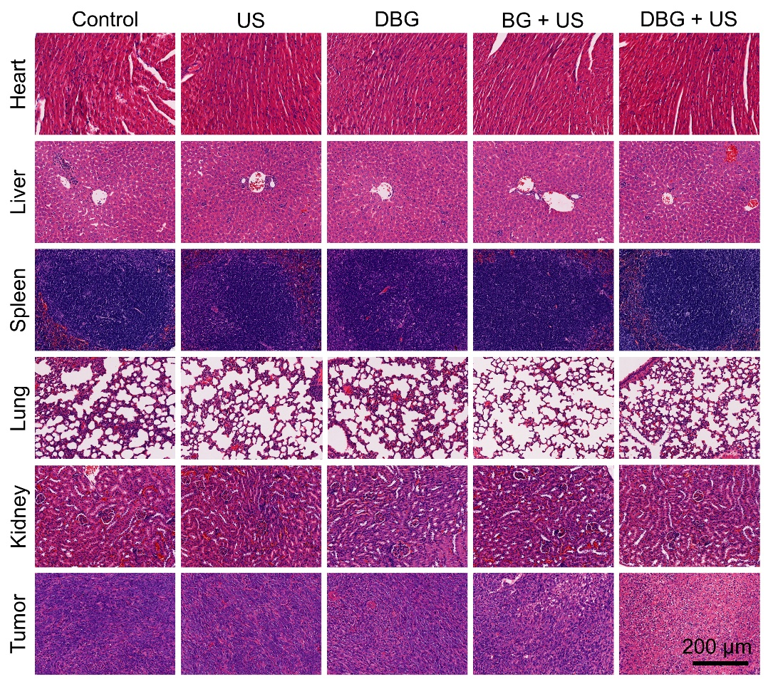
Figure S7. Analysis of the excised main organs and tumor slices of 4T1-bearing mice after different treatments by H&E staining.

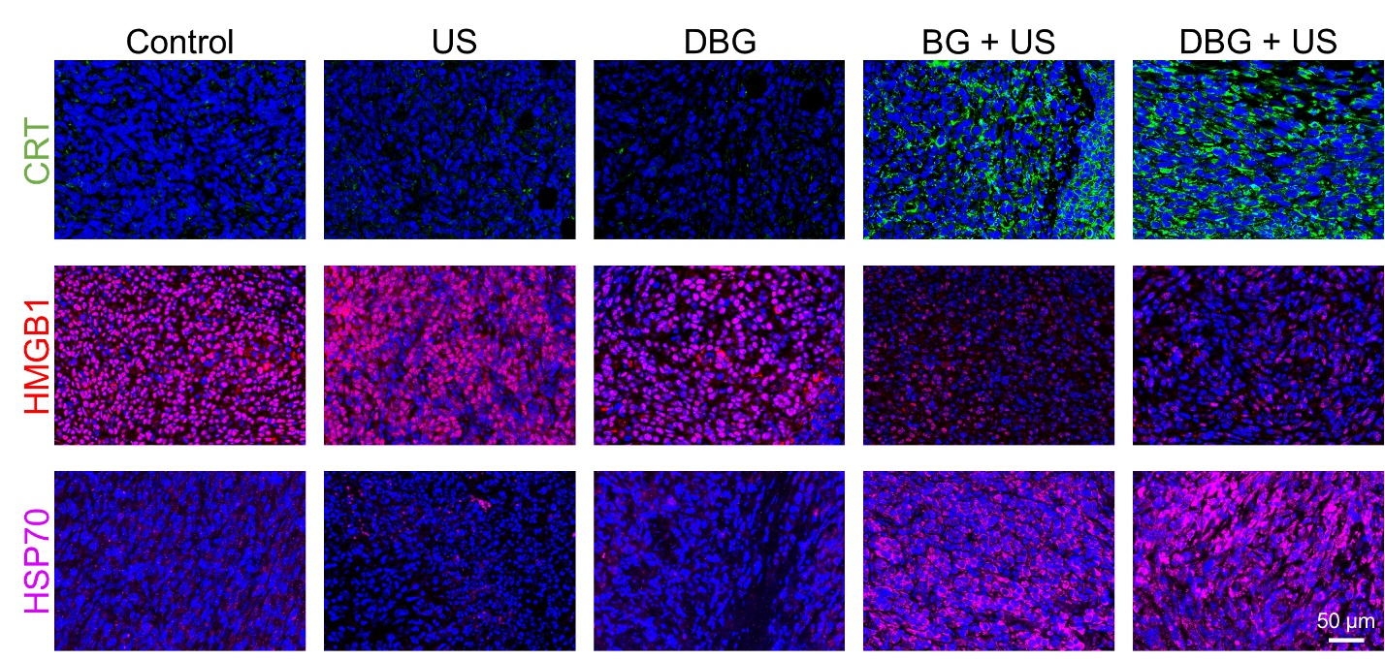
Figure S8. Immunofluorescence analysis of the expressions of CRT, and HSP70, as well as the release of HMGB1 from tumor tissue after different treatments.
Figure S9. The contents of various cytokines in tumor tissues of mice after different treatments measured by ELISA.
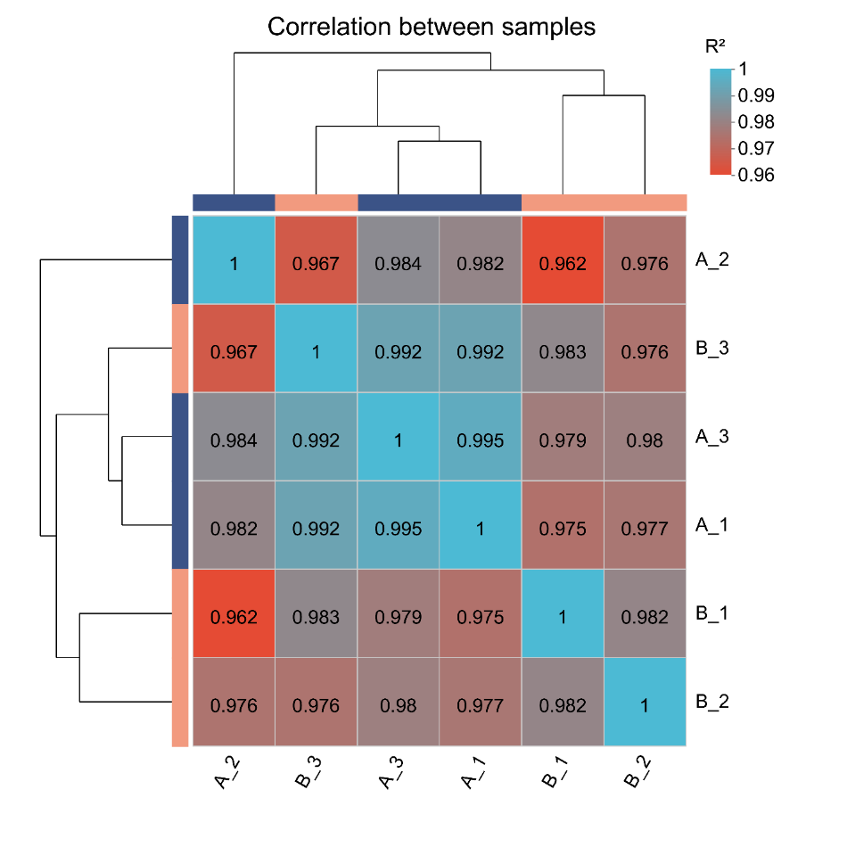
Figure S10. Sample correlation test of genes alteration with or without DBG + US treatment.
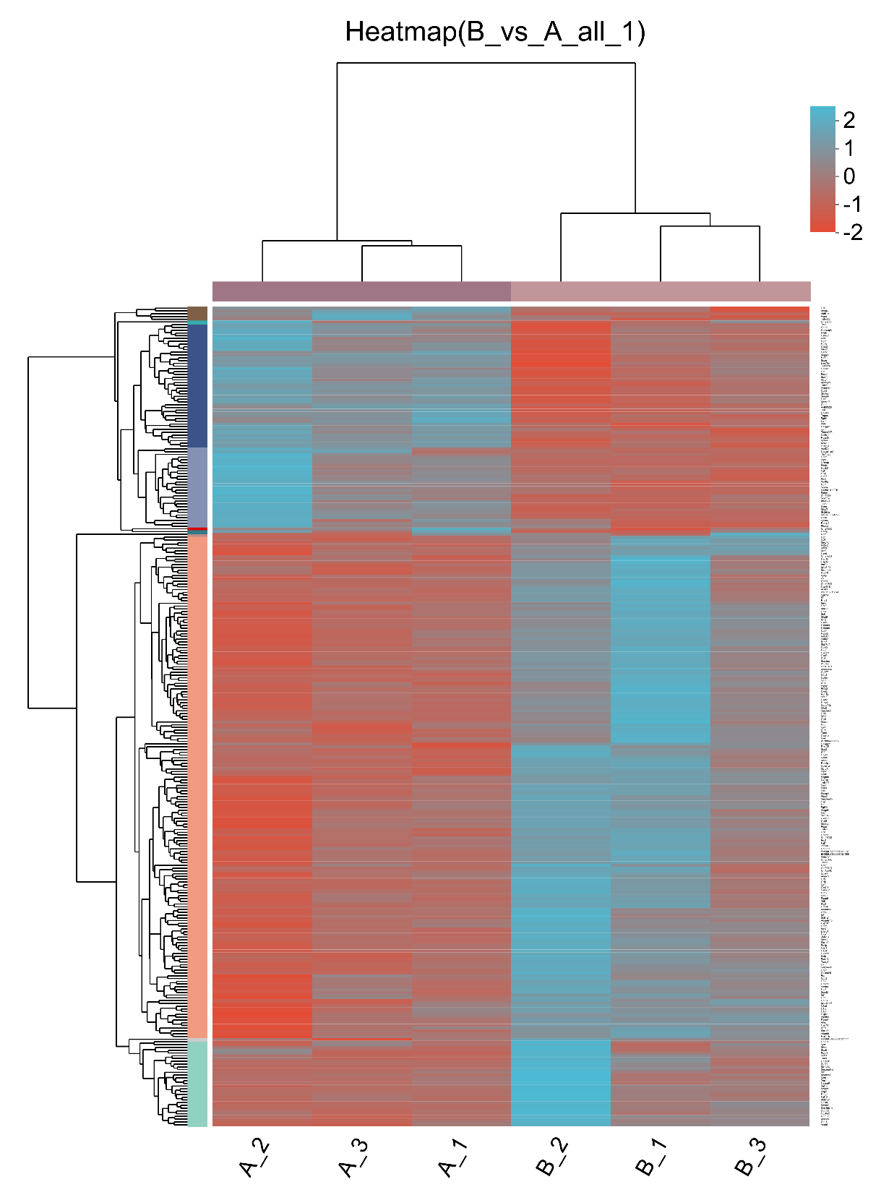
Figure S11. Heatmap of genes alteration with or without DBG + US treatment (P < 0.05, |fold change | ≥ 2).
Figure S12. Flow cytometry analysis of in vivo a) CD206⁺ macrophages (gated on CD11b⁺/F4/80⁺ macrophages), b) CD86⁺ macrophages (gated on CD11b⁺/F4/80⁺ macrophages), c) CD4⁺ T cells (gated on CD3⁺ T cells), and d) CD4⁺ T cells (gated on CD3⁺ T cells) in tumors of mice after different treatments.

Figure S13. H&E staining of lung tissue from different groups of 4T1 tumor-bearing mice.
Figure S14. Immunofluorescence images of proliferated polarized M1 TAMs (F4/80+/CD86⁺) and cytotoxic T lymphocytes (CD3⁺/CD8⁺) in 4T1 tumor tissue slices of lung metastatic tumors.

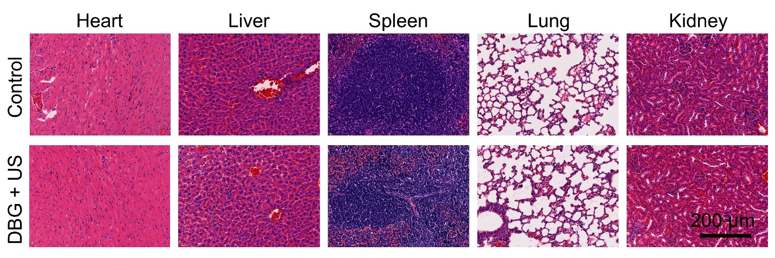
Figure S15. Analysis of the excised main organs of 4T1-bearing mice after different treatments by H&E staining.
Figure S16. The Kaplan-Meier survival curves of mice after different treatments.

Figure S17. Quantitative statistical analysis result of the proportion of different types of immune cells in tumors of control and DBG + US treated mice.

Figure S18. Representative statistical data of T_{EM} and T_{CM} in the splenic lymphocytes analyzed by flow cytometry.

