Supporting Information for
Cyclic Peptide High-Entropy Noncovalent Glass

Chengqian Yuan^{1,2,5}, Wei Fan^{1,2,5}, Ruirui Xing^{1,2}, Peng Zhou^{1,2}, Shuai Cao^{1,2}, Xuehai Yan^{1,2,3,4}*

¹ State Key Laboratory of Biochemical Engineering, Institute of Process Engineering, Chinese Academy of Sciences, Beijing 100190
² Key Laboratory of Biopharmaceutical Preparation and Delivery, Chinese Academy of Sciences, Beijing 100049
³ School of Chemical Engineering, University of Chinese Academy of Sciences, Beijing 100049
⁴ Center for Mesoscience, Institute of Process Engineering, Chinese Academy of Sciences, Beijing 100190
⁵ These authors contributed equally to this work.
*Corresponding Author: yanxh@ipe.ac.cn
Supplementary Fig. 1. TGA-DSC curves of typical CPs (TYPE I). Such a type of CPs is characterized by the absence of thermal decomposition below their melting points (T_{m}).

Supplementary Fig. 2. TGA-DSC curves of typical CPs (TYPE II). Such a type of CPs is characterized by serious decomposition before or near the T_{m}.

Supplementary Fig. 3. HR-ESI-MS spectra of CPY crystal and glass, showing the unchanged chemical structure after CPY glass formation.

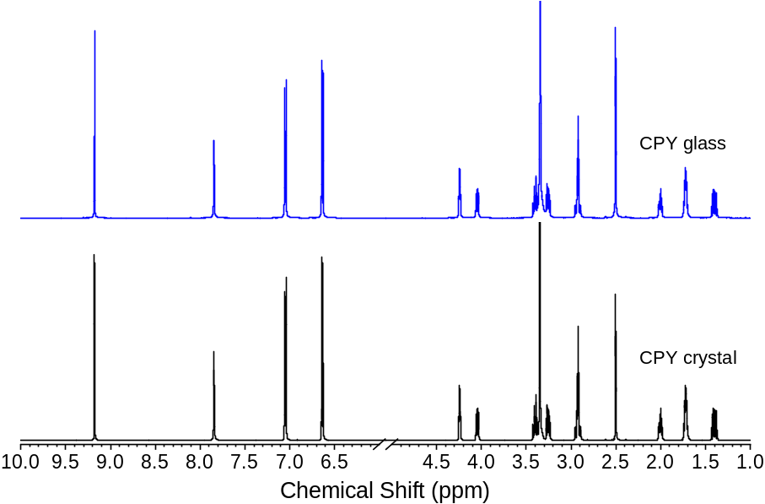
Supplementary Fig. 4. ¹H NMR spectra of CPY crystal and glass, demonstrating the unchanged chemical structure after CPY glass formation.

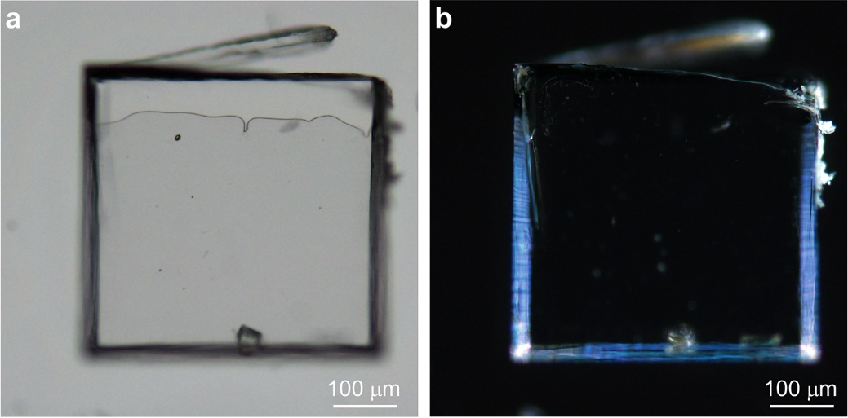
Supplementary Fig. 5. Bright-field (a) and POM (b) images of CPY crystals. The anisotropic POM image indicates the crystalline nature of CPY crystals.

Supplementary Fig. 6. Molecular packing patterns within the single crystal of CPY. (a) A supramolecular layer consisting of dimer 1 (Fig. 2d) stabilized by C-H…π interactions. (b) A supramolecular layer consisting of dimer 2 (Fig. 2d) stabilized by hydrogen bonding and π…π stacking interactions. (c) The aromatic stacking patterns within the supramolecular layer shown in a. (d) The aromatic stacking patterns within the supramolecular layer shown in b. Red and blue dotted lines shown in a and b denote different types of hydrogen bonds.
Supplementary Figure 7. Typical molecular clusters representing the local arrangements within CPY glass. (a) Slipped π-π stacking. (b) Local cluster containing dimer 1 and dimer 2 stabilized by hydrogen bonds. (c and d) Disordered aromatic packing modes within CPY glass. The CPY molecule marked with orange Carbon atoms denotes that the molecular conformation has changed after glass formation. Red and blue dotted lines represent different types of hydrogen bonds.
Supplementary Fig. 8. Multicolor emission of CPY glass. (a) Bright-field and fluorescent imaging of CPY glass. (b) Solid-state fluorescence spectra of CPY glass. (c) Solid UV-Vis spectra of CPY glass. The UV-vis absorption spectra of CPY glass demonstrated spike-like absorbance with four peaks at 319 nm, 370 nm, 478 nm, and 517 nm in the range from 300 nm to 800 nm, characteristic of the quantum-confined photoluminescence, revealing the presence of multiple CPs clusters with different sizes in the CPY glass^{1, 2}.
Supplementary Fig. 9. The second upscan DSC curves of CFP, CWY, and CWW. It is obvious that the T_{g} of CP glasses can be tuned by modulating the amino acid types in peptides.

Supplementary Table 1. Dynamic and thermodynamic parameters of cyclic dipeptides glass formers in this study.

Supplementary Fig. 10. TGA-DSC curves of typical CPs (TYPE III). Such CPs failed to obtain stable glass at the regular cooling rate of 10 °C min⁻¹ even though they didn’t undergo decomposition before melting.

Supplementary Fig. 11. The second upscan DSC curves of CLP with different cooling rates and annealing temperatures. The sharp endothermic peaks that emerged in the DSC curves indicate the occurrence of recrystallization during the cooling process. This result demonstrates that even reducing the annealing temperature or increasing the cooling rate is still not favorable for the formation of CLP glass.

Supplementary Fig. 12. ESI-MS spectrum of HECP glass consisting of CGP, CLP, CPT, and CFS. The molecular ions of individual CPs in the ESI-MS spectra confirmed the presence of all the CPs involved in the HECP glass.
Supplementary Fig. 13. The second upscan DSC curve of a mixture containing CPY, CFP, CLP, and CPT.

Supplementary Fig. 14. The second upscan DSC curve of a mixture containing CFW, CWY, CWW, and CPY, as compared with those of individual CPs, revealing that the introduction of CWY, CWW, and CPY completely inhibits the crystallization of CFW and leads to the glass formation.

Supplementary Fig. 15. The second upscan DSC curve of the mixture containing CPY, CLP, CPT, CFS, and CGP.

Supplementary Fig. 16. The second upscan DSC curve of a mixture containing CPY, CFP, CLP, CPT, CFS, and CGP.
Supplementary Fig. 17. Fluorescence imaging of two typical HECP glasses. The pronounced multicolor emission of such two typical glasses indicates the existence of multiple CP clusters with quantum sizes within the HECP glass.

Supplementary Fig. 18. The second upscan DSC curve of a mixture containing CPY, CFP, and CLP, as compared with those of individual CPs, demonstrating that the introduction of CPY and CFP completely inhibits the crystallization of CLP and facilitates the glass formation.
Supplementary Fig. 19. The second upscan DSC curve of a mixture containing CFW, CWY, and CWW, as compared with those of individual CPs. The results reveal that the introduction of CWY and CWW ultimately hampers the crystallization of CFW and facilitates the glass formation.

Supplementary Fig. 20. The second upscan DSC curves of a mixture containing CFF, CFW, CPY, CWY, and CWW. The words marked with red color denote that CFF is thermally labile.
Supplementary Fig. 21. The second upscan DSC curves of a mixture containing CAA, CGG, CPY, CFW, and CWY. The words marked with red color denote that these peptides are thermally labile.

Supplementary Fig. 22. Tunable T_{g} of HECP glasses. (a) HECP glasses containing proline-rich CPs. (b) HECP glasses containing tryptophan-rich CPs.
Supplementary Table 2. Molecular diameter of CPs involved in CFF- and CGG-containing HECP glasses.

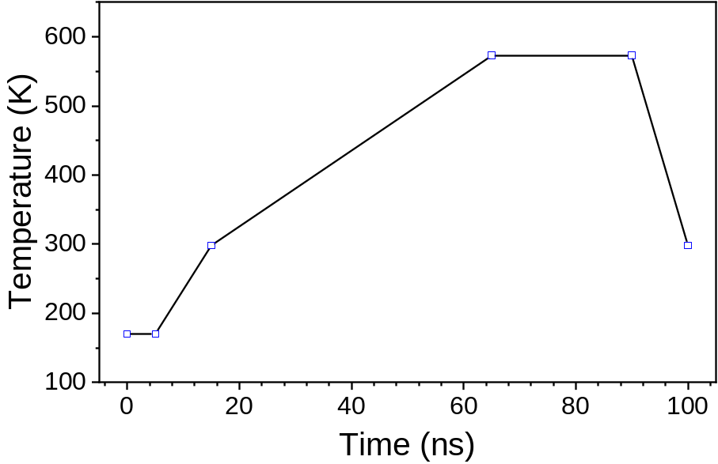
Supplementary Fig. 23. The annealing temperature setting of AAMD simulation.
References
1. Amdursky, N., Molotskii, M., Gazit, E. & Rosenman, G., Self-assembled bioinspired quantum dots: Optical properties. Appl. Phys. Lett. 94, 261907 (2009).
2. Tao, K., et al., Quantum confined peptide assemblies with tunable visible to near-infrared spectral range. Nat. Commun. 9, 3217 (2018).

