Figure7D: n = 4
miR-204-3p
inhibitor

Inhibitor
NC

Inhibitor
NC

miR-204-3p
inhibitor

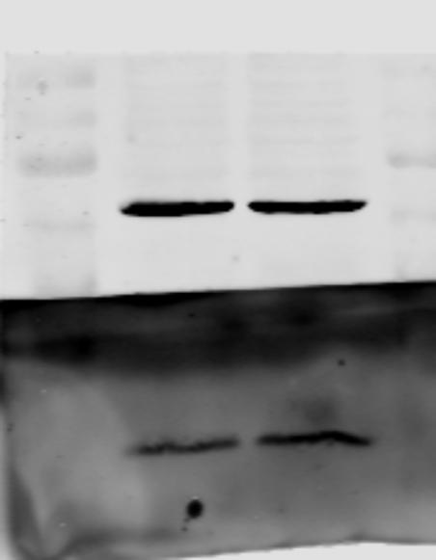
1. 2.
55kDa
43kDa
34kDa
26kDa
16kDa
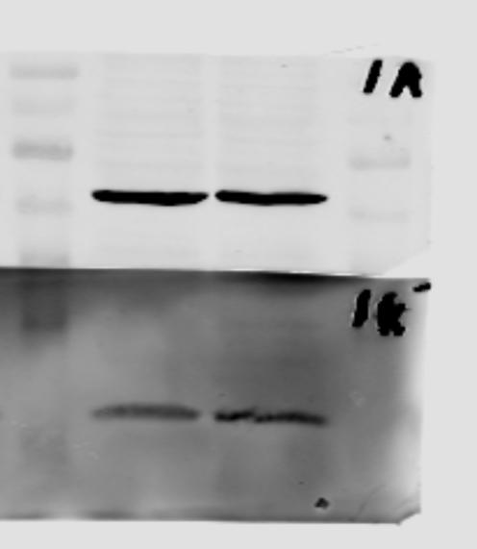
55kDa
43kDa
34kDa
26kDa
16kDa

Actin
Actin

KRAS
KRAS

Inhibitor
NC

miR-204-3p
inhibitor

miR-204-3p
inhibitor

Inhibitor
NC

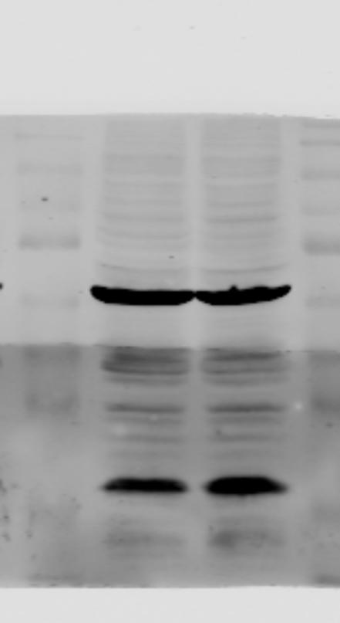
3. 4.
55kDa
43kDa
34kDa
26kDa
16kDa
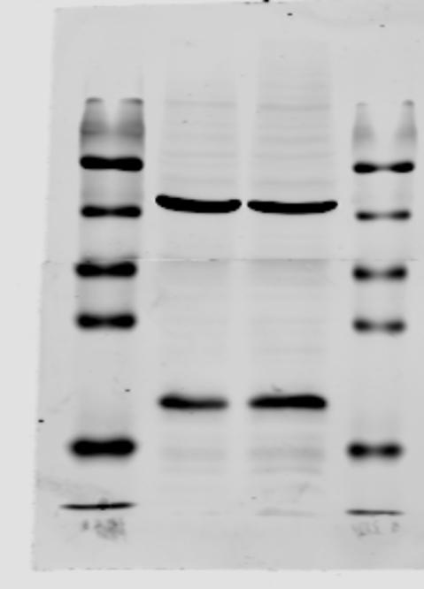
55kDa
43kDa
34kDa
26kDa
16kDa

Actin
KRAS
Actin

KRAS

1

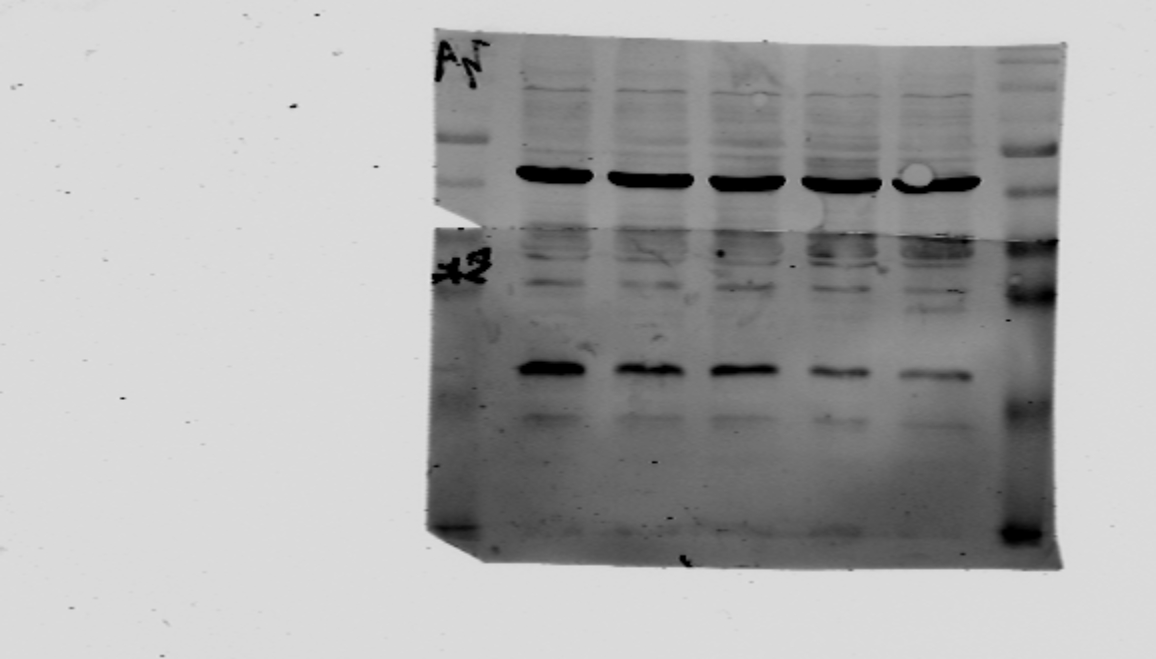
55kDa
43kDa
34kDa
26kDa
16kDa
C si-NC si1 si2 si3
Figure7E: n = 3
si-3
si-2
si-1
si-NC
C
si-3
si-2
si-1
si-NC
C
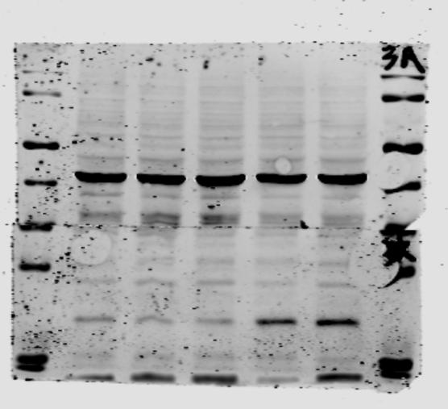
55kDa
43kDa
34kDa
26kDa
16kDa
55kDa
43kDa
34kDa
26kDa
16kDa

Actin
Actin

KRAS

KRAS

si-NC
si-1
si-3
si-2
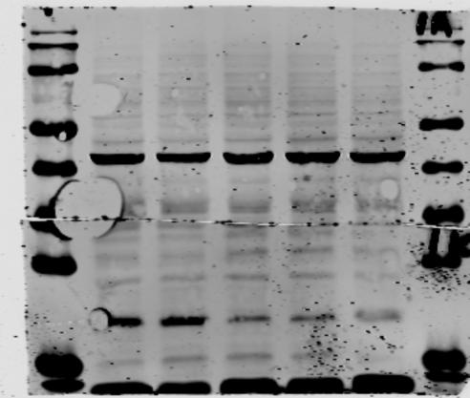
KRAS
Actin
55kDa
43kDa
34kDa
26kDa
16kDa

si-hsa_circ_0001846+
miR-204-3p inhibitor

miR-204-3p inhibitor+

Figure7G: n = 3
miR-204-3p inhibitor

si-hsa_circ_0001846+
miR-204-3p inhibitor

miR-204-3p inhibitor+

miR-204-3p inhibitor

si-hsa_circ_0001846

si-hsa_circ_0001846

si-NC
si-NC
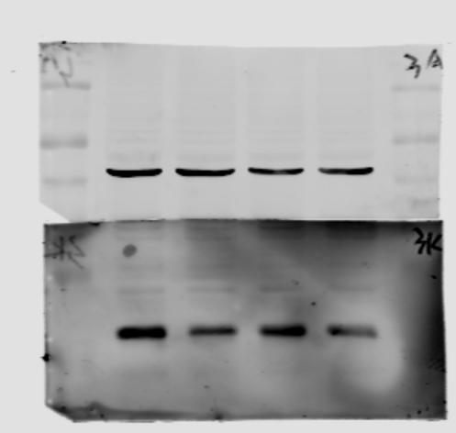
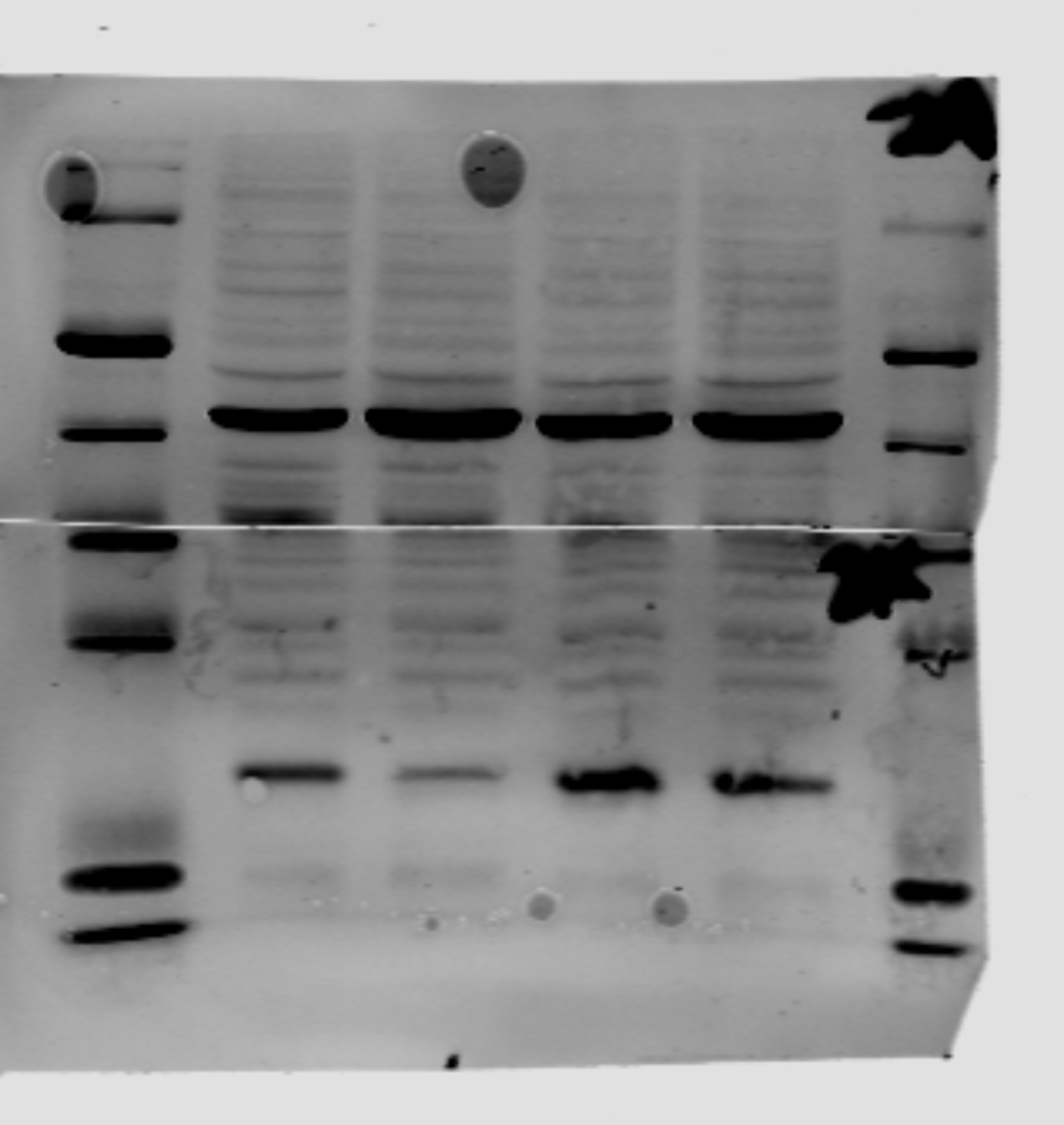
1. 2.
55kDa
43kDa
34kDa
26kDa
16kDa
55kDa
43kDa
34kDa
26kDa
16kDa

Actin
Actin

KRAS
KRAS

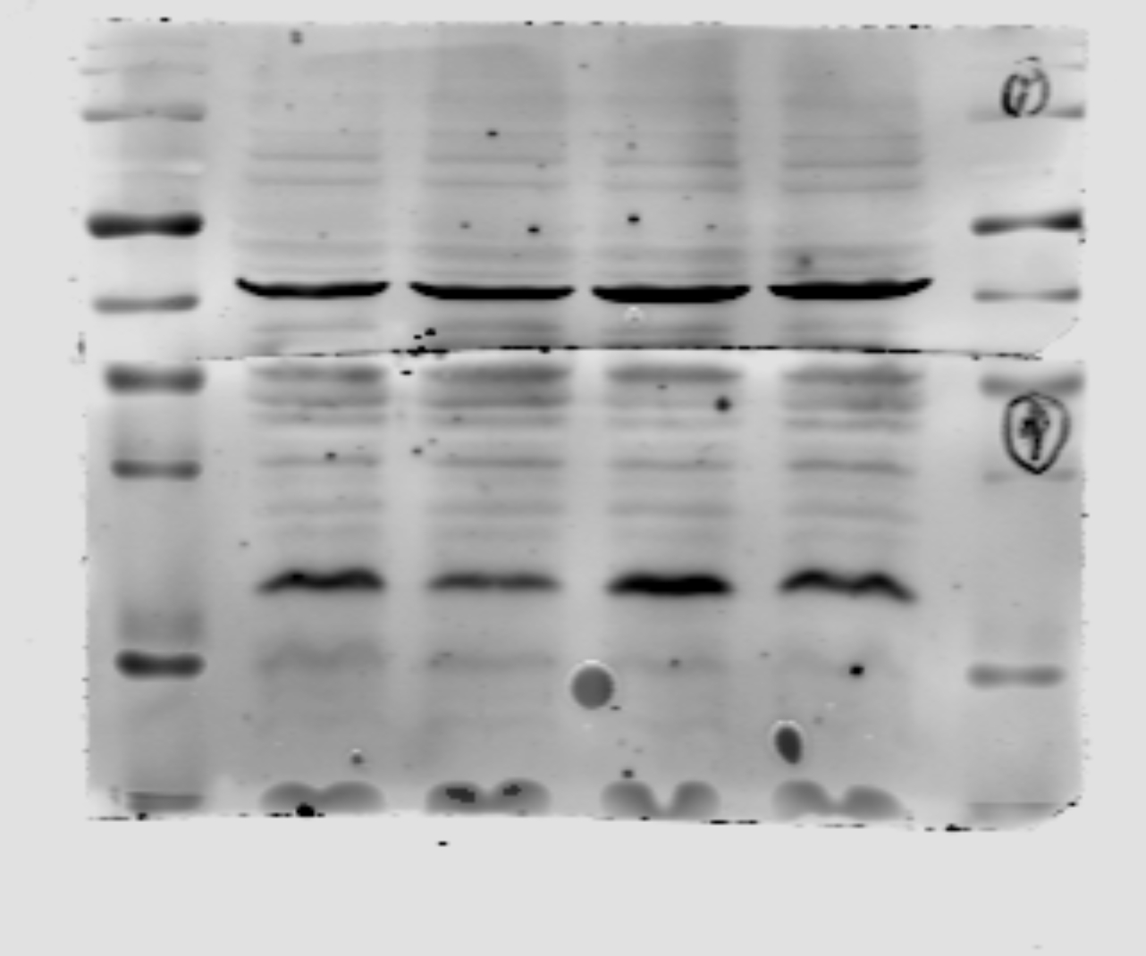
3.
Actin
KRAS
si-hsa_circ_0001846+
miR-204-3p inhibitor

miR-204-3p inhibitor+

miR-204-3p inhibitor

si-hsa_circ_0001846

si-NC
55kDa
43kDa
34kDa
26kDa
16kDa

