Supporting Information for

Decoding the dynamic of poleward shifting climate zones using aqua-planet model simulation

Hu Yang∗, Jian Lu, Xiaoxu Shi, Qiang Wang, Gerrit Lohmann
Correspondence to: hu.yang@awi.de

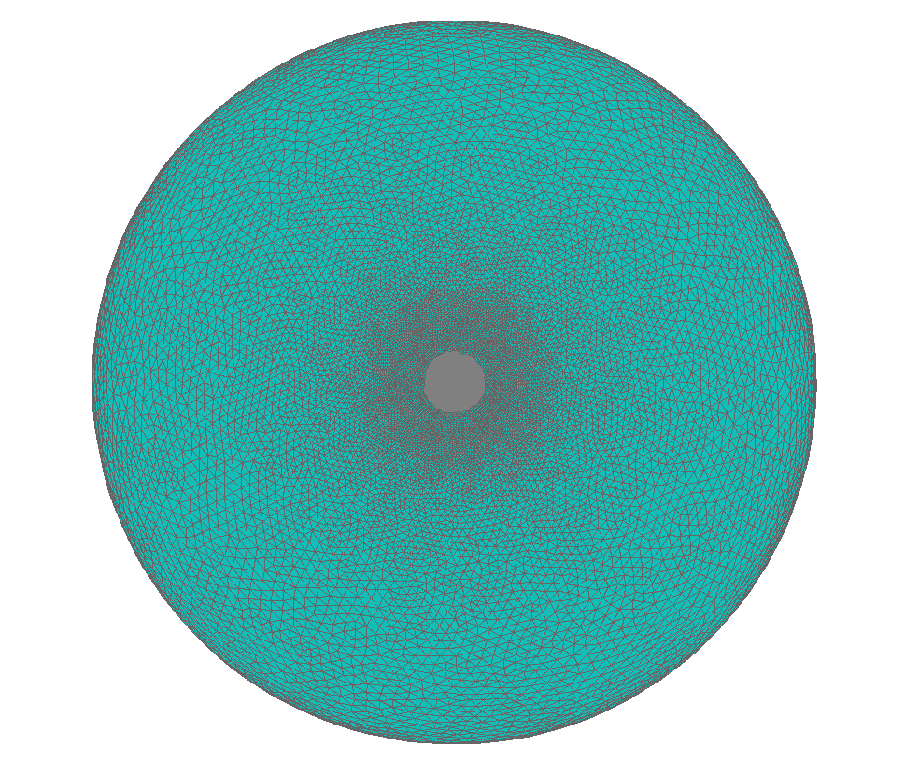
Figure. S1. The mesh of the ocean component (i.e. FESOM) in the aqua-planet model. Most of the earth is covered by ocean, except the region higher than 85 degrees over both hemispheres.

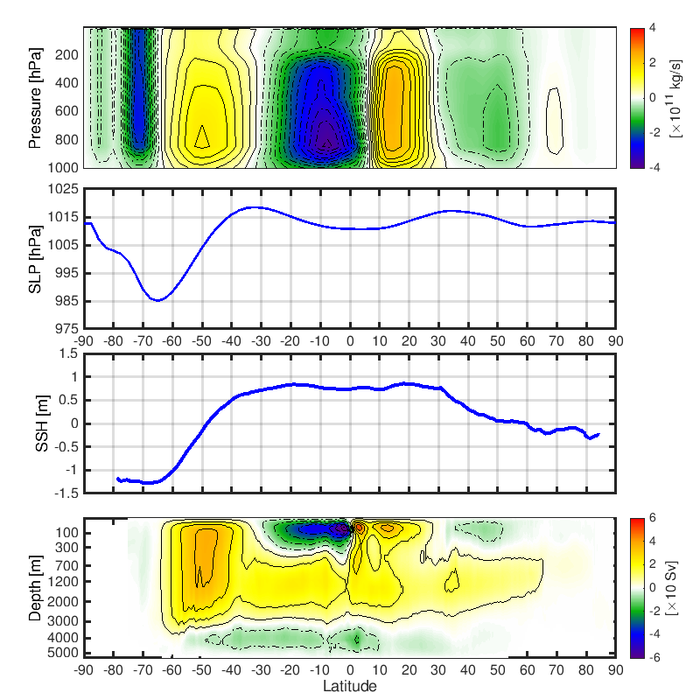

Figure. S2. Climatological patterns of the atmosphere and ocean circulation in real-world observations. A: Stream function of the atmospheric overturning circulation. Positive values represent clockwise flow, and negative values stand for anticlockwise flow. B: Zonal mean sea level pressure (SLP). Subtropical high SLP is associated with sinking branches of Hadley cell and Ferrel cell, while, subpolar low SLP corresponds to the raising branches of Ferrel cell and Polar cell. C: Zonal mean sea surface height (SSH). Subtropical high SSH represents the centre of the subtropical gyre, while subpolar low SSH presents the position of subpolar gyre. D: Stream function of the overturning circulation of the ocean. Positive values represent clockwise flow, and negative values stand for anticlockwise flow. Results based on NCEP-DOP (Kanamitsu et al., 2002), AVISO (https://www.aviso.altimetry.fr) and SODA2.4 (Carton and Giese, 2008) datasets. Due to the land-sea distribution, the SLP and SSH fields have zonal gradients. The zonally mean profile does not accurately reproduce the peak SSH and SLP as shown in the aqua-planet world, since it is offset by the zonally asymmetric structure. The detailed spatial distribution of the SLP and SSH fields are also shown in Fig. S3.
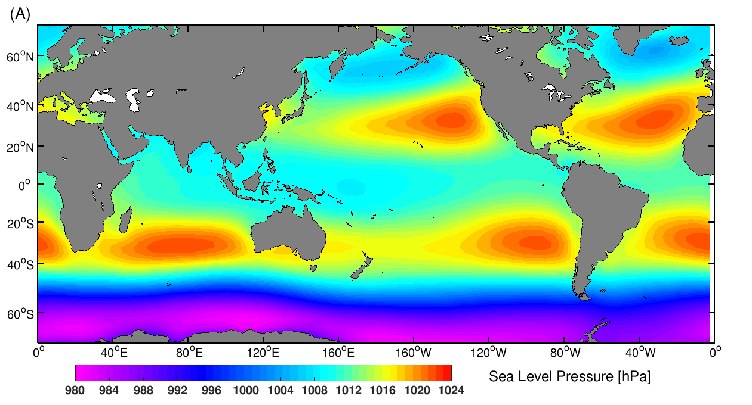

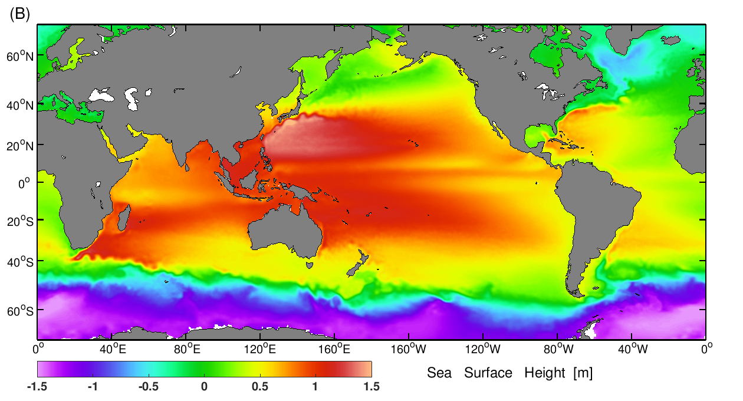 Figure. S3. Observed spatial distribution of the climatological A. sea level pressure (SLP) and B. sea surface height (SSH). The results are based on the NCEP-DOP atmospheric reanalysis and AVISO satellite derived SSH.

References:

Kanamitsu, M., Ebisuzaki, W., Woollen, J., Yang, S.‐K., Hnilo, J., Fiorino, M., & Potter, G. (2002). NCEP‐DOE AMIP‐II Reanalysis (R‐2). Bulletin of the American Meteorological Society, 83(11), 1631– 1643.

Carton, J.A.; Giese, B.S. A reanalysis of ocean climate using Simple Ocean Data Assimilation (SODA). Mon. Weather Rev. 2008, 136, 2999–3017.

The altimeter products were produced by Ssalto/Duacs and distributed by Aviso, with support from Cnes (http://www.aviso.altimetry.fr/duacs/).

