Supplementary materials of Nakano et al.

Table S1. Events around Tonga obtained from the USGS earthquake catalog
Origin (UTC) | Latitude (°S) | Longitude (°W) | Depth (km) | Mw
2023-02-10 17:06:22 | 22.3 | 174.4 | 10 | 5.3
2023-02-13 01:21:39 | 22.2 | 175.4 | 59.8 | 4.7

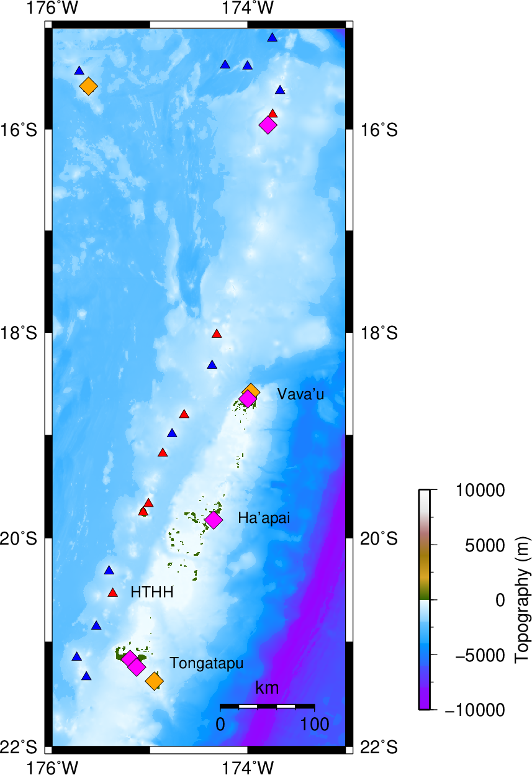

Fig. S1. Regional map showing the seismic stations and volcanoes around Tonga. Diamonds show the permanent seismic stations installed after the HTHH eruption. The pink diamonds are the stations used in this study. The red and blue triangles mark land and ocean-bottom volcanoes, respectively (Global Volcanism Program, 2023)

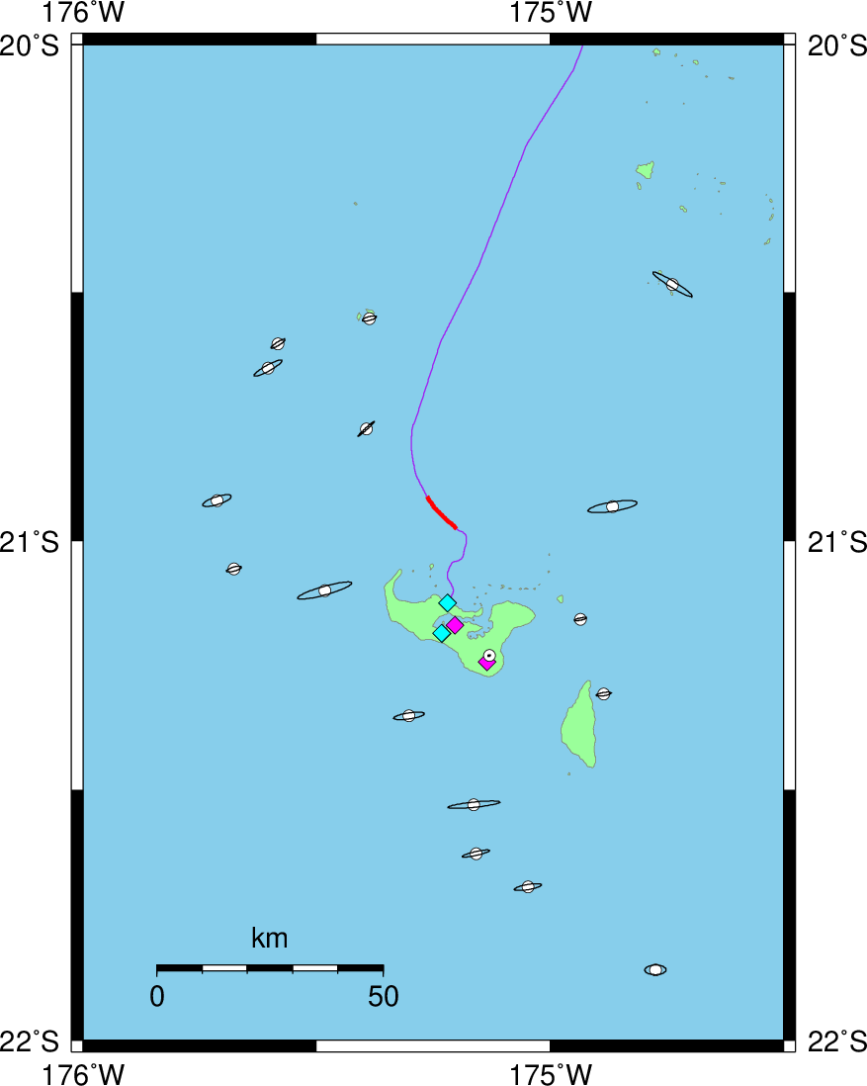

Fig. S2. Map showing errors of hypocenter determinations. Error ellipsoids are plotted at each epicenter (white circles). Purple and red lines and diamonds are the same as in Fig. 1

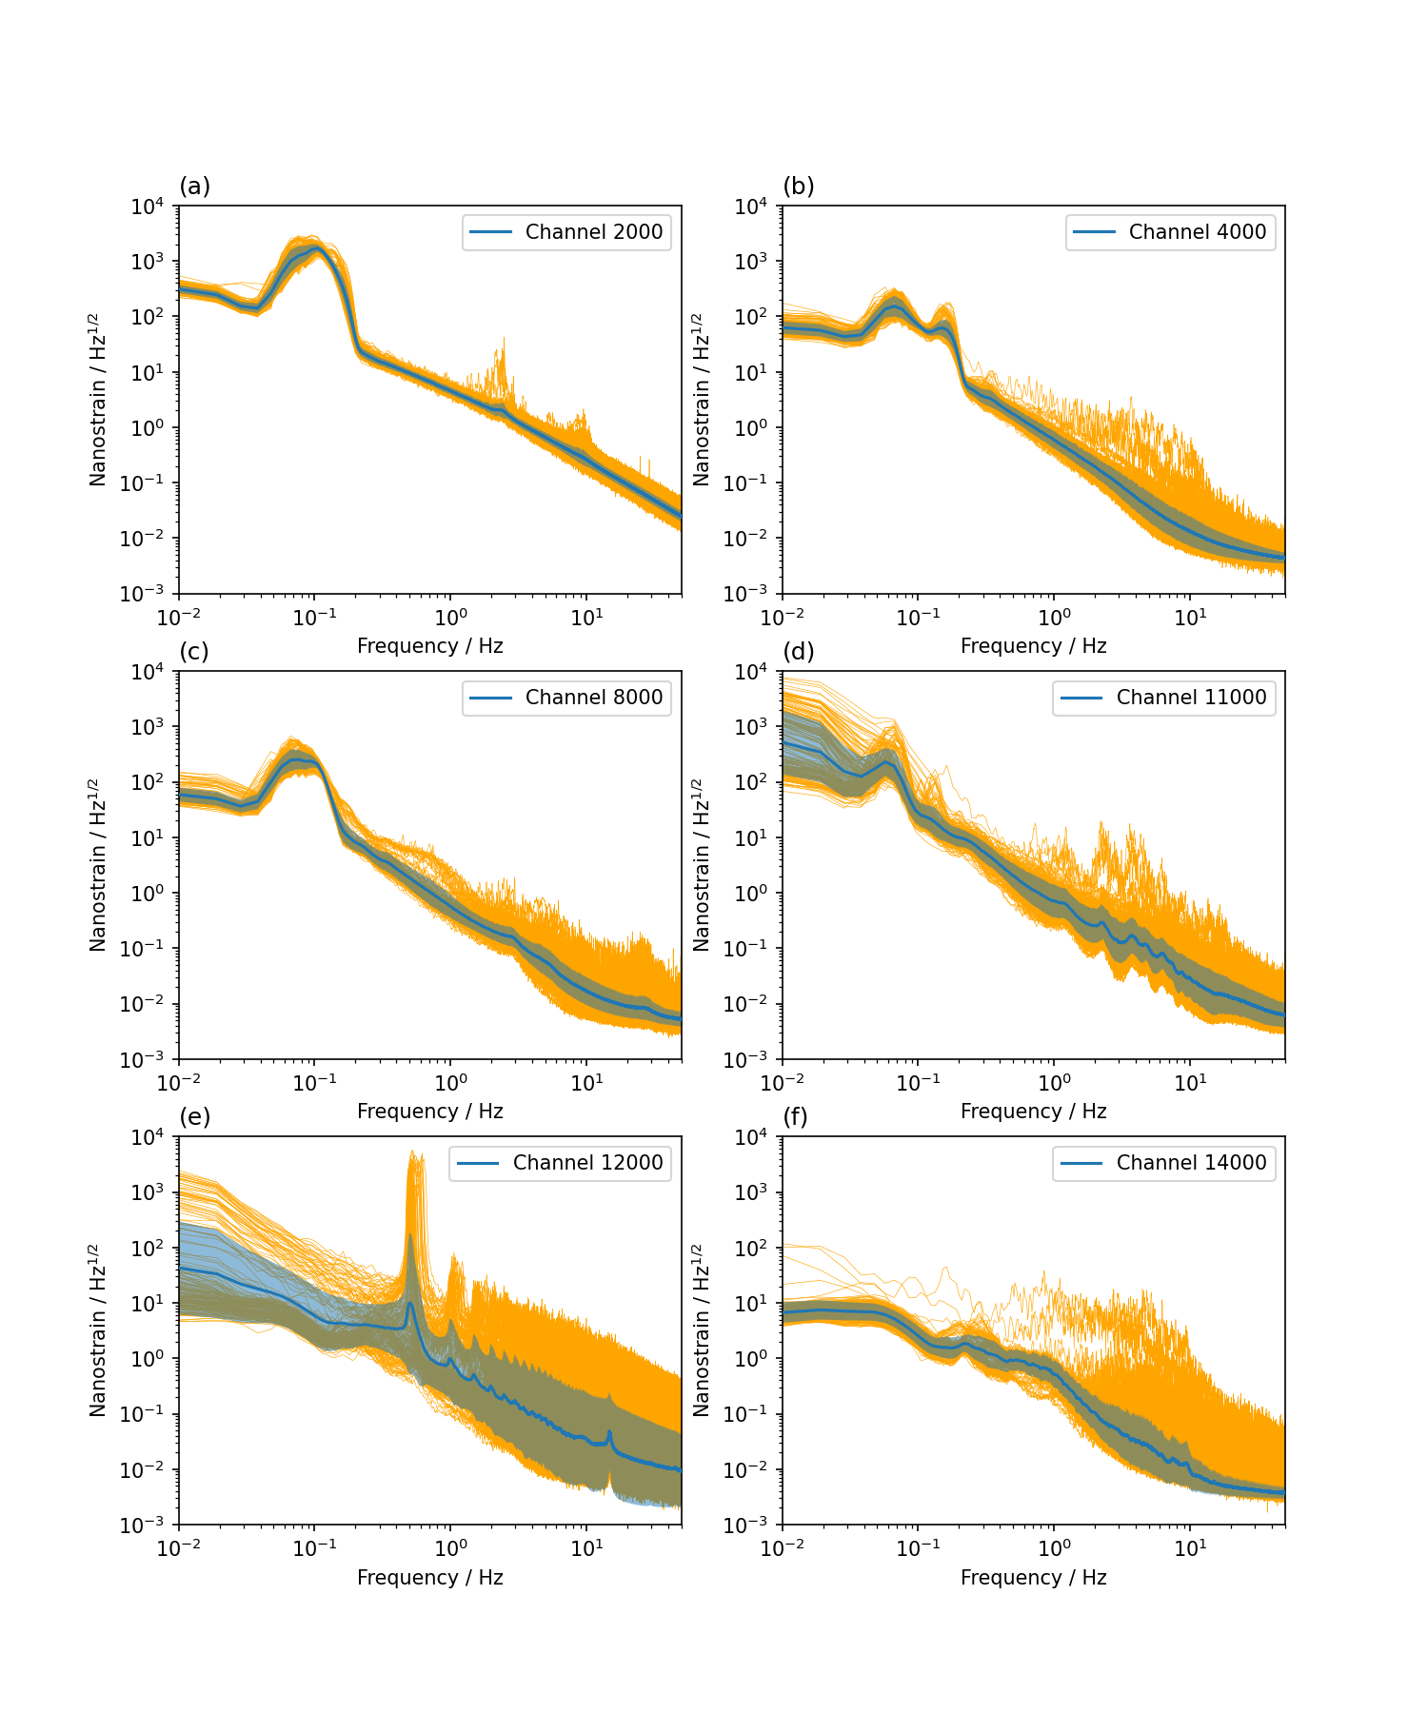

Fig. S3. PSDs of DAS strain records at selected channels. The blue lines and shaded areas indicate the average and standard deviation during the observation period, respectively. Orange lines are hourly computed PSDs

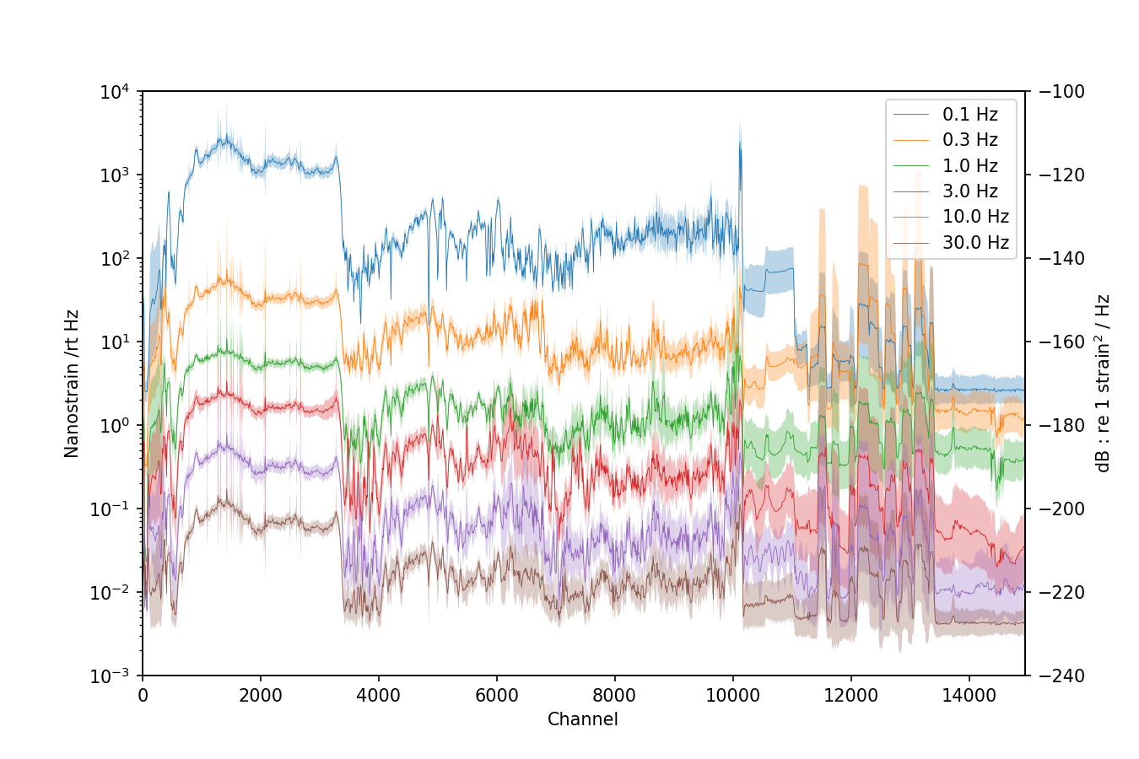

Fig. S4. PSDs of DAS strain records for selected frequencies plotted against channel number. Lines and shaded areas indicate averages and standard deviations during the observation period, respectively
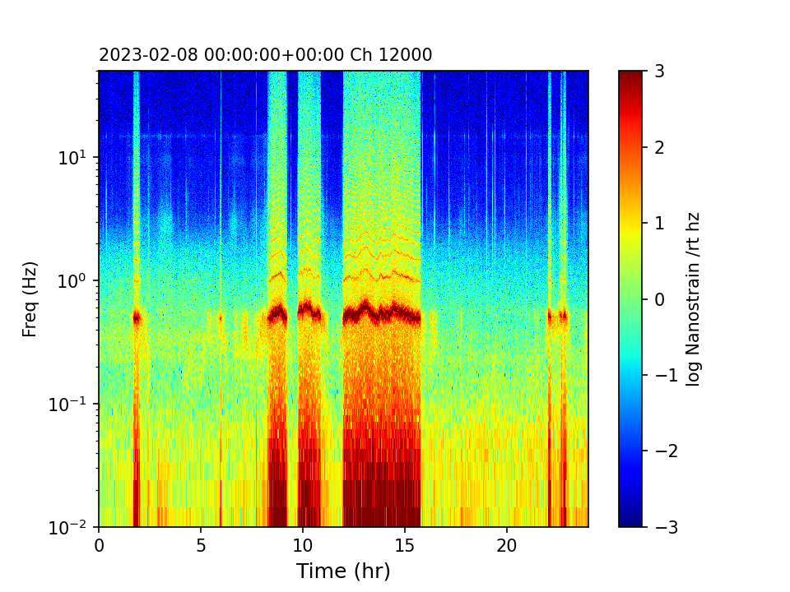

Fig. S5. Running spectrum for 1 day of recording at channel 12,000

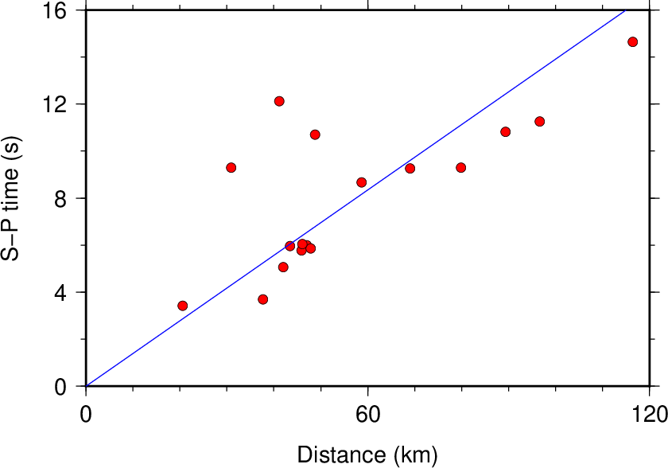

Fig. S6. S − P time versus event distance. The blue line is calculated assuming Vp = 5.2 km/s and Vp/Vs = 1.73 according to the Omori formula

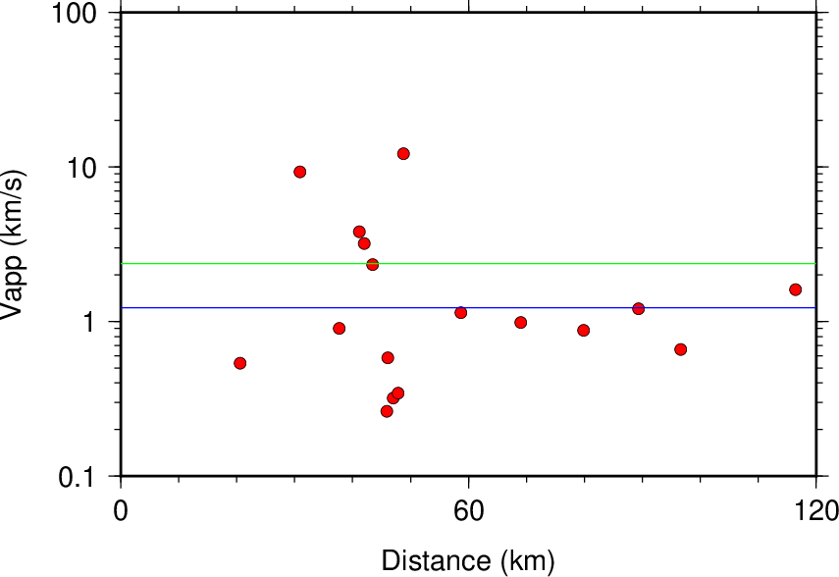

Fig. S7. Vapp estimated from the maximum strain and velocity expected at the cable end. See Discussion for details. The green and blue lines are averages at linear and logarithmic scales, respectively

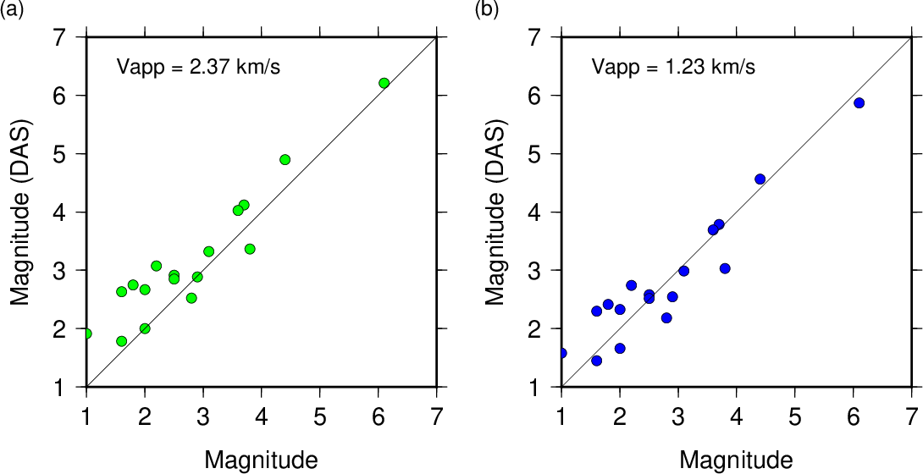

Fig. S8. Comparisons of magnitudes from hypocenter determinations (x-axis) and those estimated using empirical parameters from DAS records (y-axis). (a) and (b) assume apparent velocities of 2.37 and 1.23 km/s, respectively, for conversion of DAS strain to velocity

