Supplementary Information Figure S1-S6

Fig. S1: Model Initialization and Lithospheric Rheological Structure
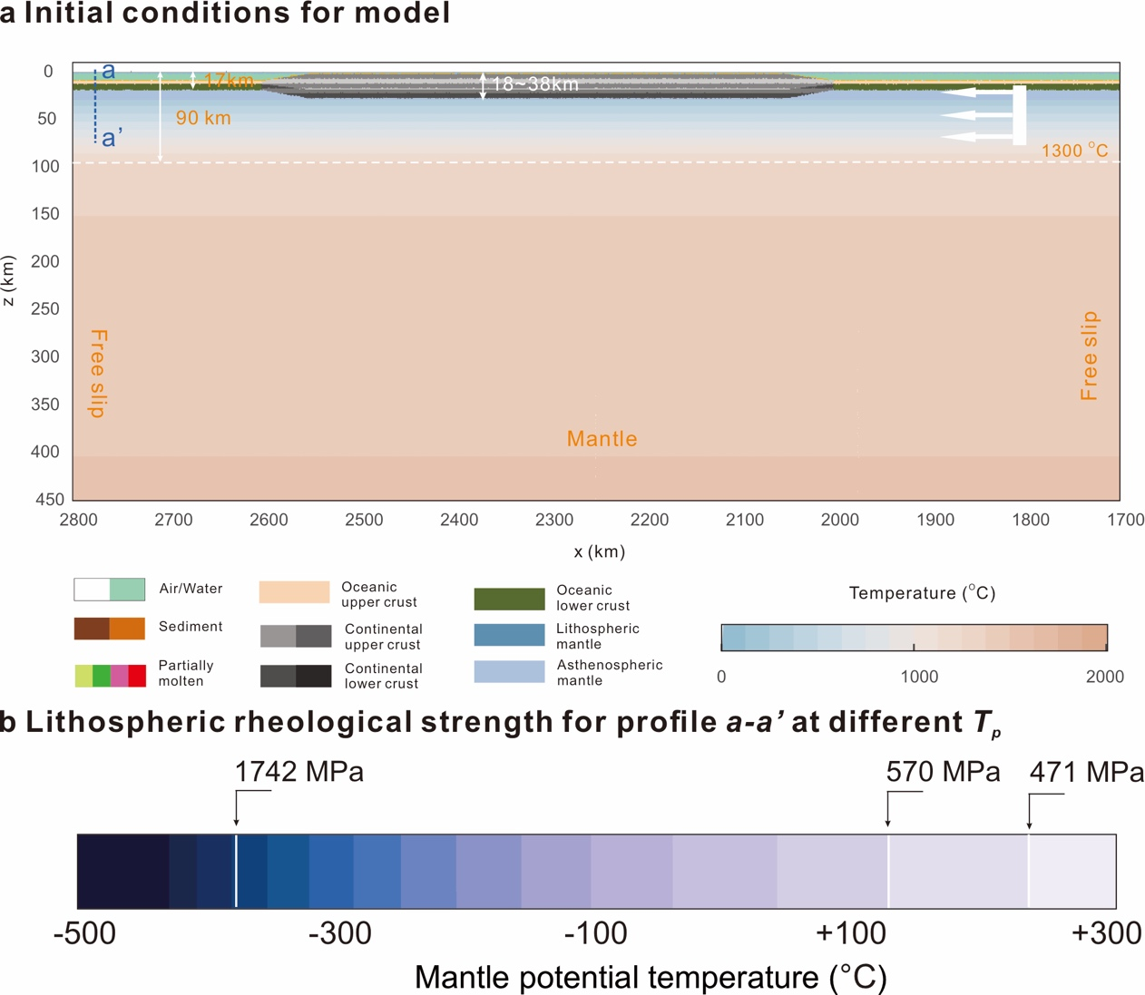
a, Model's initial configuration is depicted, with the compositional field of the Model indicated above the 50 km, while the temperature field is represented below. The 1300°C isotherm is delineated by the white contour line. A comprehensive palette for distinct materials is illustrated at the lower left corner, while the temperature spectrum is depicted via the color bar at the lower right. The directional velocity is symbolized by the white arrow. b, The Lithospheric Rheological Strength is analysed along the profile a-a', revealing variations at different T_{p} values.

Fig. S2: Long-term Evolution of the Different Models and Their Initial Rheological Structures.
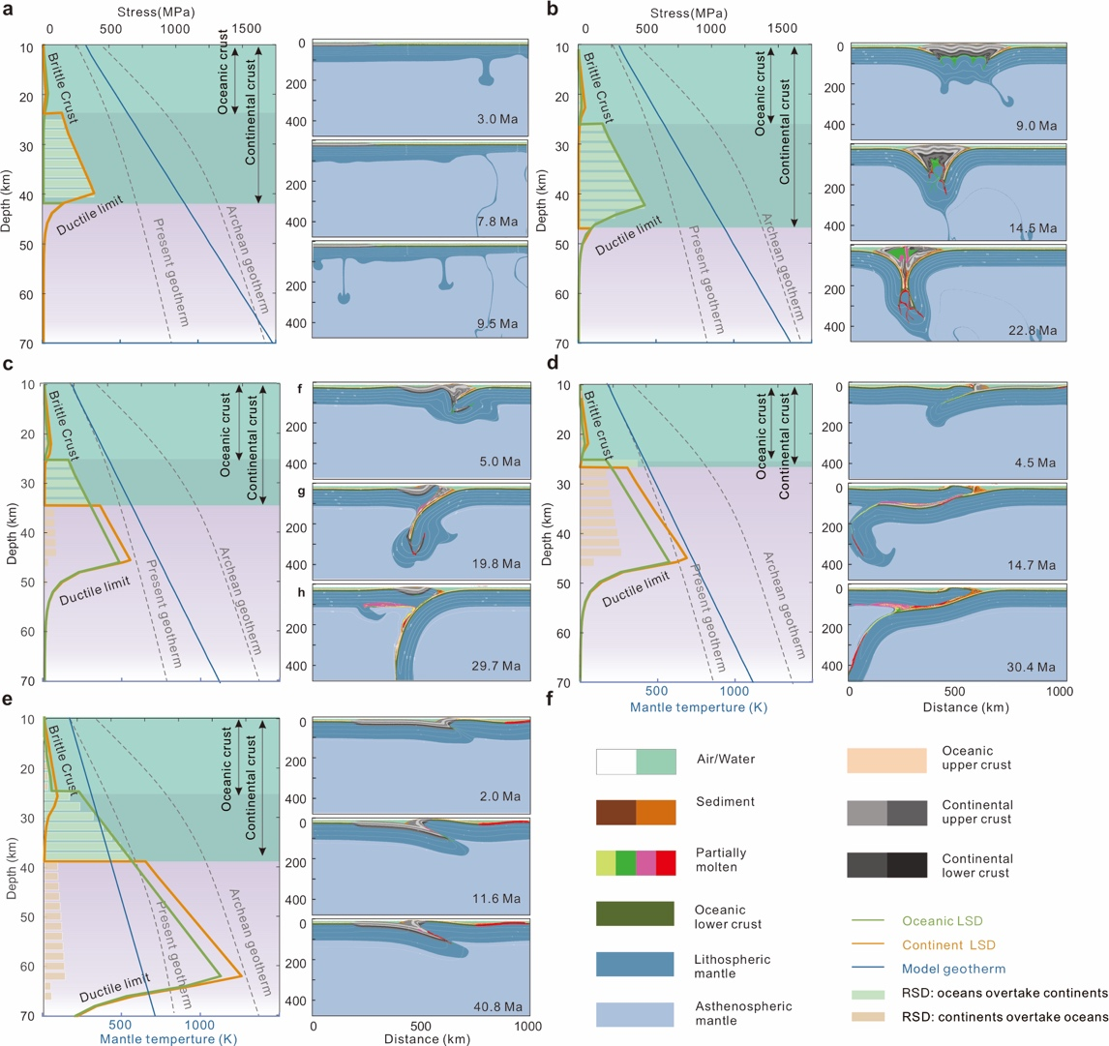
a, Model 1: the drip-delamination model. b, Model 2: double-subduction model. c, Model 3: steep-subduction model. d, Model 4: flat-subduction model. e, Model 5: transition-model model. (a-e) (a-e) On the left-hand side, the foundational rheological structure of each model is depicted. The 1D rheological composition of the continental (orange lines) and oceanic (green lines) domains is presented. The 1D lithospheric strength is computed by taking the minimum value between the linear Mohr–Coulomb yielding stress and the power-law dislocation creep stress under a constant strain rate (1.6 × 10⁻¹⁵ s⁻¹). Related parameters are listed in Table S2. Divergences in the ocean-continent rheological strengths are indicated by the bars, where green signifies positive values (the oceanic lithospheric strength surpassing the continental one at identical depths), and orange signifies negative values (the continents with a comparatively weaker rheology). The temperature gradient of the model is expressed through the blue line. f, The colour key for different materials.

Fig. S3: The Model Evolution as a Function of Continental Crustal Thickness and ΔTp.
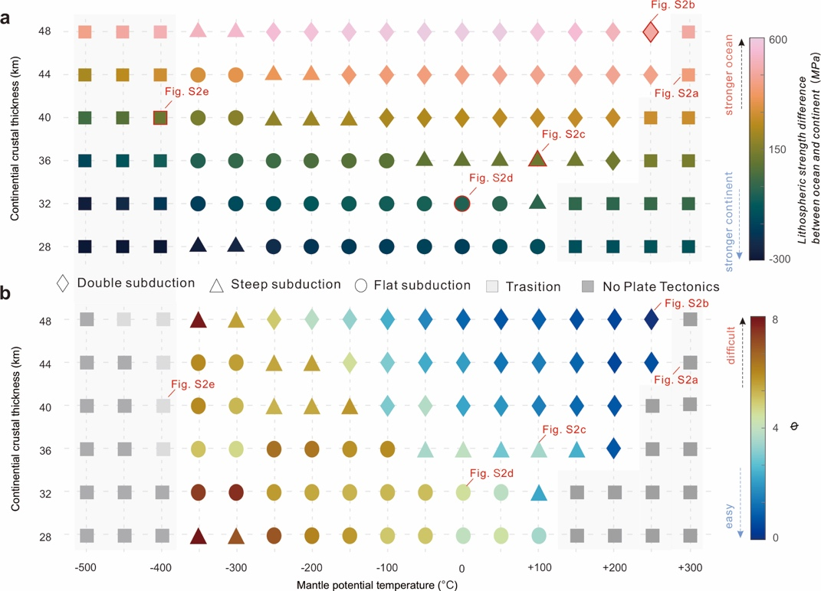
a, Depiction of the disparity in Lithospheric Rheological Strength, as represented by strength contrast between oceanic and continent lithosphere between continents and oceans. b, Exploration of the parameter ϕ, denoting a crucial factor in the Earth's geological processes. The diversity of evolutionary paradigms is symbolized by distinct white silhouettes, embodying various models: drip-delamination (fork sign), double-subduction (diamond), steep-subduction (triangle), flat-subduction (circle), transition-model (rectangle), and death-model (rectangle).

Fig. S4: Model Input Parameters and Extrapolation.
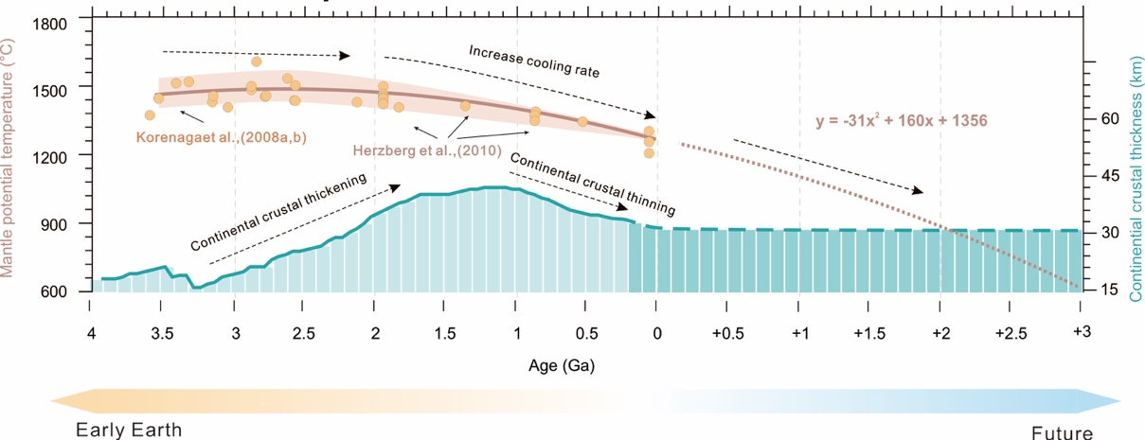
a, the continental crustal thickness and mantle potential temperature (T_{p}) employed for constructing the model, as illustrated in Figure S4, are derived. The temporal framework utilized for this analysis is referenced from Dhuime et al. (2015) and Herzberg et al. (2010). These sources contribute pivotal data points for the present context. In the context of future predictions, the forthcoming continental crustal thickness is vividly indicated by the blue bar, held consistently at a value of 30 km. The projection of future mantle potential temperature (T_{p}) is represented by the brown dashed line. This forecasted T_{p} value is ascertained through calculations based on quadratic linear fitting techniques. b, the reciprocal interplay between the Earth's cooling processes and the concomitant amplification of the continental thickness drives the temporal variation in the lithospheric rheological strength. In this context, the strong yield strength envelope (YSE) values of the oceanic (yellow) and continental (grey) compositions are different, representing the culmination of the lithospheric strengths.

Fig. S5: Subduction Forces and Morphodynamical Evolution.
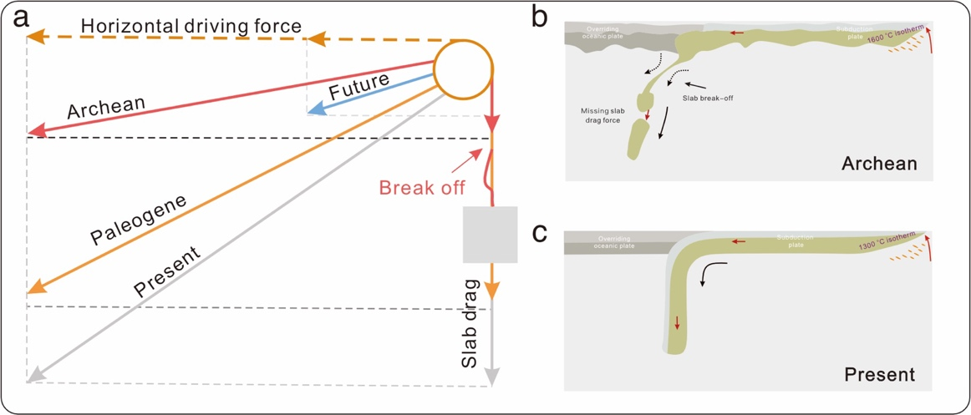
a, the examination of subduction forces across diverse temporal epochs is undertaken. The distinct colored lines signify the stress states along subduction zones corresponding to different geological periods: Archean (red), Paleogene (orange), present (grey), and future (blue). b, A visual elucidation of extensive-scale crustal fold deformation during the Archean period is presented, modified from Burov (2011). Subduction plate sheet drag forces fail easily, making it difficult to form continuous subduction. c, an insightful portrayal of the contemporary subduction scenario is showcased.

