COSMIC-based mutation database enhances identification efficiency of HLA-I immunopeptidome

Supplementary Materials

Supplementary Figures 1
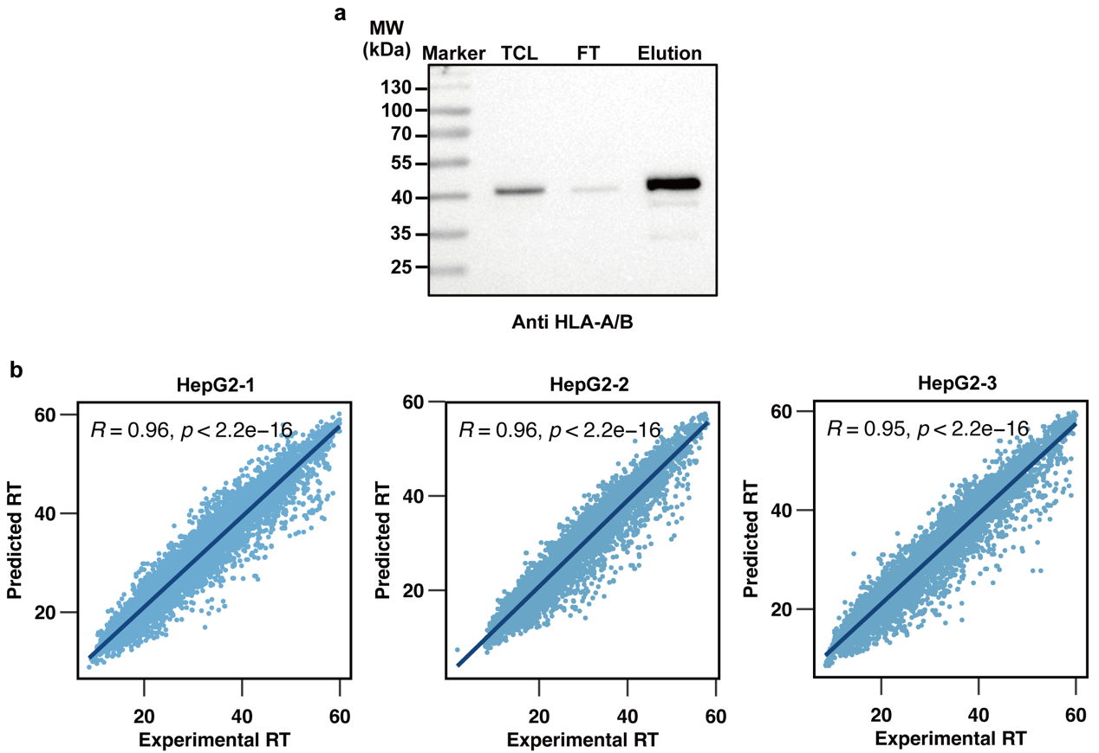
Supplementary figure. 1
A. Whole picture of HLA-A/B western blot.
B. Scatter plot experimental RT and predicted RT for PSM from 3 biological replicates of HepG2 cell line.

Supplementary Figures 2
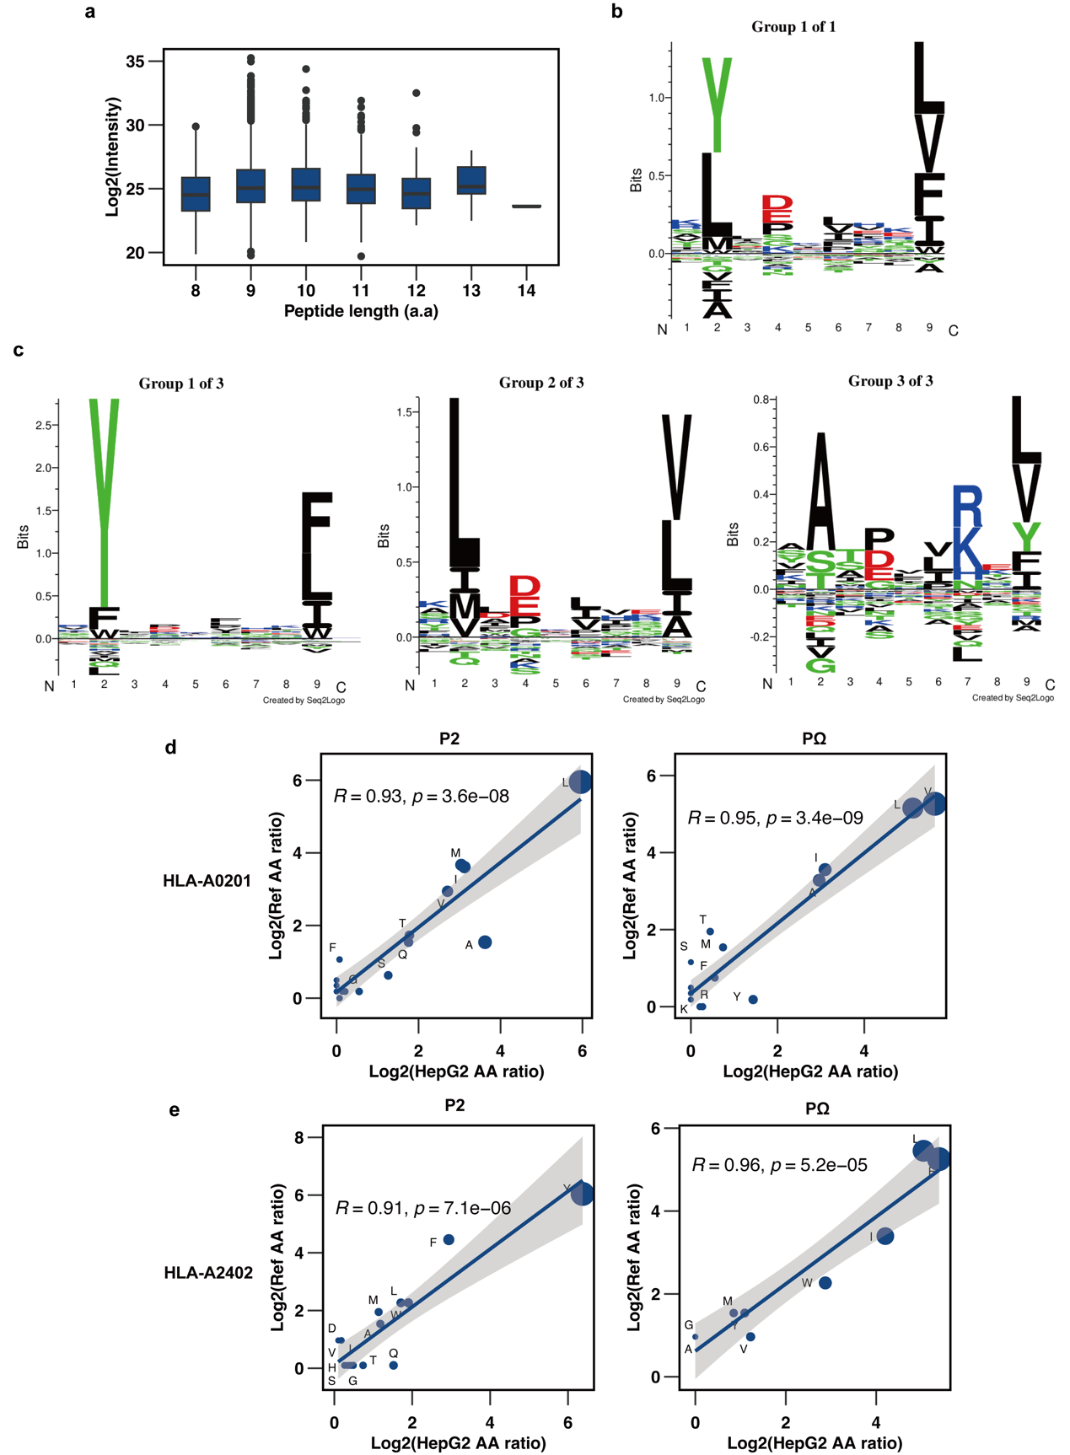
Supplementary figure. 2
A. Log₂ intensity for binding peptides predicted by NetMHCpan, ranked by peptide length.
B. HLA-I immunopeptides main binding motifs by Gibbs cluster, when cluster number = 1.
C. HLA-I immunopeptides main binding motifs by Gibbs cluster, when cluster number = 3.
D. Scatter plot shows the proportion of P2 and P3 amino acids in the Gibbs clustered peptides and NetMHCpan HLA-A0201 data set.
E. Scatter plot shows the proportion of P2 and P3 amino acids in the Gibbs clustered peptides and NetMHCpan HLA-A2402 data set.

Supplementary Figures 3
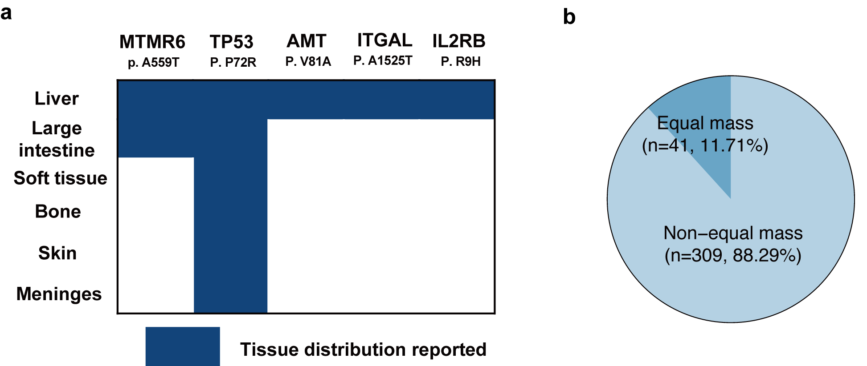

Supplementary figure. 3
A. Tumor tissue distribution of COSMIC-reported somatic mutations in the identified mutant peptides using COSMIC-based database.
B. The proportion of equal weight peptides to unique peptides HepG2 WES-based or COSMIC-based database.

Supplementary Figures 4
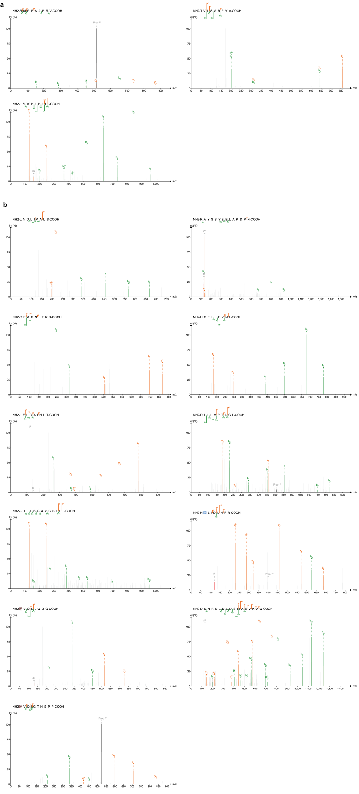
Supplementary figure. 4
A. MS2 spectrum of identified binder mutant peptides using COSMIC-based database.
B. MS2 spectrum of identified non-binder mutant peptides using COSMIC-based database.

Supplement table 1. HLA-I peptidome identification from UniProt Human database
Sample | MS₂ | PSM | Peptide | Protein | 8-14 a.a  Peptide | PSM/MS₂ | PSM/  Peptide | Peptide  /Protein
HepG2-1 | 51917 | 6497 | 5401 | 2996 | 4537 | 12.5% | 1.20 | 1.80
HepG2-2 | 53101 | 5636 | 5004 | 2474 | 3900 | 10.5% | 1.13 | 2.02
HepG2-3 | 53079 | 5518 | 4618 | 2193 | 3530 | 10.4% | 1.19 | 2.52

