Supplementary Figures and Tables

Figure S1: PCA plot showing PC1 vs PC2 of all metabolites that pass QC.

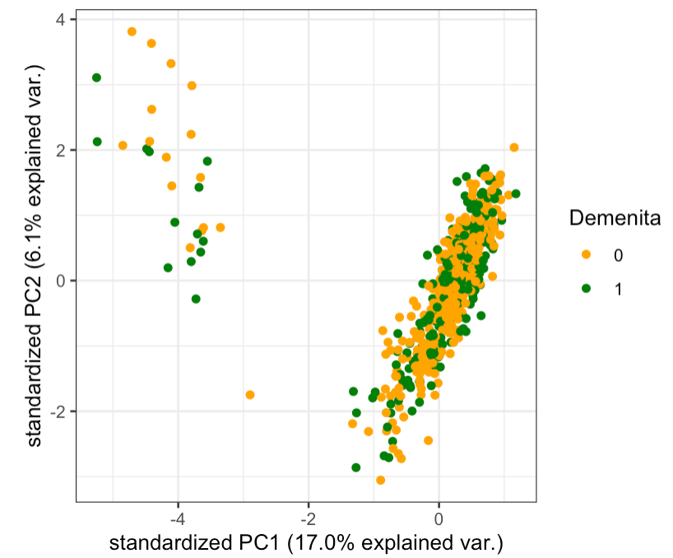
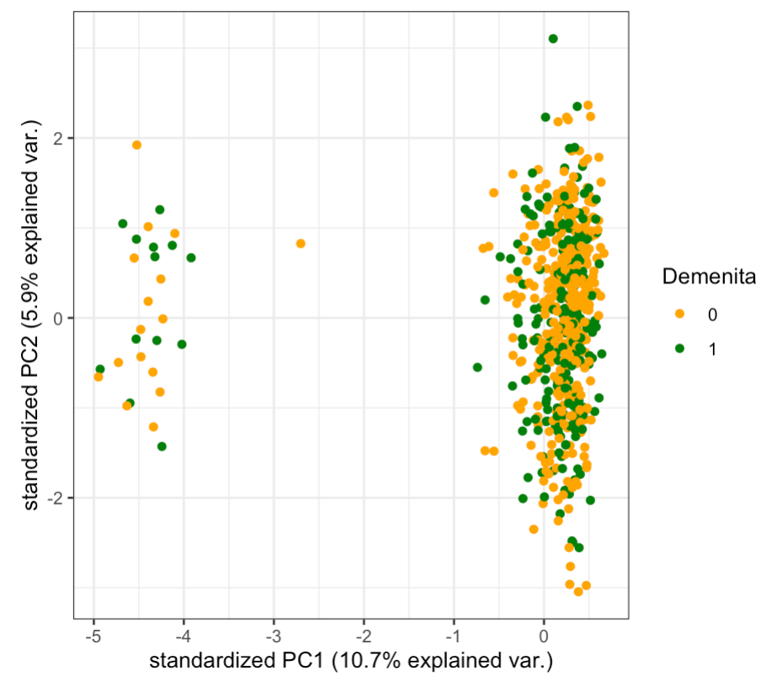
HILIC +
C18 -
29 individuals identified as outliers were removed from the analysis.

Figure S2: Modules of metabolites detected by WGCNA
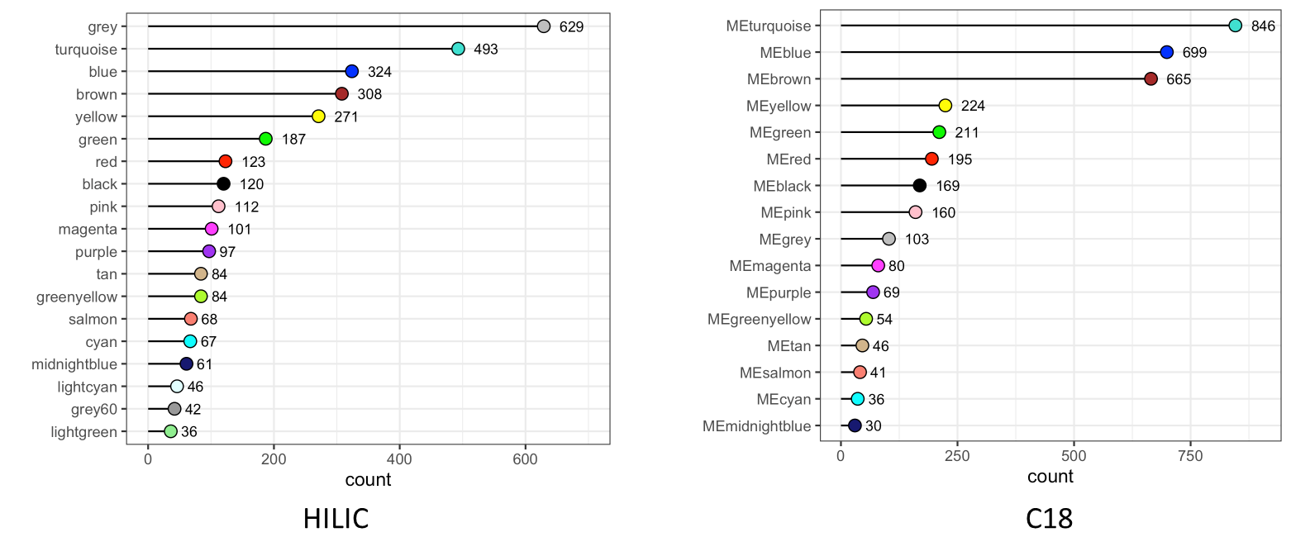
Grey module contains metabolites not clustered with any other metabolites.

Figure S3. Scree plot of LysoPC components
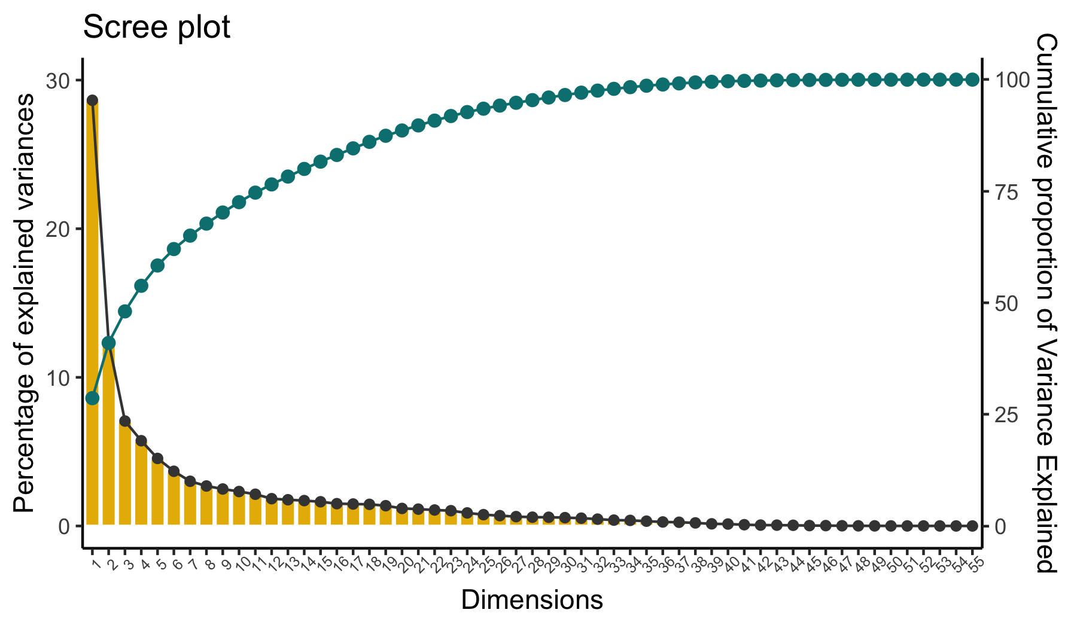

Figure S4. Results from co-expression analysis using data from the C18 column. In A, the volcano plot shows metabolic modules significantly associated with clinical AD, biomarker positive status and AD biomarkers using Bonferroni adjusted p-value. In B, the chemical classes enriched by module member metabolic features present at a proportion of at least 6.5%. In C, module hub members of the cyan module with KME > 0.6 and associated with biomarker positive status at FDR q-value < 0.1. In D, module hub members of the cyan module with KME > 0.2 and associated with clinical AD at FDR q-value < 0.05. In E, module hub members of the salmon module with KME > 0.6 and associated with clinical AD at FDR q-value < 0.05. In F, module hub members of the brown module with KME > 0.6 and associated with clinical AD at FDR q-value < 0.05. In G, module hub members of the greenyellow module with KME > 0.6 and associated with biomarker positive status at FDR q-value < 0.1.

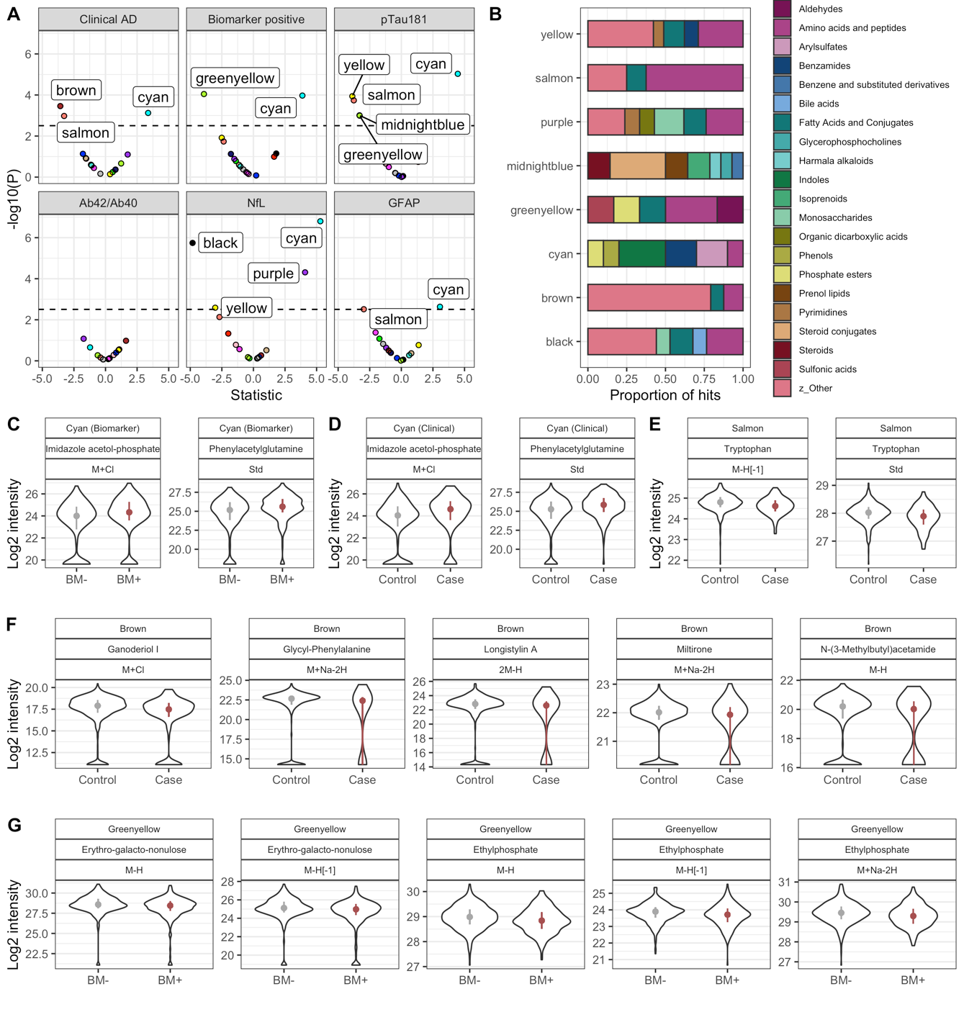
Figure S5: Correlation of lysoPCs with polyunsaturated fatty acids in plasma and CSF. In A, the correlation between plasma lysoPC profiles and plasma PUFAs. In B, the characteristics of fatty acids associated with circulating lysoPCs. In C, the correlation between plasma lysoPC profiles and CSF PUFAs. In D, the correlation between lysoPCs that carry PUFAs of interest (DHA, EPA, AHA) and the levels of these PUFAs measured in CSF.
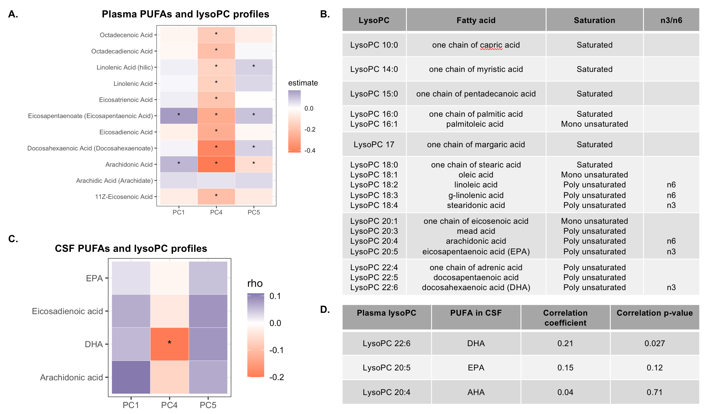

Figure S6: Brain LysoPC association in ROSMAP cohort
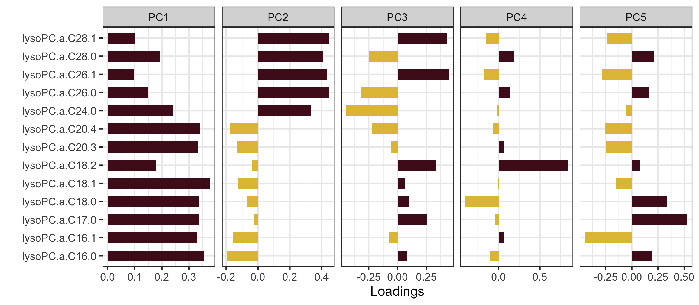
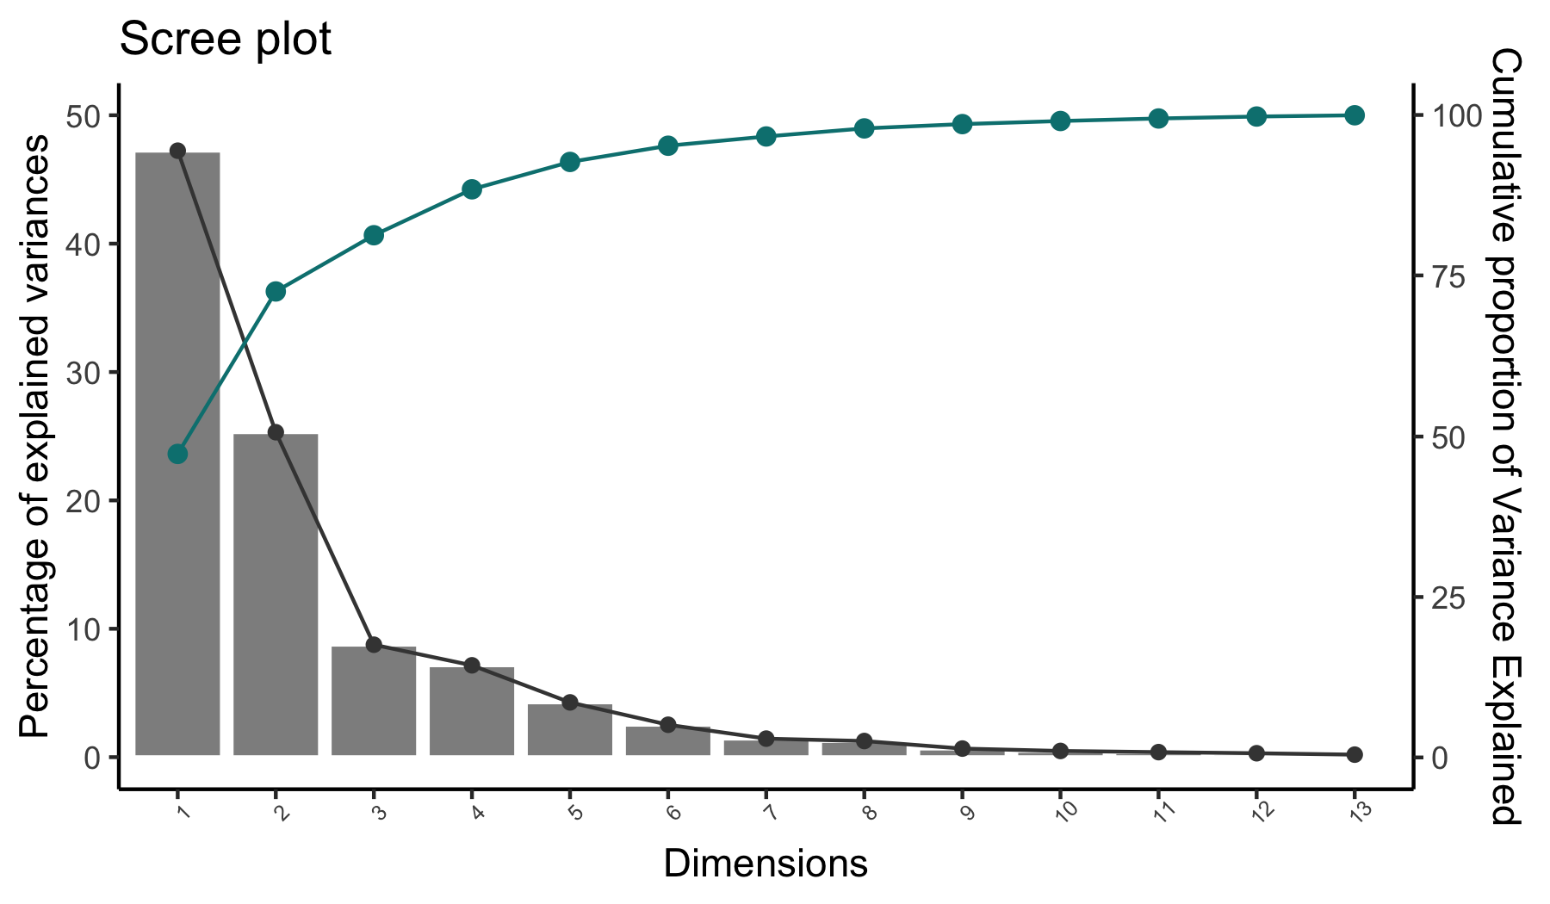
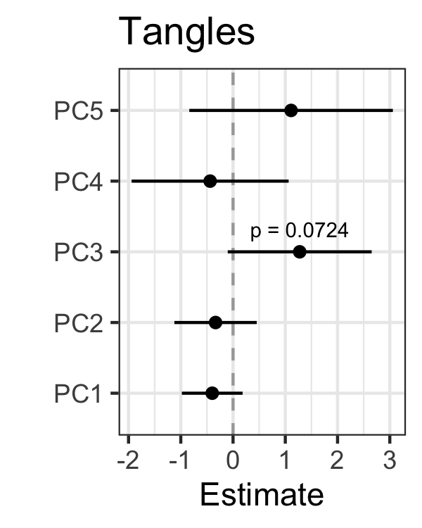
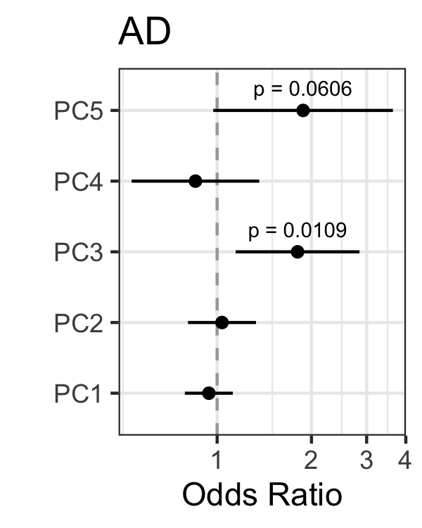
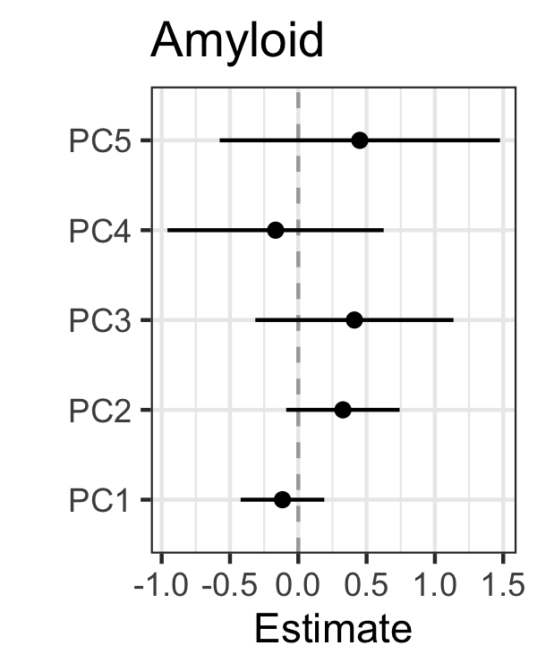
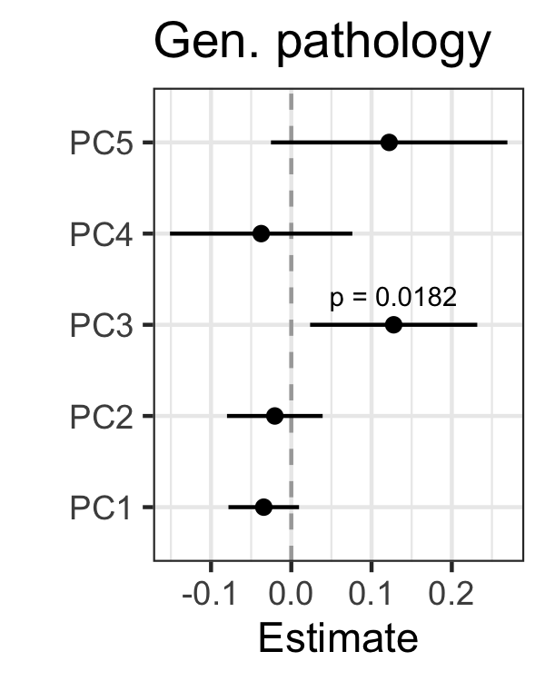
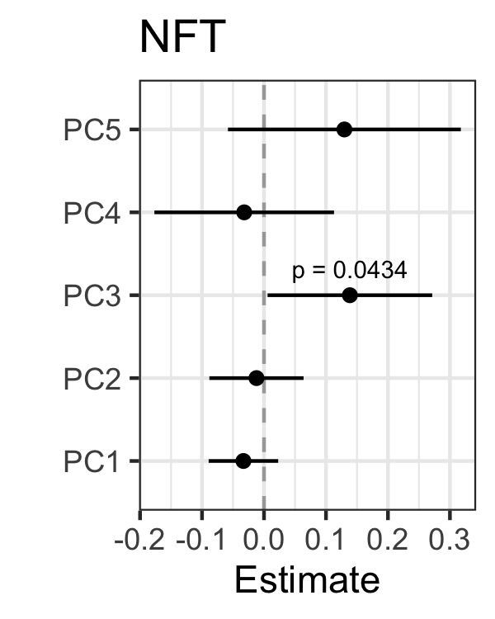
S6-A First five principal components explain over 95% of the variance
A
B
C
S6-B PC3 is nominally associated with pathological definition of AD, Tau Tangles, General pathology and Neurofibrillary tangles.
S6-C LysoPCs detected in the ROSMAP cohort, EPA and DHA carrying LysoPCs were not detected. LysoPC.a.20.4 carries AHA
Figure S7: Levels of metabolites by Biomarker and clinical AD status
Top left= Creatinine, Top right= phenylacetylglutamine, Bottom left=LysoPC (20:5-EPA), Bottom Right=LysoPC (22:6-DHA)

