Supporting Information for Polyketides from Neohelicosporium griseum: structure assignment and bioactivity investigation
Lijuan Zhang ^{1,2,3} · Jian Ma ^{1,2,3} · Mingfei Yang ⁴ · Tianming Zhao ³ · Mei Yan Han ³ · Dege Zheng ³ ·· Ausana Mapook ² · Yongzhong Lu ^{3*} · Ruvishika S. Jayawardena ^{1,2,5*}

¹ School of Science, Mae Fah Luang University, Chiang Rai 57100, Thailand.
² Center of Excellence in Fungal Research, Mae Fah Luang University, Chiang Rai 57100, Thailand.
³ School of Food and Pharmaceutical Engineering, Guizhou Institute of Technology, Guiyang 550003, China.
⁴ Department of Health Management, Guiyang Healthcare Vocational University, Guiyang 550081, China.
⁵ Kyung Hee University, 26 Kyungheedae-ro, Dongdaemun-gu, Seoul 02447, South Korea.
* Correspondence: yzlu@git.edu.cn (Y.-Z.L.); Tel.: +86-085188210723 (Y.-Z.L.); ruvishika.jay@mfu.ac.th (R.-S.J.); Tel.: +6653916962 ((R.-S.J.)

List of Figures.
Figure S1. ¹H NMR spectrum of compound 1 (400 MHz, DMSO) ...........................................................1
Figure S2. ¹³C NMR spectrum of compound 1 (100 MHz, DMSO) ..........................................................1
Figure S3. HSQC spectrum of compound 1 (100 MHz, DMSO) ...............................................................2
Figure S4. HMBC spectrum of compound 1 (100 MHz, DMSO) ..............................................................2
Figure S5. ESIMS of compound 1 .............................................................................................................3
Figure S6. HR-ESIMS of compound 1 (ESI+) ..........................................................................................4
Figure S7. HR-ESIMS of compound 1 (ESI-) ...........................................................................................5
Figure S8. ¹H NMR spectrum of compound 2 (400 MHz, DMSO) ...........................................................6
Figure S9. ¹³C NMR spectrum of compound 2 (100 MHz, DMSO) ..........................................................6
Figure S10. ESIMS of compound 2 ...........................................................................................................7
Figure S11. HR-ESIMS of compound 2 (ESI+) ........................................................................................8
Figure S12. HR-ESIMS of compound 2 (ESI-) .........................................................................................9
Figure S13. ¹H NMR spectrum of compound 3 (400 MHz, DMSO) .......................................................10
Figure S14. ¹³C NMR spectrum of compound 3 (100 MHz, DMSO) ......................................................10
Figure S15. ESIMS of compound 3 .........................................................................................................11
Figure S16. HR-ESIMS of compound 3 (ESI-) .......................................................................................12
Figure S17. ¹H NMR spectrum of compound 4 (600 MHz, DMSO) ......................................................13
Figure S18. ¹³C NMR spectrum of compound 4 (150 MHz, DMSO) ......................................................13
Figure S19. ESIMS of compound 4 .........................................................................................................14
Figure S20. HR-ESIMS of compound 4 (ESI-) .......................................................................................15
Figure S21. ¹H NMR spectrum of compound 5 (400 MHz, DMSO) .......................................................16
Figure S22. ¹³C NMR spectrum of compound 5 (100 MHz, DMSO) ......................................................16
Figure S23. ESIMS of compound 5 .........................................................................................................17
Figure S24. HR-ESIMS of compound 5 (ESI+) ......................................................................................18
Figure S25. HR-ESIMS of compound 5 (ESI-) ......................................................................................19
Figure S26. ¹H NMR spectrum of compound 6 (400 MHz, DMSO) .......................................................20
Figure S27. ¹³C NMR spectrum of compound 6 (100 MHz, DMSO) ......................................................20
Figure S28. ESIMS of compound 6 .........................................................................................................21
Figure S29. HR-ESIMS of compound 6 (ESI-) ......................................................................................22
Figure S30. ¹H NMR spectrum of compound 7 (400 MHz, DMSO) .......................................................23
Figure S31. ¹³C NMR spectrum of compound 7 (100 MHz, DMSO) .....................................................23
Figure S32. ESIMS of compound 7 .........................................................................................................24
Figure S33. HR-ESIMS of compound 7 (ESI+) ......................................................................................25
Figure S34. HR-ESIMS of compound 7 (ESI-) ......................................................................................26
Figure S35. ¹H NMR spectrum of compound 8 (600 MHz, DMSO) ......................................................27
Figure S36. ¹³C NMR spectrum of compound 8 (150 MHz, DMSO) ......................................................27

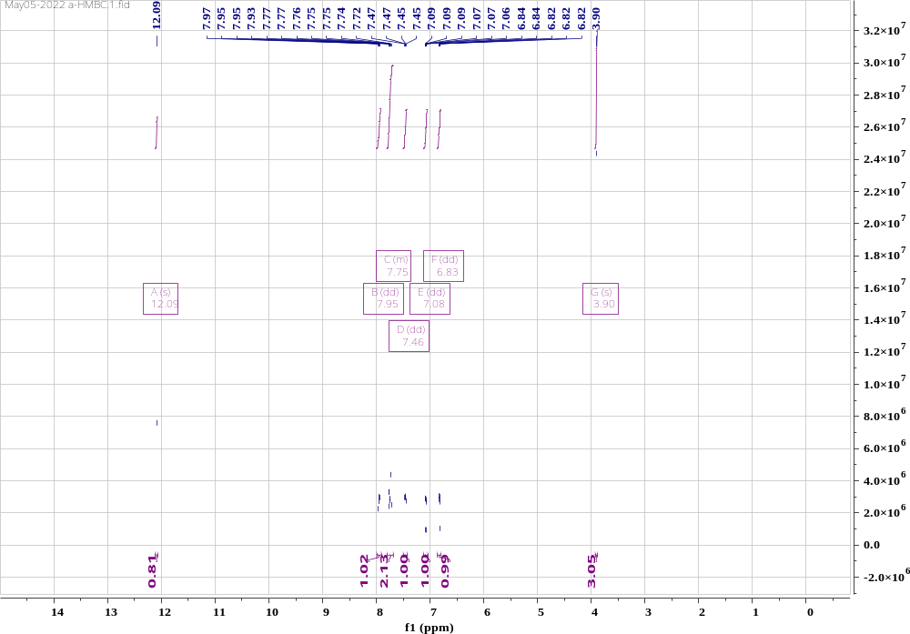
Figure S1. ¹H NMR spectrum of compound 1 (400 MHz, DMSO).
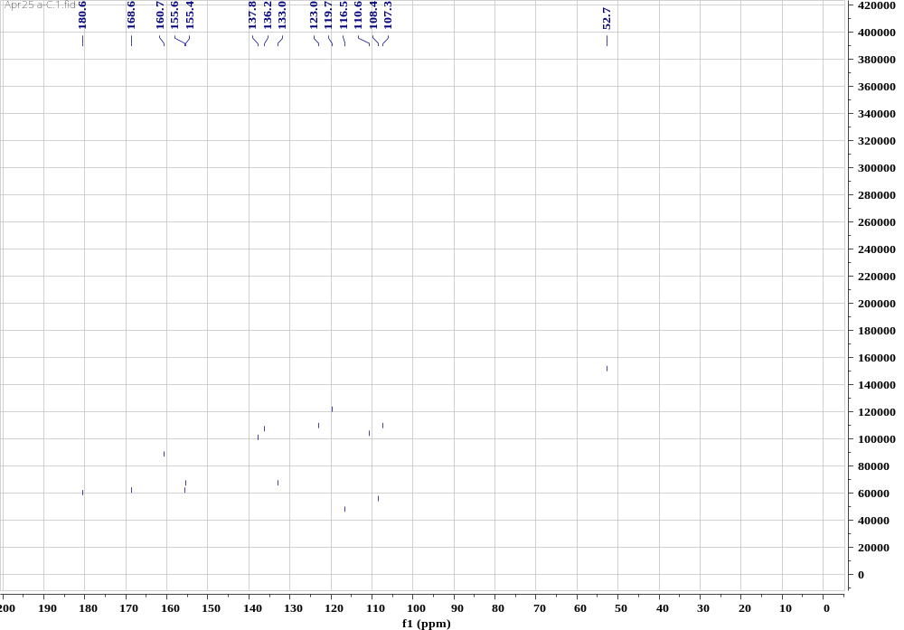
Figure S2. ¹³C NMR spectrum of compound 1 (100 MHz, DMSO).

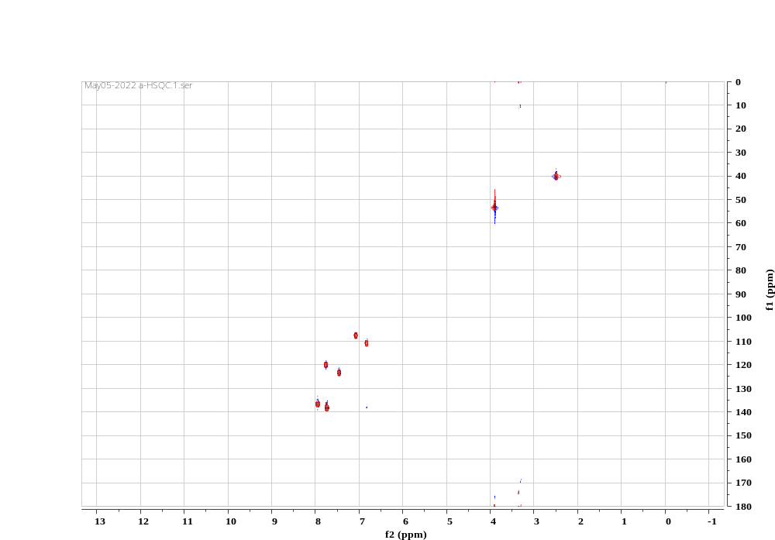
Figure S3. HSQC spectrum of compound 1 (100 MHz, DMSO)
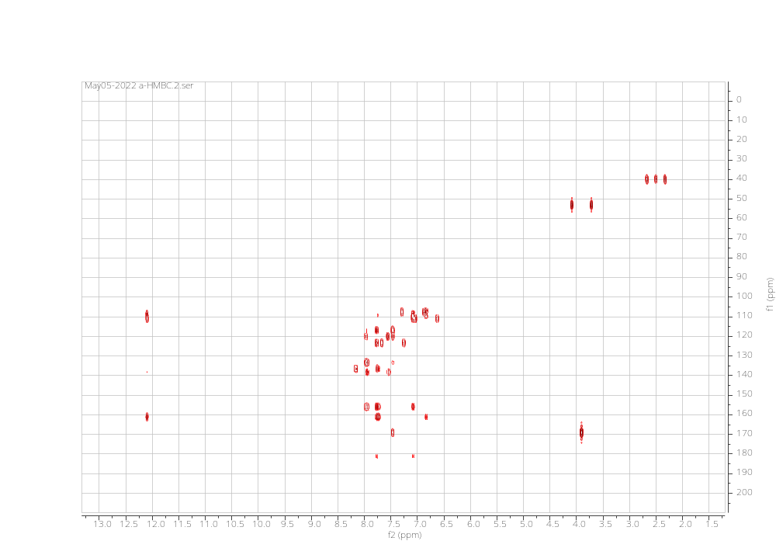
Figure S4. HMBC spectrum of compound 1 (150 MHz, DMSO)

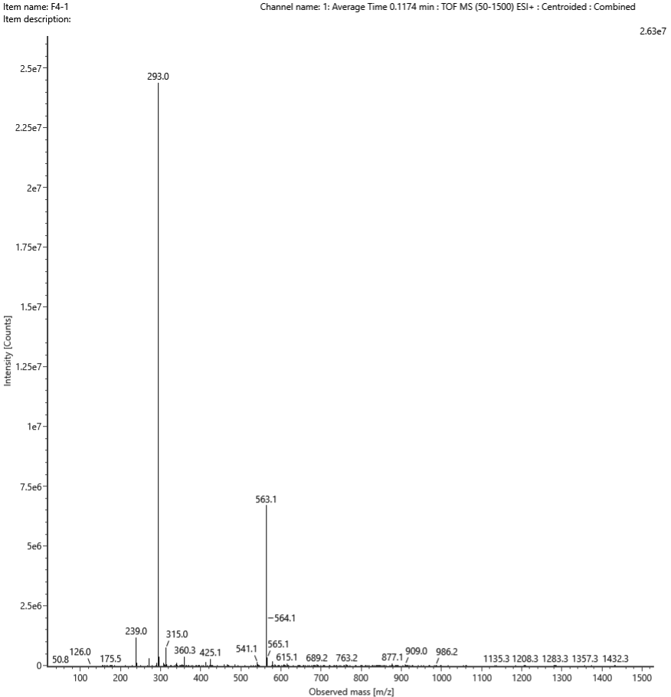
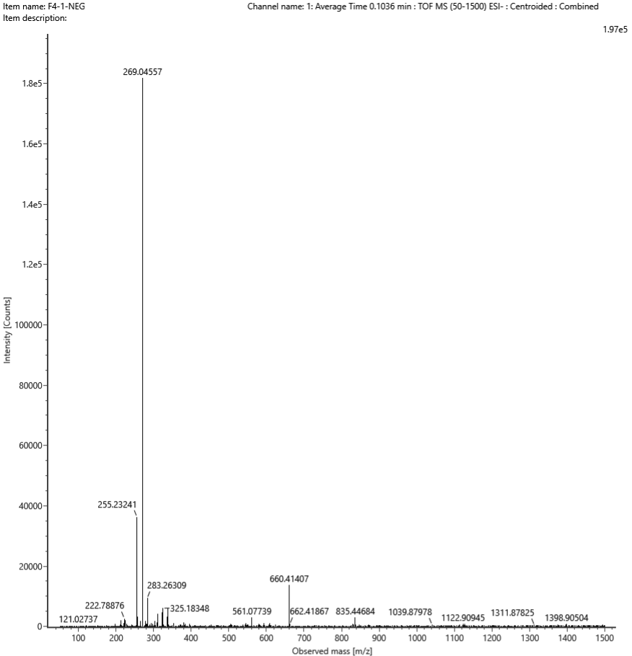
Figure S5. ESIMS of compound 1
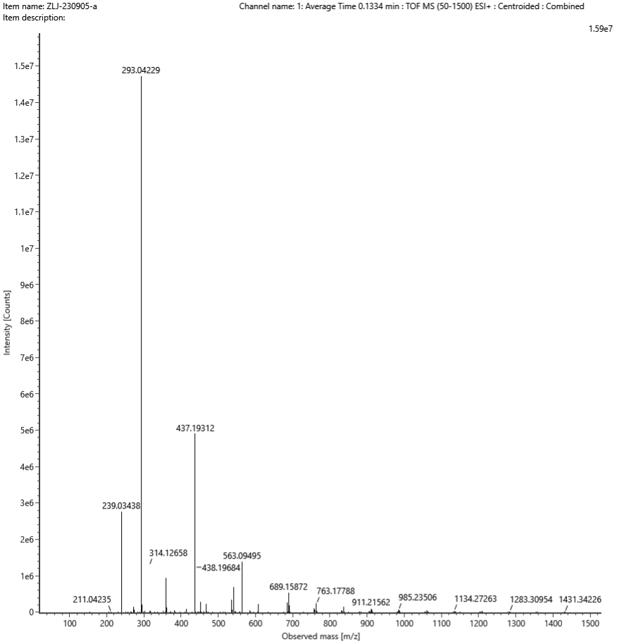
[M+Na]⁺
Composition | i-FIT Confidence (%) | Predicted m/z | m/z error (PPM)
C₁₅H₁₀O₅Na | 100.000000 | 293.042045 | 0.840616
Figure S6. HR-ESIMS of compound 1 (ESI+)

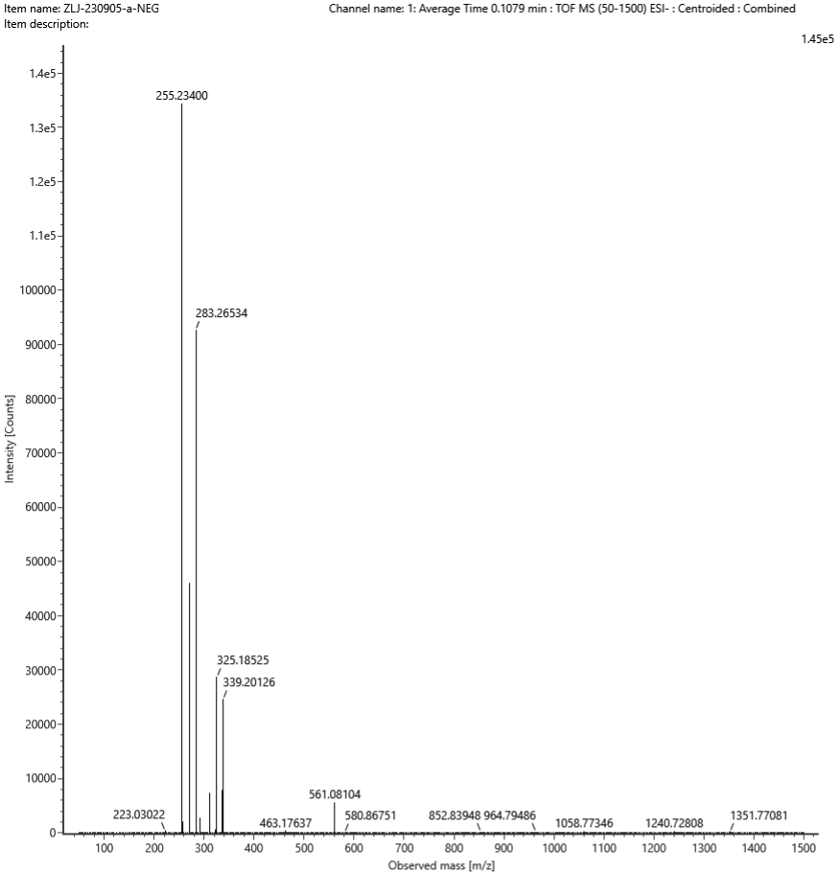
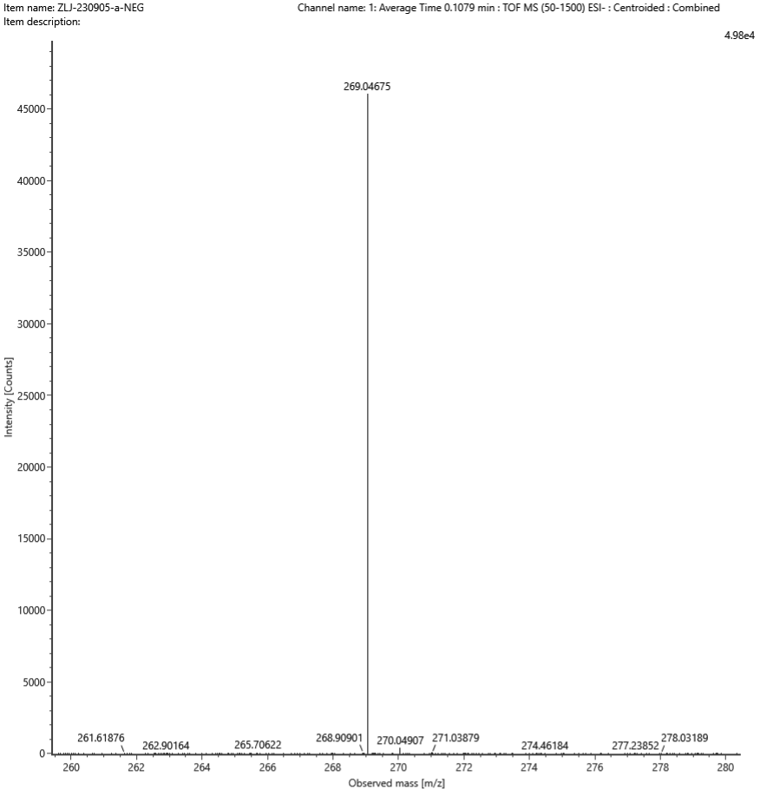
[M-H]⁻
Composition | i-FIT Confidence (%) | Predicted m/z | m/z error (PPM)
C₁₅H₉O₅ | 100.000000 | 269.045547 | 4.454744
Figure S7. HRESIMS of compound 1 (ESI-)

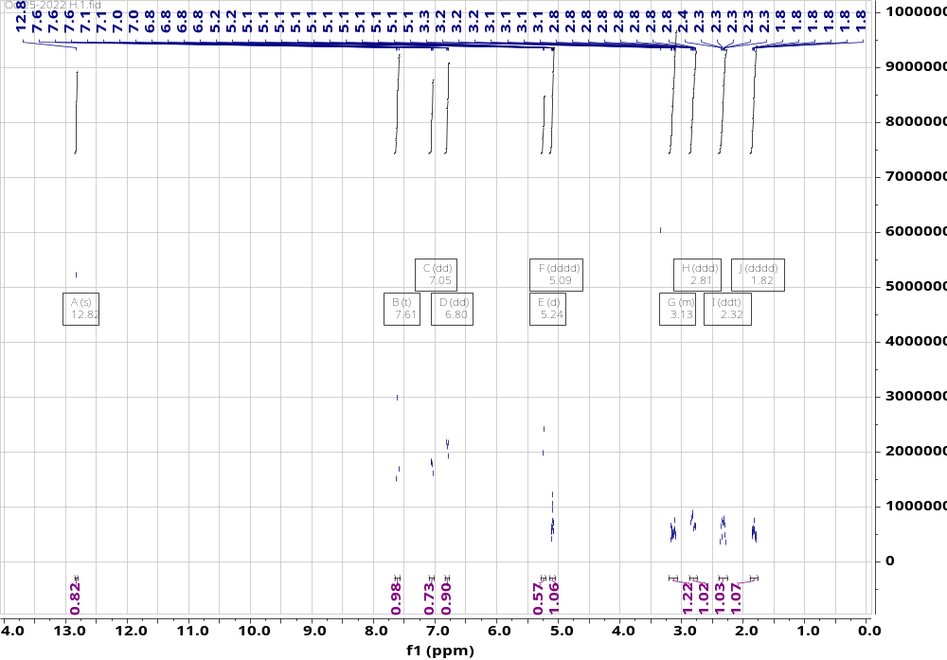
Figure S8. ¹H NMR spectrum of compound 2 (400 MHz, DMSO)
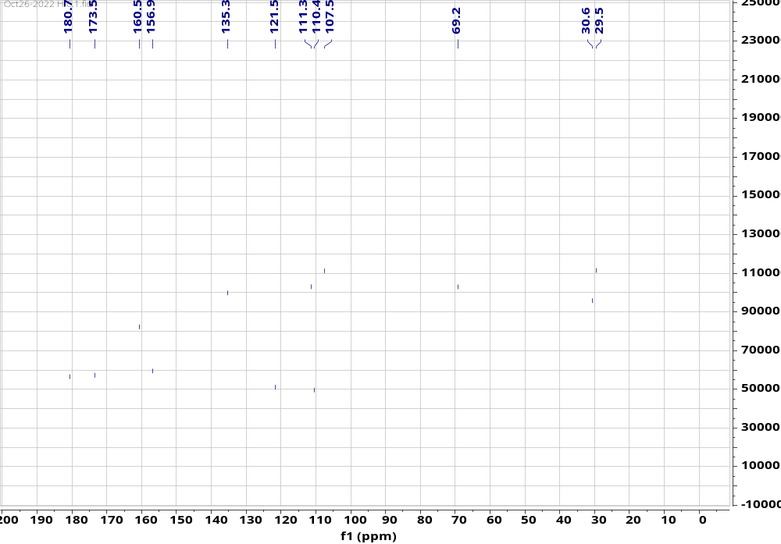
Figure S9. ¹³C NMR spectrum of compound 2 (100 MHz, DMSO)
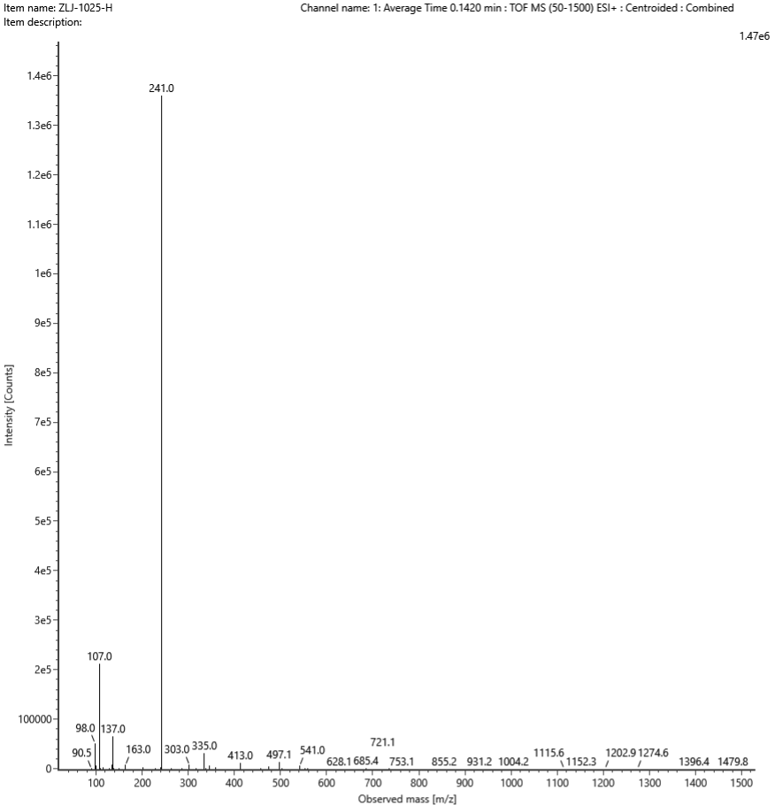
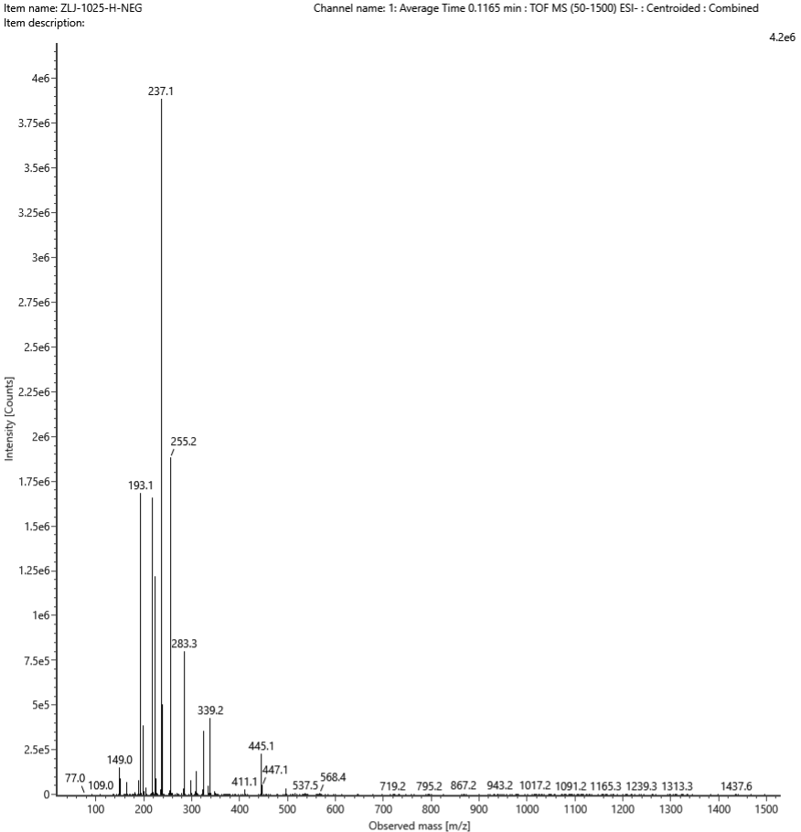
Figure S10. ESIMS of compound 2
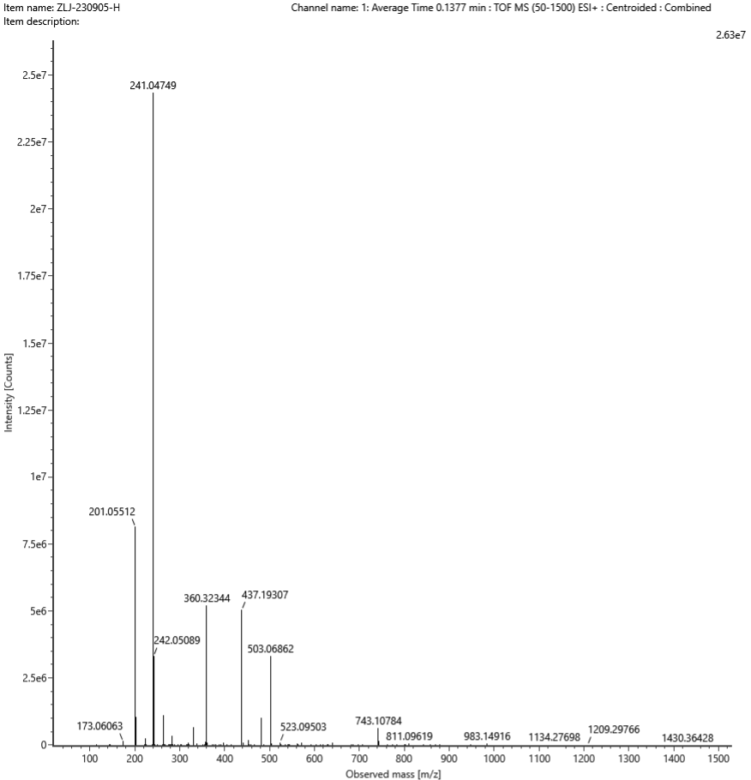
[M+Na]⁺
Composition | i-FIT Confidence (%) | Predicted m/z | m/z error (PPM)
C₁₂H₁₀O₄Na | 100.000000 | 241.047130 | 1.500214
Figure S11. HR-ESIMS of compound 2 (ESI+)
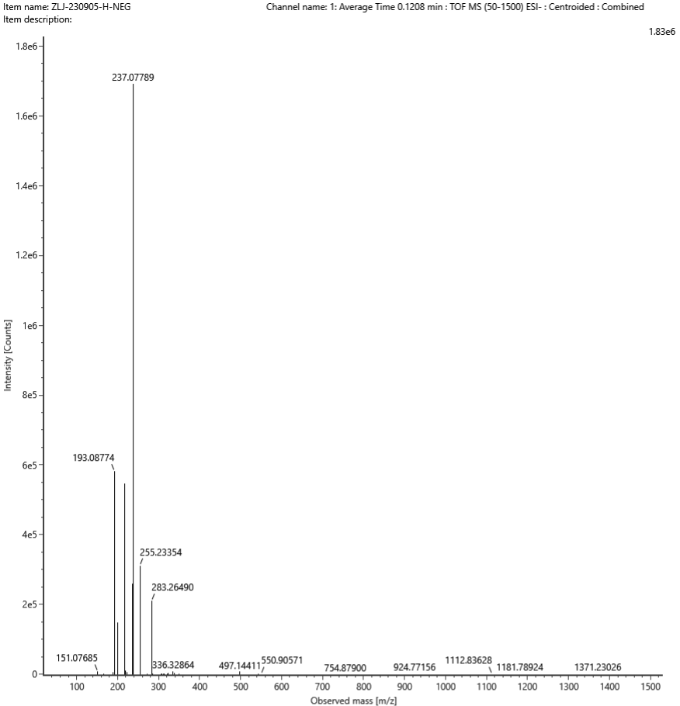
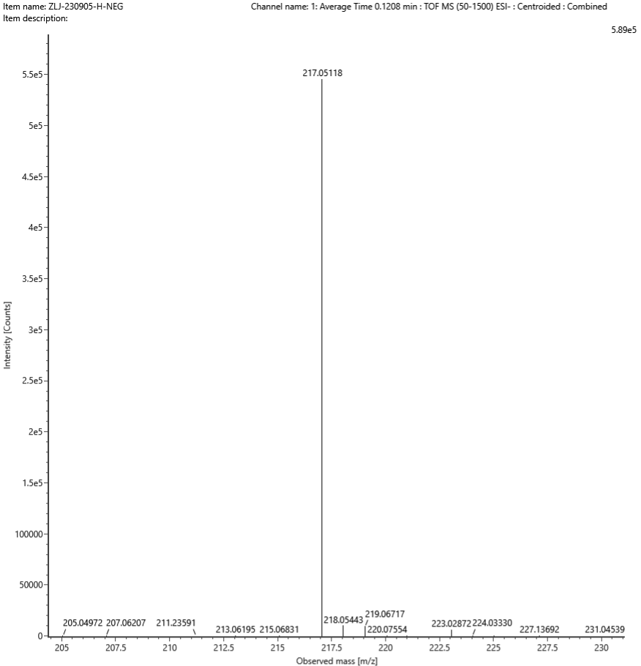
[M-H]⁻
Composition | i-FIT Confidence (%) | Predicted m/z | m/z error (PPM)
C₁₂H₉O₄ | 100.000000 | 217.050632 | 2.511454
Figure S12. HR-ESIMS of compound 2 (ESI-)

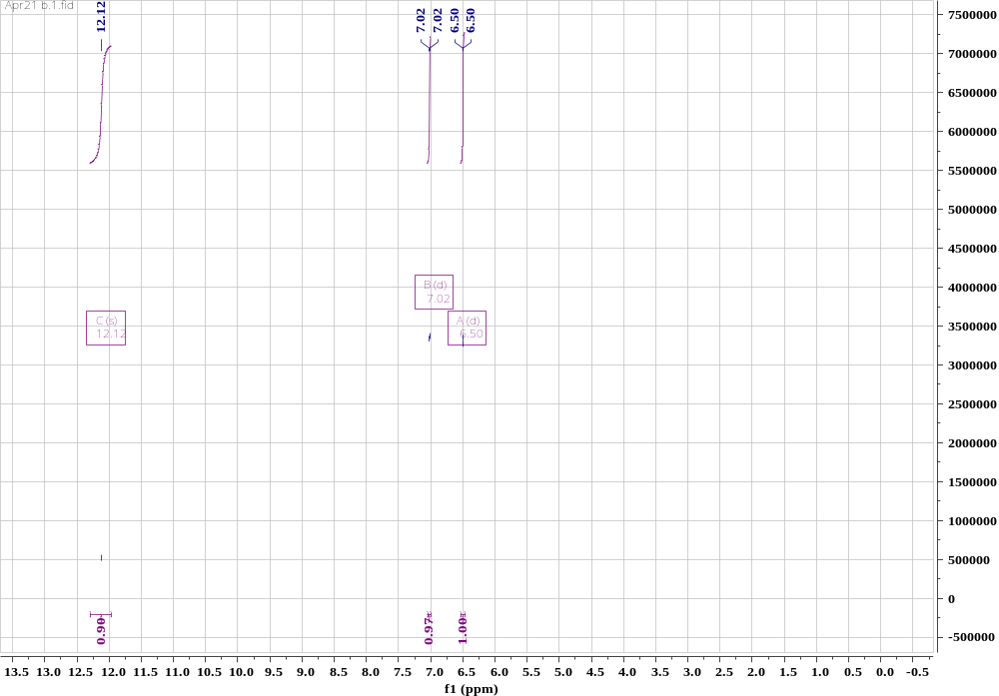
Figure S13. ¹H NMR spectrum of compound 3 (400 MHz, DMSO)
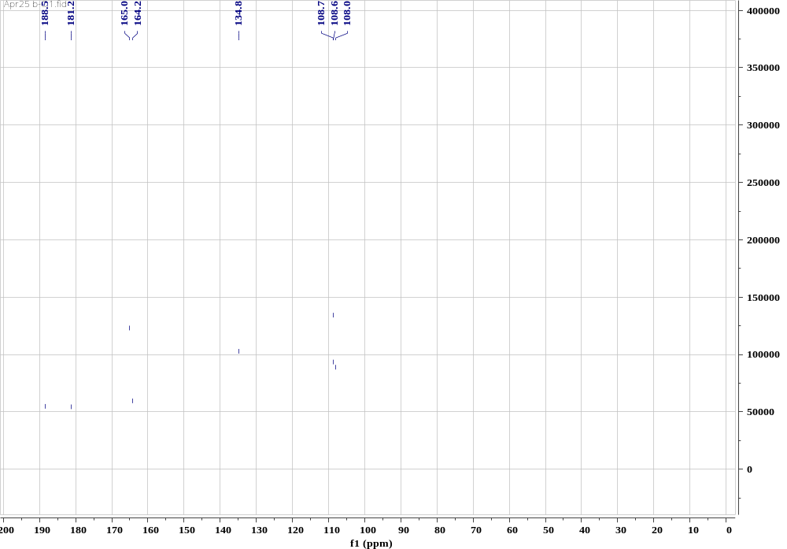
Figure S14. ¹³C NMR spectrum of compound 3 (100 MHz, DMSO)
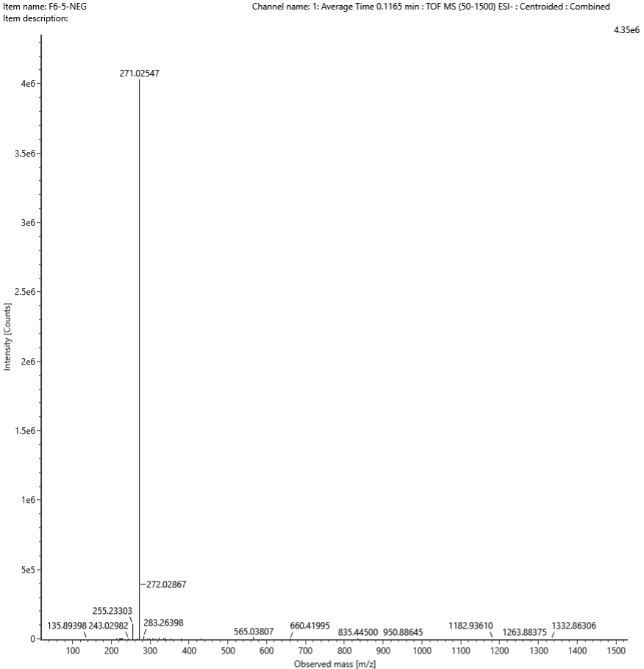
Figure S15. ESIMS of compound 3

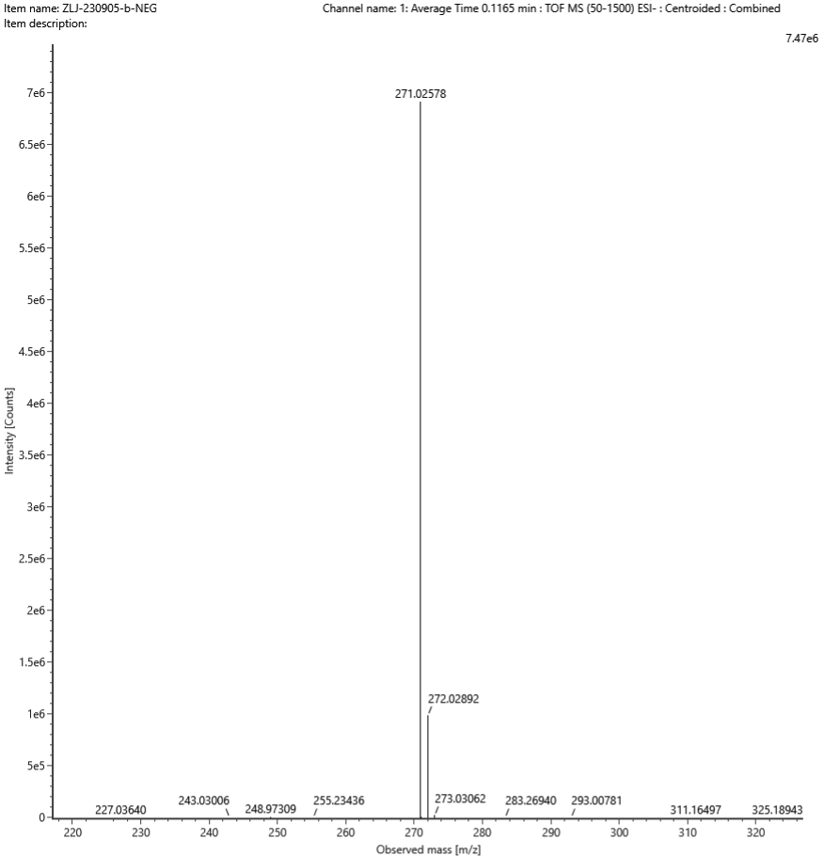
[M-H]⁻
Composition | i-FIT Confidence (%) | Predicted m/z m/z | Error (PPM)
C₁₄H₇O₆ | 100.000000 | 271.024812 | 3.560093
Figure S16. HR-ESIMS of compound 3 (ESI-)

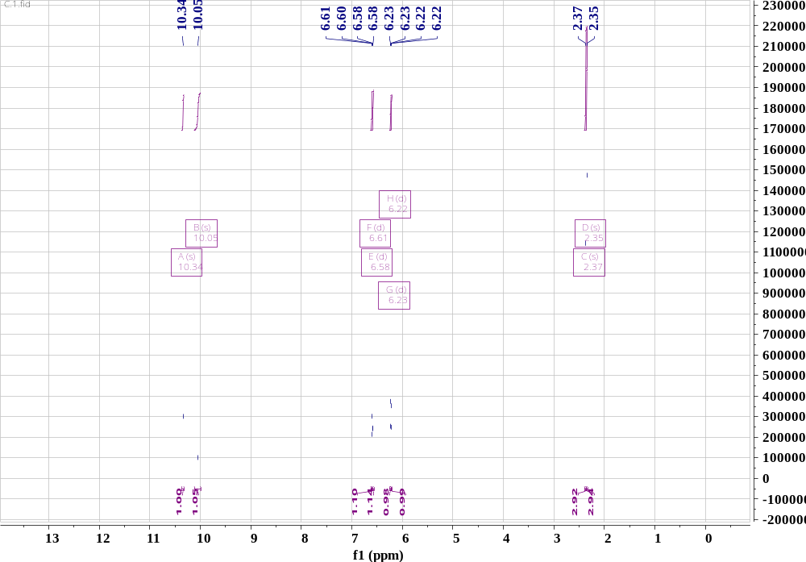
Figure S17. ¹H NMR spectrum of compound 4 (600 MHz, DMSO)
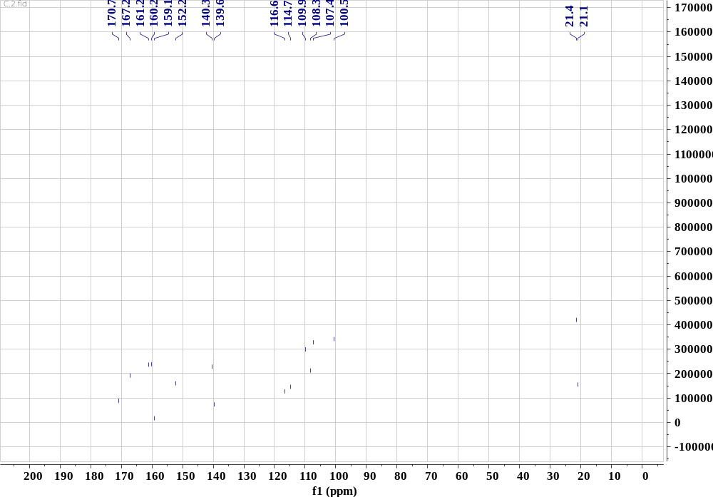
Figure S18. ¹³C NMR spectrum of compound 4 (150 MHz, DMSO)
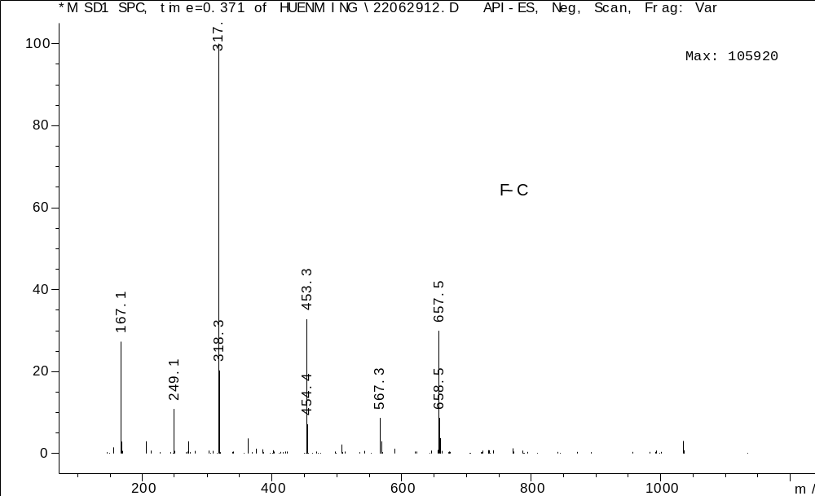
Figure S19. ESIMS of compound 4

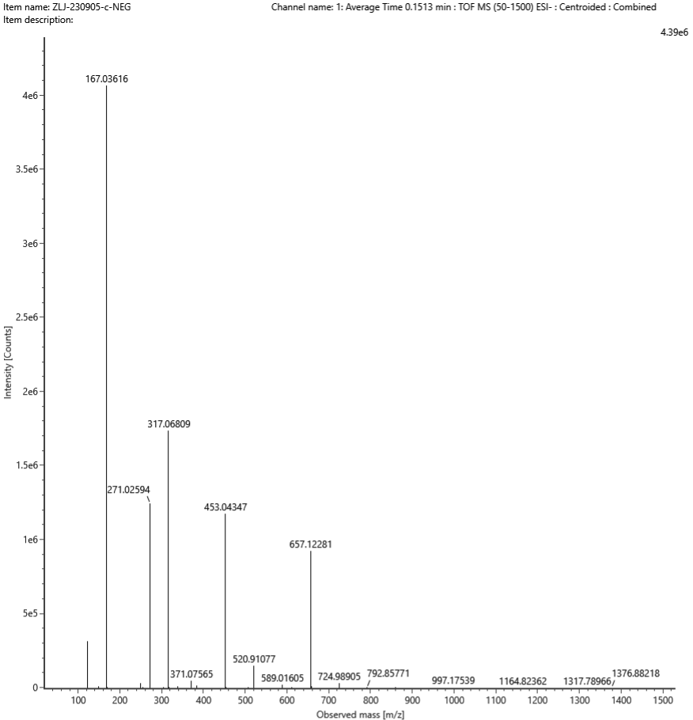
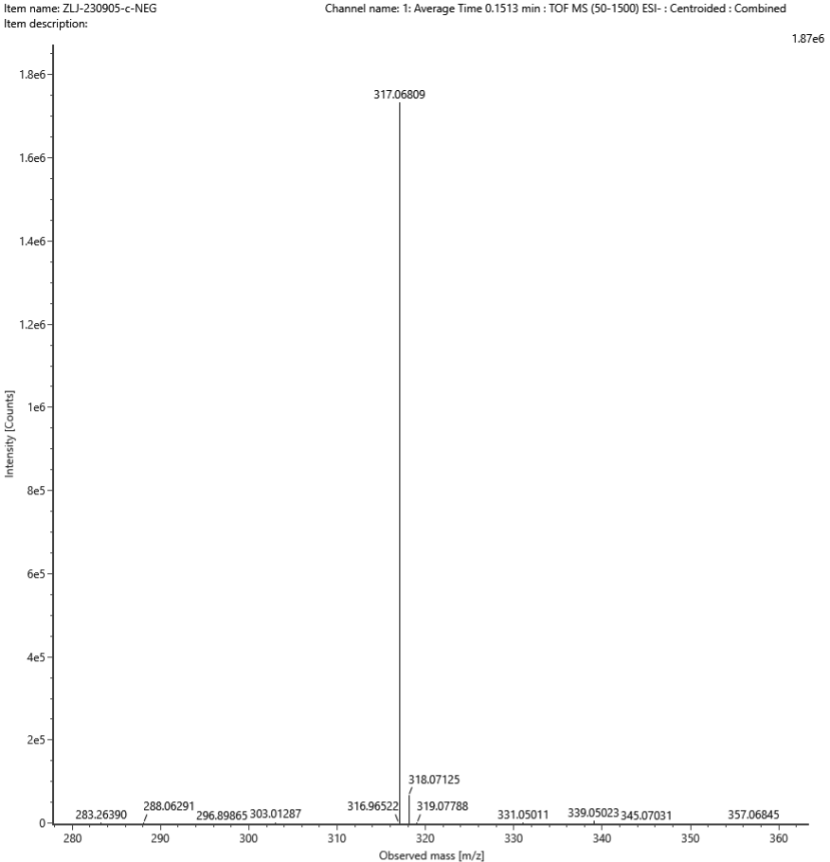
[M-H]⁻
Composition | i-FIT Confidence (%) | Predicted m/z | m/z error (PPM)
C₁₆H₁₃O₇ | 100.000000 | 317.066676 | 4.444385
Figure S20. HR-ESIMS of compound 4 (ESI-)

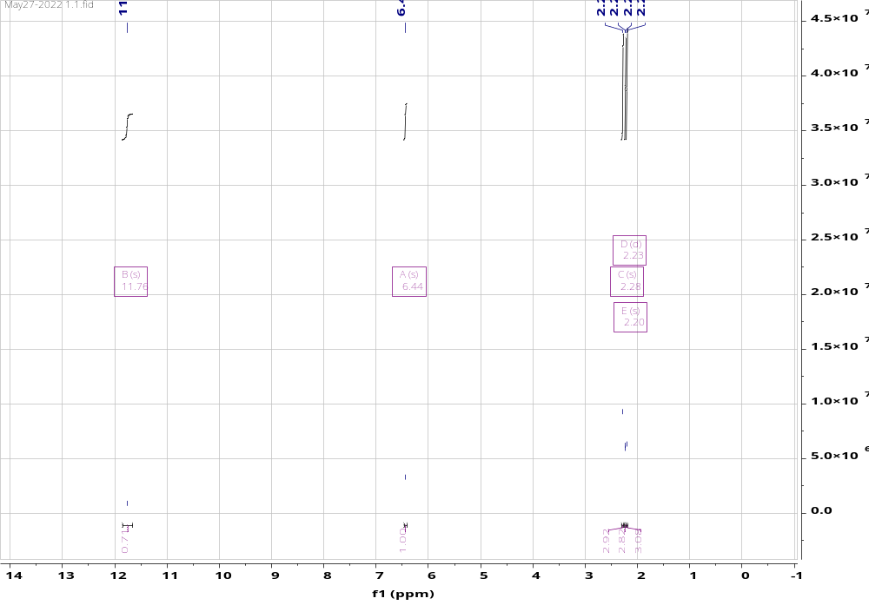
Figure S21. ¹H NMR spectrum of compound 5 (400 MHz, DMSO)
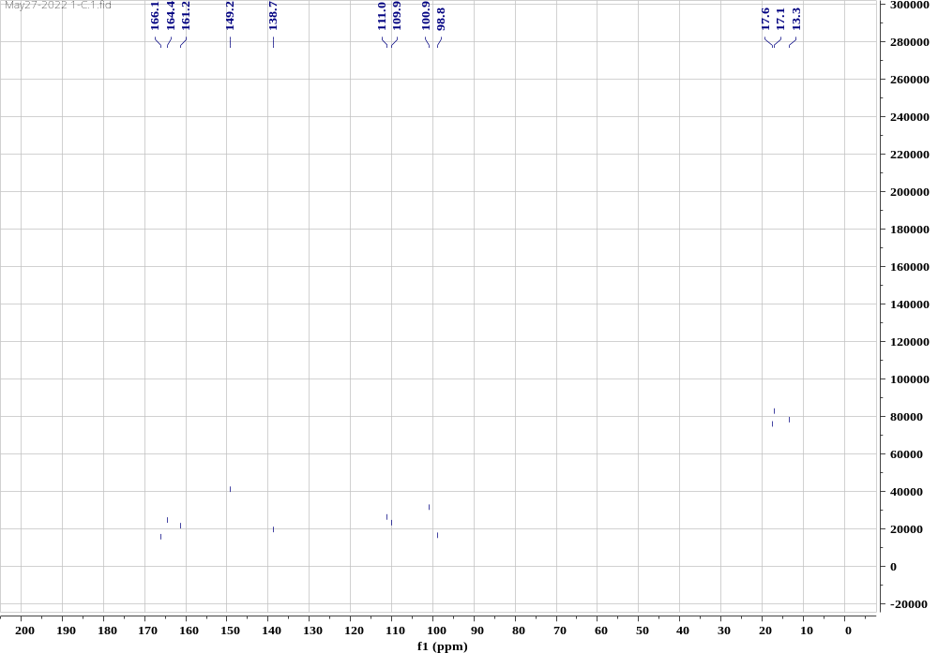
Figure S22. ¹³C NMR spectrum of compound 5 (100 MHz, DMSO)

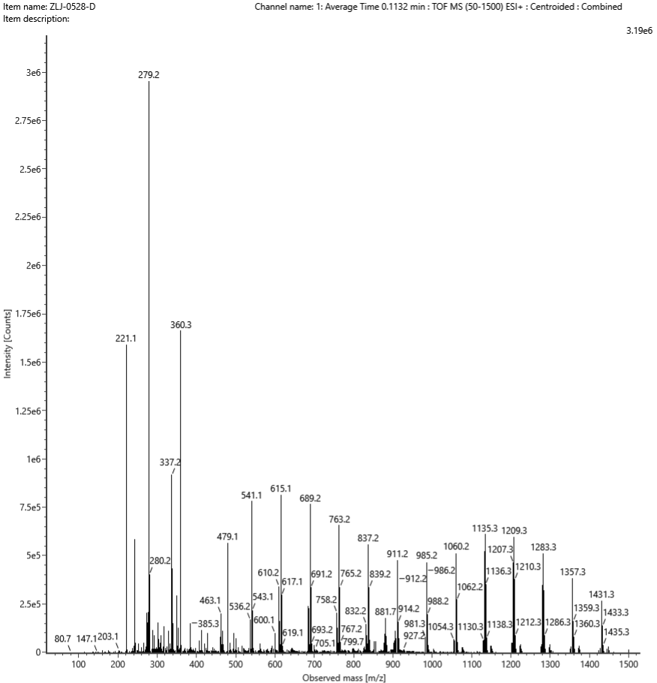Figure S23. ESIMS of compound 5

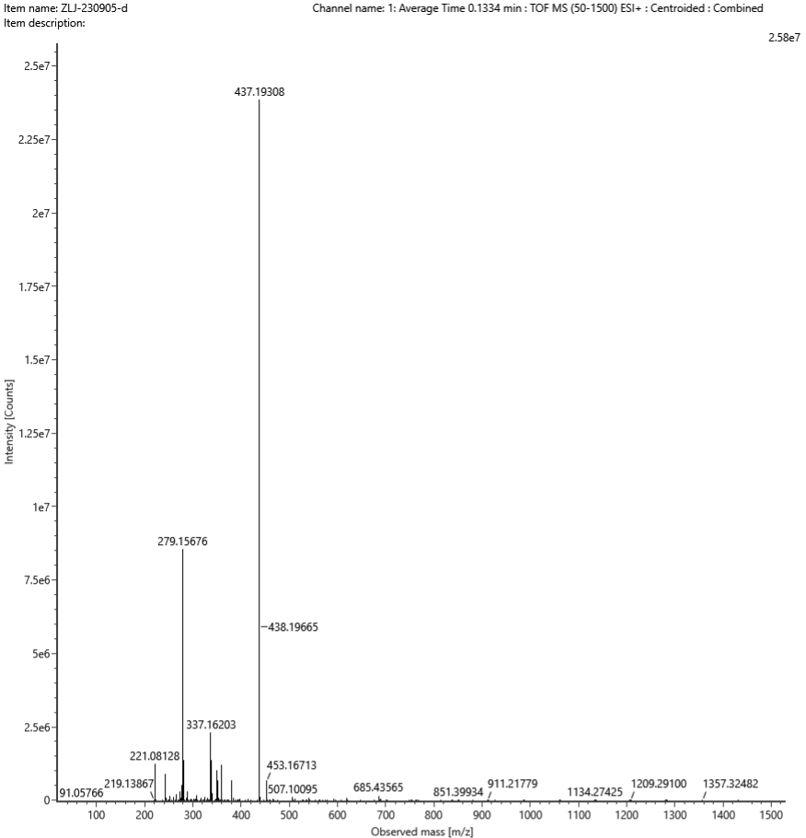
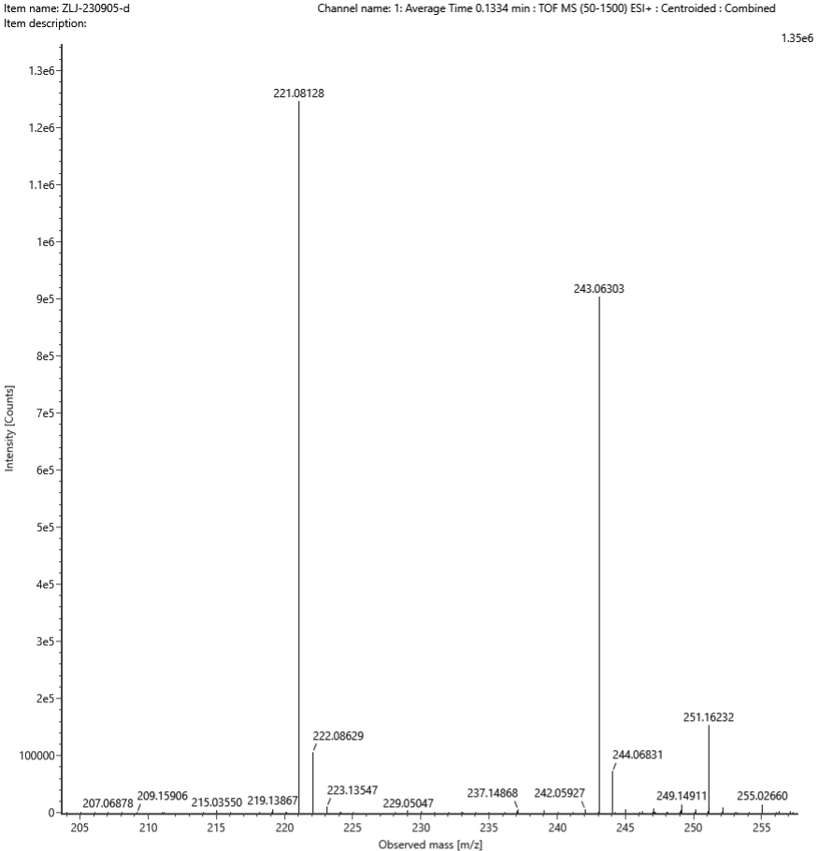
[M+H]⁺
Composition | i-FIT Confidence (%) | Predicted m/z | m/z error (PPM)
C₁₂H₁₃O₄ | 100.000000 | 221.080835 | 2.020575
Figure S24. HR-ESIMS of compound 5 (ESI+)
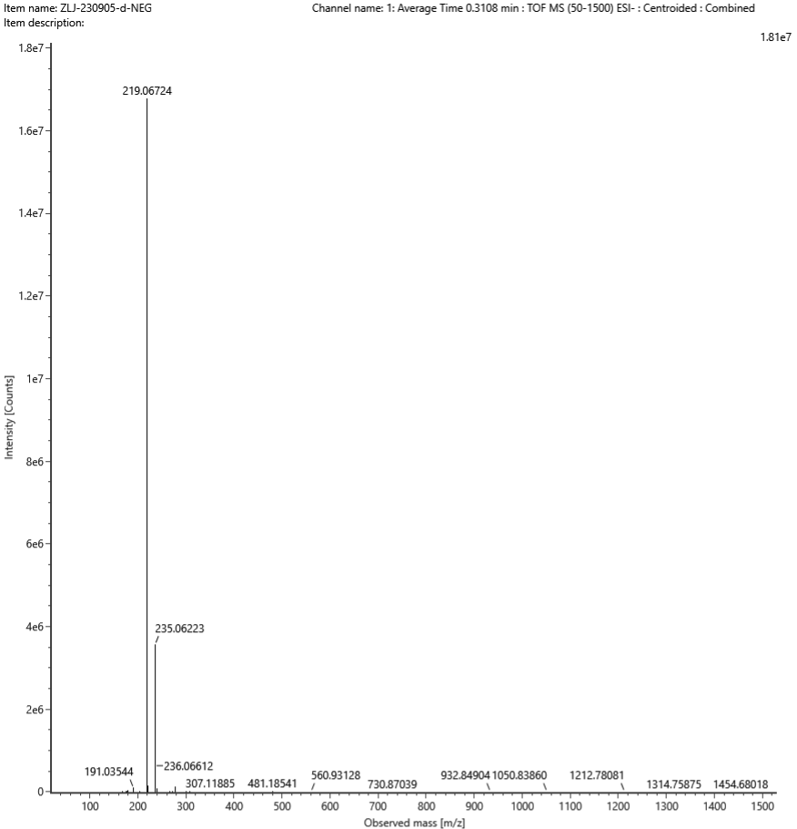
[M-H]⁻
Composition | i-FIT Confidence (%) | Predicted m/z | m/z error (PPM)
C₁₂H₁₁O₄ | 100.000000 | 219.066282 | 4.351163
Figure S25. HR-ESIMS of compound 5 (ESI-)

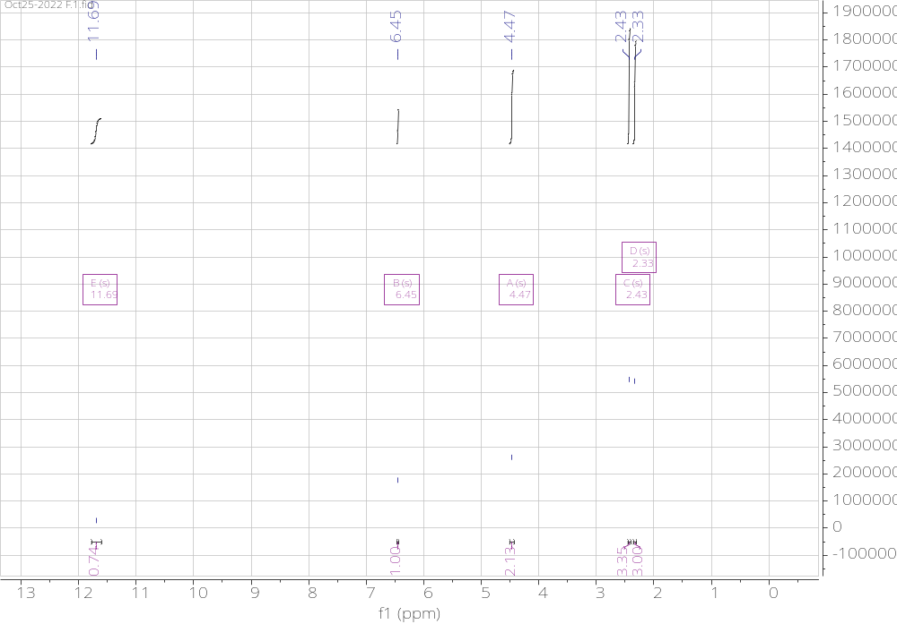
Figure S26. ¹H NMR spectrum of compound 6 (400 MHz, DMSO)
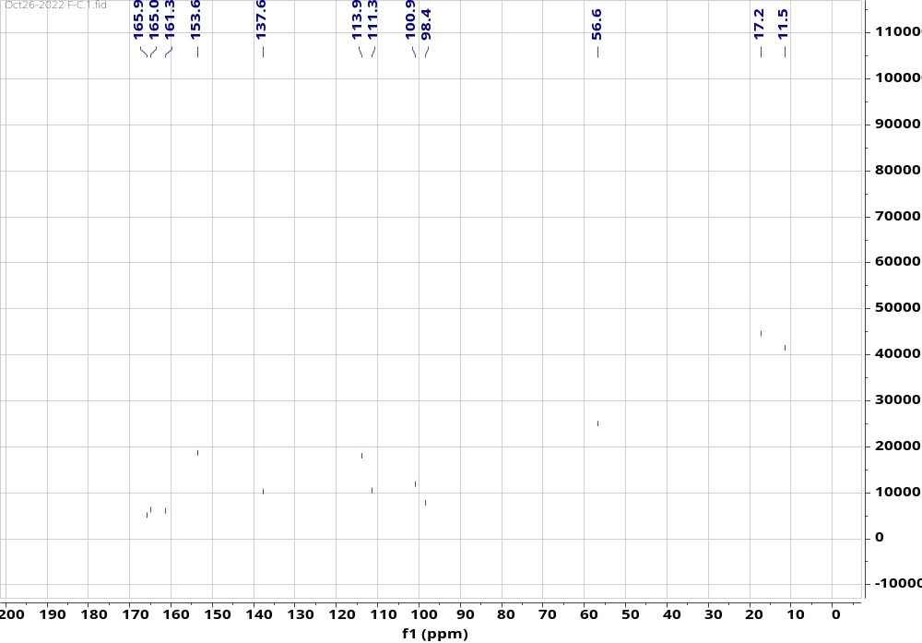
Figure S27. ¹³C NMR spectrum of compound 6 (100 MHz, DMSO)

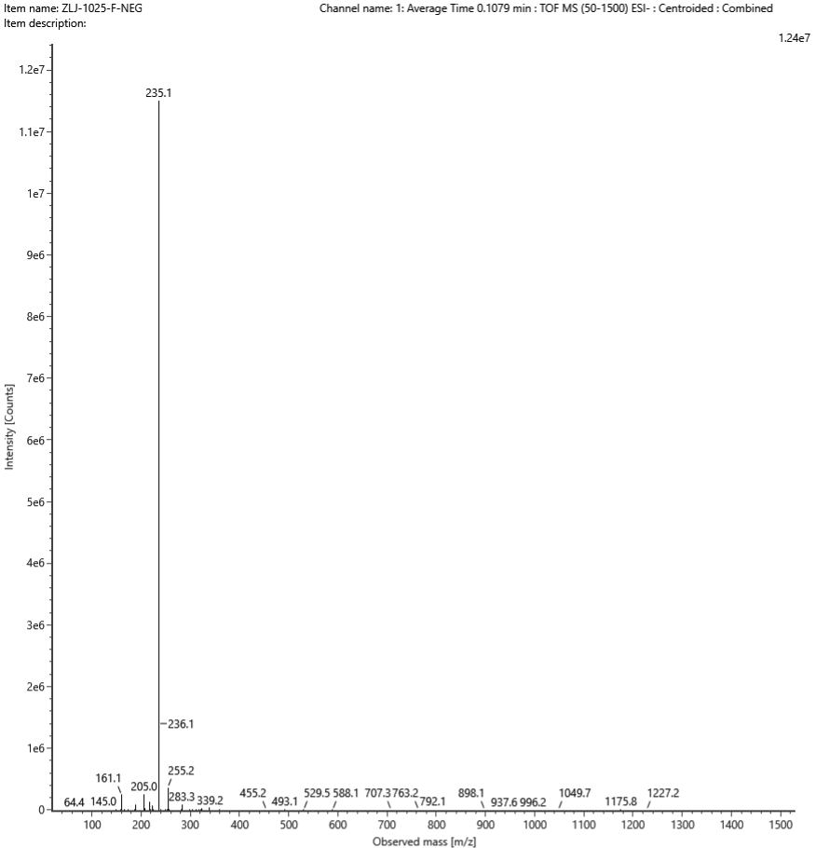Figure S28. ESIMS of compound 6

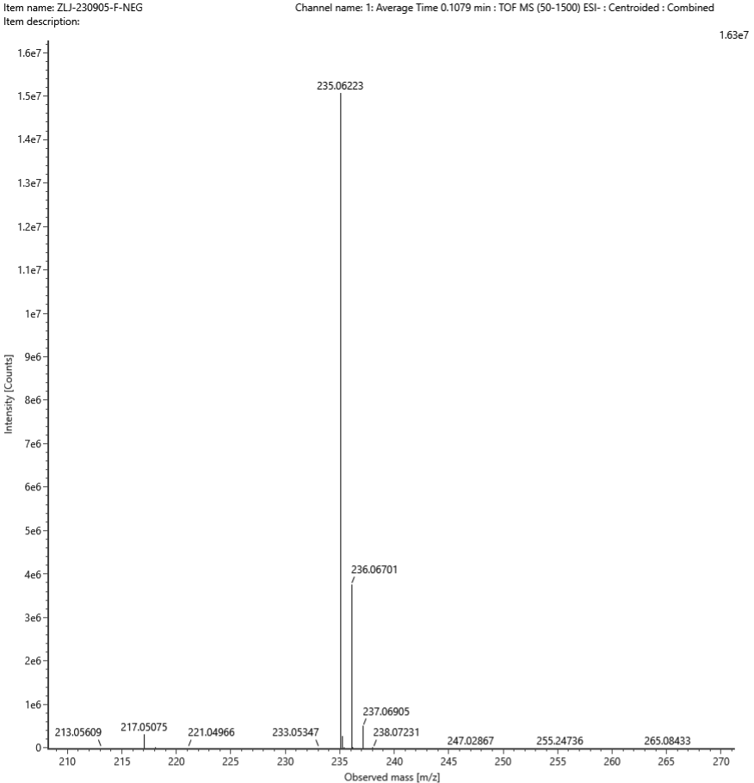
[M-H]⁻
Composition | i-FIT Confidence (%) | Predicted m/z | m/z error (PPM)
C₁₂H₁₁O₅ | 100.000000 | 235.061197 | 4.375651
Figure S29. HR-ESIMS of compound 6 (ESI-)

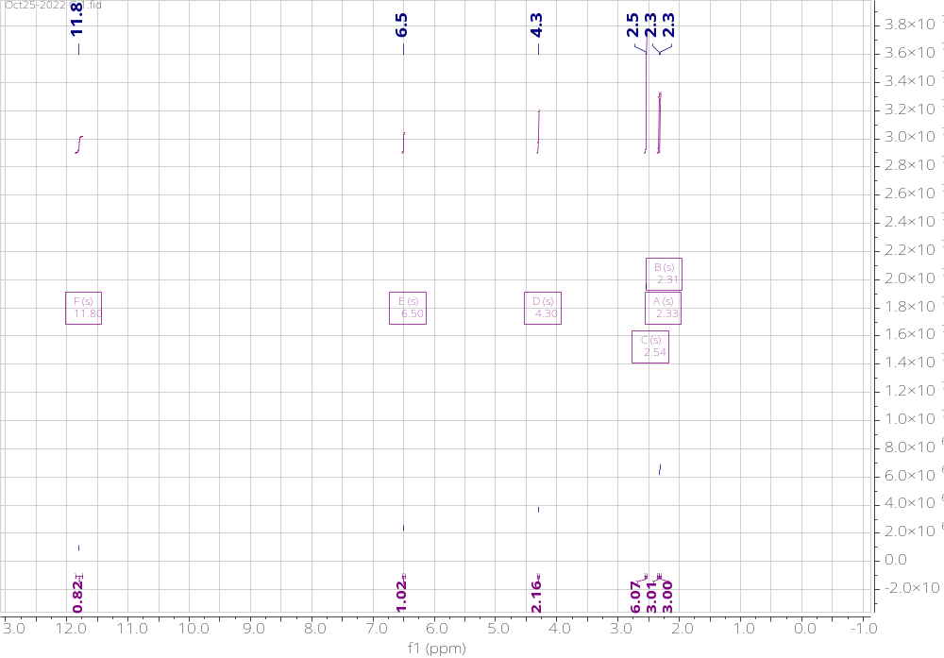
Figure S30. ¹H NMR spectrum of compound 7 (400 MHz, DMSO)
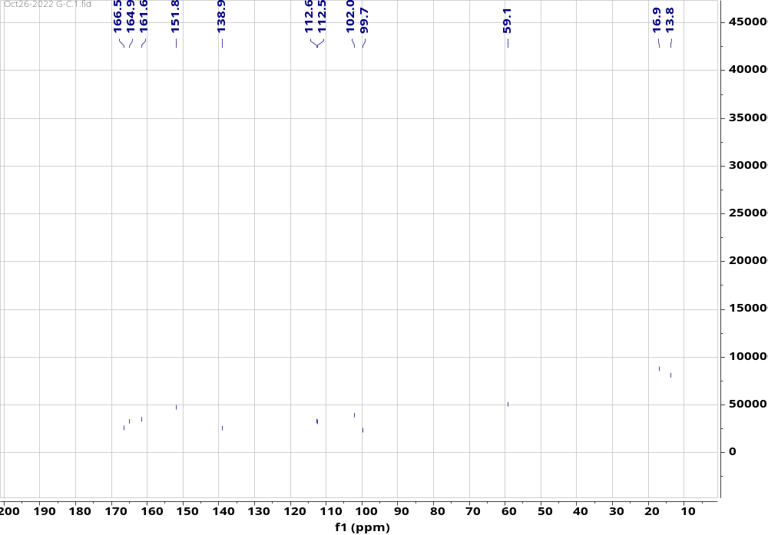
Figure S31. ¹³C NMR spectrum of compound 7 (100 MHz, DMSO)
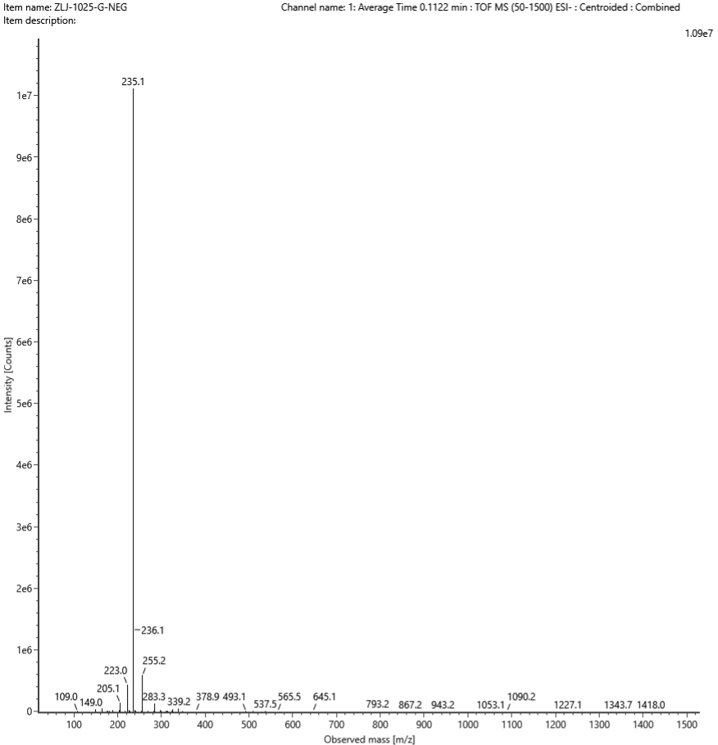
Figure S32. ESIMS of compound 7

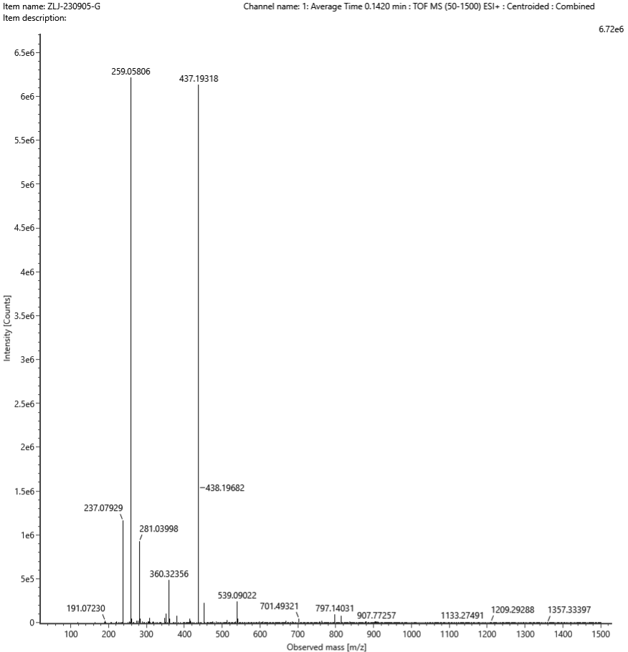
[M+Na]⁺
Composition | i-FIT Confidence (%) | Predicted m/z | m/z error (PPM)
C₁₂H₁₂O₅Na | 100.000000 | 259.057695 | 1.416100
Figure S33. HR-ESIMS of compound 7 (ESI+)

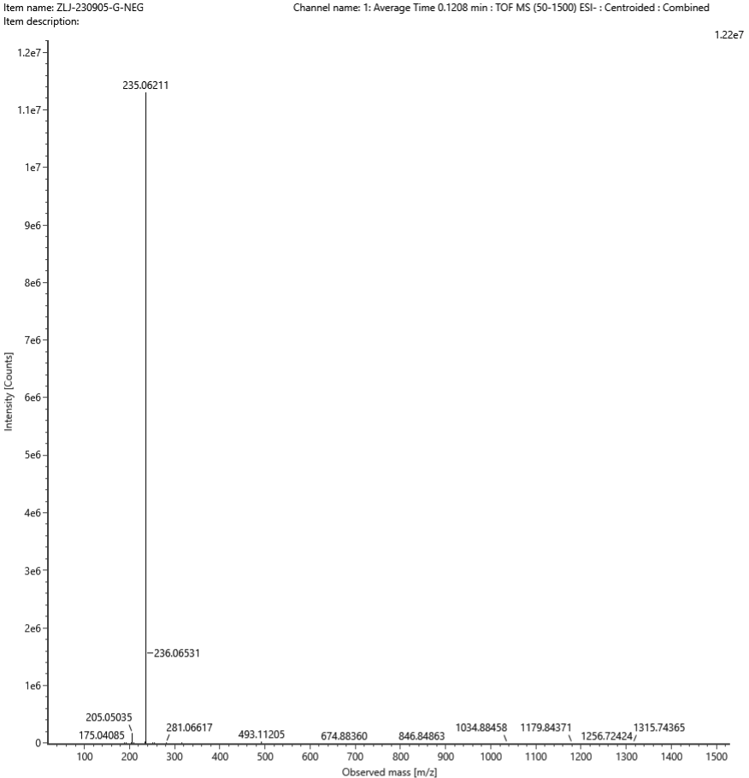
[M-H]⁻
Composition | i-FIT Confidence (%) | Predicted m/z | m/z error (PPM)
C₁₂H₁₁O₅ | 100.000000 | 235.061197 | 3.867328
Figure S34. HR-ESIMS of compound 7 (ESI-)

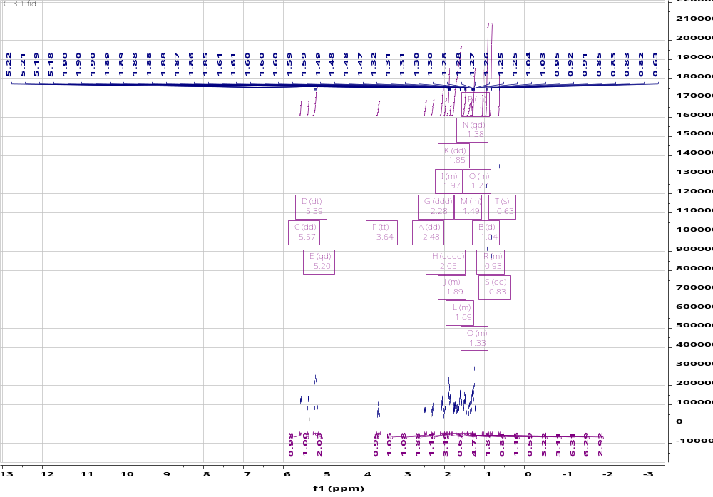
Figure S35. ¹H NMR spectrum of compound 8 (600 MHz, DMSO)
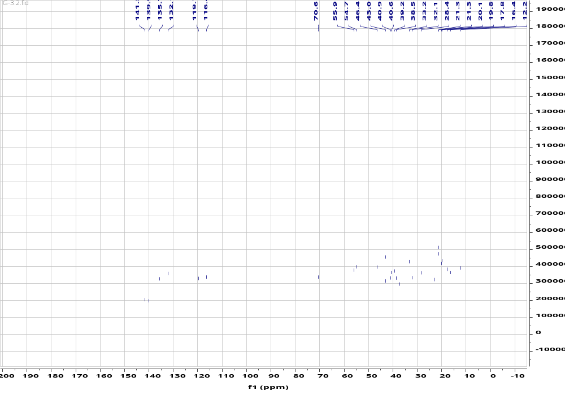
Figure S36. ¹³C NMR spectrum of compound 8 (150 MHz, DMSO)

