Fig. S1. subgroup analysis of the effects of aromatherapy on nurses' stress based on the control types.

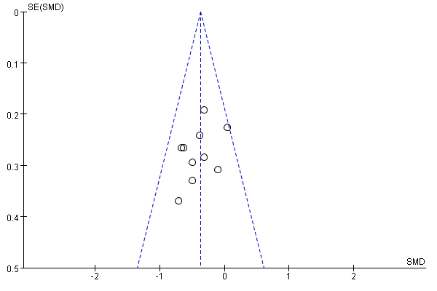

Fig. S2. The Funnel plot for exploration of publication bias.

Table S1. Literature search strategy.
Electronic database  (From each database inception to Nov. , 2022) | Search terms | Number  of articles
PubMed | ("Nurses"[MeSH Terms] OR ("personnel nursing"[Title/Abstract] OR "nursing personnel"[Title/Abstract] OR"registered nurses"[Title/Abstract] OR "nurse registered"[Title/Abstract] OR "nurses registered"[Title/Abstract] OR "registered nurses"[Title/Abstract])) AND ("Aromatherapy"[MeSH Terms] OR ("Aromatherapy"[Title/Abstract] OR "essential oil"[Title/Abstract] OR "aromatic therapy"[Title/Abstract] OR "essence"[Title/Abstract] OR "Aroma"[Title/Abstract] OR "Aromatherapies"[Title/Abstract] OR "aroma therapy"[Title/Abstract] OR "aroma therapies"[Title/Abstract] OR (("therapeutics"[MeSH Terms] OR "therapeutics"[All Fields] OR "Therapies"[All Fields] OR"Therapy"[MeSH Subheading] OR "Therapy"[All Fields] OR "therapy s"[All Fields] OR "therapys"[All Fields]) AND "Aroma"[Title/Abstract]) OR (("therapeutics"[MeSH Terms] OR "therapeutics"[All Fields] OR "Therapies"[All Fields] OR "Therapy"[MeSH Subheading] OR "Therapy"[All Fields] OR "therapy s"[All Fields] OR "therapys"[All Fields]) AND "Aroma"[Title/Abstract]))) | 207
Embase | #1 aromatherapy:ab,ti OR 'essential oil':ab,ti OR 'aromatic therapy':ab,ti OR essence:ab,ti OR aroma:ab,ti OR aromatherapies:ab,ti OR'aroma therapy':ab,ti OR 'aroma therapies':ab,ti OR 'therapies, aroma':ab,ti OR 'therapy, aroma':ab,ti  #2 nurses:ab,ti OR nurse:ab,ti OR 'personnel, nursing':ab,ti OR 'nursing personnel':ab,ti OR 'registered nurses':ab,ti OR 'nurse registered':ab,ti OR 'nurses, registered':ab,ti OR 'registered nurse':ab,ti  #3 'randomized controlled trial'/exp OR 'randomized controlled trials as topic'/exp OR 'clinical trials, randomized' OR 'trials, randomized clinical' OR 'controlled clinical trials, randomized' OR rct  #1 AND #2 AND #3 | 71
the Cochrane library (CENTRAL) | #1 [Aromatherapy] explode all trees OR (Aromatherapy OR essential oil OR aromatic therapy OR essence OR aroma OR Aromatherapies OR Aroma Therapy OR Aroma Therapies OR Therapies, Aroma OR Therapy, Aroma): ti,ab,kw  #2 MeSH descriptor: [Nursing] in all MeSH products OR (Nurse or Personnel, Nursing or Nursing Personnel or Registered Nurses or Nurse, Registered or Nurses, Registered or Registered Nurses):ti,ab,kw  #3 [Randomized Controlled Trial] explode all trees OR (Clinical Trials, Randomized OR Trials, Randomized Clinical OR Controlled Clinical Trials, Randomized or RCT):ti,ab,kw  #1 AND #2 AND #3 | 113
Web of Science | TS =(Aromatherapy OR essential oil OR aromatic therapy OR essence OR aroma OR Aromatherapies OR Aroma Therapy OR Aroma Therapies OR Therapies, Aroma OR Therapy, Aroma)  TS =（Nurse or Personnel, Nursing OR Nursing Personnel OR Registered Nurses OR Nurse, Registered or Nurses, Registered OR Registered Nurses）  TS = (Randomized Controlled Trial OR Clinical Trials, Randomized OR Trials, Randomized Clinical OR Controlled Clinical Trials, Randomized or RCT) | 219

