Supporting Information for “Wildfire worsens population exposure to PM2.5 pollution in the Continental United States”

Danlu Zhang¹, Wenhao Wang¹, Yuzhi Xi¹, Jianzhao Bi², Yun Hang¹, Qingyang Zhu¹, Qiang Pu¹, Howard Chang³, Yang Liu^{1*}
¹ Gangarosa Department of Environmental Health, Rollins School of Public Health, Emory University; Atlanta, GA, United States
² Department of Environmental & Occupational Health Sciences, School of Public Health, University of Washington; Seattle, WA, United States
³ Department of Biostatistics and Bioinformatics, Rollins School of Public Health, Emory University; Atlanta, GA, United States
*Email: yang.liu@emory.edu

Contents: supporting text, Figures S1 to S6, Tables S1 to S4 and supporting information references
Supporting Information Text

Materials and Methods
PM_{2.5} Predictor Variables for Statistical Modeling
To develop the PM_{2.5} prediction models, we collected a large array of predictor variables, including satellite-retrieved aerosol, cloud, and smoke plumes information, gridded meteorology, population, land cover and topographic data.
The Multi-Angle Implementation of Atmospheric Correction (MAIAC) is an algorithm using on time series analysis and a combination of pixel and image-based processing based on Moderate Resolution Imaging Spectroradiometer (MODIS) Collection 6 to improve the aerosol retrievals accuracy and optimized the spatial resolution to 1 km (1). MAIAC AOD at 550 nm from the Terra (overpass at 10:30 a.m. local time) and Aqua (overpass at 1:30 p.m. local time) were obtained from NASA EOSDIS Land Processes Distributed Active Archive Center (2). Cloud cover and water or ice glint reflectance can cause a considerable proportion of random missing data in satellite AOD (3, 4), so we extracted modelled AOD data from Monitoring Atmospheric Composition and Climate - Interim Implementation (MACC-II) project, processed by Copernicus Atmosphere Monitoring Service (CAMS). CAMS AOD at five different wavelengths (469 nm, 550 nm, 670 nm, 865 nm and 1240 nm) were downloaded from the European Centre for Medium-Range Weather Forecasts (ECMWF) with a spatial resolution of 0.75° × 0.75° and a temporal resolution of 3 hours (5).
Cloud fractions at a 5 km resolution were obtained from Moderate Resolution Imaging Spectroradiometer (MODIS) Level-2 Cloud product (6). Remotely sensed infrared visible and near infrared solar reflected radiances were used to derive the cloud fraction (7). It has been indicated that MODIS cloud product had an agreement with the lidar about 85% of the time (8). Only daytime cloud fraction was extracted to represent the cloud condition at satellite overpass times. Smoke plumes were taken from the National Oceanic and Atmospheric Administration/National Environmental Satellite, Data, and Information Service (NOAA/NESDIS) Satellite Analysis Branch's Hazard Mapping System (HMS), based on visual classification using GOES-16 and GOES-17 ABI true-color imagery (9). Attributes of smoke plumes included the plume density along with start and end times of the satellite image sequence used to outline the smoke polygon.
Gridded hourly meteorological factors, including air temperature, specific humidity, surface pressure, surface downward longwave and shortwave radiation, U and V wind component, total precipitation, and potential evaporation, with a spatial resolution of 0.125° × 0.125°, were obtained from the North American Land Data Assimilation System phase 2 (NLDAS-2) (10). Planetary boundary layer height was downloaded from the North American Regional Reanalysis (NARR) at a spatial resolution of 32 km (11). Daily averaged meteorological factors were calculated between 9 a.m. and 3 p.m. at local time zones to represent the weather condition at satellite overpass times. The land cover data at 30-meter resolution were obtained from the National Land Cover Database (NLCD) (12). NLCD released land cover for years of 2008, 2011, 2013, 2016 and 2019. Land cover data in gap years were taken from later released products. The percentage of each land cover type, such as water, developed area, barren, forest, shrubland, herbaceous area, cultivated area, and wetland, was calculated by reclassifying 20 original land cover types. Annual population counts at 30 arc second spatial resolution were download from Oak Ridge National Laboratory’s LandScan (13). Road network data, including road types of highways, primary road, secondary road, tertiary road, and local road, at a 5 arcminutes resolution were downloaded from the Global Roads Inventory Project (GRIP) (14). The elevation data was extracted from the Terra Advanced Spaceborne Thermal Emission and Reflection Radiometer (ASTER) Global Digital Elevation Model (GDEM) Version 3 (ASTGTM) at a resolution of 1 arc second (15).
The Community Multiscale Air Quality (CMAQ) is a numerical chemical transport air quality model that combines emission sources, weather-based atmospheric transport, dispersion, chemical transformation, and deposition to predict the air pollution concentrations (16). In this study, two CMAQ models were involved to predict daily ground PM_{2.5} concentrations at ~12km spatial resolution. While the full model simulated the total PM_{2.5} concentrations using both all emission sources, the non-fire model excluded the fire events information to predict the non-fire PM_{2.5} concentrations. The details and methodologies of the CMAQ models are published elsewhere (17). We then calculated the smoke PM_{2.5} concentrations and the ratio of smoke PM_{2.5} based on the two CMAQ simulations using the equation 1 and 2, respectively.
$$Smoke PM_{2.5\left(s,t\right)}=Total PM_{2.5\left(s,t\right)}-Non smok{e PM}_{2.5\left(s,t\right)}$$
$$Smoke PM_{2.5} Ratio_{\left(s,t\right)}=Smoke PM_{2.5\left(s,t\right)} / Total PM_{2.5\left(s,t\right)}$$

Satellite AOD Gap-filling Approach
To address the missing data issue of satellite AOD, we customized a two-step approach to improve the spatial coverage of satellite AOD data. First, we fitted linear regression models between daily Terra and Aqua AOD to predict missing Terra AOD when only Aqua AOD was available in those grids and vice versa. Daily averaged AOD in each grid was calculated as the mean from both satellites. Second, we developed a RF-based model to predict the daily AOD over grids where both Terra and Aqua AOD were missing (3, 4). The equation is expressed as
$${AOD}_{(s,t)}=f({cloud fraction}_{(s,t)},{air temperature}_{(s,t)},{ specific humidity}_{(s,t)},$$
$${precipitation}_{(s,t-1)},{elevation}_{(s,t)},\sum_{i=1}^{M}{\sum_{j=1}^{N}{{CAMS AOD}_{(s,t)}}})$$
where s is the location of a grid cell, and t is the time of an observation. M is the number of wavelength (M = 5) and N represents the available hours (N = 8). MAIAC AOD was the dependent variable. The independent variables consisted of cloud fraction, air temperature, specific humidity, precipitation on the previous day, elevation, and separate CAMS AOD at five wavelengths and available hours. To balance the computing time and prediction accuracy, we kept the training dataset in each single day no more than 750,000, which indicates if the full training data was over 750,000, we randomly selected 750,000 observations to train the RF-based gap-filling model and num.tree and mtry were set as 50 and 10, respectively (4).
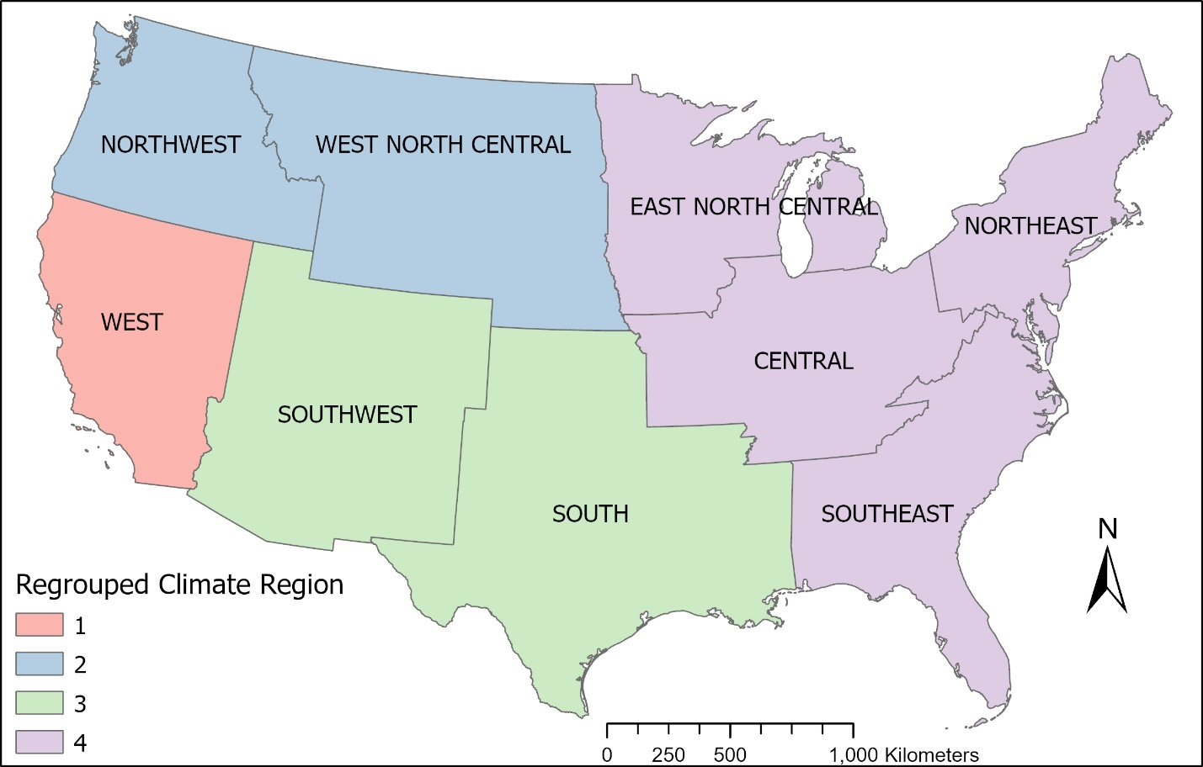
Figure S1. Regrouped nine climate regions in four parts.

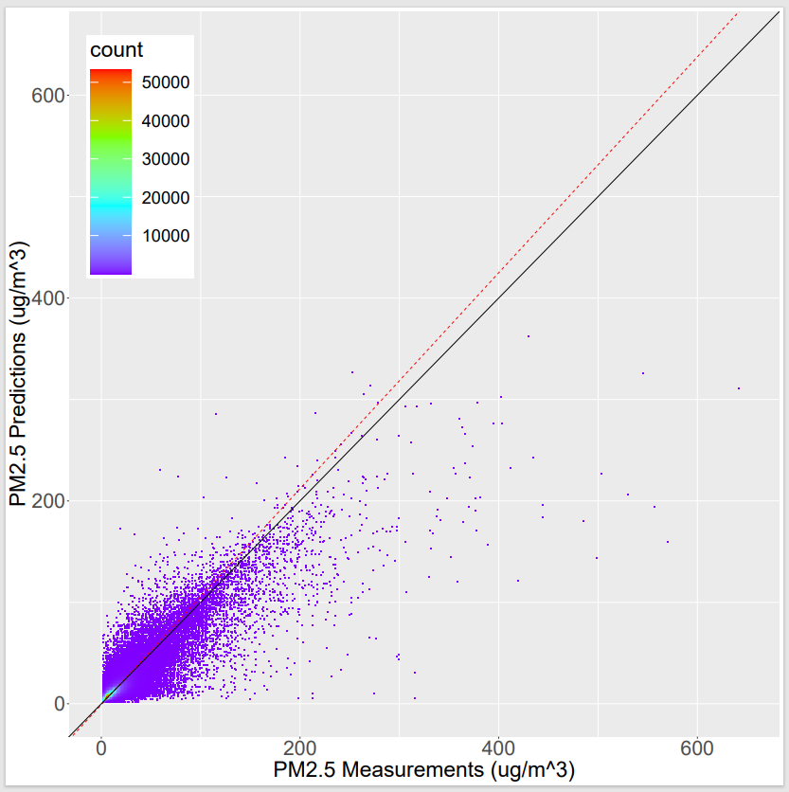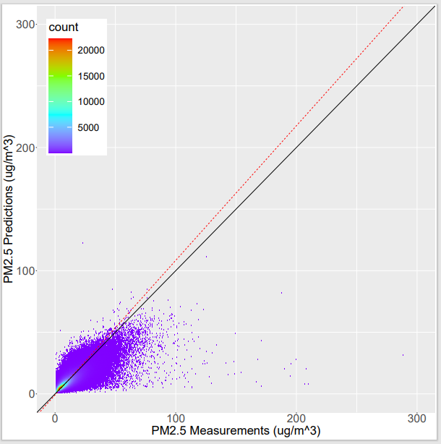
N=2,003,085
R²=0.68
RMSE=3.35
Intercept=-0.86
Slope=1.09
N=1,657,449
R²=0.75
RMSE=4.59
Intercept=-0.89
Slope=1.06
Figure S2. Scatter Plot for 20-fold Cross-validation of Daily PM_{2.5} in fire (left) and non-fire (right) models. Red dashed line is the regression line. Black line is the 1:1 line.

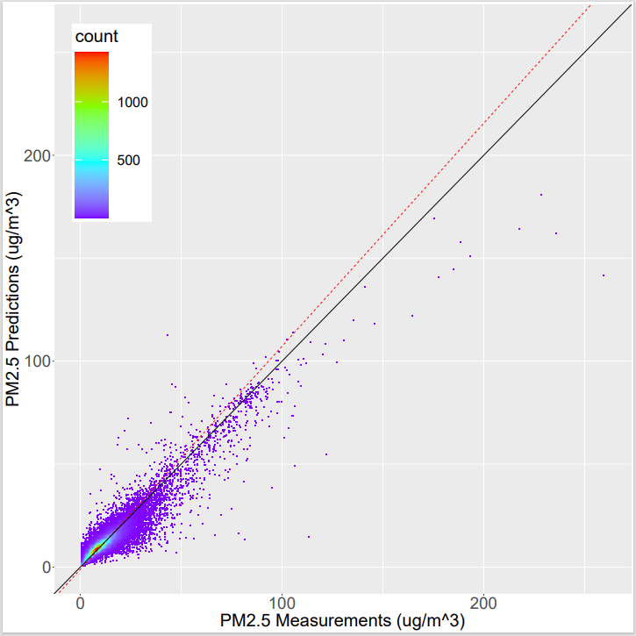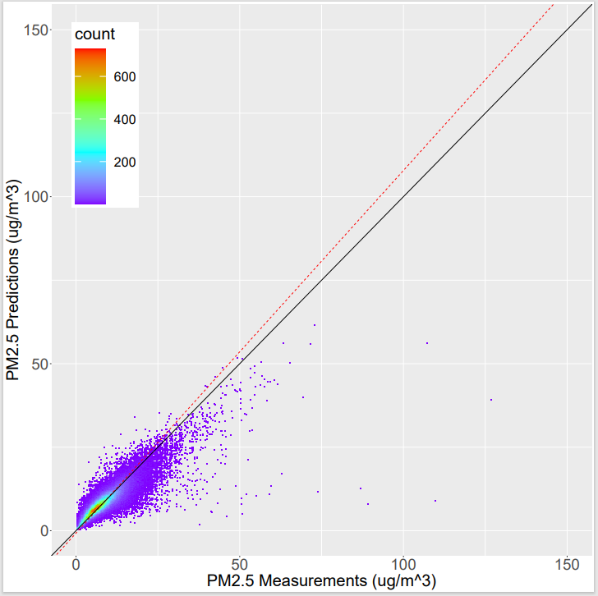
N=175.281
R²=0.78
RMSE=2.08
Intercept=-0.72
Slope=1.09
N=175,903
R²=0.84
RMSE=2.66
Intercept=-1.07
Slope=1.08
Figure S3. Scatter Plot for 20-fold Cross-validation of Monthly PM_{2.5} in fire (left) and non-fire (right) models. Red dashed line is the regression line. Black line is the 1:1 line.

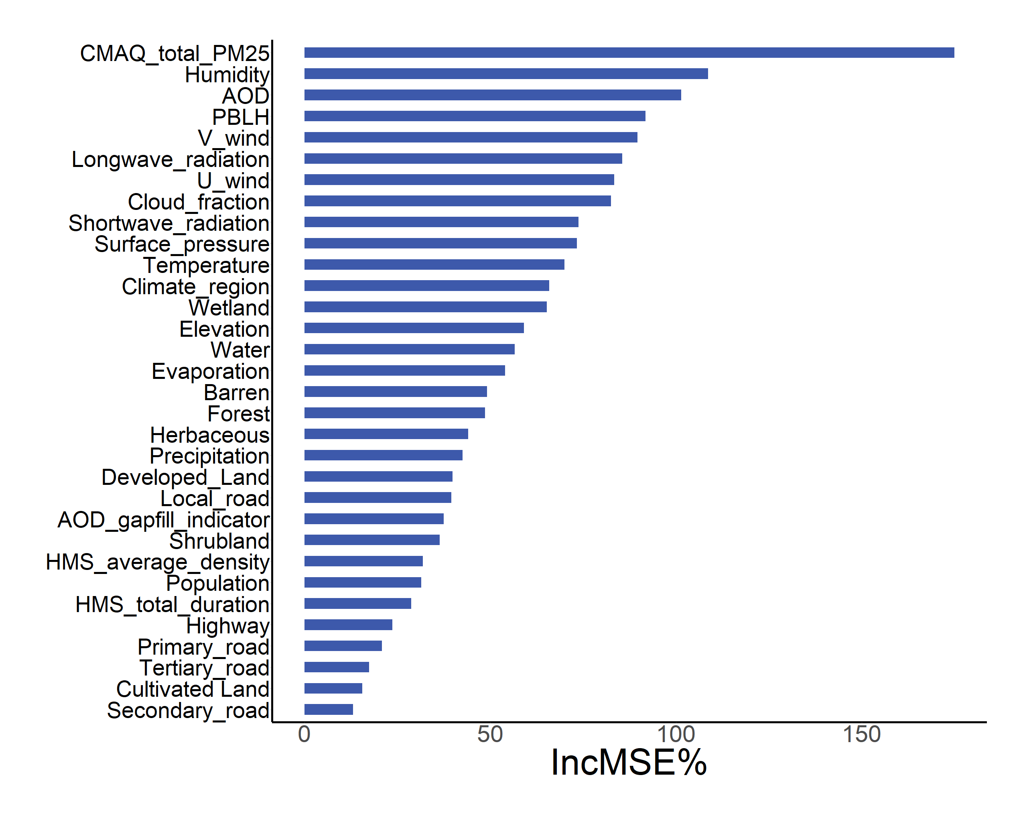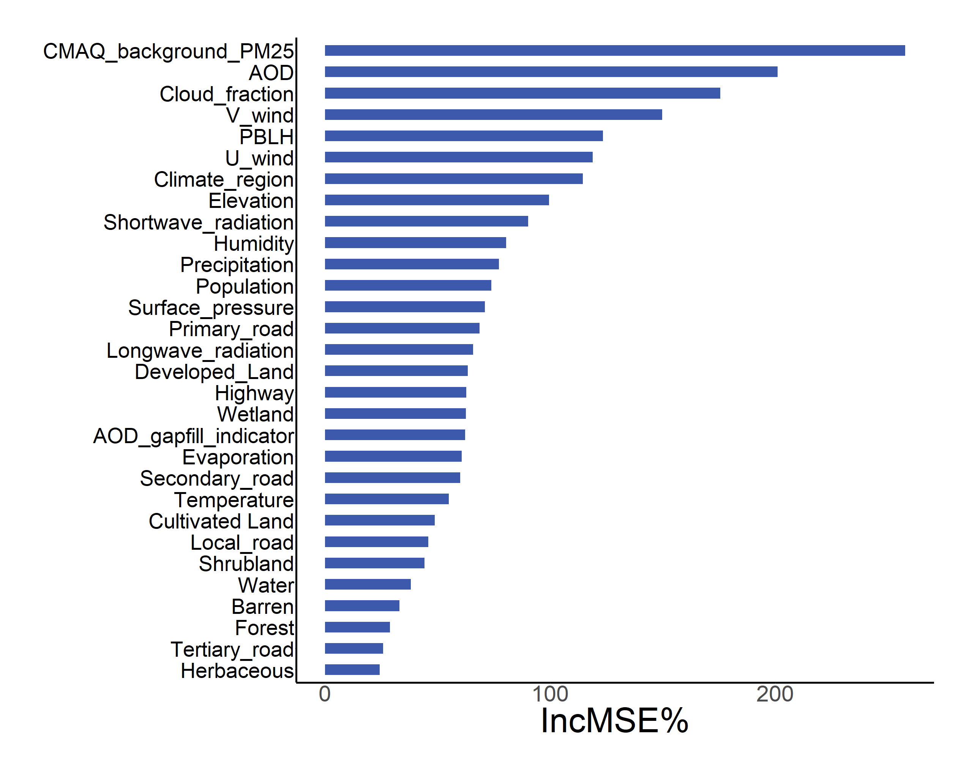
Figure S4. Variables importance rank of fire (left) and non-fire (right) models.

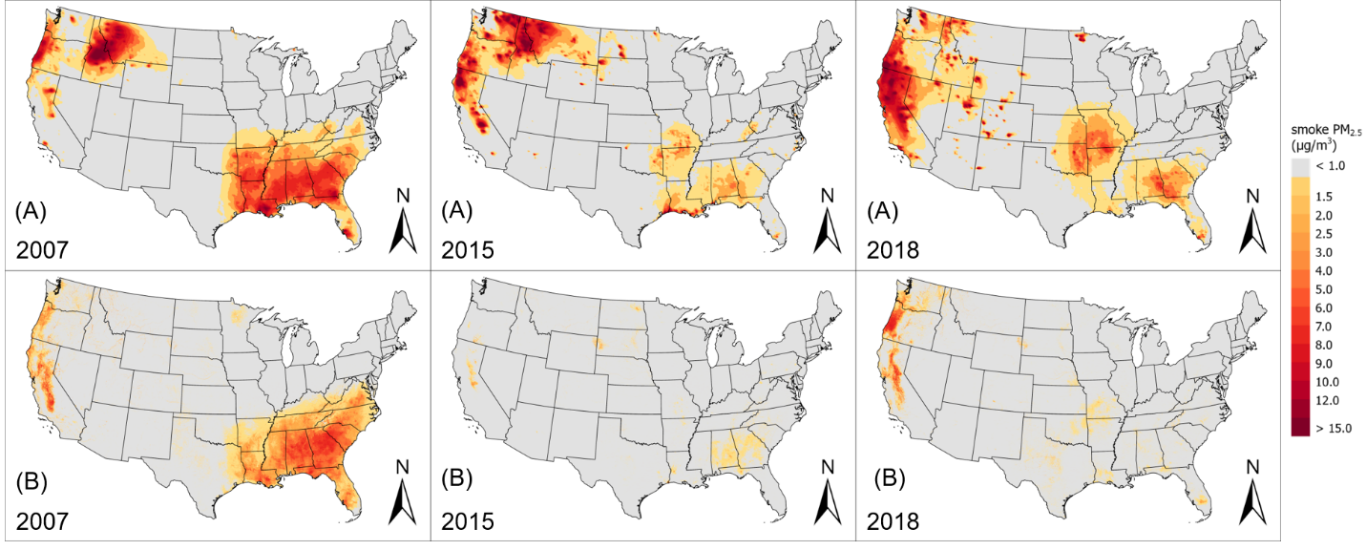
Figure S5. (Panel A) Interpolated CMAQ simulations of smoke PM_{2.5} in 2007, 2015 and 2018. (Panel B) Annual smoke PM_{2.5} predictions in 2007, 2015 and 2018 from models without PurpleAir measurements.

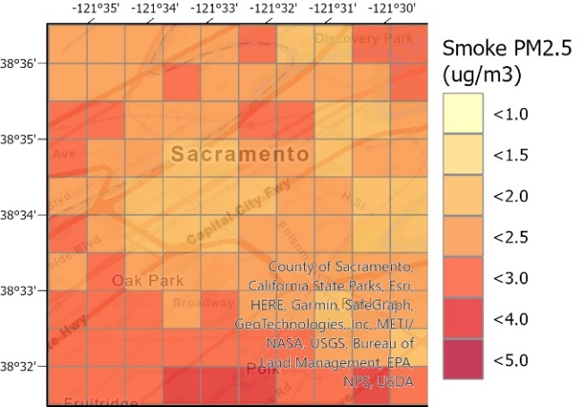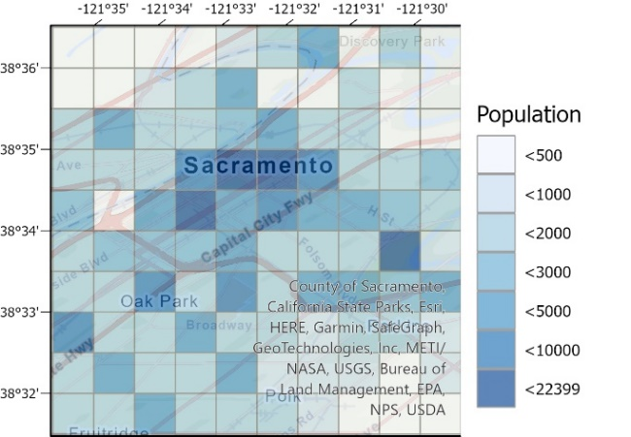
Figure S6. 2018 annual level smoke PM_{2.5} prediction distributions in the 100 km² area in Sacramento, California (left). Population count at 1 km resolution in the same area (right).

Table S1. Variables Used in Random Forest Models
Ground Monitors | EPA PM_{2.5} observations, Type: continues, Unit: g/m³
Ground Monitors | PurpleAir PM_{2.5} observations, Type: continues, Unit: g/m³
CMAQ Simulations | Total PM_{2.5} simulations, Type: continues, Unit: g/m³
CMAQ Simulations | Background PM_{2.5} simulations, Type: continues, Unit: g/m³
MAIAC AOD | Gap-filled AOD, Type: continues, Unit: dimensionless
MAIAC AOD | Gap-filling indictor, Type: categorical, 0 = observed, 1 = gap-filled
Cloud fractions | Cloud fraction, Type: continues, Unit: dimensionless
Meteorological factors | Air temperature, Type: continues, Unit: K
Meteorological factors | Specific humidity, Type: continues, Unit: kg/kg
Meteorological factors | Surface pressure, Type: continues, Unit: Pa
Meteorological factors | Surface downward longwave radiation, Type: continues, Unit: W/m²
Meteorological factors | Surface downward shortwave radiation, Type: continues, Unit: W/m²
Meteorological factors | U wind component, Type: continues, Unit: m/s
Meteorological factors | V wind component, Type: continues, Unit: m/s
Meteorological factors | Total precipitation, Type: continues, Unit: dimensionless
Meteorological factors | Potential evaporation, Type: continues, Unit: kg/m²
Meteorological factors | Planetary boundary layer height, Type: continues, Unit: m
HMS data | Total duration time, Type: continues, Unit: minute
HMS data | Average smoke density, Type: continues, Unit: mg/m³
Land use data | Water fraction, Type: continues, Unit: dimensionless
Land use data | Developed fraction, Type: continues, Unit: dimensionless
Land use data | Barren fraction, Type: continues, Unit: dimensionless
Land use data | Forest fraction, Type: continues, Unit: dimensionless
Land use data | Shrubland fraction, Type: continues, Unit: dimensionless
Land use data | Herbaceous fraction, Type: continues, Unit: dimensionless
Land use data | Cultivated fraction, Type: continues, Unit: dimensionless
Land use data | Wetland fraction, Type: continues, Unit: dimensionless
Land use data | Population, Type: continues, Unit: dimensionless
Land use data | Highway length, Type: continues, Unit: m
Land use data | Primary road length, Type: continues, Unit: m
Land use data | Secondary road length, Type: continues, Unit: m
Land use data | Tertiary road length, Type: continues, Unit: m
Land use data | Local road length, Type: continues, Unit: m
Elevation | Elevation, Type: continues, Unit: m
Climate regions | Climate region, Type: categorical, 1-Central, 2-East North Central, 3-Northeast, 4-Northwest, 5-South, 6-Southeast, 7-Southwest, 8-West, 9-West North Central

Table S2. Summaries of overall, spatial and temporal 20-fold CV for models in the smoke-impacted and no-smoke regions
Smoke-impacted Model |  | N | R² | RMSE | Intercept | Slope
Daily | Random 20-fold CV | 1,657,449 | 0.75 | 4.59 | -0.89 | 1.06
Daily | Spatial 20-fold CV | 1,657,449 | 0.59 | 5.88 | -1.35 | 1.07
Daily | Temporal 20-fold CV | 1,657,449 | 0.67 | 5.18 | -0.68 | 1.05
Monthly | Random 20-fold CV | 175,903 | 0.84 | 2.66 | -1.07 | 1.08
Monthly | Spatial 20-fold CV | 175,903 | 0.67 | 3.82 | -1.89 | 1.12
Monthly | Temporal 20-fold CV | 175,903 | 0.79 | 3.00 | -1.21 | 1.10
No-smoke Model |  | N | R² | RMSE | Intercept | Slope
Daily | Random 20-fold CV | 2,003,085 | 0.68 | 3.35 | -0.86 | 1.09
Daily | Spatial 20-fold CV | 2,003,085 | 0.47 | 4.30 | -0.96 | 1.07
Daily | Temporal 20-fold CV | 2,003,085 | 0.63 | 3.59 | -0.70 | 1.07
Monthly | Random 20-fold CV | 175,281 | 0.78 | 2.08 | -0.72 | 1.09
Monthly | Spatial 20-fold CV | 175,281 | 0.54 | 2.98 | -1.00 | 1.09
Monthly | Temporal 20-fold CV | 175,281 | 0.74 | 2.24 | -0.65 | 1.08

Table S3. Estimated number of AQS monitors that would fall into nonattainment areas by the proposed PM_{2.5} standard (annual mean, averaged over 3 years).
Yearª | AQS monitors w/ total PM2.5 ≥ 9 µg/m3 | AQS monitors w/ background PM2.5 ≥9 µg/m3 | AQS monitors w/ total PM2.5 ≥10 µg/m3 | AQS monitors w/ background PM2.5 ≥10 µg/m3
2009 | 55% | 46% | 42% | 38%
2010 | 54% | 47% | 40% | 36%
2011 | 58% | 51% | 45% | 40%
2012 | 58% | 49% | 44% | 37%
2013 | 57% | 48% | 45% | 37%
2014 | 53% | 44% | 39% | 33%
2015 | 48% | 39% | 33% | 27%
2016 | 37% | 30% | 20% | 16%
2017 | 39% | 28% | 21% | 15%
2018 | 45% | 33% | 27% | 20%
Average | 50% | 41% | 36% | 30%
ª Annual mean indicates the averages of previous three years (i.e. annual mean in 2009 is averaged over 2007-2009).

Table S4. Estimated population affected by the proposed PM_{2.5} standard (annual mean, averaged over 3 years).
Yearª | Population in nonattainment areas w/ total PM_{2.5} ≥ 9 µg/m³ (million) | Population in nonattainment areas w/ background PM_{2.5} ≥9 µg/m³ (million) | Population in nonattainment areas w/ total PM_{2.5} ≥10 µg/m³ (million) | Population in nonattainment areas w/ background PM_{2.5} ≥10 µg/m³ (million)
2009 | 199.01 | 176.73 | 153.45 | 137.41
2010 | 197.00 | 177.29 | 143.81 | 132.15
2011 | 215.93 | 191.76 | 164.78 | 144.70
2012 | 219.27 | 185.09 | 168.20 | 139.08
2013 | 225.27 | 192.81 | 176.82 | 148.74
2014 | 214.34 | 182.20 | 155.63 | 132.47
2015 | 197.18 | 166.16 | 132.06 | 109.22
2016 | 153.73 | 128.79 | 83.81 | 68.73
2017 | 167.62 | 125.18 | 90.91 | 68.83
2018 | 187.47 | 146.33 | 113.21 | 87.03
Average | 197.68 | 167.23 | 138.27 | 116.83
ª Annual mean indicates the averages of previous three years (i.e. annual mean in 2009 is averaged over 2007-2009).

SI References

1. A. Lyapustin, Y. Wang, S. Korkin, D. Huang, MODIS Collection 6 MAIAC algorithm. Atmos. Meas. Tech. 11, 5741-5765 (2018).
2. A. Lyapustin, Wang, Y (2018) MCD19A2 MODIS/Terra+Aqua Land Aerosol Optical Depth Daily L2G Global 1km SIN Grid V006. (NASA EOSDIS Land Processes DAAC).
3. J. Bi et al., Impacts of snow and cloud covers on satellite-derived PM2. 5 levels. Remote sensing of environment 221, 665-674 (2019).
4. M. Stafoggia et al., Estimation of daily PM10 and PM2.5 concentrations in Italy, 2013–2015, using a spatiotemporal land-use random-forest model. Environment International 124, 170-179 (2019).
5. A. Inness et al., The CAMS reanalysis of atmospheric composition. Atmos. Chem. Phys. 19, 3515-3556 (2019).
6. S. Platnick, S. A. Ackerman, M. D. King, K. Meyer, W. P. Menzel, R. E. Holz, B. A. Baum, and P. Yang (2015) MODIS atmosphere L2 cloud product (06_L2). (NASA MODIS Adaptive Processing System, Goddard Space Flight Center).
7. S. Platnick, S. Ackerman, M. King, G. Wind, K. Meyer, P. Menzel, R. Frey, R. Holz, B. Baum, and P. Yang, MODIS atmosphere L2 cloud product (06_L2). 10.5067/MODIS/MOD06_L2.006; 10.5067/MODIS/MYD06_L2.006 (2015).
8. S. Ackerman et al., Cloud detection with MODIS. Part II: validation. Journal of Atmospheric and Oceanic Technology 25, 1073-1086 (2008).
9. Hazard Mapping System Fire and Smoke Product. https://www.ospo.noaa.gov/Products/land/hms.html.
10. NLDAS-2 Forcing Dataset Information. https://ldas.gsfc.nasa.gov/nldas/v2/forcing.
11. G. D. Fedor Mesinger, Eugenia Kalnay, Kenneth Mitchell, Perry C. Shafran, Wesley, D. J. Ebisuzaki, Jack Woollen, Eric Rogers, Ernesto H. Berbery, Michael B. Ek, Yun, R. G. Fan, Wayne Higgins, Hong Li, Ying Lin, Geoff Manikin, David Parrish, and, W. Shi, A long-term, consistent, high-resolution climate dataset for the North American domain, as a major improvement upon the earlier global reanalysis datasets in both resolution and accuracy. the Bulletin of the American Meteorological Society (2004).
12. J. Dewitz, and U.S. Geological Survey (2021) National Land Cover Database (NLCD) 2019 Products (ver. 2.0, June 2021): U.S. Geological Survey data release.
13. A. Rose, Weber, E., Moehl, J., Laverdiere, M., Yang, H., Whitehead, M., Trombley, N., Sims, K., Whitlock, C., & Bhaduri, B (2019) LandScan USA 2018. (Oak Ridge National Laboratory).
14. J. R. Meijer, Huijbregts, M.A.J., Schotten, C.G.J. and Schipper, A.M., Global patterns of current and future road infrastructure. Environmental Research Letters 13-064006 (2018).
15. NASA/METI/AIST/Japan Spacesystems and U.S./Japan ASTER Science Team (2019) ASTER Global Digital Elevation Model V003 (NASA EOSDIS Land Processes DAAC).
16. K. R. Baker et al., Contribution of regional-scale fire events to ozone and PM2.5 air quality estimated by photochemical modeling approaches. Atmospheric Environment 140, 539-554 (2016).
17. P. D. Koman et al., Mapping Modeled Exposure of Wildland Fire Smoke for Human Health Studies in California. Atmosphere (Basel) 10 (2019).

