Supplementary Material

xCT as a potential marker for neuroendocrine cells in high-risk prostate cancer and the relation to AL122023.1-miR-26a/30d/30e axis
Elena D. Wilhelm¹, Marc Wiesehöfer¹, Jaroslaw T. Dankert¹, Sven Wach², Mathias Wagner³, Martin Spahn^{4,5}, Marianna Kruithof de Julio^{6,7}, and Gunther Wennemuth^{1,}*
* Correspondence: Gunther Wennemuth: gunther.wennemuth@uk-essen.de

Supplementary Data

Supplementary Figures
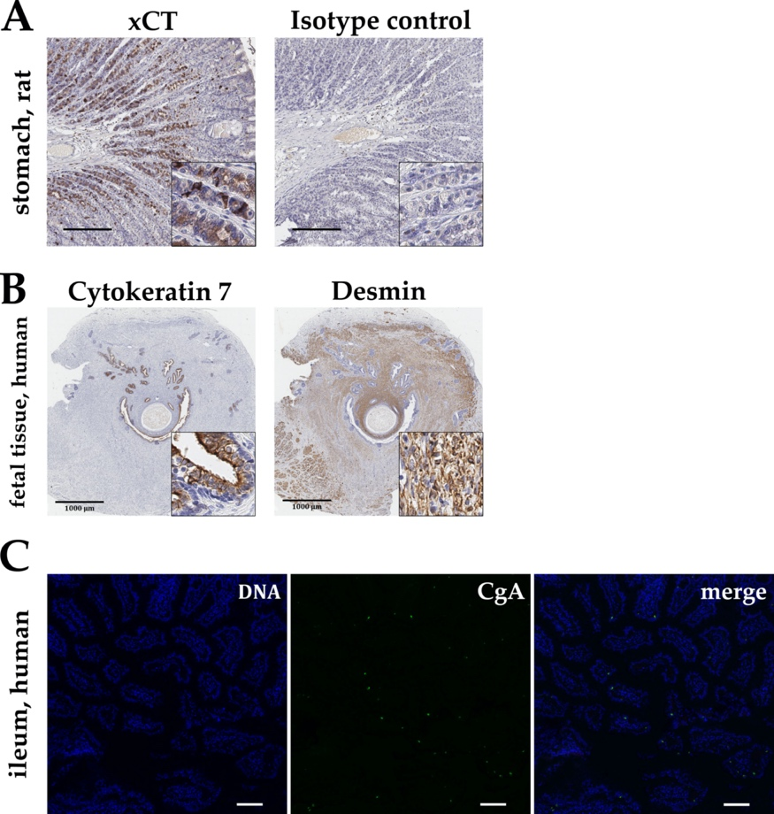
Figure S1. Immunohistochemistry and immunofluorescence for the confirmation of antibody specificity using formalin fixed and paraffin embedded tissue (A) Rabbit-anti-xCT antibody staining using rat stomach tissue as positive control. For negative or isotype controls, IgG fraction of non-immunized rabbits or mouse anti-rat-CEACAM1 (IgG κ) were used (both kindly provided by B. B. Singer). Scale bar, 200 μm. (B) Representative immunohistochemistry of fetal prostate tissue with anti-cytokeratin 7 antibody to detect glandular epithelium and anti-desmin antibody to identify muscle cells in the stroma. Scale bar, 1000 μm. (C) For mouse-anti-CgA antibody, human ileum served as positive tissue control. Scale bar, 100 μm.
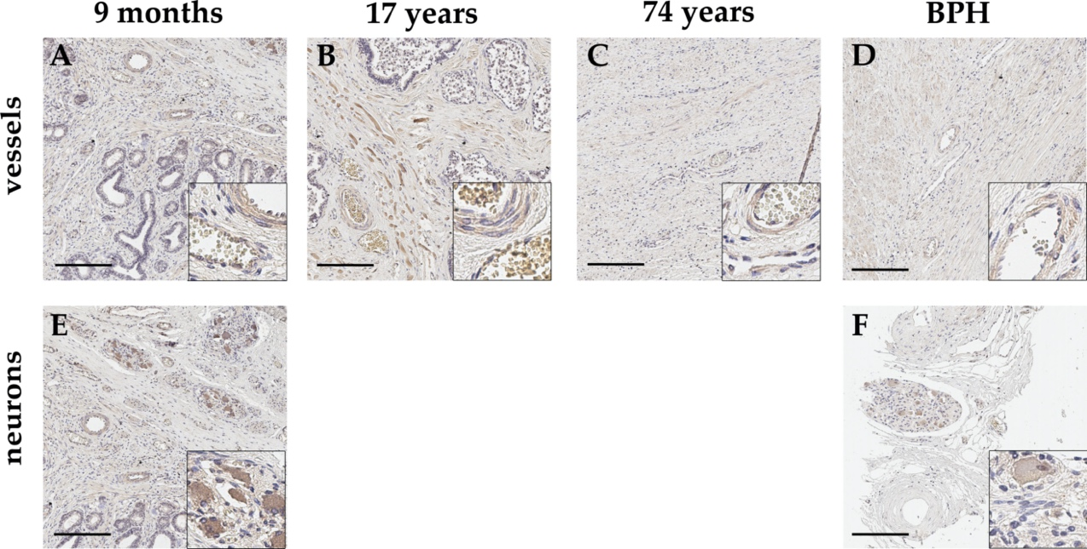
Figure S2. Representative immunohistochemical staining with anti-xCT antibody of healthy prostate tissue of different donor age (A-C, E) and BPH (D,F). The endothelium of small vessels appears weakly xCT-positive (A-D) while perikarya of neurons show a more distinct staining (E-F). Scale bar, 200 μm.

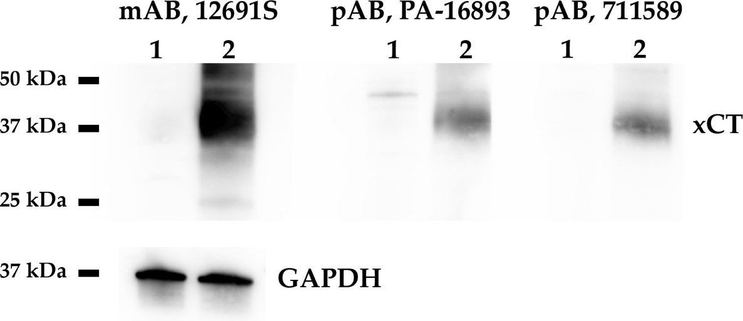
Figure S3. Western Blot analyses of xCT antibody specificity with HEK293T cell lysates (1, control transfection with empty vector; 2, xCT overexpression) using different anti-xCT-antibodies (from left to right; 12691S (clone D2M7A), Cell Signaling; PA1-16893, Invitrogen; #711589 (clone 3HCLC), Invitrogen). xCT can be uniquely identified with a molecular weight of 35 kDa. GAPDH (36 kDa) served as loading control. mAB, monoclonal antibody; pAB, polyclonal antibody.

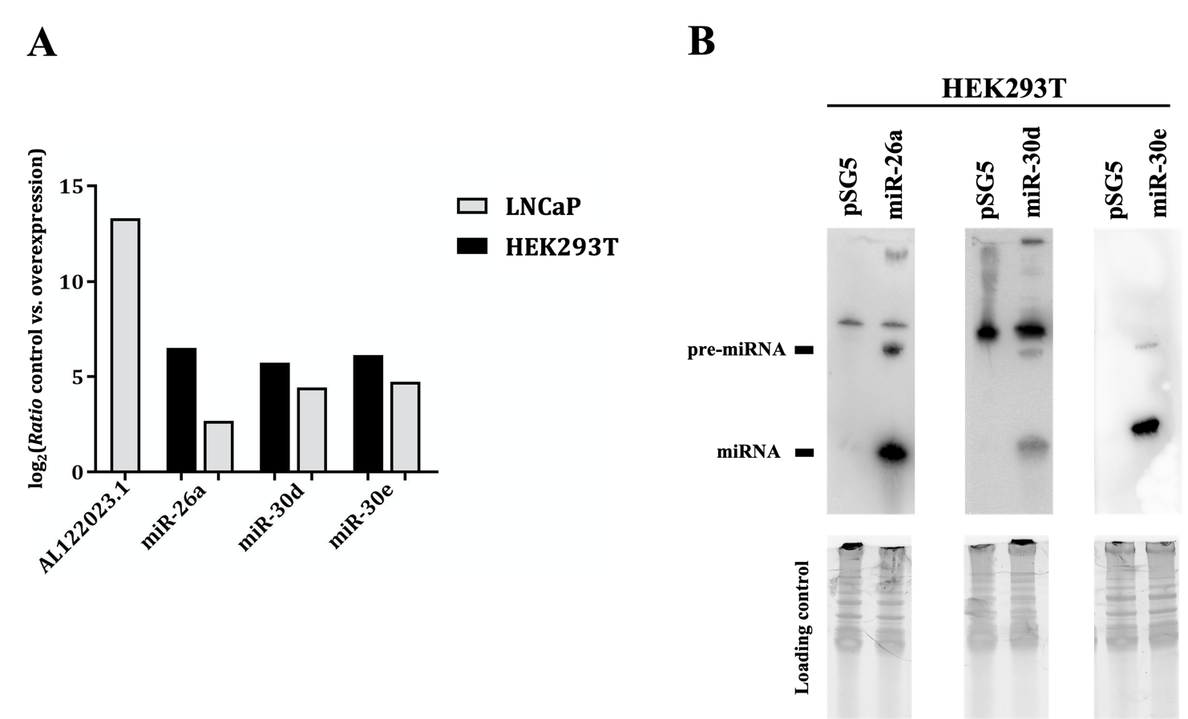
Figure S4. Verification of functional plasmids for pcDNA3.1-AL122023.1, pSG5-miR-26a, pSG5-miR-30d and pSG5-miR-30e on RNA level. (A) Validation of overexpression of miRNAs and AL122023.1 in LNCaP cells and HEK293T cells by quantitative real-time PCR. (B) Northern Blot results of miRNA overexpression in HEK293T cells. The empty effector plasmid pSG5 served as negative control. RNA was priorly visualized by GelRed and UV light to control the loading effectiveness.

Supplementary Tables
Table S1. Oligonucleotide pairs and resulting fragment size for quantitative real-time PCR.
Gene | Sequence (5’-3’), complementary reverse | Amplicon size (bp)
5‘AL122023.1 | CATGGGATTCTAAACACCGTATTG | 83
3‘AL122023.1 | CATACTCAAGTCTGCCTGTCC | 83
5‘ GAPDH | TGGAGAAGGCTGGGGCTCAT | 176
3‘ GAPDH | GACCTTGGCCAGGGGTGCTA | 176
5‘ HPRT1 | GCATACCTAATCATTATGCTGAGG | 87
3‘HPRT1 | CTCGAGCAAGACGTTCAGTC | 87
5‘ SLC7A11/xCT | TCATGTCCGCAAGCACACTCC | 210
3‘ SLC7A11/xCT | GGGATGAACAGTGGCACCTTGA | 210
For amplification of miRNAs as well as 5S rRNA (reference gene), the following oligonucleotide pairs were purchased from Qiagen (Hilden, Germany): hsa-miR-26a-5p (YP00206023), hsa-miR-30d-5p (YP00206047), hsa-miR-30e-5p (YP00204714), and 5S rRNA (YP00203906).
Table S2. 5’ biotinylated probes for Northern Blotting (purchased from Eurofins, Ebersberg, Germany).
miRNA | Sequence (5’-3’), antisense reverse
miR-26a-1-5p | AGCCUAUCCUGGAUUACUUGAA
miR-30d-5p | CUUCCAGUCGGGGAUGUUUACA
miR-30e-5p | CUUCCAGUCAAGGAUGUUUACA

Table S3. Oligonucleotide sequences with highlighted cut site for restriction endonucleases (underlined) for cloning into the target vector and resulting fragment size.
Vector | Gene and restriction endonuclease | Sequence (5’-3’) | Fragment size
pMIR | 5’ AL122023.1_SpeI  3’ AL122023.1_SacI | cgACTAGTcagtgtccacctcttgttcc  cgGAGCTCcttctattgttgttgatacc | 548
pMIR | 5’AL122023.1_mut_SpeI  3’AL122023.1_mut_SacI | cgACTAGTcagtgtccacctcttgttcc  cgGAGCTCcggactgatcttatttaac | 446
pcDNA | 5’ AL122023.1_HindIII  3’ AL122023.1_EcoRI | cgAAGCTTagtgtccacctcttgttcc  cgGAATTCttctattgttgttgatacc | 546
pSG5 | 5‘ miR-26a_EcoRI  3‘ miR-26a_BamHI | cgGAATTCtgctgacccattcttgca  cgGGATCCccacaagactcctcgttgc | 423
pSG5 | 5‘ miR-30d_EcoRI  3‘ miR-30d_BamHI | cgGAATTCtaggagaaattgcacttggtga  cgGGATCCcacgctaagtctgggaagc | 466
pSG5 | 5‘ miR-30e_EcoRI  3‘ miR-30e_BamHI | cgGAATTCggagcaaagctgtgccttg  cgGGATCCggaactgacaggatgtgac | 714

