SUPPLEMENTAL INFORMATION 1

Description and Details on the WRF Implementation
The Weather Research and Forecasting (WRF) model, Version 4.2.1, was used to simulate the climatic conditions in Riyadh. The Mellor-Yamada-Janjić scheme (MYJ) [1-3] was used for the planetary boundary layer parameterization, combined with the Rapid Radiative Transfer Model for Global Circulation Models (RRTMG) scheme for longwave and shortwave radiation [4]. All grids in the domains were created following the Lambert projection The Noah land surface model (LSM) coupled with single-layer urban canopy model (UCM) was used for Land surface parameterization [5-6]. Modified Tiedtke scheme was applied for Cumulus parameterization [7-9]. Janjić surface-layer scheme [10] based on the Monin–Obukhov similarity theory was employed for the surface layer parameterization and Thompson scheme [11] was used for microphysics.
The datasets of Moderate Resolution Imaging Spectroradiometer (MODIS), i.e., 15s resolution land surface datasets, were used to represent the land surface. The urban grid cells were remapped using the remote sensing products from the U.S Geological Survey [12]. The Landsat 8 – with a resolution of 30m (spectrum band 1 to 11) were used to remap the urban categories from year 2015 to 2017. The urban geometry parameters and anthropogenic heat flux numbers were assigned to each of the three urban categories based on the existing literature. The meteorological boundary condition and initial condition are extracted from ERA interim datasets. Simulations were performed for three months during the summer period from 12:00 June 1st, 2018, to 18:00 Aug 31st, 2018.
The simulation domain was centred on the city of Riyadh, and three one-way nested domains with horizontal resolutions of 4.5 km, 1.5 km and 0.5 km were used. The outer two domains were used to provide boundary conditions for the innermost domain (Figures S1 and S2).
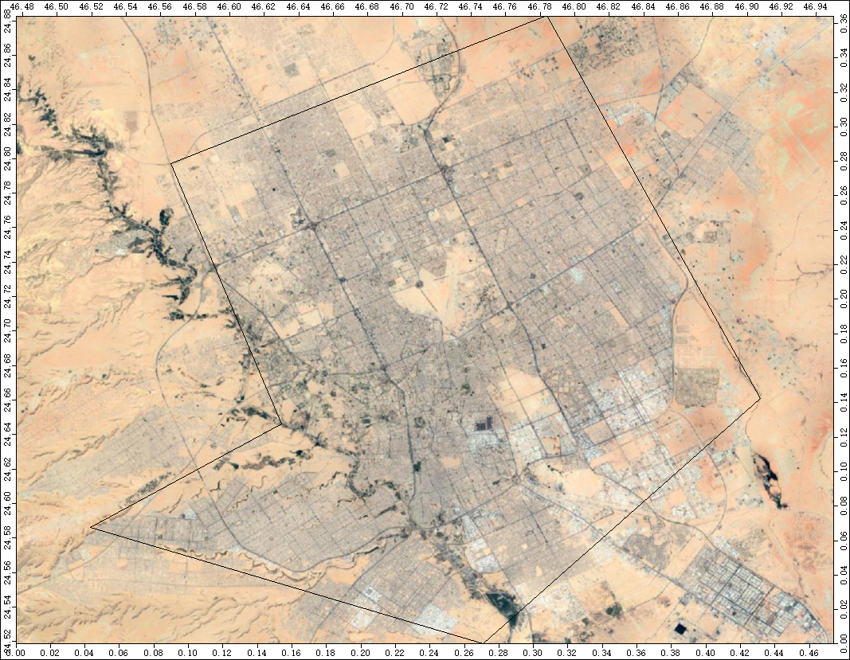
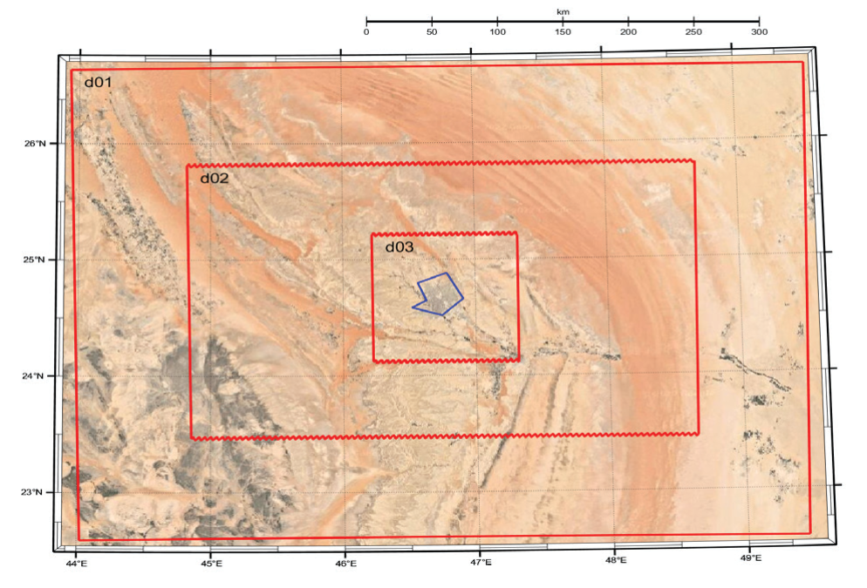 Figure S1. The Boundaries of the WRF domains (a), Boundaries of the urban area (b).
b)
a)

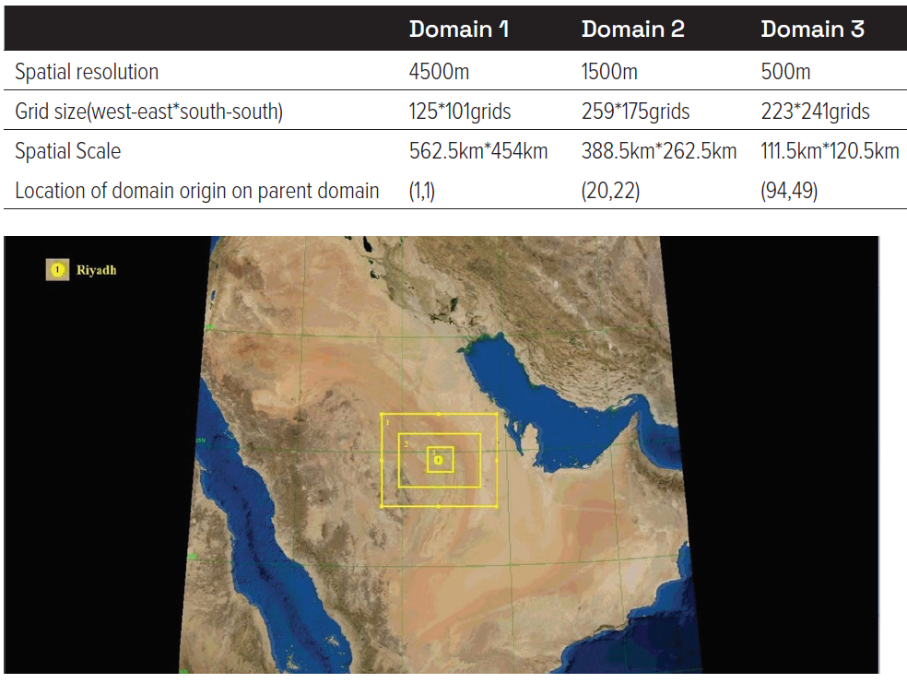
Figure S2. Details on the Boundaries of the WRF domains

Validation Data of the Reference Case
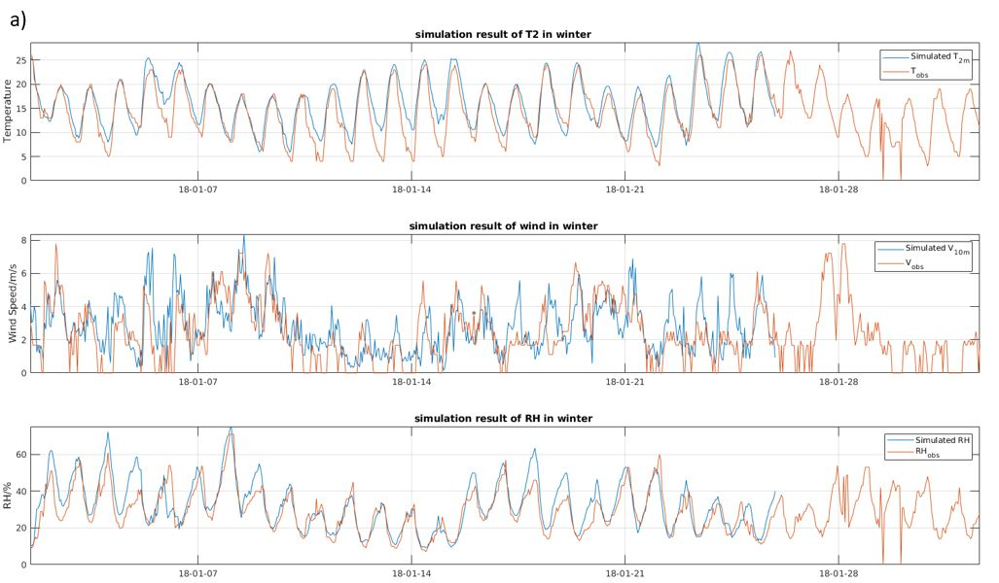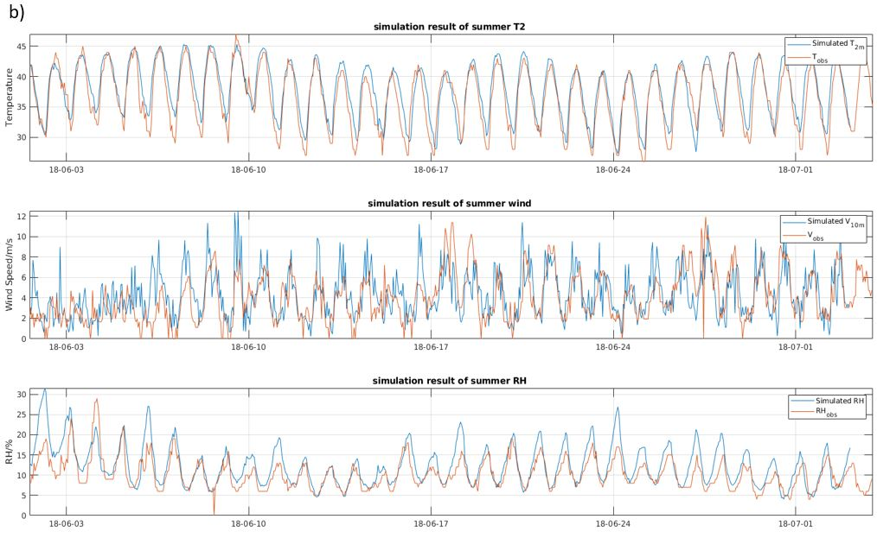
Figure S3. Khalid International airport station. Comparison of the simulated and measured ambient temperature, wind speed and Relative Humidity during a) The winter and b) the summer period

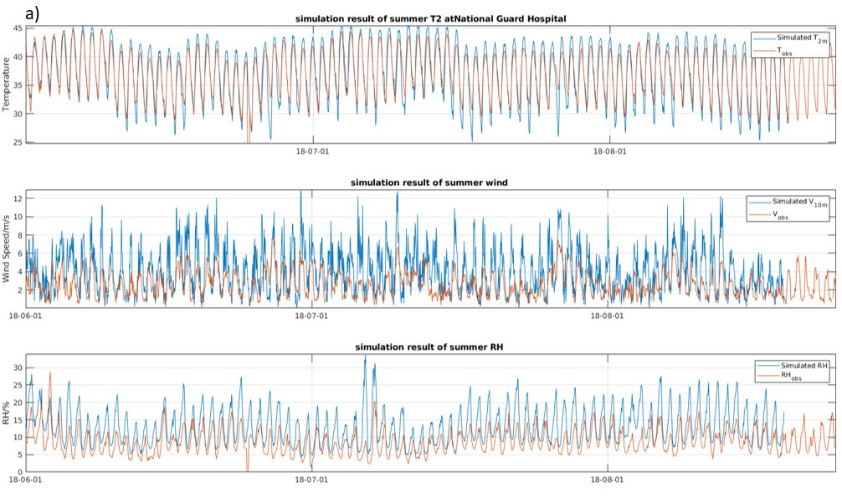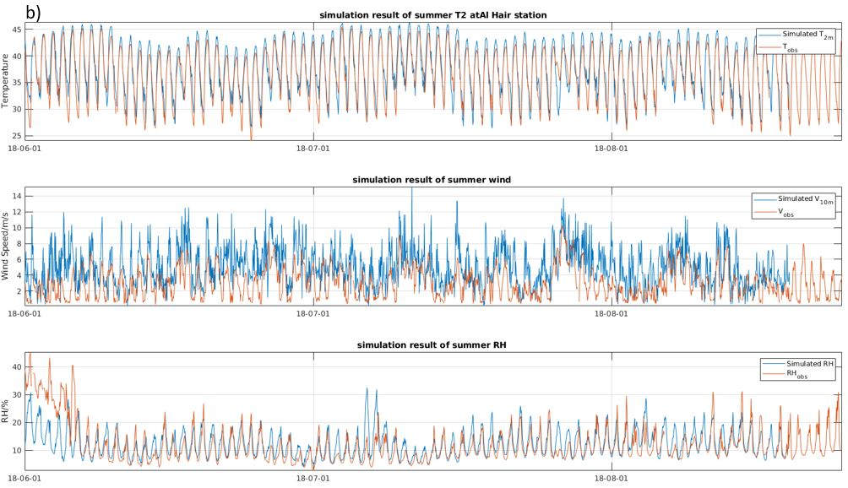
Figure S4. Measured and Simulated data of the summer ambient temperature, wind speed and relative humidity for a) The station at Guard Hospital and b) the Al Hair Station

Additional Data of Climatic Analysis
In addition to the urban heat island, a less known but not less relevant phenomenon is the urban moisture island. In desert climates, urban areas can be more humid than the xeric surroundings, while in temperate climates cities are typically drier than the non-urban adjacent zones. Here, we computed that the city is systematically drier than the reference non-urban areas, as captured by the reference stations. On average, the urban area contains less humidity than the air out of the city by 0.58 g/m³ of air, which corresponds to approximately 2.8% in relative humidity computed at 23.0°C. Drier conditions can be explained by increased evaporation within the urban area because of higher temperatures and the prevalence of impervious surfaces, with limited moisture capacity. Urban areas are also drier because the UHI induces the deviation of low-pressure circulation and therefore rainfall.

Study Area
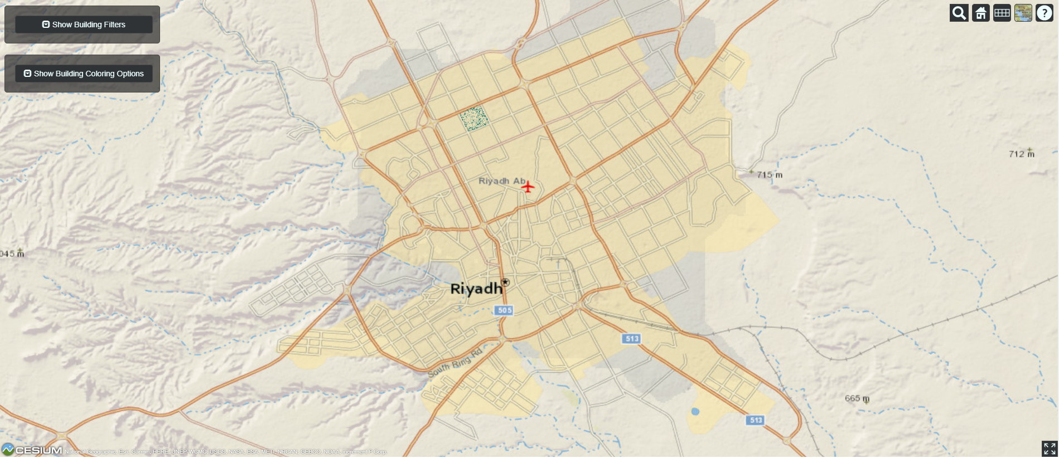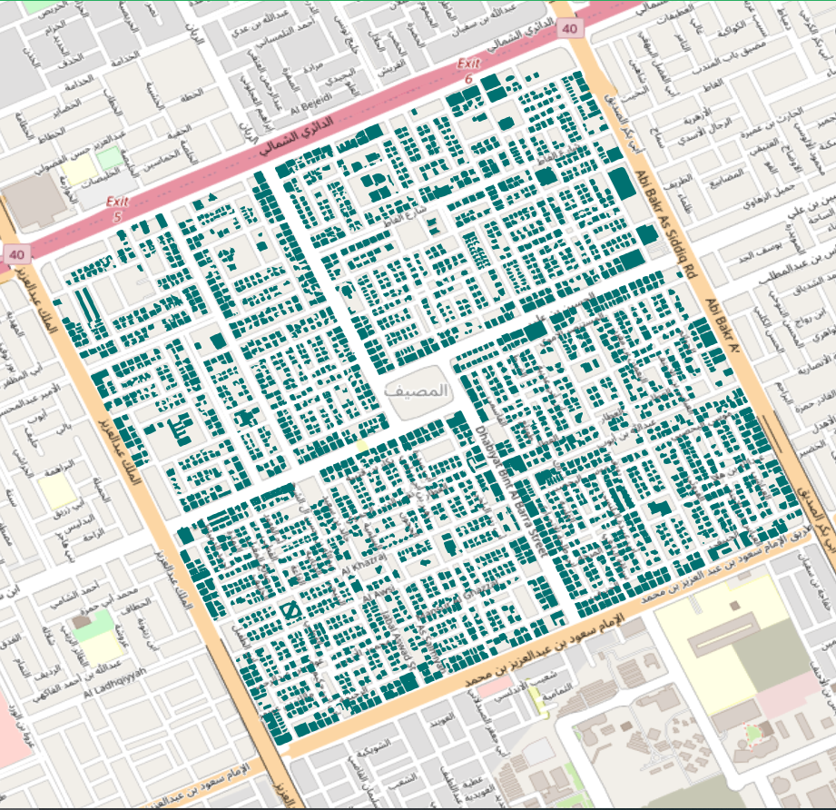

Figure S5. Location of Al-Masiaf precinct in Riyadh (left), distribution of buildings in Al-Masiaf precinct (right). Source: https://citybes.lbl.gov/

Implementation of CityBES
First, we created building dataset using GIS dataset in GeoJSON format, which consolidates city data in a format that can then be imported into the energy modelling tool. Table S1 shows the inputs used in the building dataset for the residential and office buildings in the selected precinct. CityBES processes the city GIS data to determine the buildings, shared walls, and weather file for each building. Then, each building is assigned the associated weather file and neighbourhood buildings as well as the GIS-based building footprint, year built, building type, building height, and number of stories. The neighbourhood buildings are modelled as shading surfaces in EnergyPlus to consider the solar overshadowing effect between buildings. The building performance is visualised by color-coding the 3D view of the buildings based on annual cooling electricity use intensity. CityBES generates sub-hourly load profiles for each building which we used to calculate cooling electricity use intensity during summer period.
Table S1. Building characteristics and inputs used for energy simulations in CityBES
Parameters | Residential | Office
Lighting power density (W/m²) | 5 | 12
Equipment power density (W/m²) | 5 | 10
Occupancy density (person/m²) | 0.02 | 0.14
Outdoor air flow per person (l/s.person) | 7 | 7
Infiltration flow rate per exterior wall area (l/s.m²) | 0.49 | 0.49
Roof insulation R-value (m² K/W) | 2.2 | 2.2
Roof solar reflectance | 0.20 | 0.20
Wall insulation R-value (m² K/W) | 1.3 | 1.3
Window u-value (W/m²K) | 5.6 | 5.6
Window SHGC | 0.36 | 0.36
Window visual transmittance | 0.7 | 0.7
HVAC system type id | Packaged single zone rooftop heat pump | Packaged single zone rooftop air conditioner
HVAC cooling COP* | 2.2 | 2.5
HVAC heating efficiency* | 1.5 | 1.5
HVAC fan efficiency* | 1 | 1
Heating setpoint (°C) | 20.0 | 20.0
Cooling setpoint (°C) | 24.0 | 24.0
*Note: Simulations were performed to calculate both cooling load (using cooling coefficient of performance (COP) of 1) and cooling energy use (normal/assigned COP reported in Table 2). In the simulations performed to derive cooling load, we considered HVAC cooling COP, HVAC heating efficiency, and HVAC fan efficiency equal to 1. All other parameters were kept unchanged.

Characteristics of the Local Climatic Stations and Analysis of Data
Table S2. Meteorological stations and metadata (gaps for air temperature). Metadata from provided by ArRiyadh Air Quality (http://195.66.100.41/aq/?site_id=5015).
Type | Station | Station name | Height (m) |  | Gaps T_{air}
Background | 1 | Prince Sultan Humanitarian City | 685 |  | 16.5%
Background | 2 | National Guard Hospital | 579 |  | 12.1%
Background | 3 | Al Hair | 498 |  | 9.4%
Background | 4 | Wadi Hanifa | 672 |  | 15.4%
Suburban | 5 | Al Aziziyah hospital | 585 |  | 12.8%
Suburban | 6 | Al Shifa | 616 |  | 7.4%
Suburban | 7 | Al Zamroud | 632 |  | 7.8%
Suburban | 8 | Al Amal | 591 |  | 12.7%
Suburban | 9 | Al Zahrah | 655 |  | 12.4%
Suburban | 10 | Al Mauroj | 638 |  | 7.0%
Suburban | 11 | King Faisal | 626 |  | 15.2%

Four of these stations measure the background at the boundaries of the city, while seven more urban stations collect data within Riyadh. Unrealistic values (i.e., wrong readings) were filtered performing the validation procedures detailed by Estevez et al. [13] performing the following tests, with context specific values:
- Range tests (e.g., relative humidity comprised between 0.8 and 100%);
- Step tests (e.g., ait temperature change of less than 12 ºC in one hour, or relative humidity variation not exceeding 45% in one hour);
- Persistence tests (e.g., steady values for long periods are filtered as equipment failure);
- Relational tests (i.e., if the wind speed is null, then the wind direction cannot be different from 0º).
To deal with the missing values [14] in the raw data recorded by weather stations, we linearly interpolated between values if the gaps accounted for maximum three hours similar to Paolini et al. [15] who used a Back-Propagated Neural Network to infill the gaps in the data series. For longer gap in the data series, we found an analytical relation between a quantity (e.g., air temperature) at one station and the same quantity measured by the three closest stations triangulating the target station, also as a function of the previous hours. We found these relations by means of the genetic programming software tool Heuristic Lab [16,17].

Magnitude of Urban Heat Island

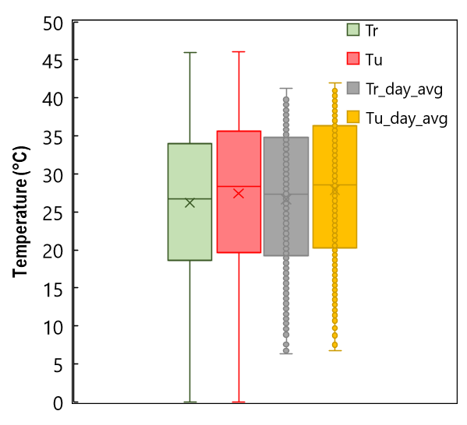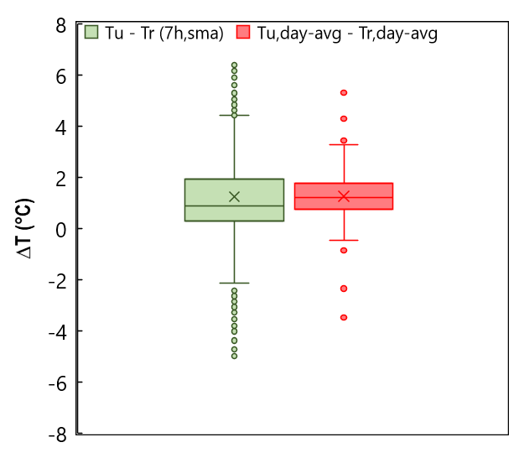
b)
a)
Figure S6. Boxplots of the ambient temperature in Riyadh. Temperature out of the city (T_{r}, average of the temperature recorded by the four reference stations), temperature within the city (T_{u}, average of the urban records), and daily averages of the reference and urban data (T_{r_day_avg} and T_{u_day_avg}) (a). Boxplot of the temperature difference (T_{r} – T_{u}, based on the 7-hour simple moving average of the urban and reference data) and difference between the daily averages (b).

Cooling Degree Hours
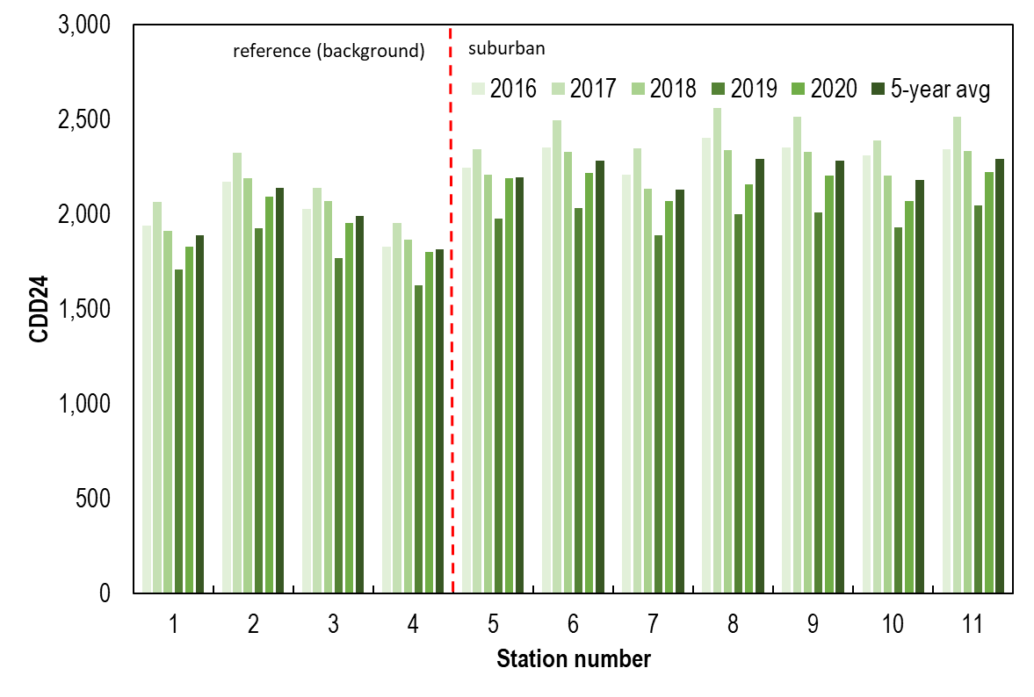
Figure S7. Bar plot of the Cooling Degree Days with base temperature of 24 °C (CDD24) for the five complete years of temperature records and the five-year average for the reference locations (background, Stations 1-4, Table S2) out of Riyadh and the suburban locations within Riyadh (Stations 5-11, Table S2)

Spatial Distribution of the Main Climatic Parameters Calculated by the Mesoscale Mode
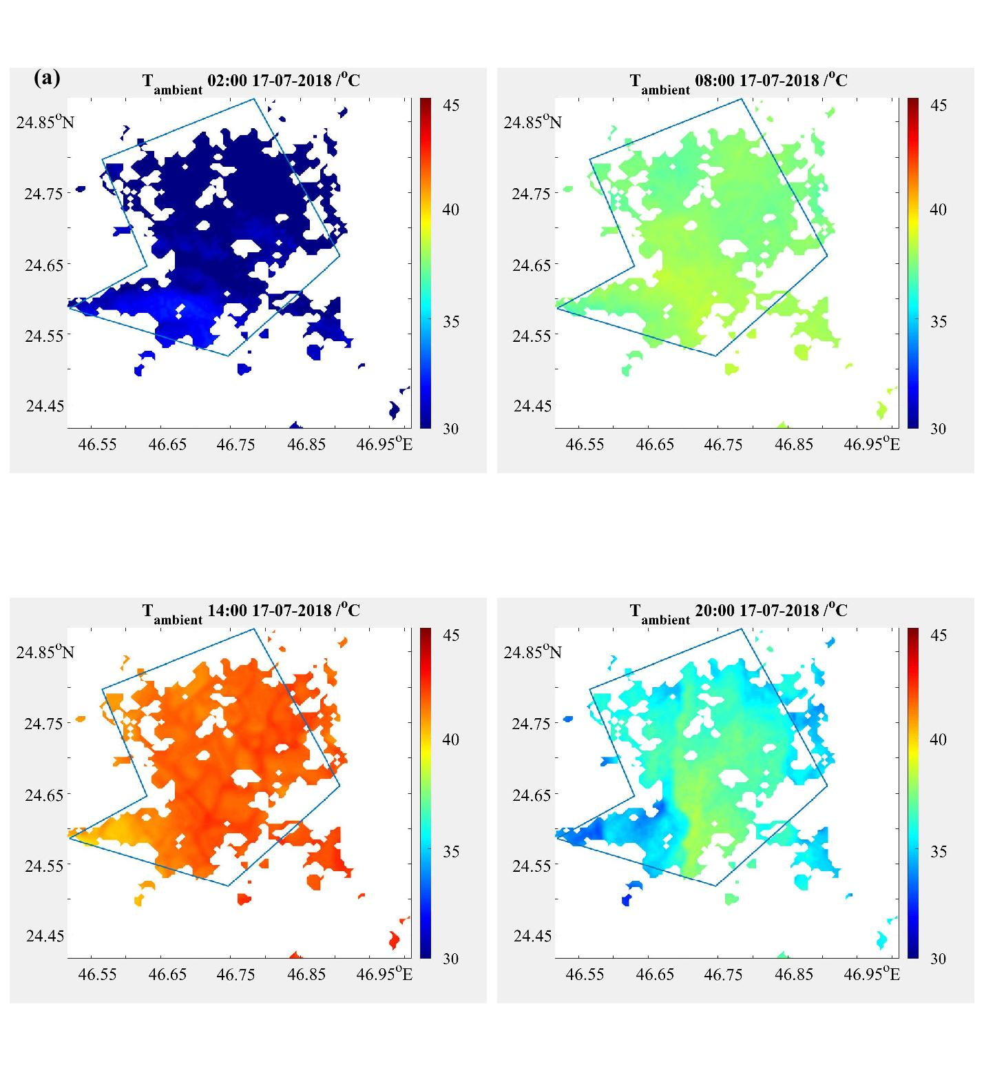
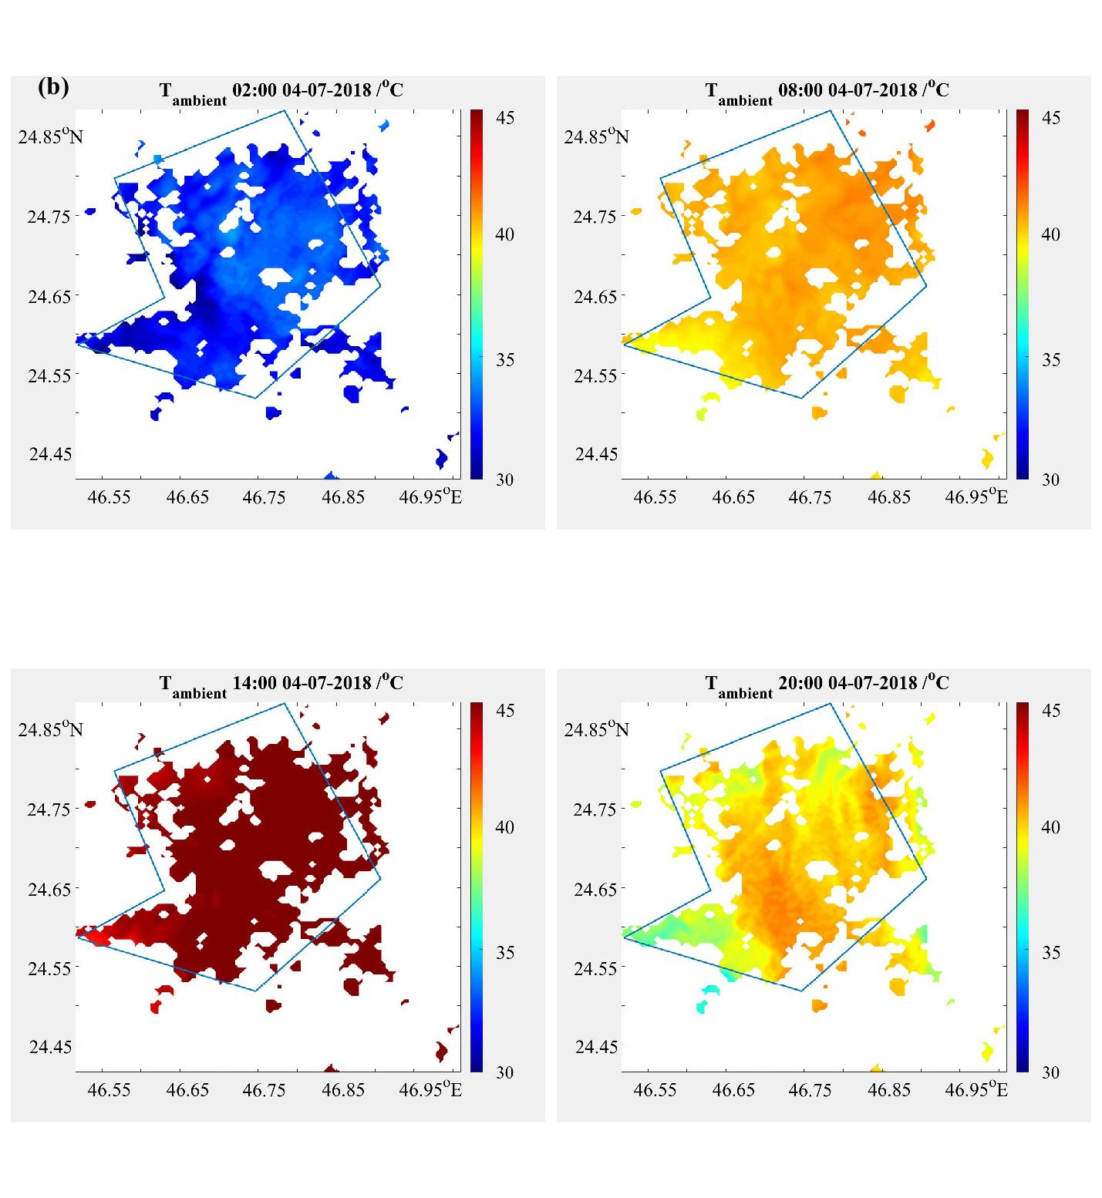
Figure S8. Air temperature distribution in the average summer day (a), in the hottest day (b).

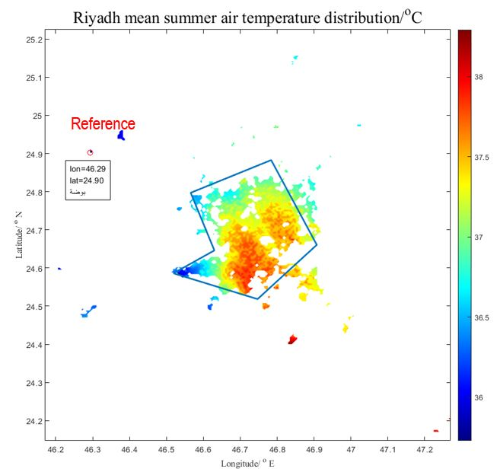
Figure S9. Average ambient temperature distribution during the entire simulation period

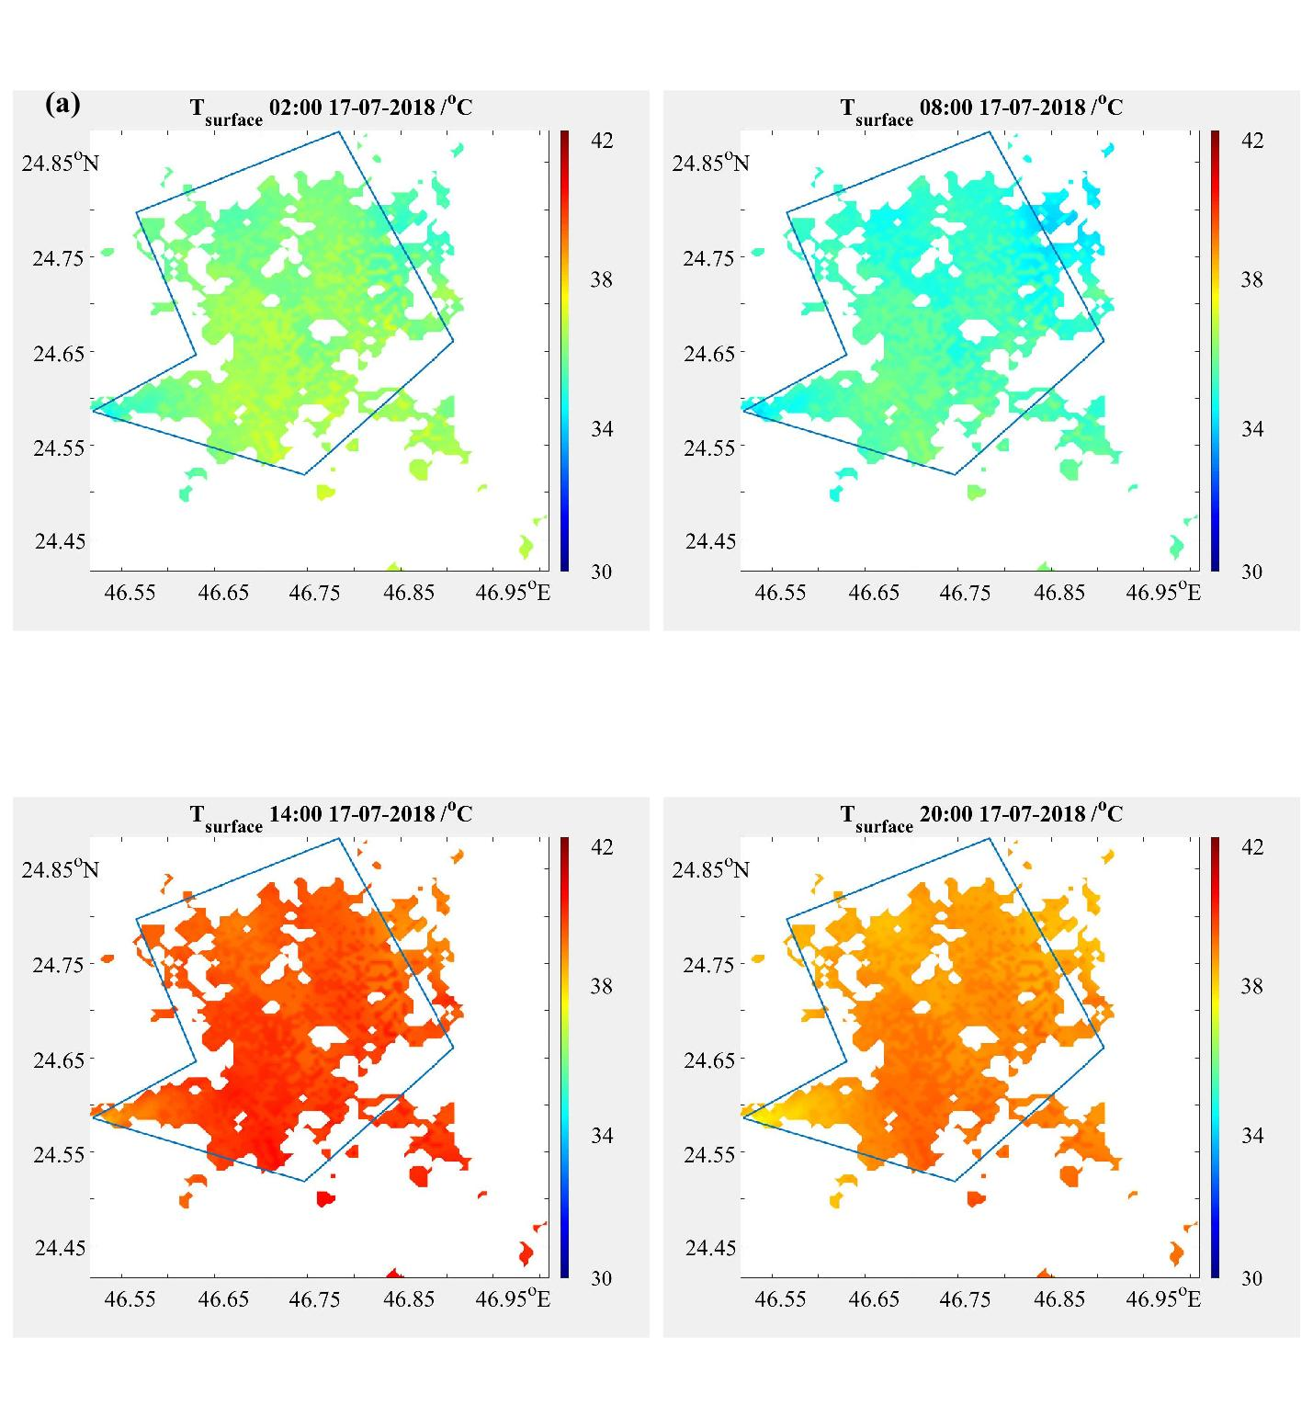
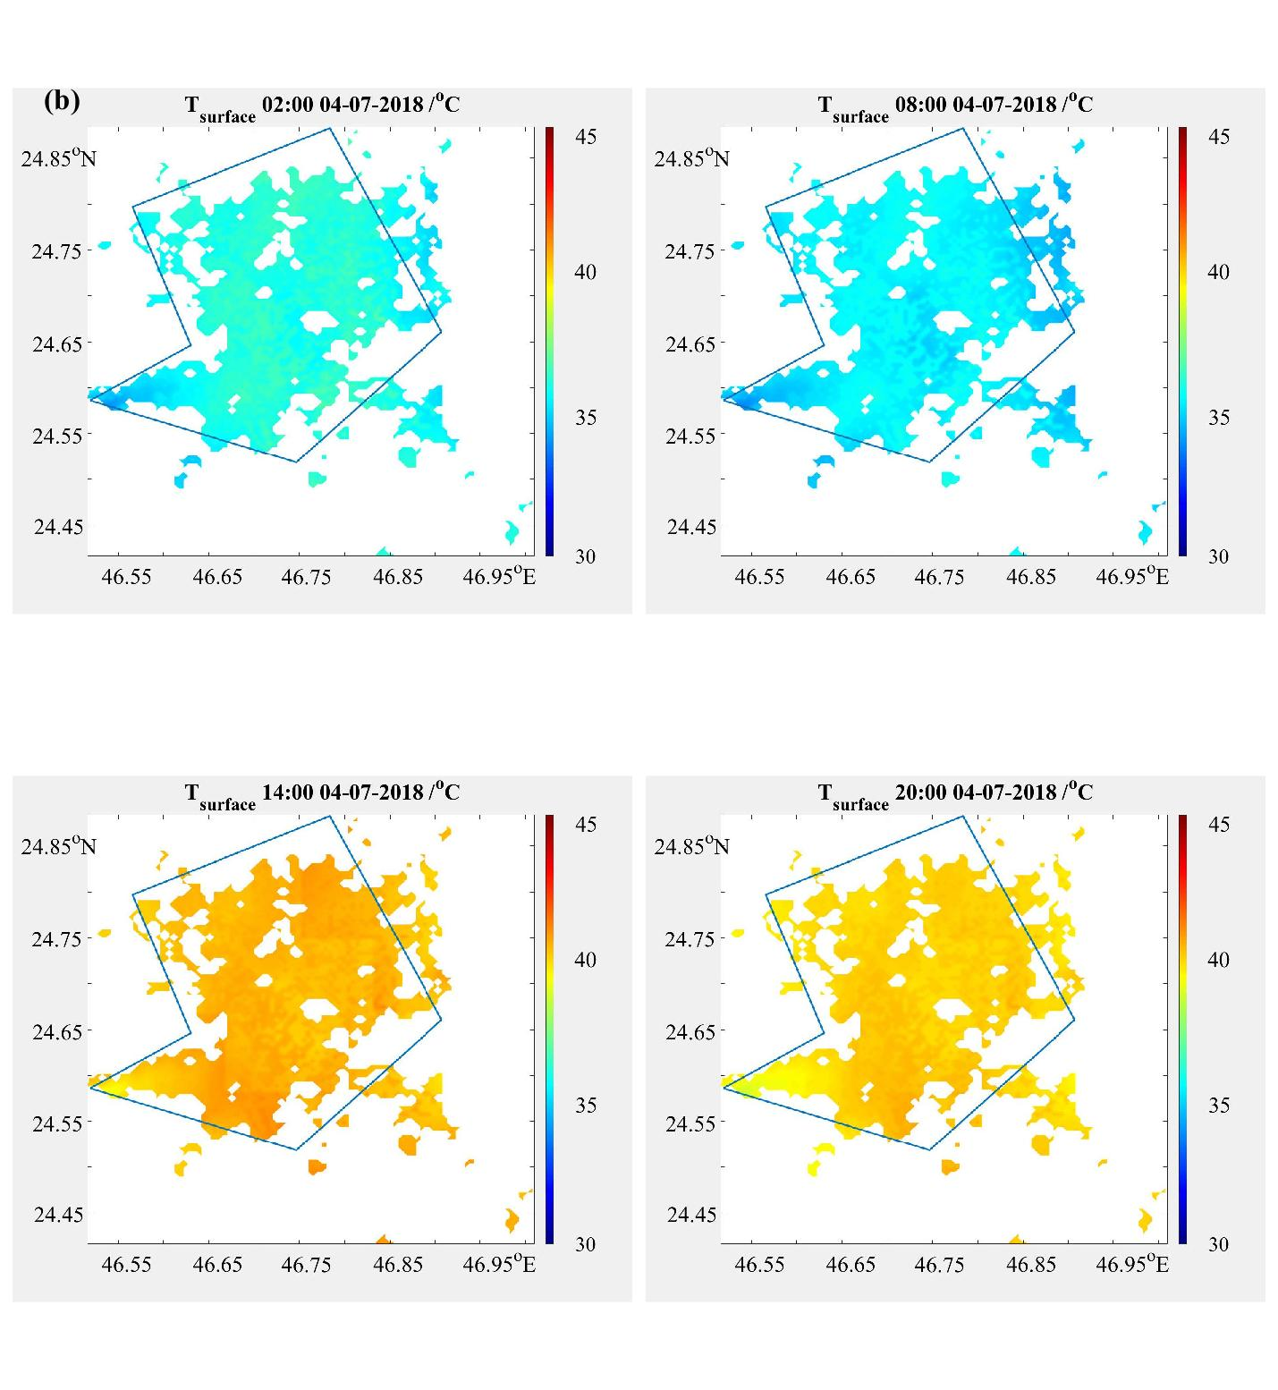
Figure S10. Surface temperature distribution in the average summer day (a), in the hottest day (b).

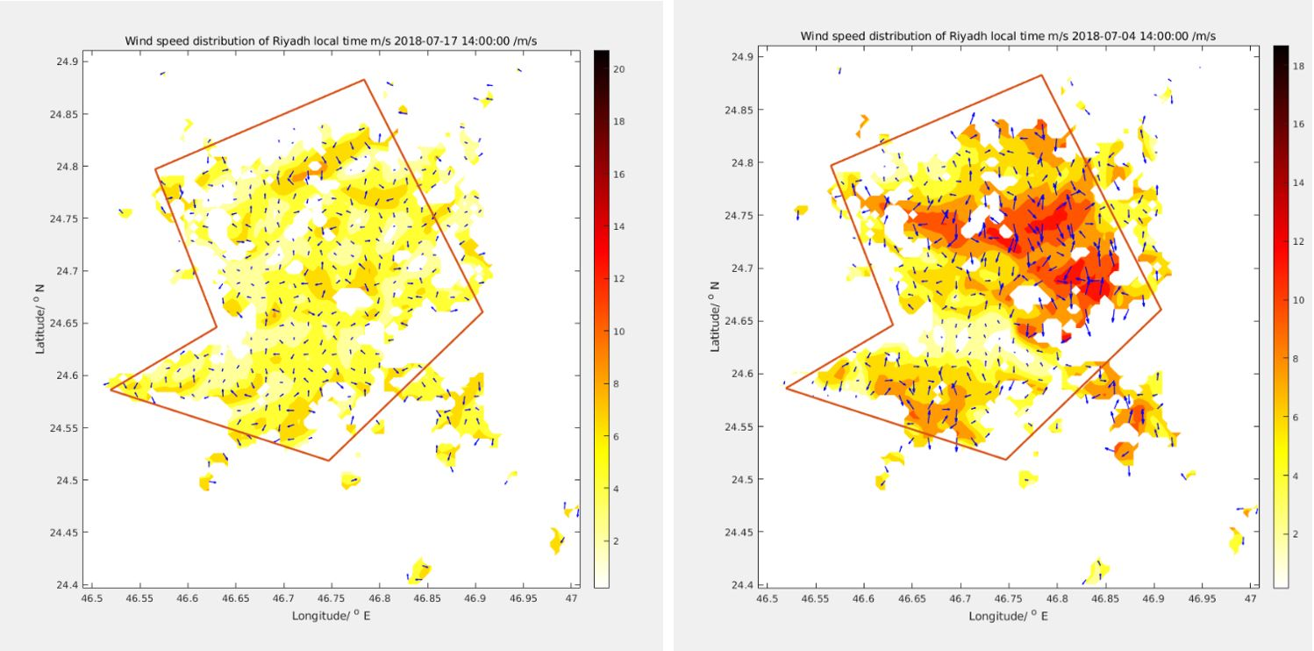
Figure S11. Wind speed/direction at 14:00 on July 17 (left)- average summer day and July 14 (right) hot summer day.

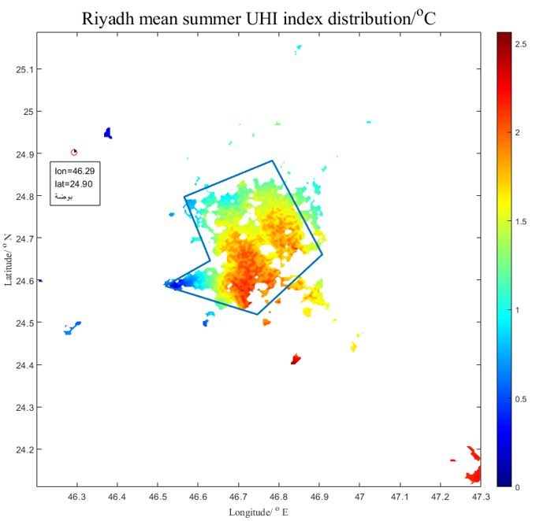
Figure S12. Average summer UHI intensity distribution
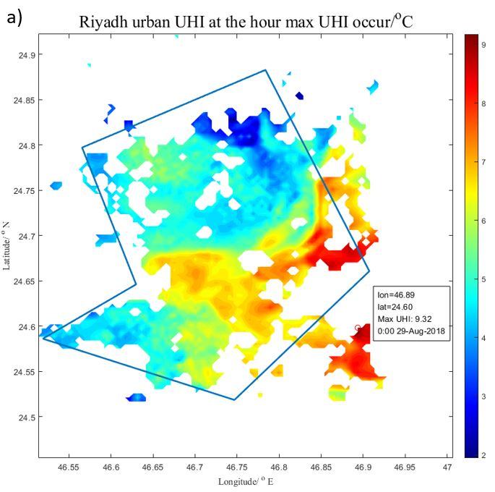
Figure S13. Spatial Distribution of the maximum UHI values.
Satellite Images

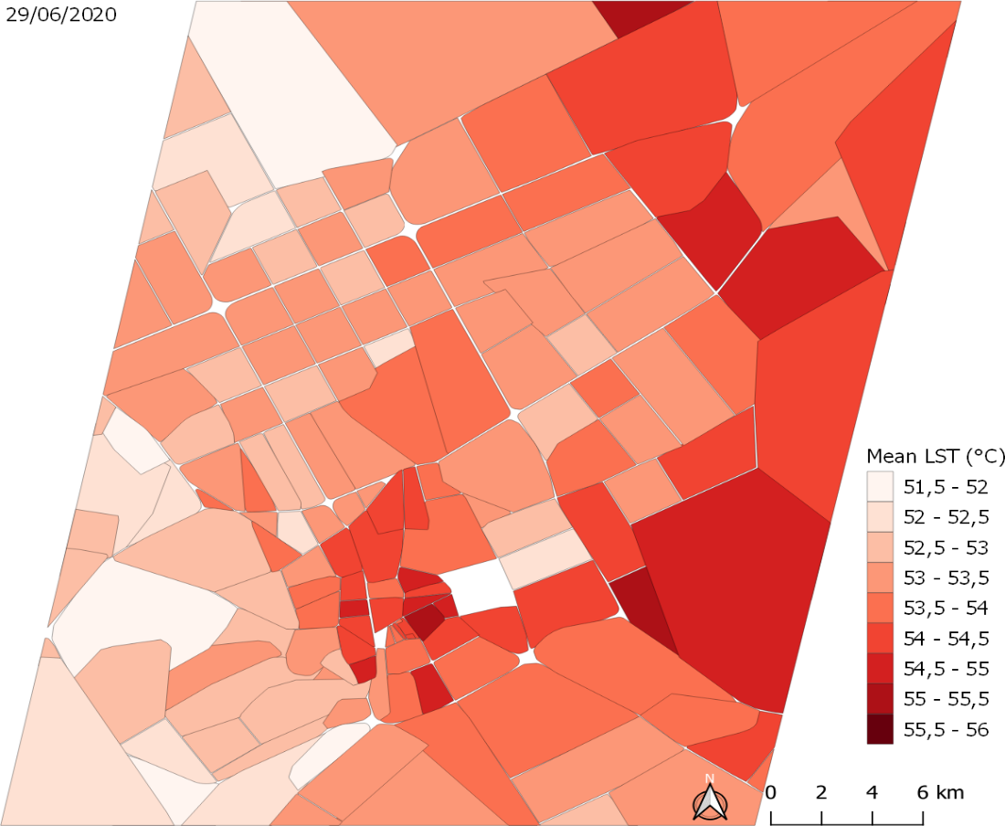
Figure S14. Mean daily Land Surface Temperature per district on 29/06/2020

Calculation of the Discomfort Index

Table S3. Parameter values used for the quantile classification
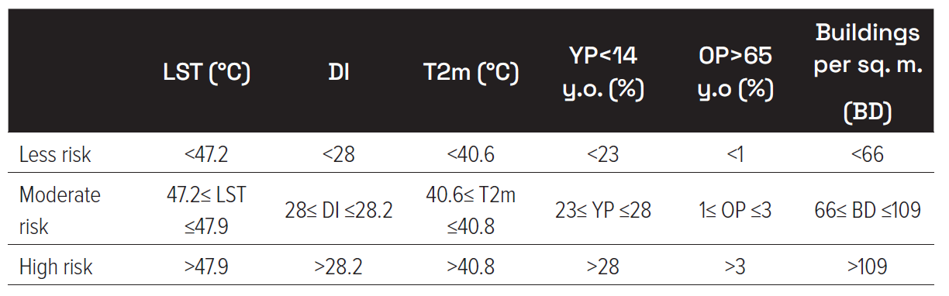

References
- Janjić, Z., The surface layer parameterization in the NCEP Eta Model. World Meteorological Organization-Publications-WMO TD, 1996: p. 4.16-4.17.
- Janjić, Z.I., The step-mountain coordinate: Physical package. Monthly weather review, 1990. 118(7): p. 1429-1443.
- Janić, Z.I., Nonsingular implementation of the Mellor-Yamada level 2.5 scheme in the NCEP Meso model. 2001.
- Iacono, M.J., et al., Radiative forcing by long‐lived greenhouse gases: Calculations with the AER radiative transfer models. Journal of Geophysical Research: Atmospheres, 2008. 113(D13)
- Chen, F. and J. Dudhia, Coupling an advanced land surface–hydrology model with the Penn State–NCAR MM5 modeling system. Part I: Model implementation and sensitivity. Monthly weather review, 2001. 129(4): p. 569-585.
- LeMone, M.A., et al., Influence of land cover and soil moisture on the horizontal distribution of sensible and latent heat fluxes in southeast Kansas during IHOP_2002 and CASES-97. Journal of Hydrometeorology, 2007. 8(1): p. 68-87.
- Tiedtke, M., A comprehensive mass flux scheme for cumulus parameterization in large-scale models. Monthly weather review, 1989. 117(8): p. 1779-1800.
- Nordeng, T.E., Extended versions of the convective parametrization scheme at ECMWF and their impact on the mean and transient activity of the model in the tropics. Research Department Technical Memorandum, 1994. 206: p. 1-41.
- Gordon, C., et al., The simulation of SST, sea ice extents and ocean heat transports in a version of the Hadley Centre coupled model without flux adjustments. Climate dynamics, 2000. 16(2): p. 147-168.
- Janjić, Z.I., J. Gerrity Jr, and S. Nickovic, An alternative approach to nonhydrostatic modeling. Monthly Weather Review, 2001. 129(5): p. 1164-1178.
- Thompson, G., et al., Explicit forecasts of winter precipitation using an improved bulk microphysics scheme. Part II: Implementation of a new snow parameterization. Monthly Weather Review, 2008. 136(12): p. 5095-5115.
- 12 USGS science for a changing world. 2022; Available from: https://www.usgs.gov.
- Estévez, J., P. Gavilán, and J.V. Giráldez, Guidelines on validation procedures for meteorological data from automatic weather stations. Journal of Hydrology, 2011. 402(1-2): p. 144-154.
- Levermore, G.J. and J. Parkinson, Analyses and algorithms for new Test Reference Years and Design Summer Years for the UK. Building services engineering research and technology, 2006. 27(4): p. 311-325
- Paolini, R., et al., The hygrothermal performance of residential buildings at urban and rural sites: Sensible and latent energy loads and indoor environmental conditions. Energy and Buildings, 2017. 152: p. 792-803
- Wagner, S. and M. Affenzeller, A Generic and Extensible Optimization Environment. 2005, Springer Vienna: Vienna. p. 538–541.
- Wagner, S., et al., Architecture and design of the HeuristicLab optimization environment, in Advanced methods and applications in computational intelligence. 2014, Springer. p. 197-261.

