Development of a tool for predicting HNF1B mutations in children with congenital anomalies of the kidneys and urinary tract – a retrospective multicenter study

Pediatric Nephrology

Marcin Kołbuc, Mateusz F. Kołek, Rafał Motyka, Beata Bieniaś, Sandra Habbig, Kathrin Burgmaier, Larisa Prikhodina, Svetlana Papizh, Velibor Tasic, Christine Okorn, Maria Szczepańska, Katarzyna Kiliś-Pstrusińska, Anna Wasilewska, Piotr Adamczyk, Marcin Tkaczyk, Małgorzata Pańczyk-Tomaszewska, Monika Miklaszewska, Krzysztof Pawlaczyk, Ewelina Bukowska-Olech, Aleksander Jamsheer, Augustina Jankauskiene, Jens König, Hae Il Cheong, Yo Han Ahn, Sophie Kaspar, Przemysław Sikora, Bodo B. Beck, Marcin Zaniew

Corresponding author:
Marcin Kołbuc MD, PhD; E-mail: M.Kolbuc@inm.uz.zgora.pl or Marcin Zaniew, MD, PhD; E-mail: M.Zaniew@inm.uz.zgora.pl; Department of Pediatrics, University of Zielona Góra, Zielona Góra, Poland
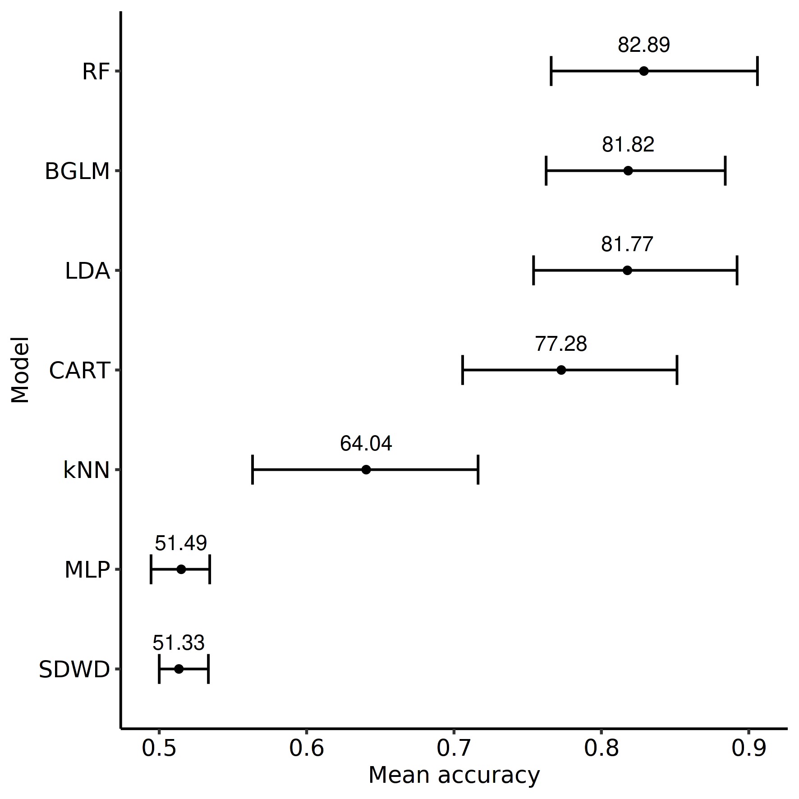

Supplementary Fig. S1: Performance of tested algorithms. Data presented as mean accuracy, 1st and 3rd quartile
Abbreviations: random forest, RF; k-nearest neighbors, k-NN; support vector machine, SVM; classification and regression trees, CART; Bayes generalized linear model, BGLM; linear discriminant analysis, LDA; multilayer perceptron, MLP; sparse distance weighted discrimination, SDWD; shrinkage discriminant analysis, SDA

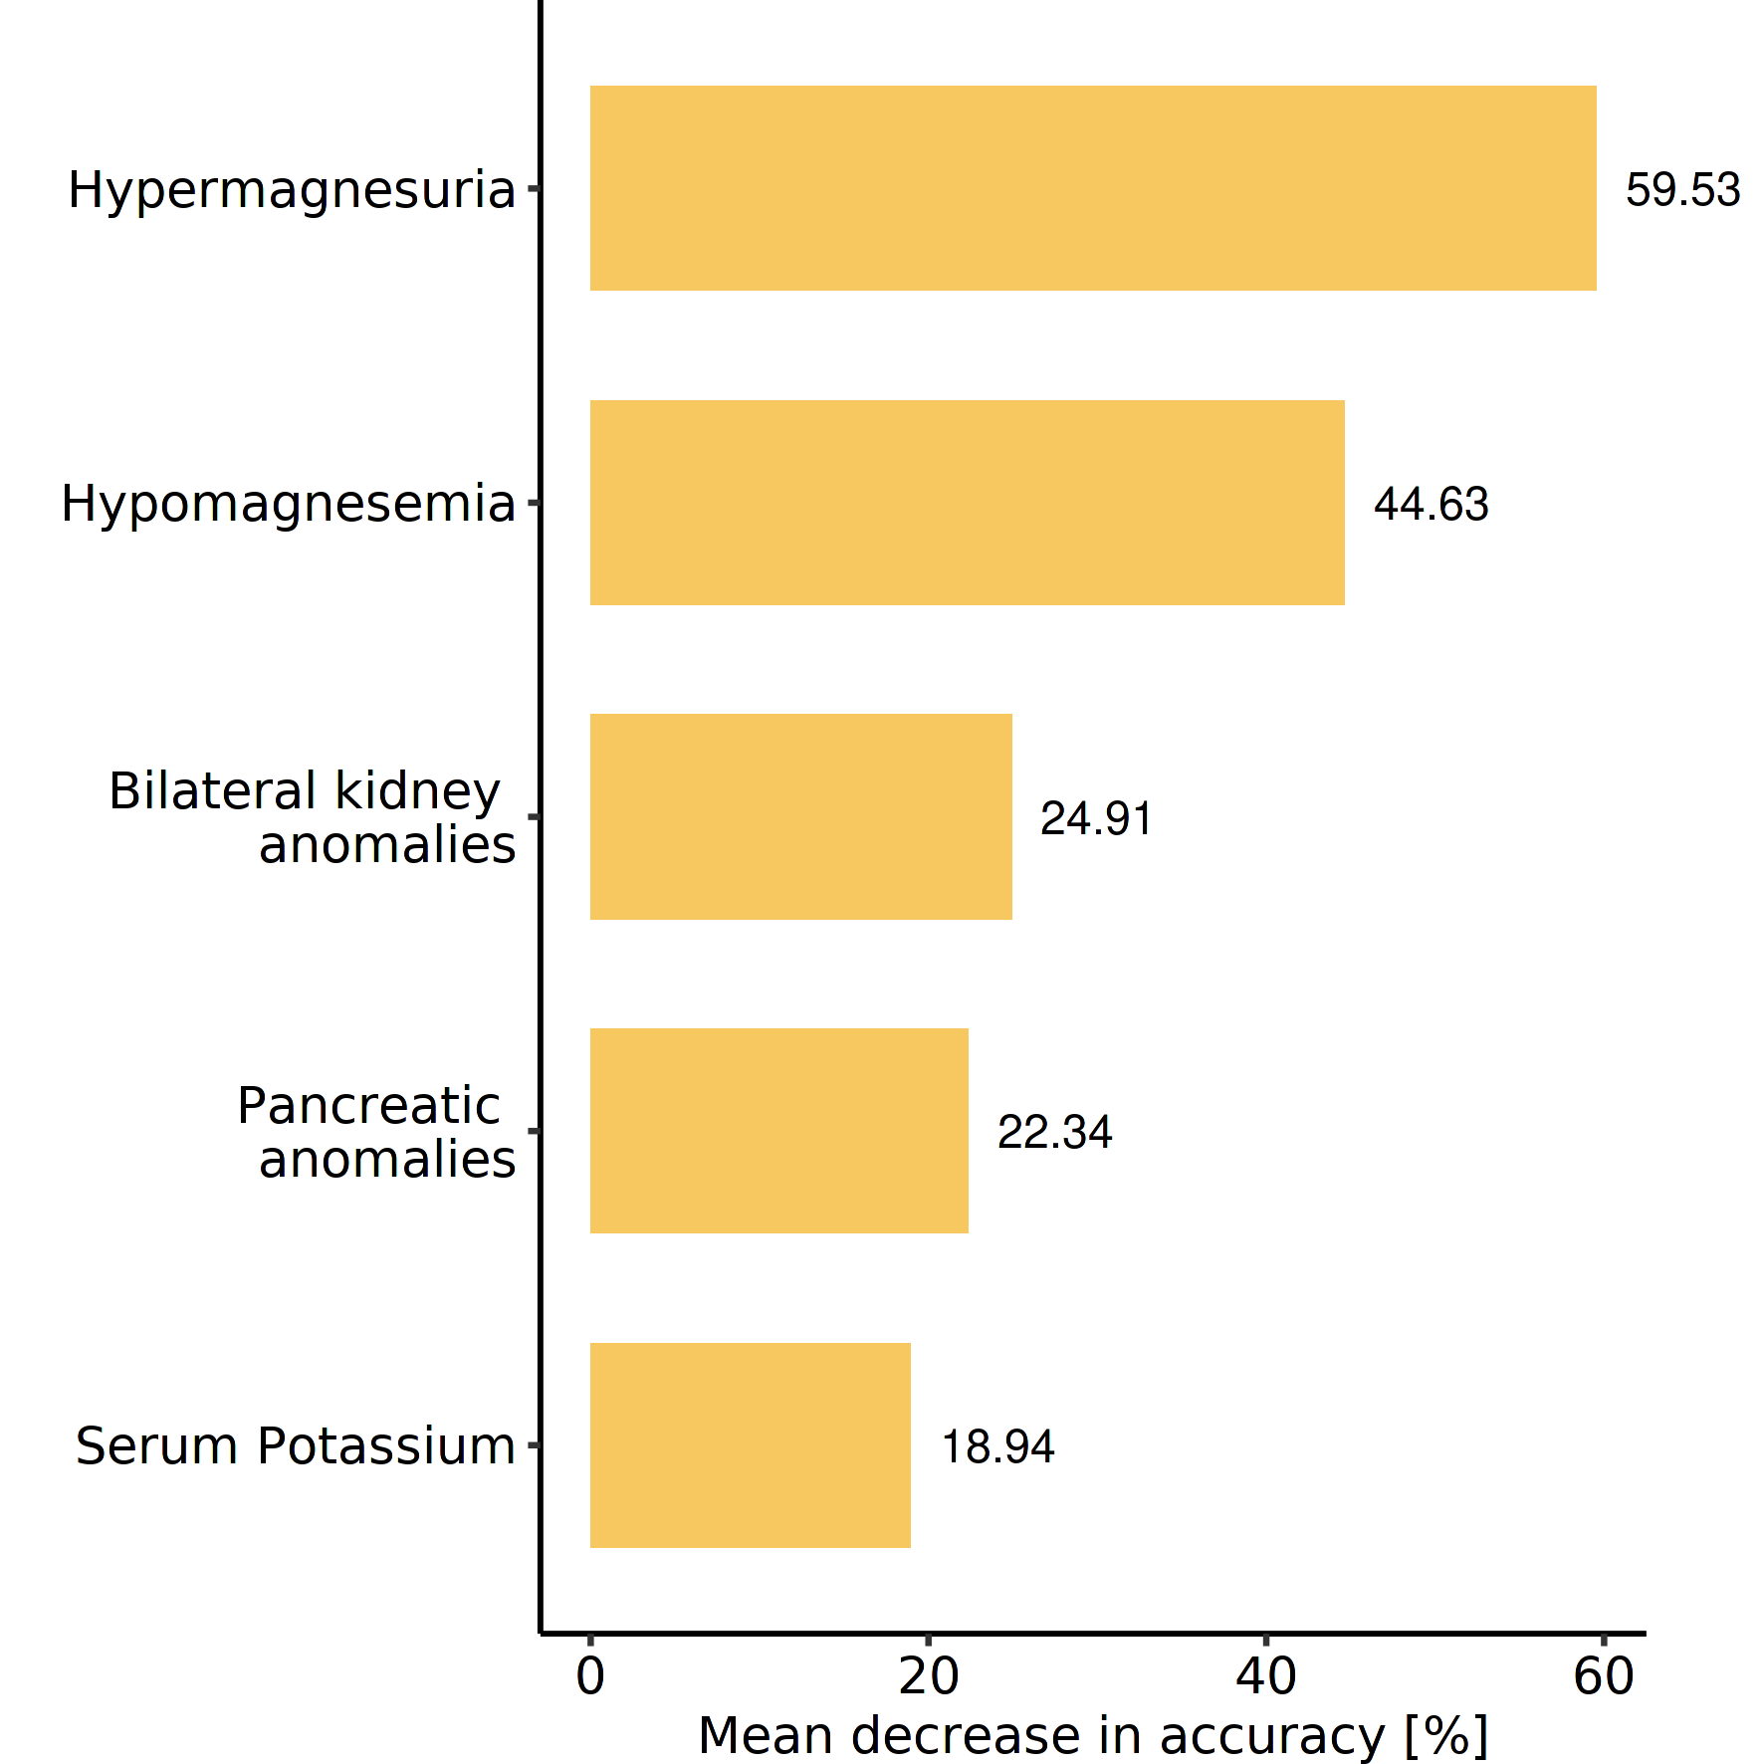

Supplementary Fig. S2 Importance of the variables, defined by mean decrease in accuracy, selected for the predictive model

