Supporting Information

Prevention of neointimal hyperplasia after coronary artery bypass graft via local delivery of sirolimus and rosuvastatin: network pharmacology and in vivo validation

Ji-yeon Ryu^{1,†}, Eui Hwa Jang^{1,†}, JiYong Lee², Jung-Hwan Kim¹, Young-Nam Youn^{1,*}

¹Division of Cardiovascular Surgery, Department of Thoracic and Cardiovascular Surgery, Severance Cardiovascular Hospital, Yonsei University College of Medicine, Seoul 03722, South Korea.
² School of Mechanical Engineering, Yonsei University, Seoul 03722, South Korea.

* Contact information for Corresponding Author
Prof. Young-Nam Youn, E-mail: ynyoun@yuhs.ac,
Tel.: +82-2 228 8487

†These authors contributed equally to this work.
Table S1. Top ten biological process enrichment analysis of overlapping targets of coronary artery bypass graft and sirolimus involved in neointimal hyperplasia
Biological process | Genes | Adjusted P-Value
Negative regulation of apoptotic process | RB1, FHL2, TNF, MPO, IGF1R, AKT2, MYC, CASP3, KDR, AKT1, CTSG, IL10, PRKCD, F2R, MIF, SIRT1, MMP9, PIK3CA, CAT, BIRC5, TP53, SQSTM1, HDAC2, PRKAA1, SRC, PIK3R1, EGFR, RELA, MAPK8, MAPK1, PPARGC1A, MCL1, MAPK3, XBP1, HSPA5, IGF1, PTK2, IL2, NFKB1, VEGFA, SOD1, IL4, NFKBIA, IL6, RPS6KB1, ALB, CDK1, FAS, CTNNB1, TEK, BCL2L1 | 1.80385E-33
Cellular response to oxygen-containing compound | CXCL8, NCF1, IRS1, SERPINE1, PDGFB, ACTB, EGFR, RELA, MAPK8, CASP1, AKT1, NLRP3, MAPK1, CTSG, TGM2, MAPK3, IL10, P2RY12, XBP1, JUN, DAPK1, PRKCD, MMP3, NR1H3, MAPK14, ESR1, MMP9, RHOA, NFKB1, MTOR, CXCL10, IL6, CREB1, IL1B, CDK2, VIM | 3.09319E-24
Regulation of inflammatory response | RB1, SERPINE1, TNF, RELA, ALOX5, CASP1, NLRP3, ELANE, IL10, CMA1, PRKCD, MMP3, IL18, NR1H3, SELE, MMP9, AGT, IL2, IL4, NFKBIA, ACE2, IL6, IFNG, IL1B, PPARG, TEK, PPARA, S100A9 | 4.553E-21
Cellular response to oxidative stress | JUN, PRKAA1, NCF1, NCF2, DAPK1, PRKCD, CYBA, FOXO3, HIF1A, EIF2S1, MMP9, EGFR, SOD1, MAPK8, CAT, AKT1, HMOX1, MAPK1, TP53, PPARGC1A, NFE2L2, MAPK3 | 5.81443E-19
Vascular endothelial growth factor receptor signaling pathway | HSP90AA1, NCF1, NCF2, SRC, CYBA, PIK3CB, PIK3R1,  MAPK14, RHOA, PGF, PTK2, VEGFA, CDC42, PIK3CA, KDR, RAC1 | 6.01571E-16
Extracellular matrix organization | SERPINE1, PDGFB, CTSS, ICAM1, TTR, CTSK, KDR, SPP1, CTSG, ELANE, POSTN, TGFB2, TGFB1, VCAM1, MMP7, MMP1, CMA1, MMP2, MMP3, FN1, MMP9, MMP12, MMP14, VCAN, COL1A2, ITGA6 | 8.47536E-15
Regulation of blood vessel endothelial cell migration | TGFB1, NOS3, KDR, PDGFB, AKT1, PPARG, MAPK14, TNF, SIRT1, HIF1A, VEGFA, FGFR1 | 1.39621E-11
Regulation of vascular associated smooth muscle cell proliferation | IL10, CDKN1A, JUN, CDKN1B, MMP2, PDGFB, PTEN, PPARG, IGF1, MMP9 | 1.08492E-10
Platelet degranulation | TGFB2, TGFB1, SERPINA1, EGF, SERPINE1, PDGFB, IGF2, FN1,IGF1, VEGFA, SOD1, SELP, ALB, TIMP3, CD36 | 1.23604E-10
Regulation of nitric-oxide synthase activity | HSP90AA1, CAV3, NOS3, IL1B, AKT1, PIK3CB, TNF, HIF1A, EGFR, INS | 1.81453E-10
Table S2. Top ten cellular component enrichment analysis of overlapping targets of coronary artery bypass graft and sirolimus involved in neointimal hyperplasia
Cellular component | Genes | Adjusted P-Value
Secretory granule lumen | SERPINA1, SERPINE1, PDGFB, MPO, INS, TTR, ALOX5, TIMP3, MAPK1, CTSG, ELANE, TGFB2, HSP90AA1, TGFB1, EGF, PRKCD, FN1, IGF2, MIF, IGF1, MAPK14, NFKB1, VEGFA, PKM, ALB, CAT, LCN2, S100A9 | 9.65342E-16
Collagen-containing extracellular matrix | SERPINA1, SERPINE1, PDGFB, CTSS, ICAM1, LGALS3, NPPA, TIMP3, CTSG, CCN2, ELANE, TGM2, POSTN, TGFB2, TGFB1, CMA1, MMP2, FN1, F2, F3, MMP9, AGT, VCAN, COL1A2, PKM, S100A9, FGFR2 | 4.95029E-13
Platelet alpha granule | TGFB2, SERPINA1, TGFB1, EGF, SERPINE1, PDGFB, FN1, IGF2, IGF1, VEGFA, SELP, ALB, CD36 | 4.29879E-10
Endoplasmic reticulum lumen | SERPINA1, F10, HSPA5, PDGFB, FN1, APOA2, F2, CP, INS, ACE2, IL6, VCAN, COL1A2, BGLAP, ALB, SPP1, MAPK1, IL12A, PNPLA2, MAPK3 | 8.53162E-10
Platelet alpha granule lumen | TGFB2, SERPINA1, TGFB1, EGF, SERPINE1, ALB, PDGFB, FN1, IGF2, IGF1, VEGFA | 2.56541E-09
Focal adhesion | MME, CAV3, HSPA5, SRC, FHL2, ACTB, PTK2, RHOA, EGFR, ICAM1, CDC42, MMP14, PTPRC, PLAU, CAT, CTNNB1, MAPK1, ITGA6, RAC1, VIM, TGM2, MAPK3 | 3.32203E-09
Cell-substrate junction | MME, CAV3, HSPA5, SRC, FHL2, ACTB, PTK2, RHOA, EGFR, ICAM1, CDC42, MMP14, PTPRC, PLAU, CAT, CTNNB1, MAPK1, ITGA6, RAC1, VIM, TGM2, MAPK3 | 4.20519E-09
Caveola | CAV3, IRS1, SRC, NOS3, F2R, MAPK1, CD36, SELE, MAPK3 | 2.22182E-07
Membrane raft | ABCA1, CAV3, MME, SRC, TNF, SELE, EGFR, ACE2, PTPRC, KDR, FAS, CD36, TEK | 3.12926E-07
Cyclin-dependent protein kinase holoenzyme complex | CDKN1A, CCND1, CCNE2, CCNE1, CDK4, CDK2, CDK1 | 3.23855E-07
Table S3. Top ten molecular function enrichment analysis of overlapping targets of coronary artery bypass graft and sirolimus involved in neointimal hyperplasia
Molecular function | Genes | Adjusted P-Value
Receptor ligand activity | SEMA3A, PDGFB, FGF1, TNF, INS, NPPB, LGALS3, NPPA,  IL12A, IL10, EDN1, TGFB2, TGFB1, EGF, IGF2, IL18, MIF, IGF1, F2, AGT, PGF, IL2, VEGFA, IL4, CXCL10, BMP2, IL6, IFNG, IL1B | 8.17294E-17
Endopeptidase activity | C1S, CTSS, CASP9, CASP7, CASP8, PLAU, CTSK, CASP3, CASP1, CTSG, ELANE, MMP7, MME, F10, MMP1, CMA1, MMP2, MMP3, F2, F3, MMP9, MMP12, ACE2, MMP14, REN | 8.7075E-13
Kinase binding | RB1, BECN1, CDKN1A, CDKN1B, SRC, FOXO3, HIF1A, ACTB, EGFR, RELA, CASP9, CDC42, CCND1, CASP1, RAC1, PTPN1, PRKCD, STAT3, ESR1, PTK2, RHOA, ACTA2, KAT2B, PTPRC, FAS, CTNNB1, TP53, SQSTM1, BCL2L1 | 1.43998E-12
RNA polymerase II-specific DNA-binding transcription factor binding | RB1, JUN, HDAC2, NR1I2, STAT3, MAPK14, FOXP3, HIF1A, SIRT1, ACTB, RELA, NFKBIA, CREB1, CTNNB1, PPARG, PPARA, TP53, PPARGC1A, NFE2L2 | 1.57518E-11
Cytokine activity | IL10, TGFB2, EDN1, TGFB1, CXCL8, IL18, MIF, TNF, IL2, VEGFA, IL4, CXCL10, BMP2, IL6, IFNG, IL1B, IL12A | 3.09568E-10
Growth factor activity | IL10, EGF, PDGFB, IGF2, FGF1, F2, PGF, AGT, IL2, VEGFA, IL4, IL6, IL12A | 3.98218E-10
Phosphatase binding | CDKN1B, STAT3, PIK3R1, MAPK14, PTK2, EGFR, LGALS3, MAPK1, CTNNB1, TP53, JAK3, MET, MAPK3 | 1.14995E-08
DNA-binding transcription factor binding | RB1, JUN, HDAC2, STAT3, FHL2, SIRT1, RELA, CREB1, MYC, DDIT3, CTNNB1, NLRP3, PPARG, PPARA, TP53, NFE2L2 | 3.16459E-08
Growth factor receptor binding | IL4, IL10, IL6, SRC, EGF, IL1B, PDGFB, IL12A, FGF1, PGF, IL2, VEGFA | 4.48598E-08
Protein tyrosine kinase activity | SRC, KIT, KDR, TEK, JAK3, MET, EPHB4, PTK2, FGFR2, EGFR, IGF1R, FGFR1 | 5.66818E-08
Table S4. Top ten KEGG pathway enrichment analysis of overlapping targets of coronary artery bypass graft and sirolimus involved in neointimal hyperplasia
KEGG | Genes | Adjusted P-Value
Lipid and atherosclerosis | CXCL8, NCF1, NCF2, PIK3CD, PIK3CB, TNF, ICAM1, CASP9, CASP7, CASP8, AKT2, CASP3, CASP1, AKT1, OLR1, IL12A, RAC1, CD36, HRAS, HSP90AA1, MMP1, MMP3, IL18, CYBA, MMP9, RHOA, PIK3CA, DDIT3, IL1B, PPARG, TP53, SRC, PIK3R1, RELA, CDC42, MAPK8, NLRP3, MAPK1, MAPK3, ABCA1, XBP1, JUN, VCAM1, HSPA5, NOS3, STAT3, MAPK14, SELE, EIF2S1, PTK2, NFKB1, SELP, NFKBIA, MAPK10, IL6, FAS, BAX, NFE2L2, BCL2L1 | 5.50358E-66
AGE-RAGE signaling pathway in diabetic complications | CXCL8, CDKN1B, SERPINE1, PIK3CD, PIK3R1, PIK3CB, TNF, RELA, ICAM1, CDC42, MAPK8, CCND1, AKT2, CASP3, AKT1, MAPK1, RAC1, HRAS, MAPK3, TGFB2, JUN, EDN1, TGFB1, VCAM1, PRKCB, NOS3, MMP2, PRKCD, STAT3, FN1, MAPK14, SELE, F3, NFKB1, AGT, VEGFA, MAPK10, IL6, COL1A2, PIK3CA, CDK4, IL1B, BAX | 2.07439E-57
PI3K-Akt signaling pathway | CDKN1A, CDKN1B, IRS1, PTEN, PIK3CD, PIK3CB, FGF1, PIK3CG, IGF1R, CASP9, CCND1, AKT2, MYC, KDR, AKT1, RAC1, HRAS, JAK3, HSP90AA1, F2R, PGF, CREB1, CCNE2, PIK3CA, CCNE1, KIT, ITGA6, TP53, MET, PRKAA1, PDGFB, PIK3R1, FOXO3, EGFR, RELA, INS, SPP1, MAPK1, MCL1, MAPK3, NOS3, EGF, FN1, IGF2, IGF1, PTK2, IL2, NFKB1, MTOR, VEGFA, IL4, IL6, COL1A2, RPS6KB1, CDK4, IL2RA, CDK2, MDM2, TEK, FGFR2, FGFR1, BCL2L1 | 1.17381E-56
Fluid shear stress and atherosclerosis | PRKAA1, NCF1, NCF2, SRC, PDGFB, PIK3CD, PIK3R1, PIK3CB, TNF,  ACTB, RELA, ICAM1, MAPK8, AKT2, KDR, AKT1, HMOX1, RAC1, JUN, EDN1, HSP90AA1, VCAM1, CAV3, NOS3, MMP2, CYBA, MAPK14, SELE, MMP9, NFKB1, PTK2, RHOA, VEGFA, MAPK10, PIK3CA, IFNG, IL1B, CTNNB1, SQSTM1, TP53, NFE2L2 | 6.97917E-47
FoxO signaling pathway | CDKN1A, PRKAA1, CDKN1B, IRS1, PTEN, PIK3CD, PIK3R1, PIK3CB, FOXO3, EGFR, IGF1R, INS, MAPK8, CCND1, AKT2, S1PR1, AKT1, MAPK1, SKP2, HRAS, MAPK3, IL10, TGFB2, TGFB1, EGF, STAT3, IGF1, MAPK14, SIRT1, MAPK10, IL6, PIK3CA, CDK2, CAT, MDM2 | 2.54619E-38
HIF-1 signaling pathway | CDKN1A, CDKN1B, SERPINE1, PIK3CD, PIK3R1, PIK3CB, ENO2, HIF1A, RELA, EGFR, IGF1R, INS, AKT2, NPPA, AKT1, HMOX1, MAPK1, MAPK3, EDN1, NOS2, PRKCB, EGF, NOS3, STAT3, IGF1, NFKB1, MTOR, VEGFA, IL6, PIK3CA, IFNG, RPS6KB1, TEK | 3.47966E-38
TNF signaling pathway | PIK3CD, PIK3R1, PIK3CB, TNF, RELA, ICAM1, CASP7, MAPK8, CASP8, AKT2, CASP3, AKT1, MAPK1, MAPK3, JUN, EDN1, VCAM1, MMP3, MAPK14, SELE, MMP9, NFKB1, NFKBIA, MAPK10, CXCL10, IL6, MMP14, CREB1, PIK3CA, IL1B, FAS | 1.41853E-34
Focal adhesion | SRC, PDGFB, PTEN, PIK3CD, PIK3R1, PIK3CB, ACTB, EGFR, MYLK, IGF1R, CDC42, MAPK8, CCND1, AKT2, KDR, SPP1, AKT1, MAPK1, RAC1, HRAS, MAPK3, JUN, CAV3, PRKCB, EGF, FN1, IGF1, PTK2, RHOA, PGF, VEGFA, MAPK10, COL1A2, PIK3CA, CTNNB1, ITGA6,  MET | 2.68411E-34
Apoptosis | BECN1, PIK3CD, PIK3R1, PIK3CB, TNF, ACTB, CTSS, RELA, CASP9, CASP7, MAPK8, CASP8, AKT2, CTSK, CASP3, LMNA, AKT1, MAPK1, HRAS, MCL1, MAPK3, JUN, EIF2S1, NFKB1, NFKBIA, MAPK10, PIK3CA, DDIT3, BIRC5, FAS, BAX, TP53, BCL2L1 | 3.87485E-34
C-type lectin receptor signaling pathway | SRC, PIK3CD, PIK3R1, PIK3CB, TNF, RELA, MAPK8, CASP8, AKT2, CASP1, AKT1, NLRP3, MAPK1, IL12A, HRAS, MAPK3, IL10, JUN, PRKCD, MAPK14, NFKB1, IL2, RHOA, NFKBIA, MAPK10, IL6, PIK3CA, IL1B, MDM2 | 1.29265E-32

Table S5. Top ten biological process enrichment analysis of overlapping targets of coronary artery bypass graft and rosuvastatin involved in neointimal hyperplasia
Biological process | Genes | Adjusted P-Value
Negative regulation of apoptotic process | ITGB1, HDAC2, SRC, PIK3R1, TNF, EGFR, IGF1R, MAPK8, AKT2, CASP3, KDR, AKT1, MAPK1, CCL2, CTSG, MCL1, CSNK2A1, MIF, IGF1, MMP9, PTK2, IL2, SOD1, ALB, CAT, TEK | 1.89715E-15
Regulation of inflammatory response | PTGIS, CMA1, MMP3, APOA1, NR1H3, TNF, SELE, MMP9, IL2, ACE2, IL1B, AGTR1, CASP1, PPARG, TEK, PPARA, S100A9, ELANE | 3.62003E-14
Extracellular matrix disassembly | MMP12, MMP14, MMP7, MMP1, CMA1, CTSK, MMP2, MMP3, CTSG, MMP9, CTSS, ELANE | 3.86799E-13
Extracellular matrix organization | ITGB1, TGFB1, MMP7, ITGA4, MMP1, CMA1, ITGB3, MMP2, MMP3, MMP9, CTSS, MMP12, MMP14, TTR, CTSK, KDR, PECAM1, CTSG, ELANE | 1.41623E-12
Cellular response to oxygen-containing compound | P2RY12, DAPK1, MMP3, NR1H3, MAPK14, ESR1, MMP9, EGFR, MAPK8, IL1B, CDK2, CASP1, AKT1, MAPK1, CCL2, CTSG, TGM2 | 4.59619E-10
Cellular response to oxidative stress | MAPK8, DAPK1, CAT, AKT1, HMOX1, MAPK1, CYBA,  MMP9, EGFR, NFE2L2, SOD1 | 7.69466E-09
Vascular endothelial growth factor receptor signaling pathway | HSP90AA1, SRC, ITGB3, KDR, CYBA, PIK3R1, MAPK14, PGF, PTK2 | 7.69466E-09
Extracellular structure organization | ITGB1, MMP7, ITGA4, MMP1, ITGB3, MMP2, MMP3, MP9, MMP12, MMP14, TTR, KDR, PECAM1 | 1.70767E-08
Regulation of blood vessel endothelial cell migration | TGFB1, NOS3, KDR, AKT1, PPARG, MAPK14, TNF, FR1 | 3.62269E-08
Platelet degranulation | SELP, TGFB1, SERPINA1, ITGB3, ALB, PECAM1, APOA1, IGF1, SOD1 | 1.29722E-06
Table S6. Top ten cellular component enrichment analysis of overlapping targets of coronary artery bypass graft and rosuvastatin involved in neointimal hyperplasia
Cellular component | Genes | Adjusted P-Value
Secretory granule lumen | HSP90AA1, TGFB1, SERPINA1, ARG1, APOA1, MIF,  IGF1, MAPK14, TTR, ALB, CAT, LCN2, MAPK1, CTSG, S100A9, ELANE | 9.29312E-09
Membrane raft | ABCA1, ITGB1, ACE2, MME, SRC, KDR, TEK, TNF, SELE, EGFR | 2.95561E-06
Collagen-containing extracellular matrix | TGFB1, SERPINA1, CMA1, MMP2, APOA1, F2, MMP9, CTSS, LGALS3, CTSG, S100A9, ELANE, FGFR2, TGM2 | 2.95561E-06
Vacuolar lumen | HSP90AA1, TTR, ARG1, CTSK, MAPK1, CTSG, APOB, ELANE, CTSS | 1.16247E-05
Focal adhesion | PDGFRB, ITGB1, MME, ITGA4, SRC, ITGB3, PTK2, EGFR, MMP14, PLAU, CAT, MAPK1, TGM2 | 1.16247E-05
Cell-substrate junction | PDGFRB, ITGB1, MME, ITGA4, SRC, ITGB3, PTK2, EGFR, MMP14, PLAU, CAT, MAPK1, TGM2 | 1.16247E-05
Ficolin-1-rich granule lumen | HSP90AA1, SERPINA1, CAT, MAPK1, MIF, MAPK14, MMP9, CTSS | 1.16247E-05
Platelet alpha granule | SELP, SERPINA1, TGFB1, ITGB3, ALB, PECAM1, IGF1 | 1.59172E-05
Ficolin-1-rich granule | LGALS3, HSP90AA1, SERPINA1, CAT, MAPK1, MIF, MAPK14, MMP9, CTSS | 1.90186E-05
Endocytic vesicle | ABCA1, ACE2, HSP90AA1, NOS3, MDM2, APOA1, APOB, CTSS | 0.00019612
Table S7. Top ten molecular function enrichment analysis of overlapping targets of coronary artery bypass graft and rosuvastatin involved in neointimal hyperplasia
Molecular function | Genes | Adjusted P-Value
Endopeptidase activity | C1S, ECE1, CTSS, CASP7, CASP8, PLAU, CTSK, CASP3, CASP1, CTSG, ELANE, ACE, MMP7, MME, F10, MMP1, CMA1, MMP2, MMP3, F2, MMP9, MMP12, ACE2, MMP14, REN | 8.29395E-19
Protein tyrosine kinase activity | PDGFRB, SRC, PTK2, EGFR, IGF1R, KIT, KDR, TEK, JAK3, MET, EPHB4, FGFR2, FGFR1 | 1.10851E-11
Transmembrane receptor protein kinase activity | PDGFRB, KIT, KDR, TEK, MET, EPHB4, EGFR, FGFR2, IGF1R, FGFR1 | 1.60499E-10
Transmembrane receptor protein tyrosine kinase activity | PDGFRB, KIT, KDR, TEK, MET, EPHB4, EGFR, FGFR2, IGF1R, FGFR1 | 1.60499E-10
Metallopeptidase activity | MMP12, ACE2, MMP14, ACE, MMP7, MME, MMP1, MMP2, MMP3, ECE1, MMP9 | 8.80195E-09
Metalloendopeptidase activity | MMP12, MMP14, MMP7, MME, MMP1, MMP2, MMP3, ECE1, MMP9 | 6.74608E-08
Transition metal ion binding | PTPN1, ACE, MME, ARG1, NOS3, ECE1, CYP3A4, MMP9, SOD1, MMP12, ACE2, ALB, MDM2, LCN2, PPARG, S100A9 | 3.76116E-07
Serine-type endopeptidase activity | C1S, F10, PLAU, CMA1, MMP2, CTSG, F2, MMP9, ELANE | 4.62887E-07
Serine-type peptidase activity | C1S, F10, PLAU, CMA1, MMP2, CTSG, F2, MMP9, ELANE | 1.89587E-06
Heme binding | CYP26A1, PTGIS, NOS2, SRC, CBS, NOS3, CAT, HMOX1 | 2.01525E-06
Table S8. Top ten KEGG pathway enrichment analysis of overlapping targets of coronary artery bypass graft and rosuvastatin involved in neointimal hyperplasia
KEGG | Genes | Adjusted P-Value
Lipid and atherosclerosis | SRC, PIK3R1, TNF, CASP7, MAPK8, CASP8, AKT2, CASP3, CASP1, AKT1, MAPK1, CCL2, APOB, HRAS, ABCA1, HSP90AA1, MMP1, NOS3, MMP3, APOA1, CYBA, MAPK14, SELE, MMP9, PTK2, SELP, MAPK10, IL1B, BAX, PPARG, NFE2L2 | 1.88656E-32
Fluid shear stress and atherosclerosis | HSP90AA1, SRC, NOS3, ITGB3, MMP2, CYBA, PIK3R1, MAPK14, TNF, SELE, MMP9, PTK2, MAPK10, MAPK8, AKT2, IL1B, KDR, PECAM1, AKT1, HMOX1, CCL2, NFE2L2 | 1.33573E-23
PI3K-Akt signaling pathway | ITGB1, ITGB3, PIK3R1, FGF1, PIK3CG, EGFR, IGF1R, AKT2, KDR, AKT1, MAPK1, HRAS, JAK3, MCL1, PDGFRB, HSP90AA1 ITGA4, NOS3, IGF1, PGF, PTK2, IL2, CDK2, KIT, MDM2, TEK, MET, FGFR2, FGFR1 | 2.84561E-23
AGE-RAGE signaling pathway in diabetic complications | TGFB1, NOS3, MMP2, PIK3R1, MAPK14, TNF, SELE, MAPK10, MAPK8, AKT2, CASP3, IL1B, AGTR1, AKT1,  CCL2, MAPK1, BAX, HRAS | 1.79973E-20
Rap1 signaling pathway | PDGFRB, ITGB1, SRC, ITGB3, PIK3R1, IGF1, FGF1, MAPK14, PGF, EGFR, IGF1R, AKT2, KIT, KDR, AKT1, MAPK1, TEK, HRAS, MET, FGFR2, FGFR1 | 1.36615E-18
TNF signaling pathway | MMP3, PIK3R1, MAPK14, TNF, SELE, MMP9, MAPK10, CASP7, MMP14, MAPK8, CASP8, AKT2, CASP3, IL1B, AKT1, CCL2, MAPK1 | 3.85867E-18
MAPK signaling pathway | PDGFRB, TGFB1, IGF1, FGF1, MAPK14, TNF, PGF, EGFR,IGF1R, MAPK10, MAPK8, AKT2, CASP3, IL1B, KIT, KDR, AKT1, MAPK1, TEK, HRAS, MET, FGFR2, FGFR1 | 4.19402E-18
Relaxin signaling pathway | TGFB1, NOS2, MMP1, SRC, NOS3, MMP2, PIK3R1, MAPK14, MMP9, EGFR, MAPK10, MAPK8, EDNRB, AKT2, AKT1, MAPK1, HRAS | 3.83237E-17
Focal adhesion | PDGFRB, ITGB1, ITGA4, SRC, ITGB3, PIK3R1, IGF1, PGF, PTK2, EGFR, IGF1R, MAPK10, MAPK8, AKT2, KDR, AKT1, MAPK1, HRAS, MET | 1.67561E-16
IL-17 signaling pathway | HSP90AA1, MMP1, MMP3, MAPK14, TNF, MMP9, MAPK10, MAPK8, CASP8, CASP3, IL1B, LCN2, CCL2, MAPK1, S100A9 | 1.72105E-16
Table S9. Top ten biological process enrichment analysis of overlapping targets of coronary artery bypass graft and both drugs involved in neointimal hyperplasia
Biological process | Genes | Adjusted P-Value
Negative regulation of apoptotic process | HDAC2, SRC, MIF, PIK3R1, IGF1, TNF, MMP9, EGFR, PTK2, IL2, IGF1R, SOD1, MAPK8, CASP3, AKT2, CAT, ALB, KDR, AKT1, MAPK1, CTSG, TEK, MCL1 | 1.66895E-14
Extracellular matrix disassembly | MMP12, MMP14, MMP7, MMP1, CMA1, CTSK, MMP2, MMP3, CTSG, MMP9, CTSS, ELANE | 4.26476E-14
Regulation of inflammatory response | CMA1, MMP3, NR1H3, TNF, MMP9, SELE, IL2, ACE2, IL1B, CASP1, PPARG, TEK, PPARA, S100A9, ELANE | 4.82227E-12
Cellular response to oxygen-containing compound | P2RY12, DAPK1, MMP3, NR1H3, MAPK14, MMP9, ESR1, EGFR, MAPK8, IL1B, CDK2, CASP1, AKT1, MAPK1, CTSG, TGM2 | 1.86511E-10
Extracellular matrix organization | MMP7, TGFB1, MMP1, CMA1, MMP2, MMP3, MMP9, CTSS, MMP12, MMP14, TTR, CTSK, KDR, CTSG, ELANE | 6.91047E-10
Cellular response to oxidative stress | MAPK8, DAPK1, CAT, AKT1, HMOX1, MAPK1, CYBA, MMP9, EGFR, SOD1, NFE2L2 | 9.73019E-10
Regulation of blood vessel endothelial cell migration | TGFB1, NOS3, KDR, AKT1, PPARG, MAPK14, TNF, FGFR1 | 8.38921E-09
Vascular endothelial growth factor receptor signaling pathway | HSP90AA1, SRC, KDR, CYBA, PIK3R1, MAPK14, PGF, PTK2 | 3.79661E-08
Regulation of nitric-oxide synthase activity | HSP90AA1, NOS3, IL1B, AKT1, TNF, EGFR | 8.32987E-07
Extracellular structure organization | MMP12, MMP14, MMP7, TTR, MMP1, MMP2, MMP3, KDR, MMP9 | 1.60149E-05
Table S10. Top ten cellular component enrichment analysis of overlapping targets of coronary artery bypass graft and both drugs involved in neointimal hyperplasia
Cellular component | Genes | Adjusted P-Value
Secretory granule lumen | HSP90AA1, SERPINA1, TGFB1, MIF, IGF1, MAPK14, TTR, CAT, ALB, LCN2, MAPK1, CTSG, S100A9, ELANE | 4.40212E-08
Collagen-containing extracellular matrix | SERPINA1, TGFB1, CMA1, MMP2, F2, MMP9, CTSS, LGALS3, CTSG, S100A9, ELANE, FGFR2, TGM2 | 2.16527E-06
Membrane raft | ABCA1, ACE2, MME, SRC, KDR, TEK, TNF, SELE, EGFR | 3.56783E-06
Ficolin-1-rich granule lumen | HSP90AA1, SERPINA1, CAT, MAPK1, MIF, MAPK14, MMP9, CTSS | 3.56783E-06
Ficolin-1-rich granule | LGALS3, HSP90AA1, SERPINA1, CAT, MAPK1, MIF, MAPK14, MMP9, CTSS | 5.47928E-06
Vacuolar lumen | HSP90AA1, TTR, CTSK, MAPK1, CTSG, CTSS, ELANE | 0.000204203
Platelet alpha granule | SELP, SERPINA1, TGFB1, ALB, IGF1 | 0.000949449
Focal adhesion | MMP14, MME, PLAU, SRC, CAT, MAPK1, EGFR, PTK2, TGM2 | 0.001205216
Cell-substrate junction | MMP14, MME, PLAU, SRC, CAT, MAPK1, EGFR, PTK2, TGM2 | 0.001265156
Caveola | SRC, NOS3, MAPK1, SELE | 0.001676182
Table S11. Top ten molecular function enrichment analysis of overlapping targets of coronary artery bypass graft and both drugs involved in neointimal hyperplasia
Molecular function | Genes | Adjusted P-Value
Endopeptidase activity | MMP7, MME, C1S, F10, MMP1, CMA1, MMP2, MMP3, F2, MMP9, CTSS, MMP12, ACE2, CASP7, MMP14,CASP8, PLAU, CTSK, CASP3, CASP1, CTSG, REN, ELANE | 1.19552E-18
Protein tyrosine kinase activity | SRC, KIT, KDR, TEK, JAK3, MET, EPHB4, EGFR, PTK2, FGFR2, IGF1R, FGFR1 | 1.79289E-11
Transmembrane receptor protein kinase activity | KIT, KDR, TEK, MET, EPHB4, EGFR, FGFR2, IGF1R, FGFR1 | 7.09973E-10
Transmembrane receptor protein tyrosine kinase activity | KIT, KDR, TEK, MET, EPHB4, EGFR, FGFR2, IGF1R, FGFR1 | 7.09973E-10
Serine-type endopeptidase activity | C1S, F10, PLAU, CMA1, MMP2, CTSG, F2, MMP9, ELANE | 9.67702E-08
Metalloendopeptidase activity | MMP12, MMP14, MMP7, MME, MMP1, MMP2, MMP3, MMP9 | 2.36993E-07
Metallopeptidase activity | MMP12, ACE2, MMP14, MMP7, MME, MMP1, MMP2, MMP3, MMP9 | 2.44033E-07
Serine-type peptidase activity | C1S, F10, PLAU, CMA1, MMP2, CTSG, F2, MMP9, ELANE | 2.84508E-07
Phosphatase binding | LGALS3, MAPK1, PIK3R1, MAPK14, JAK3, MET, EGFR, PTK2 | 2.15221E-06
Protein phosphatase binding | LGALS3, PIK3R1, MAPK14, JAK3, MET, EGFR, PTK2, SOD1 | 3.49922E-06
Table S12. Top ten KEGG pathway enrichment analysis of overlapping targets of coronary artery bypass graft and both drugs involved in neointimal hyperplasia
KEGG | Genes | Adjusted P-Value
Lipid and atherosclerosis | SRC, PIK3R1, TNF, CASP7, MAPK8, CASP8, CASP3, AKT2, CASP1, AKT1, MAPK1, HRAS, ABCA1, HSP90AA1, MMP1, NOS3, MMP3, CYBA, MAPK14, MMP9, SELE, PTK2, MAPK10, SELP, IL1B, BAX, PPARG, NFE2L2 | 9.65327E-31
Fluid shear stress and atherosclerosis | HSP90AA1, SRC, NOS3, MMP2, CYBA, PIK3R1, MAPK14, TNF, MMP9, SELE, PTK2, MAPK10, MAPK8, AKT2, IL1B, KDR, AKT1, HMOX1, NFE2L2 | 5.56189E-21
PI3K-Akt signaling pathway | PIK3R1, FGF1, PIK3CG, EGFR, IGF1R, AKT2, KDR, AKT1, MAPK1, HRAS, JAK3, MCL1, HSP90AA1, NOS3, IGF1, PGF, PTK2, IL2, KIT, CDK2, MDM2, TEK, MET, FGFR2, FGFR1 | 7.26477E-21
AGE-RAGE signaling pathway in diabetic complications | TGFB1, NOS3, MMP2, PIK3R1, MAPK14, TNF, SELE, MAPK10, MAPK8, CASP3, AKT2, IL1B, AKT1, MAPK1, BAX, HRAS | 6.10025E-19
MAPK signaling pathway | TGFB1, IGF1, FGF1, MAPK14, TNF, PGF, EGFR, IGF1R, MAPK10, MAPK8, CASP3, AKT2, IL1B, KIT, KDR, AKT1, MAPK1, TEK, HRAS, MET, FGFR2, FGFR1 | 6.10025E-19
Relaxin signaling pathway | TGFB1, NOS2, MMP1, SRC, NOS3, MMP2, PIK3R1, MAPK14, MMP9, EGFR, MAPK10, MAPK8, EDNRB, AKT2, AKT1, MAPK1, HRAS | 9.81145E-19
TNF signaling pathway | MMP3, PIK3R1, MAPK14, TNF, MMP9, SELE, MAPK10, CASP7, MMP14, MAPK8, CASP8, CASP3, AKT2, IL1B, AKT1, MAPK1 | 3.137E-18
C-type lectin receptor signaling pathway | SRC, PIK3R1, MAPK14, TNF, IL2, MAPK10, MAPK8, CASP8, AKT2, IL1B, CASP1, MDM2, AKT1, MAPK1, HRAS | 3.61244E-17
Rap1 signaling pathway | SRC, PIK3R1, IGF1, FGF1, MAPK14, PGF, EGFR, IGF1R, AKT2, KIT, KDR, AKT1, MAPK1, TEK, HRAS, MET, FGFR2, FGFR1 | 1.31573E-16
IL-17 signaling pathway | HSP90AA1, MMP1, MMP3, MAPK14, TNF, MMP9, MAPK10, MAPK8, CASP8, CASP3, IL1B, LCN2, MAPK1, S100A9 | 2.58281E-16
Table S13. Top ten significant bottleneck genes ranked by CytoHubba
No. | Name | Description | MCC¹⁾ Score | BottleNeck Score | DC²⁾ | BC³⁾ | CC⁴⁾
Sirolimus
1 | TP53^{*5)} | Tumor protein p53 | 9.22E+13 | 50.00 | 146.00 | 972.93 | 178.00
2 | IL6* | Interleukin 6 | 9.22E+13 | 19.00 | 163.00 | 1400.41 | 186.50
3 | STAT3* | Signal transducer and activator of transcription 3 | 9.22E+13 | 15.00 | 134.00 | 541.92 | 172.00
3 | VCAM1 | Vascular cell adhesion molecule 1 | 9.22E+13 | 15.00 | 87.00 | 194.11 | 148.33
5 | IL1B | Interleukin 1 beta | 9.22E+13 | 8.00 | 146.00 | 898.27 | 178.00
6 | MAPK14 | Mitogen-activated protein kinase 14 | 9.22E+13 | 6.00 | 93.00 | 214.59 | 151.50
6 | ESR1 | Estrogen receptor 1 | 9.22E+13 | 6.00 | 113.00 | 489.63 | 161.33
6 | ALB* | Albumin | 9.22E+13 | 6.00 | 161.00 | 1908.35 | 185.50
9 | AKT1 | AKT serine/threonine kinase 1 | 9.22E+13 | 4.00 | 173.00 | 1687.52 | 191.50
9 | MMP2 | Matrix metallopeptidase 2 | 9.22E+13 | 5.00 | 99.00 | 220.08 | 154.50
9 | SRC | SRC proto-oncogene, non-receptor tyrosine kinase | 9.22E+13 | 5.00 | 134.00 | 766.75 | 172.00
Rosuvastatin
1 | ALB* | Albumin | 9.22E+13 | 44.00 | 93.00 | 1177.20 | 105.08
2 | AKT1* | AKT serine/threonine kinase 1 | 9.22E+13 | 11.00 | 89.00 | 878.05 | 103.08
3 | TNF* | Tumor necrosis factor | 9.22E+13 | 8.00 | 97.00 | 1270.34 | 106.92
4 | IL1B* | Interleukin 1 beta | 9.22E+13 | 6.00 | 79.00 | 557.01 | 97.92
5 | SELE | Selectin E | 1.82E+13 | 5.00 | 36.00 | 94.79 | 76.83
6 | CAT | Catalase | 9.22E+13 | 4.00 | 48.00 | 194.11 | 82.58
6 | PTGIS | Prostaglandin I2 synthase | 279 | 5.00 | 12.00 | 400.50 | 61.67
8 | MDM2 | MDM2 proto-oncogene | 9.22E+13 | 2.00 | 33.00 | 50.64 | 74.42
8 | ESR1 | Estrogen receptor 1 | 9.22E+13 | 3.00 | 57.00 | 260.82 | 86.92
8 | CASP3* | Caspase 3 | 9.22E+13 | 3.00 | 65.00 | 379.67 | 90.92
8 | PECAM1 | Platelet and endothelial cell adhesion molecule 1 | 9.22E+13 | 1.00 | 50.00 | 129.10 | 83.42
8 | MMP9* | Matrix metallopeptidase 9 | 9.22E+13 | 5.00 | 77.00 | 474.21 | 96.92
Sirolimus + Rosuvastatin
1 | ALB* | Albumin | 9.22E+13 | 40.00 | 79.00 | 992.34 | 87.00
2 | AKT1* | AKT serine/threonine kinase 1 | 9.22E+13 | 11.00 | 75.00 | 629.42 | 85.00
3 | TNF* | Tumor necrosis factor | 9.22E+13 | 5.00 | 82.00 | 952.30 | 88.50
3 | ESR1 | Estrogen receptor 1 | 9.22E+13 | 5.00 | 49.00 | 194.33 | 71.83
5 | MMP9* | Matrix metallopeptidase 9 | 9.22E+13 | 3.00 | 66.00 | 404.38 | 80.50
5 | IL1B | Interleukin 1 beta | 9.22E+13 | 7.00 | 67.00 | 418.99 | 81.00
7 | IGF1 | Insulin like growth factor 1 | 9.22E+13 | 3.00 | 54.00 | 190.52 | 74.50
7 | CAT | Catalase | 9.22E+13 | 3.00 | 38.00 | 110.59 | 66.50
7 | CASP3* | Caspase 3 | 9.22E+13 | 3.00 | 58.00 | 322.68 | 76.50
10 | SRC* | SRC proto-oncogene, non-receptor tyrosine kinase | 9.22E+13 | 2.00 | 57.00 | 227.32 | 76.00
10 | PPARA | Peroxisome proliferator activated receptor alpha | 2.99E+12 | 1.00 | 31.00 | 85.01 | 63.00
10 | HSP90AA1* | Heat shock protein 90 alpha family class A member 1 | 9.22E+13 | 2.00 | 48.00 | 162.96 | 71.50
10 | HMOX1 | Heme oxygenase 1 | 3.46E+12 | 2.00 | 34.00 | 228.22 | 64.50
10 | MDM2 | MDM2 proto-oncogene | 9.22E+13 | 2.00 | 31.00 | 37.13 | 62.83
10 | SERPINA1 | Serpin family A member 1 | 1670018 | 2.00 | 22.00 | 70.77 | 58.33
10 | MMP2 | Matrix metallopeptidase 2 | 7.18E+13 | 2.00 | 47.00 | 127.75 | 71.00
¹⁾ MCC, maximal clique centrality; ²⁾ DC, degree centrality; ³⁾ BC, betweenness centrality; ⁴⁾ CC, closeness centrality; ⁵⁾ Asterisks (*) indicate genes with overlapping hub-bottlenecks.
Fig. S1. Local drug delivery using a localized perivascular drug delivery device.
(A) Diagram of the localized perivascular drug delivery device with sequential release of sirolimus and rosuvastatin. (B) in vitro test of the local drug delivery device. Fluorescence image of a spot inserted into an agarose gel after use of the localized perivascular drug delivery device. (C) Optical image and (D) scanning electron transmission image of the localized perivascular drug delivery device.

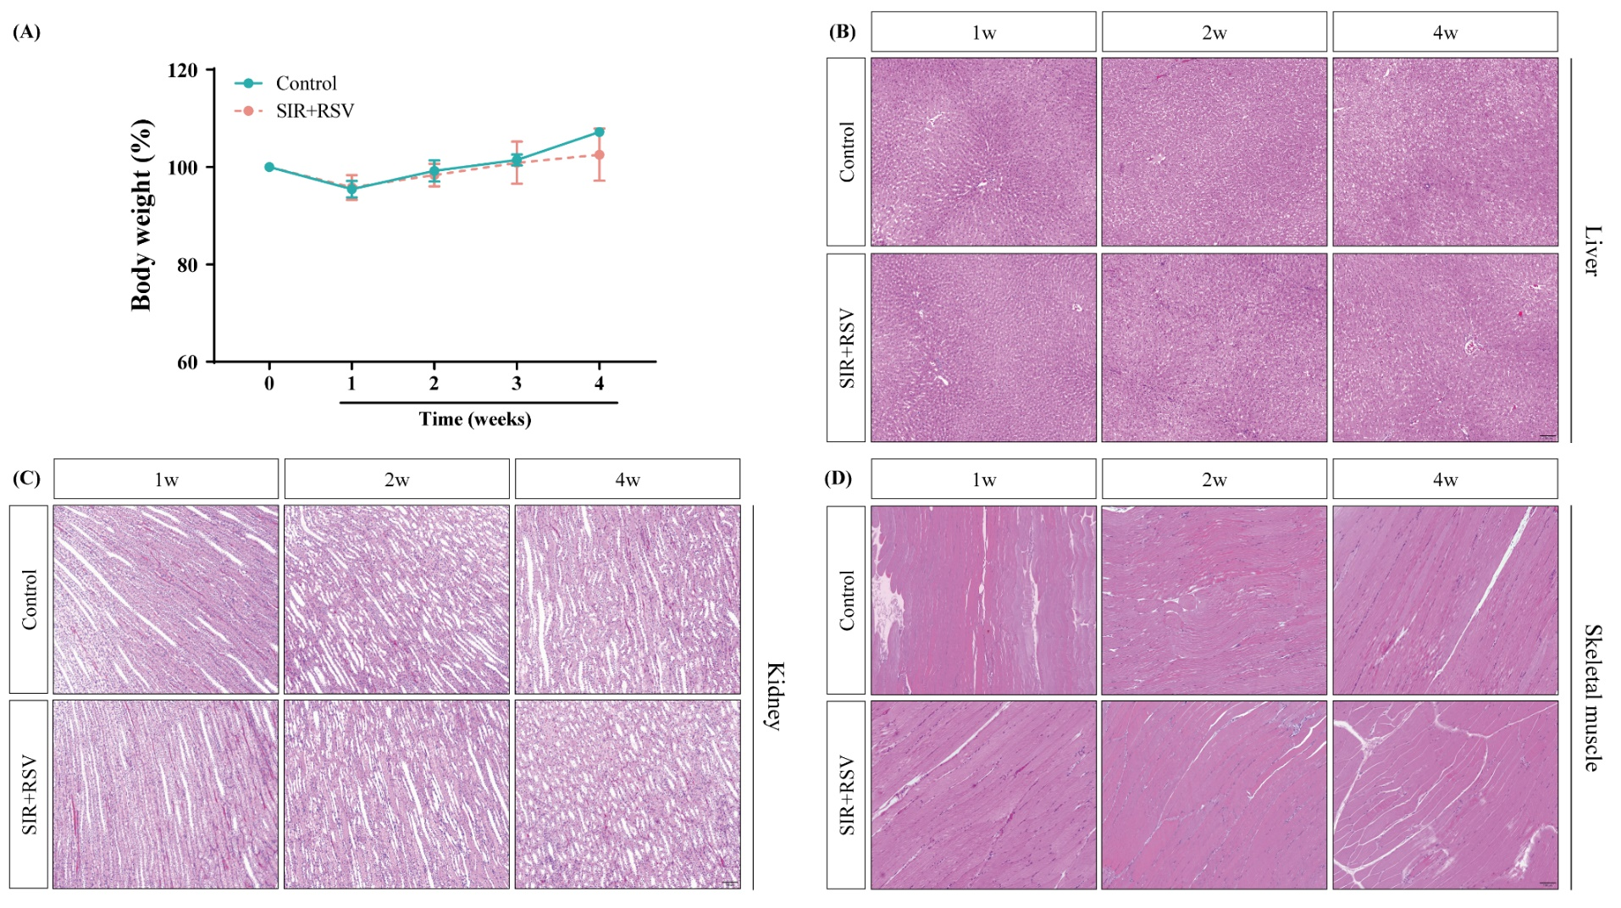
Fig. S2. In vivo safety assessment of the localized perivascular drug delivery device.
(A) Changes in body weight of the rabbits in each group during the four‐week experiment (n = 3–5/group). (B–D) Toxicity assessment of the localized perivascular drug delivery device via H&E staining in organs (liver, kidney, and skeletal muscle) of rabbits in the control and SIR+RSV groups. No significant pathological differences were observed in the two groups (scale bars = 100 μm). H&E, hematoxylin and eosin; SIR+RSV, combination of sirolimus and rosuvastatin.
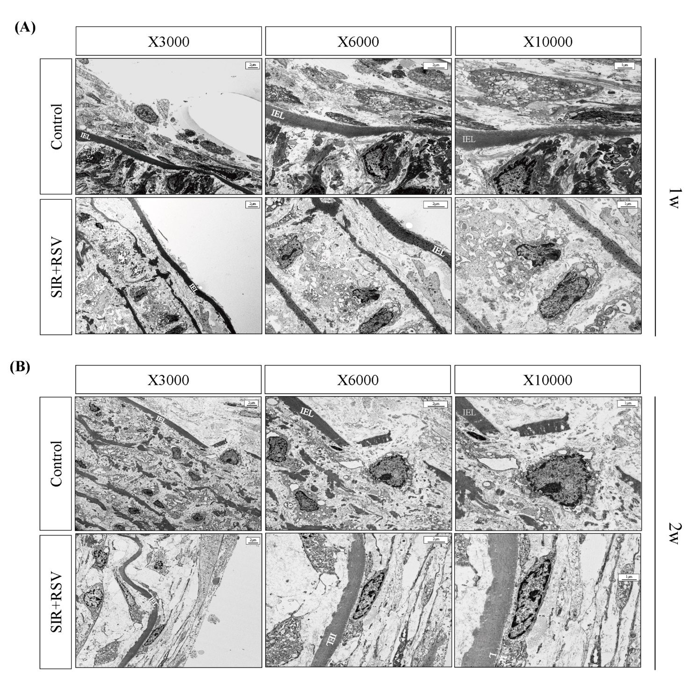
Fig. S3. Effect of the localized perivascular drug delivery device on cell morphology.
(A and B) Transmission electron microscopy sections of rabbit abdominal aortas at both the hyper-acute stage (1 week) and the acute stage (2 weeks) after injury. The aortas were treated with a localized perivascular drug delivery device containing either no drug (control) or SIR+RSV. SIR+RSV, combination of sirolimus and rosuvastatin.

