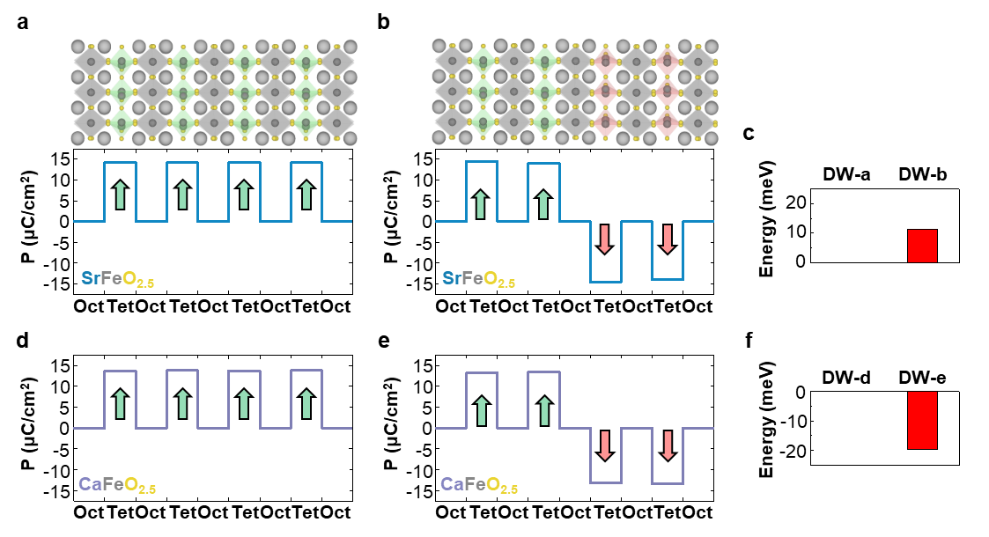

Extended Data. Fig. 1 | Stability of unit cell width polar domains in brownmillerite SrFeO_{2.5} and CaFeO_{2.5}. a-b, Variation of unit cell width polarization in brownmillerite SrFeO_{2.5} with the 0° domain (a) and with the 180° domain (b). Octahedral layers have no polarizations. c, Small energy difference between domain configurations of (a) and (b) indicated as domain wall (DW)-a and DW-b, respectively. d-e, Polarization variation in CaFeO_{2.5} with the 0° domain (d) and with the 180° domain (e). Octahedral layers have no polarizations. f, Small energy difference between domain configurations of (d) and (e) indicated as DW-d and DW-e, respectively. Negative energy means that CaFeO_{2.5} favors the antiferroelectric state.

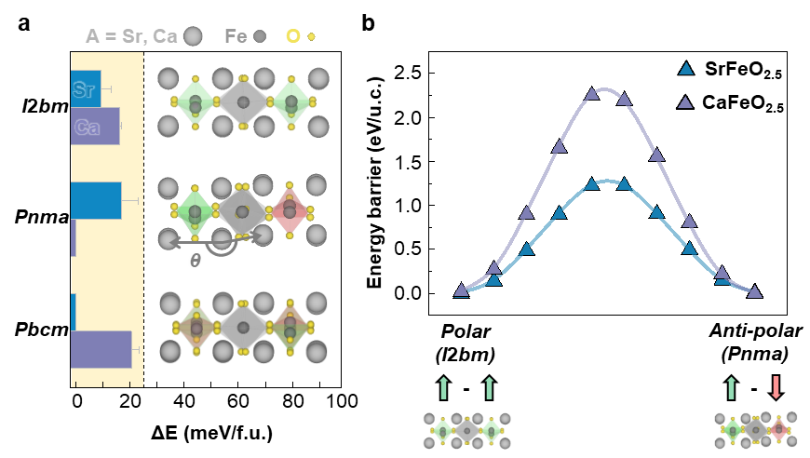

Extended Data. Fig. 2 | Space groups in SrFeO_{2.5} and CaFeO_{2.5}. a, Calculated relative energy of SrFeO_{2.5} (blue bar) and CaFeO_{2.5} (purple bar) from reference 23, 26, and 27. Each atomic structure along the zone axis of [101]_{O} is illustrated on the graph. Yellow boxed region means negligible energy difference between structures. A-site ion (Sr, Ca), Fe and O elements are represented by white, dark gray, and yellow dots, respectively. A-site buckling is indicated by θ in Pnma. In terms of the space group, three major structures, I2bm, Pnma, and Pbcm, are expected for AFeO_{2.5} (A = Sr, Ca). Among them, I2bm is the only polar space group with a broken inversion symmetry, where the polarization in the FeO₄ tetrahedral layer is aligned towards the same direction (top of (a)). In contrast, Pnma accompanies A-site buckling (θ), resulting in antipolarized FeO₄ tetrahedral layers, and the overall structure is centrosymmetric (middle of (a)). Pbcm is also centrosymmetric; however, in contrast to Pnma, up- and down-polarized FeO₄ tetrahedra appear alternately through an intralayer; therefore, the projected FeO₄ tetrahedra along [101]_{O} becomes nondisplacive (bottom of (a)). b, Energy barrier between polar I2bm and anti-polar Pnma phases. Brownmillerite AFeO_{2.5} (A = Sr (blue), Ca (purple)) have stable polar and anti-polar structure. Energy barriers between polar I2bm and anti-polar Pnma are 1.22 eV for SrFeO_{2.5} and 2.25 eV for CaFeO_{2.5}.

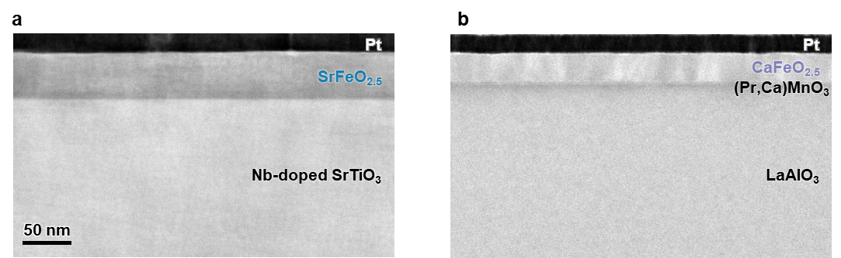

Extended Data. Fig. 3 | Low magnification BF-STEM images of SrFeO_{2.5} and CaFeO_{2.5} films. a, SrFeO_{2.5} films are grown on the Nb-doped SrTiO₃ substrate. Pt and Nb-doped SrTiO₃ serve as electrodes for electrical poling. b, CaFeO_{2.5} films are grown on the LaAlO₃ substrate and (Pr,Ca)MnO₃ electrode layer. Also, Pt on the top serve as an electrode. Both films are well grown without prominent defects.

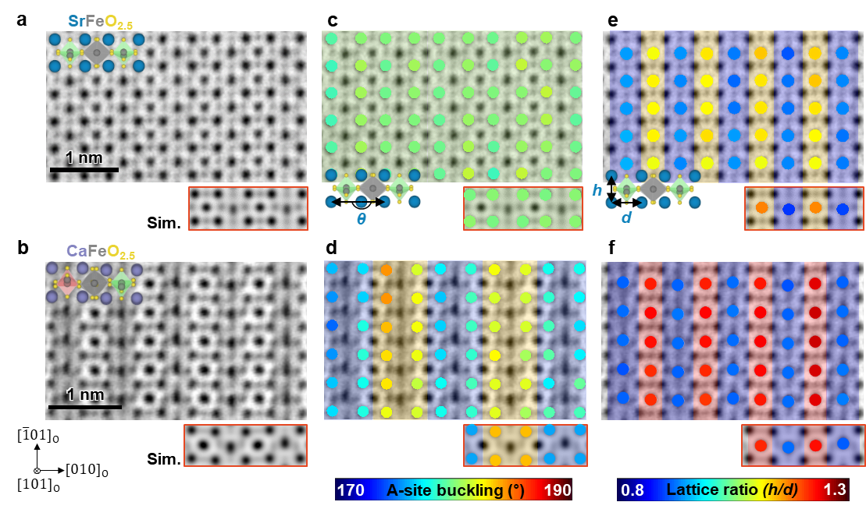

Extended Data. Fig. 4 | Atomic scale structural analysis of the SrFeO_{2.5} and CaFeO_{2.5}. a-b, Experimental ABF-STEM and simulation images along the zone axis of [101]_{O} for I2bm SrFeO_{2.5} (a) and Pnma CaFeO_{2.5} films (b) with overlaid corresponding atomic structures. c-d, A-site buckling angles obtained by atomic peak position analysis in the same regions as in (a) and (b), respectively. A-site buckling angle is negligible (~ 180°) in I2bm SrFeO_{2.5} structure and regularly up (~ 176°) and down (~ 184°) moves in Pnma CaFeO_{2.5} structure. e-f, Lattice ratio obtained by atomic peak position analysis in the same regions as in (a) and (b), respectively. Ratios are calculated by height over distance between neighbor A-site atoms.

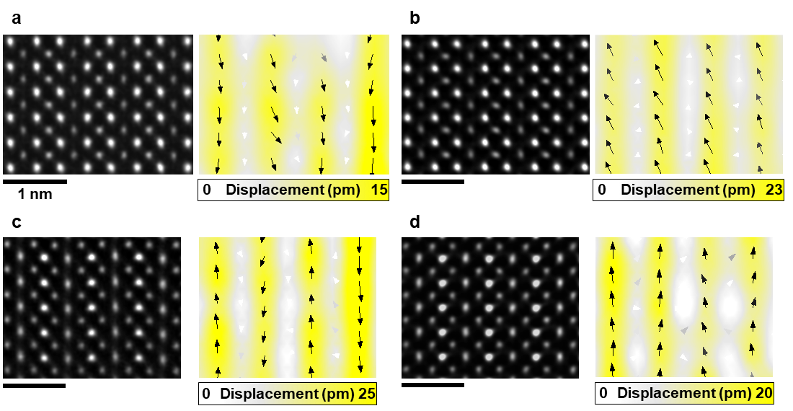

Extended Data. Fig. 5 | Displacement mapping of the SrFeO_{2.5} and CaFeO_{2.5}. a-b, HAADF-STEM image and Fe displacement map along the zone axis of [101]_{O} for pristine SrFeO_{2.5} (a) and poled SrFeO_{2.5} (b). c-d, HAADF-STEM image and Fe displacement map of pristine CaFeO_{2.5} (c) and poled CaFeO_{2.5} (d). In displacement maps, arrows indicate the direction of displacement, and the amount of displacement is illustrated by the size and color of arrows. Magnitude of polarization is also expressed as a color map.
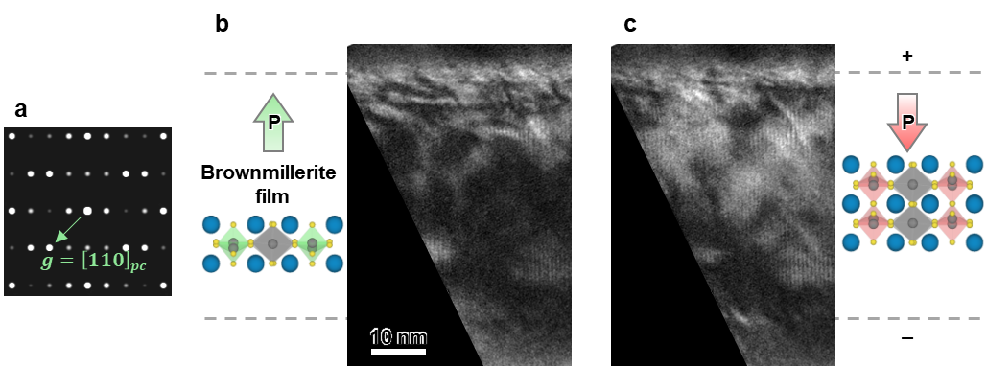

Extended Data. Fig. 6 | Electrical biasing induced phase contrast change in a brownmillerite film. a, Electron diffraction pattern of a brownmillerite structure and green arrow indicates g₁₁₀ reciprocal lattice vector. b-c, In-situ two-beam BF-TEM images with g₁₁₀ and atomic structures before electrical biasing (b) and after electrical biasing (c) on films with tungsten tip. Pt electrode, top layer is positively biased. Electric field induced ferroelectric switching is shown by the diffraction contrast change inside the film, although the contrast change is not clear compared to Pb(Zr,Ti)O₃ because the intensity of the relevant reflection is not significantly changed.

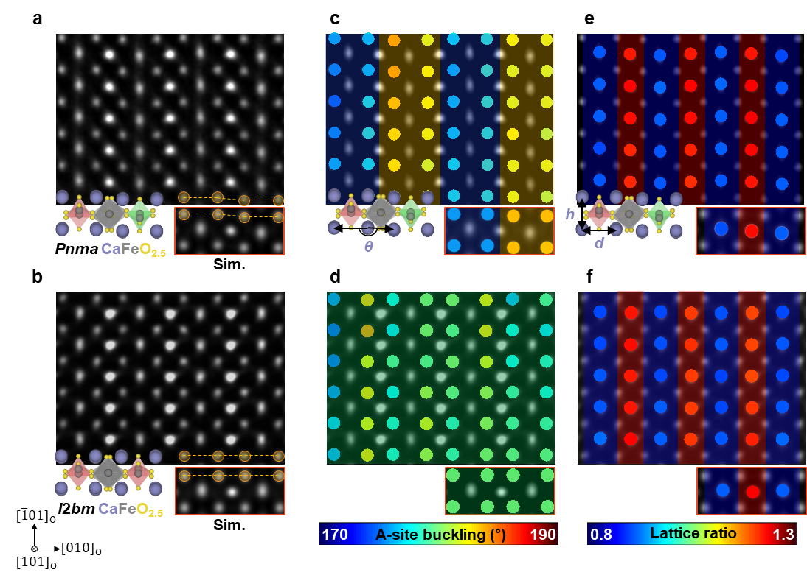

Extended Data. Fig. 7 | Atomic structural difference between pristine and poled CaFeO_{2.5}. a-b, Experimental HAADF-STEM and simulation images along the zone axis of [101]_{O} for pristine CaFeO_{2.5} (a) and poled CaFeO_{2.5} (b). Yellow line indicates significant difference of A-site buckling angle. c-d, A-site buckling angles obtained by atomic peak position analysis in the same regions as in (a) and (b), respectively. Pristine CaFeO_{2.5} shows alternative up (~ 176°) and down (~ 184°) A-site buckling by 2 layers indicating Pnma structure, while poled sample shows random and almost 180° angle of A-site buckling indicating I2bm structure. e-f, Lattice ratio obtained by atomic peak position analysis in the same regions as in (a) and (b), respectively. Although CaFeO_{2.5} structure changed from Pnma to I2bm, lattice ratio is preserved regularly.

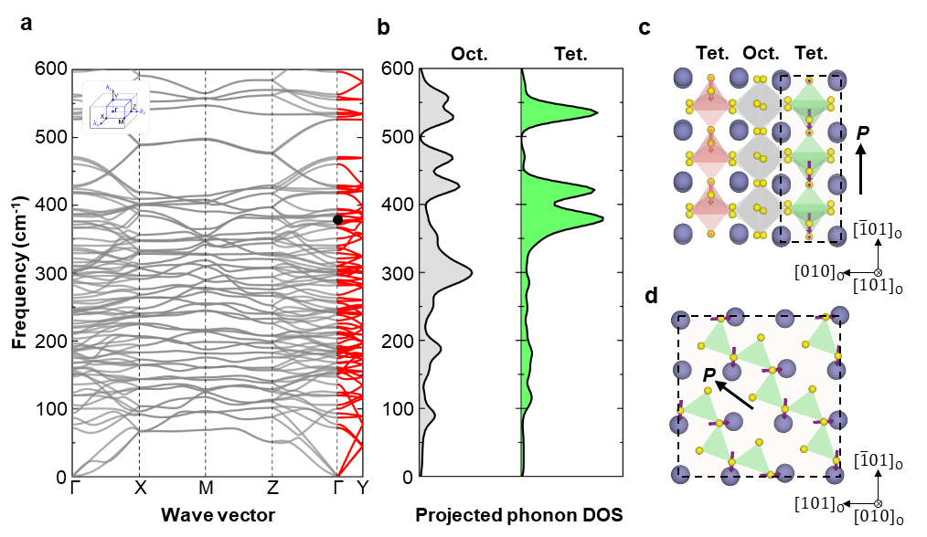

Extended Data. Fig. 8 | Phonon decoupling in anti-polar CaFeO_{2.5}. a, Phonon dispersion of CaFeO_{2.5}. Phonon dispersion curve along the Γ-Y direction is indicated in the red line. b, Projected phonon DOS of oxygen in FeO₆ octahedral and FeO₄ tetrahedral sites on the Γ-Y path. Oxygen-octahedral (gray) and oxygen-tetrahedral phonons (green) are a little decoupled except around 550 cm⁻¹, reflecting weak interaction between them. Oxygen-tetrahedral phonon is strongly localized from 350 cm⁻¹ to 410 cm⁻¹, resulting in the formation of flat phonon band. c, The schematic illustration of a Γ point phonon mode near 370 cm⁻¹ (indicated in black dot in (a)) along the [101] projection view. d, The [010] projection view for the region indicated in dashed-rectangle in (c). The arrows represent the real displacement vectors of the atoms, with a magnified amplitude. The purple and pink arrows indicate the displacement vectors for the distinguishing intralayer FeO₄ tetrahedra. The bold black arrows represent the direction of the polarization.

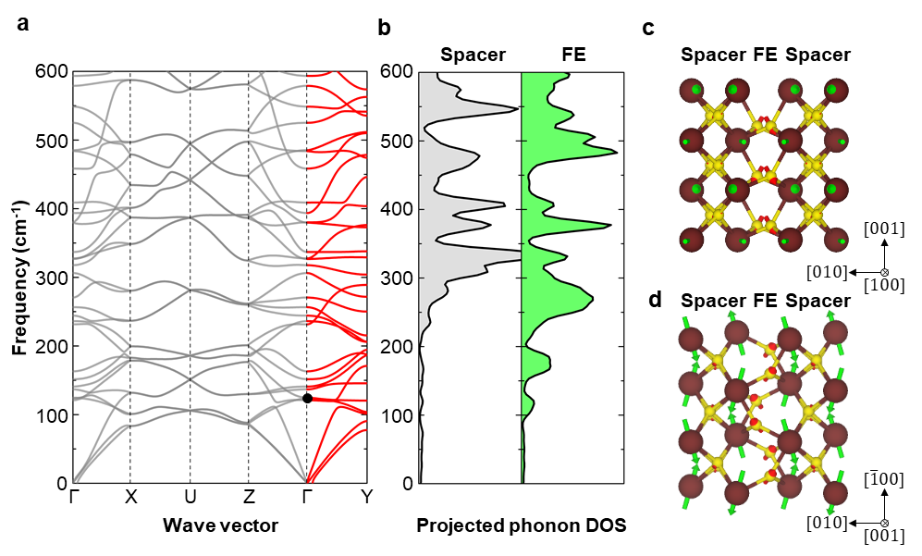

Extended Data. Fig. 9 | Phonon decoupling in polar HfO₂. a, Phonon dispersion of HfO₂. Phonon dispersion curve along the Γ-Y direction is indicated in the red line. b, Projected phonon DOS of oxygen in spacer and ferroelectric (FE) layers on the Γ-Y path. Spacer (gray) and ferroelectric layer phonons (green) are a little decoupled around 130 cm⁻¹, reflecting weak interaction between them. c-d, The schematic illustration of a Γ point phonon mode near 130 cm⁻¹ (indicated in black dot in (a)) along the [100] projection view (c) and the [001] projection view (d). The arrows represent the real displacement vectors of the atoms, with a magnified amplitude. The red arrows indicate the displacement vectors.

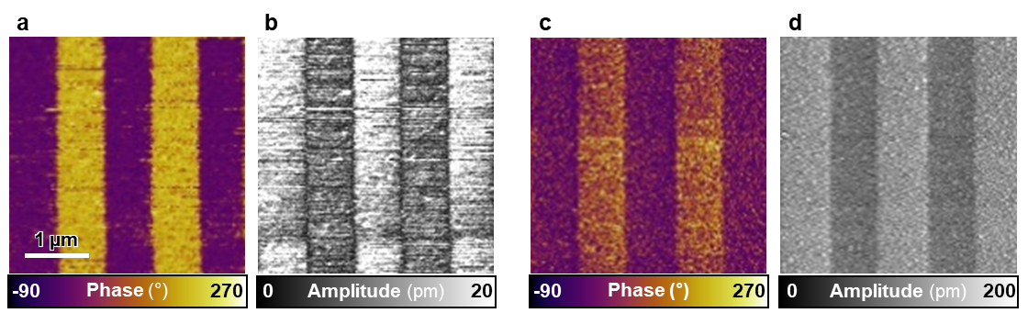

Extended Data. Fig. 10 | Microscopic characterization of switchable and stable polarization in AFeO_{2.5} (A = Sr, Ca) films. a-b, Electric field induced stable piezoelectric phase (a) and amplitude (b) in SrFeO_{2.5} films which show ferroelectric domains with sharp domain boundaries. c-d, Electric field induced stable piezoelectric phase (c) and amplitude (d) in CaFeO_{2.5} films which show ferroelectric domains with sharp domain boundaries.

