Electronic Supplementary Material
Synthesis of lanthanum and waste lye modified-zeolite from fly ash and its application in constructed wetland for nitrogen and phosphorus removal
Zhimei Liu ^{1,2,3}, Zhen Liang ^{4∗} , Shengju Wu ^{2,3}
(1.Chongqing University , Chongqing,400044, China
2.College of Resources and Environment, Chongqing School, University of Chinese Academy of Sciences, Chongqing,400714, China
3.Chongqing Institute of Green and Intelligent Technology, Chinese Academy of Sciences, Chongqing,400714, China
4.College of Fisheries , Southwest University, Chongqing,402460, China)

∗Corresponding author E-mails: liangzh2004@163.com

Table S1 Design and results of BBD factors
Numbers | LaCl₃ concentration（mM） | pH | Roasting temperature  （℃） | P Removal  （%）
1 | 10.8 | 12 | 300 | 86.06
2 | 16.2 | 6 | 200 | 93.43
3 | 10.8 | 9 | 200 | 96.34
4  5 | 16.2  5.4 | 12  6 | 200  200 | 92.81  89.59
6 | 10.8 | 12 | 100 | 83.05
7 | 10.8 | 9 | 200 | 96.86
8 | 16.2 | 9 | 300 | 89.28
9 | 10.8 | 6 | 300 | 86.17
10 | 5.4 | 12 | 200 | 89.49
11 | 16.2 | 9 | 100 | 86.69
12 | 5.4 | 9 | 300 | 87.72
13 | 10.8 | 9 | 200 | 96.34
14 | 5.4 | 9 | 100 | 84.71
15 | 10.8 | 9 | 200 | 96.13
16 | 10.8 | 9 | 200 | 96.44
17 | 10.8 | 6 | 100 | 83.16
Note：three replicates of each experimen

Table S2 Optimal optimization and validation analysis of P removal under restricted domain conditions
Factor selection range |  |  | Response Value Limiting Conditions | Optimal conditions |  |  | Model P Predicted Value | P experimental value（%） | Deviation (%) | Experimental value of N removal of LZFA（%） | N removal of ZFA(%) | Rate of change（%）
LaCl₃ concentration  （mM） | pH | Roasting temperature  （℃） | ＞90% | LaCl₃ concentration  （mM） | pH | Roasting temperature（℃） | 96.83 | 95.98 | 0.88 | 81.88 | 89.33 | -8.3
5.4-16.2 | 6-12 | 100-300 | ＞90% | 13.56 | 8.93 | 208.72

Table S3 Chemical composition of the substances tested by XRF
Samples | SiO₂ | Al₂O₃ | Fe₂O₃ | CaO | F | K₂O | TiO₂ | MgO | Na₂O | La₂O₃ | 其余 | Si/Al
FA | 50.28 | 25.79 | 7.25 | 4.79 | 4.05 | 2.93 | 1.45 | 0.81 | 0.71 | 0 | 1.94 | 1.8
ZFA | 33.49 | 18.65 | 4.83 | 2.81 | _ | 2.01 | 0.90 | 0.43 | 36.12 | 0 | 0.76 | 1.58
LZFA | 36.68 | 22.35 | 7.11 | 4.00 | _ | 0.92 | 1.25 | 0.82 | 8.53 | 17.81 | 0.53 | 1.44

Table S4 Specific surface and pore size distribution
Sample | BET  （m²/g） | Total Pore Volume  （cm³ /g） | r  ( nm) | Mircropore  Area  （m²/ g） | Mircropore volume  （cm³ /g） | r_{mic}  ( nm)
ZFA | 3.79 | 0.021 | 21.60 | 1.507 | 0.000768 | 2.03
LZFA | 207.12 | 0.217 | 4.19 | 158.32 | 0.083 | 2.09
Note: r and rmic represent the total and micropore average pore diameters, respectively, and are calculated from 4V/A, where V is the pore volume and A is the Bet calculated specific surface area.

Table S5 Kinetic parameters of N and P adsorption by ZFA and LZFA
Adsorbent | Initial concentration（mg/L） | Pseudo first-order model |  |  |  |  |  |  | Pseudo second-order model
 |  | q_{e,cal}  （mg/g） |  |  | K₁  （min⁻¹） |  | R² |  | q_{e,cal}  （mg/g） |  |  | K₂  （g/(mg.min)) |  |  | R²
ZFA | N 5 | 0.433 |  |  | 0.178 |  | 0.536 |  | 0.447 |  |  | 0.495
LZFA | N 5 | 0.404 |  |  | 0.0240 |  | 0.622 |  | 0.412 |  |  | 0.982 |  |  | 0.921
LZFA | P 5 | 0.469 |  |  | 0.0246 |  | 0.596 |  | 0.481 |  |  | 0.653 |  |  | 0.913
Adsorbent | Initial concentration（mg/L） | Intra particle diffusion model
 |  | K_{d1}  （mg/（g.min^{0.5}）） | C1 | R² |  | K_{d2}  （mg/（g.min^{0.5}）） |  | C2 |  | R² | K_{d3}  （mg/（g.min^{0.5}）） |  | C3 | R²
ZFA | N 5 | 0.0107 | 0.3297 | 0.9946 |  | 0.0033 |  | 0.3872 |  | 0.6845 | 3.680×10⁻⁴ |  | 0.4332 | 0.393
LZFA | N 5 | 0.0103 | 0.309 | 0.935 |  | 0.00367 |  | 0.357 |  | 0.985 | 6.428×10⁻⁵ |  | 0.413 | 0.405
LZFA | P 5 | 0.0144 | 0.333 | 0.997 |  | 0.00498 |  | 0.407 |  | 0.944 | 1.451×10⁻⁴ |  | 0.478 | 0.291

Table S6 Isothermal parameters of N and P adsorption by ZFA and LZFA
Adsorbent |  | Langmuir |  |  | Freundlich
 |  | Q_{m}(mg/g) | K_{L}（L/mg） | R² | K_{F}（(mg/g)/（mg/L）^{1/n}） | 1/n | R²
ZFA | N | 21.32 | 0.118 | 0.809 | 4.302 | 0.328 | 0.649
LZFA | N | 17.26 | 0.204 | 0.957 | 4.100 | 0.302 | 0.797
LZFA | P | 21.48 | 0.280 | 0.801 | 5.732 | 0.277 | 0.549

Table S7 Relative content of surface elements before and after adsorption of N
and P by LZFA
Atomic ratio  （%） | O | N | P | Fe | Ca | La
LZFA | 58.41 | 0.44 | 0.51 | 1.11 | 1.86 | 3.46
LZFA+N+P | 57.45 | 1.29 | 3.28 | 0.94 | 0.91 | 1.75

Table S8 The fitting parameters of O1s split peaks for the X-ray photoelectron spectra before and after adsorption of N and P by LZFA

Sample | Peak | Position（eV） | Area | FWHM | Percent（%）
LZFA | M-OH | 533.36 | 424596.50 | 2.57 | 93.88
 | M-O | 528.60 | 13882.62 | 2.57 | 3.07
 | H₂O | 535.16 | 13821.12 | 2.57 | 3.06
LZFA+N+P | M-OH | 532.07 | 372813.05 | 2.62 | 80.48
 | M-O | 530.18 | 82080.16 | 2.62 | 17.71
 | H₂O | 535.85 | 8331.26 | 2.62 | 1.798

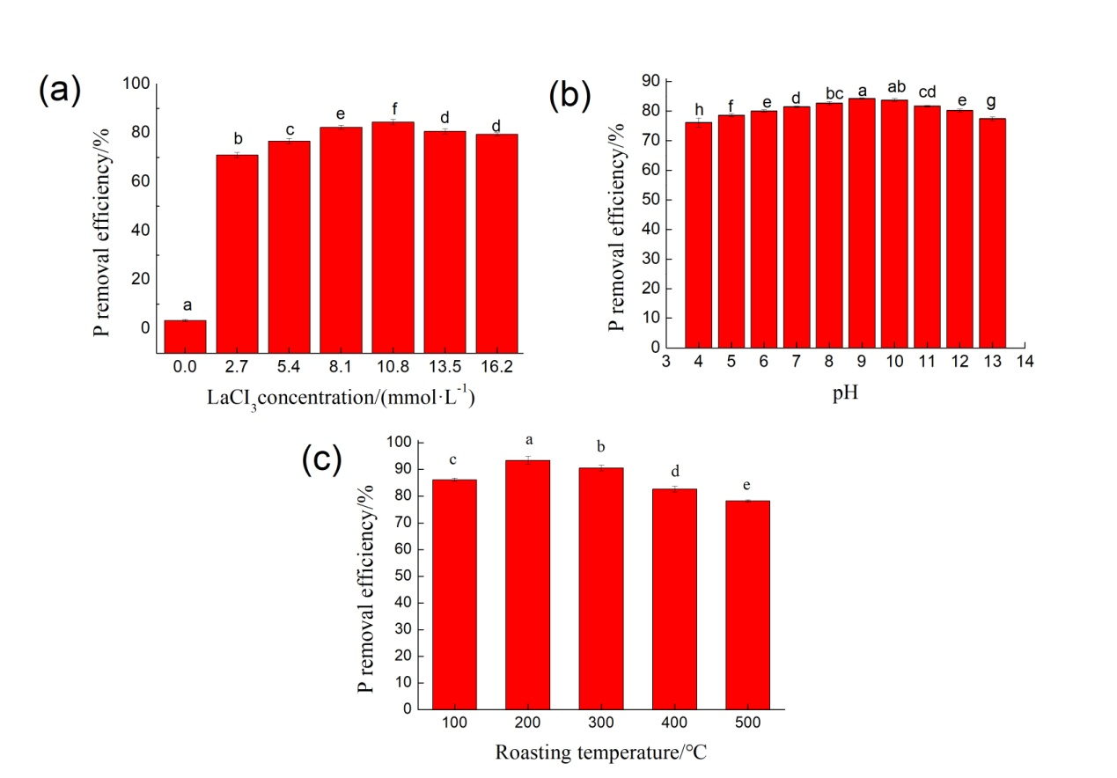
Fig. S1 Effect of different LaCl₃ concentrations(a), pH (b) and roasting temperatures (c) on phosphorus removal

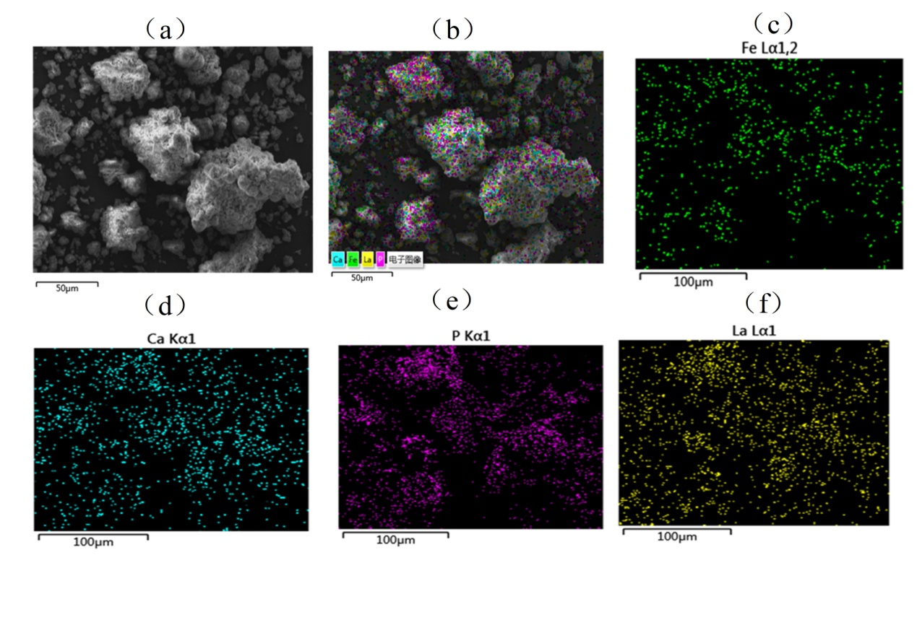
Fig. S2 Scanning electron microscopy–energy dispersive X-ray spectroscopy (SEM–EDS) of LZFA after adsorption phosphate of 500 mg/L: (a) SEM image; (b) EDS stratified diagram; (c)–(f) Fe, Ca, P and La elemental distributions, respectively.

