Supporting Information
Solution synthesis of two-dimensional ZnO / MoS₂ heterostructure through reactive templating for enhanced visible-light degradation of Rhodamine B (RB)
Lili Liu,¹ Ping Chen,¹ Xin Zhang,¹ Libor Kovarik,¹ James J. De Yoreo,^{1, 2} Jun Liu,^{2, 3} Maria L. Sushko^{1,*}
¹Physical and Computational Sciences Directorate, Pacific Northwest National Laboratory, Richland, Washington 99352, United States
²Department of Materials Science and Engineering, University of Washington, Seattle, Washington 98195, United States
³Energy and Environmental Directorate, Pacific Northwest National Laboratory, Richland, Washington 99352, United States
*Corresponding author. E-mail: maria.sushko@pnnl.gov

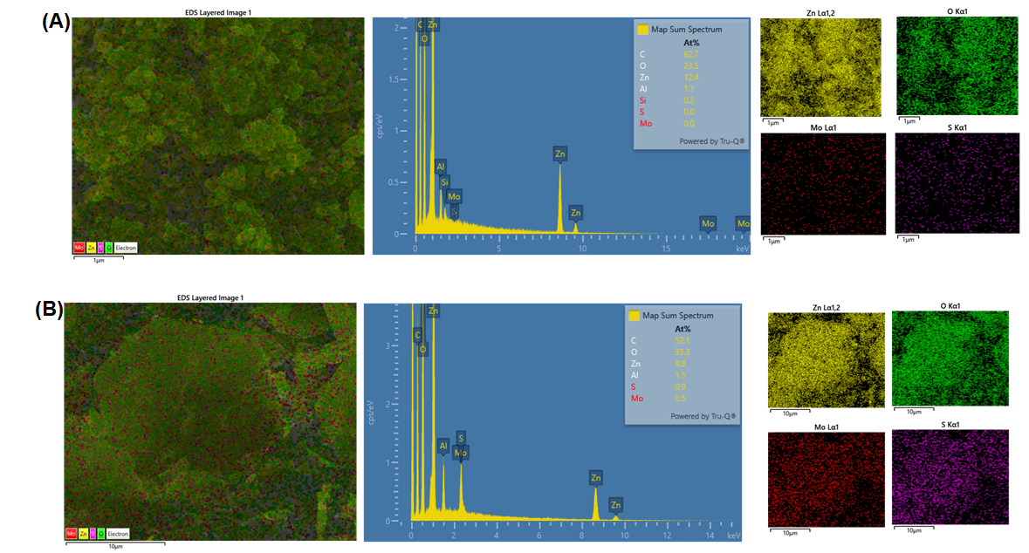
Figure S1. SEM-EDS mapping showing (A) the coexistance of Zn, O elements in the control sample, and (B) the coexistance of Zn, O, Mo and S elements in the sample synthesized in solution of Zn(NO₃)₂ + HMTA + 5% MoS₂.

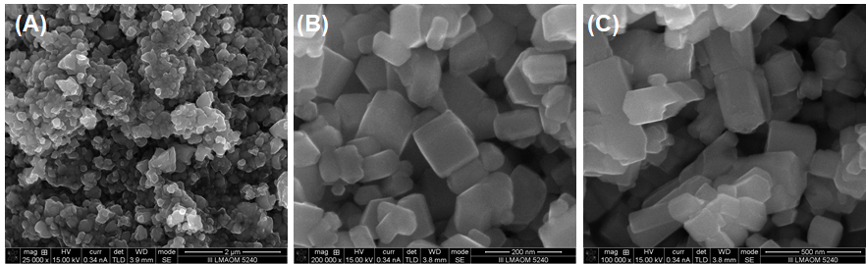
Figure S2. SEM images of ZnO nanoparticles obtained at different conditions. (A) 200mM Zn(NO₃)₂+ 20mM HMTA in the absence of MoS₂. (B) 200mM Zn(NO₃)₂+ 20mM NaOH in the presence of 5% MoS₂. (C) 200mM Zn(NO₃)₂+20mM HMTA in pure water containing 5% MoS₂.

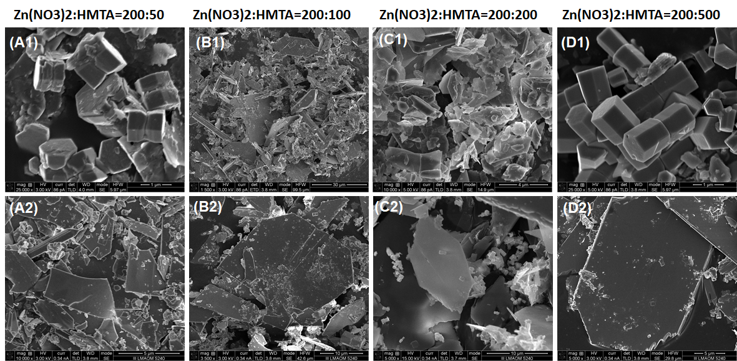
Figure S3. Effect of HMTA concentration on the growth of ZnO, characterized by SEM. (A1-D1) in the absence of MoS₂. (A2-D2) in the presence of MoS₂.
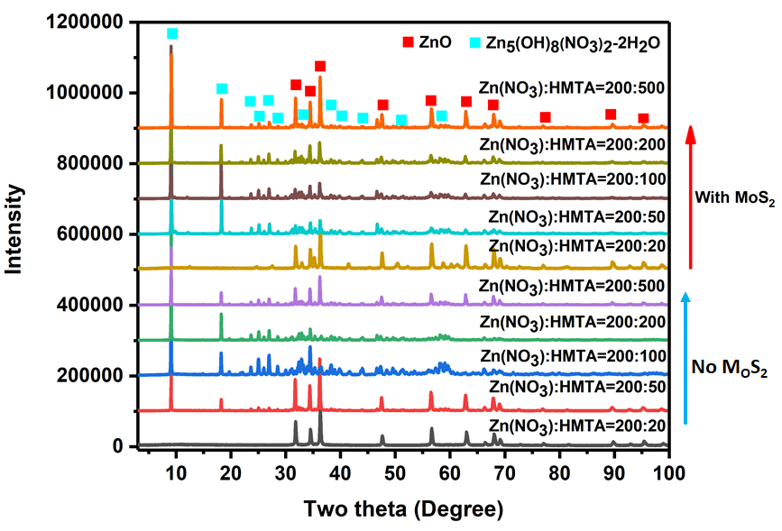
Figure 4. Effect of HMTA concentration on the growth of ZnO, characterized by XRD.

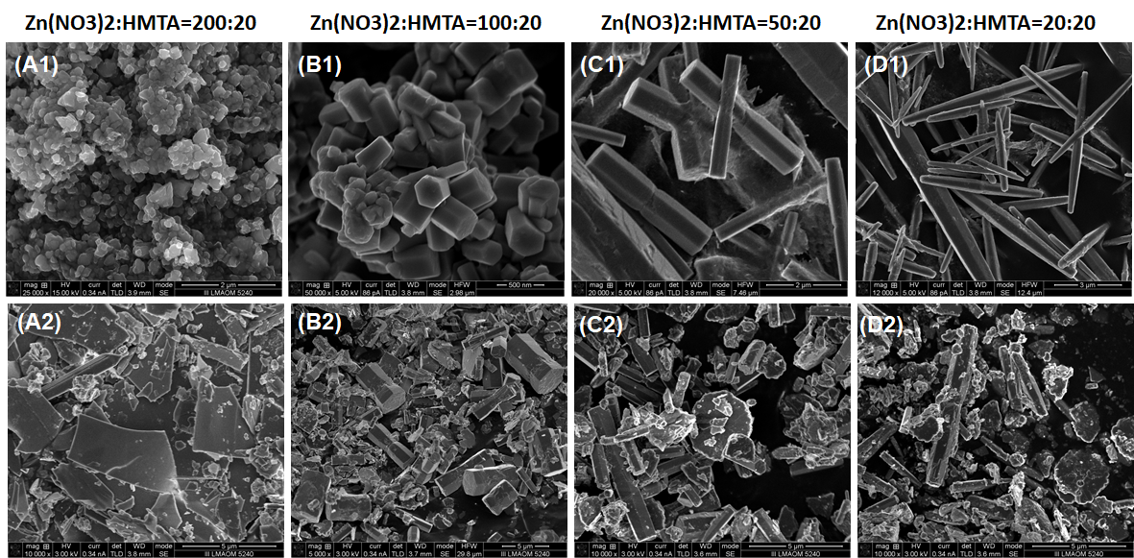
Figure S5. Effect of Zn(NO₃)₂ concentration on the growth of ZnO, characterized by SEM. (A1-D1) in the absence of MoS₂. (A2-D2) in the presence of MoS₂
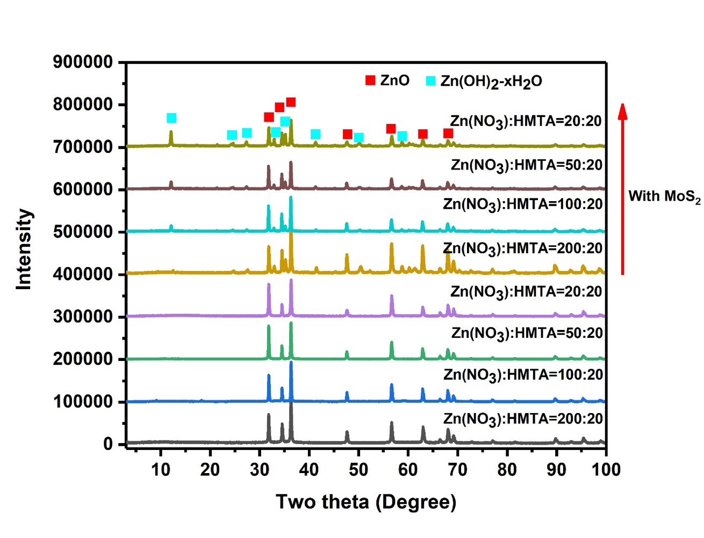
Figure S6. Effect of Zn(NO₃)₂ concentration characterized by XRD.

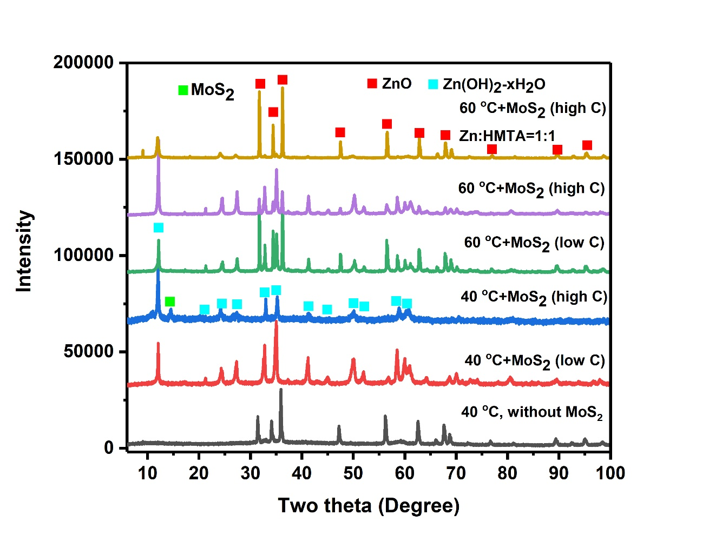
Figure S7. XRD pattern showing the effect of MoS₂ content on the formation of Zn(OH)₂-xH₂O phase at 40 °C and 60 °C.

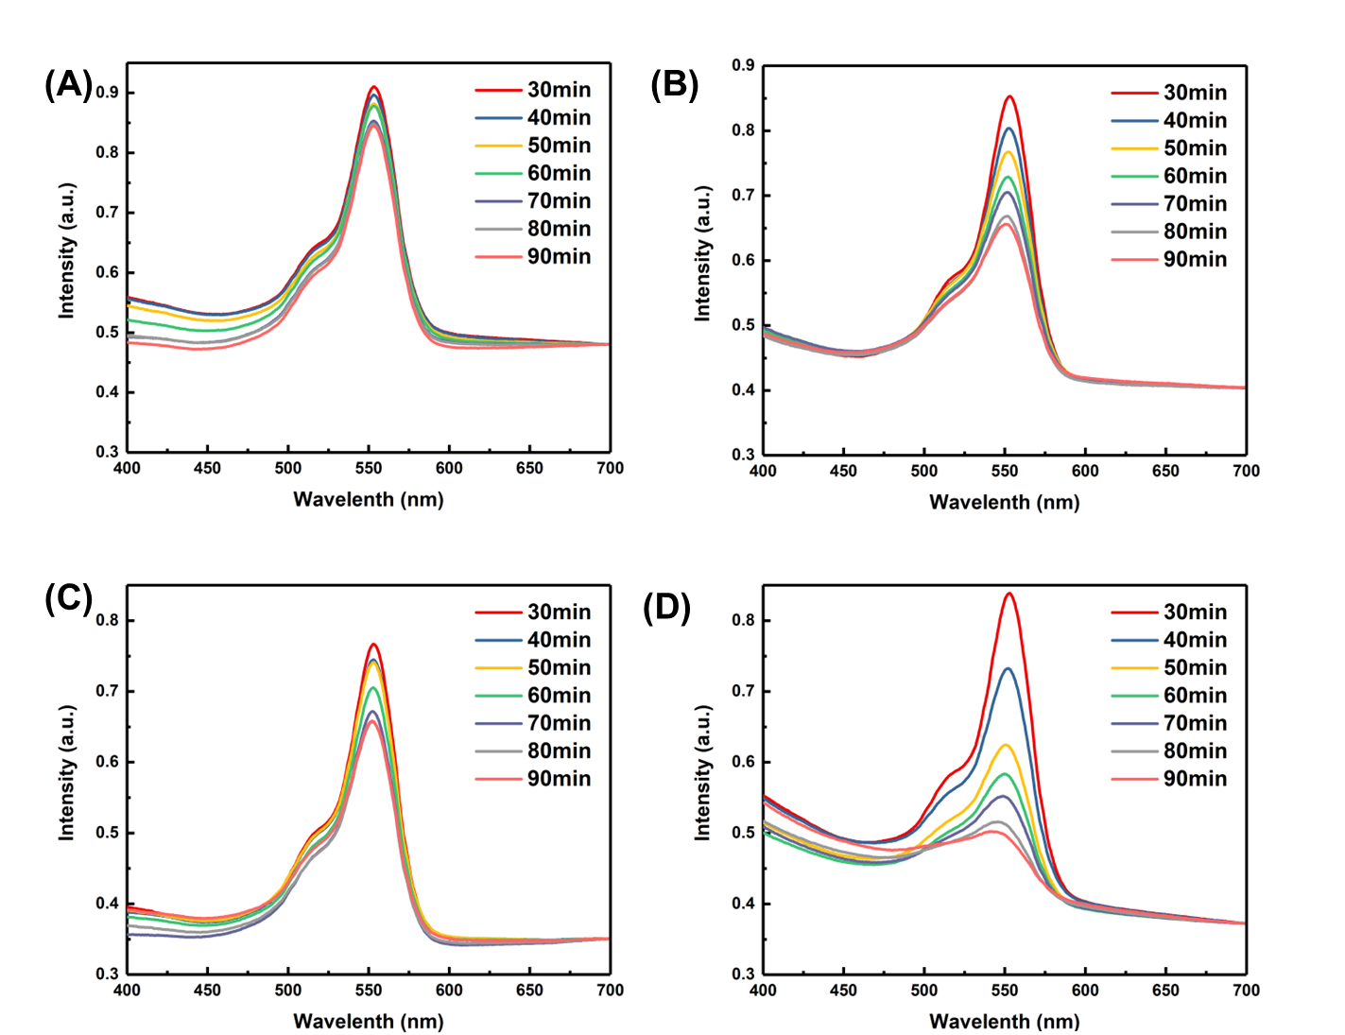

Figure S8. Photoluminescence spectra of different catalysts: (A) Zn(OH)₂ mixed with MoS₂; (B) ZnO mixed with MoS₂; (C) Zn(OH)₂-ZnO-MoS₂; (D) ZnO-MoS₂ heterostructure.

