Supplemental Information

Figure S1. Group differences in epigenetic maternal neglect (EMN).

The genetic data comprised 7718 CpG islands after pruning the residuals by comparing the Control and Neglect groups. The threshold was set to p < 0.021, corresponding to the first percentile of p values. EMNs, indexing the mothers’ epigenetic load, were significantly lower in the non-neglect control group (CG) than in the neglect group (NG): CG (M = 0.152; SD = 0.05); NG (M = 0.430; SD = 0.202): t-test (53.668) = -9.614, p < .0001, using the mother’s educational level, age, the plate position, and leukocytes as covariates, and without showing outliers.

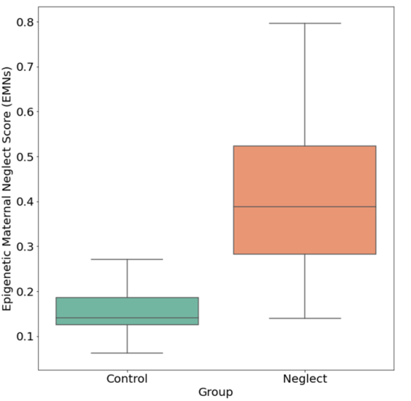

Figure S1. Significant group differences in EMN scores between control (CG) and neglect groups (NG) of mothers using their educational level, age, plate position, and leukocytes as covariates, without showing outliers.

Figure S2. Variables involved in all the models tested and their intercorrelation.
The Epigenetic Maternal Neglect scores (EMNs) significantly and positively correlated with i) the intensity of adverse events and all subtypes of childhood maltreatment and ii) psychopathological internalizing and externalizing dimensions. By contrast, EMNs significantly and negatively correlated with iii) cognitive integrity; and vi) emotional availability measures (maternal and child behavior). Finally, emotional availability (mother and child) did not correlate with cognitive integrity or psychopathology (Internalizing and Externalizing symptoms).
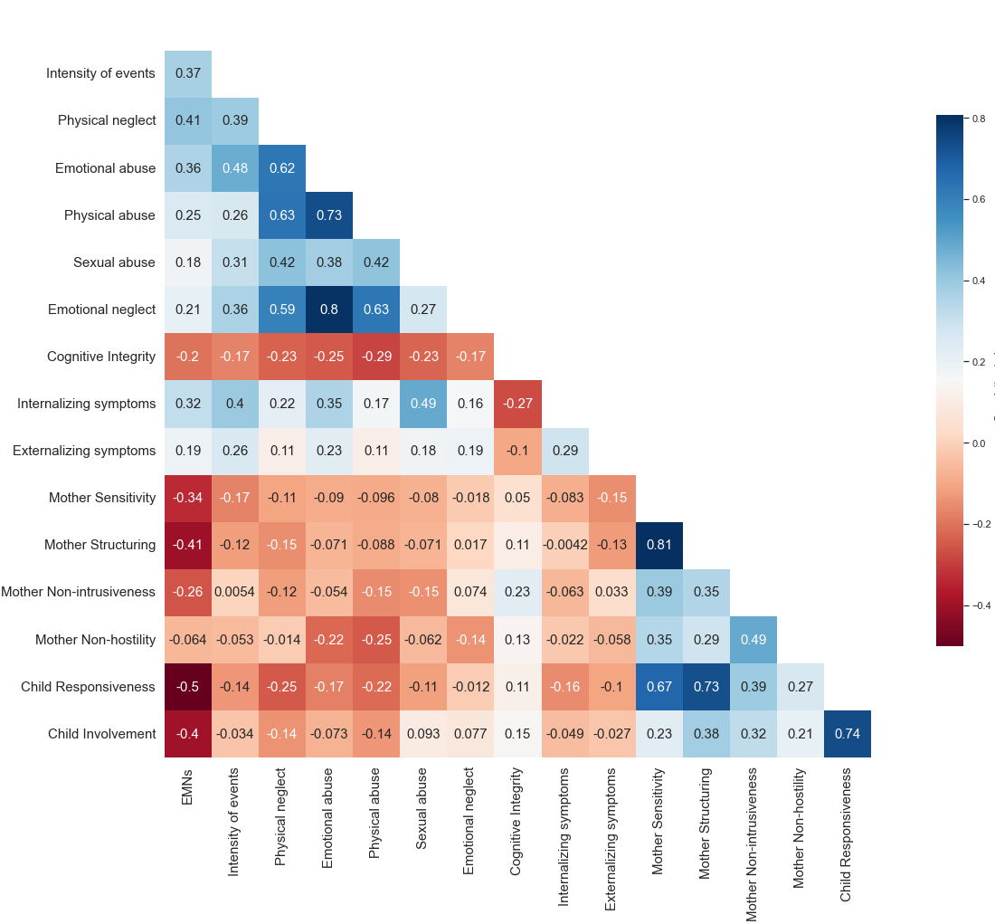
Figure S2. Pearson matrix of correlations among the variables included in the SEM initial model.

Additional SEMs non-fitting results when substituting physical neglect by the intensity of life events or any other type of maltreatment as covariates.

Fitting indexes for those alternative models:
- substituting physical neglect by the intensity of events (Chi-squared (29) = 57.584; p = 0.001; CFI=0.916; TLI=0.87; NFI=0.851; NNFI=0.87; MFI=0.9; RMSEA=0.085; CI= [0.052; 0.117]);
- substituting physical neglect by emotional abuse as the maltreatment variable (Chi-squared (29) = 63.089; p = 0.0001; CFI=0.901; TLI=0.846; NFI=0.838; NNFI=0.846; MFI=0.882; RMSEA=0.093; CI= [0.062; 0.124]);
- substituting physical neglect by physical abuse as the maltreatment variable (Chi-squared (29) = 52.716; p = 0.005; CFI=0.927; TLI=0.887; NFI=0.857; NNFI=0.887; MFI=0.917; RMSEA=0.078; CI=[0.043; 0.11]);
- substituting physical neglect by sexual abuse as the maltreatment variable (Chi-squared (29) =79.129; p = 0.0001; CFI=0.856; TLI=0.776; NFI=0.798; NNFI=0.776; MFI=0.832; RMSEA=0.113; CI=[0.083; 0.143]);
- substituting physical neglect by emotional neglect as the maltreatment variable (Chi-squared (29) =55.151; p = 0.002; CFI=0.919; TLI=0.875; NFI=0.851; NNFI=0.875; MFI=0.908; RMSEA=0.081; CI=[0.048; 0.114]).

