Supplementary Materials for

Surface Roughness parameters at a Tropical Semi-Arid Site: 4 years of Atmosphere Boundary Layer observations in the Deccan Plateau region at Shadnagar, India

This file includes:

Supplementary Figures 1 to 3

Supplementary Figure 1
Comparison of 100 m winds from reanalysis and LogL model. Vertically extrapolated winds from 31 m sonic anemometer using the LogL model are compared against 100 m ERA5 reanalysis winds for 2016 to 2019 period across different wind-direction sectors
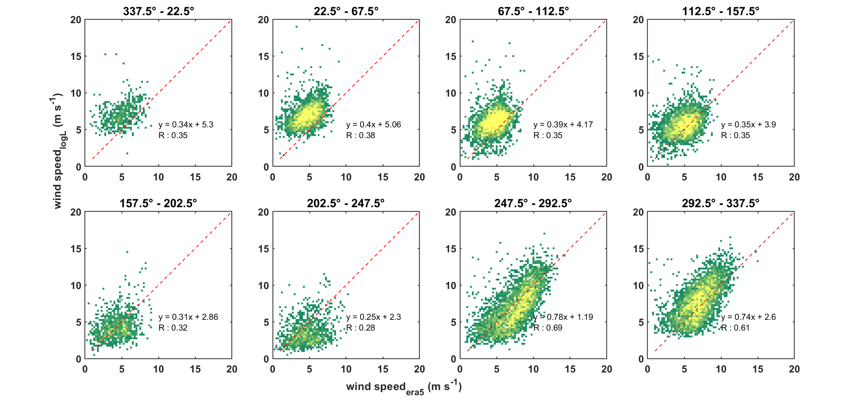

Supplementary Figure 2
Comparison of 100 m winds from reanalysis and PL model. Vertically extrapolated winds from 31 m sonic anemometer using the PL model are compared against 100 m ERA5 reanalysis winds for 2016 to 2019 period across different wind-direction sectors
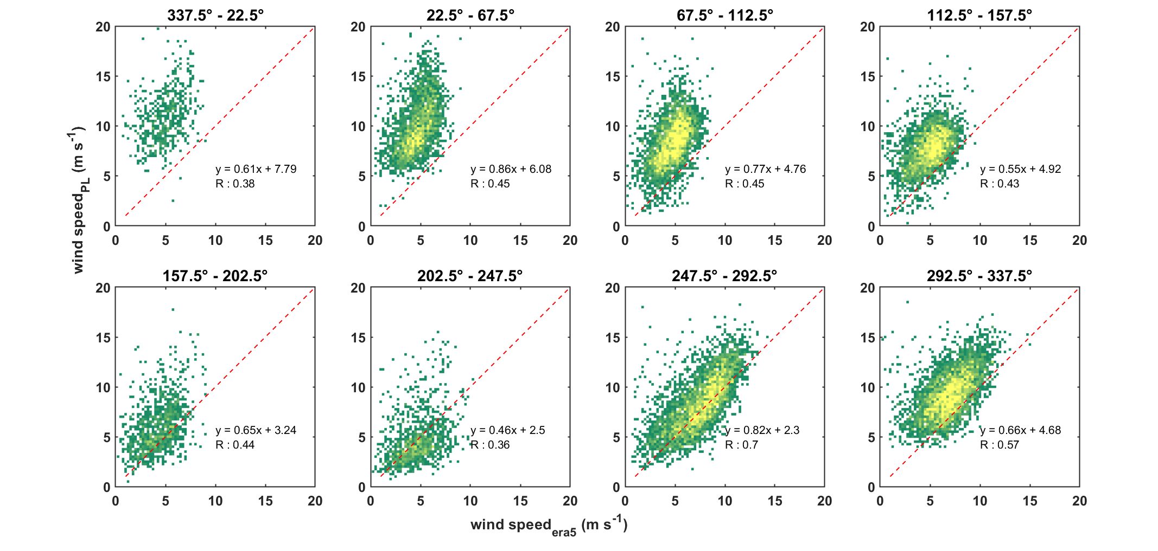

Supplementary Figure 3
Land Cover and Topography around the study area. Region within the footprint of nearest ERA5 pixel (0.25 degree spatial scale) is presented for (a) Land Use Land Cover map from DynamicWorld is presented for the year 2017 and, (b) Digital Elevation map from Shuttle Radar Tomography Mission (SRTM). Yellow-diamond marker denotes the site location
