New N-heterocyclic aroyl hydrazone containing 4-oxopiperidine nucleus and its metal complexes: synthesis, spectroscopic, thermal, DFT, molecular docking and antimicrobial studies
Gajanan Dongare¹. Anand Aswar²
1 Department of Chemistry, Shri Shivaji College of Arts, Commerce & Science, Akola-444001.MS, India.
2 Department of Chemistry, Sant Gadge Baba Amravati University, Amravati-444602. MS, India.
1 Email: infogmdongare@gmail.com ORCID: https://orcid.org/0000-0002-3986-9796
2 Corresponding email: aswaranand@gmail.com ORCID: https://orcid.org/0000-0003-4368-496X

Sr.No. | Figures and tables |  | Page no.
 | Fig. S1 | IR spectrum of 4-oxo-1-carbo piperidone hydrazide(CPHN) | 2
 | Fig. S2 | ¹H-NMR spectrum of 4-oxo-1-carbo piperidone hydrazide (CPHN) | 2
 | Fig. S3 | ¹³C-NMR spectrum of 4-oxo-1-carbo piperidone hydrazide (CPHN) | 3
 | Fig. S4 | ¹H NMR spectrum of hydrazone ligand (H₂L) | 3
 | Fig. S5 | ¹³C-NMR spectrum of hydrazone ligand (H₂L) | 5
 | Fig. S6 | Mass spectrum of hydrazone ligand (H₂L) | 5
 | Fig. S7 | Simulated IR spectra of (a) H₂L ligand, and its (b) Cr(III),  (c) Mn(II), (d) Co(II), (e) Ni(II) complexes | 5-7
 | Fig. S8 | Molecular structure of hydrazone ligand (H₂L) showing numbering to carbon atoms | 7
 | Fig. S9 | Electronic spectra of (a) hydrazone ligand (H₂L), and (b) its metal (II/III) complexes | 8
 | Fig. S10 | XRD spectra of (a) Ligand, (b) Cr(III),(c) Mn(II), (d) Fe(III), (e) Cu(II) metal complexes | 8
 | Scheme 2 | Schematic thermal decomposition pattern of [Co(HL)(H₂O)₂Cl] complex | 9
 | Fig. S11 | Optimized molecular structures of (e) Co(II), (f) Ni(II),(g) Cu(II) complexes | 9
 | Fig. S12 | Molecular electrostatic potential map surface of (a) Cr(III),  (b) Co(II), (c) Ni(II), (d) Cu(II) complexes | 10
 | Fig. S13 | Inhibition zone growth of microorganisms of ligand (H₂L), and  its metal complexes | 11
 | Table S1 | ESR tensor parameters of Cu(II) complex | 12
 | Table S2 | Indexed X-ray diffraction data of hydrazone ligand (H₂L) | 13
 | Table S3 | Indexed X-ray diffraction data of Cr(III) complex | 14
 | Table S4 | Indexed X-ray diffraction data of Mn(II) complex | 15
 | Table S5 | Indexed X-ray diffraction data of Fe(III) complex | 16
 | Table S6 | Indexed X-ray diffraction data of Cu(II) complex | 17
 | Table S7 | Bioactivity score of the hydrazone ligand, and its metal complexes | 18
 | Table S8 | Lipinski parameters of the hydrazone ligand, and its metal complexes | 19
 | Table S9 | ADMET activity score of the hydrazone ligand, and its metal complexes | 20
Supplementary information

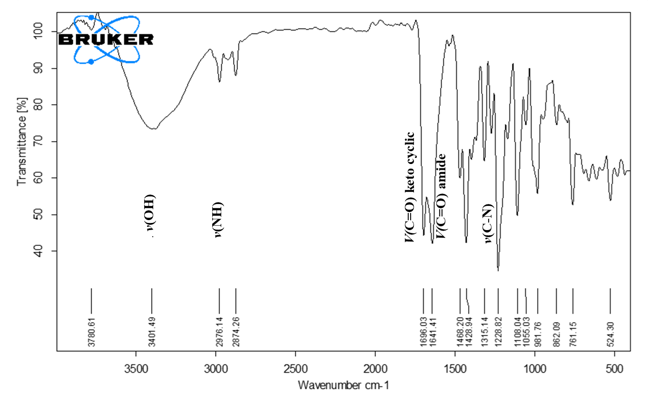
Fig. S1 IR spectrum of 1-carbo-4-oxo-piperidine hydrazide (CPHN)
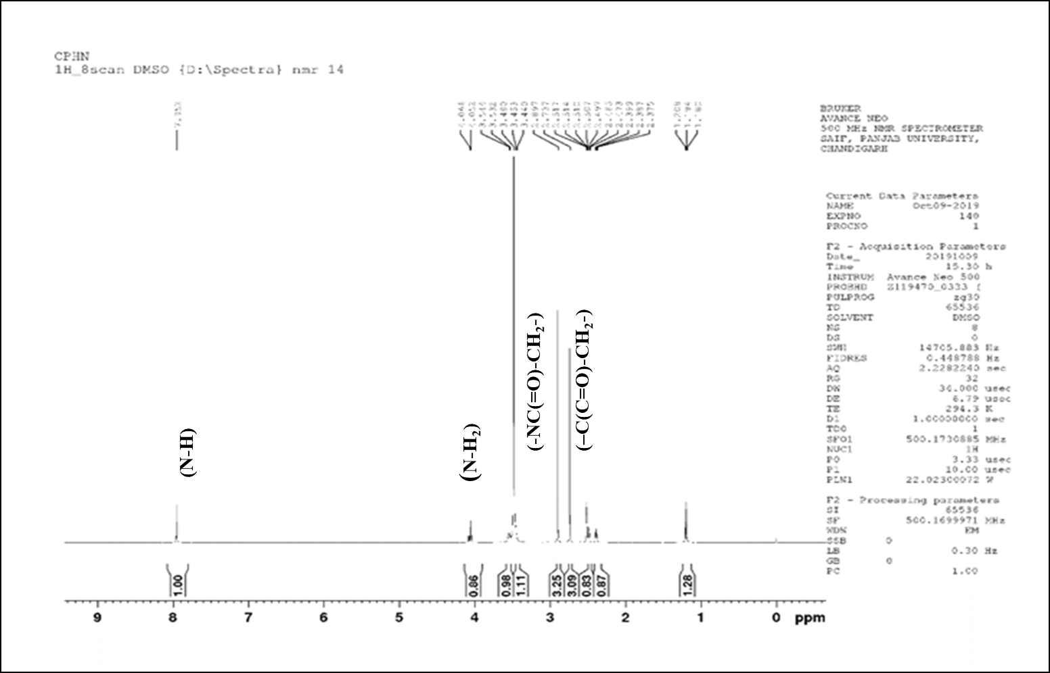
Fig. S2 ¹H-NMR spectrum of 1-carbo-4-oxo-piperidine hydrazide (CPHN)

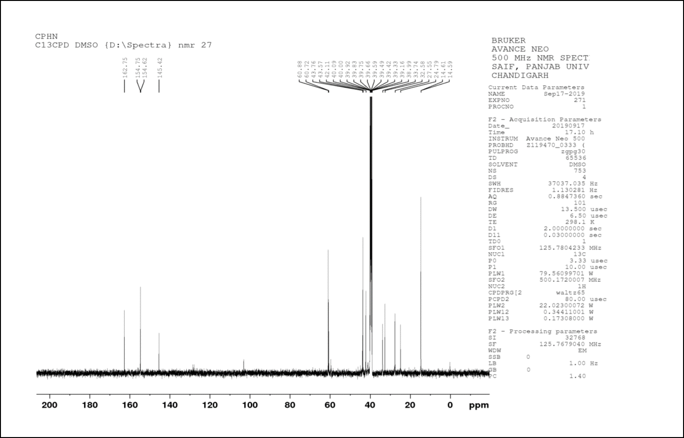
Fig.3 ¹³C-NMR spectrum of 1-carbo-4-oxo-piperidine hydrazide (CPHN)
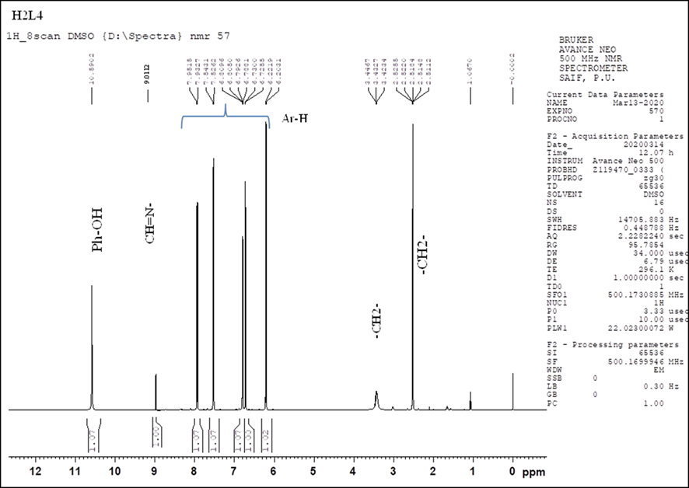
Fig. S4 ¹H NMR spectrum of hydrazone ligand (H₂L)
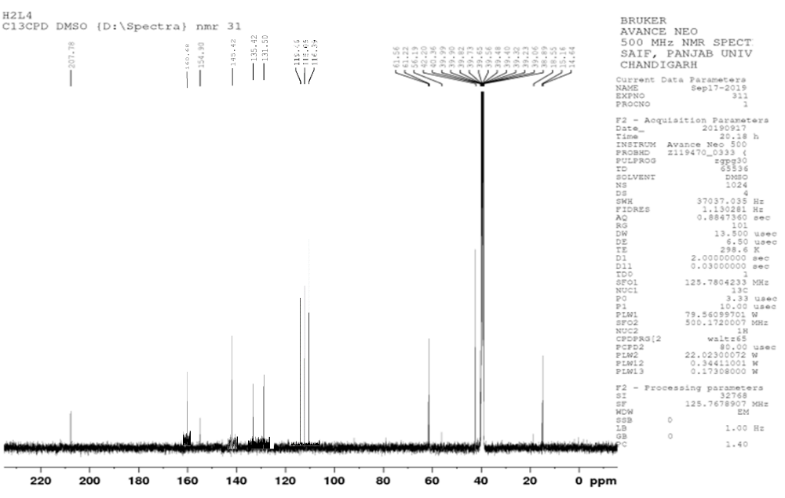
Fig. S5 ¹³C-NMR spectrum of hydrazone ligand (H₂L)

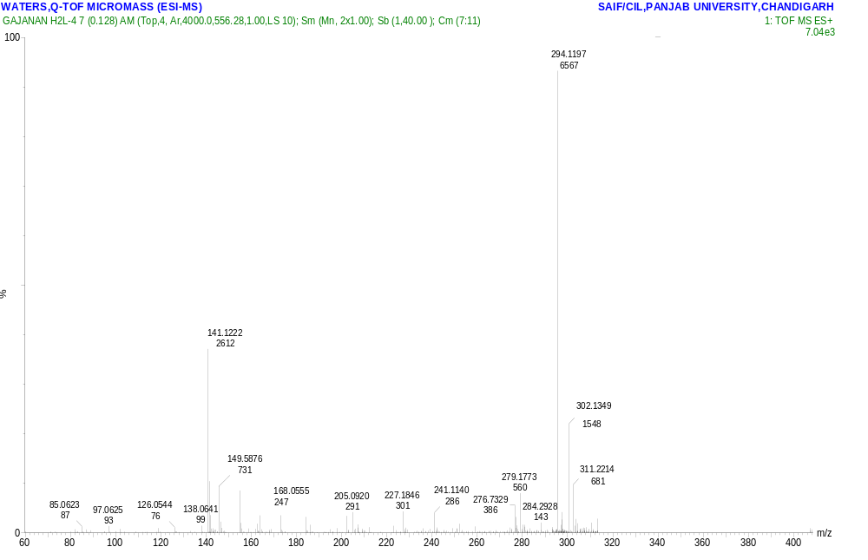
Fig. S6 Mass spectrum of hydrazone ligand (H₂L)

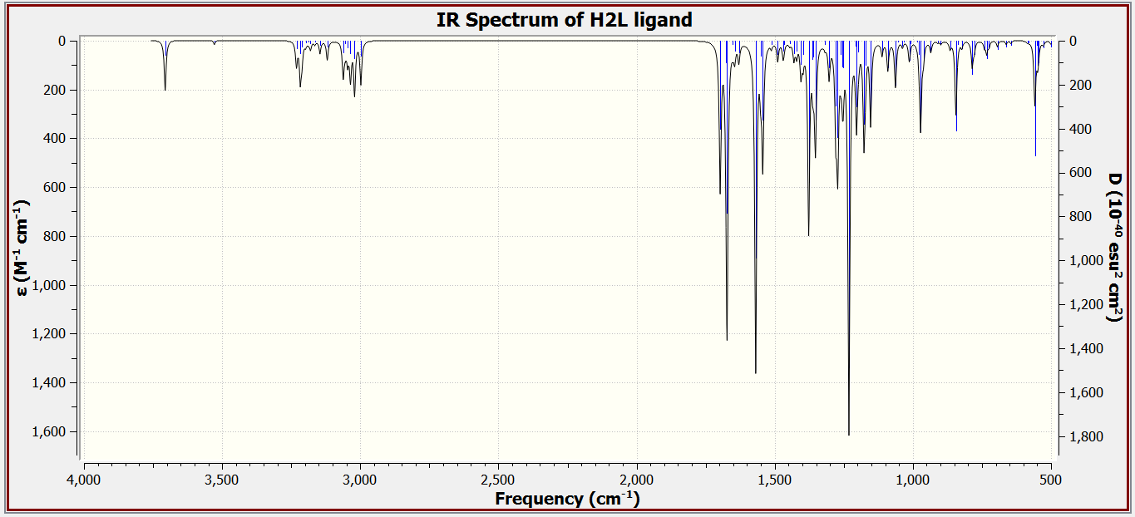
Fig.7S (a) Simulated IR spectrum of hydrazone ligand (H₂L)
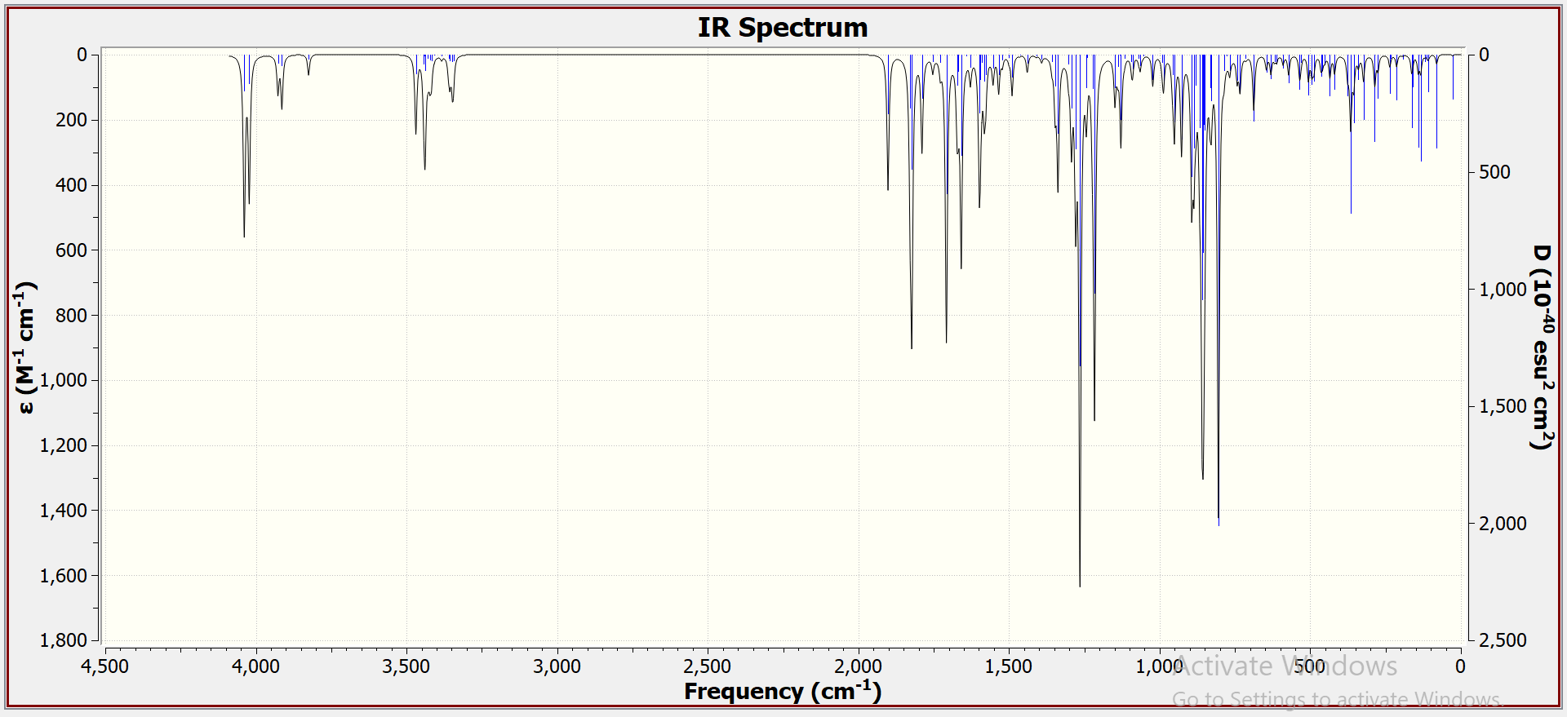
Fig.7S (b) Simulated IR spectrum of Cr(III) complex

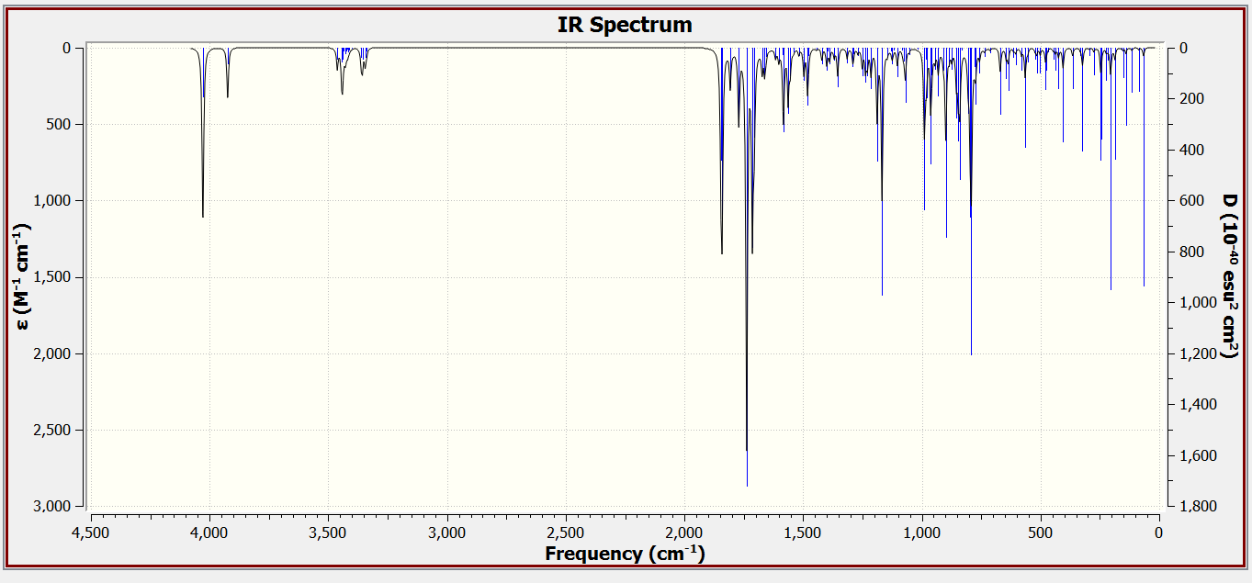
Fig.7S (c) Simulated IR spectrum of Mn(II) complex
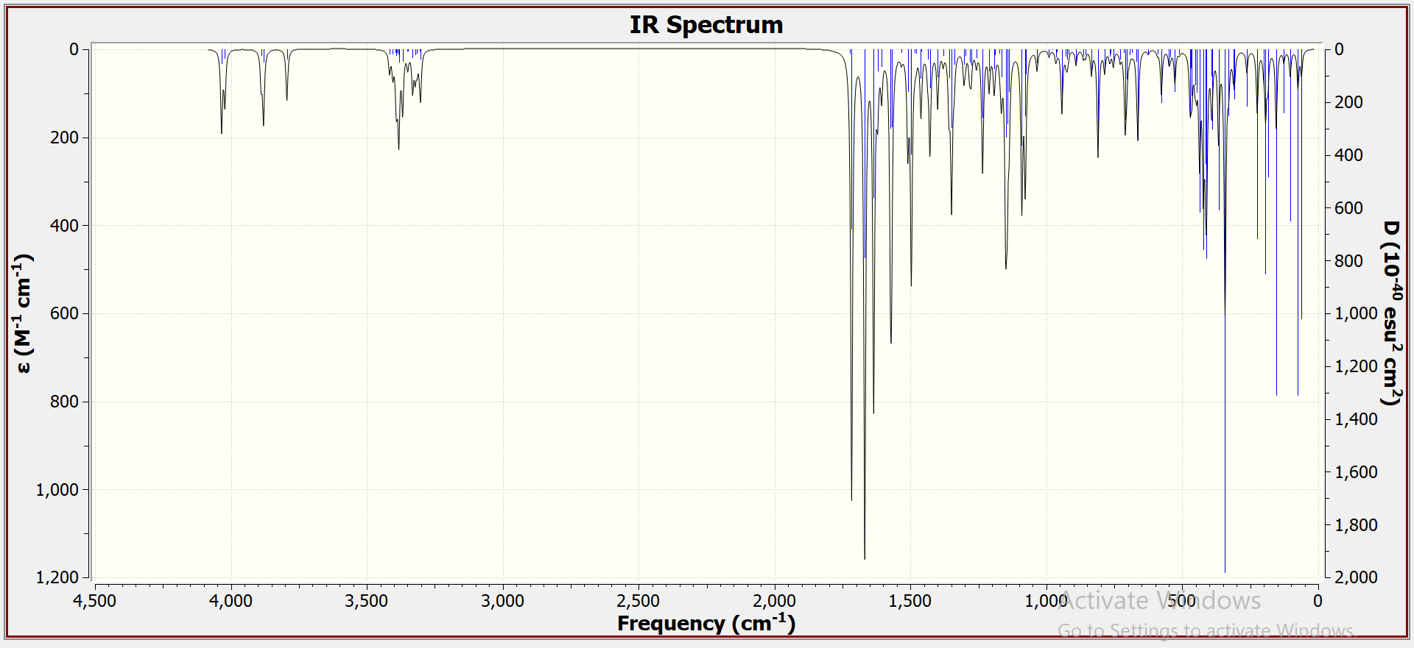
Fig. 7S (d) Simulated IR spectrum of Co(II) complex
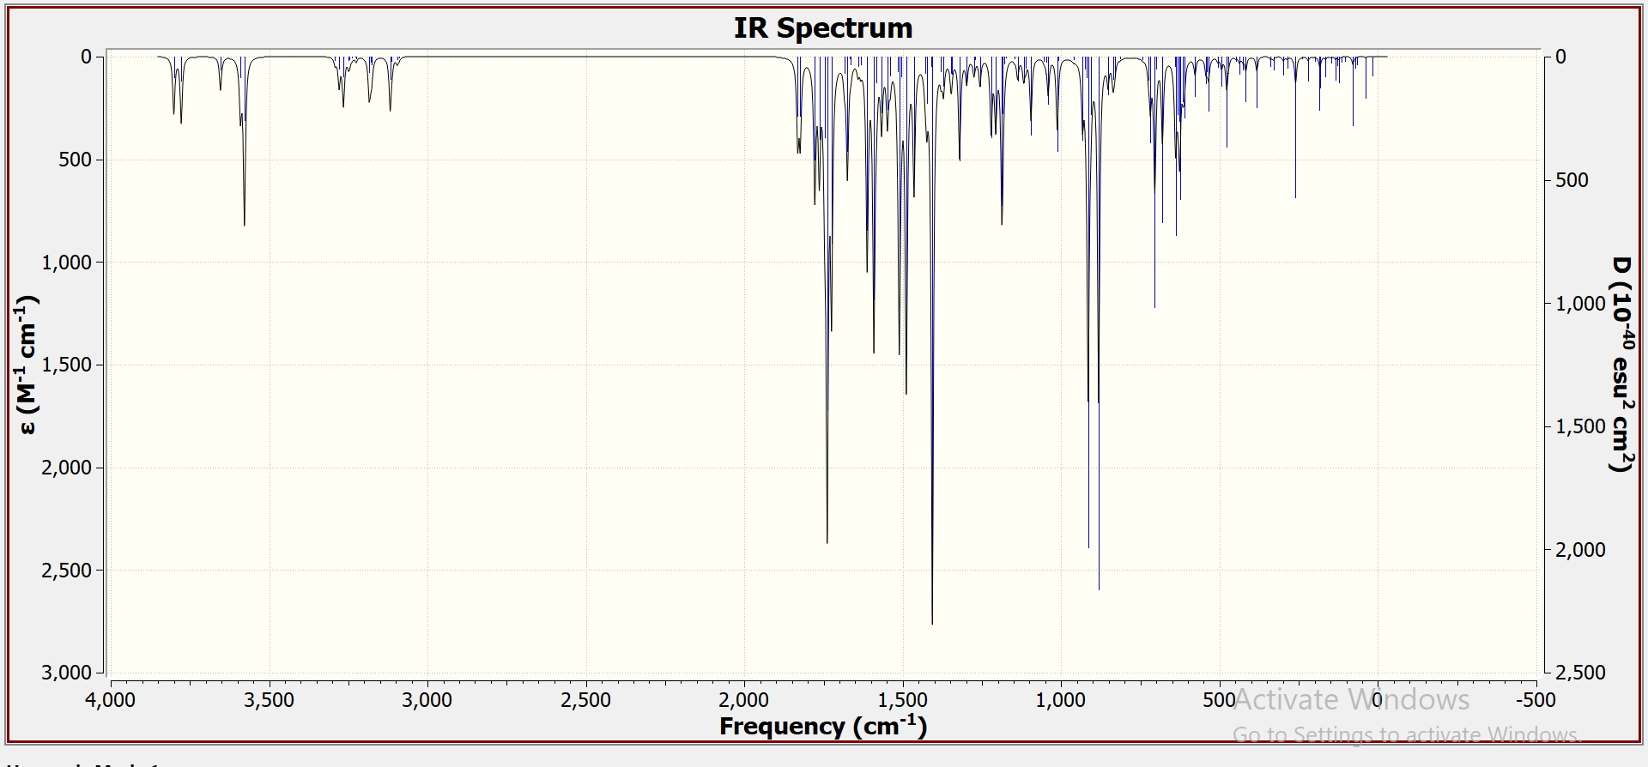
Fig. S9 (e) Simulated IR spectrum of Ni(II) complex

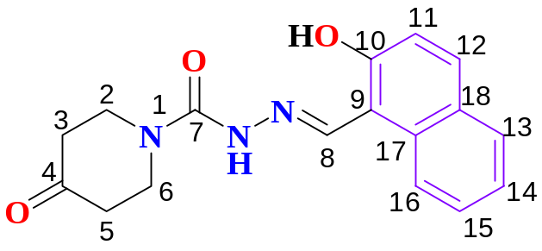

Fig. S8. Molecular structure of hydrazone ligand (H₂L) showing numbering atoms

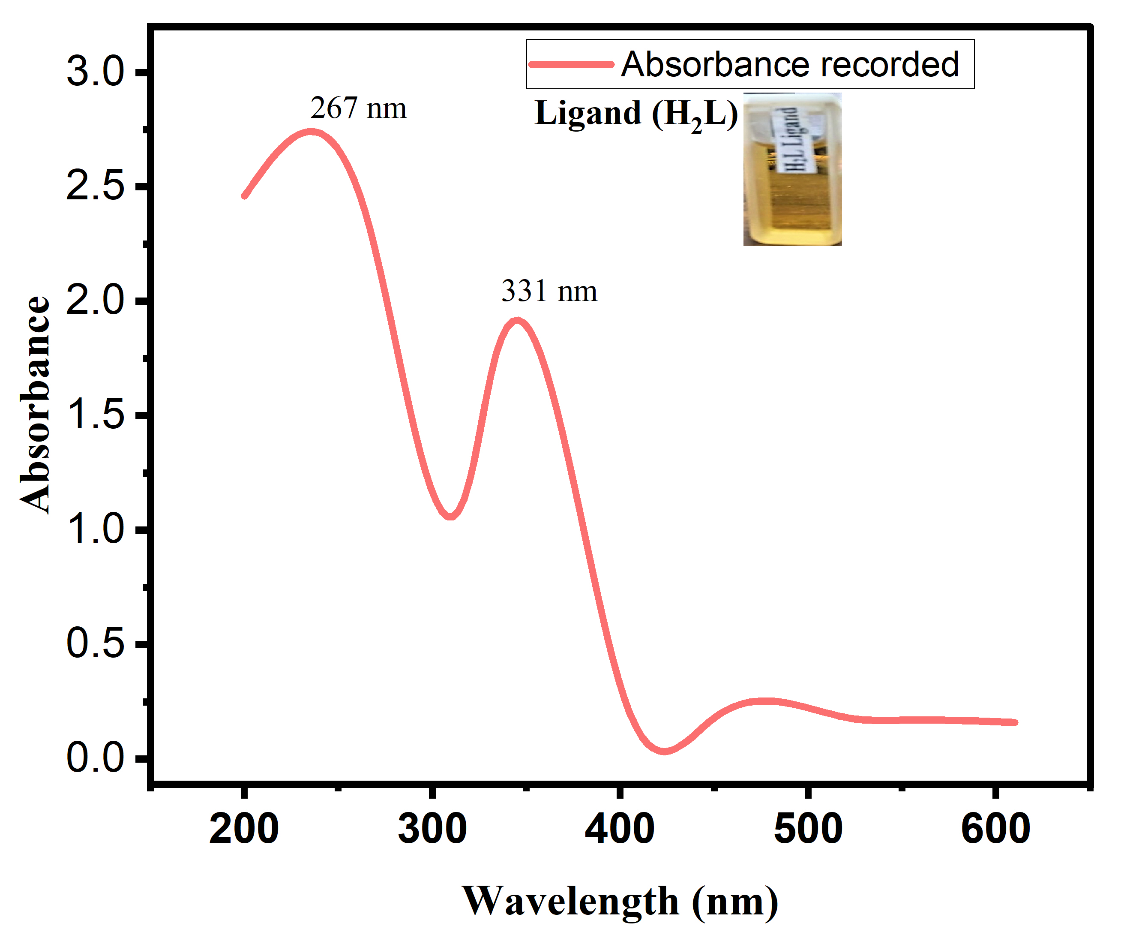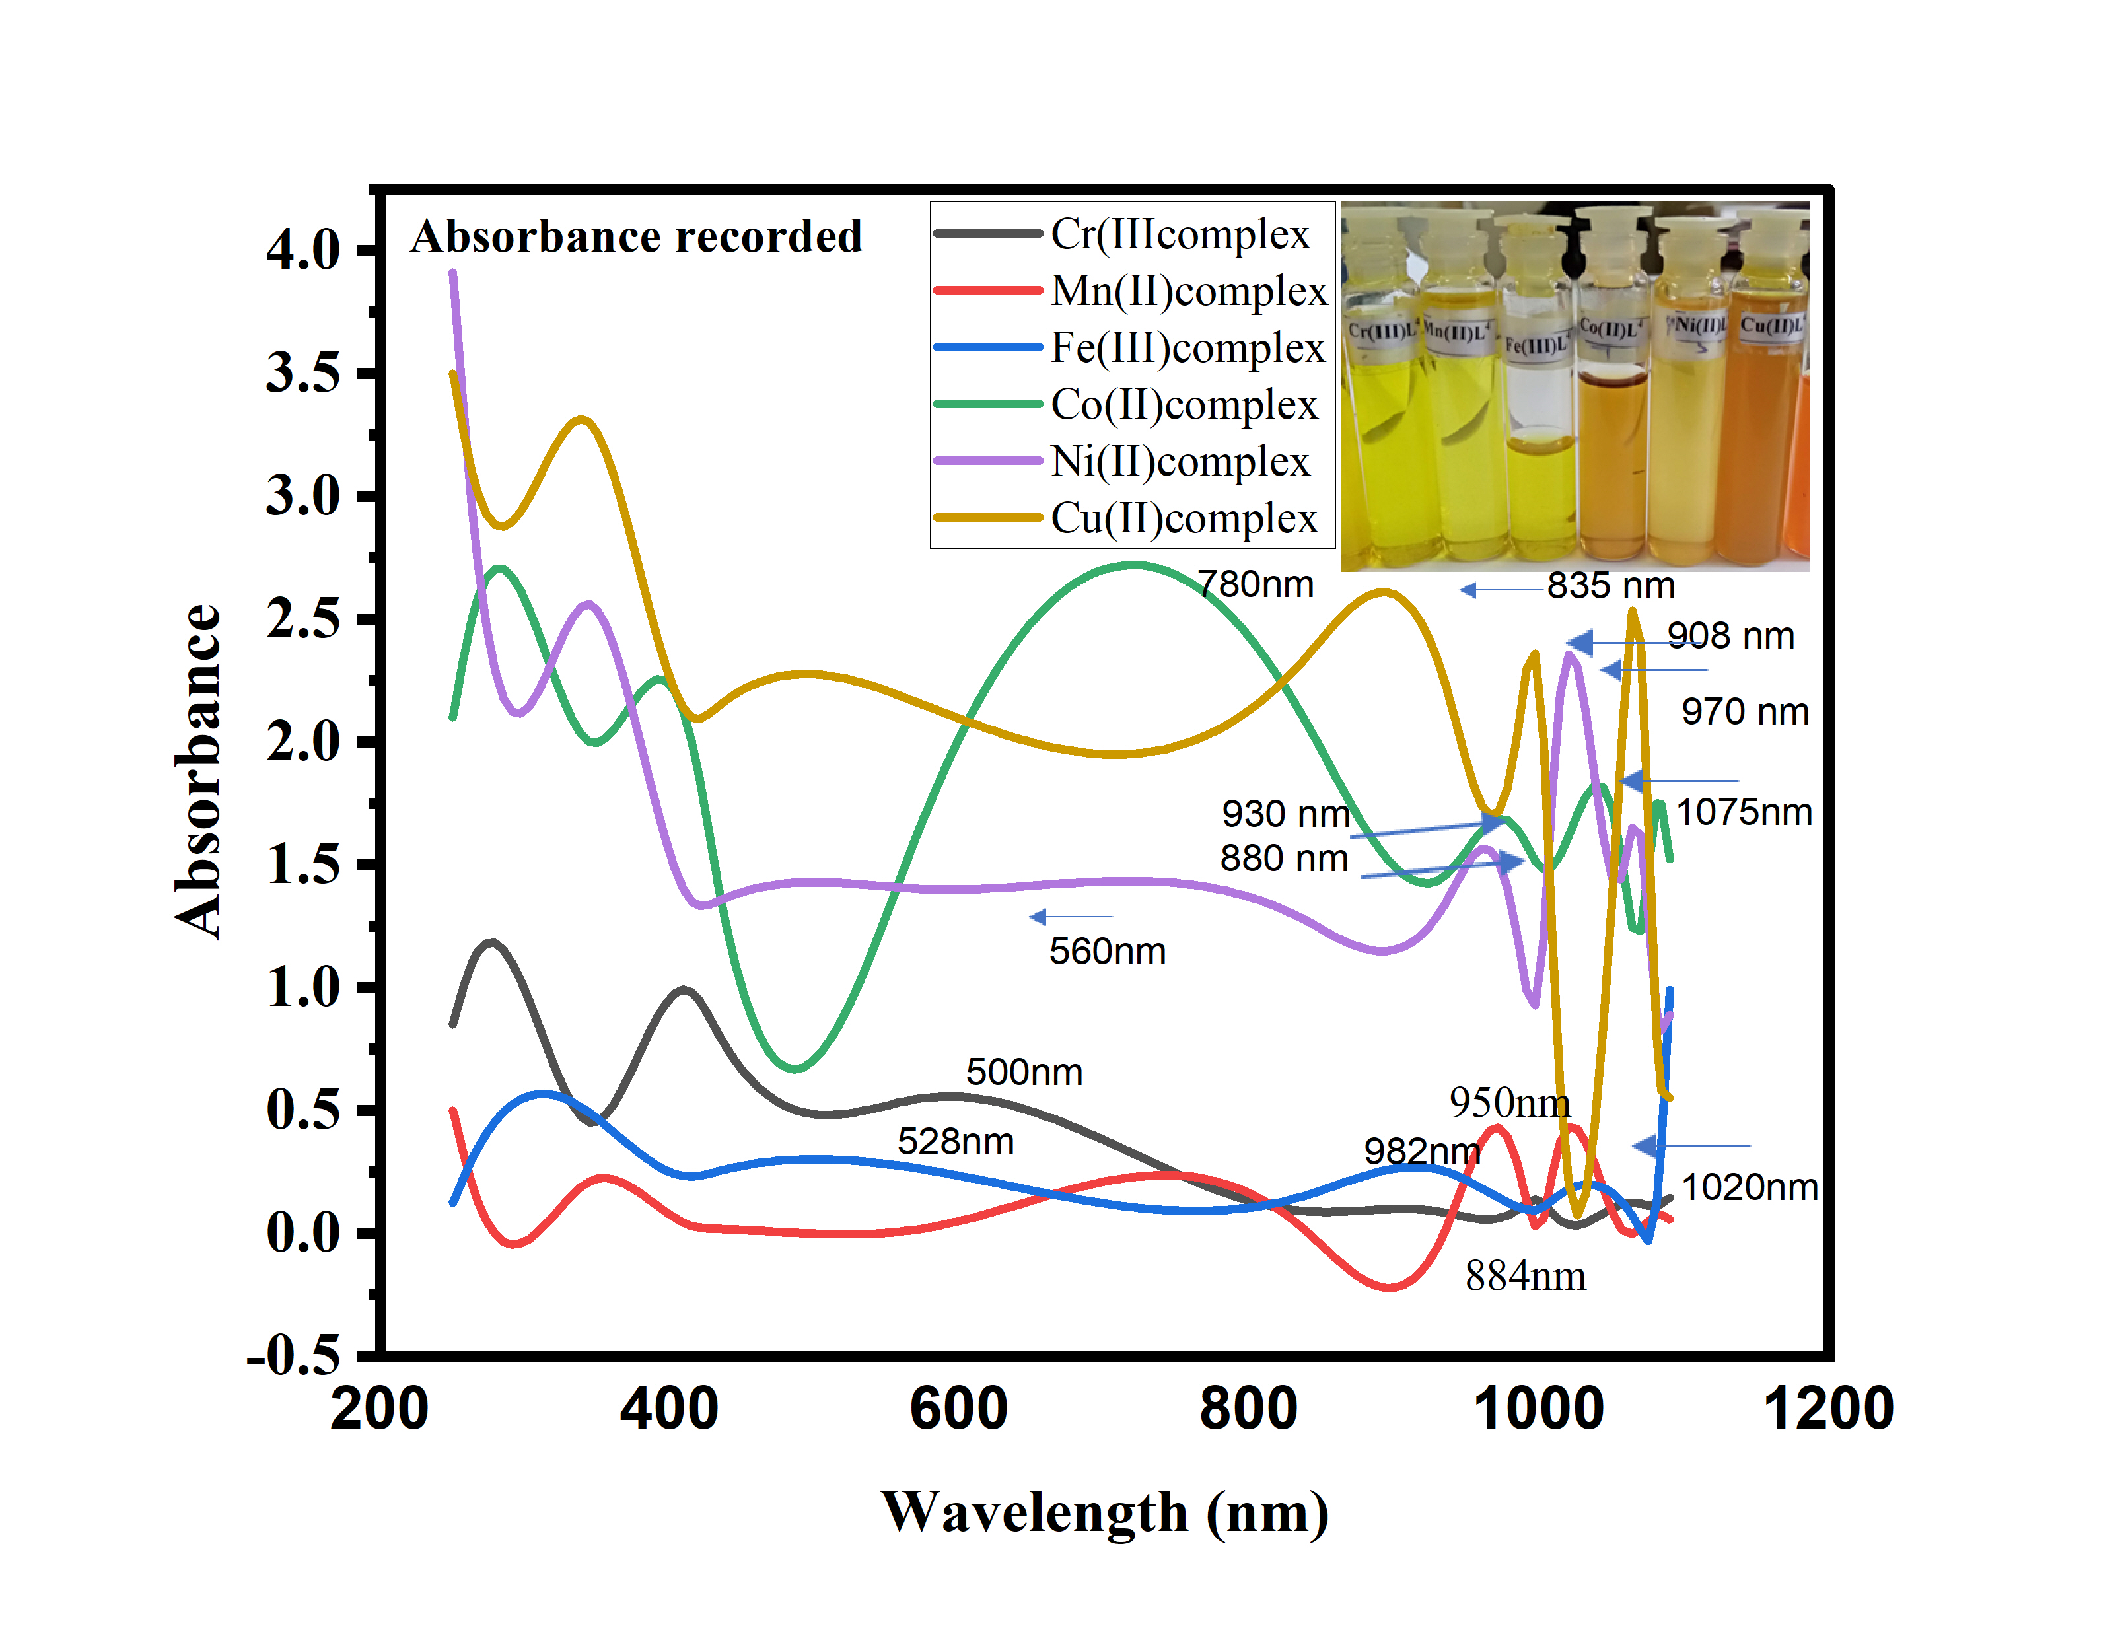
(a) (b)
Fig. S9 Electronic spectra of (a) hydrazone ligand (H₂L), and (b) its metal (II/III) complexes

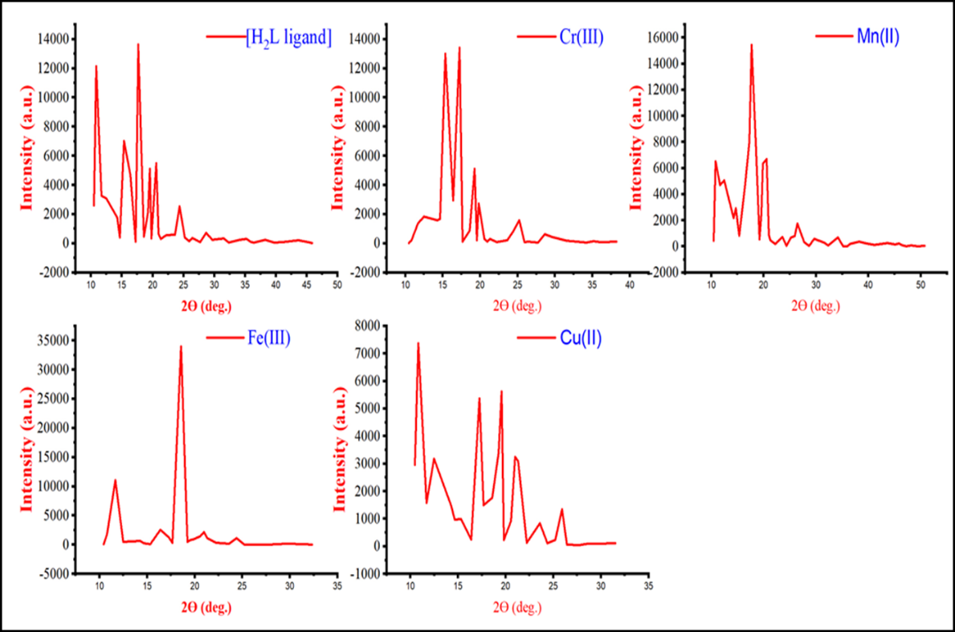

Fig. S10 XRD spectra of (a) Ligand, (b) Cr(III),(c) Mn(II), (d) Fe(III),
(e) Cu(II) metal complexes

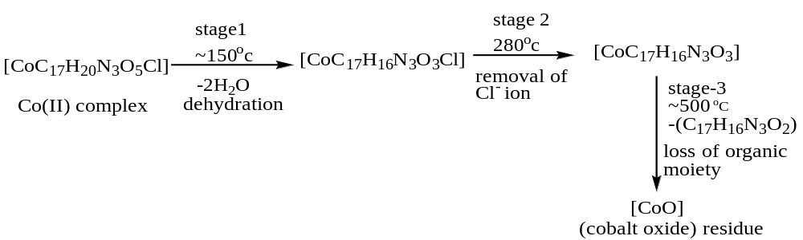
Scheme S2. Schematic decomposition pattern of [Co(HL)(H₂O)₂Cl] complex

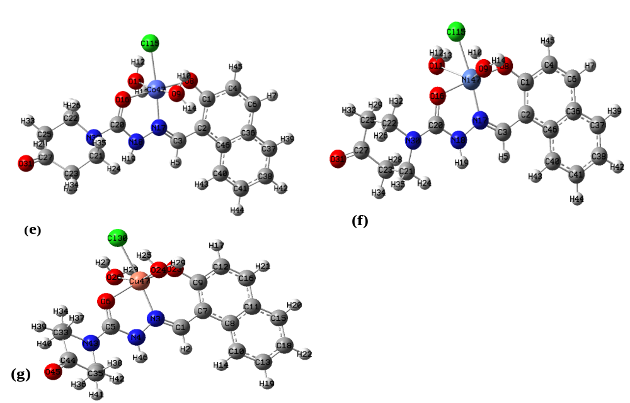
Fig. S11 Optimized molecular structures of (e) Co(II), (f) Ni(II),
(g) Cu(II) complexes

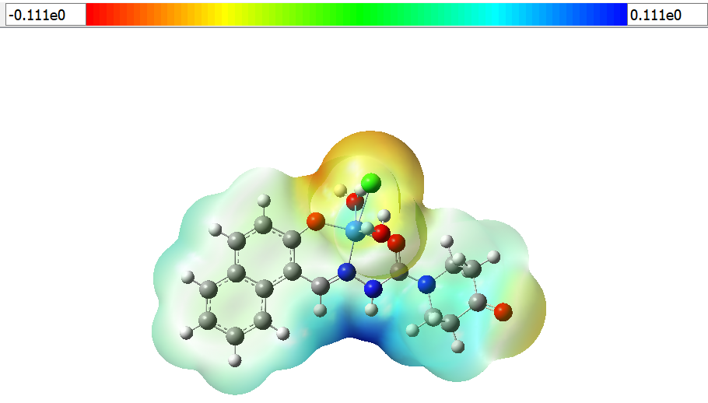
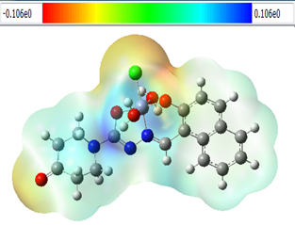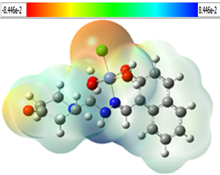
(a) (b) (c)

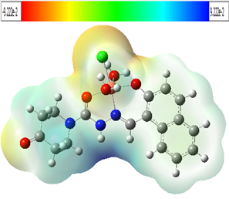
(d)
Fig. S12 Molecular electrostatic potential map surface of (a) Cr(III),
(b) Co(II), (c) Ni(II), (d) Cu(II) complexes

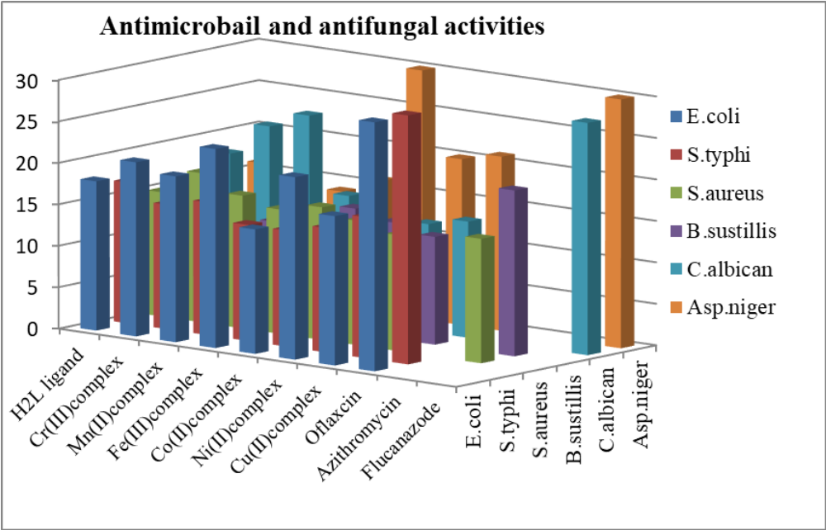
Fig. S13 Inhibition zone growth of microorganisms of
ligand (H₂L), and its metal complexes

Table S1 ESR tensor parameters of Cu(II) complex
Compound | g | g || | g⊥ | g (avg.) | Δg | G | Hyperfine splitting constant  (HSC 10⁻⁴), cm⁻¹ |  | A  (avg.) | f=  g || /A || | Bonding parameters |  | Orbital Reduction
 |  |  |  |  |  |  | A|| | A⊥ | A  (avg.) | f=  g || /A || | α² | β² | K²|| | K²⊥
Cu(II) complex | 2.0036 | 2.249 | 2.045 | 2.114 | 0.196 | 5.52 | 168 | 55.54 | 111 | 133 | 0.35 | 2.45 | 0.78 | 0.53

Table S2 Indexed X-ray diffraction data of hydrazone ligand (H₂L)
Peak No. | 2Ө (Obs.) | d (Obs.) |  | 2Ө (Cal.) | d (Cal.) | Intensities |  | Relative Intensity (%) | FWHM β | Miller Indices
 |  |  |  |  |  |  |  |  |  | h | k | l
 | 10.962 | 8.065 |  | 11.06 | 7.992 | 2600 |  | 19.07 | 0.38 | 0 | 0 | 2
 | 11.559 | 7.649 |  | 11.61 | 7.616 | 12135 |  | 88.99 | 0.467 | 1 | 0 | -1
 | 17.76 | 4.9902 |  | 17.83 | 4.97 | 3272 |  | 24.00 | 0.386 | 1 | 1 | 0
 | 18.663 | 4.7507 |  | 18.62 | 40762 | 3074 |  | 22.54 | 0.403 | 1 | 1 | -1
 | 19.358 | 4.5817 |  | 19.42 | 4.5687 | 1789 |  | 13.12 | 0.37 | 1 | 0 | -3
 | 19.705 | 4.5017 |  | 19.79 | 4.483 | 415 |  | 3.04 | 0.35 | 1 | 0 | 3
 | 20.6594 | 4.2958 |  | 20.72 | 4.283 | 7033 |  | 51.58 | 0.39 | 2 | 0 | 2
 | 21.066 | 4.2138 |  | 21.15 | 4.195 | 4700 |  | 34.47 | 0.381 | 0 | 1 | 3
 | 23.74 | 3.7448 |  | 23.74 | 3.743 | 13636 |  | 100.00 | 0.27 | 2 | 0 | 2
 | 24.555 | 3.6225 |  | 24.62 | 3.613 | 488 |  | 3.58 | 0.514 | 1 | 1 | 3
 | 25.347 | 3.511 |  | 25.39 | 3.506 | 2142 |  | 15.71 | 0.38 | 2 | 1 | 0
 | 26.051 | 3.4177 |  | 26.09 | 3.412 | 5120 |  | 37.55 | 0.36 | 2 | 1 | 1
 | 26.56 | 3.354 |  | 26.64 | 3.343 | 339 |  | 2.49 | 0.397 | 0 | 1 | 4
 | 27.855 | 3.2003 |  | 27.59 | 3.231 | 5490 |  | 40.26 | 0.47 | 2 | 1 | 2
 | 28.727 | 3.1052 |  | 28.81 | 3.095 | 662 |  | 4.85 | 0.386 | 1 | 1 | 4
 | 31.207 | 2.8638 |  | 31.09 | 2.874 | 578 |  | 4.24 | 0.37 | 1 | 2 | 0
 | 35.193 | 2.548 |  | 35.01 | 2.561 | 591 |  | 4.33 | 0.39 | 3 | 1 | -1
 | 36.596 | 2.4535 |  | 35.57 | 2.522 | 2550 |  | 18.70 | 0.51 | 1 | 2 | 3
 |  | Unit Cell Data and Crystal Lattice Parameters
 |  | a = 8.5680Å |  |  | V : 835.651Å3
 |  | b =6.1020Å |  |  | λ : 1.54059 nm
 |  | c =15.9870Å |  |  | Crystal System : Rhombohedral
 |  | α =90 deg. |  |  | Nature : Crystalline
 |  | β =90 deg. |  |  | Average Particle Size L: 19.9880nm {L=Kλ/β(2Ө)cosӨ}
 |  | γ =90 deg. |  |  | Z=2 | Space Group=P
 |  | Interplanar Spacing using Peak position =3.6380Å

Table S3 Indexed X-ray diffraction data of Cr(III) complex
Peak No. | 2Ө (Obs.) | d (Obs.) | 2Ө (Cal.) | d (Cal.) | Intensities | Relative Intensity (%) | FWHM β | Miller Indices
 |  |  |  |  |  |  |  | h | k | l
 | 10.878 | 8.127 | 11.06 | 7.992 | 233 | 1.74 | 0.16 | 0 | 0 | 2
 | 11.411 | 7.749 | 11.61 | 7.616 | 1376 | 10.26 | 0.29 | 1 | 0 | -1
 | 11.673 | 7.575 | 11.81 | 7.486 | 1836 | 13.69 | 0.32 | 1 | 0 | 1
 | 17.696 | 5.0078 | 17.83 | 4.97 | 1583 | 11.80 | 0.2 | 1 | 1 | 0
 | 18.54 | 4.7818 | 18.62 | 4.762 | 1696 | 12.65 | 0.295 | 1 | 1 | -2
 | 20.531 | 4.3225 | 20.72 | 4.283 | 13005 | 96.97 | 0.257 | 2 | 0 | 0
 | 20.954 | 4.2361 | 20.92 | 4.243 | 2939 | 21.91 | 0.176 | 1 | 1 | -2
 | 23.589 | 3.7686 | 23.589 | 3.743 | 13412 | 100.00 | 0.226 | 2 | 0 | 2
 | 25.242 | 3.5254 | 25.39 | 3.506 | 900 | 6.71 | 0.216 | 2 | 1 | 0
 | 25.924 | 3.4342 | 25.91 | 3.437 | 5112 | 38.12 | 0.18 | 2 | 1 | -1
 | 26.37 | 3.377 | 26.64 | 3.343 | 234 | 1.74 | 0.29 | 0 | 1 | 4
 | 27.751 | 3.212 | 27.94 | 3.19 | 2735 | 20.39 | 0.216 | 2 | 1 | 2
 | 28.663 | 3.1119 | 28.61 | 3.231 | 320 | 2.39 | 0.8 | 1 | 1 | -4
 | 31.247 | 2.8602 | 31.37 | 2.85 | 312 | 2.33 | 0.35 | 0 | 2 | 2
 | 35.09 | 2.5552 | 35.01 | 2.561 | 233 | 1.74 | 0.38 | 3 | 1 | -1
 | 35.847 | 2.503 | 35.96 | 2.495 | 790 | 5.89 | 0.35 | 3 | 0 | 3
 | 36.48 | 2.461 | 36.5 | 2.46 | 1587 | 11.83 | 0.39 | 2 | 2 | 1
 | 45.128 | 2.00745 | 45.15 | 2.007 | 621 | 4.63 | 0.14 | 0 | 2 | 6
 | 46.303 | 1.9592 | 46.27 | 2.007 | 435 | 3.24 | 0.28 | 0 | 2 | 6
 |  | Unit Cell Data and Crystal Lattice Parameters
 |  | a = 9.8045Å |  | V : 1000.551Å3
 |  | b =7.2010Å |  | λ : 1.54059 nm
 |  | c =16.701Å |  | Crystal System : Orthorombic
 |  | α =90 deg. |  | Nature : Crystalline
 |  | β =90 deg. |  | Average Particle SizeL: 33.28 nm {L=Kλ/β(2Ө)cosӨ}
 |  | γ =90 deg. |  | Z=2 | Space Group=P
 |  | Interplanar Spacing using Peak position = 3.38844 Å

Table S4 Indexed X-ray diffraction data of Mn (II) complex
Peak No. | 2Ө (Obs.) | d (Obs.) | 2Ө (Cal.) | d (Cal.) | Intensities | Relative Intensity (%) | FWHM β | Miller Indices
 |  |  |  |  |  |  |  | h | k | l
 | 11.573 | 7.64 | 11.612 | 7.616 | 6534 | 42.26 | 0.48 | 1 | 1 | -1
 | 11.744 | 7.5293 | 11.81 | 7.486 | 4715 | 30.49 | 0.199 | 1 | 0 | 1
 | 17.734 | 4.9973 | 17.83 | 4.97 | 5062 | 32.74 | 0.367 | 1 | 1 | 0
 | 18.501 | 4.792 | 18.28 | 4.85 | 2180 | 14.10 | 0.27 | 1 | 1 | -1
 | 18.714 | 4.7377 | 18.62 | 4.762 | 2922 | 18.90 | 0.23 | 1 | 1 | -1
 | 20.691 | 4.2893 | 20.72 | 4.283 | 4519 | 29.23 | 0.32 | 2 | 0 | 0
 | 21.131 | 4.2011 | 21.15 | 4.198 | 8029 | 51.93 | 0.45 | 1 | 1 | 2
 | 23.596 | 3.7674 | 23.34 | 3.808 | 15462 | 100.00 | 0.32 | 2 | 0 | -2
 | 23.804 | 3.7349 | 23.75 | 3.743 | 7305 | 47.24 | 0.2 | 2 | 0 | 2
 | 25.296 | 3.518 | 25.39 | 3.506 | 2544 | 16.45 | 0.304 | 2 | 1 | 0
 | 26.037 | 3.4195 | 26.09 | 3.412 | 6328 | 40.93 | 0.387 | 2 | 1 | 1
 | 27.793 | 3.2074 | 27.59 | 3.231 | 6706 | 43.37 | 0.321 | 2 | 1 | -2
 | 36.676 | 2.4483 | 36.63 | 2.451 | 1765 | 11.42 | 0.43 | 2 | 2 | 1
 | 11.573 | 7.64 | 11.612 | 7.616 | 6534 | 42.26 | 0.48 | 1 | 1 | -1
 | 11.744 | 7.5293 | 11.81 | 7.486 | 4715 | 30.49 | 0.199 | 1 | 0 | 1
 | 17.734 | 4.9973 | 17.83 | 4.97 | 5062 | 32.74 | 0.367 | 1 | 1 | 0
 | 18.501 | 4.792 | 18.28 | 4.85 | 2180 | 14.10 | 0.27 | 1 | 1 | -1
 | 18.714 | 4.7377 | 18.62 | 4.762 | 2922 | 18.90 | 0.23 | 1 | 1 | -1
 | 20.691 | 4.2893 | 20.72 | 4.283 | 4519 | 29.23 | 0.32 | 2 | 0 | 0
 |  | Unit Cell Data and Crystal Lattice Parameters
 |  | a = 8.7080Å |  | V : 1200.221Å3
 |  | b =7.1312Å |  | λ : 1.54059 nm
 |  | c =16.2070Å |  | Crystal System : Orthorombic
 |  | α =90 deg. |  | Nature : Crystalline
 |  | β =90 deg. |  | Average Particle SizeL: 25.11 nm {L=Kλ/β(2Ө)cosӨ}
 |  | γ =90 deg. |  | Z=2 | Space Group=P
 |  | Interplanar Spacing using Peak position = 4.07523 Å

Table S5 Indexed X-ray diffraction data of Fe(III) complex
Peak No. | 2Ө (Obs) | d (Obs) |  | 2Ө (Cal) | d (Cal) |  | Intensities | Relative Intensity (%) | FWHM β | Miller Indices
 |  |  |  |  |  |  |  |  |  | h | k | l
 | 11.567 | 7.644 |  | 11.61 | 7.616 |  | 1870 | 5.51 | 0.19 | 1 | 0 | -1
 | 11.794 | 7.4973 |  | 11.81 | 7.486 |  | 11065 | 32.58 | 0.172 | 1 | 0 | 1
 | 18.652 | 4.7535 |  | 18.62 | 4.762 |  | 643 | 1.89 | 0.3 | 1 | 1 | -1
 | 20.662 | 4.2953 |  | 20.72 | 4.283 |  | 2556 | 7.53 | 0.195 | 2 | 0 | 0
 | 21.017 | 4.2236 |  | 21.15 | 4.198 |  | 1266 | 3.73 | 0.25 | 1 | 1 | 2
 | 23.73 | 3.7465 |  | 23.75 | 3.743 |  | 33966 | 100.00 | 0.198 | 2 | 0 | 2
 | 24.46 | 3.637 |  | 24.32 | 3.656 |  | 830 | 2.44 | 1.1 | 1 | 1 | -3
 | 25.314 | 3.5155 |  | 25.39 | 3.506 |  | 913 | 2.69 | 0.34 | 2 | 1 | 0
 | 25.984 | 3.4264 |  | 25.91 | 3.437 |  | 1438 | 4.23 | 0.35 | 2 | 1 | -1
 | 27.854 | 3.2004 |  | 27.94 | 3.19 |  | 2153 | 6.34 | 0.33 | 2 | 1 | 2
 | 32.618 | 2.743 |  | 32.599 | 2.345 |  | 1117 | 3.29 | 0.246 | 3 | 1 | 0
 | 36.609 | 2.4527 |  | 36.63 | 2.451 |  | 1132 | 3.33 | 0.245 | 2 | 2 | 1
 |  | Unit Cell Data and Crystal Lattice Parameters
 |  | a = 18.5680Å |  |  | V : 1600.178Å3
 |  | b =16.1020Å |  |  | λ : 1.54059 nm
 |  | c =15.9870Å |  |  | Crystal System : Rhombohedral
 |  | α =90 deg. |  |  | Nature : Crystalline
 |  | β =90 deg. |  |  | Average Particle SizeL: 31.46nm
 |  | γ =90 deg. |  |  | Z=2 |  | Space Group=P
 |  | Interplanar spacing using Peak position = 3.80655 Å

Peak No. | 2Ө (Obs.) | d (Obs.) | 2Ө (Cal.) | d (Cal.) | Intensities | Rel.Intensities (%) | FWHM (β) | Miller Indices
 |  |  |  |  |  |  |  | h | k | l
 | 10.67 | 8.278 | 10.6 | 8.343 | 2965 | 52.67 | 0.55 | 1 | 1 | 0
 | 11.494 | 7.692 | 11.27 | 7.842 | 7375 | 131.02 | 0.385 | 1 | 0 | 1
 | 11.699 | 7.5583 | 11.51 | 7.679 | 1583 | 28.12 | 0.15 | 0 | 1 | 2
 | 15.242 | 5.808 | 15.73 | 5.629 | 3188 | 56.64 | 0.67 | 1 | 2 | 1
 | 16.936 | 5.231 | 16.95 | 5.226 | 1460 | 25.94 | 0.7 | 1 | 1 | -3
 | 17.59 | 5.038 | 17.2 | 5.15 | 972 | 17.27 | 0.28 | 0 | 3 | 1
 | 18.49 | 4.7947 | 18.56 | 4.776 | 984 | 17.48 | 0.32 | 1 | 2 | 2
 | 20.574 | 4.3135 | 20.47 | 4.334 | 5361 | 95.24 | 0.25 | 1 | 3 | -2
 | 20.932 | 4.2405 | 20.98 | 4.23 | 1494 | 26.54 | 0.281 | 2 | 2 | -1
 | 21.81 | 4.0717 | 21.91 | 4.053 | 1759 | 31.25 | 0.39 | 2 | 2 | -2
 | 23.361 | 3.8048 | 23.32 | 3.811 | 3395 | 60.31 | 0.57 | 2 | 1 | 2
 | 23.6428 | 3.760 | 23.81 | 3.734 | 5629 | 100.00 | 0.39 | 1 | 4 | 0
 | 25.203 | 3.5307 | 23.81 | 3.734 | 926 | 16.45 | 0.199 | 1 | 4 | 0
 | 26.008 | 3.4233 | 26.1 | 3.412 | 3252 | 57.77 | 0.28 | 0 | 1 | 5
 | 27.784 | 3.2084 | 27.8 | 3.207 | 3099 | 55.05 | 0.26 | 0 | 1 | 5
 | 30.979 | 2.8844 | 30.96 | 2.886 | 832 | 14.78 | 0.54 | 1 | 2 | 5
 | 36.467 | 2.4619 | 36.43 | 2.464 | 1339 | 23.79 | 0.45 | 0 | 1 | 7
 |  | Unit Cell Data and Crystal Lattice Parameters
 |  | a = 9.9540Å |  | V = 2808.992Å³
 |  | b =16.1700Å |  | λ = 1.54059 nm
 |  | c =17.8373Å |  | Crystal System : Monoclinic
 |  | α =90 deg. |  | Nature : Crystalline
 |  | β =101deg. |  | Average particle size L = 26.28nm
 |  | γ =90 deg. |  | Z=4 | Space group=p
 |  | Interplanar Spacing using Peak position = 4.2051 Å
Table S6 Indexed X-ray diffraction data of Cu(II) complex

Table S7 Bioactivity score of the hydrazone ligand, and its metal complexes
Compounds | Bioactivity score parameters
Compounds | GPCRL | ICM | KI | NRL | PI | EI
H₂L ligand | -0.14 | -0.46 | -0.43 | -0.27 | -0.12 | -0.09
Cr(III) complex | 0.11 | -0.08 | -0.14 | 0.00 | 0.06 | 0.14
Fe(III) complex | 0.17 | -0.08 | -0.14 | 0.00 | 0.06 | 0.18
Mn(II) complex | 0.04 | -0.09 | -0.18 | -0.02 | 0.04 | 0.11
Co(II) complex | 0.04 | -0.09 | -0.18 | -0.02 | 0.04 | 0.11
Ni(II) complex | 0.04 | -0.09 | -0.18 | -0.02 | 0.04 | 0.11
Cu(II) complex | 0.04 | -0.09 | -0.18 | -0.02 | 0.04 | 0.11

Compounds | Lipinski's Parameters
Compounds | Molecular Weight | % Abs. | TPSA  (Å)² | logP | nOHNH | nON | nrtb | Lipinski’s violations
H₂L ligand | 311.34 | 80.71 | 82.00 | 2.63 | 2 | 6 | 2 | 0
Cr(III) complex | 432.80 | 74.19 | 100.91 | -5.04 | 4 | 8 | 1 | 0
Fe(III) complex | 436.65 | 74.19 | 100.91 | -5.25 | 4 | 8 | 1 | 0
Mn(II) complex | 436.75 | 73.64 | 102.50 | -5.21 | 5 | 8 | 1 | 0
Co(II) complex | 440.75 | 73.64 | 102.50 | -5.21 | 5 | 8 | 1 | 0
Ni(II) complex | 440.51 | 73.64 | 102.50 | -5.21 | 5 | 8 | 1 | 0
Cu(II) complex | 445.36 | 73.64 | 102.50 | -5.33 | 5 | 8 | 1 | 0
Table S8 Lipinski’s parameters of the hydrazone ligand (H₂L), and its metal complexes

Table S9 ADMET activity score of hydrazone ligand (H₂L), and its metal complexes
Compounds | BBB | HIA | Caco2 | ROCT | Carcinogenicity | LogS | LD50  (mol/kg)
H₂L ligand | 0.766 | 0.974 | 0.636 | Non-inhibitor | Non-carcinogens | -3.352 | 2.351
Cr(III) complex | 0.578 | 0.573 | 0.594 | Non-inhibitor | Non-carcinogens | -3.510 | 2.635
Fe(III) complex | 0.574 | 0.894 | 0.596 | Non-inhibitor | Non-carcinogens | -3.518 | 2.636
Mn(II) complex | 0.647 | 0.510 | 0.628 | Non-inhibitor | Non-carcinogens | -3.535 | 2.622
Co(II) complex | 0.641 | 0.921 | 0.622 | Non-inhibitor | Non-carcinogens | -3.452 | 2.623
Ni(II) complex | 0.641 | 0.921 | 0.622 | Non-inhibitor | Non-carcinogens | -3.542 | 2.623
Cu(II) complex | 0.641 | 0.921 | 0.622 | Non-inhibitor | Non-carcinogens | -3.542 | 2.623

