Supporting Information
Supporting Information for:
The contribution of organic-rich mudstones to the Mesoproterozoic silicon cycle: criticality of microbial life
Claudio Delle Piane, Kitty L. Milliken, Vincent Crombez, Michael Verrall, Laure Martin, William Rickard, Colin MacRae, Nick Wilson, Matvei Aleshin
Corresponding author: Claudio Delle Piane
Claudio.dellepiane@csiro.au

This document includes:
Supporting Information 1: Areal extent and vertical patterns in the Velkerri Formation.
Supporting Information 2: Quartz elemental composition data tables with images of analytical locations.
Supporting Information 3: Parameters for volumetric estimation of authigenic quartz.
Supporting Information 4: Quartz δ¹⁸O data table and figures of analytical locations.
Supporting Information references.

Supporting Information 1: Areal extent and vertical patterns in the Velkerri Formation.
The data was sourced from publicly available well completion reports accessible online from the Northern Territory Government Geoscience Exploration and Mining Information System (GEMIS) of the Northern Territory Geological Survey (https://geoscience.nt.gov.au/gemis/)
The areal extent of the Velkerri Fm. is illustrated in SI Figure 1 and estimated from geophysical as having a minimum estimated value of 75,000 km² (Bruna and Dhu, 2017; see also Jarrett 2022) on the North Australian Craton, we consider this a conservative estimate compared to earlier values reported as large as 130,000 km² (e.g. Warren et al., 1998).

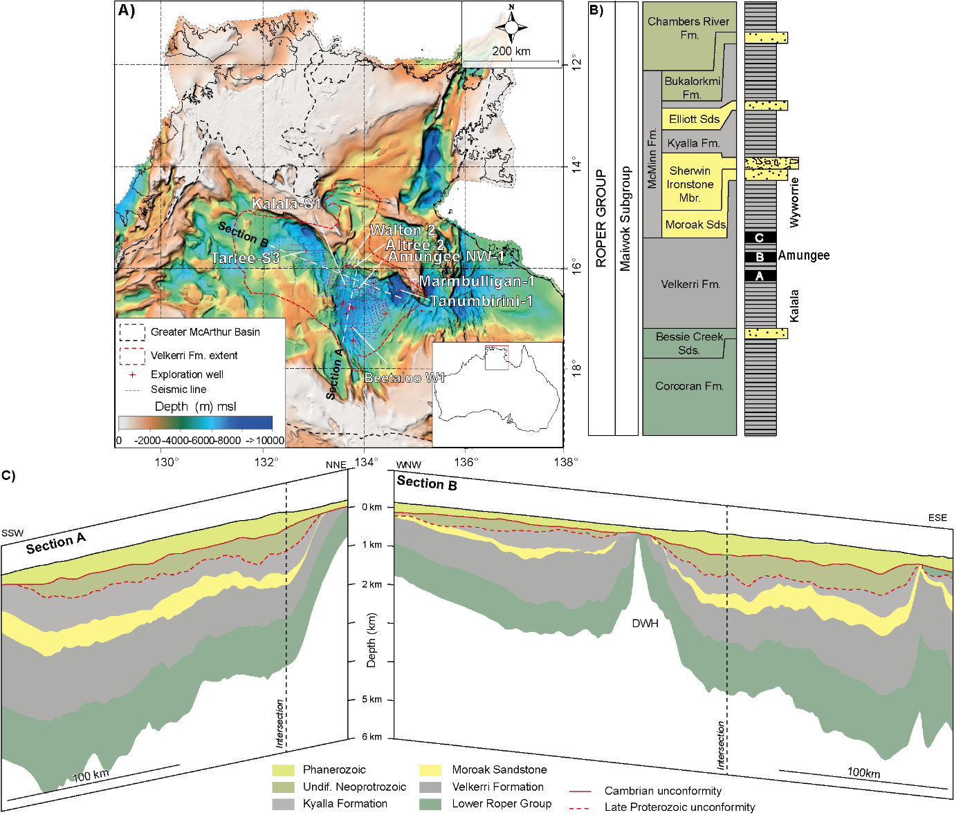
SI Figure 1 Location of the Greater McArthur Basin overlaid on basement depth map of North Australia (NTGS, 2021) with locations of wells discussed in the main text and in the supplementary information. Extent of the Velkerri Fm. based on Bruna and Dhu, 2017. B) Simplified lithostratigraphy of the Roper Group (modified from Rawlings, 1999). This study focuses on the Amungee Mbr. of the Velkerri Formation. C) Simplified geological sections interpreted from seismic lines highlighting the thickness and lateral continuity of the Velkerri Formation and other units in the area.

Vertical patterns in the Velkerri Formation are illustrate din Fig.1 in the main text, comparable data sets are available from 2 additional wells: Kalala S1 and Beetaloo W1 and reported below. Refer to SI Figure 1 for position of the well within the basin.

Kalala S1
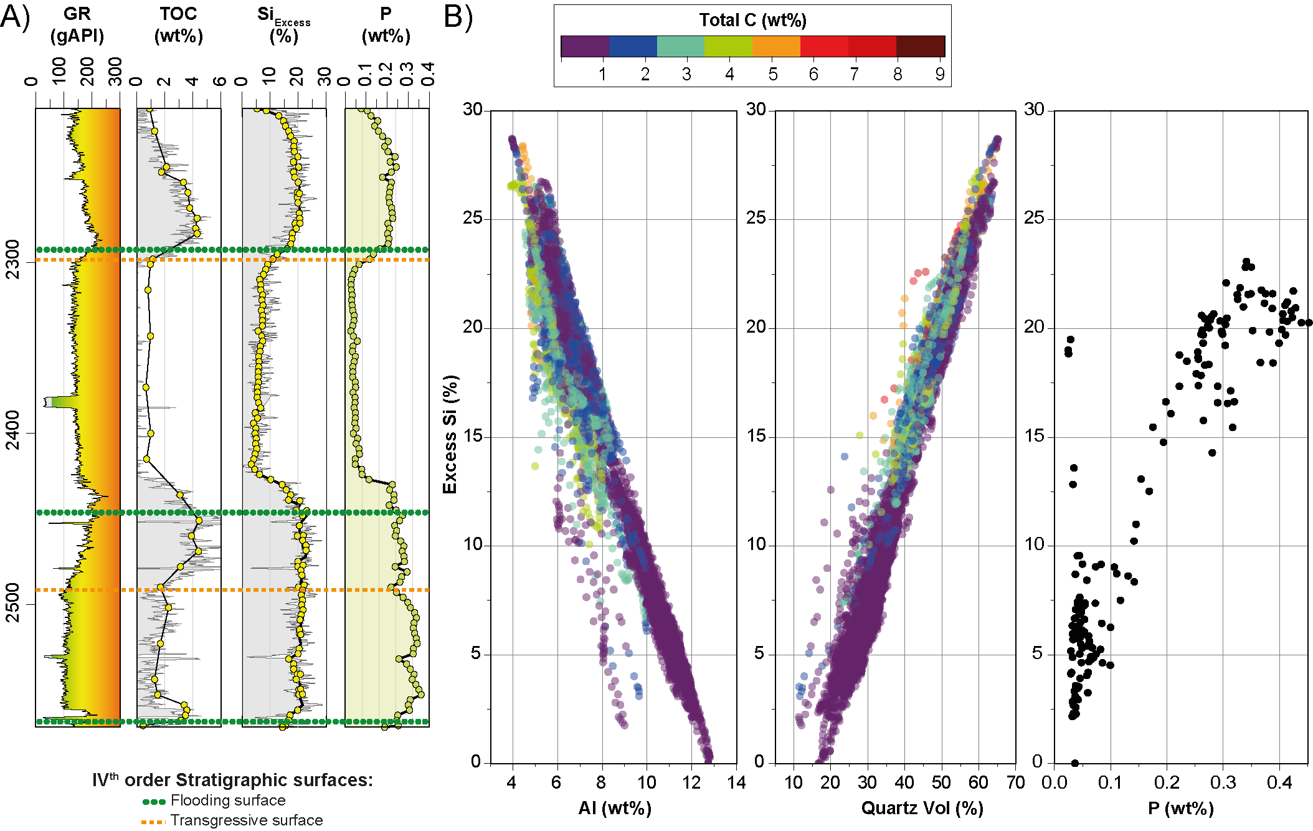
SI Figure 2 Petrophysical and geochemical character of the Amungee Member of the Velkerri Formation. A) Wireline logs through the Amungee Member in well Kalala S1. Track 1: Gamma ray (GR). Track 2: total organic carbon (TOC) from elemental capture spectroscopy log (continuous gray line) and laboratory measurements (yellow filled circles). Track 3 Si_{Excess} estimated from elemental capture spectroscopy log (continuous gray line) and X-ray fluorescence measurements on cuttings (yellow filled circles) illustrating the vertical variation in abundance of authigenic quartz, with values above 0 representing silica from non-detrital sources. Track 4: phosphorous content from X-ray fluorescence measurements on cuttings illustrating vertical variation in primary productivity. Stratigraphic surfaces from Crombez et al., 2023. B) Cross-plot of Si_{Excess} and content of Al (as a proxy for detrital input); quartz and phosphorous. Wireline logs and geochemical data from wells in the Beetaloo Sub-basin discussed in this study are available through Northern Territory Geoscience Exploration and Mining Information System.

Beetaloo W1
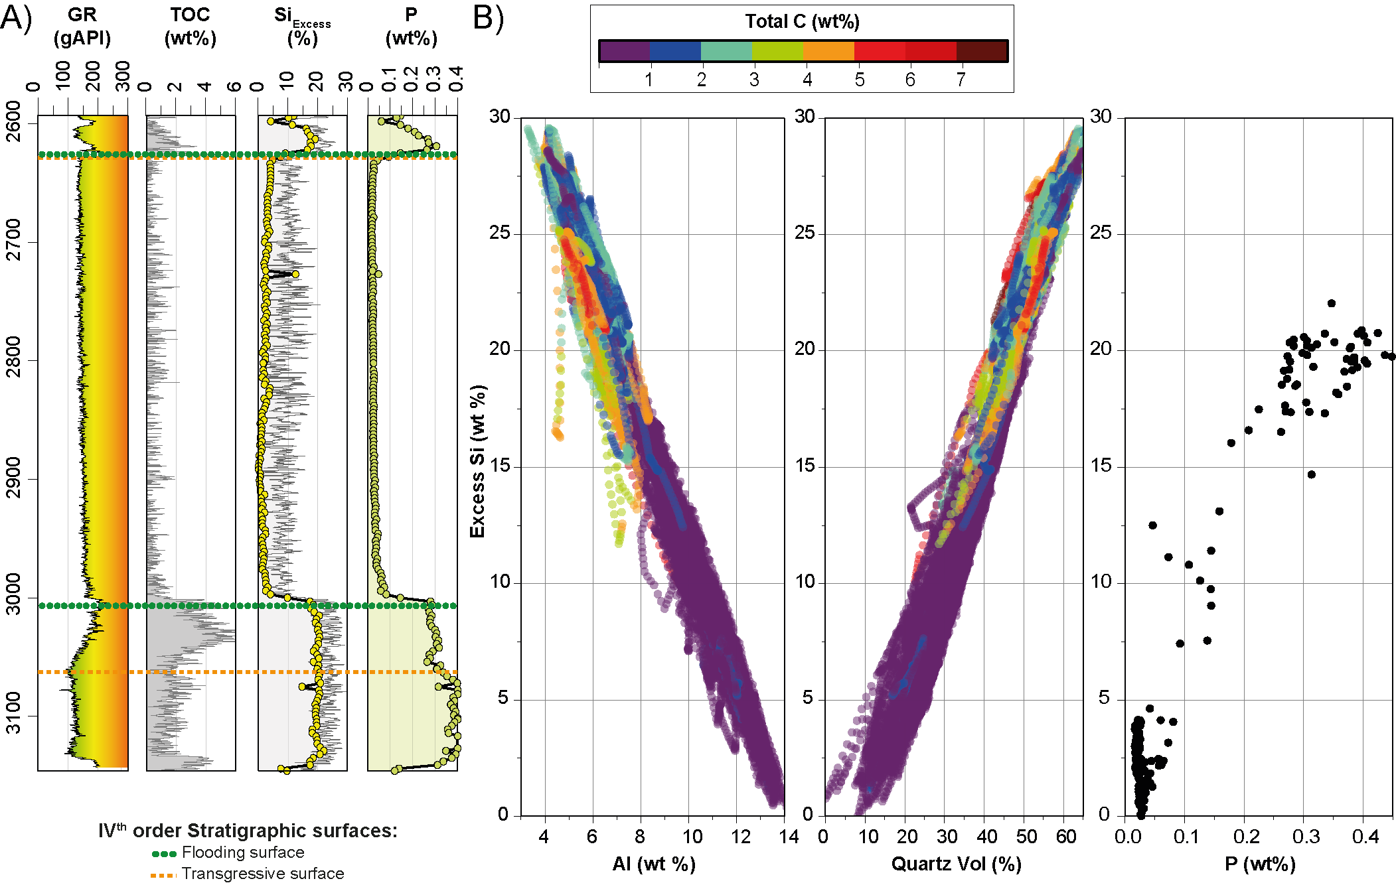
SI Figure 3 Petrophysical and geochemical character of the Amungee Member of the Velkerri Formation. A) Wireline logs through the Amungee Member in well Beetalo W1. Track 1: Gamma ray (GR). Track 2: total organic carbon (TOC) from elemental capture spectroscopy log (continuous gray line). Track 3 Si_{Excess} estimated from elemental capture spectroscopy log (continuous gray line) and X-ray fluorescence measurements on cuttings (yellow filled circles) illustrating the vertical variation in abundance of authigenic quartz, with values above 0 representing silica from non-detrital sources. Track 4: phosphorous content from X-ray fluorescence measurements on cuttings illustrating vertical variation in primary productivity. Stratigraphic surfaces from Crombez et al., 2023. B) Cross-plot of Si_{Excess} and content of Al (as a proxy for detrital input); quartz and phosphorous. Wireline logs and geochemical data from wells in the Beetaloo Sub-basin discussed in this study are available through Northern Territory Geoscience Exploration and Mining Information System.

Supporting Information 2: Quartz elemental composition data tables with images of analytical locations.

Electron probe microanalyzer (EPMA) measurements.
Acquisition conditions for peaks and background readings and detection limits (d.l.) of the analyses are reported in SI Table 1
Element | Line | Peak (s) | Background (s) | Crystal | d.l. (ppm)
Si | Kα | 6 | 3 | TAP | 193
Na | Kα | 30 | 15 | TAP | 47
Fe | Kα | 60 | 30 | LIF | 42
K | Kα | 30 | 15 | PETH | 14
Al | Kα | 60 | 30 | TAP | 118
SI Table 1 List of analysed elements in quartz using electron probe microanalyser and conditions of acquisition. TAP = thallium acid phthalate; LIF = lithium fluoride; PETH = pentaerythritol.
Following data acquisition described in the Methods section, the mapping results were processed in the software package Chimage (Harrowfield et al., 1993).

Marmbulligan 1, depth 169 m. Authigenic quartz (Al content 0.21 wt% ± 0.09; 1σ, N = 23)
Si (wt%) | Fe (wt%) | K (wt%) | Al (wt%) | O (wt%) | Total (wt%) | Point #
44.65 | 0.11 | 0.02 | 0.20 | 51.09 | 96.09 | 786
44.32 | 0.13 | 0.02 | 0.22 | 50.74 | 95.45 | 787
45.90 | 0.11 | 0.02 | 0.14 | 52.45 | 98.63 | 789
45.38 | 0.10 | 0.02 | 0.19 | 51.91 | 97.62 | 790
45.07 | 0.11 | 0.03 | 0.24 | 51.61 | 97.08 | 791
44.27 | 0.11 | 0.02 | 0.18 | 50.64 | 95.24 | 794
45.32 | 0.11 | 0.02 | 0.20 | 51.86 | 97.53 | 795
45.45 | 0.10 | 0.03 | 0.30 | 52.10 | 98.02 | 798
45.45 | 0.11 | 0.03 | 0.26 | 52.06 | 97.96 | 799
43.99 | 0.10 | 0.03 | 0.49 | 50.60 | 95.27 | 803
45.51 | 0.09 | 0.01 | 0.12 | 51.99 | 97.72 | 810
45.14 | 0.09 | 0.02 | 0.22 | 51.67 | 97.17 | 812
44.45 | 0.08 | 0.02 | 0.17 | 50.81 | 95.53 | 815
44.36 | 0.09 | 0.02 | 0.28 | 50.83 | 95.62 | 818
44.39 | 0.08 | 0.01 | 0.12 | 50.71 | 95.33 | 821
44.69 | 0.09 | 0.02 | 0.18 | 51.12 | 96.12 | 823
45.50 | 0.09 | 0.01 | 0.13 | 51.98 | 97.73 | 824
46.37 | 0.09 | 0.01 | 0.16 | 53.02 | 99.68 | 828
45.68 | 0.09 | 0.01 | 0.16 | 52.22 | 98.18 | 829
45.57 | 0.09 | 0.01 | 0.08 | 52.02 | 97.78 | 831
45.90 | 0.09 | 0.01 | 0.10 | 52.42 | 98.54 | 832
45.05 | 0.10 | 0.03 | 0.27 | 51.62 | 97.11 | 833
44.39 | 0.11 | 0.03 | 0.35 | 50.93 | 95.85 | 834
SI Table 2 Quantitative analyses of authigenic quartz by Electron probe microanalyzer (EPMA). Position of individual analytical spots is shown in SI Figure 1.
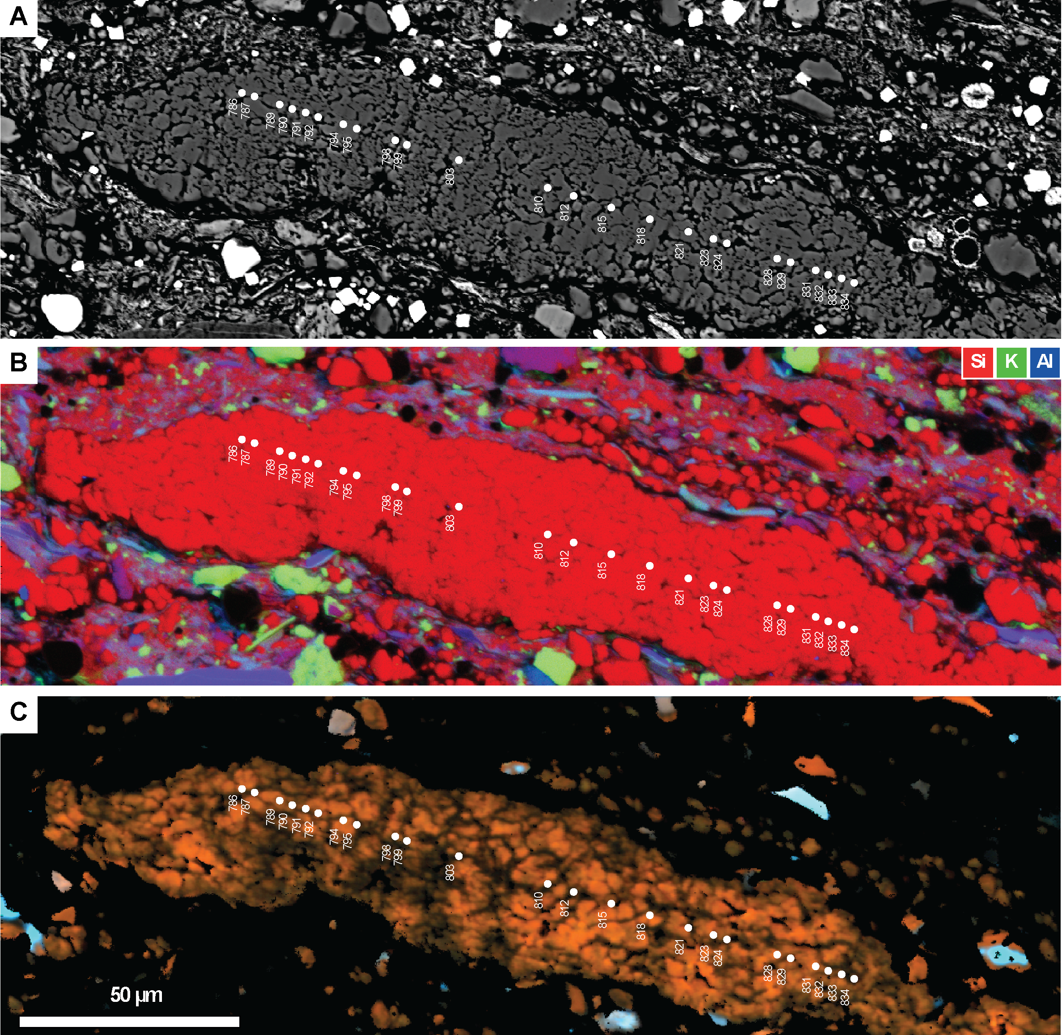
SI Figure 4 Scanning electron microscopy images of the micro-quartz mass and locations of analytical spots reported in SI Table 1. A) Back scattered electron image. B) RGB EDS map. C) cathodoluminescence map. Note the almost pure quartz nature and the dominantly orange-red CL colour of the aggregate, contrasting with variable colour of detrital quartz grains outside the aggregate.CL image is thresholded to only show the signal from quartz grains. Sample from the Marmbulligan 1 well, depth 169 m. For acquisition conditions refer to the Methods section in the main body of the manuscript.

Altree 2, depth 671 m. Authigenic quartz (Al content 0.13 wt% ± 0.11; 1σ, N = 30)
Si (wt%) | Fe (wt%) | K (wt%) | Al (wt%) | O (wt%) | Total (wt%) | Point #
47.18 | 0.25 | 0.03 | 0.22 | 54.05 | 101.78 | 391
46.96 | 0.10 | 0.01 | 0.11 | 53.63 | 100.81 | 392
46.97 | 0.09 | 0.01 | 0.02 | 53.56 | 100.65 | 393
46.66 | 0.07 | 0.01 | 0.03 | 53.21 | 99.98 | 394
45.05 | 0.09 | 0.01 | 0.08 | 51.42 | 96.66 | 395
44.92 | 0.09 | 0.01 | 0.09 | 51.28 | 96.40 | 396
46.09 | 0.08 | 0.01 | 0.12 | 52.64 | 98.94 | 397
46.62 | 0.09 | 0.01 | 0.06 | 53.20 | 99.99 | 398
46.63 | 0.07 | 0.01 | 0.03 | 53.18 | 99.93 | 399
46.64 | 0.07 | 0.01 | 0.14 | 53.28 | 100.15 | 400
48.55 | 0.07 | 0.01 | 0.11 | 55.44 | 104.20 | 406
46.18 | 0.06 | 0.02 | 0.15 | 52.77 | 99.20 | 409
45.84 | 0.07 | 0.02 | 0.16 | 52.40 | 98.49 | 411
44.61 | 0.06 | 0.02 | 0.21 | 51.04 | 95.95 | 412
44.51 | 0.08 | 0.03 | 0.27 | 50.99 | 95.89 | 413
45.01 | 0.06 | 0.02 | 0.18 | 51.46 | 96.73 | 415
46.64 | 0.06 | 0.01 | 0.07 | 53.22 | 100.00 | 416
47.10 | 0.06 | 0.01 | 0.03 | 53.71 | 100.90 | 417
47.31 | 0.06 | 0.01 | 0.09 | 54.00 | 101.46 | 418
45.62 | 0.07 | 0.03 | 0.19 | 52.17 | 98.10 | 419
46.86 | 0.07 | 0.01 | 0.14 | 53.53 | 100.63 | 839
46.42 | 0.07 | 0.01 | 0.16 | 53.06 | 99.74 | 840
46.17 | 0.06 | 0.01 | 0.08 | 52.70 | 99.02 | 841
45.46 | 0.06 | 0.01 | 0.05 | 51.86 | 97.44 | 842
46.52 | 0.06 | 0.01 | 0.07 | 53.09 | 99.75 | 843
44.15 | 0.10 | 0.12 | 0.60 | 50.89 | 95.87 | 844
45.62 | 0.05 | 0.01 | 0.09 | 52.07 | 97.84 | 846
46.88 | 0.06 | 0.01 | 0.04 | 53.47 | 100.46 | 847
46.92 | 0.06 | 0.01 | 0.12 | 53.59 | 100.72 | 848
46.39 | 0.06 | 0.02 | 0.17 | 53.03 | 99.68 | 849
SI Table 3 Quantitative analyses of authigenic quartz by Electron probe microanalyzer (EPMA). Position of individual analytical spots is shown in SI Figure 2.
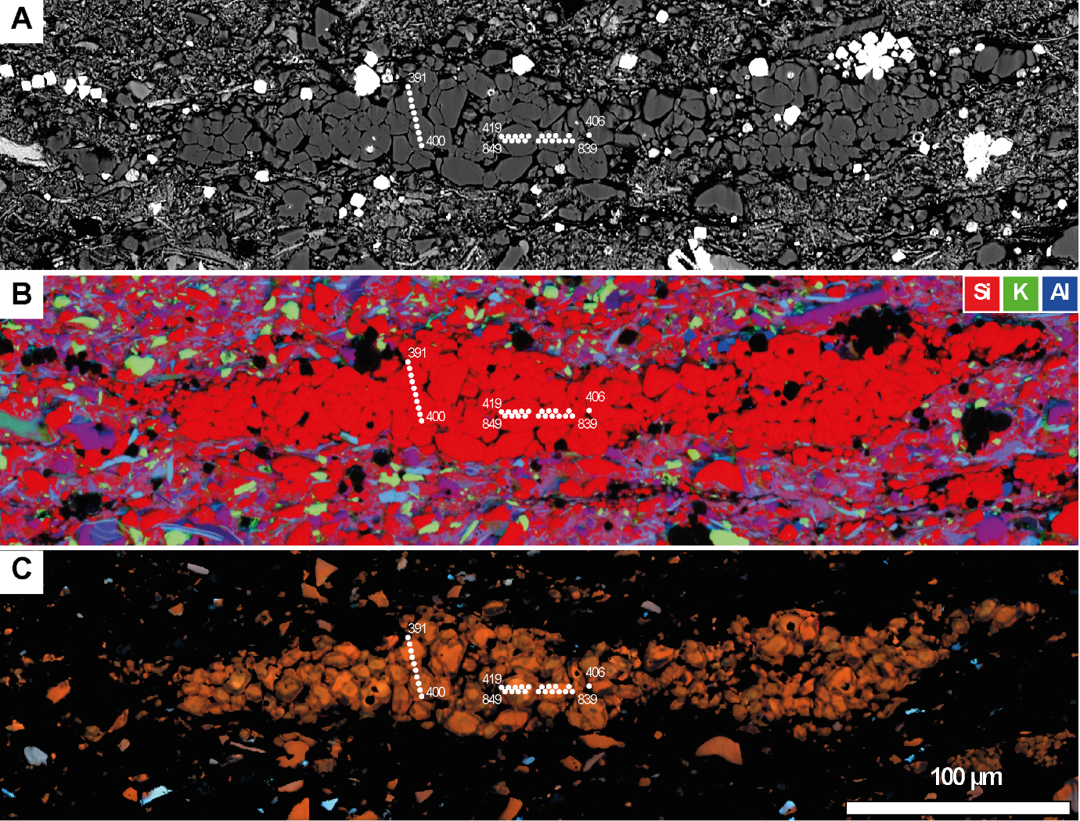
SI Figure 5 Scanning electron microscopy images of the micro-quartz mass and locations of analytical spots reported in SI Table 2. A) Back scattered electron image. B) RGB EDS map. C) cathodoluminescence map. Note the almost pure quartz nature and the dominantly orange-red CL colour of the aggregate, contrasting with variable colour of detrital quartz grains outside the aggregate.CL image is thresholded to only show the signal from quartz grains. Sample from the Altree 2 well, depth 671 m. For acquisition conditions refer to the Methods section in the main body of the manuscript.

Tanumbirini 1, depth 3258 m. Authigenic quartz (Al content 0.10 wt% ± 0.05; 1σ, N = 55)
Si (wt%) | Fe (wt%) | K (wt%) | Al (wt%) | O (wt%) | Total (wt%) | Point #
46.36 | 0.12 | 0.00 | 0.08 | 52.92 | 99.47 | 635
46.47 | 0.10 | 0.00 | 0.06 | 53.03 | 99.66 | 636
46.46 | 0.10 | 0.00 | 0.07 | 53.03 | 99.66 | 637
47.78 | 0.11 | 0.00 | 0.20 | 54.65 | 102.74 | 638
46.31 | 0.10 | 0.00 | 0.09 | 52.88 | 99.37 | 642
46.48 | 0.09 | 0.00 | 0.06 | 53.03 | 99.68 | 643
47.03 | 0.09 | 0.00 | 0.02 | 53.63 | 100.76 | 644
46.71 | 0.10 | 0.00 | 0.02 | 53.27 | 100.10 | 645
46.65 | 0.09 | 0.00 | 0.01 | 53.19 | 99.96 | 646
46.35 | 0.09 | 0.00 | 0.01 | 52.85 | 99.29 | 647
46.22 | 0.09 | 0.00 | 0.03 | 52.72 | 99.06 | 648
46.27 | 0.08 | 0.01 | 0.08 | 52.82 | 99.25 | 649
46.79 | 0.09 | 0.00 | 0.03 | 53.37 | 100.28 | 650
47.02 | 0.09 | 0.00 | 0.05 | 53.64 | 100.79 | 651
47.01 | 0.08 | 0.00 | 0.01 | 53.60 | 100.71 | 652
46.66 | 0.08 | 0.00 | 0.04 | 53.22 | 100.01 | 653
46.56 | 0.08 | 0.01 | 0.16 | 53.22 | 100.03 | 654
46.47 | 0.08 | 0.00 | 0.07 | 53.03 | 99.65 | 655
46.55 | 0.08 | 0.00 | 0.05 | 53.11 | 99.80 | 656
46.30 | 0.09 | 0.00 | 0.06 | 52.82 | 99.27 | 657
45.81 | 0.07 | 0.01 | 0.05 | 52.27 | 98.21 | 658
45.16 | 0.08 | 0.01 | 0.15 | 51.61 | 97.01 | 659
47.41 | 0.08 | 0.00 | 0.20 | 54.22 | 101.92 | 660
44.71 | 0.07 | 0.01 | 0.10 | 51.05 | 95.95 | 663
46.30 | 0.08 | 0.00 | 0.07 | 52.83 | 99.28 | 666
46.07 | 0.09 | 0.01 | 0.14 | 52.64 | 98.95 | 667
46.73 | 0.09 | 0.01 | 0.15 | 53.40 | 100.40 | 668
46.65 | 0.08 | 0.01 | 0.18 | 53.34 | 100.28 | 669
44.83 | 0.08 | 0.01 | 0.18 | 51.26 | 96.38 | 670
46.44 | 0.09 | 0.01 | 0.16 | 53.09 | 99.81 | 671
46.62 | 0.09 | 0.01 | 0.11 | 53.24 | 100.08 | 672
47.20 | 0.09 | 0.01 | 0.14 | 53.93 | 101.38 | 673
46.38 | 0.09 | 0.01 | 0.17 | 53.03 | 99.69 | 674
46.07 | 0.09 | 0.01 | 0.18 | 52.68 | 99.05 | 675
45.10 | 0.12 | 0.01 | 0.18 | 51.58 | 97.00 | 676
46.70 | 0.09 | 0.01 | 0.14 | 53.36 | 100.31 | 678
46.31 | 0.09 | 0.01 | 0.15 | 52.93 | 99.51 | 679
45.84 | 0.09 | 0.01 | 0.15 | 52.39 | 98.49 | 680
46.50 | 0.09 | 0.01 | 0.13 | 53.12 | 99.85 | 681
46.34 | 0.09 | 0.01 | 0.13 | 52.94 | 99.51 | 682

Si (wt%) | Fe (wt%) | K (wt%) | Al (wt%) | O (wt%) | Total (wt%) | Point #
46.59 | 0.09 | 0.01 | 0.06 | 53.16 | 99.92 | 683
46.44 | 0.09 | 0.00 | 0.04 | 52.97 | 99.54 | 684
46.22 | 0.08 | 0.00 | 0.07 | 52.74 | 99.11 | 685
46.34 | 0.08 | 0.00 | 0.05 | 52.87 | 99.36 | 686
46.14 | 0.09 | 0.01 | 0.09 | 52.67 | 99.00 | 687
46.56 | 0.09 | 0.01 | 0.11 | 53.17 | 99.94 | 688
46.51 | 0.09 | 0.01 | 0.13 | 53.14 | 99.89 | 689
46.49 | 0.09 | 0.01 | 0.18 | 53.15 | 99.93 | 690
46.08 | 0.09 | 0.01 | 0.16 | 52.68 | 99.04 | 691
46.43 | 0.09 | 0.01 | 0.09 | 53.00 | 99.62 | 692
46.33 | 0.09 | 0.01 | 0.12 | 52.92 | 99.47 | 693
46.01 | 0.09 | 0.01 | 0.15 | 52.59 | 98.87 | 694
45.89 | 0.10 | 0.01 | 0.15 | 52.45 | 98.62 | 695
45.74 | 0.09 | 0.01 | 0.11 | 52.23 | 98.18 | 696
46.02 | 0.09 | 0.01 | 0.13 | 52.58 | 98.86 | 697
46.12 | 0.09 | 0.01 | 0.13 | 52.69 | 99.06 | 698
46.21 | 0.09 | 0.01 | 0.07 | 52.74 | 99.13 | 699
46.27 | 0.09 | 0.01 | 0.10 | 52.84 | 99.33 | 700
46.48 | 0.10 | 0.00 | 0.05 | 53.04 | 99.68 | 701
46.44 | 0.10 | 0.00 | 0.04 | 52.98 | 99.57 | 702
46.88 | 0.09 | 0.00 | 0.07 | 53.49 | 100.54 | 703
47.06 | 0.10 | 0.00 | 0.04 | 53.69 | 100.90 | 704
46.54 | 0.09 | 0.00 | 0.06 | 53.11 | 99.81 | 705
46.23 | 0.10 | 0.01 | 0.08 | 52.78 | 99.22 | 706
46.42 | 0.10 | 0.01 | 0.09 | 53.00 | 99.63 | 707
46.18 | 0.11 | 0.01 | 0.15 | 52.79 | 99.27 | 709
46.00 | 0.10 | 0.01 | 0.15 | 52.58 | 98.86 | 710
46.25 | 0.11 | 0.01 | 0.10 | 52.81 | 99.28 | 711
47.05 | 0.10 | 0.00 | 0.06 | 53.69 | 100.91 | 712
46.68 | 0.11 | 0.01 | 0.13 | 53.33 | 100.28 | 713
46.02 | 0.11 | 0.01 | 0.16 | 52.61 | 98.93 | 714
45.96 | 0.11 | 0.01 | 0.14 | 52.54 | 98.79 | 715
46.22 | 0.10 | 0.01 | 0.17 | 52.85 | 99.38 | 716
46.31 | 0.10 | 0.01 | 0.17 | 52.95 | 99.56 | 717
45.85 | 0.11 | 0.01 | 0.12 | 52.38 | 98.48 | 718
47.04 | 0.10 | 0.01 | 0.06 | 53.68 | 100.89 | 719
46.64 | 0.12 | 0.01 | 0.12 | 53.28 | 100.16 | 720
SI Table 4 Quantitative analyses of authigenic quartz by Electron probe microanalyzer (EPMA). Position of individual analytical spots is shown in SI Figure 3.
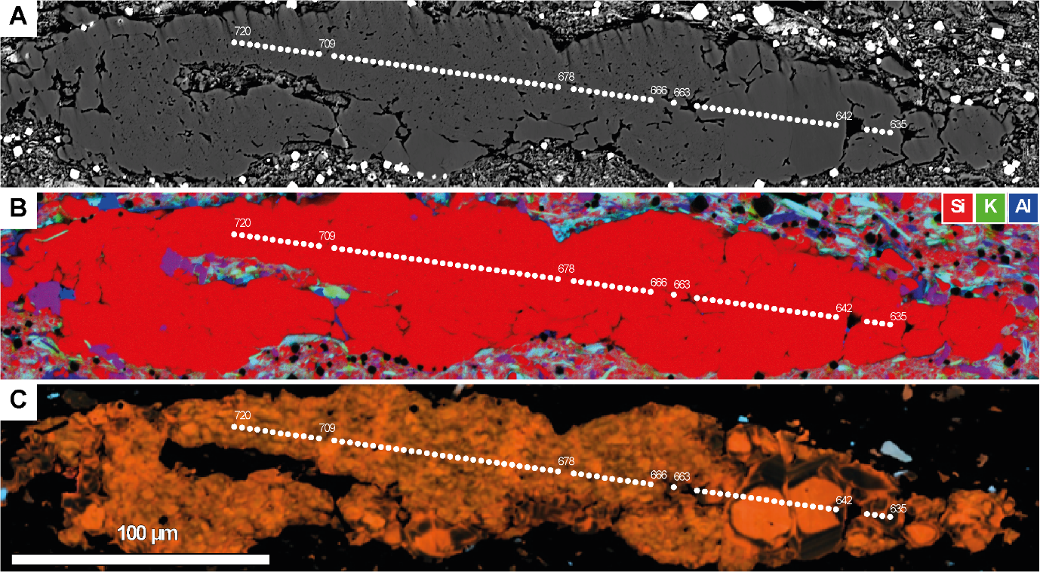
SI Figure 6 Scanning electron microscopy images of the micro-quartz mass and locations of analytical spots reported in SI Table 3. A) Back scattered electron image. B) RGB EDS map. C) cathodoluminescence map. Note the almost pure quartz nature and the dominantly orange-red CL colour of the aggregate, contrasting with variable colour of detrital quartz grains outside the aggregate.CL image is thresholded to only show the signal from quartz grains. Sample from the Tanumbirini 1 well, depth 3258 m. For acquisition conditions refer to the Methods section in the main body of the manuscript.

Marmbulligan 1, depth 122.25 m. Detrital quartz (Al content 0.04 wt% ± 0.07; 1σ, N = 78)
Si (wt%) | Fe (wt%) | K (wt%) | Al (wt%) | O (wt%) | Total (wt%) | Point #
46.64 | 0.05 | 0.01 | 0.04 | 53.20 | 99.945 | 429
46.80 | 0.06 | 0.01 | 0.02 | 53.36 | 100.244 | 430
46.71 | 0.06 | 0.01 | 0.02 | 53.26 | 100.055 | 431
46.85 | 0.05 | 0.01 | 0.03 | 53.42 | 100.353 | 432
46.61 | 0.06 | 0.01 | 0.07 | 53.19 | 99.934 | 433
46.75 | 0.06 | 0.01 | 0.03 | 53.31 | 100.15 | 435
46.67 | 0.06 | 0.01 | 0.02 | 53.21 | 99.958 | 436
46.76 | 0.07 | 0.00 | 0.01 | 53.31 | 100.143 | 437
46.75 | 0.06 | 0.00 | 0.03 | 53.30 | 100.13 | 438
46.94 | 0.06 | 0.01 | 0.02 | 53.52 | 100.55 | 439
46.92 | 0.07 | 0.01 | 0.02 | 53.50 | 100.52 | 440
46.79 | 0.07 | 0.01 | 0.02 | 53.35 | 100.25 | 441
47.05 | 0.06 | 0.01 | 0.02 | 53.65 | 100.79 | 442
47.11 | 0.08 | 0.01 | 0.05 | 53.75 | 101.00 | 443
46.79 | 0.06 | 0.01 | 0.01 | 53.34 | 100.22 | 444
46.73 | 0.06 | 0.01 | 0.02 | 53.28 | 100.10 | 445
46.72 | 0.06 | 0.01 | 0.01 | 53.27 | 100.07 | 446
46.78 | 0.07 | 0.01 | 0.01 | 53.33 | 100.21 | 447
46.75 | 0.06 | 0.01 | 0.02 | 53.30 | 100.13 | 472
46.58 | 0.06 | 0.01 | 0.02 | 53.09 | 99.75 | 473
46.54 | 0.06 | 0.01 | 0.01 | 53.05 | 99.66 | 474
46.60 | 0.09 | 0.01 | 0.05 | 53.16 | 99.92 | 475
46.60 | 0.05 | 0.01 | 0.01 | 53.12 | 99.79 | 479
46.18 | 0.06 | 0.01 | 0.01 | 52.65 | 98.90 | 480
46.41 | 0.05 | 0.01 | 0.02 | 52.91 | 99.39 | 481
46.58 | 0.04 | 0.01 | 0.01 | 53.10 | 99.74 | 482
46.38 | 0.04 | 0.01 | 0.02 | 52.87 | 99.31 | 483
46.56 | 0.04 | 0.00 | 0.01 | 53.07 | 99.69 | 484
46.73 | 0.05 | 0.00 | 0.01 | 53.27 | 100.07 | 485
46.92 | 0.04 | 0.00 | 0.01 | 53.48 | 100.44 | 486
46.52 | 0.05 | 0.01 | 0.01 | 53.03 | 99.61 | 487
46.49 | 0.05 | 0.01 | 0.03 | 53.00 | 99.57 | 488
46.37 | 0.06 | 0.01 | 0.03 | 52.88 | 99.33 | 499
46.58 | 0.06 | 0.01 | 0.02 | 53.10 | 99.77 | 500
46.46 | 0.06 | 0.01 | 0.01 | 52.97 | 99.50 | 501
46.60 | 0.05 | 0.00 | 0.02 | 53.12 | 99.78 | 502
46.35 | 0.06 | 0.01 | 0.01 | 52.84 | 99.27 | 503
46.54 | 0.06 | 0.01 | 0.02 | 53.06 | 99.67 | 504
46.52 | 0.05 | 0.00 | 0.01 | 53.04 | 99.61 | 505
46.24 | 0.05 | 0.00 | 0.01 | 52.71 | 99.00 | 506
46.39 | 0.05 | 0.01 | 0.00 | 52.89 | 99.33 | 507

Si (wt%) | Fe (wt%) | K (wt%) | Al (wt%) | O (wt%) | Total (wt%) | Point #
46.53 | 0.04 | 0.00 | 0.01 | 53.04 | 99.61 | 508
46.39 | 0.05 | 0.00 | 0.01 | 52.88 | 99.33 | 509
46.52 | 0.05 | 0.00 | 0.02 | 53.03 | 99.61 | 510
46.44 | 0.05 | 0.00 | 0.01 | 52.94 | 99.44 | 511
46.35 | 0.05 | 0.01 | 0.02 | 52.84 | 99.25 | 512
46.56 | 0.06 | 0.00 | 0.03 | 53.09 | 99.73 | 513
46.36 | 0.05 | 0.01 | 0.05 | 52.88 | 99.36 | 529
46.50 | 0.05 | 0.01 | 0.04 | 53.03 | 99.63 | 530
46.17 | 0.06 | 0.01 | 0.03 | 52.65 | 98.91 | 531
46.37 | 0.05 | 0.01 | 0.03 | 52.87 | 99.32 | 532
46.28 | 0.05 | 0.01 | 0.03 | 52.77 | 99.13 | 533
46.60 | 0.05 | 0.01 | 0.03 | 53.13 | 99.81 | 534
46.40 | 0.04 | 0.00 | 0.02 | 52.89 | 99.35 | 535
46.52 | 0.05 | 0.00 | 0.02 | 53.03 | 99.62 | 536
46.53 | 0.05 | 0.00 | 0.01 | 53.05 | 99.63 | 537
46.23 | 0.05 | 0.01 | 0.01 | 52.70 | 99.00 | 538
46.35 | 0.06 | 0.01 | 0.00 | 52.84 | 99.25 | 539
46.42 | 0.06 | 0.00 | 0.02 | 52.92 | 99.40 | 540
46.23 | 0.05 | 0.00 | 0.03 | 52.71 | 99.02 | 541
46.90 | 0.08 | 0.01 | 0.05 | 53.50 | 100.54 | 558
46.65 | 0.08 | 0.03 | 0.11 | 53.28 | 100.15 | 559
46.47 | 0.06 | 0.01 | 0.03 | 52.99 | 99.55 | 560
46.74 | 0.06 | 0.01 | 0.05 | 53.32 | 100.18 | 561
46.83 | 0.06 | 0.01 | 0.06 | 53.42 | 100.38 | 562
46.50 | 0.16 | 0.19 | 0.65 | 53.64 | 101.14 | 563
47.07 | 0.06 | 0.02 | 0.08 | 53.73 | 100.95 | 564
46.87 | 0.06 | 0.01 | 0.05 | 53.46 | 100.46 | 566
46.70 | 0.06 | 0.02 | 0.06 | 53.28 | 100.12 | 567
46.59 | 0.06 | 0.01 | 0.05 | 53.14 | 99.85 | 568
45.26 | 0.06 | 0.02 | 0.14 | 51.72 | 97.21 | 570
46.38 | 0.06 | 0.01 | 0.04 | 52.90 | 99.39 | 571
46.59 | 0.06 | 0.01 | 0.11 | 53.20 | 99.97 | 572
46.69 | 0.06 | 0.01 | 0.08 | 53.28 | 100.11 | 573
46.31 | 0.06 | 0.01 | 0.03 | 52.80 | 99.20 | 574
46.39 | 0.06 | 0.01 | 0.03 | 52.90 | 99.39 | 575
46.81 | 0.06 | 0.01 | 0.03 | 53.37 | 100.27 | 576
46.72 | 0.06 | 0.01 | 0.05 | 53.29 | 100.12 | 577
SI Table 5 Quantitative analyses of detrital quartz by Electron probe microanalyzer (EPMA). Position of individual analytical spots is shown in SI Figure 4.
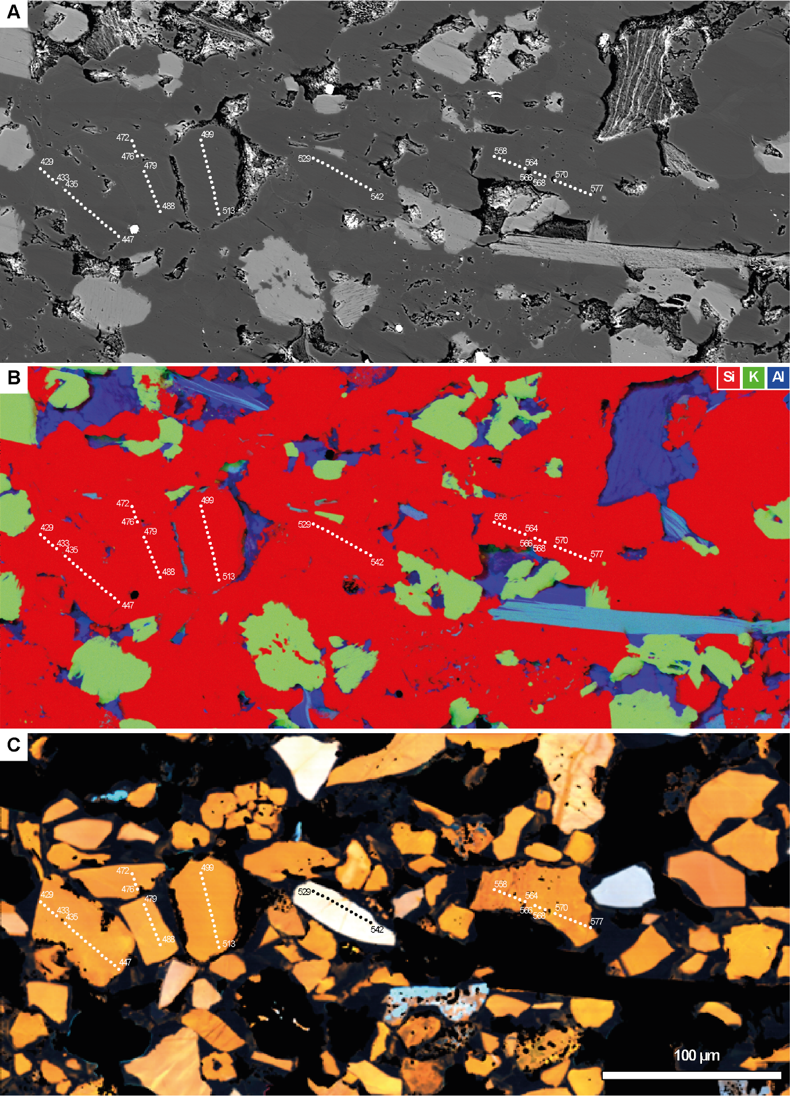
SI Figure 7 Scanning electron microscopy images of the detrital quartz grains and locations of analytical spots reported in SI Table 4. A) Back scattered electron image. B) RGB EDS map. C) cathodoluminescence map. Note the variable colour and internal texture of detrital quartz grains visible in C).CL image is thresholded to only show the signal from quartz grains. Sample from the Marmbulligan 1 well, depth 97 m. For acquisition conditions refer to the Methods section in the main body of the manuscript.

Energy Dispersive Spectroscopy Transmission Electron Microscopy estimations

TarleeS3 1347.66 m
ROI | AREA # | O (wt%) | Al (wt%) | Si (wt%) | K (wt%) | Comment
ROI A | 1 | 55.3 | 0.44 | 43.49 | 0.06 | Quartz
ROI A | 2 | 54.35 | 0.55 | 44.25 | 0.11 | Quartz
ROI A | 3 | 55.27 | 0.37 | 43.41 | 0.1 | Quartz
ROI A | 4 | 54.9 | 0.31 | 44.13 | 0.05 | Quartz
ROI A | 5 | 55.31 | 0.52 | 43.34 | 0.08 | Quartz
ROI A | 6 | 55.08 | 0.59 | 43.35 | 0.13 | Quartz
ROI B | 1 | 54.12 | 0.51 | 44.51 | 0.1 | Quartz
ROI B | 4 | 53.45 | 0.67 | 44.43 | 0.18 | Quartz
ROI B | 6 | 53.47 | 1.56 | 43.17 | 0.42 | Quartz-close to phase boundary
ROI B | 7 | 53.72 | 0.74 | 44.37 | 0.05 | Quartz
ROI B | 8 | 52.74 | 1.41 | 43.79 | 0.31 | Quartz-close to phase boundary
ROI C | 1 | 54.76 | 0.58 | 43.33 | 0.12 | Quartz
ROI C | 2 | 55.19 | 0.49 | 42.8 | 0.05 | Quartz
ROI C | 3 | 54.09 | 0.74 | 44 | 0.22 | Quartz
ROI C | 4 | 53.13 | 0.5 | 44.9 | 0.06 | Quartz
ROI C | 5 | 53.76 | 0.65 | 44.14 | 0.09 | Quartz
ROI C | 9 | 55.1 | 0.72 | 43.46 | 0.15 | Quartz
ROI D | 3 | 53.13 | 0.92 | 44.06 | 0.11 | Quartz
ROI D | 4 | 53.87 | 0.93 | 43.13 | 0.12 | Quartz
ROI D | 5 | 52.71 | 1.11 | 43.77 | 0.23 | Quartz
ROI D | 6 | 53.41 | 1.03 | 43.09 | 0.19 | Quartz
ROI E | 1 | 54.37 | 0.71 | 44.26 | 0.08 | Quartz
ROI E | 2 | 54.17 | 0.58 | 43.88 | 0.07 | Quartz
ROI E | 3 | 52.96 | 0.43 | 44.98 | 0.07 | Quartz
ROI E | 4 | 55.19 | 0.6 | 43.03 | 0.11 | Quartz
ROI E | 5 | 54.68 | 0.64 | 43.45 | 0.14 | Quartz
ROI E | 9 | 54.21 | 0.57 | 44.46 | 0.08 | Quartz
ROI F | Area #2 | 53.59 | 0.97 | 43.62 | 0.11 | Quartz
ROI F | Area #3 | 53.66 | 0.87 | 43.62 | 0.11 | Quartz
ROI F | Area #5 | 55.14 | 0.89 | 41.58 | 0.14 | Quartz
ROI F | Area #5 | 55.16 | 0.88 | 41.59 | 0.14 | Quartz
SI Table 6 Quantitative analyses of authigenic quartz determined by energy Dispersive Spectrometry (EDS). Position of each region of interest (ROI) is shown in SI Figure 5.

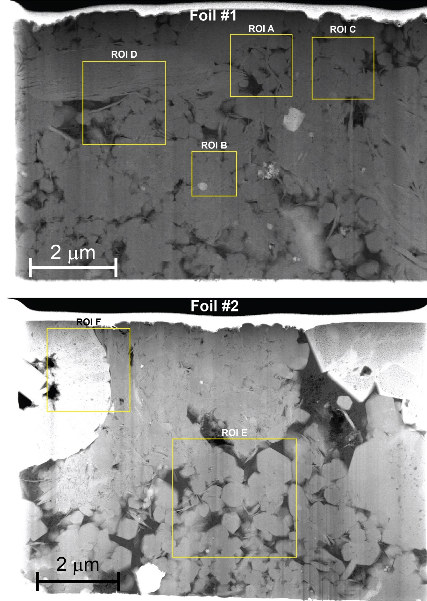
SI Figure 8 HADDF image Scanning Transmission Electron Microscopy Images Sample from the TarleeS3 well, depth 1347.66 m. Yellow boxes indicate the locations of regions of interest (ROI) shown in the following figures. For acquisition conditions refer to the Methods section in the main body of the manuscript
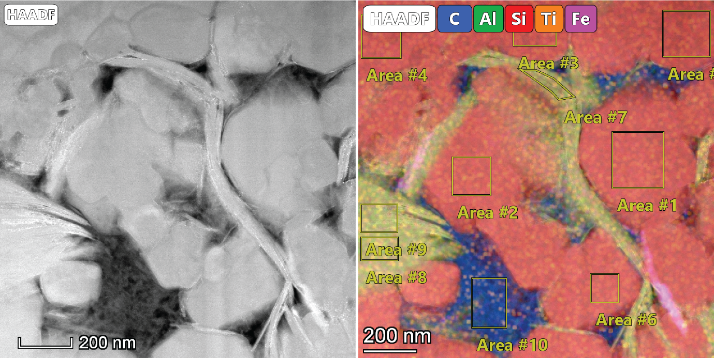
SI Figure 9 ROI A. High-angle annular dark-field (HADDF) image (left) and elemental map (right) with locations of areas for acquisition of elemental data tabulated in SI Table 5.
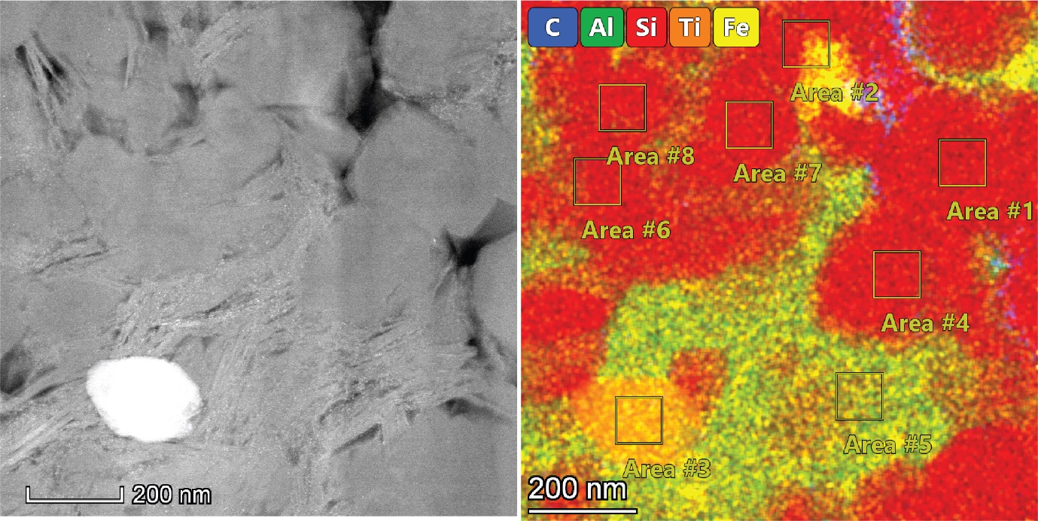
SI Figure 10 ROI B. High-angle annular dark-(HADDF) image (left) and elemental map (right) with locations of areas for acquisition of elemental data tabulated in SI Table 5.
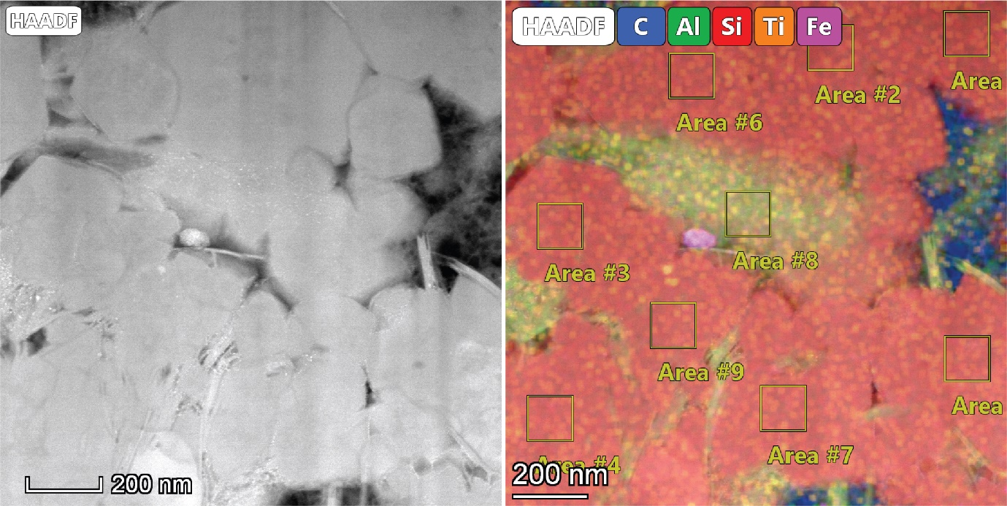
SI Figure 11 ROI C. High-angle annular dark-field (HADDF) image (left) and elemental map (right) with locations of areas for acquisition of elemental data tabulated in SI Table 5.
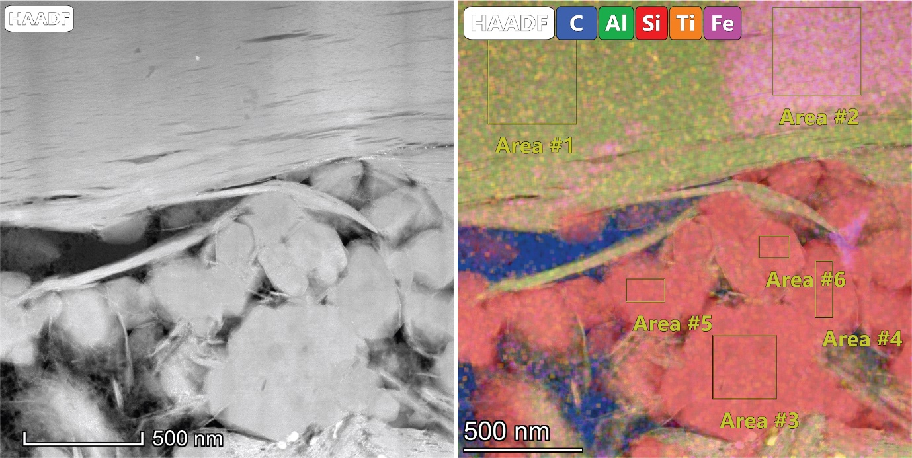
SI Figure 12 ROI D. High-angle annular dark-field image (HADDF) image and elemental map (right) with locations of areas for acquisition of elemental data tabulated in SI Table 5.
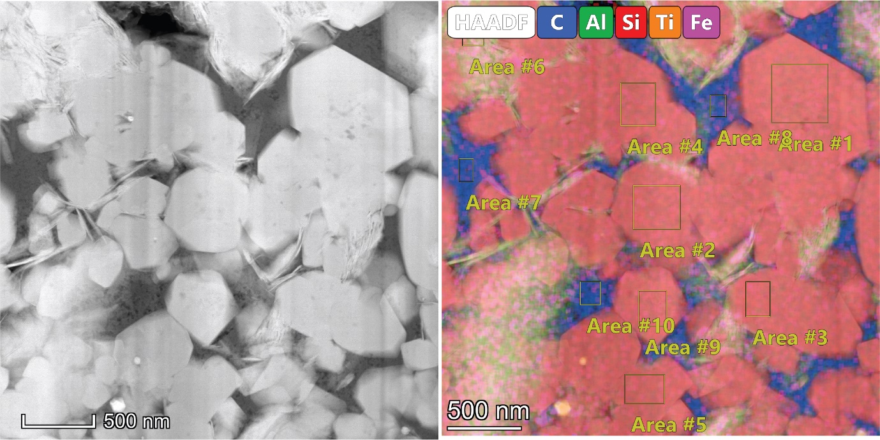
SI Figure 13 ROI E. High-angle annular dark-field image (HADDF) image and elemental map (right) with locations of areas for acquisition of elemental data tabulated in SI Table 5.
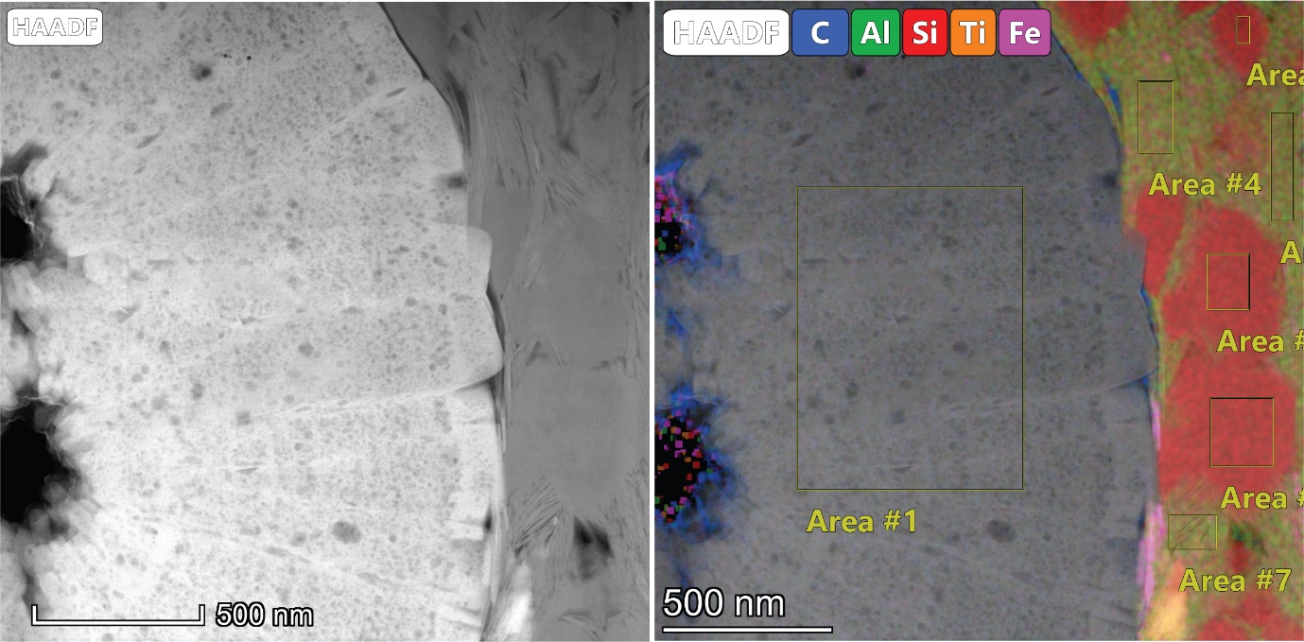
SI Figure 14 ROI F. High-angle annular dark-field image (HADDF) image and elemental map (right) with locations of areas for acquisition of elemental data tabulated in SI Table 5.

Supporting Information 3: Parameters for volumetric estimation of authigenic quartz.
Values for the areal extent of the Velkerri formation range between ± 20% of 75000 km², the value as inferred as a minimum extent by Jarrett and Munson, 2022. The minimum and maximum thicknesses of the Amungee Member are derived from the intersected minimum (well Tarlee-1) and maximum (well Beetaloo-W1) values of unit 2 in Crombez et al., 2023. Lastly the minimum and maximum fraction of diagenetic quartz are estimated from cross plots of Si_{Excess} and volume of quartz obtained from the wireline logs. The fraction of detrital quartz is estimated from the value of total quartz at zero Si_{Excess} and corresponds to ca. 15%.
1000000 simulations were run in a Monte Carlo environment, generating random values of the independent variables to estimate the volume of diagenetic quartz in the Amungee Member of the Velkerri Formation.
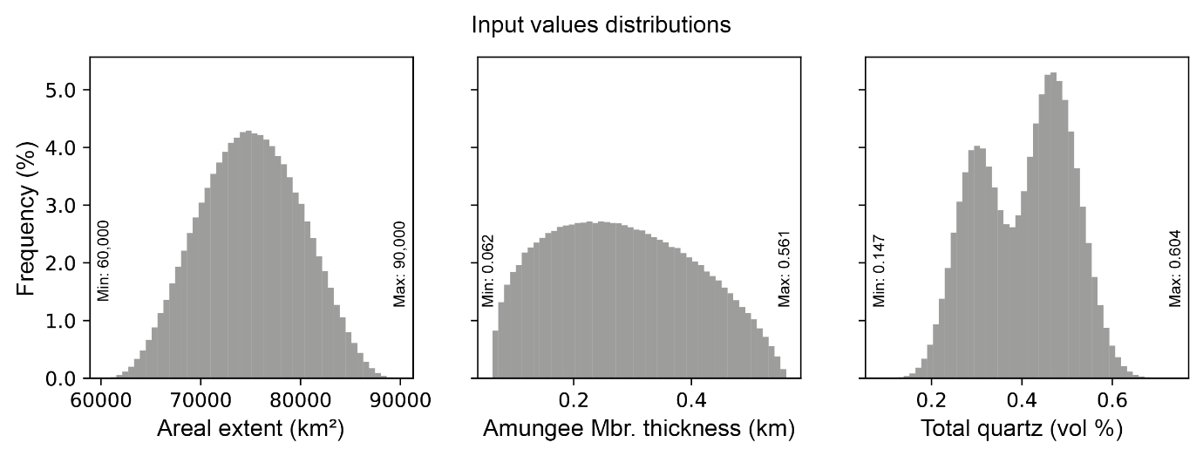
SI Figure 15 Distributions, minimum and maximum values for each of the variable used in the estimation of the volume of authigenic quartz in the Amungee Member of the Velkerri Formation.

Supporting Information 4: Quartz δ¹⁸O data table and figures of analytical locations.
Same samples used for elemental analysis shown above were micro-drilled and embedded on a new sample mount containing two quartz standards NBS-2852 ref 52 and UWQ-153 ref 53. Before in situ oxygen isotope microanalysis SIMS, the mounts’ surfaces were cleaned with detergent, ethanol and distilled water in an ultrasonic bath and coated with gold (20nm in thickness).
Instrumental mass fractionation (IMF) was corrected using UWQ1 (δ¹⁸O = 12.33 ‰, Kelly et al., 2007) following the procedure described in Kita et al. (2009). The spot-to-spot reproducibility was ~0.6‰ (2 SD) on UWQ1.NBS-28, which was analysed as a secondary quartz standard, returned a mean δ¹⁸O value of 9.1 +/- 1.4 per mil (2s), in agreement within error with the reference value (9.57‰, Hut, 1987).
26 spot analyses were collected and after quality checking, 3 spots were identified as invalid having fallen on non-quartz minerals, the remaining 23 spots were deemed valid measurements and are reported in SI Table 6.

Analysis # | δ¹⁸O | ± per mil | Reference image
2O-CDP-Altree2_671_1@01 | 22.60 | 0.35 | SIMS 1
2O-CDP-Altree2_671_1@02 | 24.48 | 0.36 | SIMS 1
2O-CDP-Altree2_671_2@01 | 19.44 | 0.35 | SIMS 1
2O-CDP-Altree2_671_3@01 | 23.52 | 0.35 | SIMS 1
2O-CDP-Altree2_671_4@01 | 20.12 | 0.37 | SIMS 1
2O-CDP-Altree2_671_4@02 | 20.48 | 0.35 | SIMS 1
2O-CDP-Altree2_671_4@03 | 20.78 | 0.37 | SIMS 1
2O-CDP-Altree2_671_5@01 | 20.36 | 0.35 | SIMS 1
2O-CDP-Altree2_671_5@02 | 21.50 | 0.36 | SIMS 1
2O-CDP-Altree2_671_7@01 | 19.64 | 0.35 | SIMS 1
2O-CDP-Altree2_671_8@01 | 20.55 | 0.37 | SIMS 1
2O-CDP-Altree2_671_9@01 | 21.19 | 0.36 | SIMS 1
2O-CDP-Altree2_671_10@01 | 19.14 | 0.35 | SIMS 1
2O-CDP-Altree2_671_11@01 | 21.20 | 0.37 | SIMS 1
2O-CDP-Altree2_671_line@01 | 19.76 | 0.54 | 2
2O-CDP-Altree2_671_line@2 | 19.53 | 0.54 | 2
2O-CDP-Altree2_671_line@3 | 19.92 | 0.53 | 2
2O-CDP-Altree2_671_line@5 | 19.83 | 0.54 | 2
2O-CDP-Altree2_671_line@06 | 19.52 | 0.53 | 2
2O-CDP-Altree2_671_line@7 | 19.92 | 0.53 | 2
2O-CDP-Altree2_671_line@8 | 21.32 | 0.54 | 2
2O-CDP-Altree2_671_line@9 | 22.52 | 0.53 | 2
2O-CDP-Altree2_671_12@01 | 20.11 | 0.53 | 3
SI Table 7 In-situ oxygen isotopes values in authigenic quartz determined by secondary ion mass spectrometry (SIMS) measurements on a sample from well Altree 2 depth 671 m. Locations of analytical spots are shown in SI Figure 13-SI Figure 15.

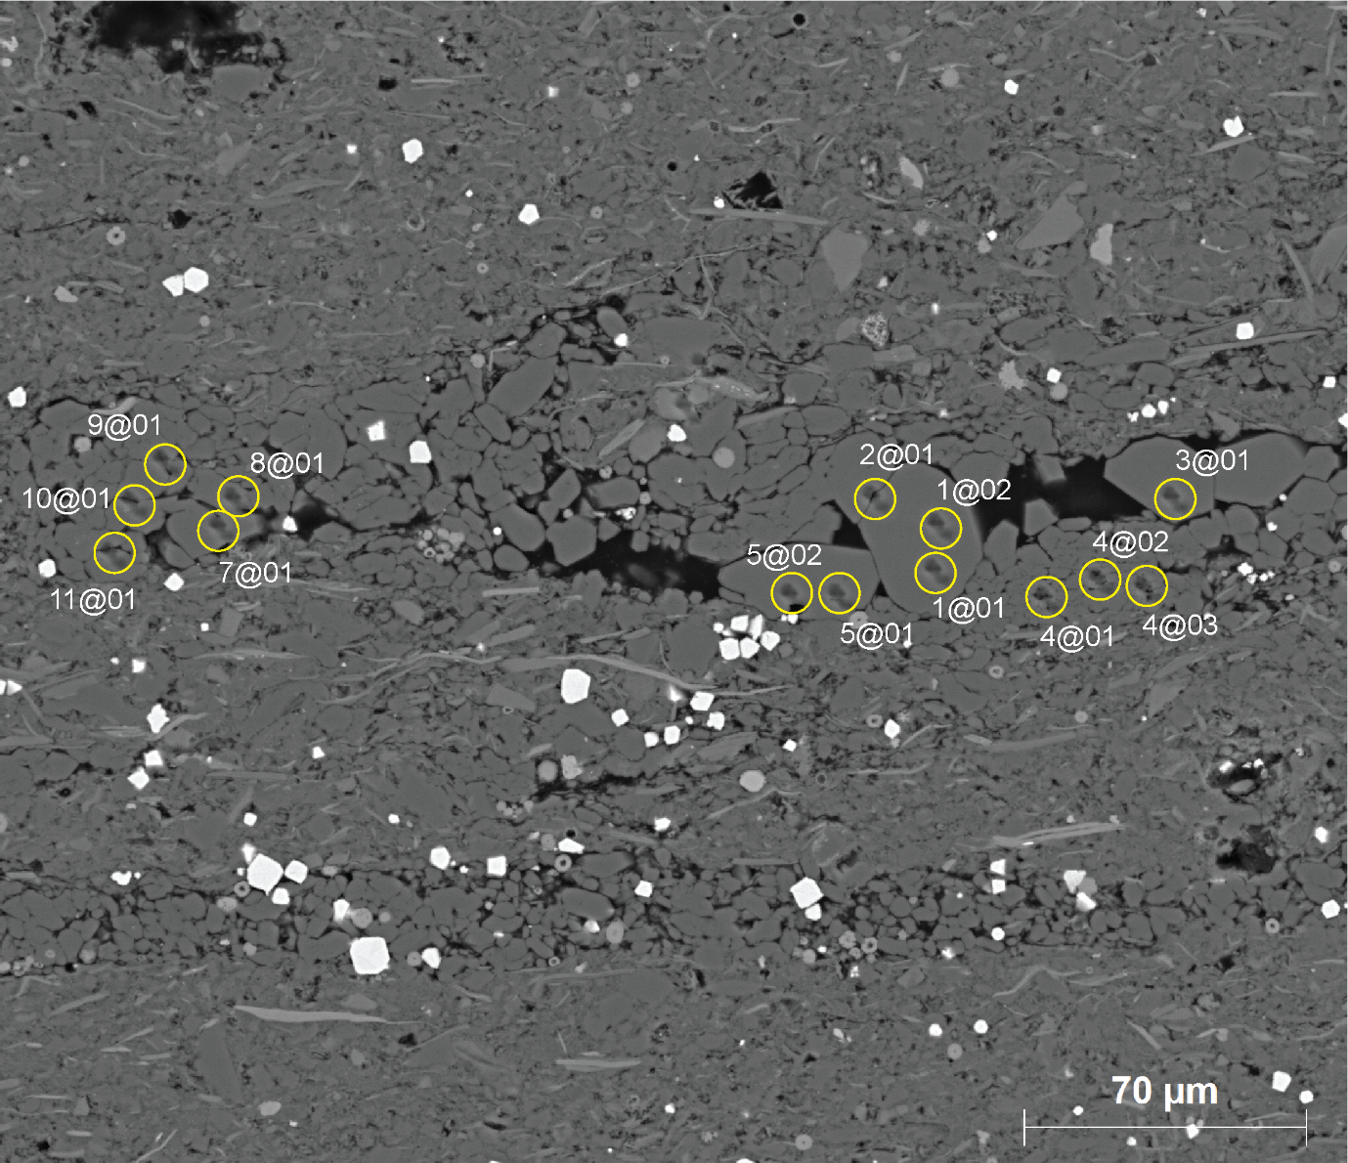
SI Figure 16 Scanning electron microscopy image in backscattered electron mode with overlay showing the location of analytical spots tabulated in SI Table 6. Yellow marker represents a circle with diameter of 10 μm.

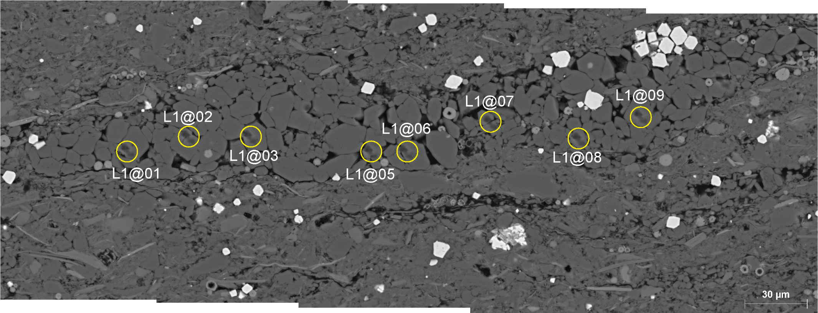
SI Figure 17 Scanning electron microscopy image in backscattered electron mode with overlay showing the location of analytical spots tabulated in SI Table 6. Yellow marker represents a circle with diameter of 10 μm.

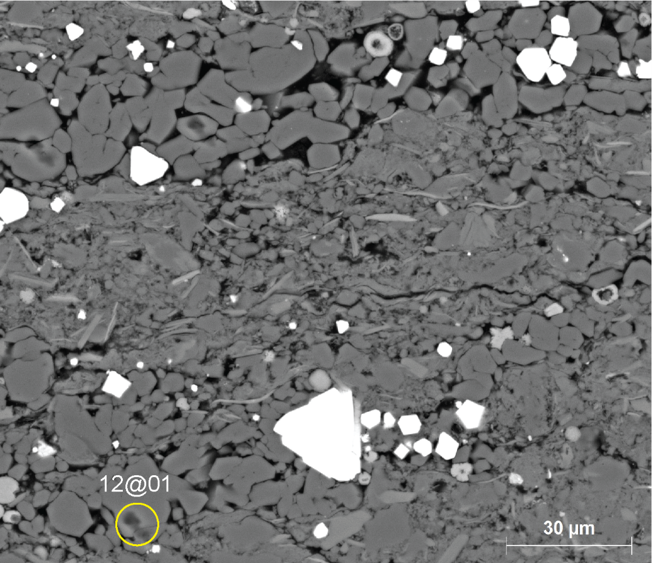
SI Figure 18 Scanning electron microscopy image in backscattered electron mode with overlay showing the location of analytical spots tabulated in SI Table 6. Yellow marker represents a circle with diameter of 10 μm.

References for Supporting Information
Bruna P.O. and Dhu T. (2017). 3D Model of the greater McArthur Basin, Version 2017.1. Northern Territory Geological Survey, Digital Information Package DIP 012. Viewed 8 September 2023, https://geoscience.nt.gov.au/gemis/ntgsjspui/handle/1/81751.
Crombez, V., Kunzmann, M., Faiz, M., Delle Piane, C., Munday, S. and Forbes, A. (2023). Stratigraphic architecture of the 1420-1210 Ma Velkerri and Kyalla Formations (Beetaloo sub-basin, Australia). AAPG Bulletin, (20,230,201).
Harrowfield, I.R.; MacRae, C.M.; Wilson, N.C. Chemical Imaging in Electron Microprobes. In Proceedings of the 27th Microbeam Analysis Society Annual MAS Meeting, New York, NY, USA, 1993; pp. 547–548.
Hut, G. (1987). Stable isotope reference samples for geochemical and hydrological investigations. Consultant Group Meeting IAEA, Vienna, 16–18 September 1985, Report to the Director General. International Atomic Energy Agency, Vienna, 42.
Jarrett, A. J. M., Munson, T. J. (2022). Prospectivity of the Beetaloo Petroleum Supersystem and stacked petroleum systems in the greater McArthur Basin. Annual Geoscience Exploration Seminar (AGES) Proceedings, Alice Springs, Northern Territory, 5–6 April (pp. 41–52). Northern Territory Geological Survey.
Kelly, J.L., Fu, B., Kita, N.T. and Valley, J.W. (2007). Optically continuous silcrete quartz cements of the St. Peter Sandstone: High precision oxygen isotope analysis by ion microprobe. Geochimica et Cosmochimica Acta, 71(15), pp.3812-3832.
Kita, N.T., Ushikubo, T., Fu, B. and Valley, J.W. (2009). High precision SIMS oxygen isotope analysis and the effect of sample topography. Chemical Geology, 264(1-4), pp.43-57.
Northern Territory Geological Survey and Geognostics Australia Pty Ltd, 2021. Northern Territory SEEBASE® and GIS - Gravity and Magnetics. Northern Territory Geological Survey, Digital Information Package DIP 031 (https://geoscience.nt.gov.au/gemis/ntgsjspui/handle/1/91172).
Rawlings, D. J. (1999). Stratigraphic resolution of a multiphase intracratonic basin system: The McArthur Basin, northern Australia: Australian Journal of Earth Sciences, v. 46, no. 5, p. 703–723, doi:10.1046/j.1440-0952.1999.00739.x.
Warren, J.K., George, S.C., Hamilton, P.J. and Tingate, P. (1998). Proterozoic source rocks: sedimentology and organic characteristics of the Velkerri Formation, Northern Territory, Australia. AAPG bulletin, 82(3), pp.442-463.

