Mace-like carbon fibers/ZnO nanorods composites derived from Typha orientalis as ultralight and high-performance electromagnetic wave absorber
Yanyan Donga, Xiaojie Zhua, Fei Pana, Baiwen Denga, Zhicheng Liua, Xiang Zhanga, Chuang Huangb, Zhen Xianga, Wei Lu^{a,}*
ª Shanghai Key Lab. of D&A for Metal-Functional Materials, School of Materials Science & Engineering, Tongji University, Shanghai 201804, China.
^{b} School of Materials Science & Engineering, University of Shanghai for Science and Technology, Shanghai 200093, China.
*Corresponding authors. E-mail address: weilu@tongji.edu.cn (Wei Lu)
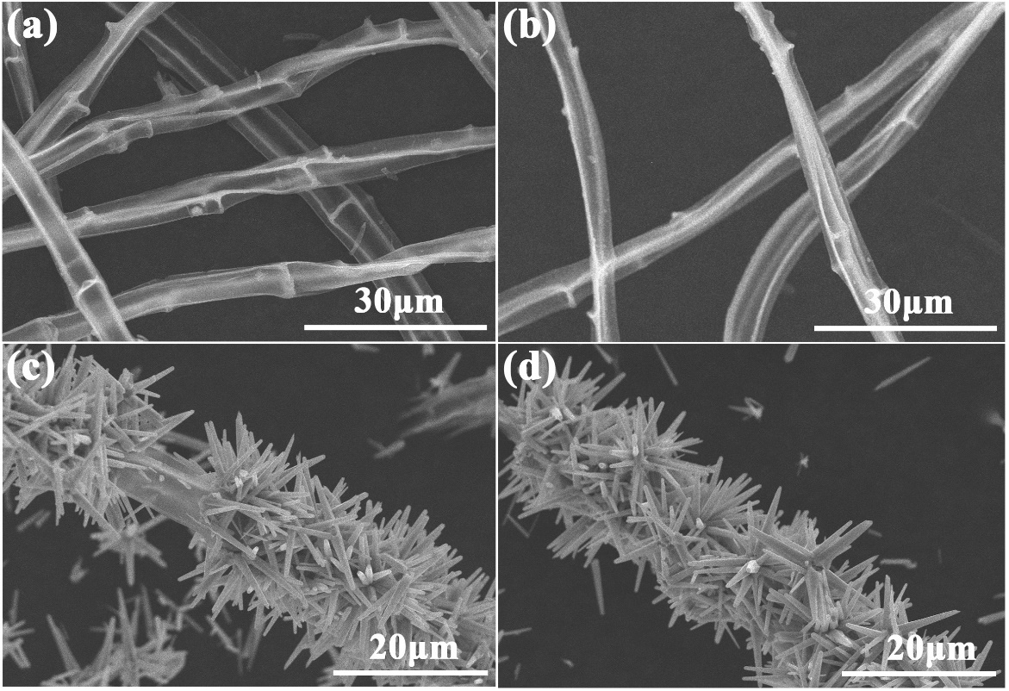
Fig. S1 SEM images of BDCFs6 (a), BDCFs8 (b), BDCFs6@ZnO (c) and BDCFs8@ZnO (d).
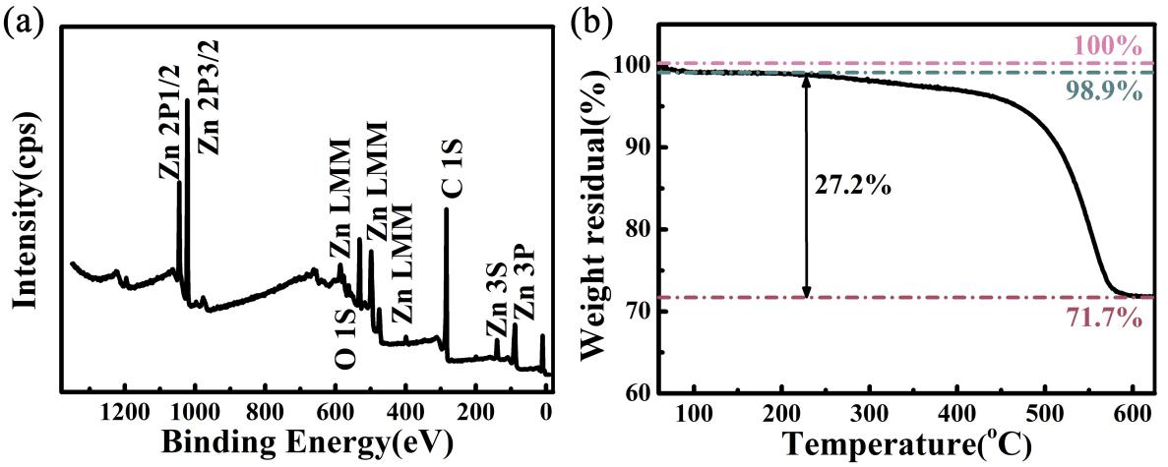
Fig. S2 XPS spectra of BDCFs7@ZnO (a) and TG curve of BDCFs7@ZnO in air (b).
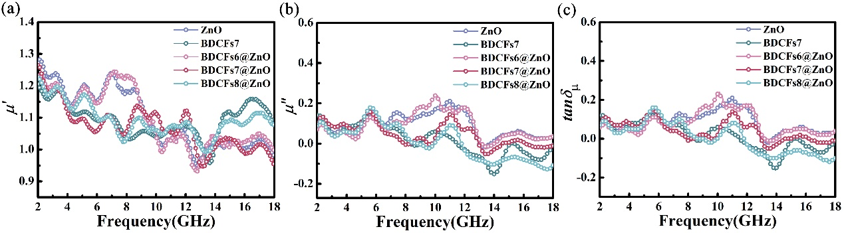
Fig. S3 Real part of permeability (a), imaginary part of permeability (b) and magnetic loss tangent (c) of different samples.
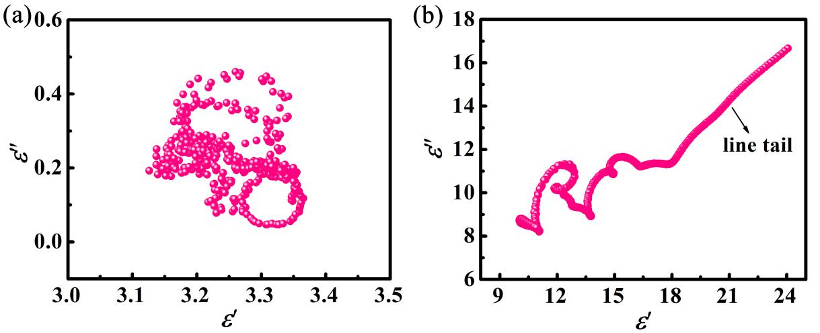
Fig. S4 Cole-Cole plot of ZnO (a) and BDCFs7 (b).
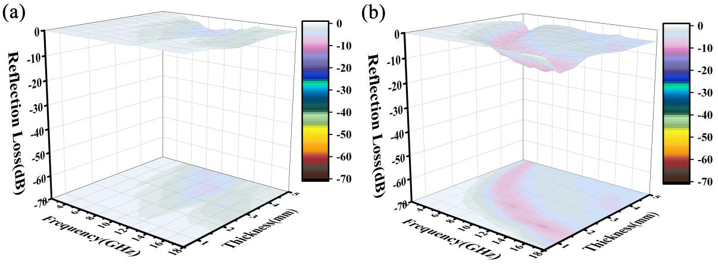
Fig. S5 3D reflection loss plots of samples at a filler content of 15%: ZnO (a) and BDCFs7(b).
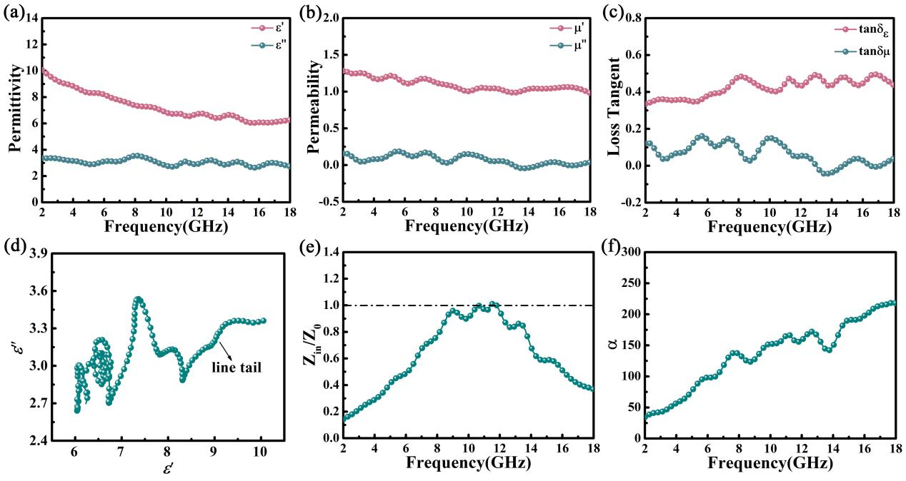
Fig. S6 The permittivity (a), permeability (b), loss tangent (c), cole-cole plot (d), impedance matching characterisitc (e) and attenuation coefficient (f) of BDCFs7.

Tab. S1 The calculation results of dielectric sum-quotient model (ε_{T} =5)
ε_{T} =5 | 1.0mm | 1.2mm | 1.4mm | 1.6mm | 1.8mm | 2.0mm
cotε=5.0 | None | None | None | None | None | None
cotε=4.0 | None | None | None | None | None | None
cotε=3.0 | None | None | None | None | None | None
cotε=2.5 | None | None | None | None | None | None
cotε=2.0 | None | None | None | None | None | None
cotε=1.5 | None | None | None | None | None | None
cotε=1.0 | None | None | None | None | None | None
ε_{T} =5 | 2.2mm | 2.4mm | 2.6mm | 2.8mm | 3.0mm
cotε=5.0 | None | None | None | None | None
cotε=4.0 | None | None | None | None | None
cotε=3.0 | None | 16.44-18.00 | 15.16-17.96 | 14.08-16.68 | 13.16-15.56
cotε=2.5 | 17.28-18.00 | 15.84-18.00 | 14.64-18.00 | 13.60-18.00 | 12.68-17.08
cotε=2.0 | 17.00-18.00 | 15.60-18.00 | 14.40-18.00 | 13.36-18.00 | 12.48-18.00
cotε=1.5 | 17.00-18.00 | 15.60-18.00 | 14.40-18.00 | 13.36-18.00 | 12.48-18.00
cotε=1.0 | 17.60-18.00 | 16.12-18.00 | 14.88-18.00 | 13.80-18.00 | 12.88-18.00

Tab. S2 The calculation results of dielectric sum-quotient model (ε_{T} =10)
ε_{T} =10 | 1.0mm | 1.2mm | 1.4mm | 1.6mm | 1.8mm | 2.0mm
cotε=5.0 | None | None | None | None | None | None
cotε=4.0 | None | None | None | 16.24-18.00 | 14.44-16.48 | 13.00-14.80
cotε=3.0 | None | None | None | 15.88-18.00 | 14.12-18.00 | 12.72-16.20
cotε=2.5 | None | None | None | 15.88-18.00 | 14.12-18.00 | 12.68-17.00
cotε=2.0 | None | None | None | 16.00-18.00 | 14.24-18.00 | 12.80-17.88
cotε=1.5 | None | None | None | 16.48-18.00 | 14.64-18.00 | 13.20-18.00
cotε=1.0 | None | None | None | None | 16.12-18.00 | 14.48-18.00
ε_{T} =10 | 2.2mm | 2.4mm | 2.6mm | 2.8mm | 3.0mm
cotε=5.0 | None | None | None | None | None
cotε=4.0 | 11.80-13.48 | 10.84-12.36 | 10.00-11.40 | 9.28-10.56 | 8.68-9.88
cotε=3.0 | 11.56-14.76 | 10.60-13.52 | 9.76-12.48 | 9.08-11.56 | 8.48-10.80
cotε=2.5 | 11.56-15.48 | 10.60-14.16 | 9.76-13.08 | 9.08-12.16 | 8.48-11.32
cotε=2.0 | 11.64-16.24 | 10.68-14.88 | 9.84-13.76 | 9.16-12.76 | 8.56-11.92
cotε=1.5 | 12.00-16.96 | 11.00-15.56 | 10.16-14.36 | 9.40-13.32 | 8.80-12.44
cotε=1.0 | 13.20-16.60 | 12.08-15.20 | 11.16-14.04 | 10.36-13.04 | 9.68-12.16

Tab. S3 The calculation results of dielectric sum-quotient model (ε_{T} =15)
ε_{T}=15 | 1.0mm | 1.2mm | 1.4mm | 1.6mm | 1.8mm | 2.0mm
cotε=5.0 | None | 17.32-18.00 | 14.88-16.36 | 13.00-14.32 | 11.56-12.72 | 10.40-11.44
cotε=4.0 | None | 17.08-18.00 | 14.60-17.36 | 12.80-15.20 | 11.36-13.48 | 10.24-12.16
cotε=3.0 | None | 17.04-18.00 | 14.60-18.00 | 12.76-16.20 | 11.36-14.40 | 10.24-12.96
cotε=2.5 | None | 17.16-18.00 | 14.72-18.00 | 12.88-16.76 | 11.40-14.88 | 10.32-13.40
cotε=2.0 | None | 17.52-18.00 | 15.00-18.00 | 13.16-17.32 | 11.68-15.40 | 10.52-13.84
cotε=1.5 | None | None | 15.76-18.00 | 13.80-17.56 | 12.28-15.60 | 11.04-14.04
cotε=1.0 | None | None | None | None | None | None
ε_{T} =15 | 2.2mm | 2.4mm | 2.6mm | 2.8mm | 3.0mm
cotε=5.0 | 9.48-10.40 | 8.68-9.52 | 8.00-8.80 | 7.44-8.16 | 6.96-7.6
cotε=4.0 | 9.32-11.04 | 8.52-10.12 | 7.88-9.32 | 7.32-8.68 | 6.84-8.08
cotε=3.0 | 9.28-11.76 | 8.52-10.80 | 7.88-9.96 | 7.32-9.24 | 6.84-8.64
cotε=2.5 | 9.36-12.16 | 8.60-11.16 | 7.92-10.32 | 7.36-9.56 | 6.88-8.92
cotε=2.0 | 9.56-12.60 | 8.76-11.52 | 8.08-10.64 | 7.52-9.88 | 7.00-9.24
cotε=1.5 | 10.04-12.76 | 9.20-11.72 | 8.52-10.80 | 7.88-10.04 | 7.36-9.36
cotε=1.0 | None | None | None | None | None

Tab. S4 The calculation results of dielectric sum-quotient model (ε_{T} =20)
ε_{T} =20 | 1.0mm | 1.2mm | 1.4mm | 1.6mm | 1.8mm | 2.0mm
cotε=5.0 | 17.60-18.00 | 14.68-16.68 | 12.56-14.28 | 11.00-12.48 | 9.80-11.12 | 8.80-10.00
cotε=4.0 | 17.52-18.00 | 14.60-17.44 | 12.52-14.96 | 10.96-13.08 | 9.72-11.64 | 8.76-10.44
cotε=3.0 | 17.68-18.00 | 14.72-18.00 | 12.64-15.72 | 11.04-13.76 | 9.84-12.24 | 8.84-11.00
cotε=2.5 | 17.92-18.00 | 14.92-18.00 | 12.84-16.16 | 11.20-14.08 | 9.96-12.56 | 8.96-11.28
cotε=2.0 | None | 15.36-18.00 | 13.16-16.48 | 11.52-14.44 | 10.24-12.84 | 9.24-11.52
cotε=1.5 | None | 16.60-18.00 | 14.24-16.20 | 12.44-14.20 | 11.08-12.60 | 9.96-11.36
cotε=1.0 | None | None | None | None | None | None
ε_{T} =20 | 2.2mm | 2.4mm | 2.6mm | 2.8mm | 3.0mm
cotε=5.0 | 8.00-9.08 | 7.36-8.32 | 6.76-7.68 | 6.28-7.12 | 5.88-6.64
cotε=4.0 | 7.96-9.52 | 7.32-8.72 | 6.76-8.04 | 6.28-7.48 | 5.84-6.96
cotε=3.0 | 8.04-10.00 | 7.36-9.16 | 6.80-8.44 | 6.32-7.84 | 5.92-7.32
cotε=2.5 | 8.16-10.28 | 7.48-9.40 | 6.92-8.68 | 6.40-8.08 | 6.00-7.52
cotε=2.0 | 8.40-10.48 | 7.68-9.60 | 7.12-8.88 | 6.60-8.24 | 6.16-7.68
cotε=1.5 | 9.04-10.32 | 8.32-9.44 | 7.68-8.72 | 7.12-8.08 | 6.64-7.56
cotε=1.0 | None | None | None | None | None

