New Porous Amine Functionalized Biochar based Desiccated Coconut Waste as Efficient CO₂ Adsorbents
Dina Sofiea Zakaria¹, Siti Khalijah Mahmad Rozi^{1,2*}, Hairul Nazirah Abdul Halim^{1,2}, Sharifah Mohamad³, Ghee Kang Zheng¹

Supplementary info

Table S1. Series of amines used for the synthesis of adsorbent
Amines | Molecular formula
Ethylenediamine (EDA) | 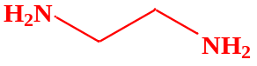
Diethylenetriamine (DETA) | 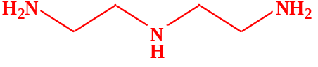
Triethylenetetramine (TETA) | 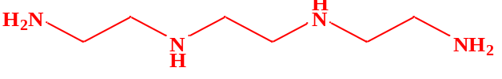
Tetraethylenepentamine (TEPA) | 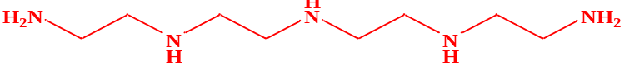
Pentaethylenehexamine (PEHA) | 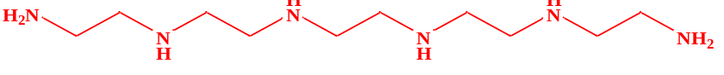

Figure S1: N₂ adsorption-desorption isotherms of (A) pristine DCW and biochar@DCW; (B) EDA- biochar@DCW, DETA-biochar@DCW, TETA-biochar@DCW, TEPA-biochar@DCW and, PEHA-biochar@DCW. (The mass ratio (m:m) of biochar@DCW:amine of all adsorbents is 1:2)
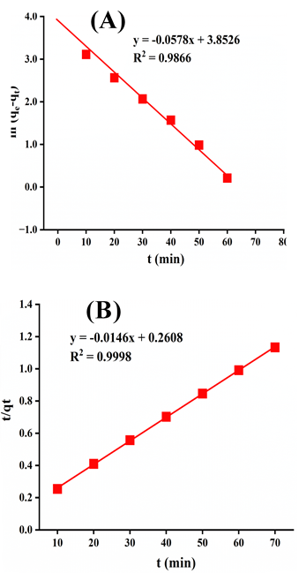
Figure S2: The graphs of kinetic models (A) pseudo first order plot and (B) pseudo second order plot

