Supplementary Materials

Supporting Information
The spatiotemporal variations of microbial community in relation to water quality in a tropical drinking water reservoir, southmost China

Di Wuª, Ying Zouª, Juan Xiaoª, Ling Mo^{b}, Sovan Lek ^{a,c} Zhiqiang Guo^{a*}, Qiongyao Fu^{d*}

ª School of Life Sciences, Key Laboratory of Tropical Biological Resources of Ministry of Education, State Key Laboratory of Marine Resource Utilization in South China Sea, Hainan University, Haikou, 570228, China.
^{b} Institute of Environmental Sciences, Hainan Province, 571126, China.
^{c} Laboratoire Evolution & Diversit´e Biologique, Universit´e Paul Sabatier, 118 route de Narbonne, Toulouse c´edex 4 31062, France
^{d} Key Laboratory of Tropical Translational Medicine of Ministry of Education, NHC Key Laboratory of Control of Tropical Diseases, School of Tropical Medicine, Hainan Medical University, Haikou, Hainan, 571199, China.

*Corresponding author: Zhiqiang Guo (e-mail: guozq@hainanu.edu.cn); Qiongyao Fu (e-mail: fuqy2020@163.com).

Contents of Supporting Information
Figure for ANOSIM of microbial abundances.............................................................Fig. S1
Figure for Lefse of microbial abundances at phylum level…....................................Fig. S2
Figure for Lefse of microbial abundances at genus level...........................................Fig. S3
Table for environmental factors..............................................................................Table S1
Table for correlation coefficient of RDA................................................................Table S2
Table for reliability and validity of PLS-SEM........................................................Table S3
Table for specific indirect effects of PLS-SEM......................................................Table S4

Fig. S1 The ANOSIM of spatiotemporal microbial abundances in Songtao Reservoir
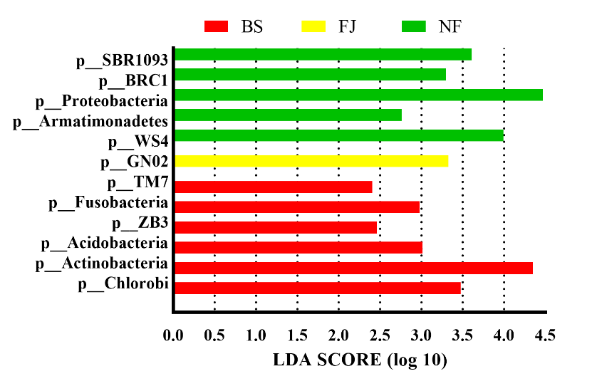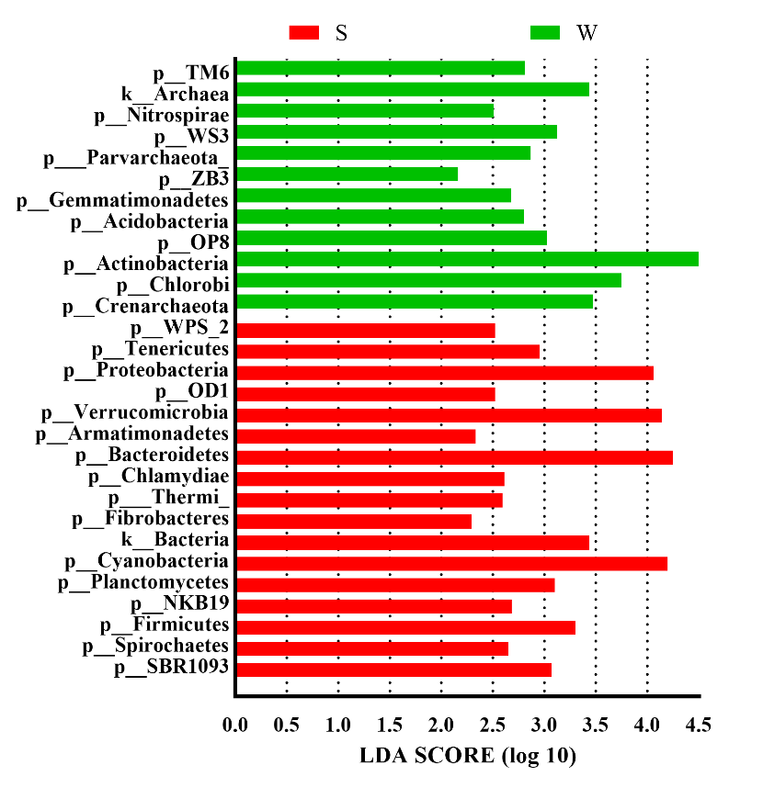
Fig. S2 Comparison of different spatiotemporal microbial abundances in Songtao Reservoir at phylum level (LDA Score > 2.0).

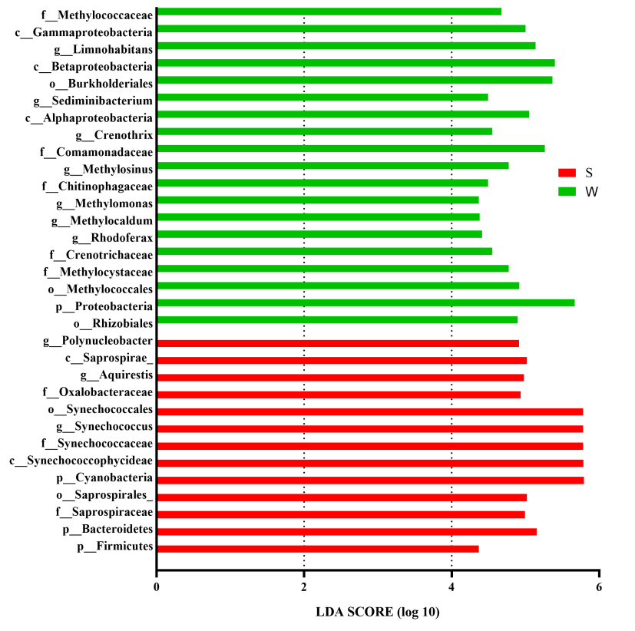
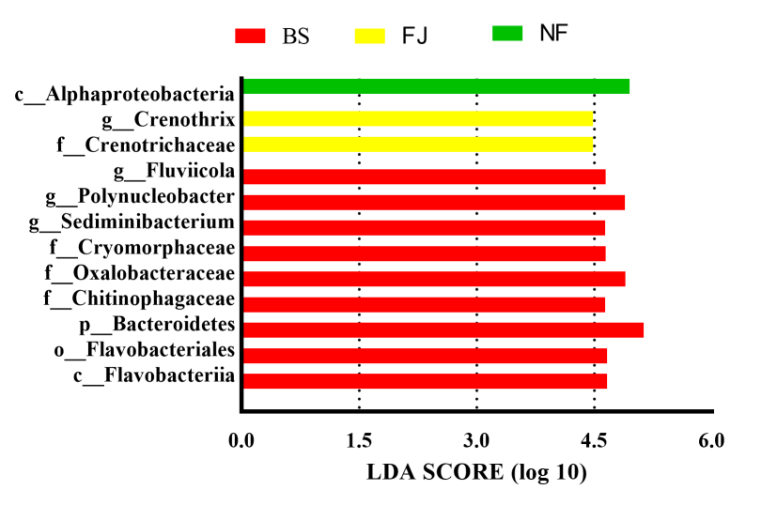
Fig. S3 Comparison of different spatiotemporal microbial abundances in Songtao Reservoir at genus level (LDA Score > 4.0).
Table S1
The results of environmental factors.
 | NF |  | FJ |  | BS
 | Summer | Winter | Summer | Winter | Summer | Winter
pH | 8.16-8.45 | 7.09-7.20 | 8.07-8.39 | 6.92-7.20 | 8.32-8.49 | 7.26-7.81
C  (mS cm⁻¹) | 82.4-99.6 | 72.0-74.8 | 86.7-89.0 | 66.7-70.8 | 113.1-151.6 | 77.6-81.8
DO  (mg L⁻¹) | 7.05-8.07 | 5.17-8.79 | 7.05-8.07 | 7.30-7.75 | 8.08-9.17 | 4.72-6.46
T (℃） | 31.4-32.3 | 22.1-22.6 | 32.1-32.7 | 21.5-22.9 | 32.1-33.1 | 22.2-23.5
TDS  (g L⁻¹） | 0.053-0.065 | 0.049-0.051 | 0.054-0.057 | 0.047-0.048 | 0.074-0.096 | 0.053-0.055
ORP (mV) | 81.0-133.8 | 178.9-225.4 | 85.5-189.5 | 170.0-234.1 | 120.1-140.0 | 112.0-146.6
Tur (NTU) | 2.54-2.80 | 2.02-2.86 | 2.04-2.78 | 1.69-2.81 | 3.29-8.37 | 2.34-3.52
TN  (mg L⁻¹) | 0.09-0.41 | 0.17-0.34 | 0.10-0.11 | 0.17-0.28 | 0.13-0.23 | 0.28-1.28
TP  (mg L⁻¹) | 0.006-0.015 | 0.023-0.036 | 0.006-0.011 | 0.035-0.041 | 0.013-0.032 | 0.041-0.045
COD  (mg L⁻¹) | 1.46-1.70 | 1.01-1.17 | 1.30-1.83 | 1.63-1.97 | 1.88-2.61 | 1.81-3.20
Cr  (μg L⁻¹) | 0.289-0.560 | 0.005-0.106 | 1.105-1.683 | 0.019-0.059 | 0.437-0.815 | 0.000-0.072
Mn  (μg L¹) | 6.558-6.666 | 56.402-119.208 | 9.055-11.328 | 31.940-197.475 | 5.080-21.280 | 5.203-126.595
Ni  (μg L⁻¹) | 1.307-1.504 | 0.306-0.367 | 1.441-2.229 | 0.211-0.260 | 1.712-1.869 | 0.226-0.478
Cu  (μg L¹) | 0.472-0.589 | - | 0.709-2.424 | - | 0.851-1.339 | -
Se  (μg L⁻¹) | 4.921-5.46 | 1.679-2.051 | 5.302-5.442 | 2.212-2.738 | 5.054-5.661 | 1.898-1.978
Cd  (μg L¹) | 0.005-0.023 | 0.001-0.018 | 0.010-0.016 | 0.001-0.002 | 0.008-0.010 | 0.001-0.004
Ba  (μg L⁻¹) | 11.751-56.560 | 34.473-60.160 | 55.153-63.570 | 60.545-71.664 | 13.892-58.373 | 43.175-54.821
Note: - denotes the values were under detection limiting.

Table S2
Correlation coefficient between environmental factors and microbial community.
 | RDA1 | RDA2 | r² | P values
Tem | -0.9135 | 0.4067 | 0.8107 | 0.001
DO | -0.9933 | -0.1160 | 0.3678 | 0.001
C | -0.5462 | 0.8377 | 0.3428 | 0.001
TDS | -0.4776 | 0.8786 | 0.3063 | 0.001
pH | -0.8567 | 0.5158 | 0.6723 | 0.001
ORP | 0.8244 | -0.5660 | 0.1413 | 0.002
Tur | -0.0987 | 0.9951 | 0.2583 | 0.001
TP | 1.0000 | -0.0101 | 0.7687 | 0.001
TN | 0.9949 | 0.1011 | 0.4070 | 0.001
Cr | -0.8669 | 0.4985 | 0.6084 | 0.001
Mn | 0.8496 | -0.5274 | 0.3502 | 0.001
Ni | -0.8931 | 0.4498 | 0.7267 | 0.001
Cu | -0.8474 | 0.5310 | 0.5388 | 0.001
Se | -0.9206 | 0.3905 | 0.8370 | 0.001
Cd | -0.9845 | -0.1755 | 0.3388 | 0.001
Ba | -0.5042 | 0.8636 | 0.1066 | 0.004

Table S3
The construct reliability and validity of PLS-SEM.

 | Cronbach's Alpha | rho_A | CR | AVE
Metals | 0.959 | 0.961 | 0.968 | 0.860
Nutrients | 0.550 | 0.958 | 0.758 | 0.655
Physicochemical factors | 0.928 | 0.956 | 0.947 | 0.818

Table S4
The specific indirect effects of PLS-SEM
 | path coefficients | P values
season - heavy metals - microbial | 0.863 | 0.000
season - physicochemical factors - microbial | -0.740 | 0.012
region - heavy metals - microbial | -0.182 | 0.000
region - nutrients - microbial | -0.104 | 0.030
season - nutrients - microbial | 0.218 | 0.018
region - physicochemical factors - microbial | -0.264 | 0.013

