Supplementary Information for:
Investigating the effect of a zeolitic imidazolate framework, ZIF-8, on the phase transition and thermal decomposition of ammonium nitrate
R. Kazemshoar-Duzduzani, A. Mousaviazar, K. Ghani, M. Jafari
Faculty of Applied sciences, Malek- Ashtar University of Technology, Shahin Shahr

Fig. S.1. DSC curves of AN/ZIF-8 mechanical mixing samples in mass ratios of a) 95:5, b) 90:10, and c) 85:15.
Fig. S.2. DSC curves of AN/ZIF-8 solvent mixing samples in mass ratios of A) 95:5, B) 90:10, and C) 85:15.
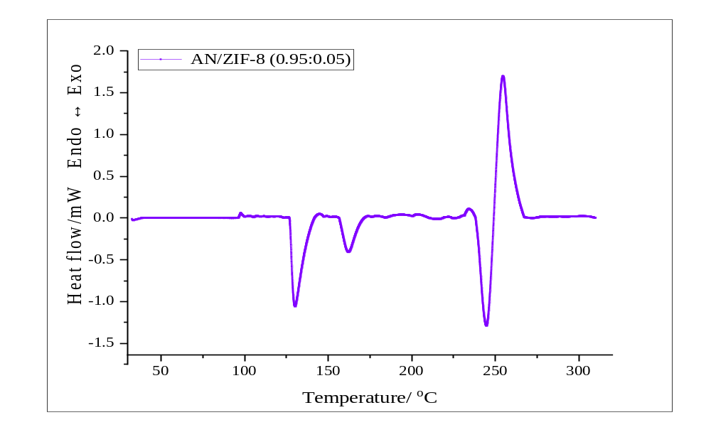
Fig.1A
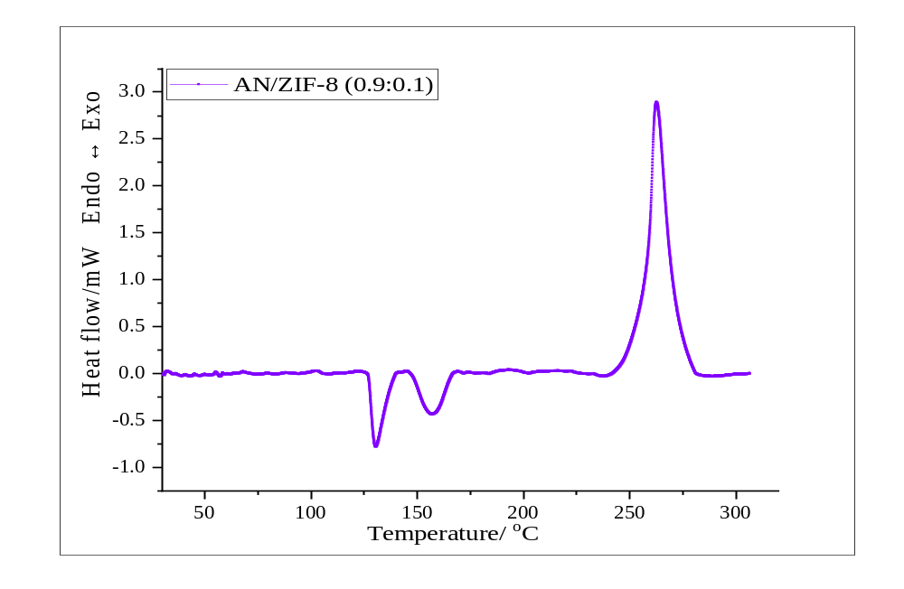
Fig.1B
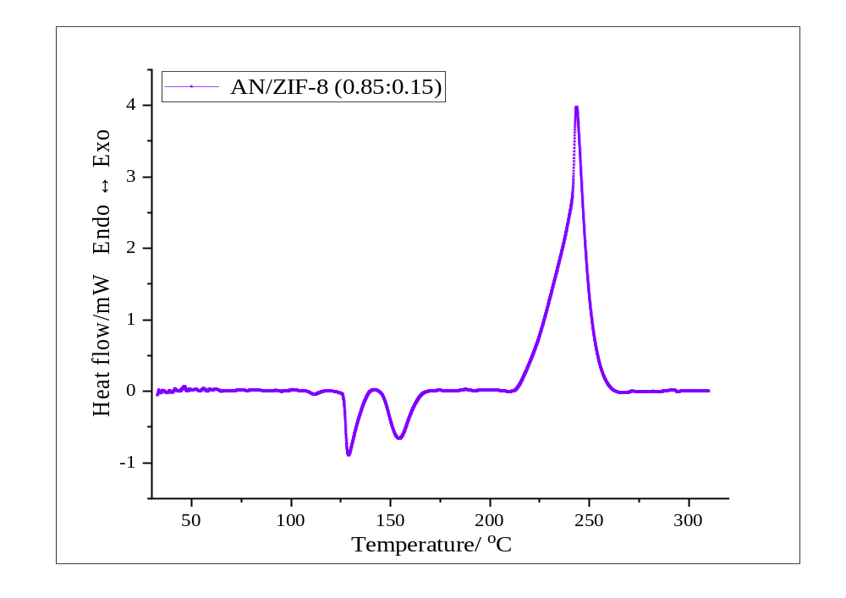
Fig.1C
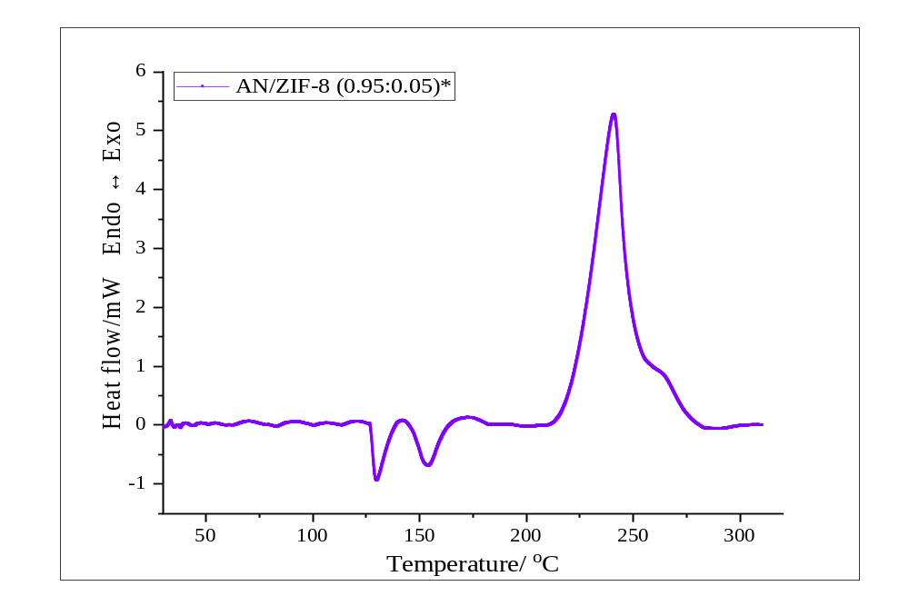
Fig.2A
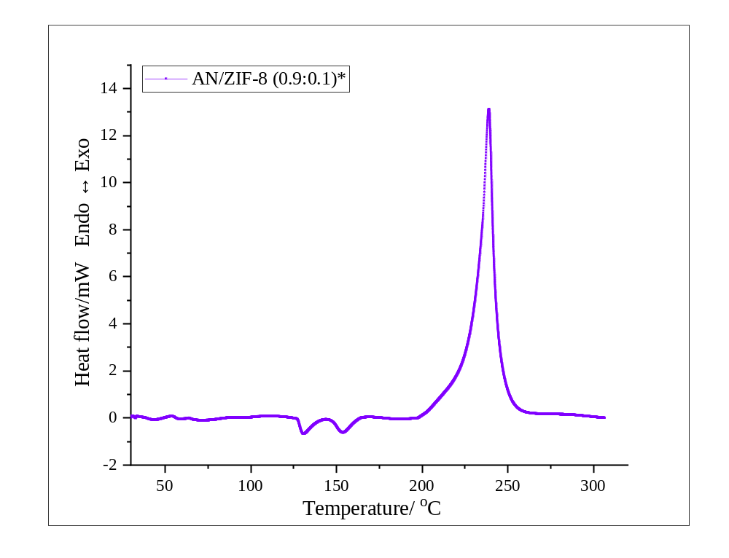
Fig.2B
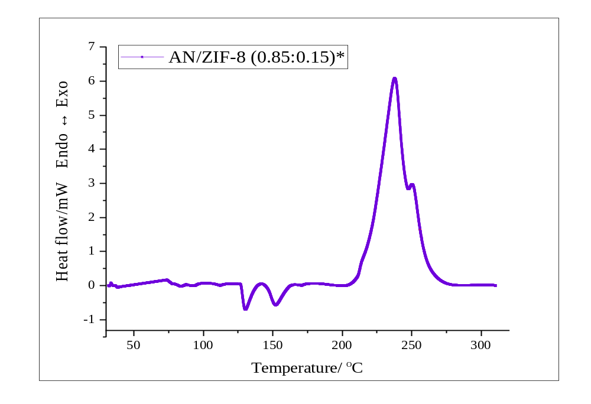
Fig.2C

