Supplemental Information

Akkermansia muciniphila may mediate the association between prenatal metal mixture exposure and childhood depressive symptoms

Kiran Nagdeo^{1#}, Vishal Midya^{1#}*, Jamil M. Lane¹, Libni A. Torres-Olascoaga², Gabriela Gil Martínez², Megan K. Horton¹, Chris Gennings¹, Martha Maria Téllez-Rojo², Robert O. Wright¹, Manish Arora¹, Shoshannah Eggers^{1,3}

^{1.} Department of Environmental Medicine and Public Health, Icahn School of Medicine at Mount Sinai, New York, New York, USA;
^{2.} Center for Research on Nutrition and Health, National Institute of Public Health, Cuernavaca, Mexico;
^{3.} Department of Epidemiology, University of Iowa College of Public Health, Iowa City, Iowa, USA

#Authors contributed equally *Corresponding author

Supplementary Table 1: Median (IQR) Concentrations (ug/L) of Prenatal Exposures to Metals in the second and third trimesters

 | Second Trimester | Third Trimester
Pb | 25.48 (21.33) | 27.72 (24.97)
As | 0.68 (0.25) | 0.70 (0.45)
Cd | 0.23 (0.16) | 0.22 (0.17)
Mn | 13.26 (6.23) | 17.77 (9.15)
Co | 0.18 (0.12) | 0.25 (0.20)
Zn | 5,928.96 (1,220.87) | 6,214.53 (1,139.77)
Cr | 0.45 (0.49) | 0.52 (0.41)
Cs | 2.71 (1.28) | 2.52 (0.99)
Cu | 1,515.92 (237.58) | 1,588.37 (263.31)
Sb | 3.57 (1.25) | 3.61 (1.59)
Se | 241.08 (35.20) | 239.02 (35.93)
lead (Pb), arsenic (As), cadmium (Cd), chromium (Cr), zinc (Zn), selenium (Se), antimony (Sb), copper (Cu), cesium (Cs), cobalt (Co), and manganese (Mn)

Supplementary Table 2: Median (IQR) Concentrations (ug/L) of Prenatal Exposures to Metals in the second and third trimesters by the presence of A. muciniphila

 | Second Trimester |  | Third Trimester
 | A. muciniphila  absent | A. muciniphila  present | A. muciniphila  absent | A. muciniphila  present
Pb | 27.49 (22.97) | 21.39 (13.85) | 30.35 (24.84) | 23.79 (18.86)
As | 0.70 (0.24) | 0.64 (0.37) | 0.70 (0.44) | 0.70 (0.60)
Cd | 0.23 (0.16) | 0.25 (0.14) | 0.21 (0.16) | 0.23 (0.17)
Mn | 13.42 (6.23) | 12.69 (5.31) | 17.60 (7.74) | 19.38 (10.09)
Co | 0.19 (0.11) | 0.14 (0.12) | 0.25 (0.18) | 0.24 (0.20)
Zn | 5,931.43 (1,285.40) | 5,909.98 (923.37) | 6,238.85 (1,195.80) | 6,190.04 (566.07)
Cr | 0.43 (0.51) | 0.48 (0.41) | 0.54 (0.39) | 0.49 (0.50)
Cs | 2.75 (1.26) | 2.38 (1.09) | 2.53 (1.15) | 2.51 (0.71)
Cu | 1,517.88 (234.43) | 1,513.96 (220.26) | 1,584.31 (253.11) | 1,603.42 (325.42)
Sb | 3.60 (1.19) | 3.06 (1.23) | 3.49 (1.59) | 3.86 (1.82)
Se | 242.33 (30.54) | 235.82 (42.55) | 239.51 (35.11) | 237.06 (37.81)
lead (Pb), arsenic (As), cadmium (Cd), chromium (Cr), zinc (Zn), selenium (Se), antimony (Sb), copper (Cu), cesium (Cs), cobalt (Co), and manganese (Mn)

s

Supplementary Figure 1:

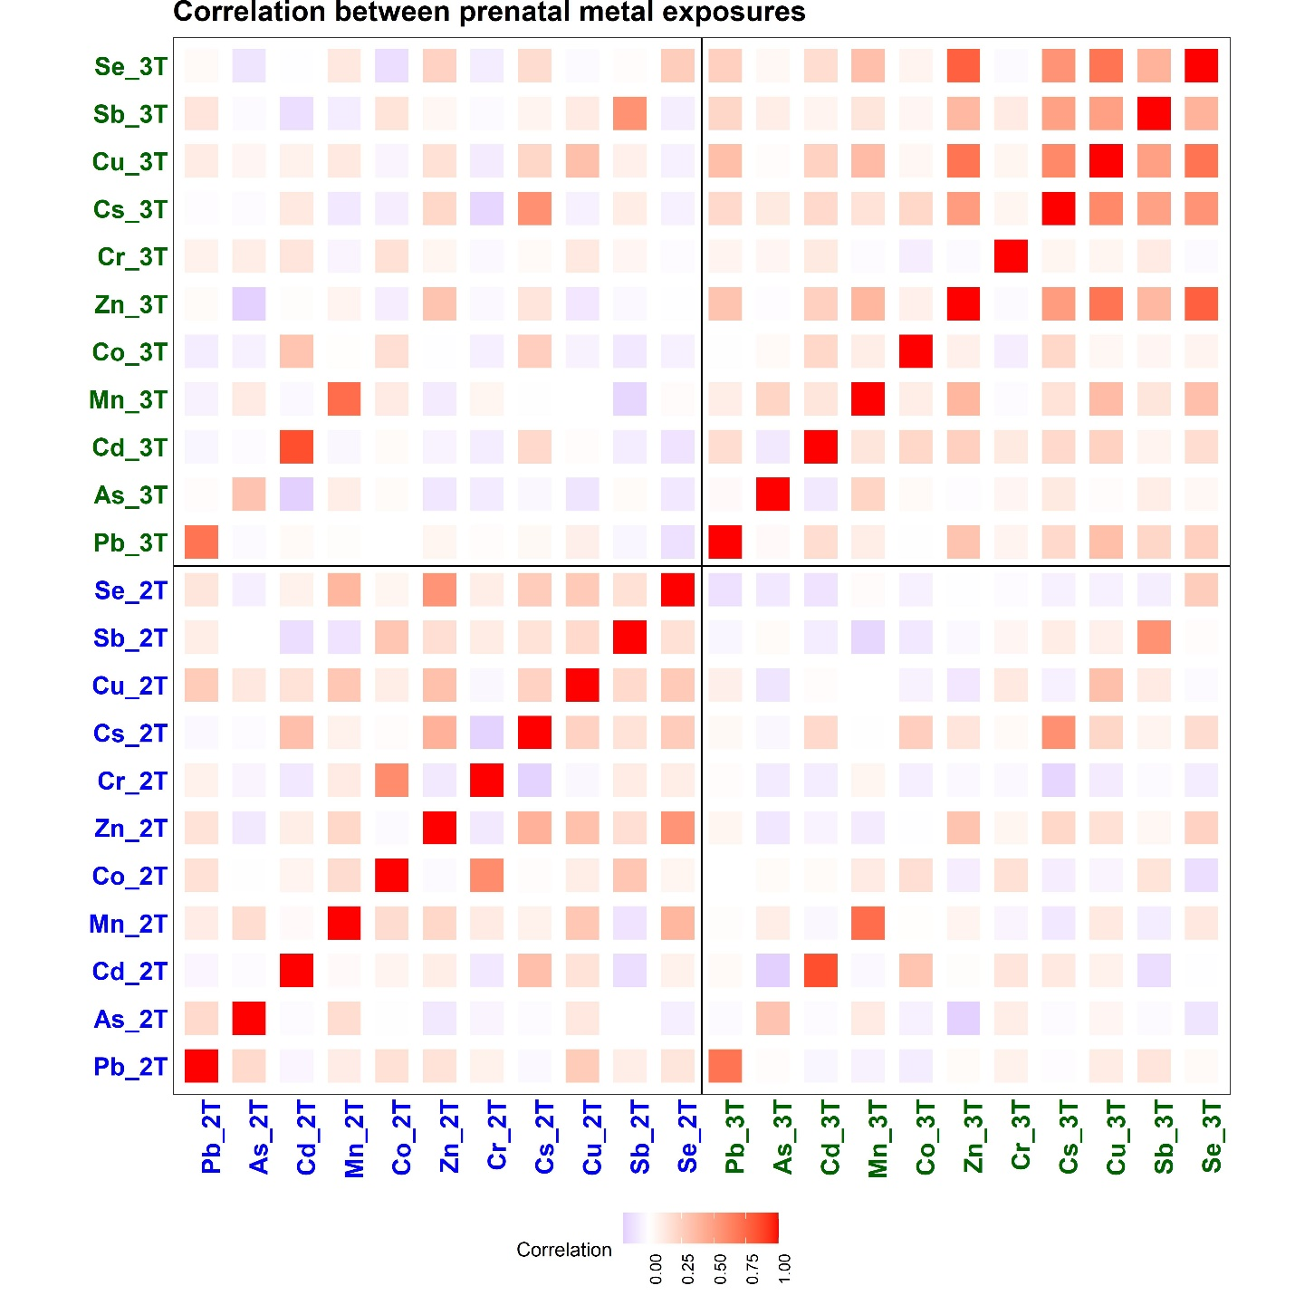Correlation between prenatal metal exposures at both second and third trimesters. "2T" implies metal exposures in the second trimester, whereas "3T" is in the third trimester. Lead (Pb), arsenic (As), cadmium (Cd), chromium (Cr), zinc (Zn), selenium (Se), antimony (Sb), copper (Cu), cesium (Cs), cobalt (Co), and manganese (Mn).

Supplementary Figure 2:

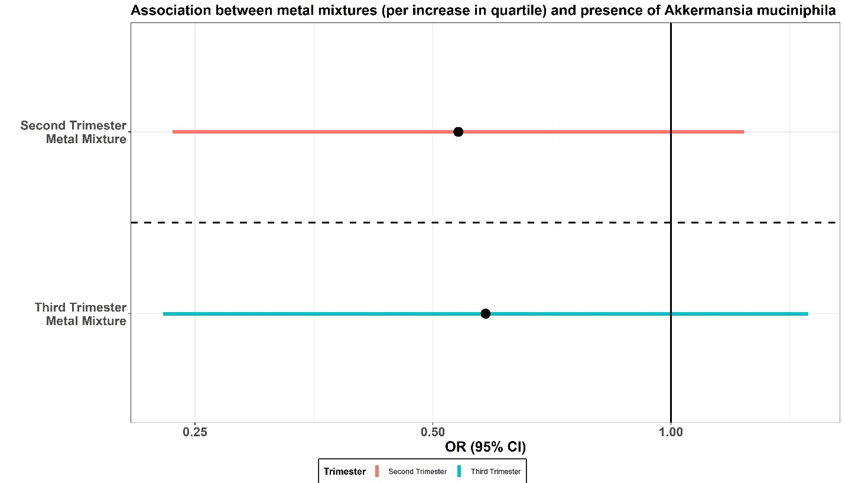Odds Ratio (OR) and 95% CI of the associations between metal mixtures (per quartile increase) and the presence of A. muciniphila at each trimester.

Supplementary Figure 3:

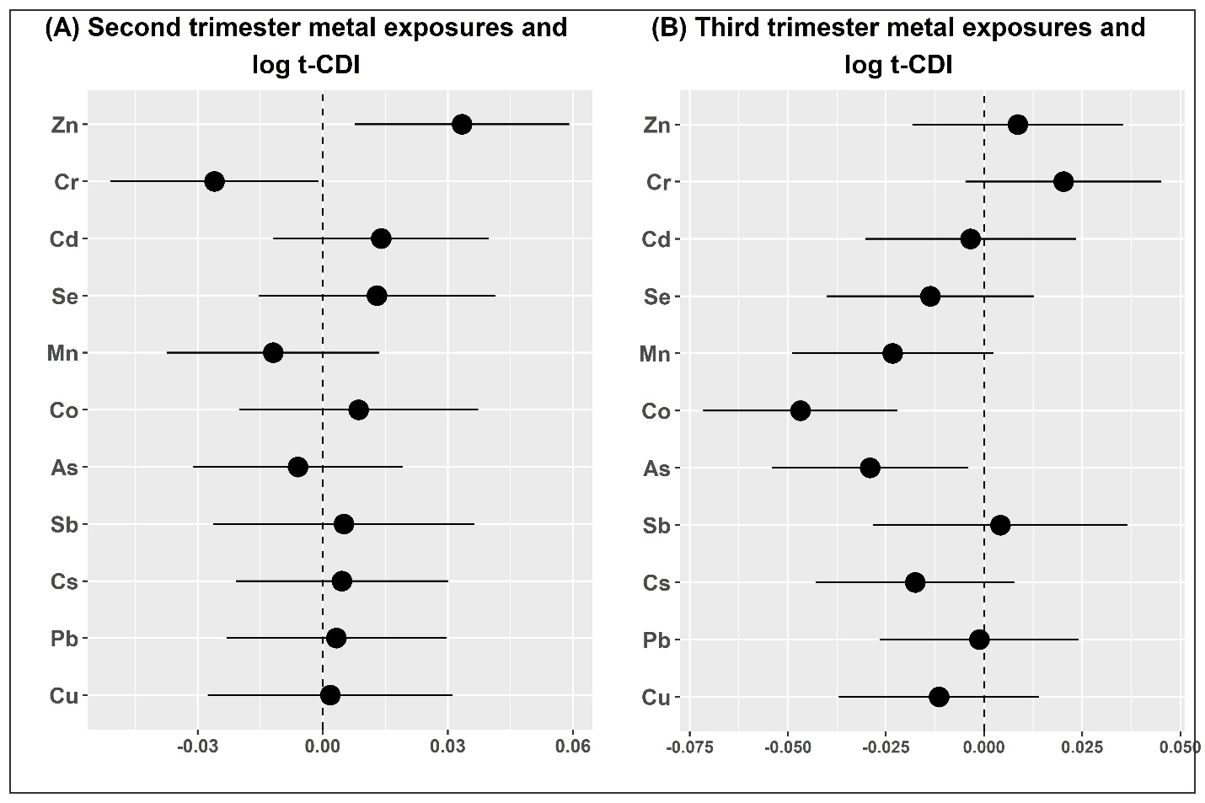
Associations between individual metal exposures (per quartile increase) and log t-CDI score for each trimester. Each model was adjusted by several additional covariates.

Supplementary Figure 4:

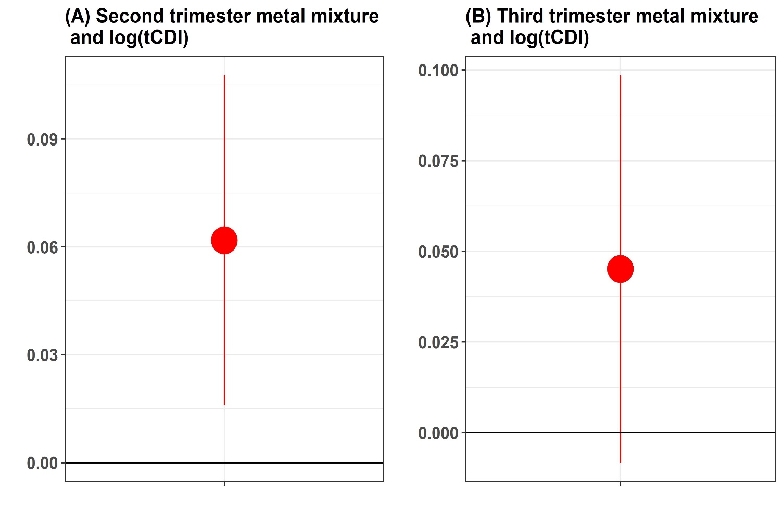Associations between metal mixtures at the trimesters and log tCDI on the non-covariate-balanced dataset

Supplementary Figure 5:

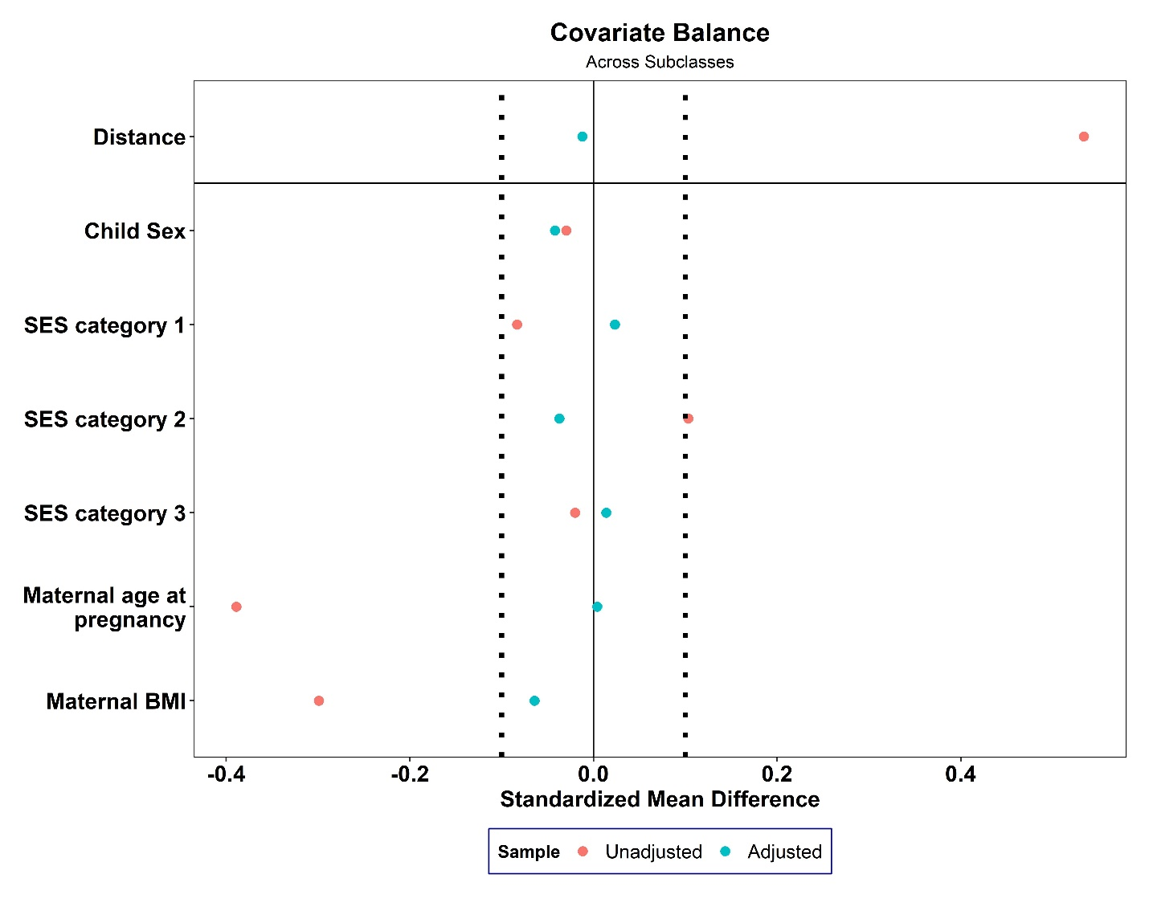Loveplot for covariate balancing using the subclass matching procedure

