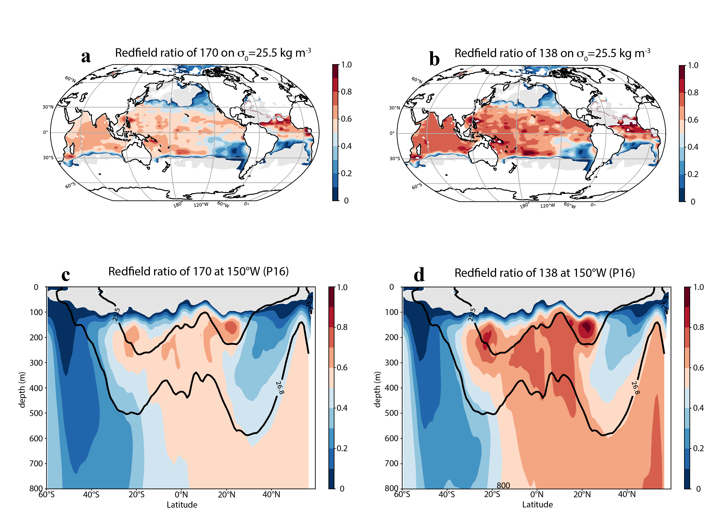

Extended Data Fig. 1. Sensitivity of regenerated fraction of PO₄³⁻ (PO4_regen) to choice of stochiometric ratio (O₂: PO₄³⁻). Value of (A) 170:1 at σ₀=25.5, (B) 138:1 at σ₀=25.5, (C) 170:1 at 150°W, and (D) 138:1 at 150°W. Values of 170 ³³ and 138 ³⁴ are chosen for comparison.

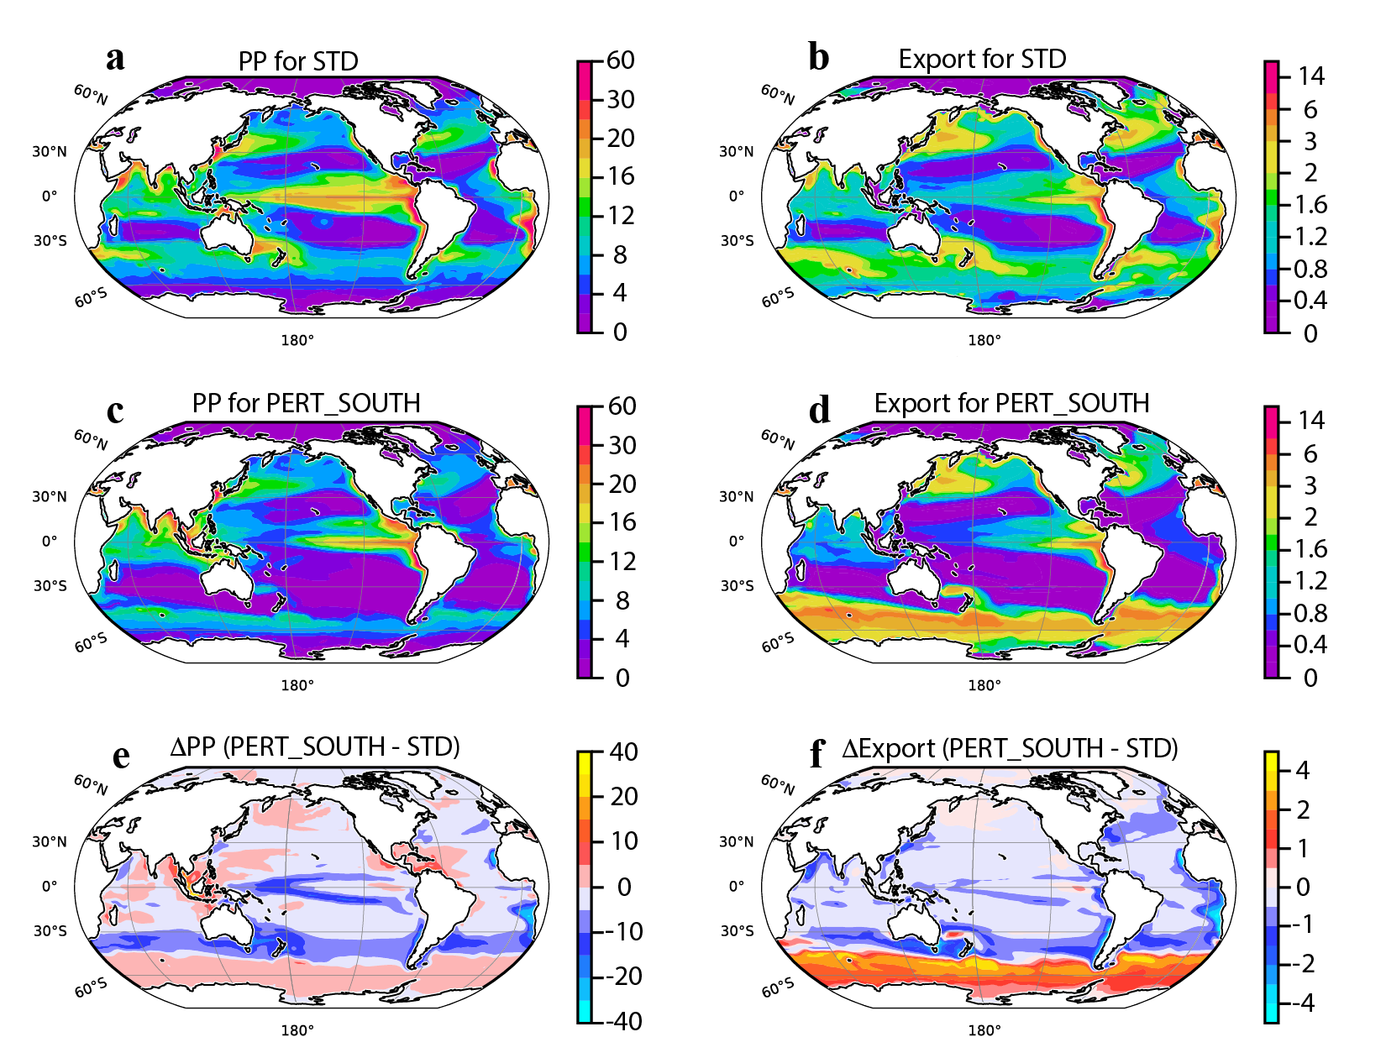

Extended Data Fig. 2. Model-derived sensitivity of primary production (PP) and export to suppression of nutrient regeneration over the Southern Ocean (90°S-30°S). PISCES-v2¹⁷ sensitivity for primary production (PP) and export to suppression of nutrient regeneration over the Southern Hemisphere extratropical domain 30°S-90°S, 150m-1500m. (A) Annual mean PP for control (STD) experiment, (B) annual mean export for STD experiment; (C) PP for PERT_SOUTH experiment; (D) Export for PERT_SOUTH experiment; (E) difference in PP between PERT_SOUTH and STD; (F) difference in export between PERT_SOUTH and STD. PP is considered for full-depth integrals, and export is considered at 150m. Units are in molesC m⁻² yr⁻¹.

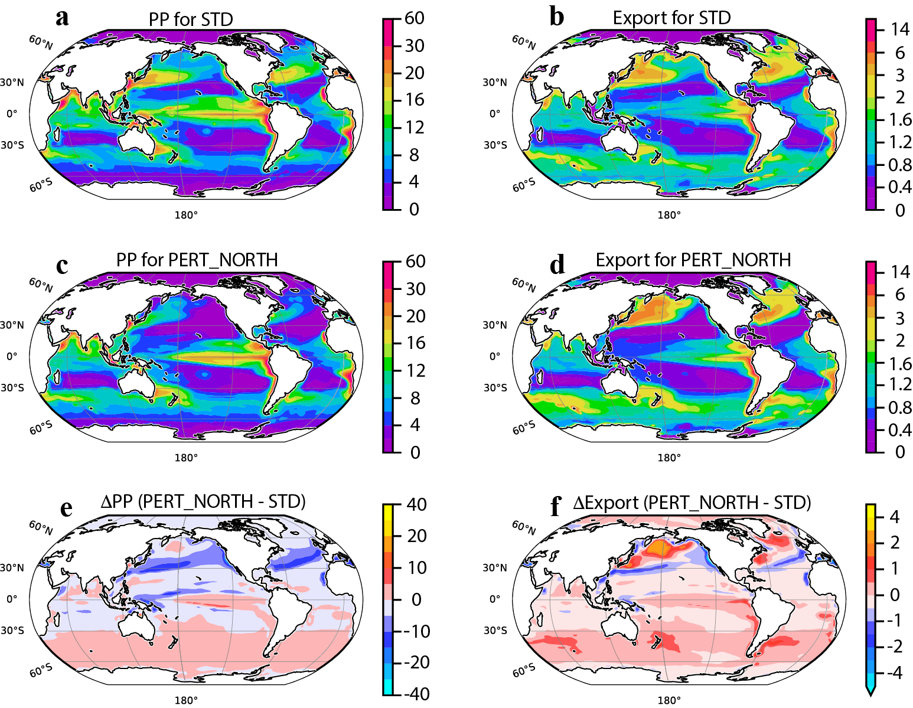

Extended Data Fig. 3. PISCES-v2 model-derived sensitivity of primary production (PP) and export to suppression of nutrient regeneration over the Northern Hemisphere extra-tropics (30°N-90°N). (A) Annual mean PP for control (STD) experiment, (B) annual mean export for STD experiment; (C) PP for PERT_NORTH experiment; (D) Export for PERT_NORTH experiment; (E) difference in PP between PERT_NORTH and STD; (F) difference in Export between PERT_NORTH and STD. PP is considered for full-depth integrals, and Export is considered at 150m. Units are in molesC m⁻² yr⁻¹.

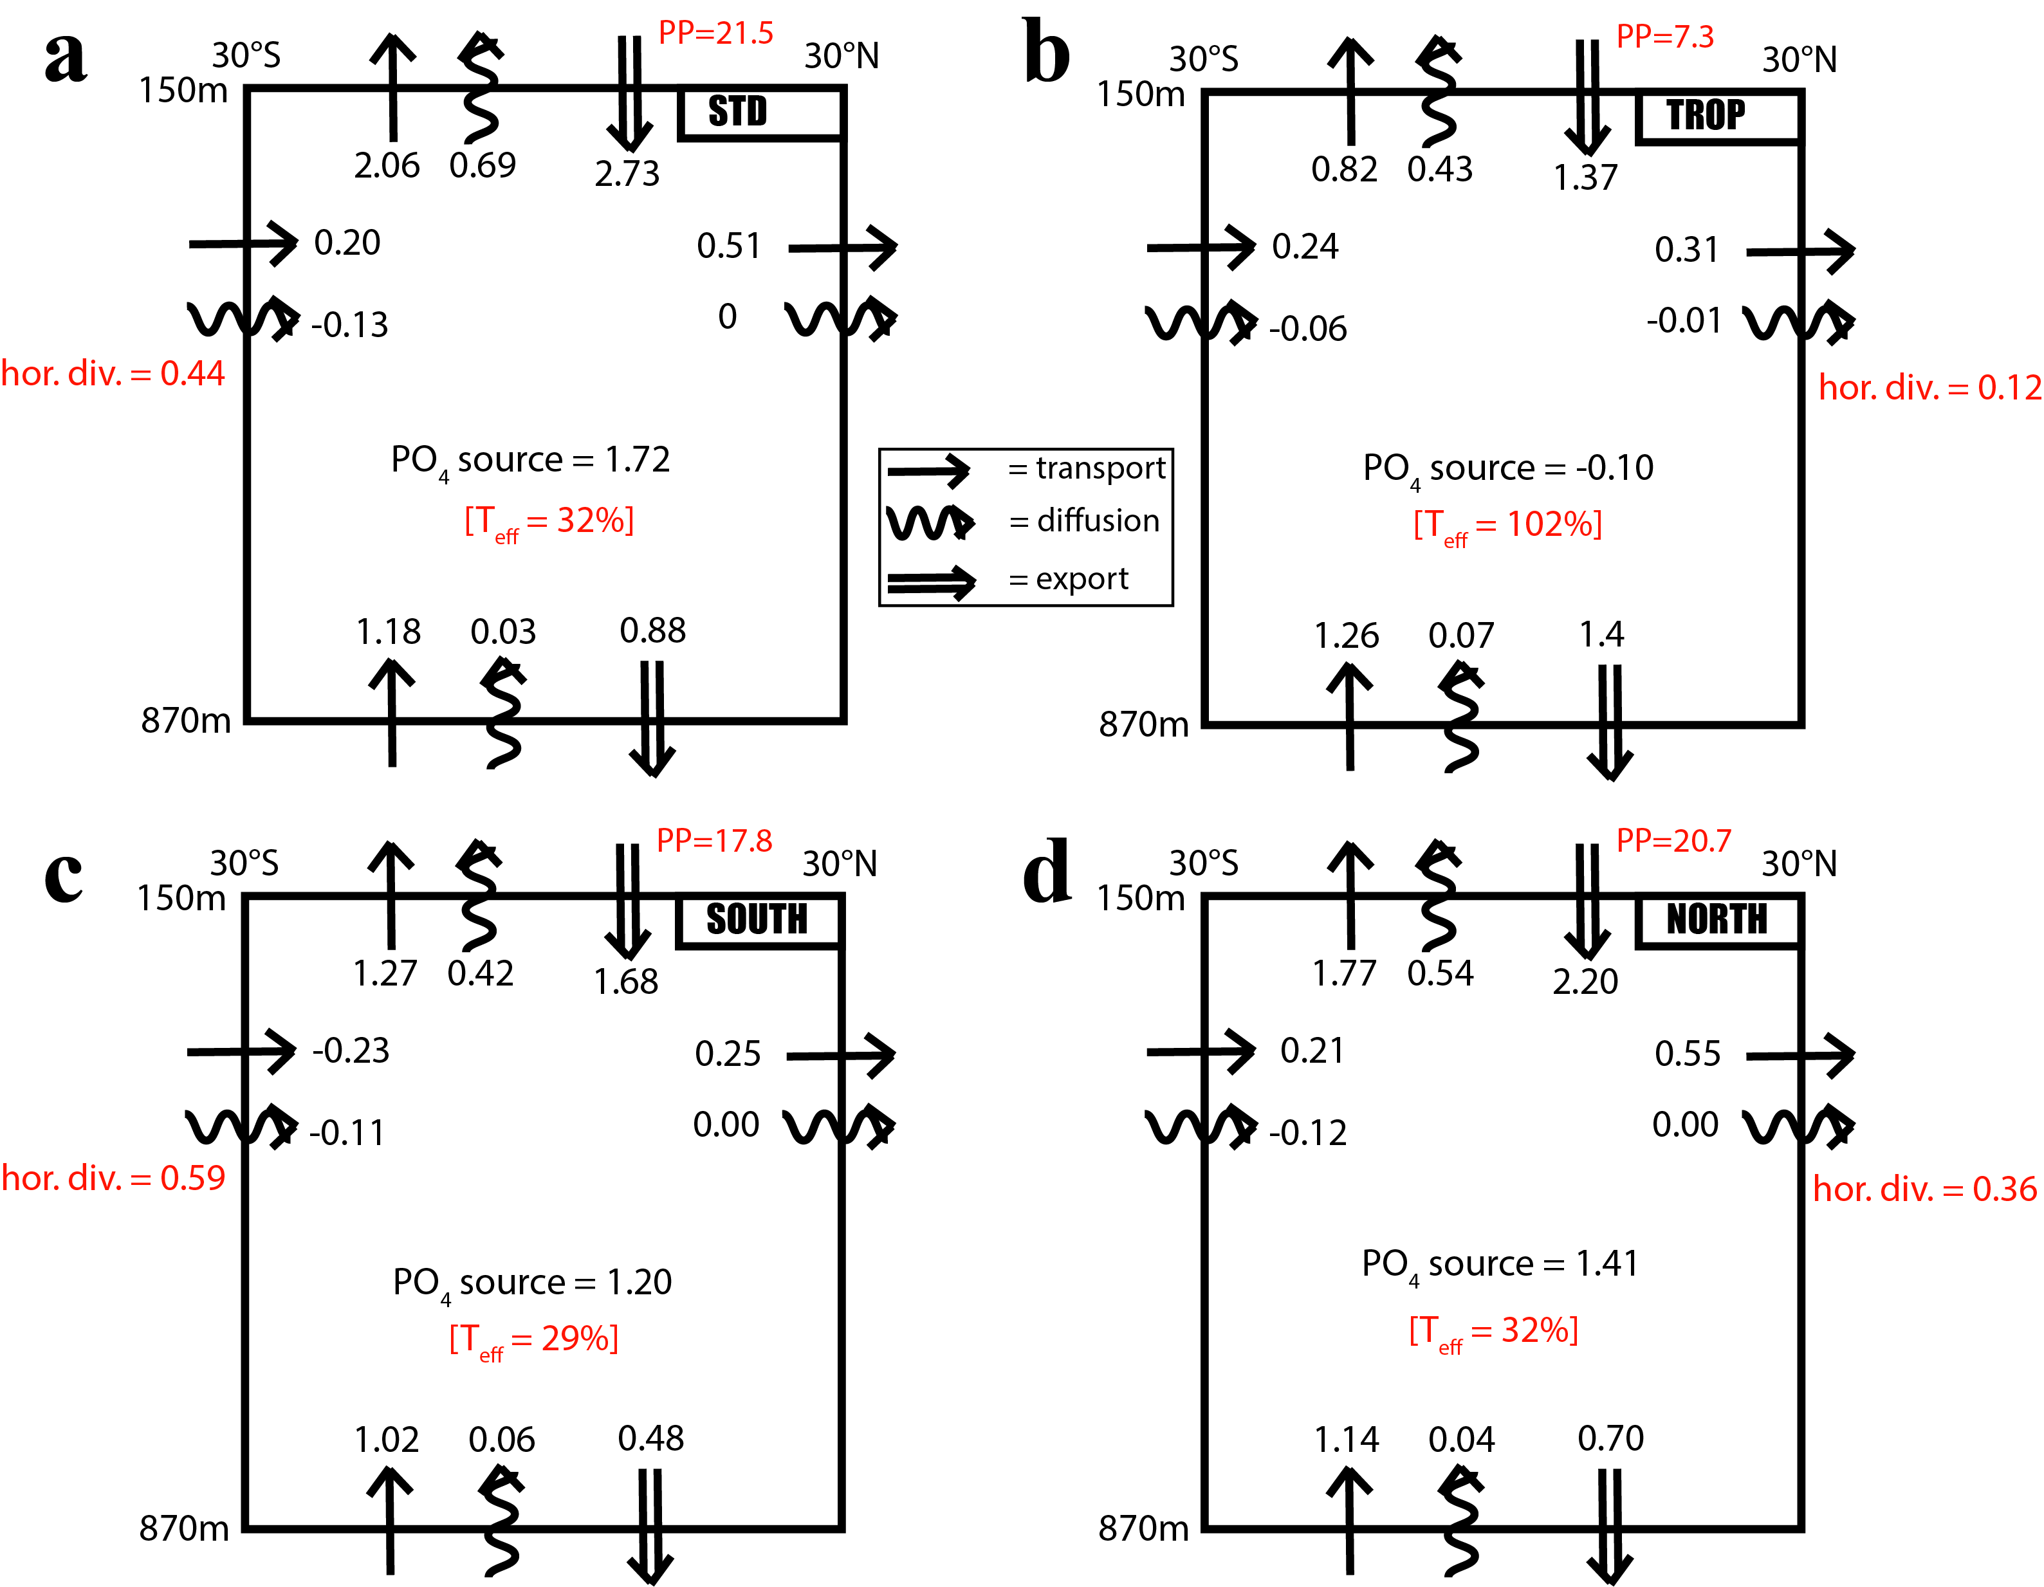

Extended Data Fig. 4. Coarse-grained view of modeled PO₄³⁻ fluxes about the low-latitude mesopelagic domain (LLMD). Fluxes are shown from the PISCES-v2¹⁷ model simulations. The boundary fluxes and interior sources of PO₄³⁻ for the domain bounded by 30°S-30°N and 150m-870m for (A) STD, (B) PERT_TROP, (C) PERT_SOUTH, and (D) PERT_NORTH. The domain for each case is the same as that used in Fig. 3. The lateral exchanges for each case represent net fluxes, and thereby account for the effects of gyre recirculation across 30°S and 30°N. Shown in red are the transfer efficiency, defined as the ratio of export flux across 870m to the export flux across 150m, the net horizontal divergence from the domain, and PP in units of PgCyr⁻¹. Fluxes are for PO₄³⁻, but shown in carbon units of PgC yr⁻¹ to be consistent with units typically used for export and the biological pump.

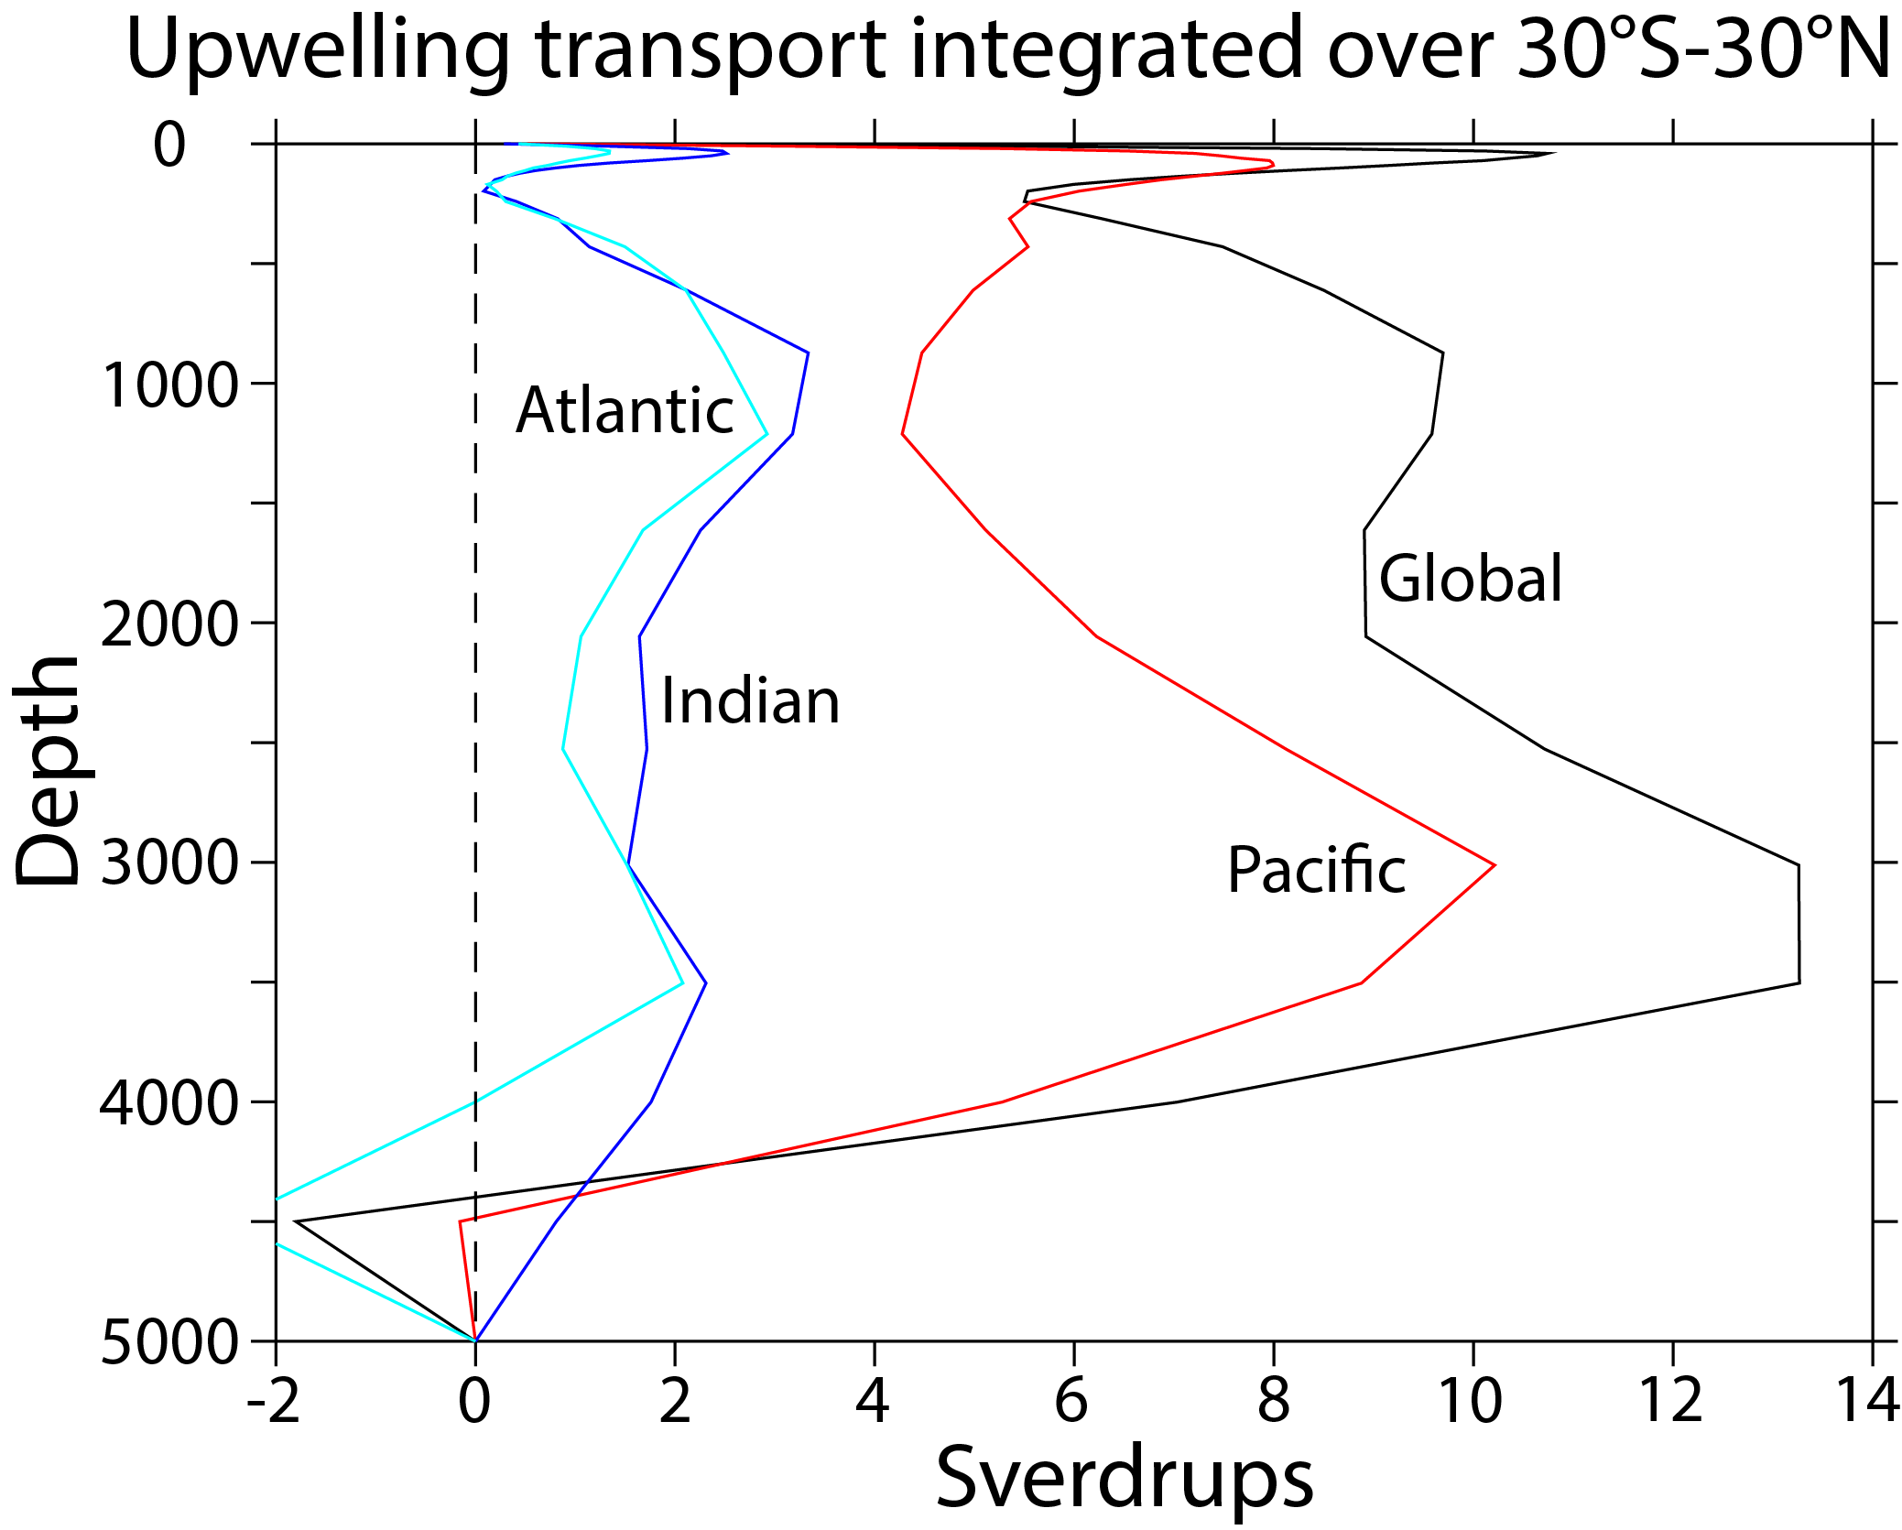

Extended Data Fig. 5. Upwelling transports within the low latitudes (30°S-30°N) for NEMO in units of Sverdrups (10⁶ m³ s⁻¹). Results are shown for the global ocean domain (black), the Pacific (red), the Indian (blue), and the Atlantic (light blue).

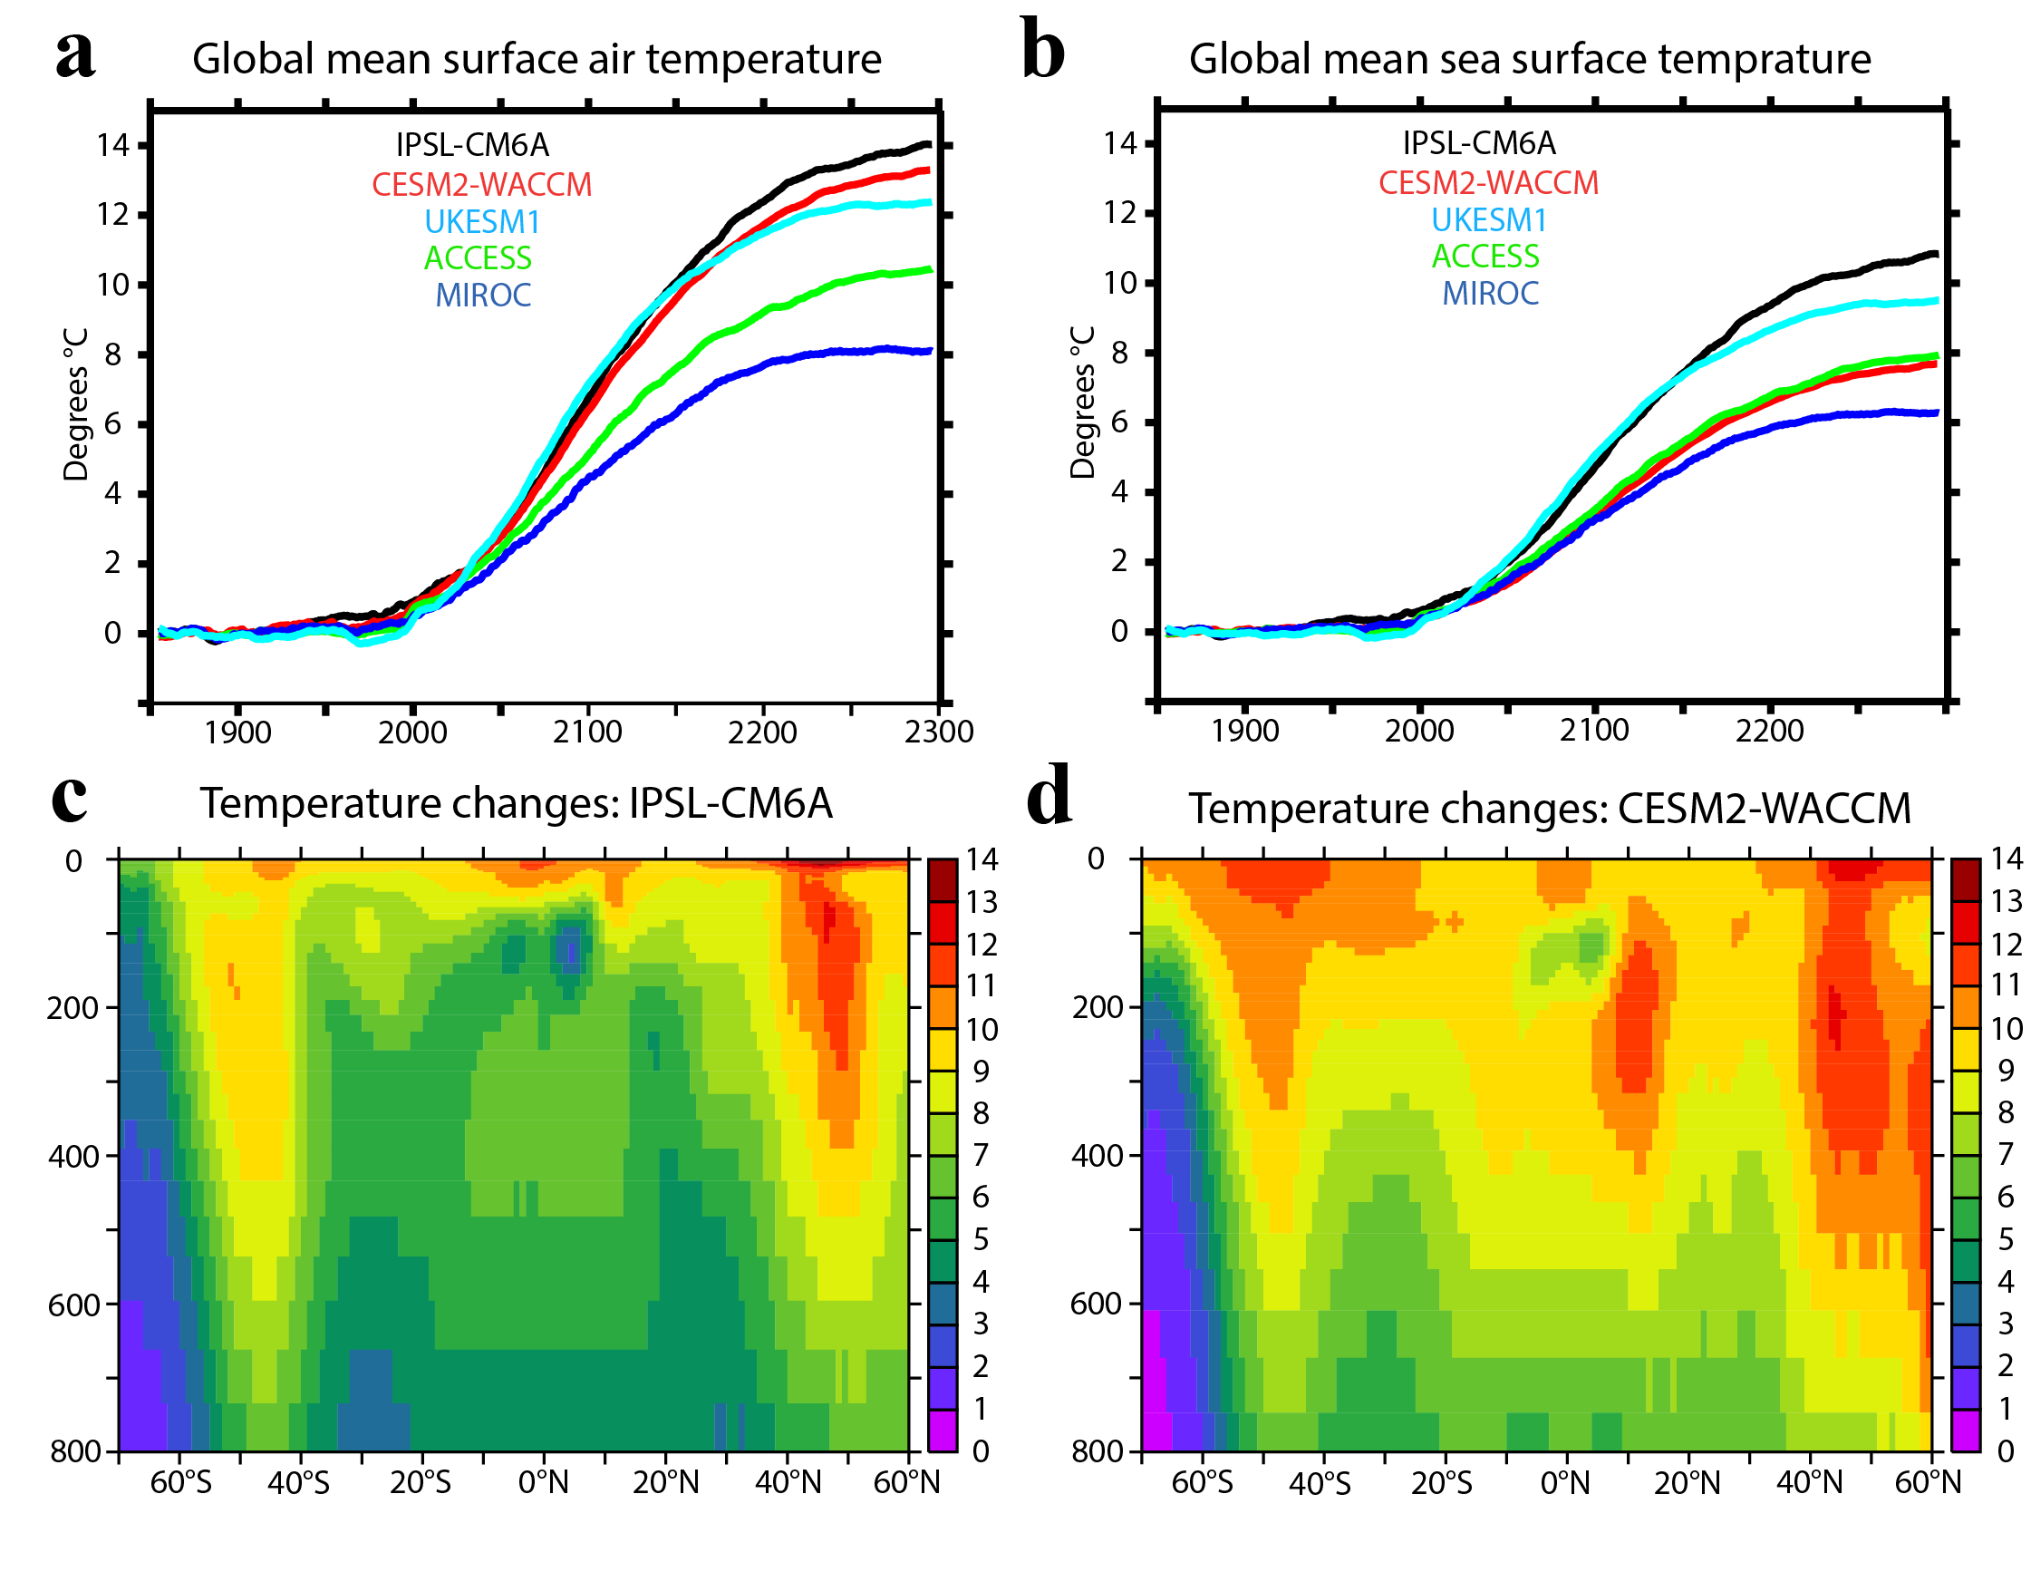

Extended Data Fig. 6. Transients in thermal state of CMIP6 models under extended simulations to 2300. Evolution of changes in temperature relative to the respective 1850-1899 mean for (A) globally-averaged 2m air temperature, and (B) globally-averaged sea surface temperature for five CMIP6 models: [IPSL-CM6A³⁵, CESM2-WACCM²³, UKESM1²⁴, ACCESS-ESM1.5³⁶, and MIROC-ES2L³⁷] run to 2300 under historical/SSP5-8.5 forcing²⁷.Changes in zonally averaged potential temperature between a 1990s climatology and a 2290s climatology for two of the models: (C) IPSL-CM6A and (D) CESM2-WACCM.

IPSL_CM6A | EPC_150m | EPC_870m | Transfer Efficiency | Accumulation
1890s | 2.98 | 0.80 | 27% | 2.18
1990s | 2.92 (-2%) | 0.77 (-4%) | 26% | 2.14 (-1%)
2090s | 2.78 (-7%) | 0.68 (-16%) | 24% | 2.10 (+3%)
2190s | 2.94 (-1%) | 0.67 (-16%) | 23% | 2.27 (+4%)
2290s | 3.00 (+0.3%) | 0.63 (-21%) | 21% | 2.36 (+8%)

Extended Data Table 1: Centennial-timescale changes in thermocline retention of carbon by the thermocline, identified using changes using reference depths of 150m and 870m, and integrated over 30°S-30°N for IPSL-CM6A²² under historical/SSP5-8.5 forcing ²⁷ (see Fig. 4c). Transfer efficiency is defined as the EPC_870m/EPC_150m, reflecting the efficiency with which the biological pump transits the depth range 100m-600m. Accumulation rate is the difference EPC_150m-EPC_870m. Fluxes are for carbon in carbon units (Pg C yr⁻¹). For the second, third, and fifth columns, percentages shown in parentheses represent temporal changes relative to the 1890s.

CESM2-WACCM | EPC_150m | EPC_780m | Transfer Efficiency | Accumulation
1890s | 3.14 | 0.920 | 29% | 2.22
1990s | 3.12 (-2%) | 0.913 (-1%) | 29% | 2.21 (-1%)
2090s | 2.90 (-8%) | 0.929 (+1%) | 32% | 1.97 (-11%)
2190s | 2.23 (-29%) | 0.736 (-20%) | 33% | 1.50 (-33%)
2290s | 1.96 (-38%) | 0.657 (-29%) | 34% | 1.30 (-42%)

Extended Data Table 2: Centennial-timescale changes integrated over 30°S-30°N for CESM2-WACCM (Danabasoglu et al., 2020) under historical/SSP5-8.5 forcing (Meinshausen et al., 2020) (see Fig. 4d).

