Supplementary methods:
Daily weather data from 1980 to 2020 were acquired from the China Meteorological Data Sharing Service System (http://data.cma.cn/), including daily average temperatures, sunshine hours, and precipitation. Subsequently, the average temperature, sunshine hours, and rainfall during the growing season were calculated (October to May for winter wheat and March to September for spring wheat, respectively). The inverse distance weighted interpolation method was used to determine the specific site weather data in ArcGIS software (ESRI, Redlands, CA, USA). The soil data were mainly derived from the collected literature, supplemented by the Dataset of Soil Basic Nutrients for Soil Testing and Fertilization to fill the missing county data, which were compiled by the National Agro-Tech Extension and Service Center (https://www.natesc.org.cn). Farmers’ attention represented by farmers’ income per capita was extracted from the provincial statistical yearbooks of 2018 (http://www.cnki.net/). These environmental conditions can interact to influence the results of optimal N strategies and were grouped into several levels to identify the potential interaction effects. The classification standards for soil data are based on the Soil Census Technology in China, compiled by the National Soil Census Office¹. Similarly, weather data and farmers’ income per capita were primarily graded according to the distribution of the collected data. Detailed information and the grading result can be found in Table S5.

Supplementary discussion:
Regional nitrogen rates and nitrogen management based on multi-objectives
Enhancing nitrogen (N) management from a single aspect (S1, optimizing a single sustainable objective) is unfavorable to drawing comprehensive conclusions and regional strategy development. In this study, optimal N application rates were investigated using threshold and linear models according to the priorities of wheat subregions in China, granting local governments and farmers the flexibility to adjust N. The North China Plain (NCP) wheat systems exhibit greater room for reducing N fertilizer, given that yield has reached 70% of yield potential². In contrast, achieving grain production should be prioritized in the Yangtze River (YR) and Southwest (SW) wheat systems with lower yields, where yield levels are comparatively lower. In the Northwest (NW) wheat system, equal importance is placed on food production and sustainability³, which is strongly demonstrated in this study. The N optimal rates obtained from the S2 (optimizing multiple sustainable objectives) or S3 (simultaneously optimizing multiple sustainable objectives) scenarios are comparable to previous studies⁴ (Figure S12). Lower N rates were recommended in the Northeast (NE) wheat system due to the fertile soils. Furthermore, NCP and YR are characterized by warm and rainy climates and high soil fertility, which are favorable for wheat growth and N uptake⁵ (Figure 5). Thus, wheat growth exhibits greater vigor with a higher N demand, resulting in higher optimal N rates⁶. In comparison, the relatively unfavorable natural environmental conditions in NW and SW wheat systems, (i.e., acidic soils, cold climate, and low rainfall), are detrimental to wheat production. From the perspective of agricultural interventions, farm management, and soil improvement are regulated factors by farmers. Here, soil quality is defined as the inherent soil productivity that supports crop production and provides a variety of ecological services⁷. Previous studies found that smallholder fields in Africa, characterized by diverse soil quality, show varying responses to nutrient inputs, aligning with the findings of this study^{8,9}. Another explanation for higher optimal N rates in the YR and NCP wheat systems is that crops growing on high-quality soil have a higher yield potential, necessitating increased nutrient inputs⁷ (Figure S10). Implicitly, the enhancement of soil quality and optimization of N application have interactive effects on crop productivity. However, no significant yield increase was observed in degraded soils, despite the additional nutrient inputs. Such spatially explicit quantification plays an important role in assessing agricultural interventions in maximizing benefits. It is of great significance to improve the N management practices. It has to be acknowledged that multi-objective N optimization marked a major advance in N management. However, managers must be aware of associated risks when applying this approach across such a large geographic area.

Economic subsidies to incentivize farmers
The majority of Chinese farmers are comprised of old and part-time farmers with relatively low education levels, with over 80% male^{10,11}. Adopting multi-objective optimization strategies is an unattractive option for smallholders due to the risks of yield reduction and expensive fertilizer costs. However, achieving this is attainable as China has successfully incentivized farmers at the provincial and county levels¹², which could effectively alleviate farmers’ concerns. Recently, domestic wheat subsidies have increased significantly from 0.58 yuan/mu in 2003 to 47.69 yuan/mu in 2008, as China decided to change its prolonged policy of taxing farmers and moving toward the tax subsidy path adopted by developing countries in 2004¹³. The cumulative grain subsidies and input subsidies in Liaoning Province reached 543 yuan/household in 2008¹³, which could effectively mitigate the economic deficits in the NE subregion (Figure 6). This study evaluates the economic and environmental benefits associated with optimal nitrogen threshold (ON) and sustainable nitrogen rate (SN) strategies. As depicted in Figure 4, the environmental benefits outweigh the economic benefits, but the slight reduction in economic gains can be compensated for smallholder farmers through policy subsidies. Furthermore, it is evident that in the Lose-Win quadrant, a negative economic gain is associated with a yield loss. However, this study does not provide a detailed explanation of the trade-offs between economic and environmental benefits in different regions, and addressing these potential trade-offs can assist guide policymakers to make informed choices.

Drivers of optimal N application
All drivers were categorized based on their attributes into 2 groups: biophysical environmental factors (growing season average temperature (GAT), growing season precipitation (GP), soil pH, growing season sunshine hours (GS), total nitrogen (TN), and soil organic matter (SOM), and socioeconomic factors (farmers’ income per capita). Weather and soil are fundamental biophysical environmental factors that shape the primary characteristics of farmland¹⁴. It is challenging to investigate the interactions between soil and climate on crop production on regional and global scales, as these factors are highly heterogeneous⁷. Soils, especially pH and TN, are the dominant factors affecting optimal N application since pH affects the rate of SOM decomposition¹⁵ and soil quality and nutrient release and availability. Additionally, lower pH could induce the release of metal ions such as aluminum and manganese, while higher pH leads to calcium and magnesium cations deficiencies¹⁶, affecting the crop’s N demand. GAT was ranked in front of affecting the change of yield, probably because temperature changes are more pronounced in winter and spring than in summer and autumn^{17,18}. Identifying the optimal temperature range (9-11℃ for NW, YR, and SW wheat systems) is imperative for yield increase, as excessive heat, drought or low temperatures tend to cause stomatal closure or slow microbial activity¹⁹. Moreover, the yield increase was more pronounced in regions with ample rainfall, such as YR and SW wheat systems⁵. Soils have the potential to regulate the impacts of climate variability on crop productivity⁷. However, the mechanisms are very complex and fall outside the scope of this study. From a human activity standpoint, the high farmer’ income per capita in inland areas contributes more to yield increase, attributable to the increased purchasing power resulting from economic development²⁰. On the contrary, coastal areas belonged to economically developed areas and a majority of farmers were reluctant to invest much effort in farming, opting instead for employment in urban areas.

Limitations and prospects
This study provides a more detailed framework for N management. However, progress from strategy development to implementation has been slow. It is important to coordinate the relationships between national policymakers, scientists, and smallholder farmers to achieve Sustainable Development Goals, especially in China. Government departments should strengthen collaboration between different sectors to propose spatially prioritized development areas. Accordingly, our study aims to provide information necessary for potential solutions for sustainable agricultural systems. Scientists serve as a bridge to enhance the profitability of farmers’ production in response to the national call. They should explore operational and scientific methods or strategies. In practice, there is often a lack of understanding between scientists and smallholders, resulting in a lack of interest among smallholders to collaborate with scientists²¹. Furthermore, the factors examined in this study, including N utilization efficiency, N surplus, and human health costs, exceed the decision-making capacity of smallholder farmers. Therefore, this study advocates collaborative efforts between scientists and farmers to implement research programs^{22,23}, achieving the leap from tightly controlled management conditions to actual production. The implementation of technical training and knowledge dissemination to farmers can be considered, as 50-55% of top producers are familiar with networking and administrative activities¹⁰, which may increase their interest in participating. Combining the strategies recommended in this study with the Science and Technology Backyard^{22,24} will significantly contribute to the achievement of sustainable development goals in the country. In addition to fertilizer management, sustainable agriculture includes a wider range of practices beyond fertilizer management such as soil health, water management, crop diversification, integrated pest management²⁵, malnutrition, and unemployment. Further optimization of these aspects is warranted in future research.

Supplementary figures
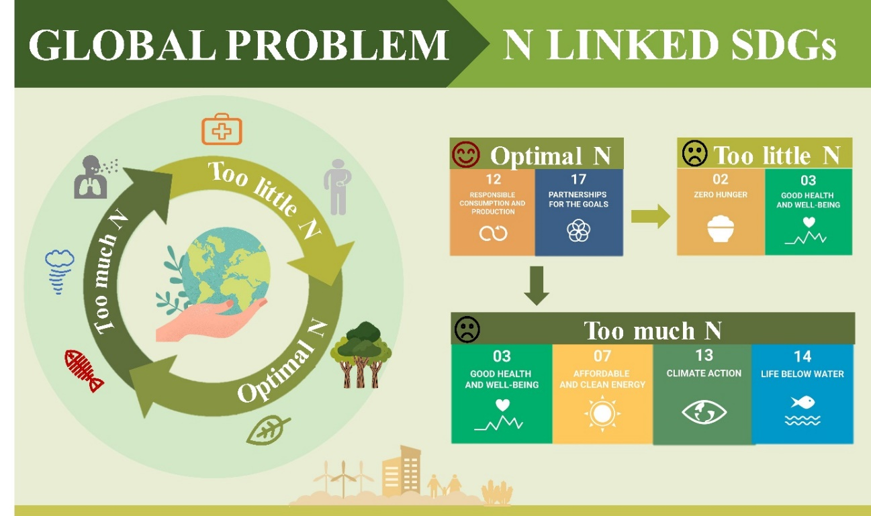
Figure S1 The effect of nitrogen (N) fertilizer on the Sustainable Development Goals (SDGs). “” and “” represent the positive and negative effects, respectively. Note: the figure was adapted from Wang et al.²⁶.
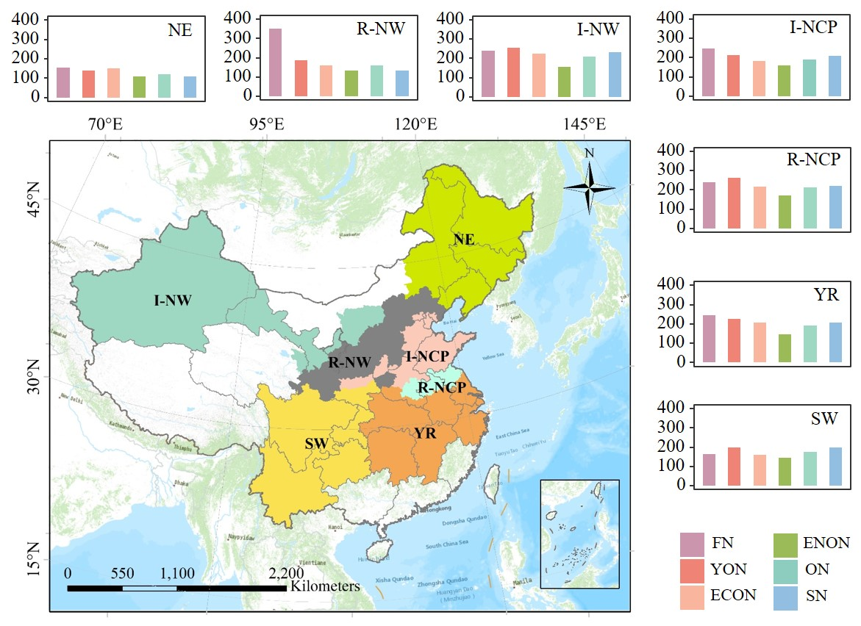
Figure S2 Comparison of different nitrogen (N) rates in subregions. Wheat systems were classified into seven ecological zones⁴. NE: Northeast; R-NW: Rainfed Northwest; I-NW: Irrigated Northwest; I-NCP: Irrigated North China Plain; R-NCP: Rainfed North China Plain; YR: Yangtze River; SW: Southwest. FN: farmers’ N rate; YON, yield optimal nitrogen rate; ECON, economic optimal nitrogen rate; ENON, environment optimal nitrogen rate; ON, optimal nitrogen threshold; and SN, sustainable nitrogen rate.
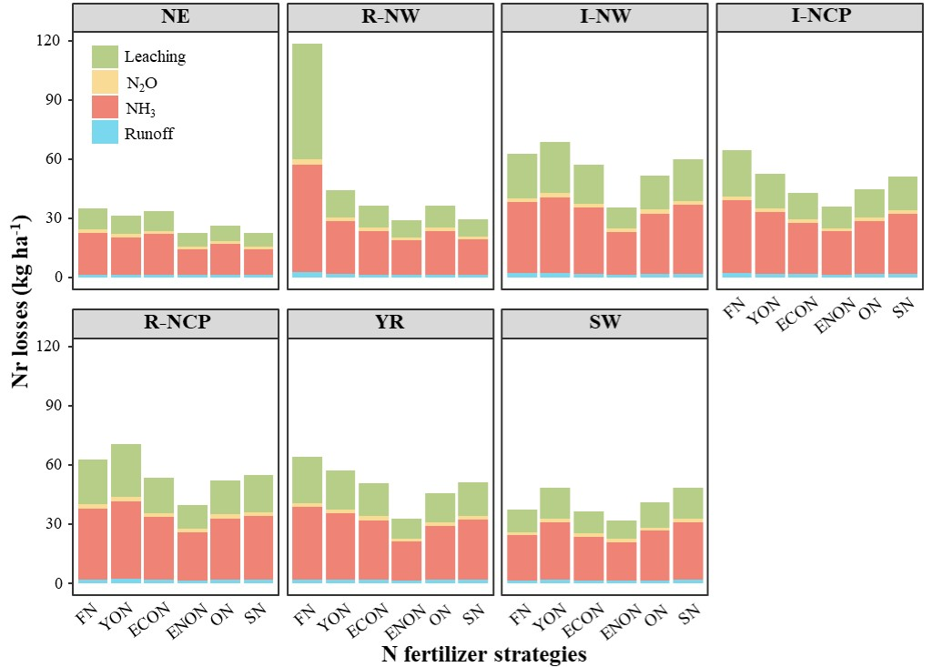
Figure S3 Reactive nitrogen (Nr) losses produced by different nitrogen (N) fertilizer strategies in subregions. NE: Northeast; R-NW: Rainfed Northwest; I-NW: Irrigated Northwest; I-NCP: Irrigated North China Plain; R-NCP: Rainfed North China Plain; YR: Yangtze River; SW: Southwest. FN: farmers’ nitrogen rate; YON, yield optimal N rate; ECON, economic optimal nitrogen rate; ENON, environment optimal nitrogen rate; ON, optimal nitrogen threshold; and SN, sustainable nitrogen rate.

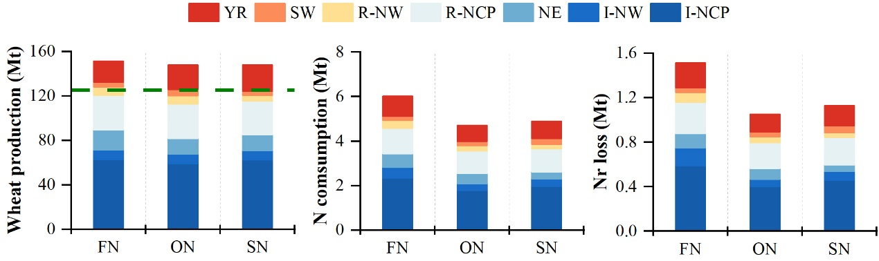
Figure S4 Wheat production, nitrogen (N) fertilizer consumption, and reactive N (Nr) losses for different N fertilizer strategies in different subregions under the 2018 planting areas. The dashed line in the figure represents the wheat demand target for 2030. NE: Northeast; R-NW: Rainfed Northwest; I-NW: Irrigated Northwest; I-NCP: Irrigated North China Plain; R-NCP: Rainfed North China Plain; YR: Yangtze River; SW: Southwest. FN: Farmers’ N rate; ON, optimal N threshold; and SN, sustainable N rate.
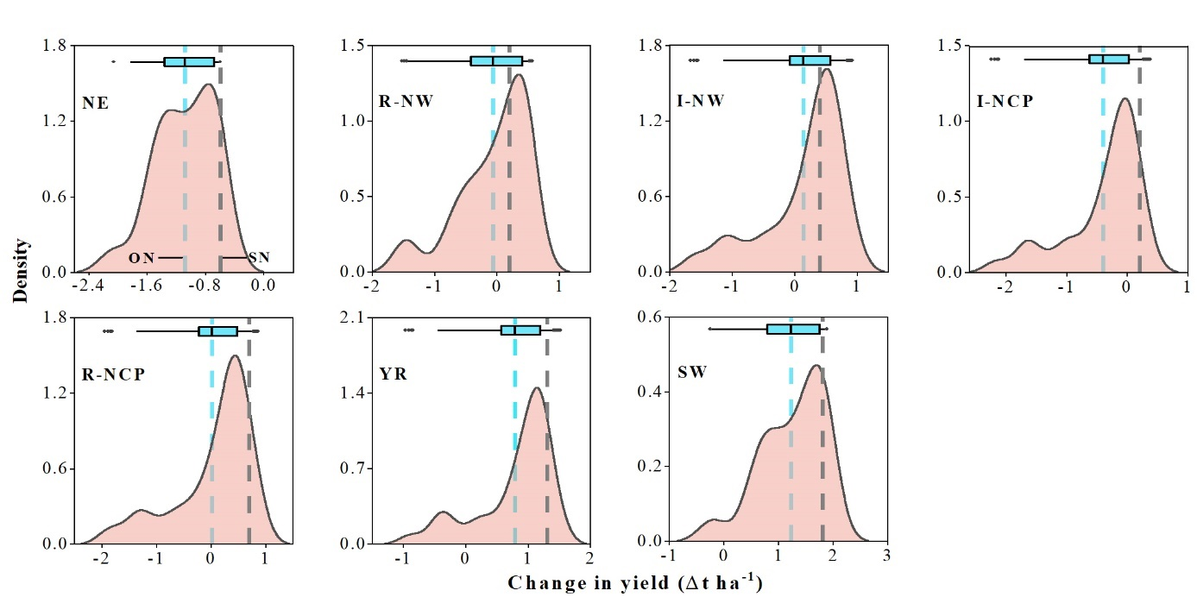
Figure S5 Probability distribution of yield risk for nitrogen (N) optimization strategies compared to the farmers’ N rates. Blue and black vertical lines represent mean values of optimal N threshold (ON) and sustainable N rate (SN), respectively. Notably, SN has only one value in each subregion without a probability distribution. NE: Northeast; R-NW: Rainfed Northwest; I-NW: Irrigated Northwest; I-NCP: Irrigated North China Plain; R-NCP: Rainfed North China Plain; YR: Yangtze River; and SW: Southwest.
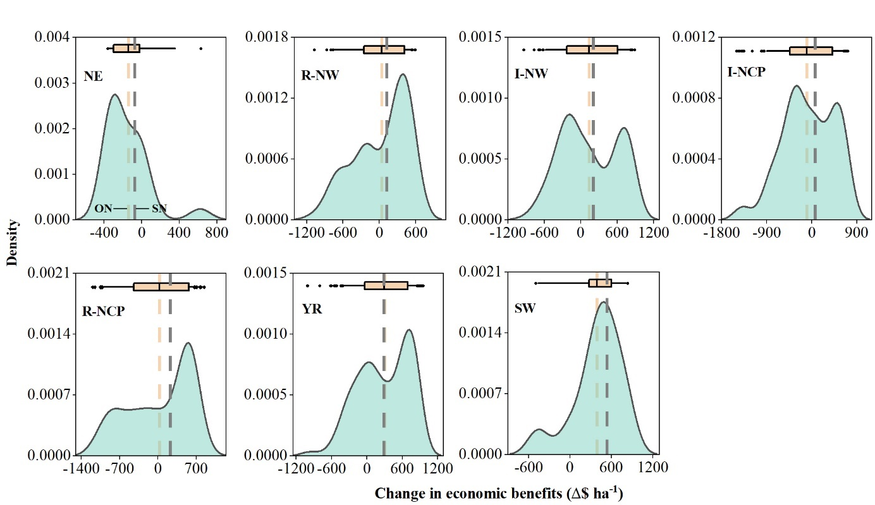Figure S6 Probability distribution of economic risk for nitrogen (N) optimization strategies compared to the farmers’ N rates. Orange and black vertical lines represent mean values of optimal N threshold (ON) and sustainable N rate (SN), respectively. Notably, SN has only one value in each subregion without a probability distribution. NE: Northeast; R-NW: Rainfed Northwest; I-NW: Irrigated Northwest; I-NCP: Irrigated North China Plain; R-NCP: Rainfed North China Plain; YR: Yangtze River; and SW: Southwest.
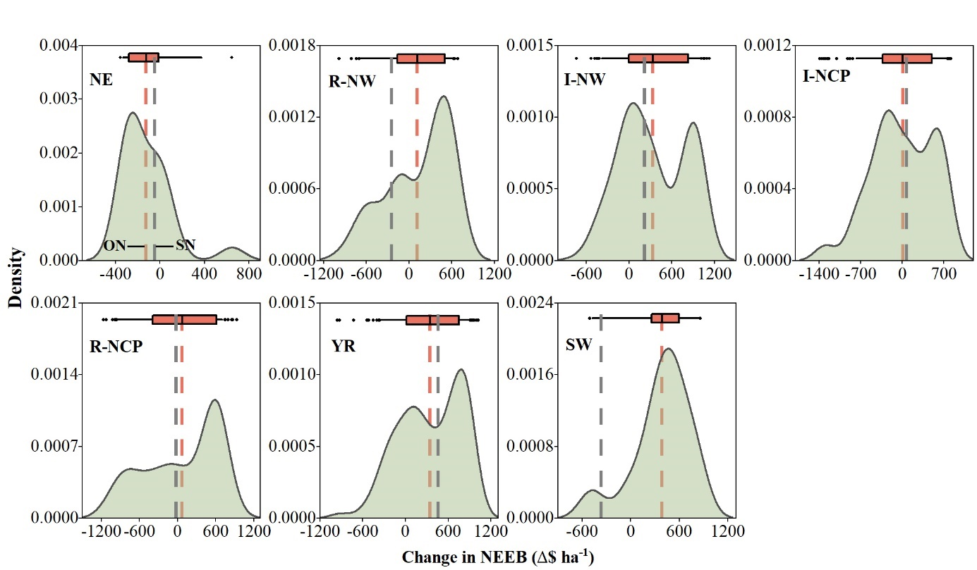
Figure S7 Probability distribution of comprehensive risk for nitrogen (N) optimization strategies compared to the farmers’ N rates. Red and black vertical lines represent mean values of optimal N threshold (ON) and sustainable N rate (SN), respectively. Notably, SN has only one value in each subregion without a probability distribution. NE: Northeast; R-NW: Rainfed Northwest; I-NW: Irrigated Northwest; I-NCP: Irrigated North China Plain; R-NCP: Rainfed North China Plain; YR: Yangtze River; and SW: Southwest.

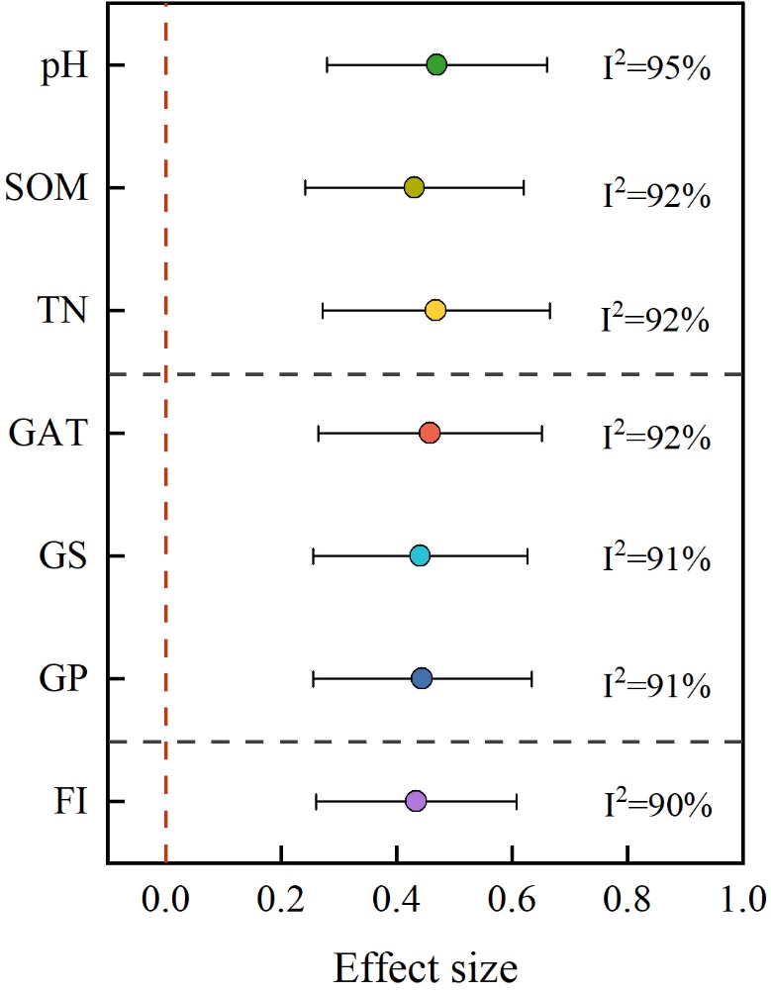
Figure S8 Change of soil factors, weather factors, and farmers’ income level in response to optimal nitrogen (N) rates within the optimal N threshold compared to the non-fertilized plots. Points indicate the mean of each treatment and bars indicate 95% confidence intervals. I² represents the heterogeneity test results and P values for difference are at p=0.001. SOM: soil organic matter; TN: total nitrogen; GAT: growing season average temperature; GS: growing season sunshine hours; GP: growing season precipitation; and FI: farmers’ income per capita.
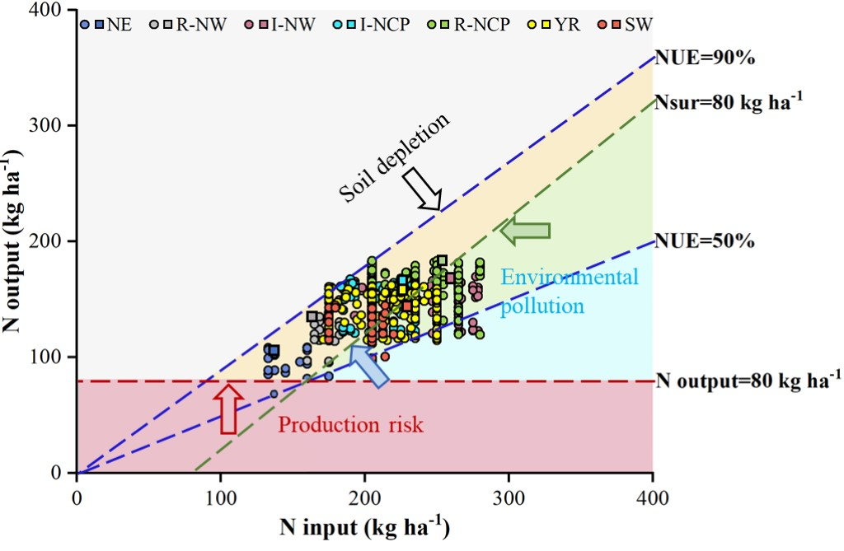
Figure S9 Optimization of nitrogen (N) management practices (modified from EU Nitrogen Expert Panel, 2015²⁷ and Ren et al.⁶). In areas where the soil is depleted, organic fertilizers should be applied; in an area that causes pollution to the environment, efficiency-enhancing nitrogen fertilizers, such as slow-release fertilizers, should be applied; in an area where there is a risk of food production, high-standard farmland should be constructed. The circle and square represent the optimal N threshold (ON) and sustainable N rate (SN), respectively. NE: Northeast; R-NW: Rainfed Northwest; I-NW: Irrigated Northwest; I-NCP: Irrigated North China Plain; R-NCP: Rainfed North China Plain; YR: Yangtze River; and SW: Southwest.

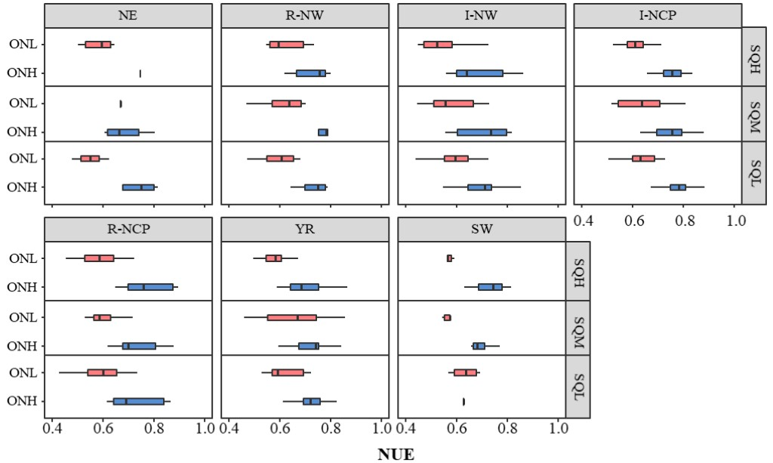
Figure S10 Scenarios of nitrogen use efficiency (NUE) under different soil quality classes and optimized nitrogen (N) rates with optimal N threshold (ON). SQH, SQM, and SQL represent the high, moderate, and low soil quality, respectively. ONL, low management level (yield below the yield corresponding to the average N rates within ON). The opposite is ONH. NE: Northeast; R-NW: Rainfed Northwest; I-NW: Irrigated Northwest; I-NCP: Irrigated North China Plain; R-NCP: Rainfed North China Plain; YR: Yangtze River; and SW: Southwest.

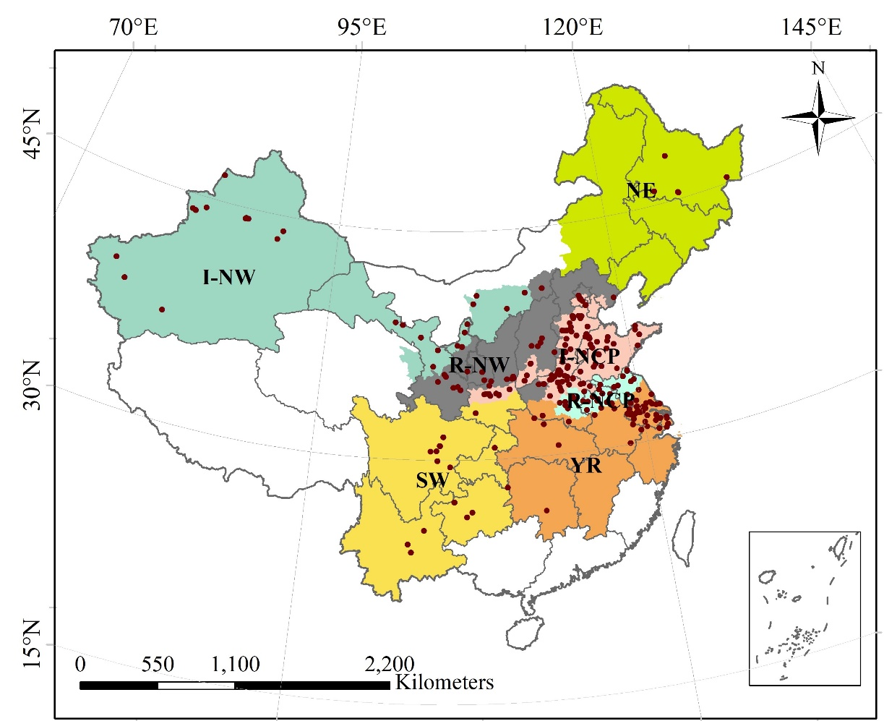
Figure S11 Location of the field experiment included in the literature in China. NE: Northeast; R-NW: Rainfed Northwest; I-NW: Irrigated Northwest; I-NCP: Irrigated North China Plain; R-NCP: Rainfed North China Plain; YR: Yangtze River; and SW: Southwest.
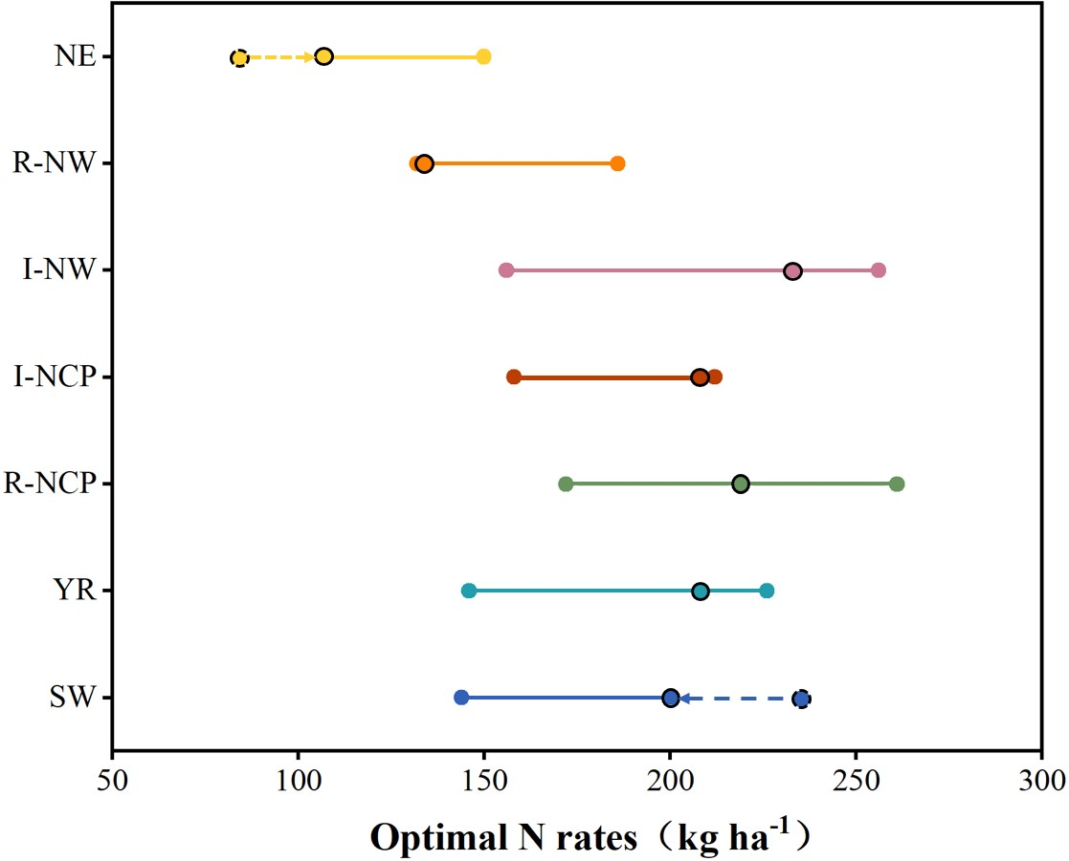
Figure S12 The illustration of optimal nitrogen threshold (ON) determined by the yield, economic, and environmental nitrogen (N) rate, and sustainable N rate (SN). The black circles represent the SN or adjusted SN if exceeds the thresholds. NE: Northeast; R-NW: Rainfed Northwest; I-NW: Irrigated Northwest; I-NCP: Irrigated North China Plain; R-NCP: Rainfed North China Plain; YR: Yangtze River; and SW: Southwest.
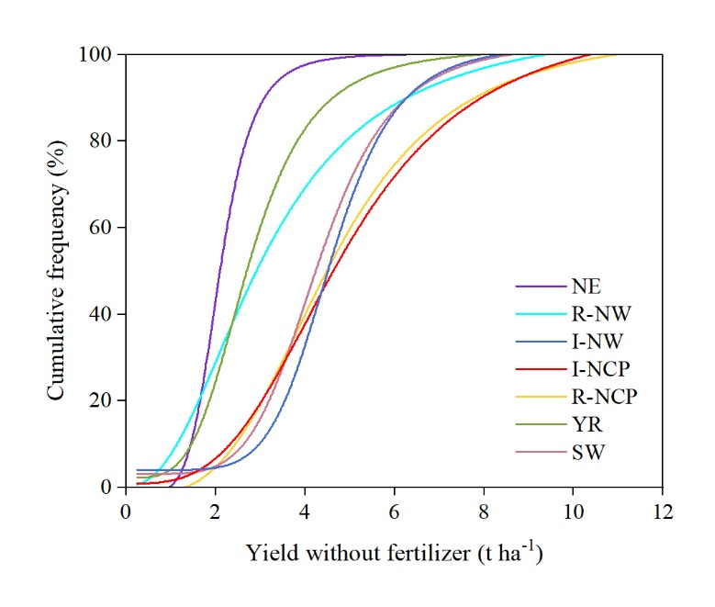
Figure S13 Cumulative frequency of wheat yield without fertilizer in China. NE: Northeast; R-NW: Rainfed Northwest; I-NW: Irrigated Northwest; I-NCP: Irrigated North China Plain; R-NCP: Rainfed North China Plain; YR: Yangtze River; and SW: Southwest.
Supplementary table
Table S1 Frequency of soil quality classes distribution.
Region | Non-fertilized yield (t ha⁻¹) | Soil quality classes  (t ha⁻¹) | Sample | Frequency  (%)
NE | 2.5±0.68 | SQL (<2) | 2 | 28.6
NE | 2.5±0.68 | SQM (2-2.5) | 2 | 28.6
NE | 2.5±0.68 | SQH (>2.5) | 3 | 42.8
R-NW | 3.5±1.78 | SQL <2.5 | 23 | 37.7
R-NW | 3.5±1.78 | SQM (2.5-4.5) | 19 | 31.1
R-NW | 3.5±1.78 | SQH (>4.5) | 19 | 31.1
I-NW | 4.7±1.32 | SQL (<4.5) | 21 | 38.9
I-NW | 4.7±1.32 | SQM (4.5-5.5) | 17 | 31.5
I-NW | 4.7±1.32 | SQH (>5.5) | 16 | 29.6
I-NCP | 5.1±2.02 | SQL (<4) | 90 | 33.7
I-NCP | 5.1±2.02 | SQM (4-6) | 88 | 33
I-NCP | 5.1±2.02 | SQH (>6) | 89 | 33.3
R-NCP | 5.1±1.94 | SQL (<4) | 26 | 37.7
R-NCP | 5.1±1.94 | SQM (4-6) | 25 | 36.2
R-NCP | 5.1±1.94 | SQH (>6) | 38 | 36.5
YR | 3.1±1.2 | SQL (<2.5) | 36 | 34.6
YR | 3.1±1.2 | SQM (2.5-3.5) | 30 | 28.8
YR | 3.1±1.2 | SQH (>3.5) | 38 | 36.5
SW | 4.5±1.37 | SQL (<3.5) | 6 | 26.1
SW | 4.5±1.37 | SQM (3.5-5.5) | 11 | 47.8
SW | 4.5±1.37 | SQH (>5.5) | 6 | 26.1
SQH, SQM, and SQL represent the high, moderate, and low soil quality, respectively. NE: Northeast; R-NW: Rainfed Northwest; I-NW: Irrigated Northwest; I-NCP: Irrigated North China Plain; R-NCP: Rainfed North China Plain; YR: Yangtze River; and SW: Southwest.

Table S2 Wheat type, sample size, nitrogen (N) application rate, and basic environmental conditions of the different wheat regions in China.
Region | NE | R-NW | I-NW | I-NCP | R-NCP | YR | SW
Wheat type | Spring wheat | Spring wheat Winter wheat | Spring wheat Winter wheat | Winter wheat | Winter wheat | Winter wheat | Spring wheat Winter wheat
Sample number | 20 | 80 | 173 | 221 | 173 | 241 | 37
N rate (kg ha-1) | 121 (13) | 160 (15) | 209 (28) | 188 (15) | 212 (24) | 191 (23) | 175 (14)
Soil pH | 6.3 (0.3) | 8.1 (0.2) | 8.0 (0.3) | 7.9 (0.5) | 7.4 (0.8) | 7.0 (0.9) | 7.1 (0.8)
Soil organic matter (g kg-1) | 29.4 (3.3) | 12.1 (3.0) | 18.8 (6.4) | 15.7 (4.6) | 15.7 (5.9) | 19.7 (8.7) | 21.1 (7.3)
Soil total N (g kg-1) | 1.9 (0.5) | 0.9 (0.2) | 1.0 (0.3) | 1.0 (0.2) | 1.1 (0.2) | 1.2 (0.4) | 1.2 (0.4)
Growing season average temperature (°C) | 14.3 (0.5) | 8.6 (2.3) | 3.7 (2.4) | 8.3 (2.86) | 9.9 (2.2) | 10.5 (2.9) | 12.4 (4.5)
Growing season sunshine hours (h) | 1752 (74) | 1522 (180) | 1843 (132) | 1456 (235) | 1353 (212) | 1335 (216) | 1141 (495)
Growing season precipitation (mm) | 440 (48) | 232 (75) | 113 (76) | 186 (71) | 268 (107) | 402 (228) | 399 (194)
Values within parentheses represent the standard deviation (SD). NE: Northeast; R-NW: Rainfed Northwest; I-NW: Irrigated Northwest; I-NCP: Irrigated North China Plain; R-NCP: Rainfed North China Plain; YR: Yangtze River; and SW: Southwest.

Table S3 Model characteristics and application in this study.
Model type | Model name | Model structure | Apply
Parametric model | Linear function | Y = aX + b | ENON
Parametric model | Linear function | X_{i} = -b/a | ENON
Parametric model | Quadratic function | Y = aX² + bX + c | YON, ECON
Parametric model | Quadratic function | X_{i} = -b / (2a) | YON, ECON
Parametric model | Linear plateau function | Y₁ = aX + b (X≤X_{i}) | YON
Parametric model | Linear plateau function | Y₂ = aX_{i} + b (X>X_{i}) | YON
Parametric model | Quadratic plateau function | Y₁ = aX² + bX + c (X≤X_{i}) | YON
Parametric model | Quadratic plateau function | Y₂ = aX_{i}² + bX_{i} + c (X>X_{i}) | YON
Non-parametric model | Local weighted regression | No specific structure | YON, ECON, ENON
Non-parametric model | Local polynomial regression | No specific structure | YON, ECON, ENON
Non-parametric model | Gaussian kernel density (deg=1) | No specific structure | YON, ECON, ENON
Non-parametric model | Gaussian kernel density (deg=2) | No specific structure | YON, ECON, ENON
YON: yield optimal nitrogen rate; ECON: economic optimal nitrogen rate; and ENON: environment optimal nitrogen rate.
Table S4 Cost of reactive nitrogen (Nr) losses
Nr loss | Social cost ($ kg⁻¹)
Nr loss | Environment | Human health²³
Leaching and runoff | Eutrophication: 1.12²⁸ | 0.2
NH₃ volatilization | Acidification: 1.87²⁹  Eutrophication: 0.24²⁸ | 3.3
N₂O emission | Greenhouse gas: 11.2³⁰ | 0.3

Table S5 Classification principles of the collected biophysical factors and socio-economic factors.
Type | Description | Principle | Unit | Classifications
Biophysical factors | Soil pH | Soil technology in China | - | ≤6; 6-8; ≥8
Biophysical factors | Soil organic matter (SOM) | Soil technology in China | g kg⁻¹ | ≤10; 10-20; ≥20
Biophysical factors | Total nitrogen (TN) | Soil technology in China | g kg⁻¹ | ≤1; 1-2; ≥2
Biophysical factors | Growing season average temperature (GAT) | Data distribution | °C | ≤9; 9-11; ≥11
Biophysical factors | Growing season sunshine hours (GS) | Data distribution | h | ≤1200; 1200-1600; ≥1600
Biophysical factors | Growing season precipitation (GP) | Data distribution | mm | ≤100; 100-300; ≥300
Socio-economic factors | Farmers’ income per capita (FI) | Data distribution | yuan | ≤15000; 15000-25000; ≥25000

References
1. National. Soil Census Technology in China (Agricultural Press, Beijing, 1992).
2. Liu, B., Wu, L., Chen, X. & Meng, Q. Quantifying the potential yield and yield gap of Chinese wheat production. Agron. J. 108, 1890-1896 (2016). DOI:10.2134/agronj2016.03.0147
3. Ministry of Agriculture and Rural Affairs of China. National Sustainable Agriculture Development Plan (2015–2030) (in Chinese) (2015); http://www.gov.cn/xinwen/2015-05/28/content_2869902.htm.
4. Li, T. et al. Region-specific nitrogen management indexes for sustainable cereal production in China. Environ. Res. Commun. 2, 75002 (2020). DOI:10.1088/2515-7620/aba12d
5. Wang, W. et al. The climatic effects of irrigation over the middle and lower reaches of the Yangtze River, China. Agric. For. Meteorol. 308-309, 108550 (2021). DOI:10.1016/j.agrformet.2021.108550
6. Ren, K. et al. Optimizing nitrogen fertilizer use for more grain and less pollution. J. Clean. Prod. 360, 132180 (2022). DOI:10.1016/j.jclepro.2022.132180
7. Qiao, L. et al. Soil quality both increases crop production and improves resilience to climate change. Nat. Clim. Chang. 12, 574-580 (2022). DOI:10.1038/s41558-022-01376-8
8. Kihara, J. et al. Understanding variability in crop response to fertilizer and amendments in sub-Saharan Africa. Agr. Ecosyst. Environ. 229, 1-12 (2016). DOI:10.1016/j.agee.2016.05.012
9. Tittonell, P. & Giller, K. E. When yield gaps are poverty traps: The paradigm of ecological intensification in African smallholder agriculture. Field Crops Res. 143, 76-90 (2013). DOI:10.1016/j.fcr.2012.10.007
10. Zhang, Q. et al. Outlook of China's agriculture transforming from smallholder operation to sustainable production. Glob. Food Secur. 26, 100444 (2020). DOI:10.1016/j.gfs.2020.100444
11. Duan, J. et al. Consolidation of agricultural land can contribute to agricultural sustainability in China. Nat. Food 2, 1014-1022 (2021). DOI:10.1038/s43016-021-00415-5
12. Zhejiang Provincial Government. Opinions of the People’s Government of Zhejiang Province on further strengthening the responsibility system of city and county governors for food security and strengthening the capability of food security (in Chinese) (2015); http://www.lswz.gov.cn/html/zt/szzrz/2018-06/14/content_236168.shtml.
13. Huang, J., Wang, X. & Rozelle, S. The subsidization of farming households in China’s agriculture. Food Policy 41, 124-132 (2013). DOI:10.1016/j.foodpol.2013.04.011
14. Ramankutty, N., A Foley, J., Norman, J. & Kevin, M. The global distribution of cultivable lands: current patterns Blackwell Science, Ltd and sensitivity to possible climate change. Global Ecol. Biogeogr. 11, 377-392 (2002). DOI:10.1046/j.1466-822x.2002.00294.x
15. Kim, P., Tarafdar, A. & Kwon, J. Effect of soil pH on the sorption capacity of soil organic matter for polycyclic aromatic hydrocarbons in unsaturated soils. Pedosphere 33, 365-371 (2023). DOI:10.1016/j.pedsph.2022.06.049
16. Zhang, H., Yuan, X., Xiong, T., Wang, H. & Jiang, L. Bioremediation of co-contaminated soil with heavy metals and pesticides: Influence factors, mechanisms and evaluation methods. Chem. Eng. J. 389, 125657 (2020). DOI:10.1016/j.cej.2020.125657
17. He, D., Fang, S., Liang, H., Wang, E. & Wu, D. Contrasting yield responses of winter and spring wheat to temperature rise in China. Environ. Res. Lett. 15, 124038 (2020). DOI:10.1088/1748-9326/abc71a
18. Fan, Y. et al. Winter night warming improves pre-anthesis crop growth and post-anthesis photosynthesis involved in grain yield of winter wheat (Triticum aestivum L.). Field Crops Res. 178, 100-108 (2015). DOI:10.1016/j.fcr.2015.04.001
19. Aparecido, L. M. T., Woo, S., Suazo, C., R., H. K. & Benjamin, B. High water use in desert plants exposed to extreme heat. Ecol. Lett. 23, 1189-1200 (2020). DOI:10.1111/ele.13516
20. Conant, R. T., Berdanier, A. B. & Grace, P. R. Patterns and trends in nitrogen use and nitrogen recovery efficiency in world agriculture. Global Biogeochem. Cy. 27, 558-566 (2013). DOI:0886-6236/13/10.1002/gbc.20053
21. Jiang, W., Zhu, A., Wang, C., Zhang, F. & Jiao, X. Optimizing wheat production and reducing environmental impacts through scientist–farmer engagement: lessons from the North China Plain. Food Energy Secur. 10, e225 (2021). DOI:10.1002/fes3.255
22. Zhang, W. et al. Closing yield gaps in China by empowering smallholder farmers. Nature 537, 671-674 (2016). DOI:10.1038/nature19368
23. Gu, B. et al. Atmospheric reactive nitrogen in China: sources, recent trends, and damage costs. Environ. Sci. Technol. 46, 9420-9427 (2012). DOI:10.1021/es301446g
24. Kang, J. et al. Ammonia mitigation campaign with smallholder farmers improves air quality while ensuring high cereal production. Nat. Food (2023). DOI:10.1038/s43016-023-00833-7
25. Zhang, X. et al. Quantitative assessment of agricultural sustainability reveals divergent priorities among nations. One Earth 4, 1262-1277 (2021). DOI:10.1016/j.oneear.2021.08.015
26. Wang, Y., Lu, Y., Yuan, J. & He, G. Evaluating the risks of nitrogen fertilizer-related grain production processes to ecosystem health in China. Resour. Conserv. Recy. 177, 105982 (2022). DOI:10.1016/j.resconrec.2021.105982
27. EU Nitrogen Expert Panel. Nitrogen Use Efficiency (NUE)-an Indicator for the Utilization of Nitrogen in Agriculture and Food Systems (2015); http://www.eunep.com/wp-content/uploads/2017/03/Report-NUE-Indicator-Nitrogen-Expert-Panel-18-12-2015.pdf
28. Xiang, P. A. et al. External costs and optimum use of nitrogen fertilizer based on the balance of economic and ecological benefits in the paddy field system of the Dongting Lake area, China. Agricultural Sciences in China 6, 347-354 (2007). DOI: 10.1016/S1671-2927(07)60055-8
29. Xia, Y. & Yan, X. Ecologically optimal nitrogen application rates for rice cropping in the Taihu Lake region of China. Sustain. Sci. 7, 33-44 (2012). DOI:10.1007/s11625-011-0144-2
30. Xia, Y. & Yan, X. Comparison of statistical models for predicting cost effective nitrogen rate at rice-wheat cropping systems. Soil science and Plant Nutrition (Tokyo). 57, 320-330 (2011). DOI:10.1080/00380768.2011.578259

