Supplementary Table 1
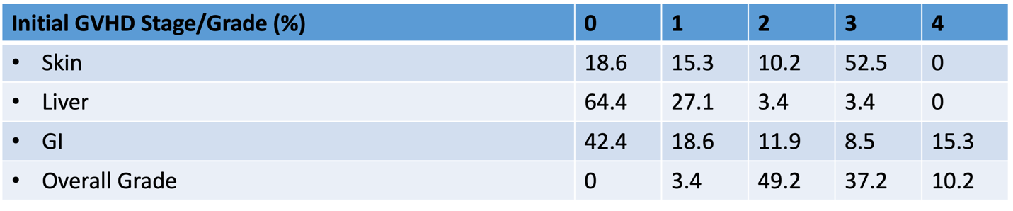
Supplementary Table 2
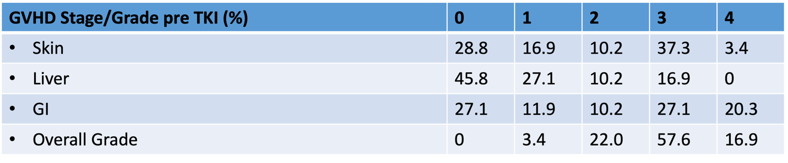Supplementary Figure 1
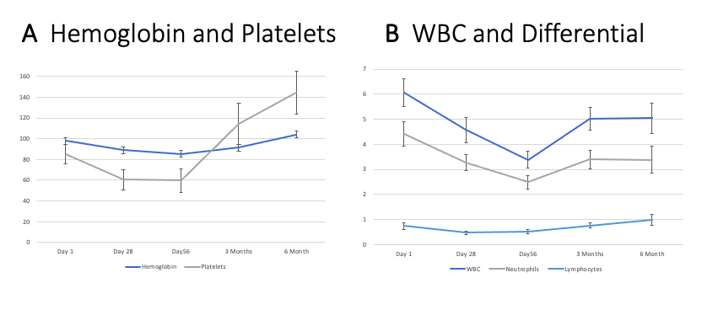
A Mean hemoglobin concentration (g/L) , platelet count (cells x 10⁹/L) with standard error bars, at Day 1, Day 28, Day 56, 3 months, and 6 months. B WBC and Differential (cells x 10⁹/L ) at Day 1, Day 28, Day 56, 3 months, and 6 months. Days and months refer to time since start of ruxolitinib.

Supplementary Figure 2
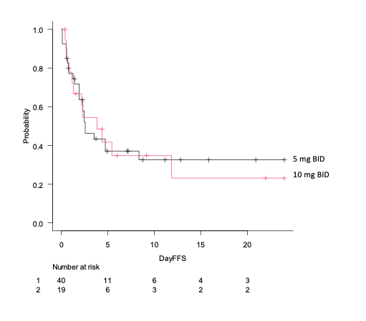
Supplementary figure 2. Failure-free survival of patients treated with ruxolitinib at a starting dose of 5 mg BID (black) compared to 10 mg BID (red).

