Article type: Original Article

Title: Genetic characterization, structural and evolutionary adaptations of Small Heat shock proteins involved in mitigating environmental stress in Fishes

Mehwish Sultana¹#, Shakeela Parveen^{*1, 2}, Muhammad Tayyab#³, Muhammad Hussain⁴,

Addresses:
²Department of Zoology, Wildlife & Fisheries, University of Agriculture, Faisalabad, Punjab, Pakistan
¹Department of Zoology, Government Sadiq College Women University, Bahawalpur, Punjab, Pakistan.
³Department of Zoology, Government College University Faisalabad, Pakistan
⁴Department of Veterinary sciences, University of Veterinary and animal sciences, Lahore, Pakistan

#Equall contribution

Dr. Shakeela Parveen
Department of Zoology,
Government Sadiq college Women university, Bahawalpur, Punjab, Pakistan
Tel.:+92 3057980780
Email: drshakeela@gscwu.edu.pk

Supplementary data
Supplementary Table 1: Data collection of sHsps from NCBI
Variants | Species Name | Protein ID | Data base | CDS ID | Data base
Hspb 1 | Cyprinus carpio | XP_042579166.1 | NCBI | XM_042723232.1 | NCBI
Hspb 1 | Danio rerio | NP_001008615.2 | NCBI | NM_001008615.2 | NCBI
Hspb 1 | Labeo rohita | XP_050966031.1 | NCBI | XM_051110074.1 | NCBI
Hspb 1 | Salmo salar | XP_013993837.2 | NCBI | XM_014138362.2 | NCBI
Hspb 1 | Oncorhynchus mykiss | XP_021481774.2 | NCBI | XM_021626099.2 | NCBI
Hspb 1 | Clupea harengus | XP_012678267.1 | NCBI | XM_012822813.3 | NCBI
Hspb 2 | Cyprinus carpio | XP_018960267.1 | NCBI | XM_019104722.2 | NCBI
Hspb 2 | Danio rerio | NP_001017744.1 | NCBI | NM_001017744.1 | NCBI
Hspb 2 | Labeo rohita | XP_050965179.1 | NCBI | XM_051109222.1 | NCBI
Hspb 2 | Salmo salar | XP_045546274.1 | NCBI | XM_045690318.1 | NCBI
Hspb 2 | Oncorhynchus mykiss | XP_036824089.1 | NCBI | XM_036968194.1 | NCBI
Hspb 2 | Clupea harengus | XP_012677436.2 | NCBI | XM_012821982.2 | NCBI
Hspb 3 | Cyprinus carpio | XP_018950626.1 | NCBI | XM_019095081.2 | NCBI
Hspb 3 | Danio rerio | NP_001092922.1 | NCBI | NM_001006040.1 | NCBI
Hspb 3 | Labeo rohita | XP_050966291.1 | NCBI | XM_051110334.1 | NCBI
Hspb 3 | Salmo salar | XP_014028184.1 | NCBI | XM_014172709.2 | NCBI
Hspb 3 | Oncorhynchus mykiss | XP_036835116.1 | NCBI | XM_036979221.1 | NCBI
Hspb 3 | Clupea harengus | XP_012684129.1 | NCBI | XM_012828675.3 | NCBI
Hspb 7 | Cyprinus carpio | XP_018921182.1 | NCBI | XM_019065637.2 | NCBI
Hspb 7 | Danio rerio | NP_001006040.1 | NCBI | NM_001099452.1 | NCBI
Hspb 7 | Labeo rohita | XP_050952037.1 | NCBI | XM_051096080.1 | NCBI
Hspb 7 | Salmo salar | XP_014021323.1 | NCBI | XM_014165848.2 | NCBI
Hspb 7 | Oncorhynchus mykiss | XP_021464987.1 | NCBI | XM_021609312.2 | NCBI
Hspb 7 | Clupea harengus | XP_012681546.1 | NCBI | XM_012826092.2 | NCBI
Hspb 8 | Cyprinus carpio | XP_042609430.1 | NCBI | XM_042753496.1 | NCBI
Hspb 8 | Danio rerio | NP_001094427.2 | NCBI | NM_001100957.2 | NCBI
Hspb 8 | Labeo rohita | XP_050966283.1 | NCBI | XM_051110326.1 | NCBI
Hspb 8 | Salmo salar | XP_014026050.1 | NCBI | XM_014170575.2 | NCBI
Hspb 8 | Oncorhynchus mykiss | XP_021477827.1 | NCBI | XM_021622152.2 | NCBI
Hspb 8 | Clupea harengus | XP_012675804.2 | NCBI | XM_012820350.3 | NCBI
Hspb 9 | Cyprinus carpio | XP_018928085.1 | NCBI | XM_019072540.2 | NCBI
Hspb 9 | Danio rerio | NP_001108177.1 | NCBI | NM_001114705.2 | NCBI
Hspb 9 | Labeo rohita | XP_050957045.1 | NCBI | XM_051101088.1 | NCBI
Hspb 9 | Salmo salar | - | - | - | -
Hspb 9 | Oncorhynchus mykiss | - | - | - | -
Hspb 9 | Clupea harengus | XP_012691738.1 | NCBI | XM_012836284.2 | NCBI
Hspb 11 | Cyprinus carpio | XP_018919420.2 | NCBI | XM_019063875.2 | NCBI
Hspb 11 | Danio rerio | NP_001092897.1 | NCBI | NM_001099427.1 | NCBI
Hspb 11 | Labeo rohita | XP_050949551.1 | NCBI | XM_051093594.1 | NCBI
Hspb 11 | Salmo salar | XP_013993696.1 | NCBI | XM_014138221.2 | NCBI
Hspb 11 | Oncorhynchus mykiss | XP_021458519.2 | NCBI | XM_021602844.2 | NCBI
Hspb 11 | Clupea harengus | XP_012693167.1 | NCBI | XM_012837713.3 | NCBI

Supplementary Table 2: Comprehensive results of sHsps from the FEL analysis are provided for each location, and statistical significance is determined using the asymptotic χ2 distribution

Gene | Codon | α | β | α = β | LRT | P value | Total branch length | dN/dS LB | dN/dS MLE | dN/dS UB | Selection type
Hspb 1 | 108 | 0 | 1.248 | 2.582 | 2.716 | 0.0994 | 500.925 | 7,966.29 | 10,000 | 10,000 | Diversifying
Hspb 1 | 146 | 0 | 0.236 | 0.186 | 3.105 | 0.078 | 36.136 | 7,590.55 | 10,000 | 10,000 | Diversifying
Hspb 1 | 164 | 0 | 0.645 | 0.352 | 4.318 | 0.0377 | 68.278 | 7,590.67 | 10,000 | 10,000 | Diversifying
Hspb 2 | 0 | 0 | 0 | 0 | 0 | 0 | 0 | 0 | 0 | 0 | 0
Hspb 3 | 56 | 0 | 6.351 | 1.971 | 3.441 | 0.0636 | 56.901 | 7,258.10 | 10,000 | 10,000 | Diversifying
Hspb 3 | 138 | 0 | 0.119 | 0.081 | 3.143 | 0.0763 | 2.324 | 6,183.96 | 10,000 | 10,000 | Diversifying
Hspb 7 | 0 | 0 | 0 | 0 | 0 | 0 | 0 | 0 | 0 | 0 | 0
Hspb 8 | 104 | 0 | 0.127 | 0.103 | 3.496 | 0.0615 | 4.638 | 6,807.56 | 10,000 | 10,000 | Diversifying
Hspb 8 | 130 | 0 | 0.181 | 0.089 | 3.299 | 0.0693 | 3.975 | 6,807.73 | 10,000 | 10,000 | Diversifying
Hspb 8 | 183 | 0 | 0.12 | 0.08 | 3.047 | 0.0809 | 3.607 | 6,182.92 | 10,000 | 10,000 | Diversifying
Hspb 8 | 186 | 0 | 0.105 | 0.069 | 3.653 | 0.056 | 3.105 | 6,806.99 | 10,000 | 10,000 | Diversifying
Hspb 9 | 65 | 0 | 10.075 | 12.331 | 2.835 | 0.0923 | 84.86 | 6,695.33 | 10,000 | 10,000 | Diversifying
Hspb 9 | 80 | 0 | 3.046 | 1.009 | 2.78 | 0.0955 | 6.947 | 6,185.92 | 10,000 | 10,000 | Diversifying
Hspb 9 | 142 | 0 | 3.98 | 2.433 | 3.112 | 0.0777 | 16.746 | 5,276.43 | 10,000 | 10,000 | Diversifying
Hspb 11 | 0 | 0 | 0 | 0 | 0 | 0 | 0 | 0 | 0 | 0 | 0

Supplementary Figures:
Hspb 1
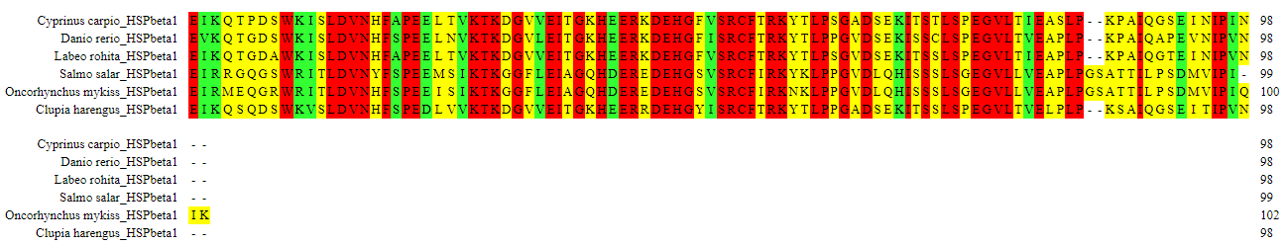
Hspb 2
Hspb 3
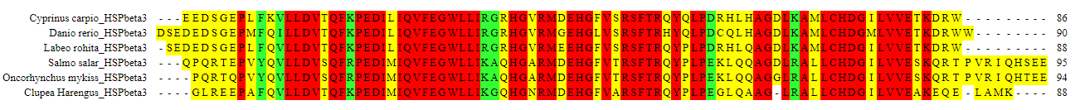
Hspb 7
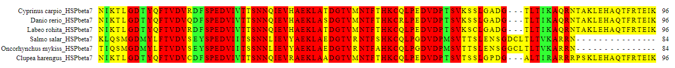
Hspb 8
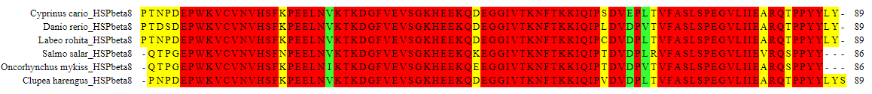
Hspb 9
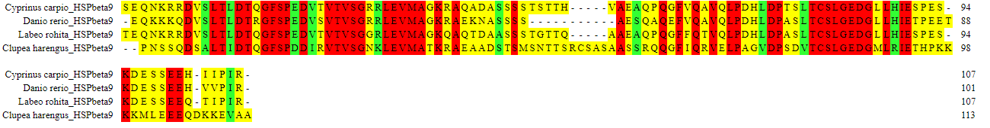

Hspb 11
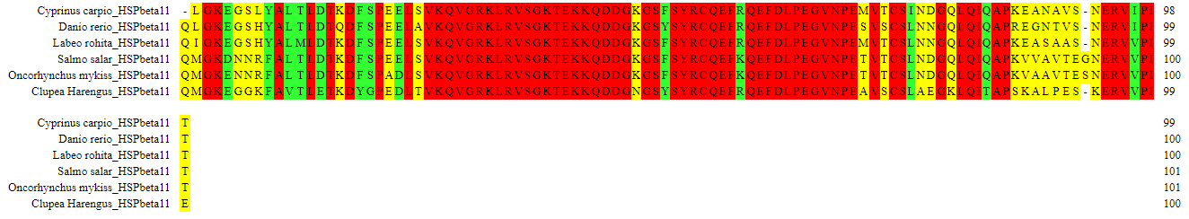
Supplementary Figure 1: Multiple sequence Alignments of Alpha crystalline Domain (ACD) of sHsps.

Hspb 1 Hspb 2
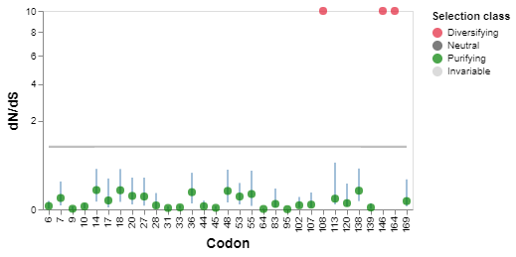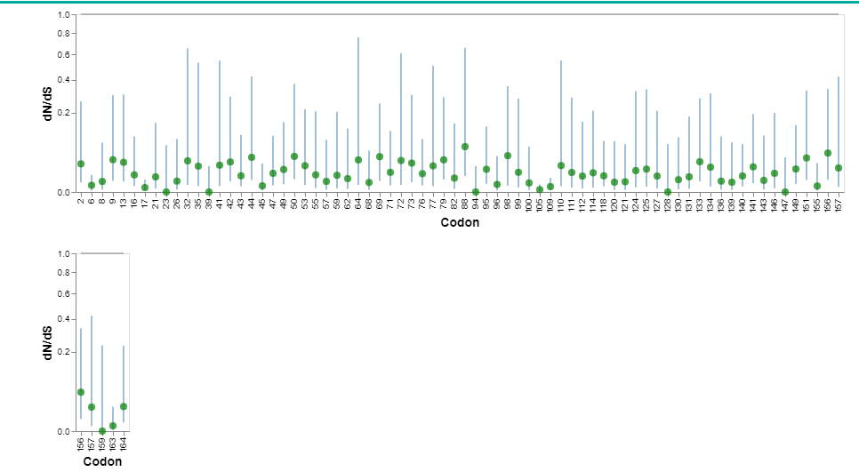
Hspb 3 Hspb 7
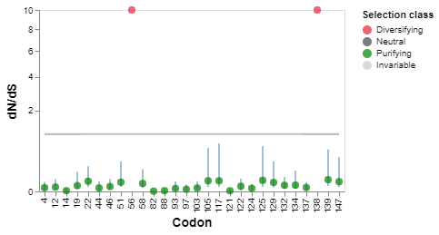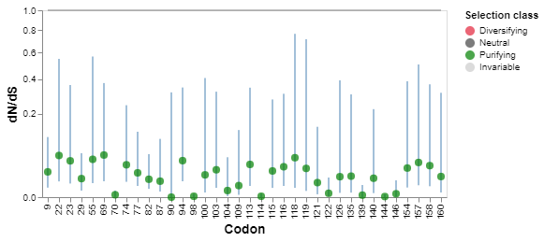
Hspb 8 Hspb 9
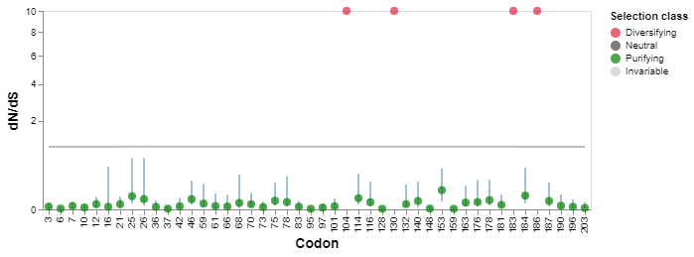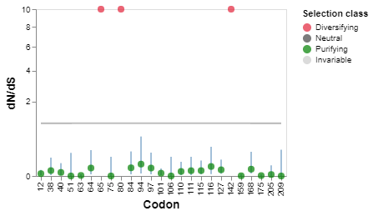
Hspb 11
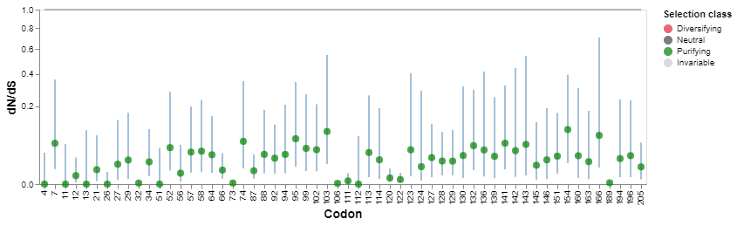

Supplementary Figure 2: Hspb 1, Hspb 2, Hspb 3, Hspb 7, Hspb 8, Hspb 9, Hspb 11 dN/dS values, maximum likelihood estimates, and predicted profile confidence intervals were determined for each site. Neutrality is shown as a horizontal grey line with slope dN/dS = 1. If there are any, vertical dashed lines show the partition borders. To assess statistical significance, we use the asymptotic 2 distribution. The variance in synonymous rates between sites is taken into account in this evaluation. For site-level dN/dS ratios, profile approximation confidence ranges have been established.

