Supplemental content 1. search strategy and process of literature selection

1)search strategy in pubmed
(("streptococcus pyogenes"[Title/Abstract] OR "streptococcus pyogenes"[MeSH Terms] OR ("streptococcus pyogenes"[MeSH Terms] OR "group a streptococcus"[Title/Abstract])) AND ("meningitis"[Title/Abstract] OR "meningitis"[MeSH Terms])) OR (((group a[Author] AND ("Streptococcus"[MeSH Terms] OR "Streptococcus"[All Fields] OR "Streptococcal"[All Fields])) AND "meningitis"[MeSH Terms]) OR "group a streptococcal meningitis"[Title/Abstract])

2)search strategy in EMBASE
('group a streptococcal meningitis':ab,ti AND 'group a streptococcal meningitis'/exp) OR ((('streptococcus pyogenes':ab,ti AND 'streptococcus pyogenes'/exp) OR ('group a streptococcus':ab,ti AND 'group a streptococcus'/exp)) AND ('meningitis':ab,ti AND 'meningitis'/exp))

275 titles identified from Medline
65 abstracts selected
48 full text selected
9 papers included from reference
57 papers included in review
5 cases series
52 cases reports
17 not included
7 focus on epidemiology of iGAS infection without detailed information of GAS meningitis
4 had no detailed information of GAS meningitis
3 not GAS meningitis
1 focus on the molecular characterization of iGAS without detailed information of GAS meningitis cases
2 no full text
130 titles identified from EMBASE
334 titles

Supplemental content 2. Detailed information of cases reviewed from case reports and reported in this study
Case No. | Published time | Author | Country | Age | Sex | Symptoms a immediate complications | Shock | Culture | Outcome | The duration of follow up | Risk factors | Extracranial foci | emm types
1 | 1966 | Dillonhj | USA | 6 days | M | Fever, seizure | No | CSF, blood | Recover | ND | No | Soft tissues infection in wrists a ankle | emm12
2 | 1976 | Burech,D.L | USA | 11 months | ND | subdural effusion | No | CSF | ND | ND | ND | ND | ND
3 | 1976 | Burech,D.L | USA | 6 years | ND | ND | ND | CSF | Sequela | ND | ND | ND | ND
4 | 1976 | Nelson,J D | USA | 17 days | F | ND | ND | CSF,pus | ND | ND | No | Umbilical infection | emm12
5 | 1976 | Shadravani | USA | 18 months | M | Fever, vomit, iritabilitysubdural effusion, brain abscess | No | CSF | Recover | ND | Fur sinus | No | ND
6 | 1979 | Nutman,J. | Israel | 3 days | F | Fever, letharge, | No | CSF, blood | Recover | ND | No | Necrotizing fasciitis | emm52
7 | 1981 | Brown,C | USA | 8 years | M | Fever, headache, vomit, earache, respiratory failure | No | CSF | Sequela | 2 years | No | Otitis media | ND
8 | 1981 | Brown,C | USA | 13 years | M | Headache, fever, letharge, earache | No | CSF | Recover | 16 months | No | Otitis media | ND
9 | 1983 | Baumgartner | USA | 26 days | M | ND | ND | CSF | Recover | ND | No | Paronychia | ND
10 | 1983 | Murphy,D.J. | USA | 4 years 9 months | M | Fever, drowsiness earache, iritability | No | CSF | Recover | ND | No | Otitis media | ND
11 | 1983 | Murphy,D.J. | USA | 10 weeks | M | Fever, iritability, drowsiness | No | CSF, blood | Sequela | 2 years | No | No | ND
12 | 1983 | Murphy,D.J. | USA | 2 weeks | F | Fever, iritability, poor appetite, seizure, letharge | No | CSF, blood, pus | Recover | 8 years | No | Soft tissues infection in foot | ND
13 | 1983 | Murphy,D.J. | USA | 7 years 10 months | M | Headache, vomit, pharyngodynia, seizure, respiratory failure, acute kidney injury | STSS | CSF, blood | Recover | 4 years | No | Pharyngitis | ND
14 | 1983 | Murphy,D.J. | USA | 8 years 8 months | F | Headache, vomit, pharyngodynia, photophoby, drowsiness | No | CSF, blood | Recover | ND | No | Pharyngitis | ND
15 | 1983 | Murphy,D.J. | USA | 12 years 4 months | F | Fever, headache, coma | No | CSF | Sequela | 19 days | CSF leakage | Pharyngitis | ND
16 | 1984 | Coulter, J B | UK | 13 days | F | Hypothermia, iritability, rash, swollen foot, seizure, respiratory failure | STSS | Autopsy | Death | No follow up | No | Soft tissues infection in lower limbs | ND
17 | 1984 | Coulter, J B | UK | 26 days | M | Fever, poor appetite, letharge, seizure, respiratory failurebrain abscess, hydrocephalus | No | CSF, pus | Recover | 3 years | No | Paronychia | ND
18 | 1984 | Rotimivo, | Nigeria | 3 years | ND | Fever, seizure | No | CSF | Sequela | ND | No | Otitis media | ND
19 | 1986 | Congeni,B.L | USA | 2 months | ND | hydrocephalus, cerebromalacia | No | CSF | ND | ND | No | No | ND
20 | 1986 | Lau, Y L | UK | 5 years | M | ND | ND | CSF | Recover | ND | Head trauma | No | ND
21 | 1987 | Yagupsky,P | Israel | 2.5 months | F | Fever, diarrhea, poor appetite | No | CSF, blood, pus | Recover | 6 months | No | Hemangiomas infection | ND
22 | 1988 | Haren,A. | UK | 10 weeks | M | Fever, poor appetite, drowsiness, seizure, subdural effusion | No | CSF, blood | Sequela | 2 years | No | No | emm1
23 | 1988 | Jagdis,F | Canada | 12 years | F | Fever, vomit, photophoby, brain abscess | No | CSF | Recover | 3 months | No | No | emm1
24 | 1988 | Wong,V.K.; | USA | 1 months | F | Fever, seizurebrain abscess | No | CSF, blood | ND | ND | No | No | ND
25 | 1990 | Wilson,N.W | USA | 14 years | ND | ND | ND | CSF, blood | ND | ND | Head trauma | No | ND
26 | 1991 | Gradon, J D | USA | 11 years | F | Fever, coma | No | CSF, blood | Recover | ND | Chickenpox | No | ND
27 | 1991 | Marshallgs | USA | 12 years | M | Fever, headache, vomit | No | blood | ND | ND | HIV | Pharyngitis | emm1
28 | 1992 | Gertner,M | USA | 7 months | F | Letharge, poor appetite, seizure, rash, respiratory failure | Septic shock | CSF, blood | Death | No follow up | No | No | ND
29 | 1992 | Levy,E.N | USA | 13 years | F | Fever, pharyngodynia, hemiplegia | No | blood | Sequela | 6 weeks | No | Pharyngitis | ND
30 | 1994 | Jevon, G P | USA | 8 years | F | Fever, coma, vomit, respiratory failure | STSS | Autopsy, CSF | Death | No follow up | No | No | emm3
31 | 1994 | Walsh,M | USA | 12 years | F | Fever, vomit | No | CSF | Recover | No follow up | Chickenpox | No | ND
32 | 1998 | Givner,L.B. | USA | Newborns | F | Fever, respiratory failure, Waterhouse-Friderichsen syrome | STSS | CSF, blood | Death | No follow up | No | No | emm3
33 | 1998 | Moses,A.E. | Israel | 2 months | M | Fever, letharge, seizure, respiratory failure, subdural effusion, cerebromalacia | No | CSF | Sequela | 18 months | No | No | emm41
34 | 1999 | Muhe,L | Switzerland | Newborns | ND | ND | ND | CSF | Death | No follow up | No | Necrotizing enteritis | ND
35 | 1999 | Mulholland, E K | Switzerland | 33 days | F | ND | ND | CSF | Death | No follow up | No | No | ND
36 | 1999 | Mulholland, E K | Switzerland | 34 days | ND | ND | ND | blood | ND | ND | No | No | emm1
37 | 1999 | Sommer,R. | Switzerland | 15 years | M | ND | ND | CSF, blood | ND | ND | Head trauma | No | ND
38 | 2000 | Bernerr | Germany | 6 years 10 months | M | Fever, photophoby, vomit, earache | No | CSF | Recover | ND | No | Mastoiditis | ND
39 | 2000 | Melzer, M | UK | 3 months | M | Fever, iritability, vomit, respiratory failure, subdural effusion | STSS | blood, pus, subdural effusion | Recover | 3 months | No | BCG scar infection | ND
40 | 2000 | Verboon-Maciolek, M. A. | Netherlands | 24 days | M | Fever, poor appetite, seizure, brain abscess | No | CSF，pus | Death | No follow up | No | No | ND
41 | 2001 | Khan,M.A | UK | 10 years | M | Headache, vomitbrain abscess | No | Pus | Recover | 2 months | No | No | emm12
42 | 2001 | Shetty, A K | USA | 2 years 6 months | M | Fever, vomit, drowsiness seizure, respiratory failure, coma, cerebral infarction | Septic shock | CSF, blood | Death | No follow up | No | No | ND
43 | 2001 | Steppberger, K | Germany | 11 years | F | Fever, headache, earache, drowsiness | No | blood | Sequela | ND | No | Mastoiditis, otitis media | ND
44 | 2003 | Brandt,C.M | Germany | 3 months | F | Fever, drowsiness | No | CSF | Recover | No follow up | Chickenpox | No | emm3
45 | 2004 | Mathur,P. | India | 10 months | F | Fever, vomit, drowsiness headache | No | CSF | Recover | No follow up | No | Maibular abscess | ND
46 | 2004 | Mathur,P. | India | 2 years | F | Fever, pharyngodynia, seizure, coma | No | CSF | Recover | No follow up | No | Pharyngitis | ND
47 | 2004 | Rezvani,M. | Canada | 2.5 months | M | Fever, seizure, coma, cerebral infarction | No | CSF | Sequela | 12 months | No | No | ND
48 | 2005 | Perera, N | UK | 6 weeks | F | Fever, drowsiness, poor appetite | No | CSF, blood | Recover | ND | No | No | ND
49 | 2005 | Pettersen, G | Canada | 4 years 6 months | M | Fever, drowsiness | No | CSF | Recover | 9 months | Cochlear implant | Otitis media | ND
50 | 2006 | Dehority,W | USA | 17 months | M | Vomit, drowsiness aphasia, seizure, respiratory failure, brain abscess | No | Pus | Recover | 4 weeks | CSF leakage | Otitis media | emm12
51 | 2007 | Arnoni, M V | Brazil | 5 years | ND | Fever, vomit, headache, earache | No | CSF | Recover | ND | No | Mastoiditis | ND
52 | 2007 | Arnoni, M V | Brazil | 3 months | ND | Fever, iritability | STSS | CSF | Death | No follow up | Chickenpox | Cellulitis of face | ND
53 | 2008 | Fanella, S | Canada | 14 years | F | Fever, poor appetite, headache, pharyngodynia, earache, cranial venous sinus thrombosis, epidural abscess | No | CSF, blood | Recover | 3 years | CSF leakage | Otitis media, mastoiditis | ND
54 | 2008 | Lardhi, A A | Saudi Arabia | 4 weeks | M | Fever, iritability, poor appetite, seizure, brain abscess | No | CSF | Recover | 12 months | No | No | ND
55 | 2010 | Bruun, T | Norway | 8 years | M | Seizure,hemiplegia, subdural effusion | No | CSF, blood | Sequela | 1 months | No | Otitis, mastoiditis, sinusitis | ND
56 | 2010 | Bruun, T | Norway | 15 years | F | Brain abscess | No | CSF | Recover | 1 months | Retinoblastoma | Cellulitis | ND
57 | 2010 | Gulsen, S | Turkey | 12 years | M | Fever, coma, brain abscess | No | Pus | Recover | No follow up | Head trauma | No | ND
58 | 2011 | Hayashi,A | Janpan | 6 years | M | Fever, headache, vomit, brain abscess | No | CSF | Sequela | 1 year | Dental extraction | No | emm1
59 | 2011 | van Zitteren, L M | Netherlands | 7 years | F | Fever, headache, vomit | No | CSF | Recover | 2 months | No | Otitis media | ND
60 | 2012 | Paul,S.P. | UK | 5 years | M | Fever, vomit, iritability, brain abscess | No | blood | Sequela | 6 months | No | Mastoiditis | ND
61 | 2013 | Busetti,M. | Italy | 4 years | M | Fever, headache, vomit, pharyngodynia | No | CSF | Recover | 2 months | No | Pharyngitis | ND
62 | 2018 | Capua,T. | Israel | 4 years | F | Fever, vomit, headache, photophoby, brain abscess | No | ND | Recover | ND | No | Otitis media | ND
63 | 2018 | Capua,T. | Israel | 31 months | M | Fever, vomitbrain abscess | No | Pus | Recover | ND | No | Pharyngitis | emm1
64 | 2018 | Capua,T. | Israel | 13 months | F | Fever, vomit, drowsiness, coma, brain abscess | No | Pus | Recover | ND | No | No | ND
65 | 2018 | Hazan, G | Israel | 7 years | F | Fever, drowsiness, letharge, vomit, respiratory failure, brain abscess | No | Pus | Recover | 6 weeks | No | Pharyngitis | emm9
66 | 2018 | Hazan, G | Israel | 3.5 years | F | Vomit, iritability, brain abscess | No | Pus | Recover | 6 weeks | No | Pharyngitis | emm1
67 | 2021 | Lee, J | Canada | 7 years | M | Fever, headache, photophoby | Septic shock | CSF, blood | Sequela | 2 weeks | No | Sinusitis | ND
68 | this study |  | China | 3 years and 9 months | M | Fever, letharge, seizure, respiratory failure, acute kidney injury, subdural abscess | STSS | Blood | Recover | 9 years | No | Sinusitis | No
69 | this study |  | China | 8 years | F | Fever, letharge, headache, photophoby | No | Blood | Recover | 5 years | No | Sinusitis | No
70 | this study |  | China | 1 year and 6 months | M | Fever, coma, seizure, hydrocephalus, subdural effusion | No | CSF | Sequela | 2 years | Right hands was scalded | No | No
71 | this study |  | China | 12 years 8 months | F | Fever, headache, vomit, seizure, swollen right eyelide | No | GAS was identified by mNGS in CSF | Recover | 4 years | No | Sinusitis, orbital cellulitis, orbital abscess | No
72 | this study |  | China | 11 years | F | Fever, headache, vomit, letharge, coma, seizure, subdural abscess, cerebral infarction | No | GAS was identified by mNGS in CSF | Sequela | 3 years | No | Sinusitis | No
ND：No discription

supplemental content 3
Published time | Author | Sequela | Duration of follow-up
1976 | Burech,D.L | persistent unilateral fourth nerve palsy | No discription
1981 | Brown, C | Learning difficulty, abnormality of spatial orientation and deficit in short-term memory | 2 years
1983 | Murphy, D. J. | Hemianopsia | 19 days
1983 | Murphy, D. J. | Functioning at a 3- month-old level with psychomotor retardation, seizures, microcephaly and optic atrophy | 2 years
1984 | Rotimi V O, | Poor vision, impaired hearing and severe mental retardation | No description
1988 | Harnden, A. | Profound sensorineural hearing loss | 2 years
1992 | Levy, E. N | Minimal impairment of fine motor skills and mild partial nominal aphasia | 6 weeks
1998 | Moses, A. E.; | Decreased abdominal amuscle tone, mild adductor spasm and relative weakness of left arm | 18 months
2001 | Steppberger K, | Oculomotor nerve palsy | No description
2004 | Rezvani, M. | Intractable seizures, profoundly delayed, only able to roll | 12 months
2010 | Bruun T | Headache, possible attention disorder | 1 month
2011 | Hayashi, A | Hemianopsia, seizures | 1 year
2012 | Paul, S. P. | Sensorineural hearing loss | 6 months
2021 | Lee J | Profound sensorineural hearing loss | 2 weeks
This study |  | paralysis, mental retardation and mood disorders | 2 years
This study |  | had difficulty in study, epilepsy (controlled with drugs) | 3 years

Supplemental Figure

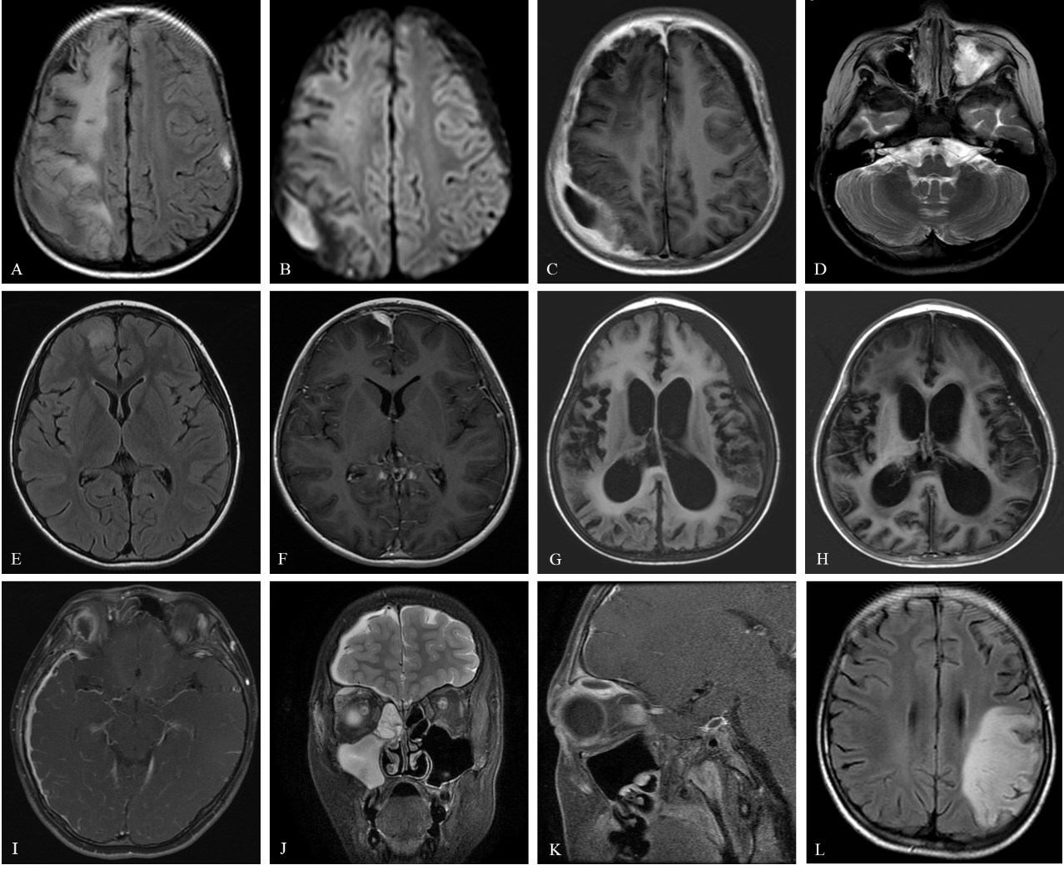
MRI image of 5 cases we reported. CASE1：A(Flair)：abnormal signals on right frontal parietal lobe; B(DWI) : subdural abscess near right parietal lobe; C(T1+C): meningeal enhancement; D(T2): opacification on his left maxillary sinus. CASE2：E(Flair),：abnormal signals on right frontal lobe; F(T1+C) : meningeal enhancement; CASE3：G(Flair), H(T1+C)：necrosis on temprol cortex, subdural effusion, communicating hydrocephalus and meningeal enhancement; CASE4.I(T1+C) enhanced leptomeninges in right hemisphere;J(T2) opacification on her right sphenoidal and maxillary sinuses; K: orbital cellulitis and orbital abscess; CASE 5. L: obvious abnormal singles and necrosis on cerebral cortex in left hemisphere.

