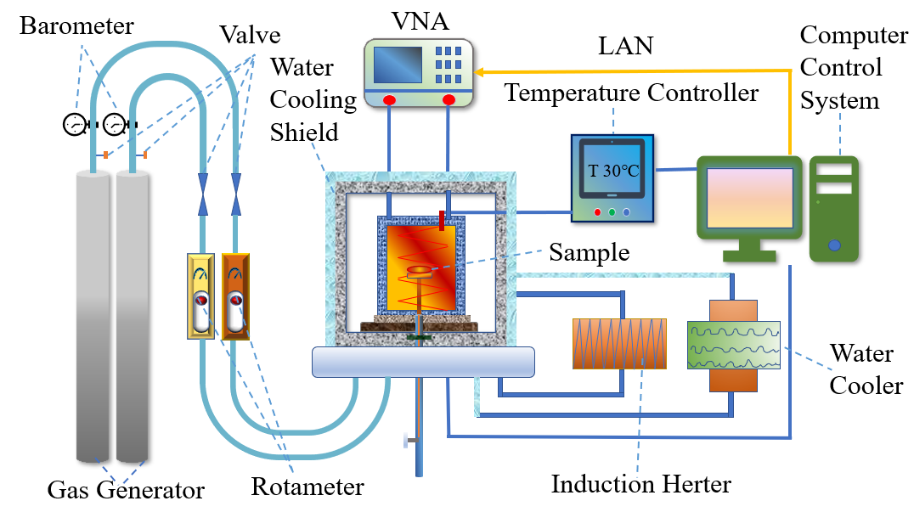
Drying mechanism diagram of microwave device.

