Extended Data Figures
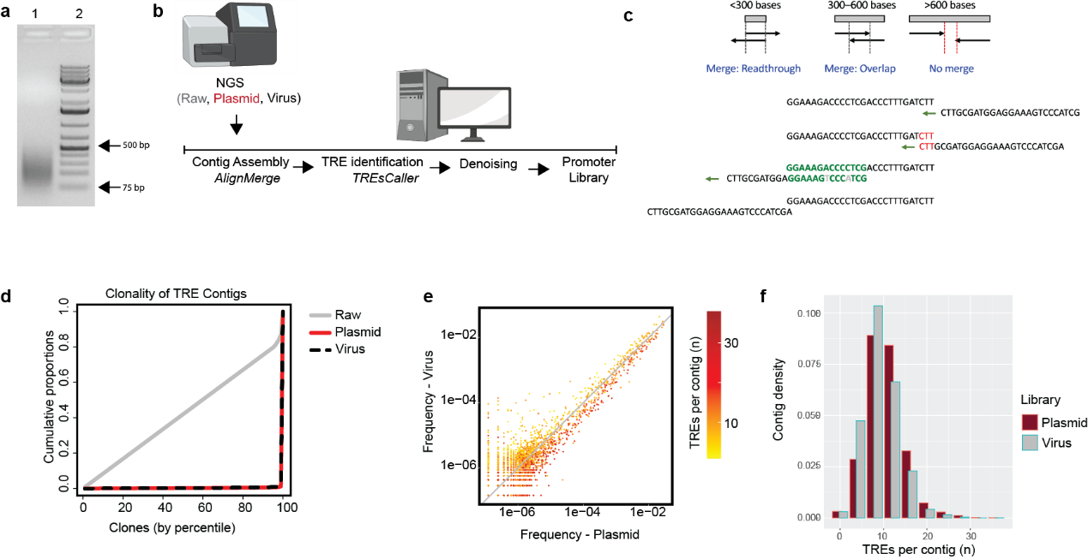
Extended Data Fig. 1 | Computational reconstruction of iSynPro library.
a, Gel electrophoresis of ligated TREs used to generate a randomly assembled iSynPro library. Lane 1: Ligated iSynPro library; Lane 2: Molecular weight ladder.
b, De novo computational pipeline to reconstruct synthetic promoters from sequence libraries.
c, Theoretical outcomes for possible contig reconstruction from paired NGS reads. Pairwise sliding alignment executed by alignMerge identifies an optimal merge (in green, with two mismatched bases) in preference to a suboptimal merge (in red, identical bases but shorter).
d, Promoter clonality of libraries observed in raw, plasmid, and virus products.
e, Scatterplot showing comparison of individual promoter frequency between virus and plasmid libraries. Color gradient indicates promoter length in TRE units.
f, Density histogram of contigs comparing promoter length distributions (measured in TRE units) between plasmid and virus libraries.
Illustration in part b was generated using BioRender

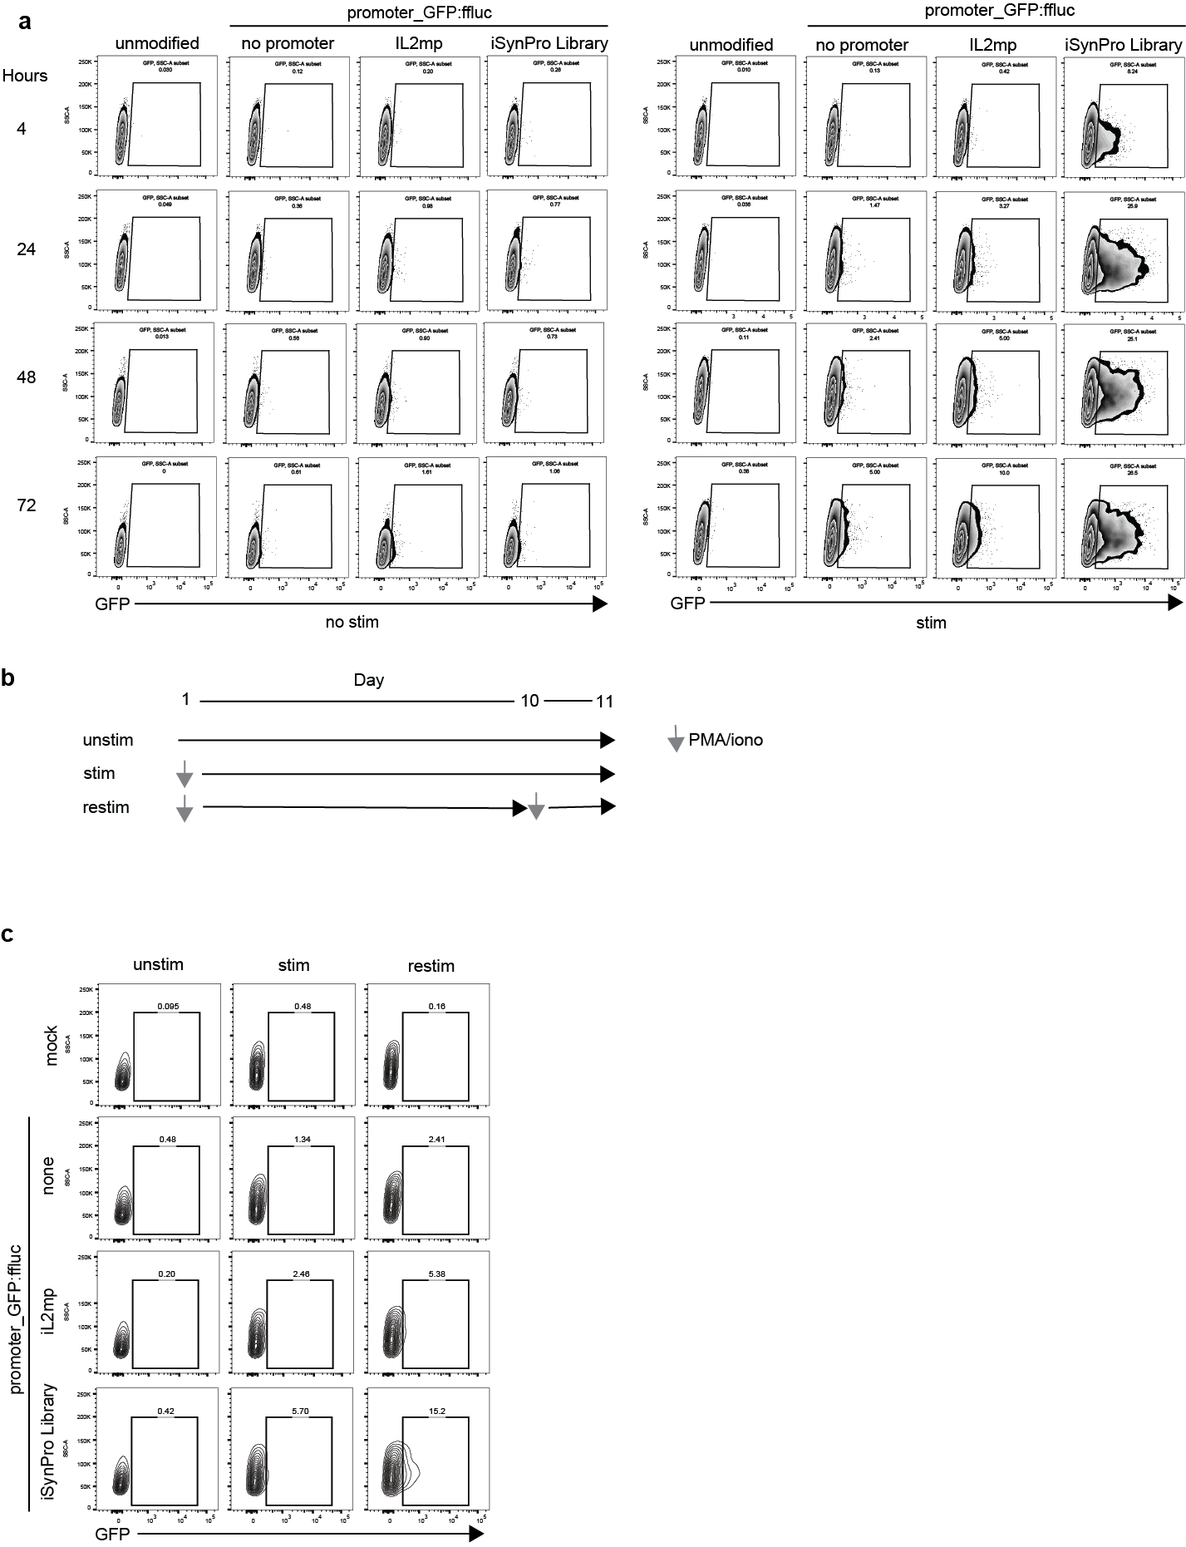
Extended Data Fig. 2 | iSynPro library inducibility time course.
a, Flow cytometry time course measuring GFP expression of unmodified or modified Jurkats with vector containing GFP:ffluc driven by no promoter, an IL-2 minimal promoter, or the iSynPro library.
b, Schema describing experiment to assess re-inducibility of iSynPro library described in c.
c, Flow cytometry measuring GFP expression in restimulated Jurkat cells described in a.

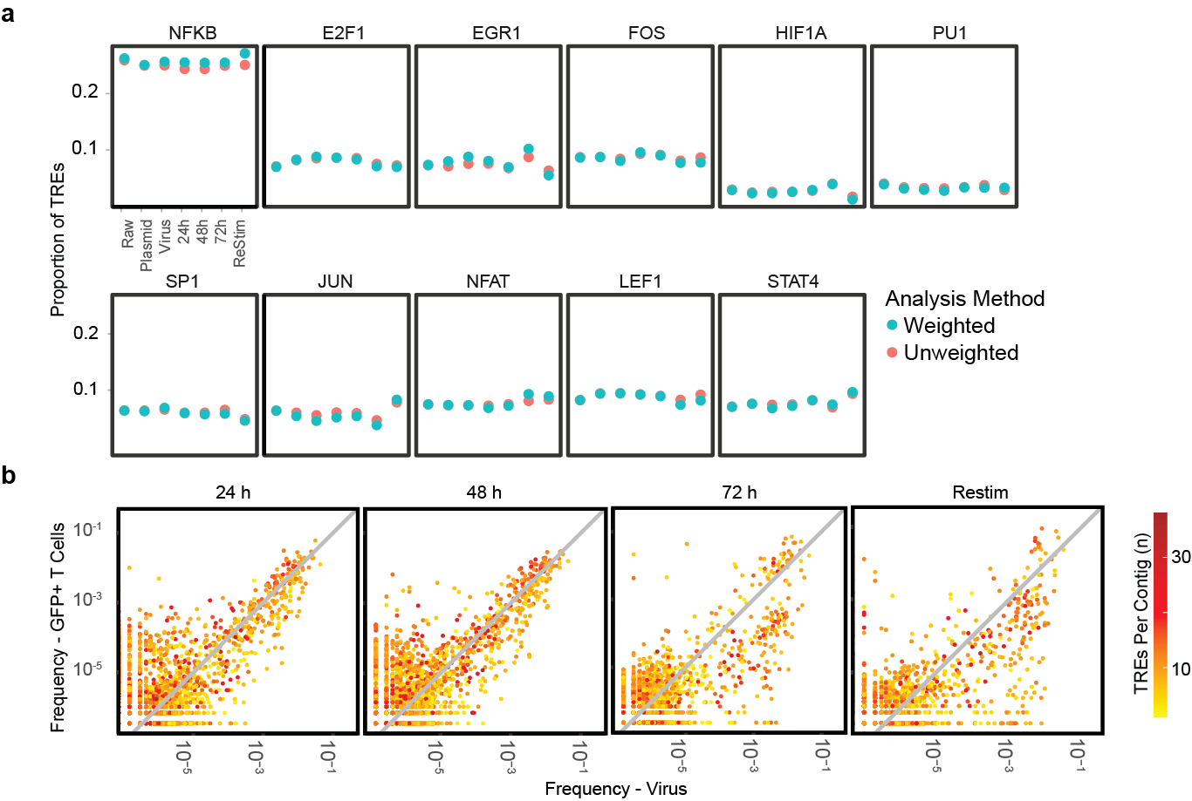
Extended Data Fig. 3 | iSynPro library metrics across screening time points.
a, TRE proportions across raw ligation, plasmid, lentivirus, and GFP⁺ cell collections.
b, Scatterplots comparing individual promoter frequencies at co-culture time points to corresponding baseline frequencies in the virus library. Color gradient indicates promoter length in TRE units.

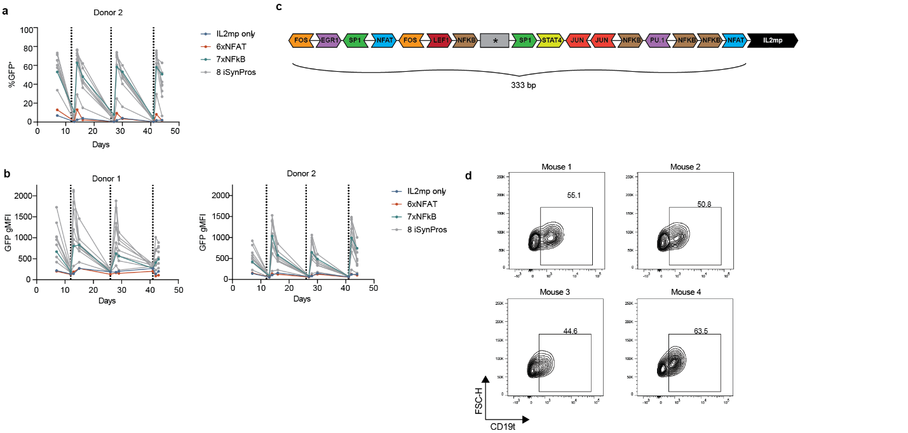
Extended Data Fig. 4 | In vitro recursive and persistent stimulation and ex vivo target phenotyping.
a, Percent GFP induction by a set of synthetic promoters, including eight iSynPro library candidates, in response to recursive antigen stimulation in CD8⁺ CD19CAR T cells. Dashed vertical lines indicate times T cells were stimulated with CD19⁺ LCL cells.
b, GFP MFI achieved by set of inducible promoters in cells featured in a.
c, Schematic of the TRE units composing iSynPro1. Arrows indicate directionality of TREs, and the asterisk represents a sequence that did not map to any TRE.
d, Ex vivo flow cytometric analysis of Raji tumor cells for the presence of the antigen CD19.

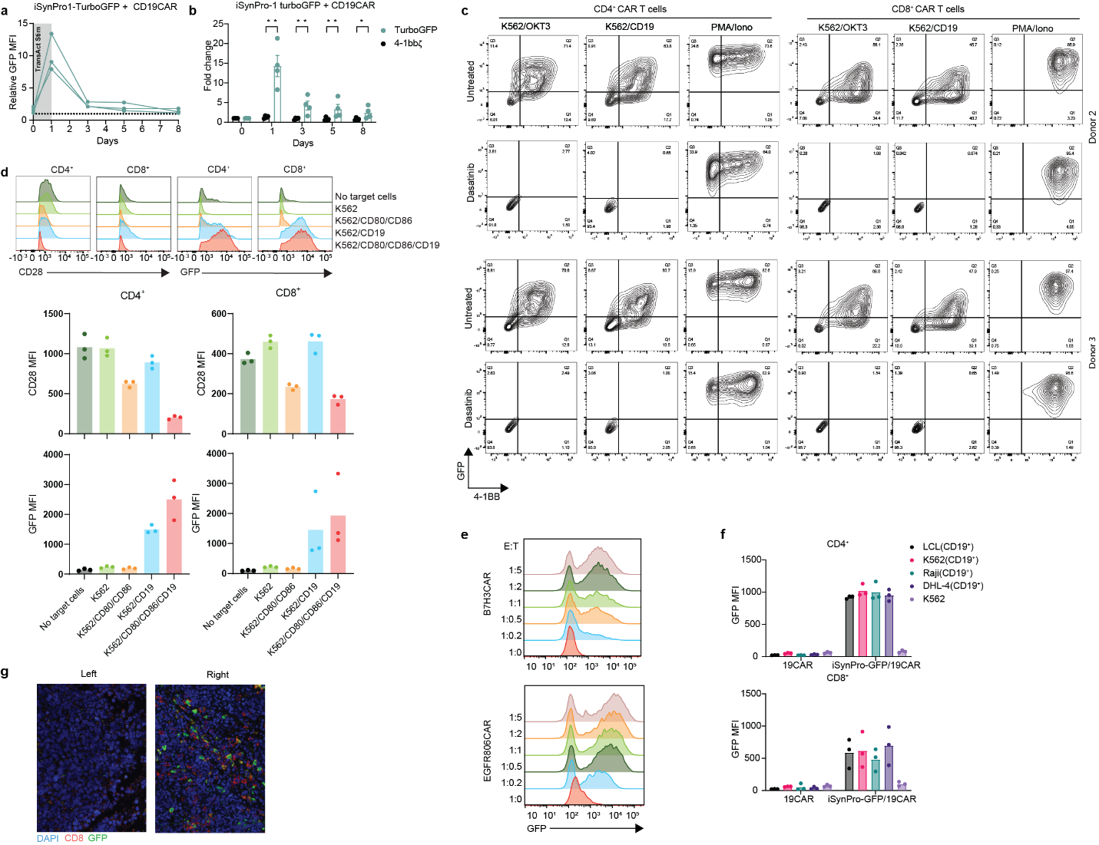
Extended Data Fig. 5 | iSynPro1 induction relies on signal 1 of T cell activation.
a, Flow cytometric analysis of iSynPro1 induction measured by GFP MFI in iSynPro1-TurboGFP_CD19CAR CD8⁺ T cells (n = 3 donors).
b, ddPCR of iSynPro1 gene expression and constitutively expressed CD19CAR using cDNA from iSynPro1-TurboGFP_CD19CAR CD8⁺ T cells. Data represented as mean ± s.e.m. (n = 4 donors). q values were determined by multiple T test with false discovery rate correction.
c, Flow cytometric analysis showing induction of GFP and expression of endogenous 4-1BB in iSynPro1-GFP:ffluc_CD19CAR T cells upon co-culture with K562 tumor cell lines in two additional donors. Cells were either untreated or incubated with 60 nM dasatinib.
d, Flow cytometric analysis showing induction of GFP and expression of endogenous CD28 in iSynPro1-GFP:ffluc_CD19CAR T cells upon co-culture with K562 tumor cell lines. Top panel: histograms from one representative donor; bottom panel: histogram plotting MFI from three donors.
e, GFP induction by iSynPro1 in B7H3CAR and EGFR806CAR T cells in response to co-culture with K562 and EGFRvIII⁺ LCL tumor cells, respectively.
f, GFP MFI in CD19CAR and iSynPro1-GFP:ffluc_CD19CAR CD8⁺ T cells upon co-culture with CD19⁺ tumor cell lines or unmodified K562s (n = 3 donors).
g, IHC imaging of CD8 and GFP expression in CD19⁻ (left) vs CD19⁺ (right) flank tumors taken from mice in the experiment detailed in Fig. 4d. DAPI stain included to distinguish cell nuclei.
q values are denoted: *, q < 0.05, **, q < 0.01, Exact q values are available in Supplemental Table 5.

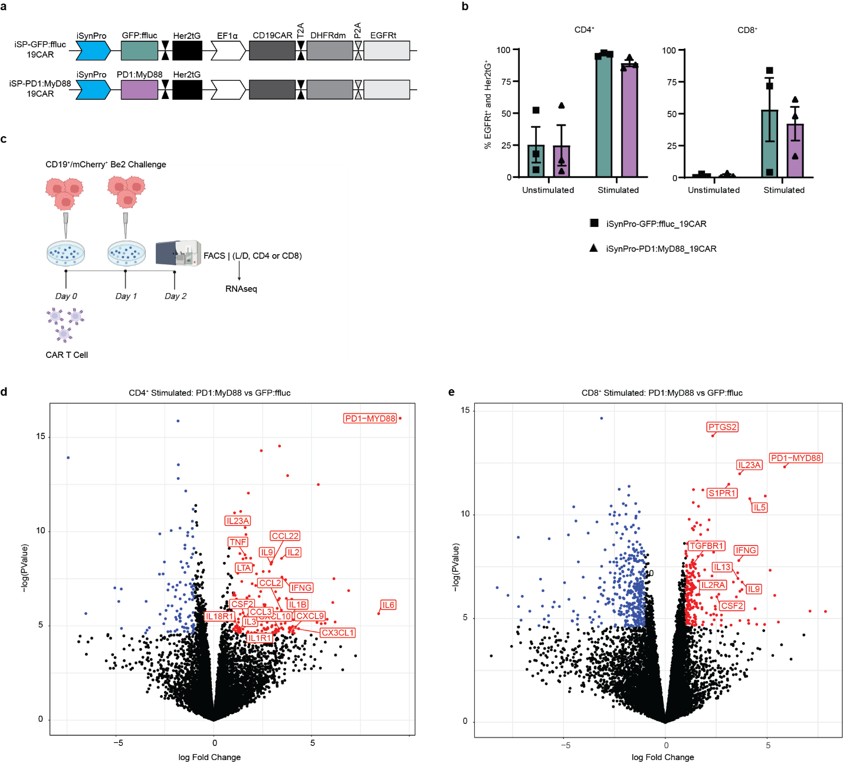
Extended Data Fig. 6| Transcriptional Analysis of PD1:MyD88-expressing CAR T cells.
a, Schematic of the piggyBac transposon-based vectors used to introduce CD19CAR alongside iSynPro1(iSP)-driven GFP:ffluc or PD1:MyD88 into primary human T cells.
b, Percent of cells expressing surface markers HER2tG and EGFRt population by flow cytometry in unstimulated or Raji-stimulated T cells. Data are mean ± s.e.m. (n = 3 donors).
c, Experimental schema for cell stimulation with CD19t⁺/mCherry⁺ Be2 target cells in preparation for RNAseq studies.
d, Volcano plot showing gene expression differences between stimulated CD4⁺ PD1:MyD88-expressing T cells vs stimulated CD4⁺ GFP:ffluc-expressing T cells. Differentially expressed genes, highlighted in color, met the following thresholds: FDR <0.01, a two-sided raw p value <0.01 and |log2(fold change)| >=1. Up-regulated genes in PD1:MyD88-expessing cells are highlighted in red, and down-regulated genes in PD1:MyD88 are highlighted in blue. Genes of interest within differentially expressed genes are annotated.
e, Volcano plot showing gene expression differences between stimulated CD8⁺ PD1:MyD88-expressing T cells vs stimulated CD8⁺ GFP:ffluc-expressing T cells. All formatting and analysis match part d.
Illustration in part c was generated using BioRender.
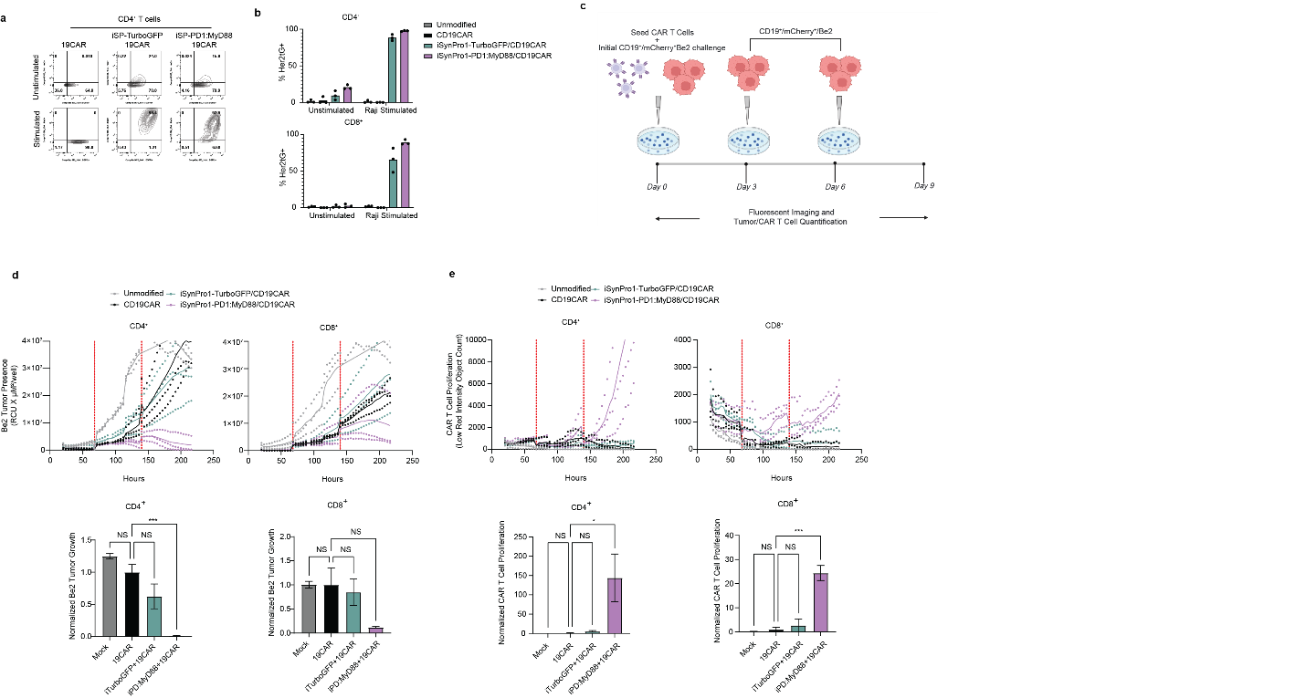
Extended Data Fig. 7 | Characterization of a potency enhancement transgene under iSynPro1 regulation.
a, Flow cytometry of CD4⁺ effectors from a representative donor showing surface marker expression of EF1- and iSynPro1-driven cassettes in unstimulated or Raji stimulated T cells.
b, Percent of cells expressing surface marker HER2tG among the EGFRt⁺ population by flow cytometry in unstimulated or Raji stimulated T cells. Data are mean ± s.e.m. (n = 3 donors).
c, Experimental schema for Incucyte assay monitoring tumor control upon recursive additions of CD19t⁺/mCherry⁺ Be2 target cells.
d, Time-course of CAR T cell control of tumor growth in one representative donor. Data are represented as mean ± s.e.m. (top). Bar charts showing average tumor presence at end of assay. Data are represented as mean ± s.e.m. (n = 3 donors) (bottom). P values were determined by Dunnett’s multiple comparison test.
e, Time-course of CAR T cell proliferation in one representative donor. Data are mean ± s.e.m. or triplicate wells (top). Bar charts showing average CAR T cell accumulation at end of assay in three donors ± s.e.m. (bottom). P values were determined comparing groups to the average of 19CAR in three donors, utilizing Dunnett’s multiple comparison test. (n = 3 donors).
P values are denoted: NS, P > 0.05 *, P < 0.05, ***, P < 0.001. Exact P values are available in Supplemental Table 5. Illustration in part c was generated using BioRender.

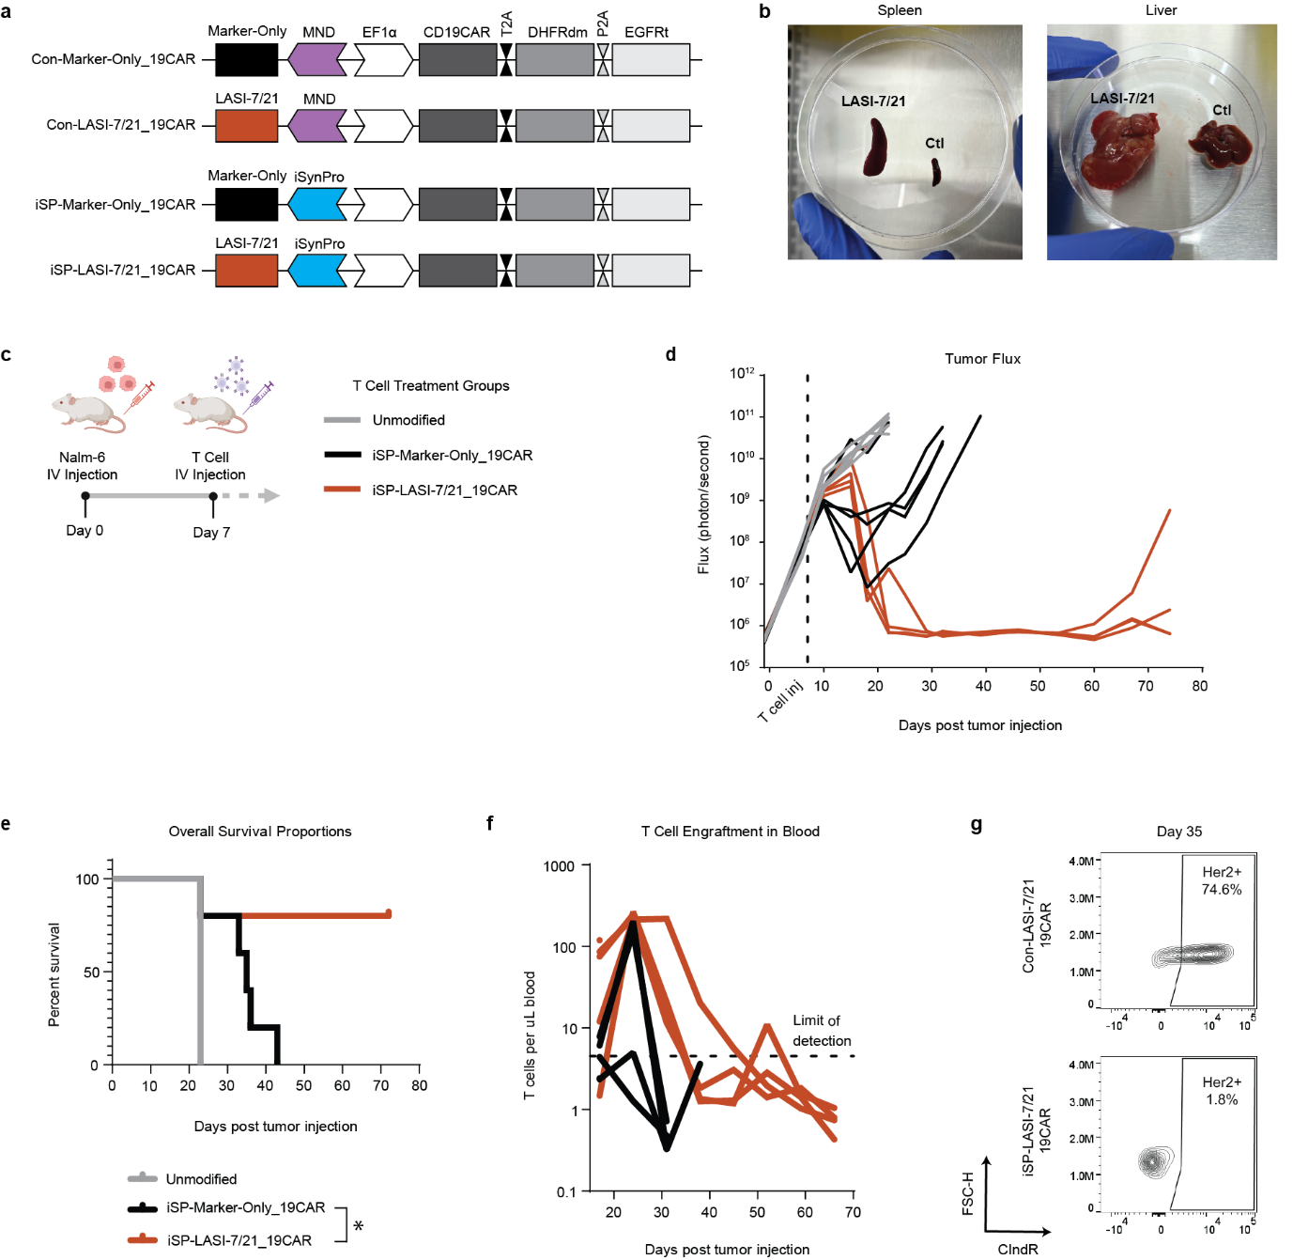
Extended Data Figure 8 | iSynPro1 regulation of a mitogenic transgene prevents T cell overgrowth and subsequent toxicity in vivo.
a, Schematics of constructs used to introduce constitutively expressed or iSynPro1-regulated transgenes alongside a constitutively expressed CD19CAR polycistron into primary human T cells.
b, Images of spleens and livers taken from a mouse treated with CD19CAR T cells constitutively expressing LASI-7/21 (“LASI-7/21”) and an untreated control mouse (“ctl”).
c, Experimental outline for in vivo testing of CD19CAR T cells.
d, Tumor flux values in mice treated with different T cell groups. Each line corresponds to an individual mouse.
e, Kaplan Meier survival curve with statistics comparing Marker-Only and LASI-7/21 groups. P values were determined by Mantel-Cox test. (n = 5 mice per group).
f, Longitudinal tracking of T cell concentrations in the peripheral blood of mice, with each line representing an individual mouse.
g, Flow cytometric analysis of LASI-7/21 expression in mice treated with CD19CAR T cells bearing constitutively expressed or iSynPro1-regulated LASI-7/21 at day 35 of study.
P value is denoted: *, P < 0.05, Exact P value is available in Supplemental Table 5. Illustration in part c was generated using BioRender.
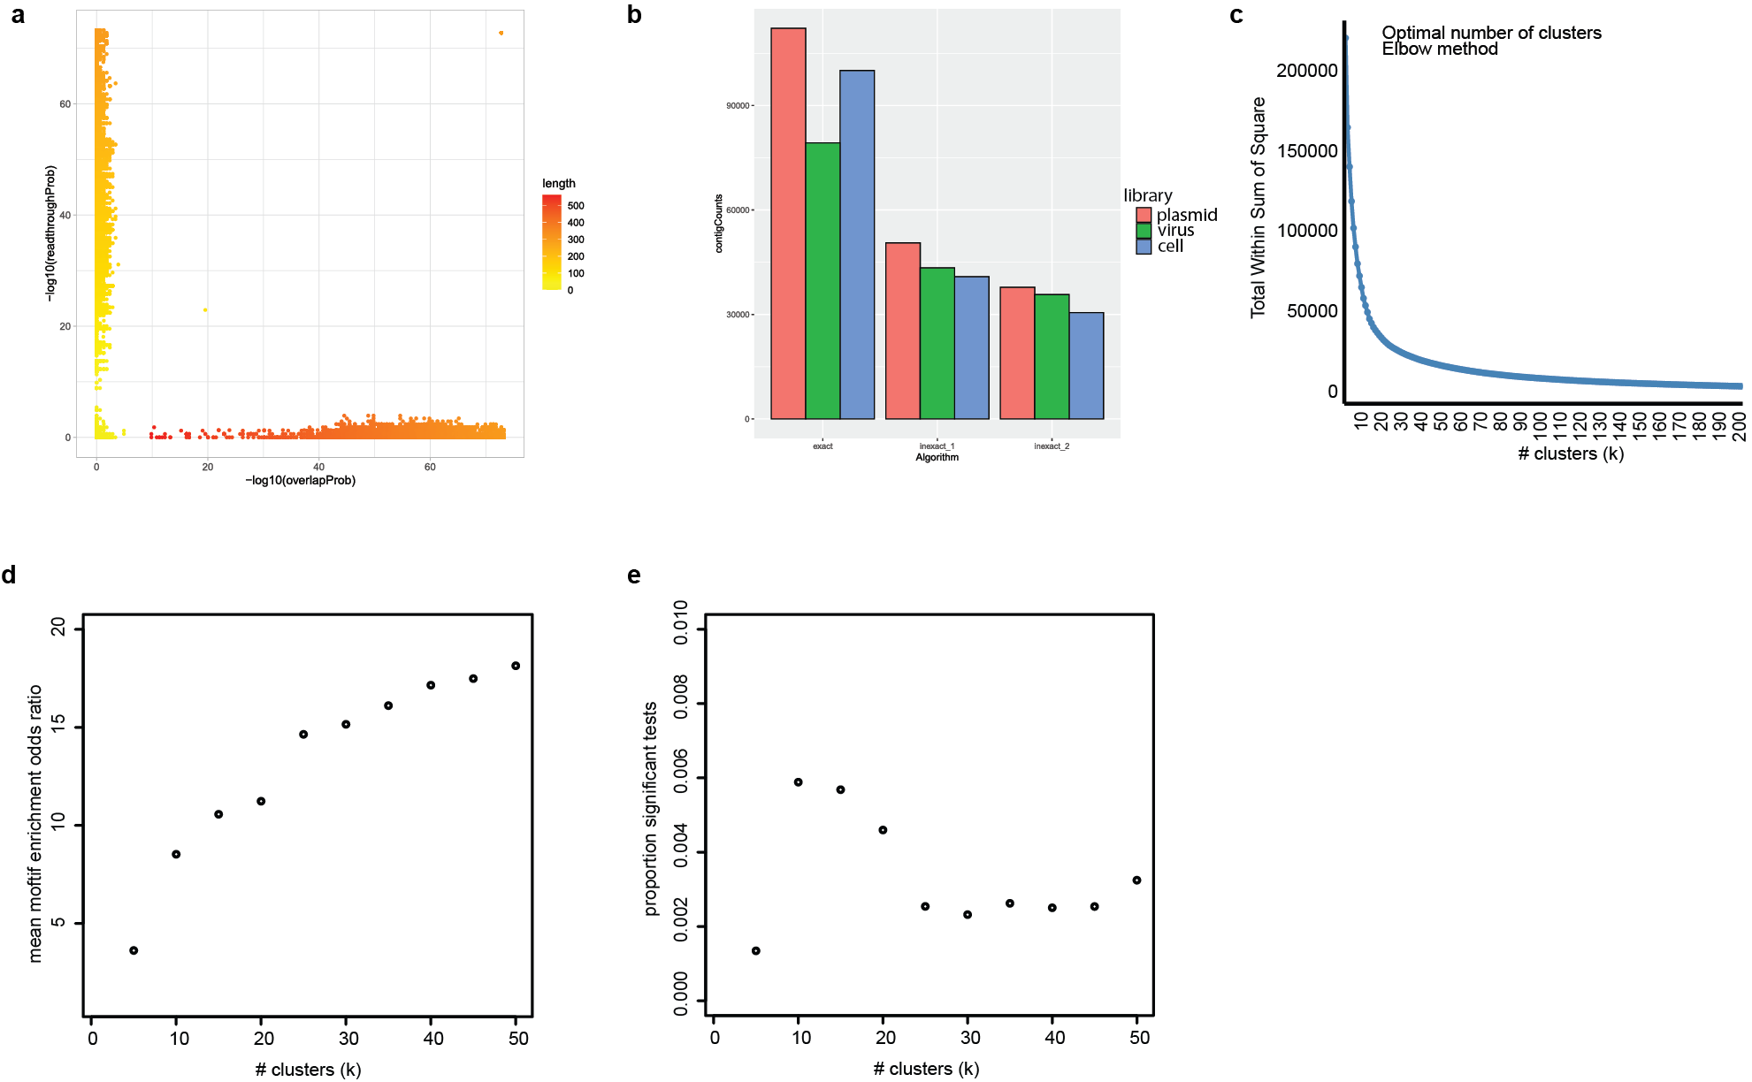
Extended Data Figure 9 | Quality measurements of iSynPro library reconstruction and assessment
a, Scatterplot showing readthrough and overlap score probabilities for read pairs during contig reconstruction by alignMerge. Legend shows final inferred length for reconstructed contigs.
b, Barplot displaying progressive TRE contig denoising for different libraries following successive algorithmic iterations of TREsCaller mapping: exact (for perfect match), inexact 1 (for one mismatch) and inexact 2 (for pairwise alignment).
c, Cluster parameter optimization evaluating within cluster sum of squares with increasing # clusters.
d, Plot of the mean of motif enrichment odds ratios for enriched TRE motifs as a function of the number of clusters. Enrichment odds ratio is determined by motif abundance within the cluster as compared to the entire population. Enrichments were assessed over motif sizes of 2-4 TREs (inclusive) and evaluated by Fisher’s test with a p-value threshold of 0.05 after Bonferroni correction.
e, Plot showing proportion of TRE motif enrichments observed as a function of the number of clusters. For each cluster and TRE motif evaluated, the proportion of positive tests (Fisher’s p value < 0.05 after Bonferroni correction) is shown. Enrichments determined as in d, above.

