SUPPLEMENTARY INFORMATION
Context-specific synthetic T cell promoters from assembled transcriptional elements.

Jia Wei*, Rithun Mukherjee*, Taylor K Ishida*, James M Rosser*, Christopher P Saxby*, John B Chase, Marc RJ Carlson, Cassandra L Sather, Wolfgang Rahfeldt, Michael Baldwin, Lindsay Flint, Michael Meechan, Cailyn H Spurrell, Josh Gustafson, Adam J Johnson, Jacob S Appelbaum**, and Michael C Jensen**#
* Contributed equally, ** Corresponding author # Primary contact

SUPPLEMENTAL TABLE LEGENDS

Supplementary Table 1. Oligos for transcription factor response elements (TREs) used in the study. Associated letter ID used in the study for purposes of mapping TREs in each orientation (forward ‘For’ and reverse ‘Rev’) to sequenced synthetic promoters along with corresponding transcription factor (TF) IDs is provided.

Supplementary Table 2. List of screened iSynPro candidates selected for further evaluation. Fold change in levels of these TRE contigs from the baseline values observed in the lentiviral library to the co-culture time-points are shown. Reference Supplementary Table 1 for TRE letter codes.

Supplementary Table 3. Numbers for TRE contig reconstruction categories by alignMerge and subsequent TRE mapping outcomes using TREsCaller.

Supplementary Table 4. Summary of “total” number of TRE contigs mapped and denoised by TREsCaller along with “selected” TRE contigs filtered for clustering. Corresponding cumulative reads (or counts) for “total” and “selected” contigs are shown. “Fraction” is the library proportion (measured in reads / counts) contributed by “selected” contigs.

Supplementary Table 5. Exact P-values and statistical tests performed.

Supplementary Table 6: List of primers and probes used for reverse transcriptase ddPCR.

SUPPLEMENTAL METHODS
Reconstruction of contiguous promoter sequences from paired NGS reads
Sequenced promoter templates are of variable length and incorporate repetitive sequences, thus containing reduced variation and presenting challenges for post-NGS template reconstruction. In addition, there is no reference sequence to guide alignment, and the underlying contig template length as well as the TRE composition is unknown. Sequencing errors and the block-like structure further exacerbate sequence ambiguity. After obtaining paired 300 base reads, we developed a computational approach (implemented in a module alignMerge) to optimize paired read assignments to one of three outcomes for underlying contig defined in bold italics as follows (also see Extended Data Fig. 1c). (1) For short templates, paired reads completely merge at their 5’ end (or prefix) and extend past each other, reading through into the backbone bases – this is deemed as a readthrough; (2) for long templates, the paired reads would merge in the middle, at their 3’ end (or suffix) – classified as an overlap; and (3) for longer templates exceeding 600 bases, there would be no merge, and as such they are beyond the scope of a 300x2 NGS configuration.
For each read pair, alignMerge slides the two reads past each other one base at a time and evaluates alignment. A maximum base mismatch-to-match ratio of 0.25 (one mismatched base for every four matched bases in an alignment) was allowed. The length of the longest qualifying suffix and prefix alignment for each read pair was recorded and a corresponding binomial p-value was calculated for the alignments using a probability of 0.25 for matched bases and 0.75 for mismatched bases and corrected for multiple comparisons (using Bonferroni method) based on the number of read pairs in a sample set. Alignments with significant p-values were considered.
For a given read pair, the outcome was deemed as an overlap or a readthrough respectively based on whether the qualifying suffix or prefix alignment was more significant. If none among the suffix or prefix alignment qualified the corrected p-value, then the outcome for the read pair was indeterminate given the insufficient evidence. Finally, if no suffix or prefix alignment was recorded, then the read pair was classified as a ‘no merge’ case, consistent with an underlying template longer than cumulative length of read pairs. Metrics for a representative sample (virus library) depicted in Extended Data Fig. 9a show probabilities for overlap (suffix alignment) or readthrough (prefix alignment) for sampled paired reads, indicating the overlap and readthrough are generally mutually exclusive findings with the exception of paired reads (top, right) for which overlap and readthrough probabilities are equal (occurs when the underlying template is exactly 300 bases long such that the prefix and suffix alignments are equivalent). Paired reads failing to merge are not shown.
Paired reads that overlap or readthrough are merged to reconstruct the underlying template sequence (if aligned bases from read pairs differ, they are resolved by choosing the base with the higher quality score) and readthrough sequences are trimmed of ‘excess’ bases that extend into non-promoter template. Sequences classified as indeterminate or no merge were discarded due to uncertainty in reconstruction of source template. Summary classification of merged promoter sequences is shown in Supplementary Table 3.
Assignment of TREs within promoter sequences
To convert paired/merged promoter nucleotide sequences assembled from paired reads to the corresponding underlying contiguous blocks of TRE units, we developed a computational module TREsCaller. First, promoter sequences were trimmed of non-TRE nucleotides sequenced at the 3’ end of the templates between the last (3’ most) TRE and the read 2 sequencing primer by identifying subsequences comprising residual capping and backbone nucleotides. Specifically, we identified either of two subsequences, TCGAGTAGAGTCTAGACTCTACATTTTGACACCCCCA or TCGATCGACTCTACATTTTGACACCCCCA, allowing for up to two nucleotide mismatches due to sequencing errors (refer Methods: NGS Library Construction). Notably, this trimming does not apply to the raw library templates, which lack backbone sequences and were sequenced by direct ligation of Illumina adapters. The remaining nucleotides, consisting of only informative bases, are expected to correspond to back-to-back TREs connected by a TCGA linker.
TREsCaller searches and annotates TRE sequences using three passes of decreasing stringency. First, TREsCaller annotates exact TRE matches, then repeats searches of unmapped regions allowing for one mismatch. A third (final) round of TRE assignments was accomplished by pairwise alignment as follows:
1. All possible 1-4 TRE combinations were generated and converted to their equivalent base sequence.
2. Remaining unannotated regions were queried against all such combinations and the best pairwise alignment recorded.
3. A threshold score was set requiring the number of matches to be 3 times or more the edit distance, which is the sum of mismatches and indels. If the best alignment qualified this threshold, the query region was annotated with the corresponding TRE combination.
Following the above steps, unannotated query regions were designated with a “*”. Longer query regions exceeding 4 TRE combinations in nucleotide length that could not be resolved with this strategy were also left unannotated (the computational cost to pairwise align >4 TRE combinations is prohibitive, and unannotated regions requiring this were rare).
Such successive TRE mapping from perfect to imperfect matches accounts for sequencing errors and minimizes noise in the sequenced dataset (Extended Data Fig. 9b). TRE-annotated denoised contiguous sequences (TRE contigs) are represented using letters for TREs (Supplementary Table 1) and * for residual unmapped regions (as noted above). Numbers of mapped TREs at each iteration of TRE assignments is tabulated in Supplementary Table 3.
Finally we assessed whether remaining alignMerge assembled sequences that failed to map to any TREs represented residual templates from the PhiX174 spike-in control by computationally fragmenting such contigs into chunks of 20 bases and aligning those to the PhiX genome. Sequences that aligned to PhiX or that did not match any TREs were discarded (Supplementary Table 3). A summary of the recovered reconstructed and denoised TRE contigs used for subsequent analyses is shown in Supplementary Table 4 (“Total” contigs and corresponding “Total” reads).
Evaluating TRE Contigs: clustering and motif enrichment
Denoised TRE contigs were obtained from each of the co-culture time points: 24h, 48h, 72h, and Restim. For each time point, TRE contig counts (i.e. reads per contig) were converted into counts per million (cpm). In subsequent examinations, TREs from each contig, or contigs themselves, were evaluated with or without consideration of the counts (or abundance) – respectively termed ‘weighted’ or ‘unweighted’ analyses. Variance in TRE levels across all libraries was assessed by first measuring proportions of each TRE within each library, and then evaluating the coefficient of variation of TRE proportions across libraries using both 'weighted’ and ‘unweighted’ approaches. (Extended Data Fig. 3a).
Next, TRE contigs with a cpm of <4 across all time points were filtered out. Remaining “selected” contigs are enumerated in Supplementary Table 4 and comprise >98% of the population of all libraries as measured by their read counts. Across all libraries, 1989 unique TRE contigs were recorded among this group. For these selected TRE contigs, counts were normalized within each library to permit assessment across time points. Using normalized levels in the lentivirus library as baseline, fold change (in log₂ units) in abundance of each TRE contig was recorded for each time point. The dynamic change in these levels across the course of the time points were clustered to reveal kinetic patterns of synthetic promoter expressions. Using the ‘within cluster sum of squares’ measure and the ‘elbow’ method of evaluation, we estimated 25 clusters would adequately summarize the observable kinetic patterns (Extended Data Fig. 9c). We generated 25 clusters ranging from 20-200 contigs each using the ‘hclust’ function and ‘ward.D’ method (implemented in R) for further investigation (Fig. 2e).
TRE motif enrichment was determined as follows. TREs from each contig were enumerated without consideration of contig abundance – accordingly, this is an ‘unweighted’ analysis that ignores contig counts (or their normalized levels). For each cluster, we asked if the number of each TRE was enriched compared to background (as evaluated by Fisher’s test) (Fig. 2f). Next, we assessed enrichment for combinatorial TRE motifs. For this exercise, we evaluated each contig with a sliding window of TRE units, and for each position recorded if the query motif was present in the window in any order. As an example, if the query motif was AB, where A and B are the two TREs, then the requirement is just that A and B occur within the neighborhood. For this purpose, AB and BA are equivalent motifs, and indeed there can be other TREs in the qualifying neighborhood. For a cluster, if the number of contigs with occurrences of such local combinatorial motifs were elevated compared to the background, then that motif was enriched (as evaluated by Fisher’s test). This exercise was repeated for motif combinations of 2, 3 and 4 TREs, with a neighborhood size of 4, 6 and 8 respectively (employing a sliding window that is 2x motif size). Summary enrichments for motif sizes of 3 is shown in Fig. 2g (other motif combination sizes are not shown).
As a sensitivity test, we varied the number of clusters and recorded the average odds ratio of TRE motif enrichments within clusters, which corresponds to the set of all qualifying Fisher’s test evaluations (significance level p < 0.05 after Bonferroni correction for multiple comparisons). This measure, which we can term ‘mean motif enrichment odds ratio’, reflects the cumulative TRE motif ‘enrichment signal’ . This measure increased when the number of clusters was expanded from 20 to 25, but thereafter remained stable (evaluated up to total # cluster of 50, in increments of 5) (Extended Data Fig. 9d). Additionally, we determined the proportion of TRE motif enrichments observed as a function of the number of clusters by evaluating the number of significant tests (or enrichments) as a proportion of all Fisher’s test evaluations performed. This second metric remained stable when total clusters numbered 25 or more (Extended Data Fig. 9e). Together, these data support the use of n = 25 clusters to evaluate TRE contig dynamics.

Supplemental Data
Supplemental Figure 1
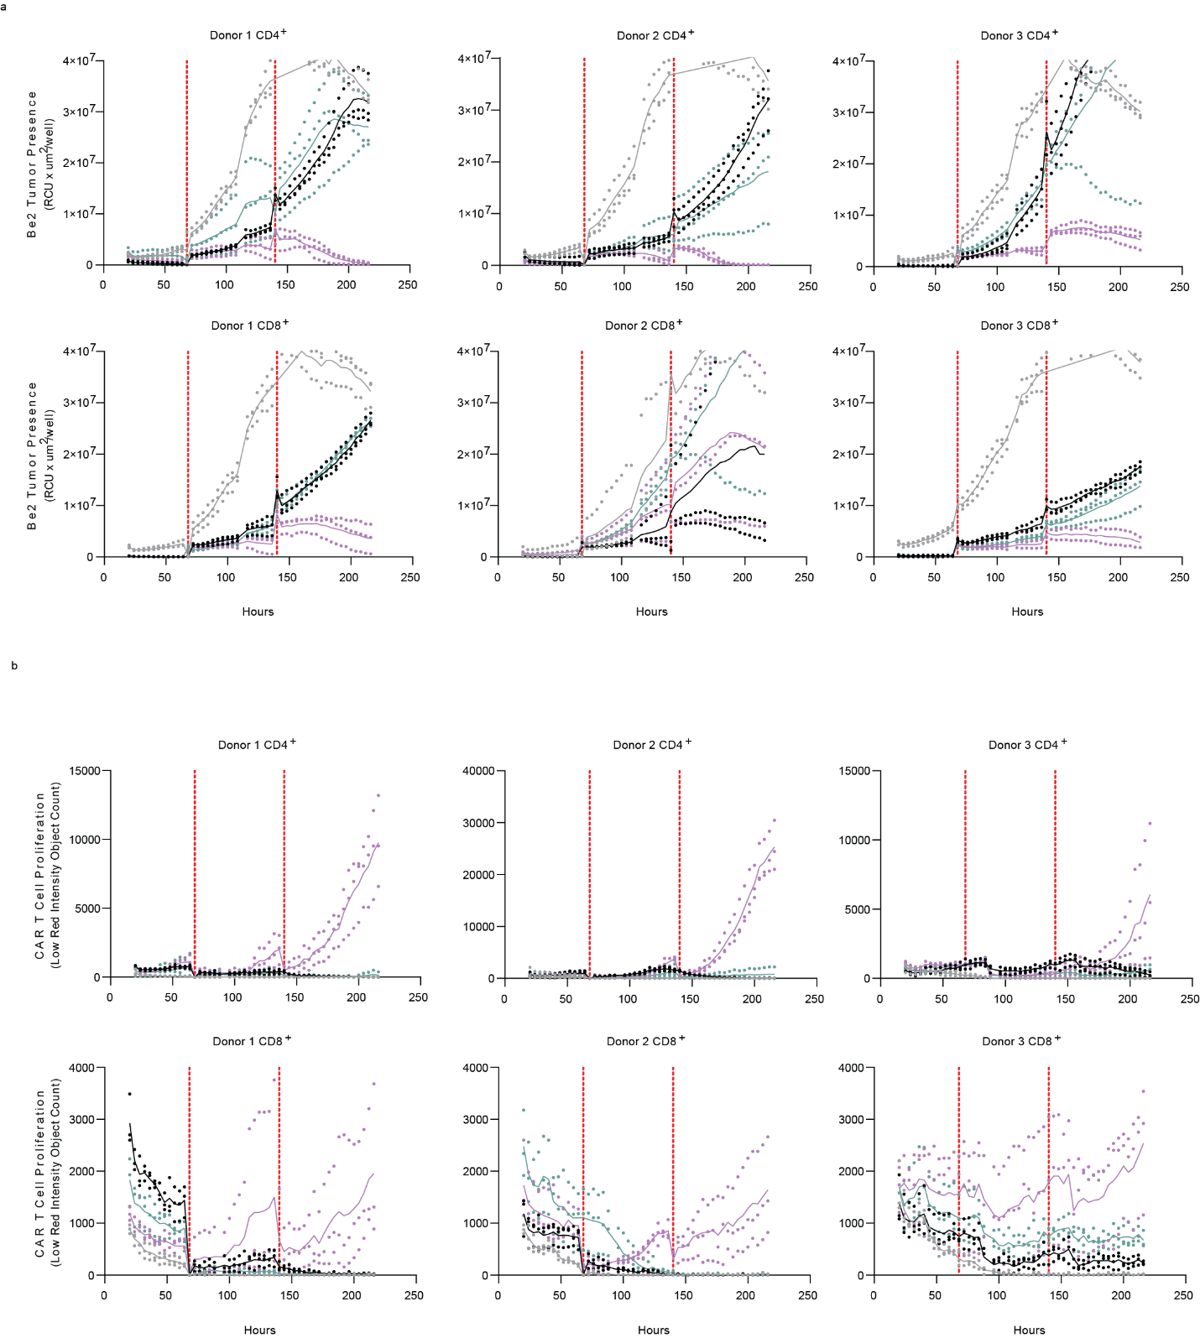

Supplemental Figure 1. Cytotoxicity and Proliferation profile of CAR T cell from individual donors following recursive tumor challenges. Incucyte traces following coculture of CD4 and CD8 effectors with Be2s over the course of nine days showing (a) tumor presences or (b) T cell proliferation. T cell products identified by color. Mock (grey), CD19CAR (black), CD19CAR + iSynPro1-turboGFP (Green) or CD19CAR + iSynPro_PD1:MYD88. Dots indicate technical replicates (n = 3). Proliferation and cytotoxicity profiles related to Extended Data Fig. 7.

Supplemental Figure 2
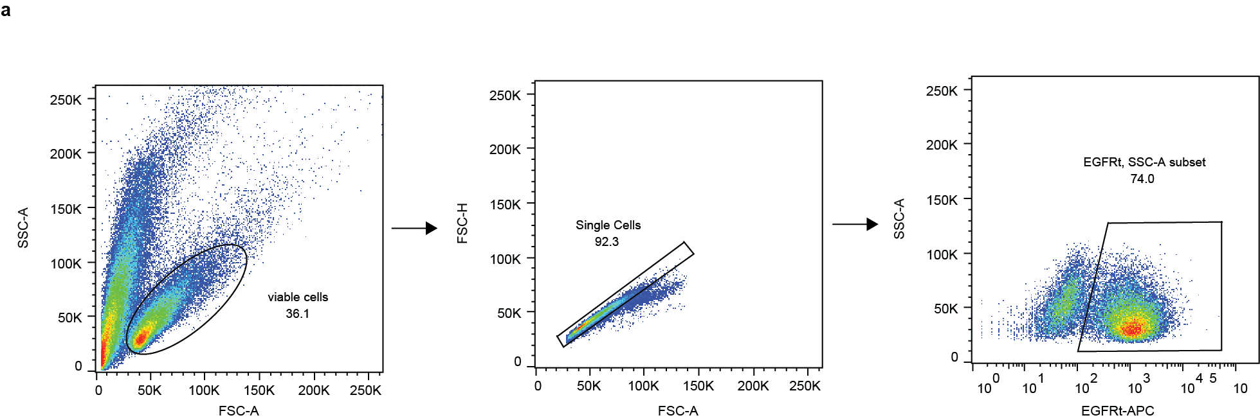
Supplemental Figure 2. Gating strategy for evaluation of transduced following immune effector cell manufacture. Cells were gated on lymphocytes -> single cells -> then EGFRt+ to determine CAR positive population.

