Additional file 1
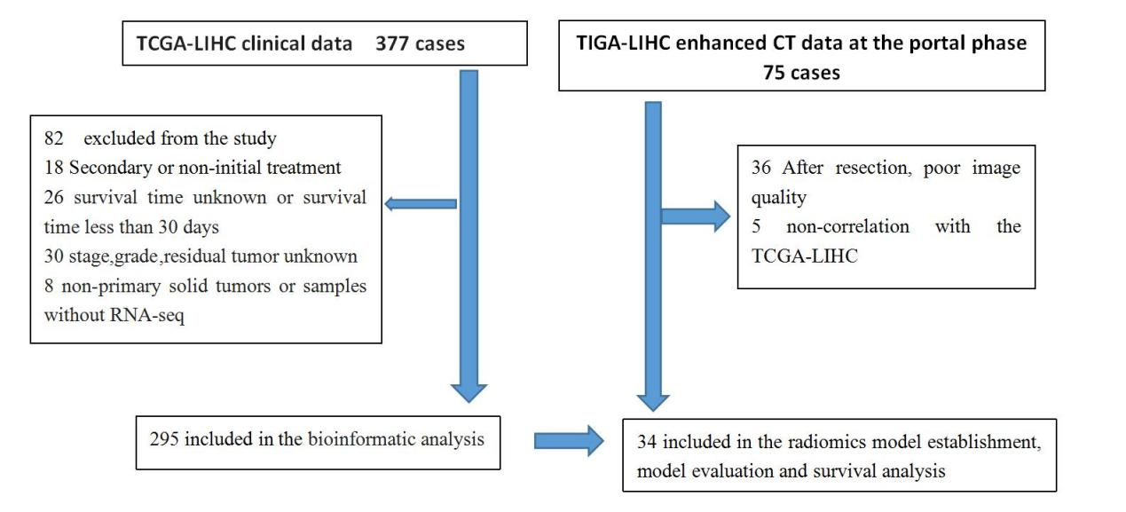
Supplemental Figure 1 Flowchart of the explicit inclusion and exclusion criteria of the study

