Unraveling the embryonic fate map through the mechanical signature of of cells and their trajectories
David Pastor-Escuredo^{a,b,*}, Benoît Lombardot^{c}, Thierry Savy^{a,c}, Adeline Boyreauª, René Doursat^{c}, Jose M. Goicolea^{d} Andrés Santos^{b}, Paul Bourgine^{a,c}, Juan C. del Álamo^{e,f,1}, María J. Ledesma- Carbayo^{b,1,*} and Nadine Peyriéras^{a,c,1,*}
Affiliations:
ªUSR3695/FRE2039 BioEmergences, CNRS, Paris-Saclay University, Gif-sur-Yvette, France.
^{b}Biomedical Image Technologies, ETSIT, Technical University Madrid, 28040, Spain. & Biomedical Research Center in Bioengineering, Biomaterials and Nanomedicine (CIBER-BBN), Spain.
^{c}UPS3611 Complex Systems Institute Paris Ile-de-France (ISC-PIF), CNRS, Paris, France
^{d}Computational Mechanics Group, Technical University Madrid, 28040, Spain.
^{e}Mechanical and Aerospace Engineering Department, University of California San Diego, La Jolla, CA 92093, United States.
^{f}Institute for Engineering in Medicine, University of California San Diego, La Jolla, CA 92093, United States.
*Corresponding authors: nadine.peyrieras@cnrs.fr, mledesma@die.upm.es, david@lifedlab.org
¹These authors equally contributed

This PDF file includes:
Figure supplements
Legends for movies
Supplementary Tables

Figures

Supplementary Fig. 1: Digital zebrafish embryo from 3D+time imaging
Supplementary Fig. 2: Cell displacement regularization
Supplementary Fig. 3: Phenomenology of gastrulation of wildtype zebrafish embryo from instantaneous deformation descriptors
Supplementary Fig. 4: Phenomenology of gastrulation of zoeptz57/tz57 mutant zebrafish embryo from instantaneous deformation descriptors for zoeptz57/tz57 mutant
Supplementary Fig. 5: Deformation of cell layers at the midline during wildtype zebrafish gastrulation
Supplementary Fig. 6: Phenomenology of wildtype zebrafish gastrulation from cumulative deformation descriptors
Supplementary Fig. 7: Instantaneous vs cumulative compression and expansion descriptors in wildtype zebrafish embryo
Supplementary Fig. 8: Selection at tailbud of cell populations within the hypoblast and epiblast layers in wildtype zebrafish embryo
Supplementary Fig. 9: Selection of presumptive forebrain at shield for the unsupervised classification of LBPs in wildtype zebrafish embryo
Supplementary Fig. 10: Selecting the relevant number of Canonical Lagrangian Biomechanical Profiles
Supplementary Fig. 11: Variability of Canonical Lagranish
Supplementary Fig. 12: CLBPs of germ layers hypoblast and epiblast in wildtype zebrafish
Supplementary Fig. 13: Mechanical signature of cell trajectories
Supplementary Fig. 14: Lagrangian Biomechanical Map of wildtype zebrafish
Supplementary Fig. 15: Lagrangian Biomechanical Map of the eye vesicle of wildtype zebrafish
Supplementary Fig. 16: Lagrangian Biomechanical Map for different intervals of integration
Supplementary Fig. 17: Comparison of wildtype and mutant zebrafish embryos according to mechanical history
Supplementary Fig. 18: Lagrangian descriptors of gsc reporter expression clusters

Movies

Supplementary Movie 1: 3D+time imaging of wildtype zebrafish gastrulation
Supplementary Movie 2: 3D+time imaging of wildtype zebrafish gastrulation with marked gsc reporter
Supplementary Movie 3: 3D+time imaging of zoep^{tz57/tz57} mutant zebrafish gastrulation
Supplementary Movie 4: Eulerian descriptors of wildtype embryo from animal pole (embryo wt1)
Supplementary Movie 5: Eulerian descriptors of wildtype embryo from animal pole (embryo wt2)
Supplementary Movie 6: Eulerian descriptors of wildtype embryo from animal pole (embryo wt3)
Supplementary Movie 7: Eulerian descriptors of wildtype embryo from animal pole (embryo wt4)
Supplementary Movie 8: Eulerian descriptors of wildtype embryo from animal pole (embryo wt5)
Supplementary Movie 9: Eulerian descriptors of wildtype embryo from animal pole (embryo wt6)
Supplementary Movie 10: Eulerian descriptors of zoep^{tz57/tz57} mutant embryo from animal pole (embryo oep1)
Supplementary Movie 11: Deformation rates at the midline of wildtype zebrafish (embryo wt1)
Supplementary Movie 12: Deformation rates at the midline of wildtype zebrafish (embryo wt2)
Supplementary Movie 13: Deformation rates at the midline of wildtype zebrafish (embryo wt3)
Supplementary Movie 14: Deformation rates at the midline of wildtype zebrafish (embryo wt4)
Supplementary Movie 15: Deformation rates at the midline of wildtype zebrafish (embryo wt5)
Supplementary Movie 16: Deformation rates at the midline of zoep^{tz57/tz57} mutant zebrafish (embryo oep1)
Supplementary Movie 17: Comparison of Eulerian descriptors in wildtype and zoep^{tz57/tz57} mutant zebrafish (embryo wt1 vs oep1)
Supplementary Movie 18: Comparison between cell lineage and flow approximation of wildtype zebrafish
Supplementary Movie 19: Maps of cumulative descriptors of wildtype zebrafish
Supplementary Movie 20: Maps of cumulative descriptors of zoep^{tz57/tz57} mutant zebrafish
Supplementary Movie 21: Comparison of compression and expansion rates in a cohort of wildtype embryos
Supplementary Movie 22: Tailbud selection of germ layers in wildtype zebrafish embryo
Supplementary Movie 23: Lagrangian Biomechanical Map of wildtype zebrafish (embryo wt1)
Supplementary Movie 24: Lagrangian Biomechanical Map section of wildtype zebrafish (embryo wt1)
Supplementary Movie 25: Lagrangian Biomechanical Map of the eye vesicle of wildtype zebrafish (embryo wt1)
Supplementary Movie 26: Lagrangian Biomechanical Map of zoep^{tz57/tz57} mutant zebrafish (embryo oep1)
Supplementary Movie 27: Lagrangian Biomechanical Map of wildtype zebrafish (embryo wt6)

Supplementary Tables

Supplementary Table 1: Image acquisition parameters
Supplementary Table 2: Instantaneous descriptors
Supplementary Table 3: Finite-time descriptors
Supplementary Table 4: Tensor invariants computation

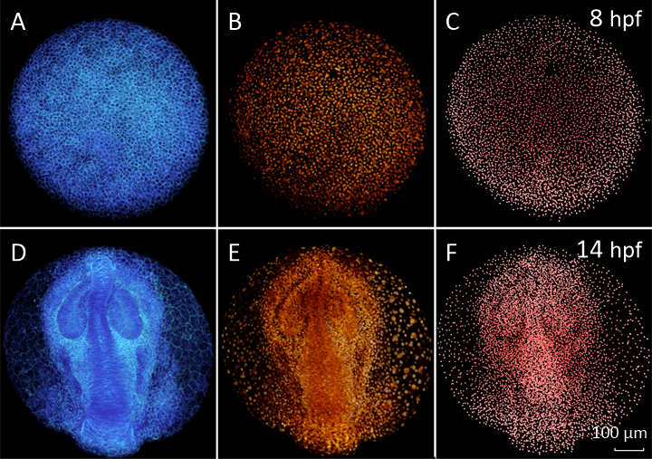

Supplementary Fig. 1: Digital zebrafish embryo from 3D+time imaging
Wild-type zebrafish embryo, animal pole view, anterior (ventral) to the top, dataset wt1 (snapshots taken with Mov-IT). Data acquisition parameters for all datasets (wild-types and zoep^{tz57/tz57} mutants) wt1-6 and oep1-5 are summarized in Supplementary Table 1. (A-C) 8 hpf, (D-F) 14 hpf. (A, D) raw data, membrane staining 3D rendering. (B, E) raw data, nuclear staining, 3D rendering. (C, F) detected nuclei $x_{i}$.
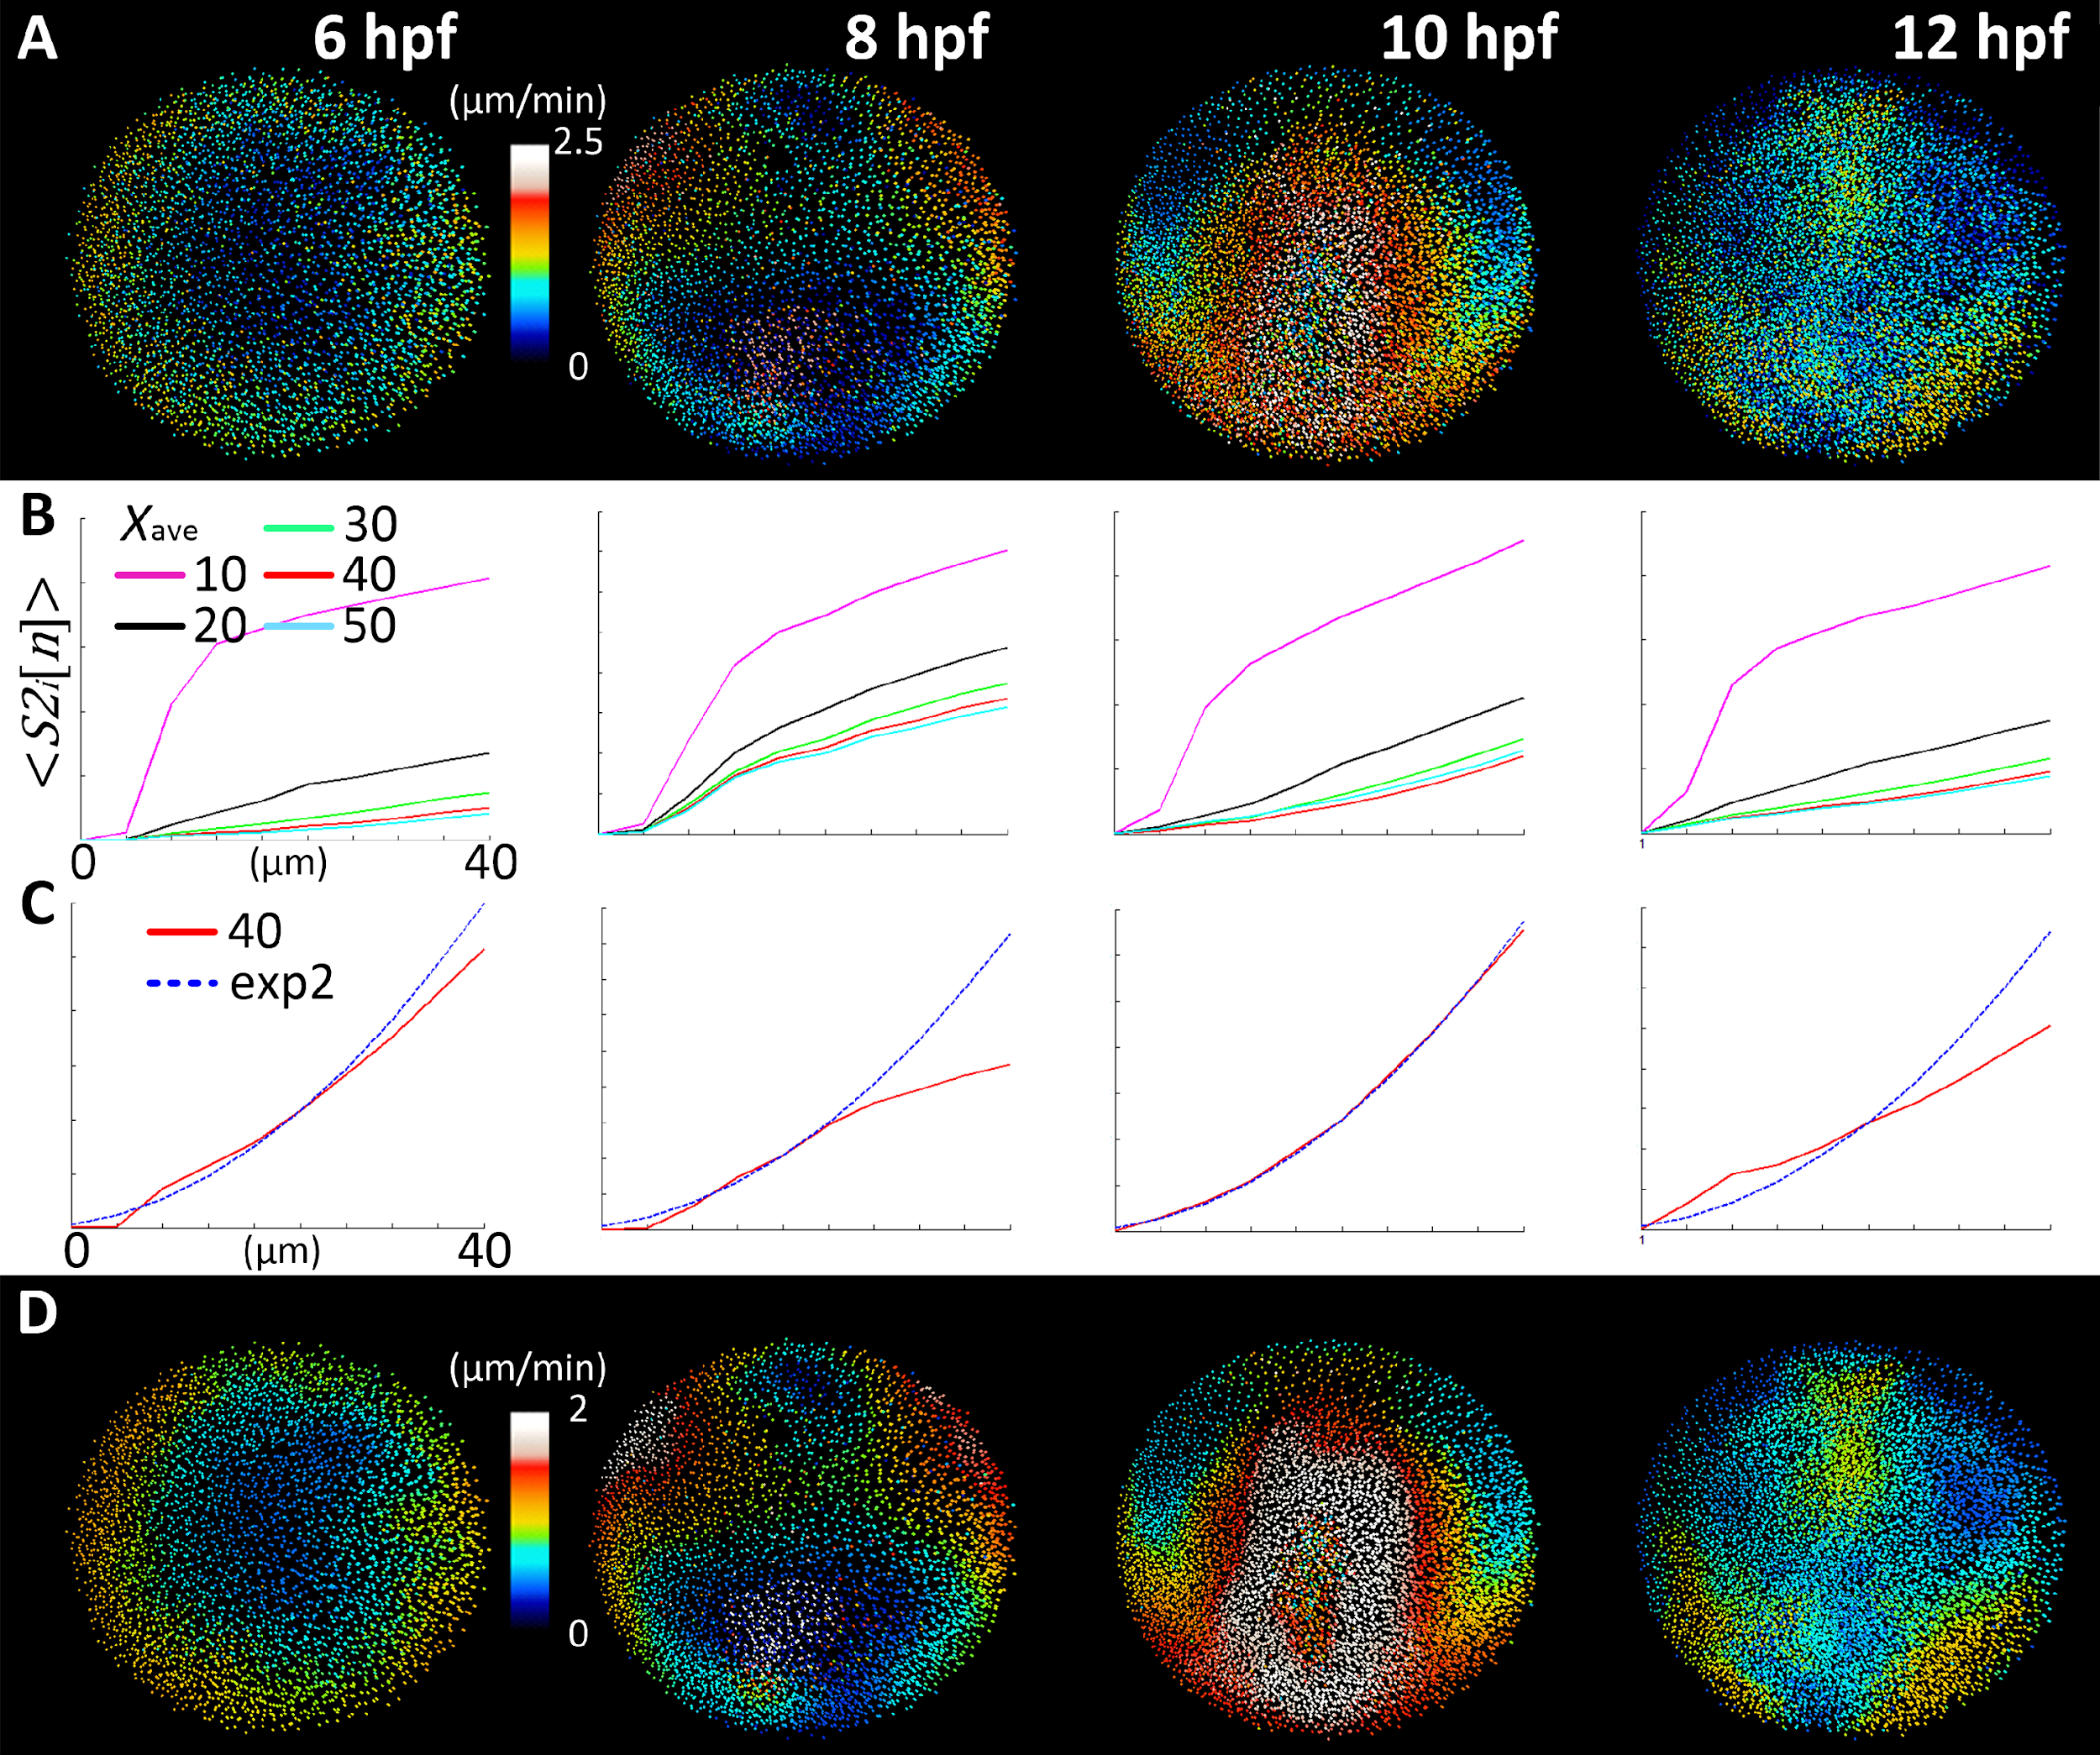Supplementary Fig. 2: Cell displacement regularization
(A) Displacement field $v_{T}(x_{i})$ implicit in the cell lineage after applying a temporal smoothing of the displacements along the lineage branches by the Gaussian kernel $N\left(0,T\right)$, ($T= 10 mins$), displayed here at different time steps of the development {6,8,10,12} hpf. Colormap goes from zero speed (dark blue) to maximum speed (white). (B) Ensemble-average of the second-order structure function $<{S2}_{i}[n]>$ for all $x_{i}$ in each time step, plotted as a function of the distance to $x_{i}$ discretized as $n$ concentric spatial rings ($dl=4 µm$, $n∈[1,10]$). Same time steps as in (A). Each curve represents the statistical differentiability given by the ensemble-average at each time step from the regularization of the vector field interpolated with a Gaussian kernel $N\left(0,R\right)$ for $X_{ave}=2R=\left\{10, 20, 30, 40, 50\right\} µm$. (C) Fitting of the ensemble-average of $<{S2}_{i}[n]>$ function for 2$R=40 µm$ to the power law curve of exponent 2 (exp2) that determines the limit of differentiability of the field. Best fit is obtained for the time step 10 hpf. For 12 hpf, the differentiable vector field had a worse fit with the differentiability limit curve. (D) Vector flow field $v_{TR}(x_{i})$ interpolating displacements using a Gaussian Kernel $N\left(0,20\right)$. This parameter value preserves the topology of the original vector field $v_{T}(x_{i})$, but with smoothened and clearer speed information. We interpret that this corresponds to the characteristic lengthscale of the tissue dynamics.

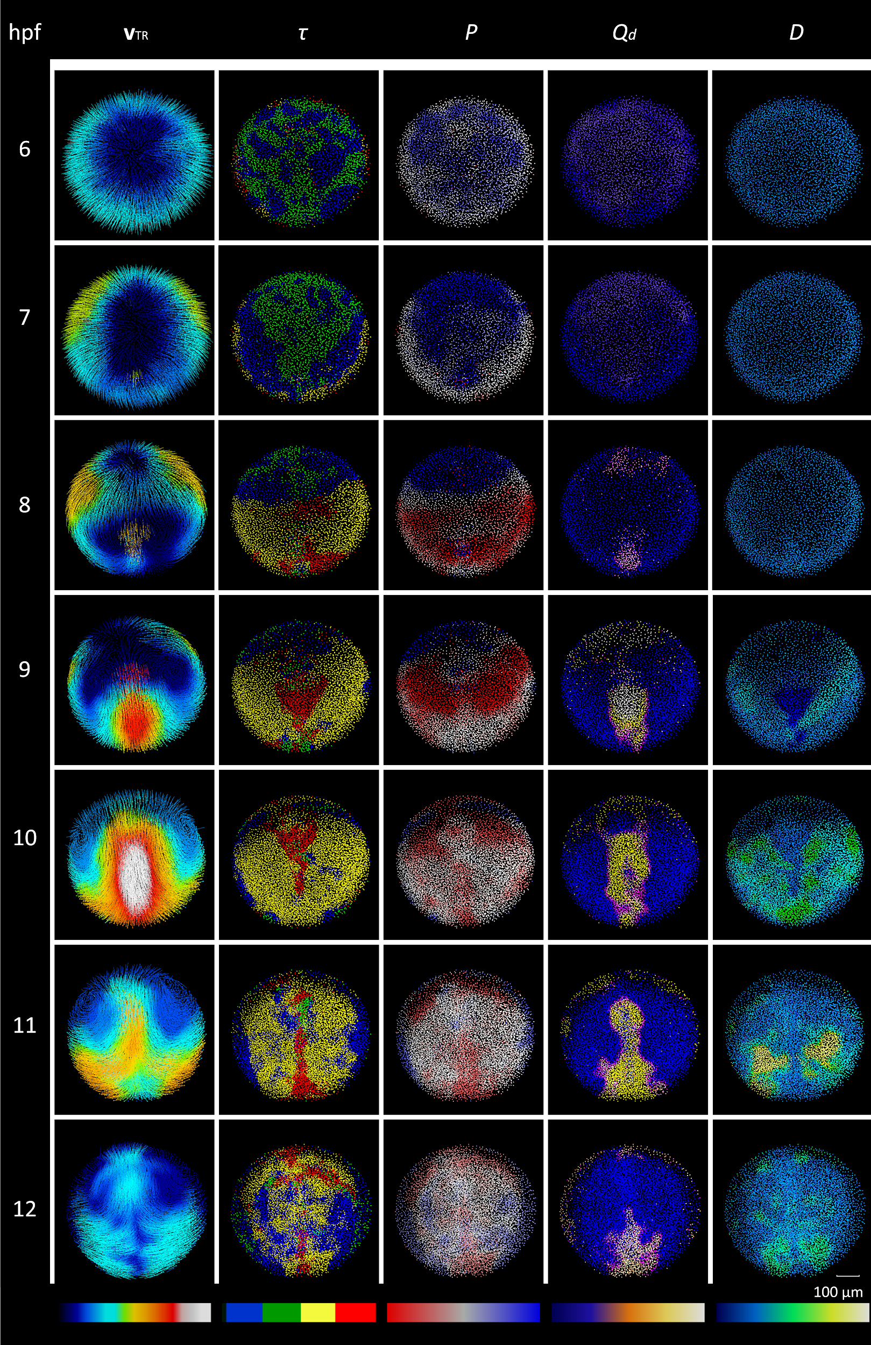
Supplementary Fig. 3: Phenomenology of gastrulation of wildtype zebrafish embryo from instantaneous deformation descriptors
Patterns of instantaneous deformation descriptors throughout gastrulation and early neurulation (6-12 hpf) in zebrafish wild-type embryo, animal pole view (wt1). Rows correspond to chosen developmental times (hpf). Columns display descriptors (Supplementary Table 2, 4): $v_{TR}$ (regularized velocity field), $P$(compression/expansion rate), $Q_{d}$ (distortion rate) and $D$ (rotation discriminant). Color map at the bottom of each column indicates minimum to maximum values from left to right. Scale bar 100 µm.

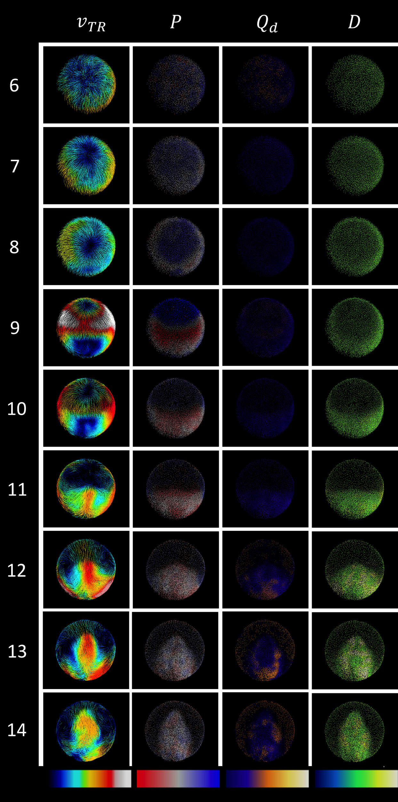
Supplementary Fig. 4: Phenomenology of gastrulation of zoep^{tz57/tz57} mutant zebrafish embryo from instantaneous deformation descriptors
Patterns of instantaneous deformation descriptors throughout gastrulation and early neurulation (6-12 hpf) in zebrafish mutant zoep^{tz57/tz57} embryo, animal pole view (oep1). Rows correspond to chosen developmental times (hpf). Columns display descriptors: $v_{TR}$ (regularized velocity field), $P$ (compression/expansion rate), $Q_{d}$ (distortion rate) and $D$ (rotation discriminant) and $τ$ (index as the combination of signs of $P$ and $D$). Color map at the bottom of each column indicates minimum to maximum values from left to right.

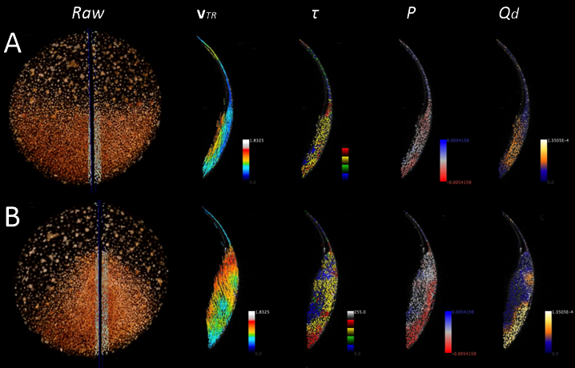
Supplementary Fig. 5: Deformation of cell layers at the midline during wildtype zebrafish gastrulation
Instantaneous descriptors ($v_{TR},$ $τ,$ $P$ and $Q_{d}$) along the midline. (A,B) Left panel: 3D rendering of the raw data (raw), animal pole view with a black line at the level of the midline. Selection of cells on both sides of the midline (in white) observed in lateral view in the four other panels. Each descriptor ($v_{TR},$ $τ,$ $P$ and $Q_{d}$ indicated top of each column) is displayed with its color code (bottom right of each panel). (A) 8:45 hpf (embryo wt4). We interpret that the descriptors distinguish the hypoblast from the epiblast as the hypoblast has a higher $v_{TR}$. The relative movements of the hypoblast and epiblast produce simple shear across the depth of the tissue as shown by $Q_{d}$. The hypoblast compresses less than the epiblast as shown by $P$ and $τ$. (B) as in (A) by 10:30 hpf. The epiblast undergoes compression ($P$) along the midline as well as high distortion ($Q_{d}$) indicating tissue rearrangement, likely to be a consequence of cell intercalation.
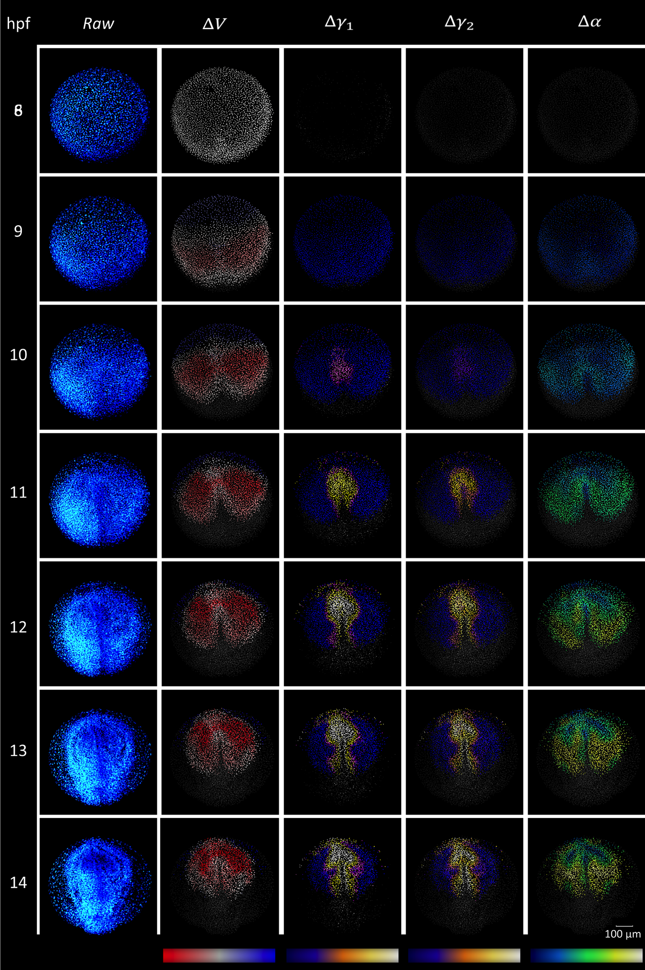
Supplementary Fig. 6: Phenomenology of gastrulation from cumulative deformation descriptors
Same type of display as in Fig. 3 for the embryo wt1 with cumulative deformation descriptors from the initial state $t_{ini}$) set at 8 hpf. Rows correspond to chosen developmental times (hpf). Columns display the 3D rendering of the raw data (nuclear staining) and the descriptors (Supplementary Table 3, 4): $∆V$(compression/expansion), $∆γ_{1}$and $∆γ_{2}$ (distortion), $∆α$ (finite rotation). Color map at the bottom of each column indicates minimum to maximum values from left to right. Scale bar represents 100 µm.

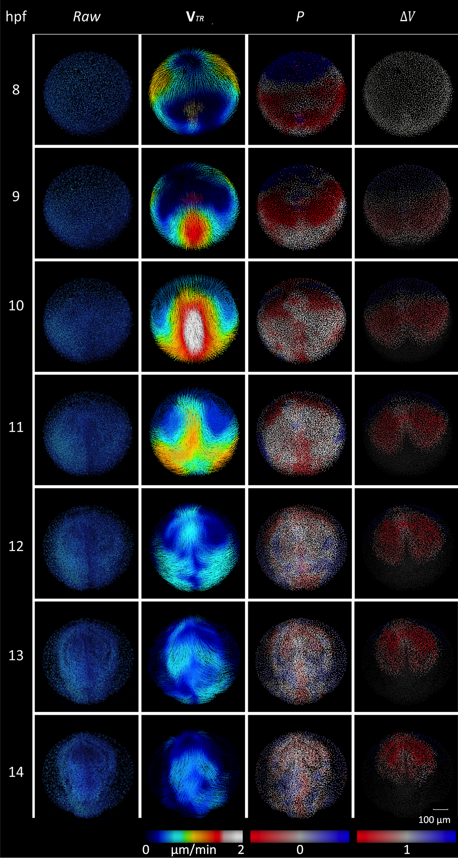
Supplementary Fig. 7: Instantaneous vs cumulative compression and expansion descriptors in wildtype zebrafish embryo
First column: raw data, 3D rendering of nuclear staining. Second column: $v_{TR}$ as in Supplementary Fig. 3. The color map from zero speed (dark blue) to the maximum of speed (white) as in Supplementary Fig. 3. Third Column: expansion activity denoted by $P$ (Eulerian descriptor). The color map for P goes from neutral (white=0) to compression (red) and expansion (blue) as in Supplementary Fig. 3. Fourth column: cumulative compression denoted by $∆V$ (LBP calculated using $t_{ini}$ = 8 hpf). Same color map as for $P$, no volume change has value 1 as in Supplementary Fig. 3. By 12 hpf P shows mainly neutral values while maximum compression has been reached for $∆V$ This observation is consistent with the decrease in $v_{TR}$ (2nd column), observed by the end of gastrulation (11 hpf), meaning that if tissue deformation happens at this stage, its scale is smaller than the mesoscopic scale defined by our smoothing step (see above).

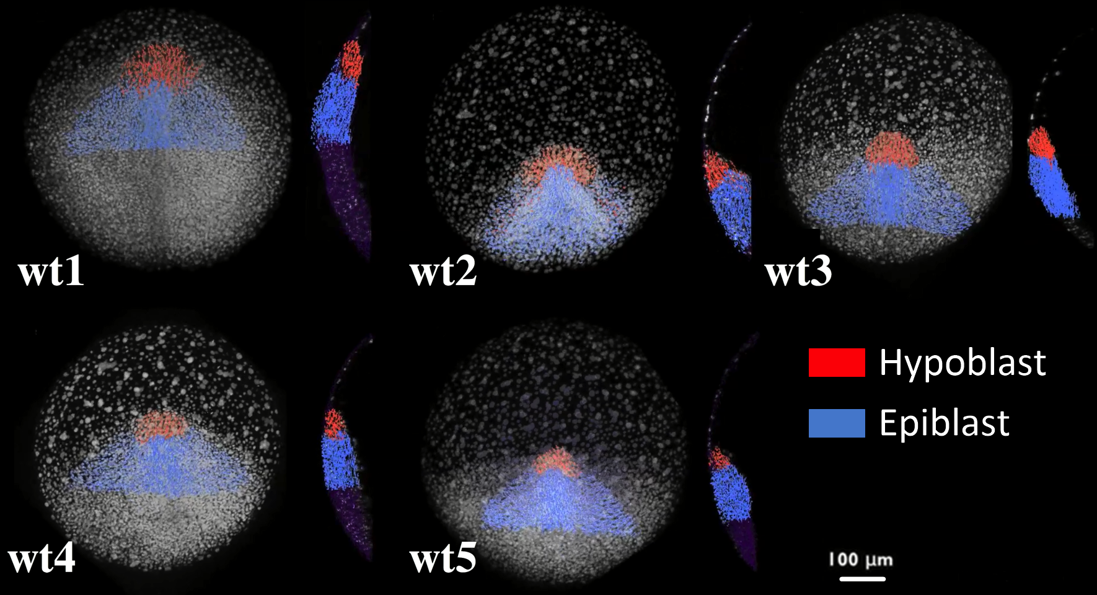
Supplementary Fig. 8: Selection at tailbud of cell populations within the hypoblast and epiblast layers in wildtype zebrafish embryo
Embryos wt1 to wt5 indicated top left. For each embryo animal pole view and lateral view of a sagittal section are displayed, anterior to the top. Snapshots with Mov-IT software display 3D rendering of nuclear raw data and selected nuclear centers. Scale bar 100 µm. Cell populations of similar shape and size were selected in the different embryos by the tailbud stage (10-11hpf). We called this selection “tailbud selection”. Based on the identification of the morphological border separating hypoblast (red) and hypoblast (blue), the two populations were distinguished. These selections are backtracked to define spatio-temporal domains throughout gastrulation (Supplementary Movie 15).

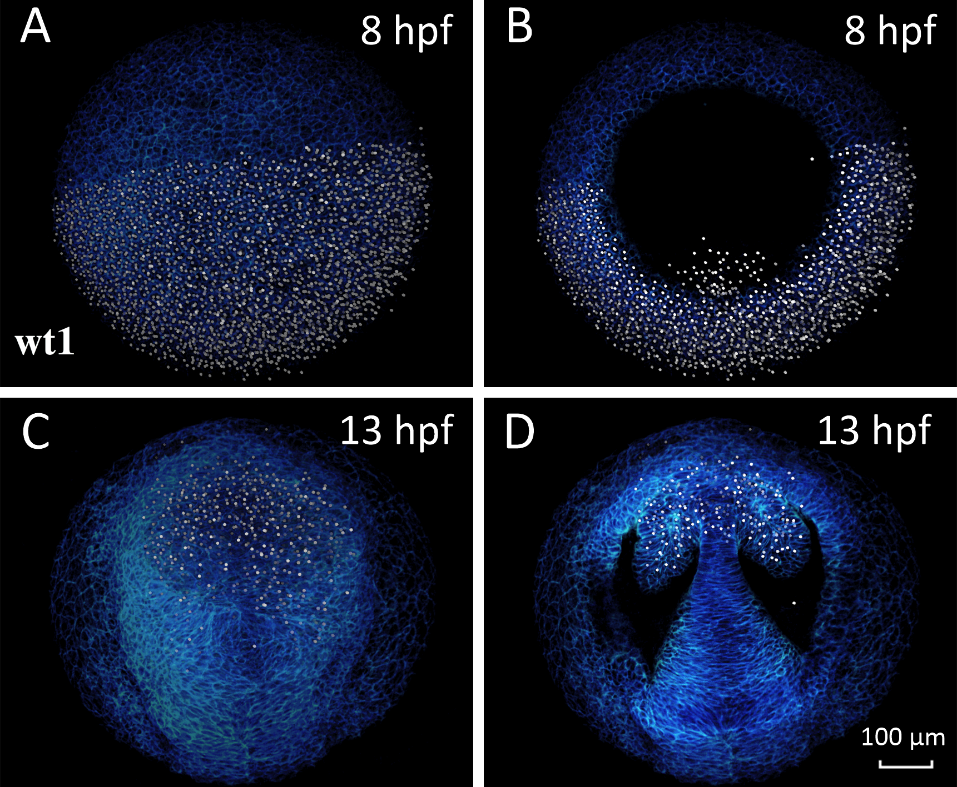
Supplementary Fig. 9: Selection of presumptive forebrain at shield for the unsupervised classification of LBPs in wildtype zebrafish embryo
Embryo wt1 animal pole view anterior to the top. 8 or 13 hpf indicated top right. Scale bar 100µm. (A) 3D rendering of the whole stack of images at 8 hpf. The domain manually selected with Mov-IT corresponds to the posterior half of the imaged volume through the whole depth of the blastoderm comprising hypoblast cells present the imaged volume (right panel 8 hpf). (B) Same selection but upper embryo sections removed up to 74 μm of depth. This selection was called “shield selection”. (C) 3D rendering of the whole stack at 13 hpf. The selection made by 8 hpf has been propagated through the cell lineage until 13 hpf showing that selected cells are fated to the forebrain including eye vesicles and that the selected cells are kept in the imaged volume. (D) Selection at 13 hpf and upper layers removed at the same depth than B showing a cross-section of the eye vesicles. This selection contains the germ layers selection of wt1 shown in Fig. 5.
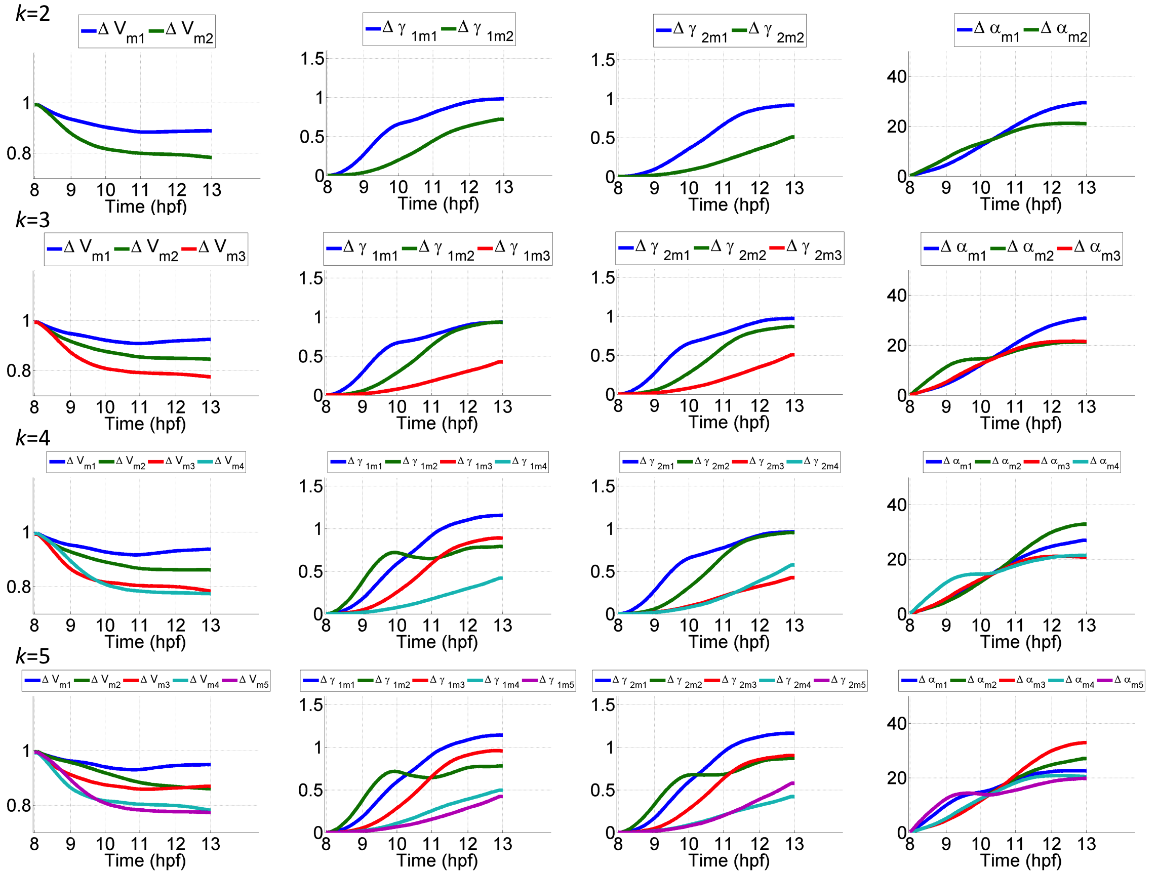
Supplementary Fig. 10: Selecting the relevant number of Canonical Lagrangian Biomechanical Profiles
Top subrow: Lagrangian Biomechanical Profiles (LBPs) ordered as resulted from the classification into Canonical Lagrangian Biomechanical Profile (CLBPs) along the trajectories (ordinates) as a function of time (abscissa in hpf) for cumulative deformation descriptors (columns: $∆V$, $∆γ_{1}$, $∆γ_{2}$ and $∆α$) for the shield selection in embryo wt1 (described in Fig. 6). Bottom subrow: The CLBP computed as the average of the trajectories grouped together by the clustering minimizing the variance of the cosine distance distribution of the trajectories. From A to C: k-means unsupervised clustering with increasing number of clusters k (from 2 to 5). Clustering minimizes the variance of the cosine distance distribution within groups of trajectories. In other words, LBPs are classified and ordered according to their similarity.

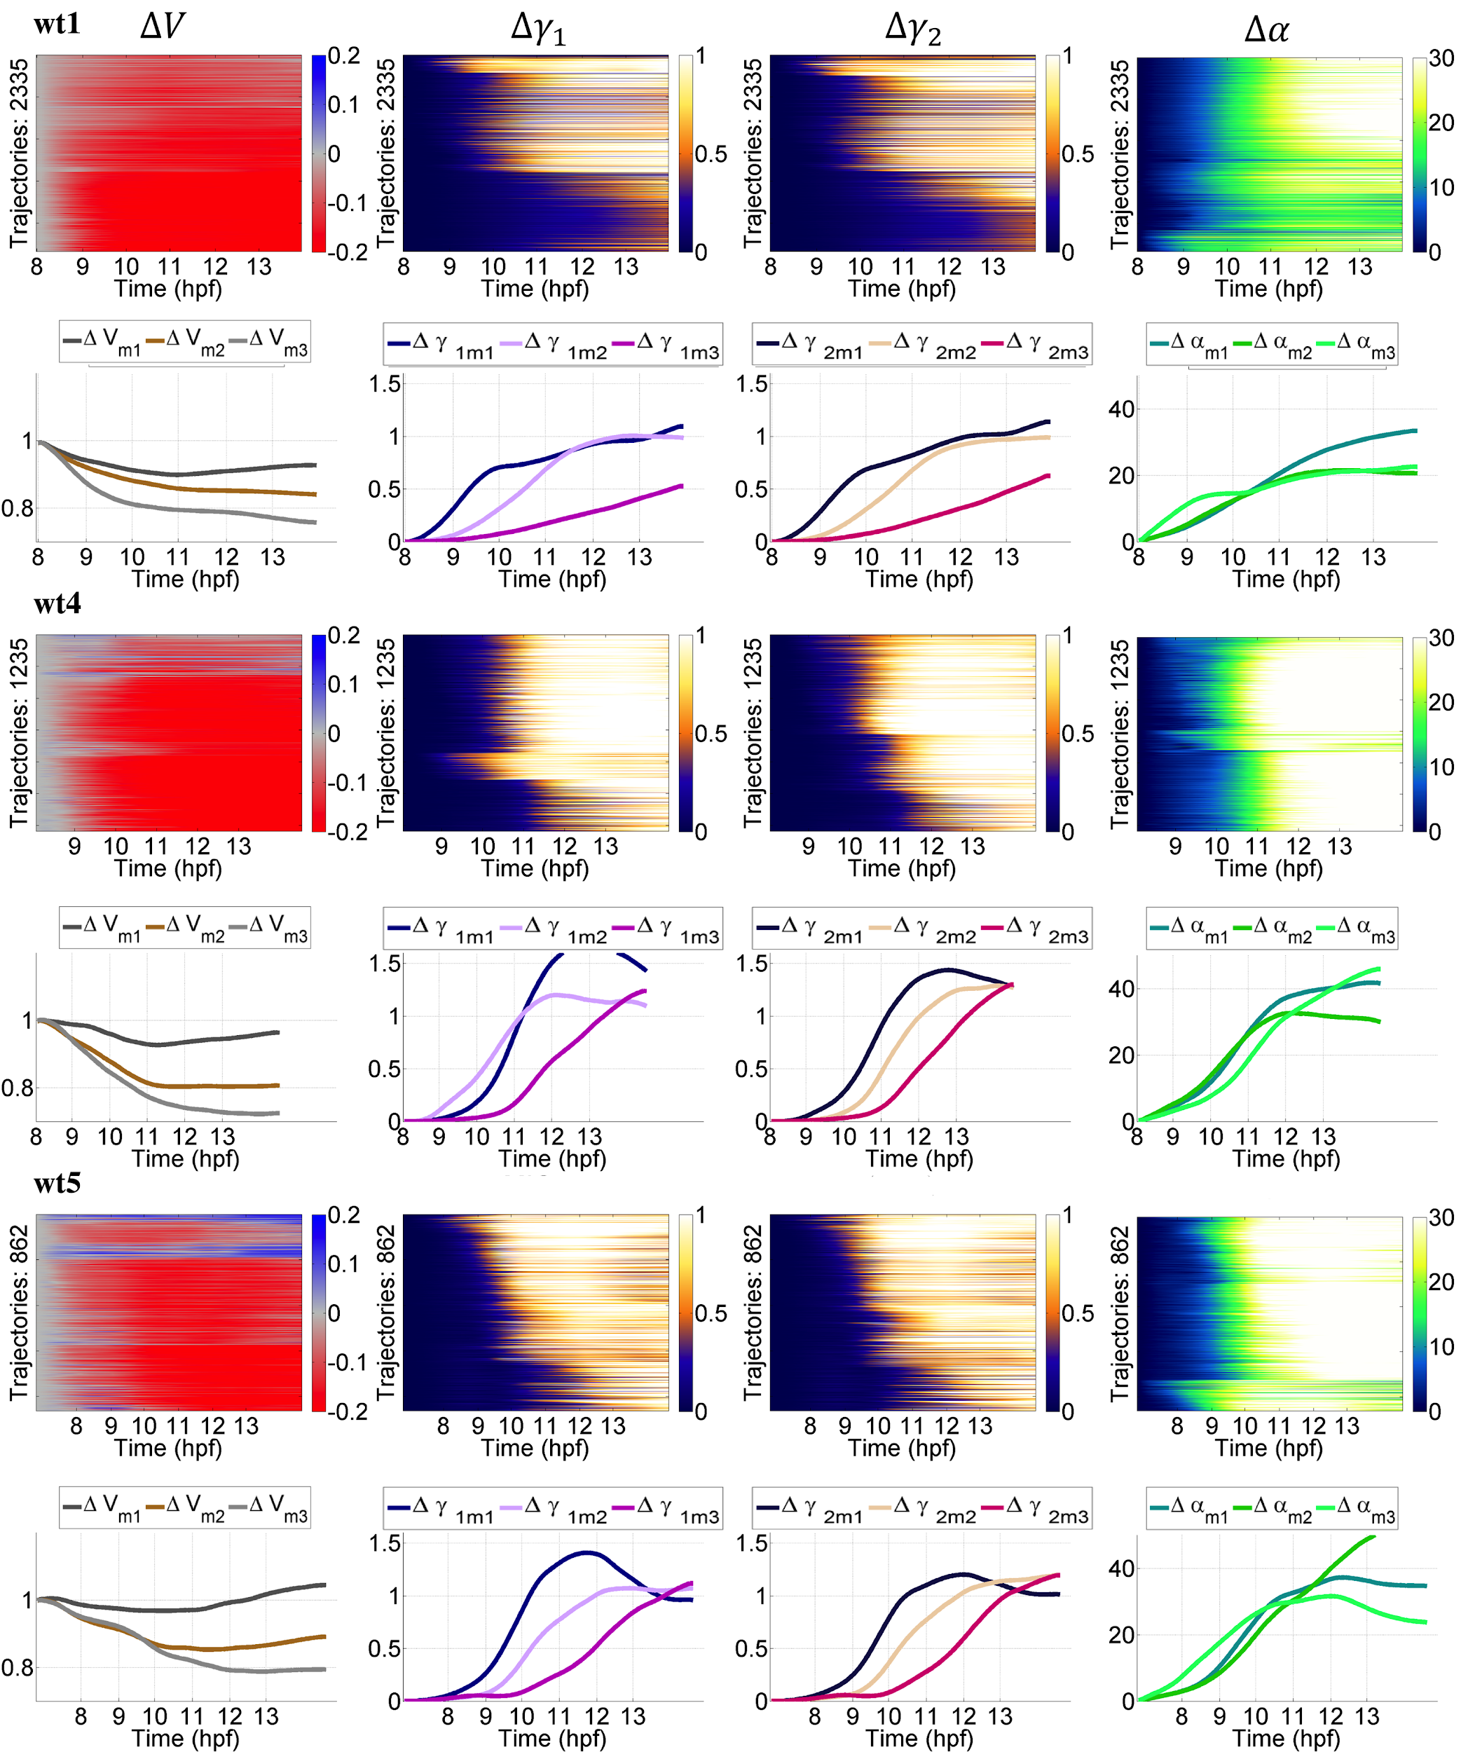
Supplementary Fig. 11: Variability of Canonical Lagrangian Biomechanical Profiles in the wildtype embryos cohort
LBPs for the cumulative deformation descriptors ($∆V$, $∆γ_{1}$, $∆γ_{2}$ and $∆α$) for the shield selection (as in Fig. 5) in embryos wt1, wt4 and wt5 (indicated top left of odd rows) corresponding to similar domains comprising epiblast and hypoblast layers. Even rows: plot as a function of time of the corresponding canonical LBPs obtained by k-means clustering with k=3.

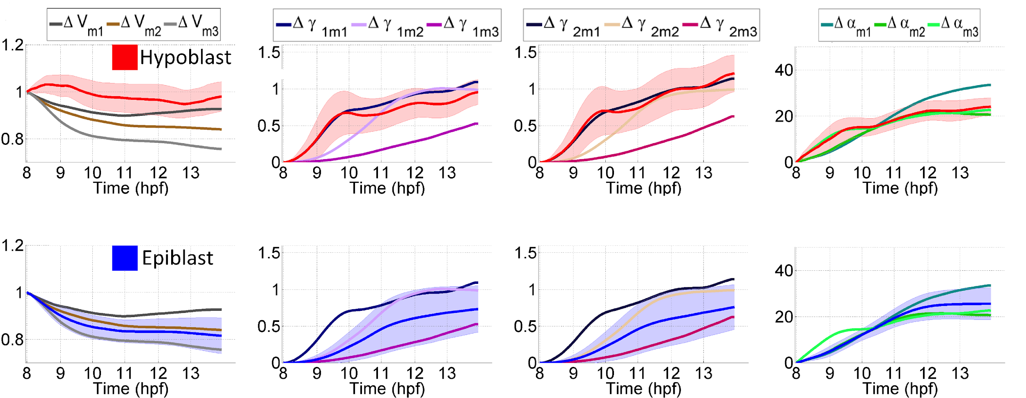
Supplementary Fig. 12: CLBPs of germ layers hypoblast and epiblast in wildtype zebrafish
(A) Lagrangian Biomechanical Profiles (LBPs) of selected cells in embryo wt1 (shield selection described in Fig. 5). Each image comprises all the LBPs by trajectory (y-axis) along time (x-axis) for $∆V$, $∆γ_{1}$, $∆γ_{2}$ and $∆α$. Trajectories are ordered by comparing their profiles with a cosine metric and using k-means clustering to group trajectories minimizing the variance of the metric. (B) Canonical LBPs for each descriptor as the mean profile of the trajectories within each cluster in (i.e. ${∆V}_{m1}$ for the first CLBP of $∆V$). Categorization was estimated as optimal with three CLBPs (Fig. 5). (C) Average LBP of the hypoblast (red as shown in Fig. 5 and Supplementary Movie 15) overlaid to the CLBPs. (D) Average LBP epiblast LBP (blue as shown in Fig. 5 and Supplementary Movie 15) overlaid to CLBPs. Two CLBPs were necessary to describe the profile of the epiblast layer.

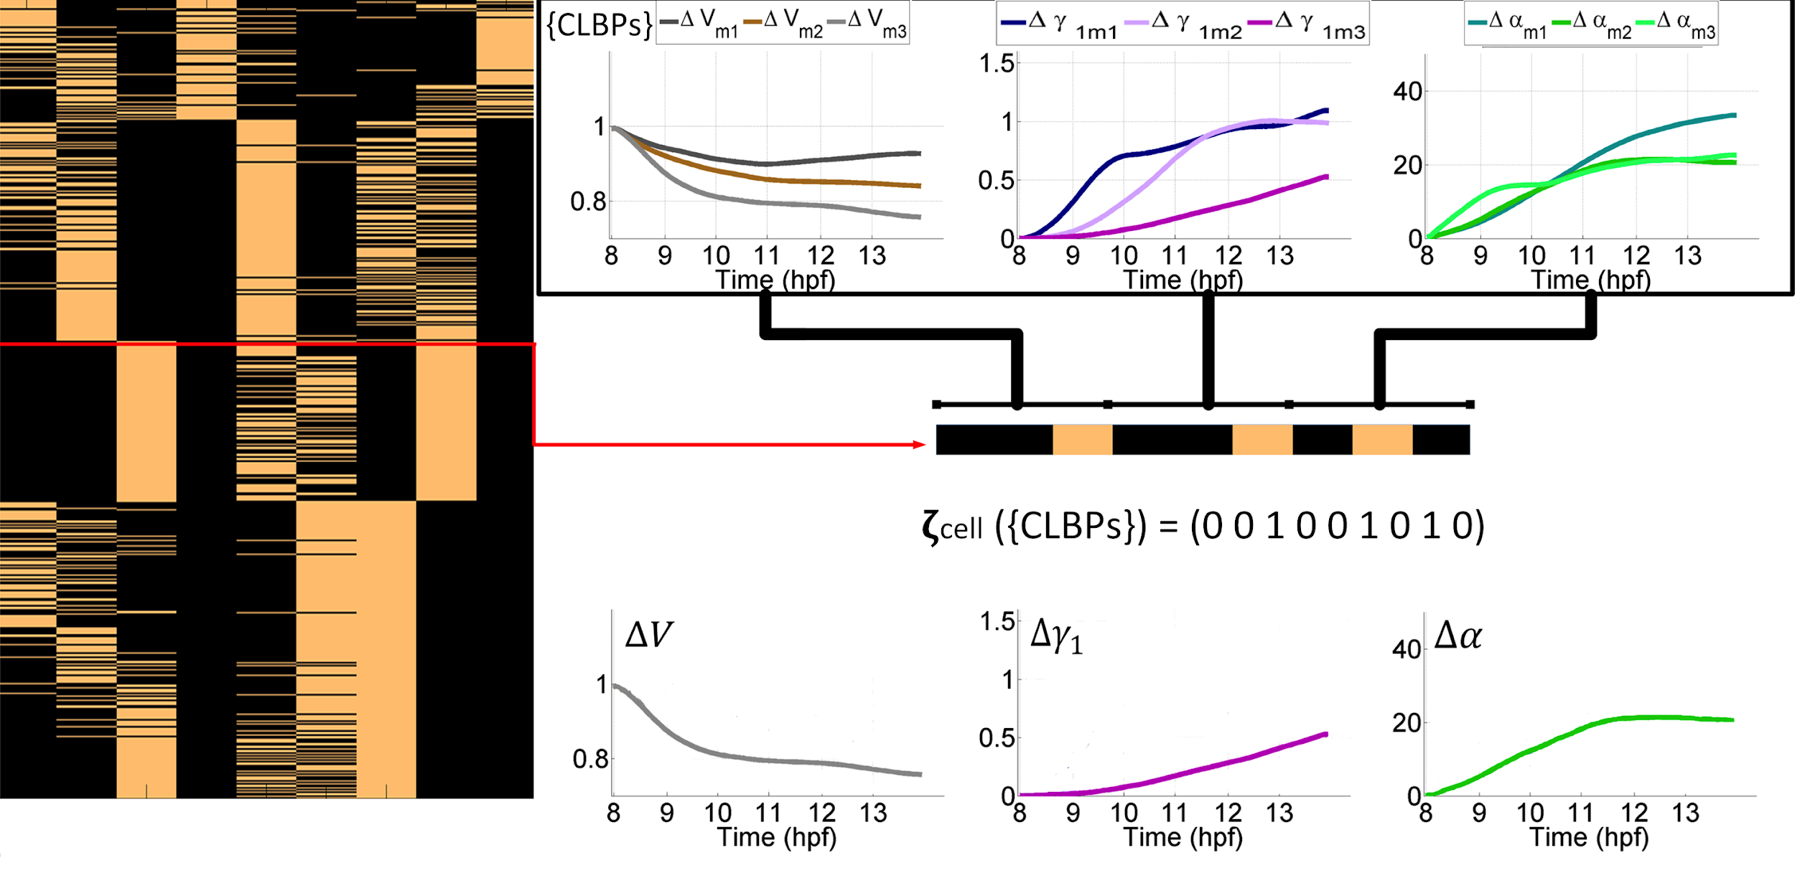
Supplementary Fig. 13: Mechanical signature of cell trajectories
Left panel: Mechanical signatures of trajectories $ζ_{j}(\left\{CLBP\right\})$ for the cells in the shield selection as shown in Fig. 5. The mechanical signature of each trajectory (ordinates) is defined by their specific set of CLBPs (abscissa). Right panel: construction of the mechanical signature of a cell trajectory. The signature is a 9-tuple composed of values 0 (black) or 1 (beige) depending on trajectory LBP greatest similarity (1 to the most similar and 0 to the others) to the canonical LBPs of the descriptors ($∆V$, $∆γ_{1}$, $∆α$ shown in the top row). Example of a trajectory with signature (001001010, middle row) resulting in a signature characterized by CLBPs ${∆V}_{m3}$, ${∆γ_{1}}_{m3}$ and${∆α}_{m2}$ (displayed right panel, bottom row).

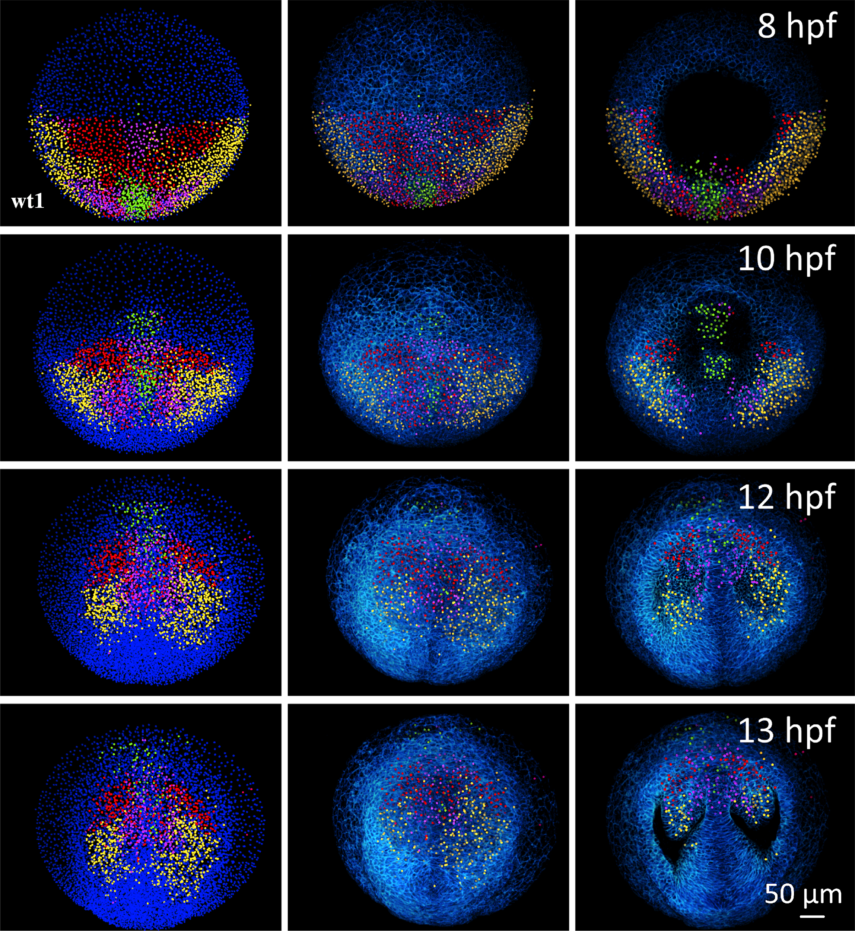
Supplementary Fig. 14: Lagrangian Biomechanical Map of wildtype zebrafish
Lagrangian Biomechanical Maps derived from the categorization of cells in 4 domains by 8 hpf (=$t_{ini}$) according to their mechanical signatures. Snapshots by 8, 10, 12 and 13 hpf (top left of each row). Animal pole view. First column: detected nuclear centers with staining of the four domains (green, red, yellow and pink). Second column: nuclear centers in the four domains with their respective colors and 3D rendering of the raw data membrane channel. Third column: same as second column but with removal of upper sections (down to 64 µm below the embryo surface) to reveal morphological landmarks for the hypoblast (8 and 10 hpf) and the regionalization of the eye vesicles (12 and 13 hpf).

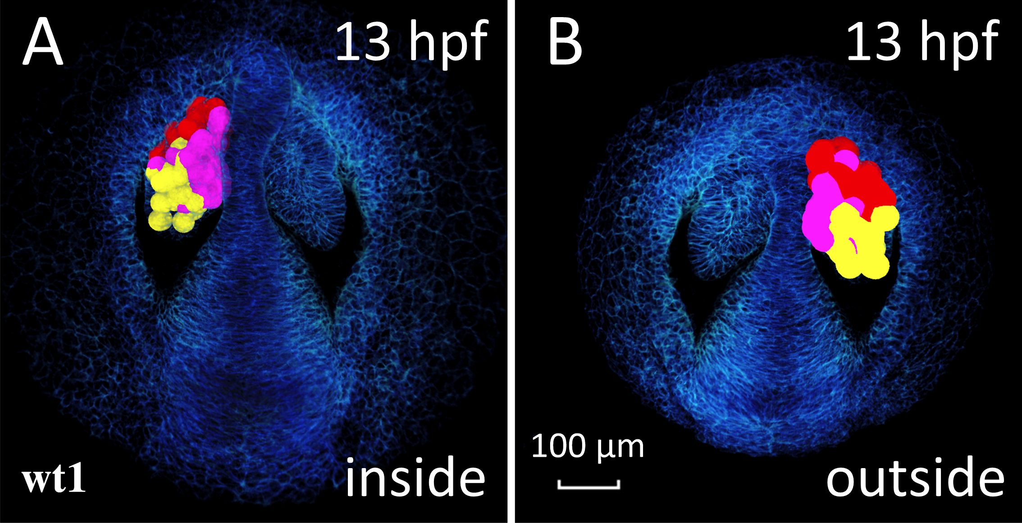
Supplementary Fig. 15: Lagrangian Biomechanical Map of the eye vesicle of wildtype zebrafish
Highlights the biomechanical domains in the eye vesicle by displaying the intersection of the Lagrangian Biomechanical Map and the eye vesicle. The cell contours are approximated by a sphere positioned on the detected nuclear center. Color code as in Fig. 5. Embryo wt1, anterior to the top, upper sections removed down to 64 µm below the embryo surface. (A) view from the outside. (B) View from the inside.

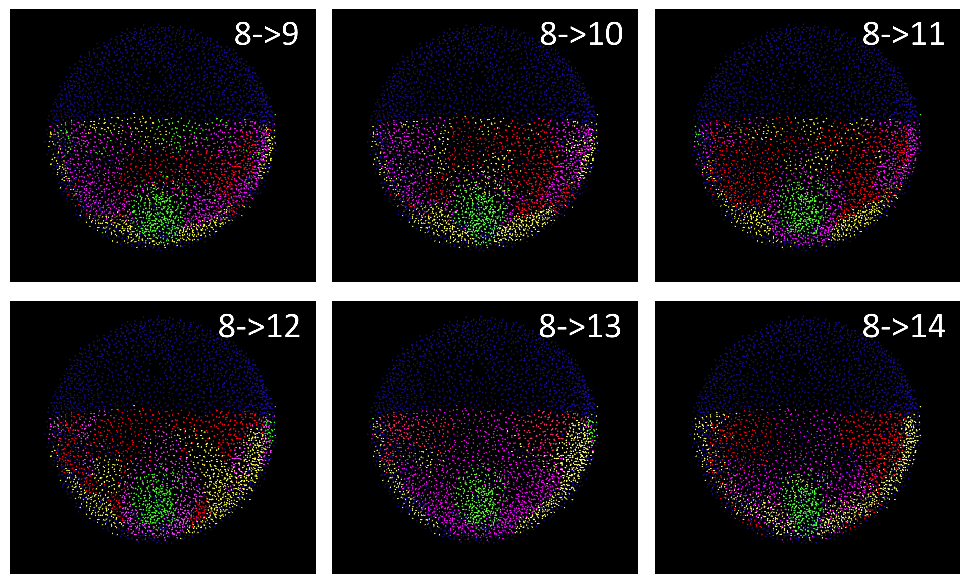

Supplementary Fig. 16: Lagrangian Biomechanical Map for different intervals of integration
Lagrangian Biomechanical Maps for wt1 derived from the categorization of cells in 4 domains by 8 hpf (=$t_{ini}$) according to their mechanical signatures. Each panel shows a different temporal interval of integration: 8-9, 8-10, 8-11, 8-12, 8-13 and 8-14 hpf.

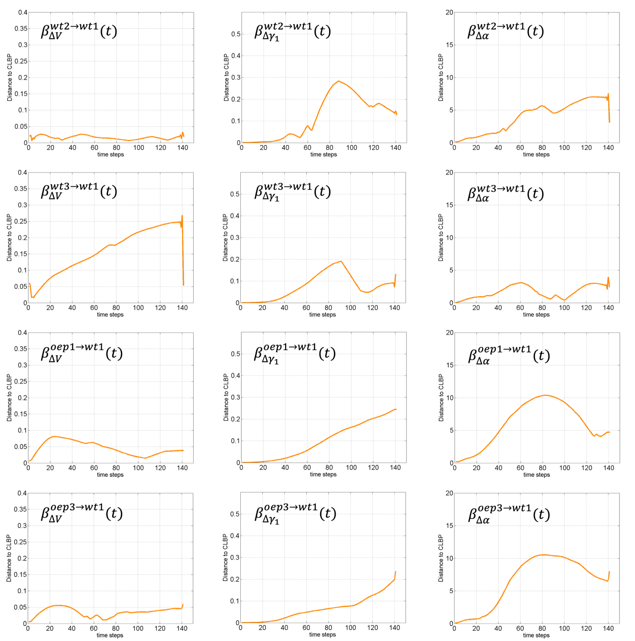-

Supplementary Fig. 17: Comparison of wildtype and mutant zebrafish embryos according to mechanical history
First row: wt2 onto wt1 projection for (from left to right) $∆V$, $∆γ_{1}$ and $∆α.$ Second row: wt3 onto wt1 projection for the same descriptors. Third row: oep1 onto wt1 projection for the same descriptors. Fourth row: panel oep3 onto wt1 projection for the same descriptors. Curves indicate the ensemble-average similarity of CLPBs of the projected specimen onto the CLBPs of the reference embryo wt1 at each time point.
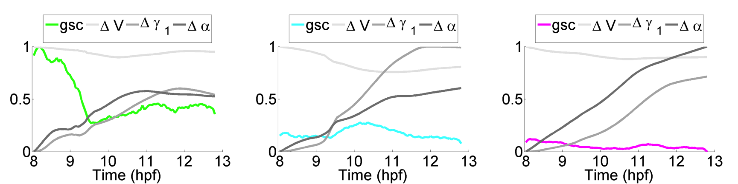

Supplementary Fig. 18: Lagrangian descriptors of gsc reporter expression clusters
Goosecoid reporter expression clusters (green, light blue and magenta) as defined in Fig. 6. The average of the cumulative descriptor for each cell domain defined by the cluster is shown. Values have been rescaled between 0 and 1 to be in the same range.

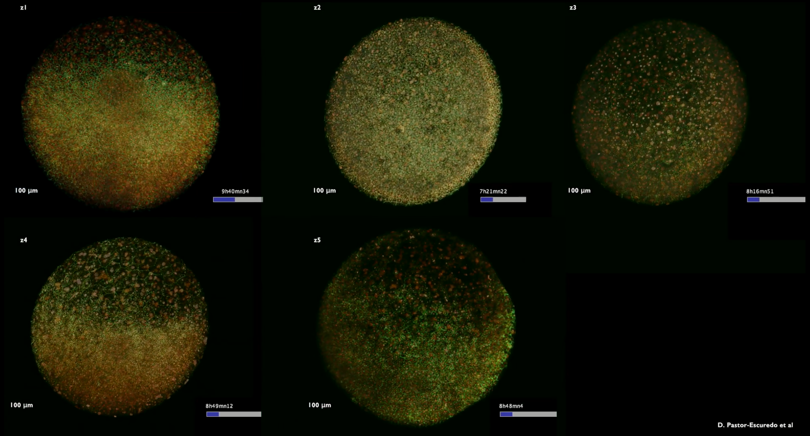
Supplementary Movie 1: 3D+time imaging of wildtype zebrafish gastrulation
Rendering of raw data overlaying the two channels for cell membranes (green) and nuclei (red) respectively (Mov-IT software). Embryos wt1 to wt5 indicated top left. Nuclei are marked with H2B-mCherry and membranes are marked with eGFP-HRAS. Embryos are aligned temporally to roughly synchronize the onset of their development. They are imaged from the animal pole and observed first from the outside then from the inside. Scale bars 100 µm.
High-resolution movie available at: http://bioemergences.eu/kinematics/videos/MovieS1.mp4

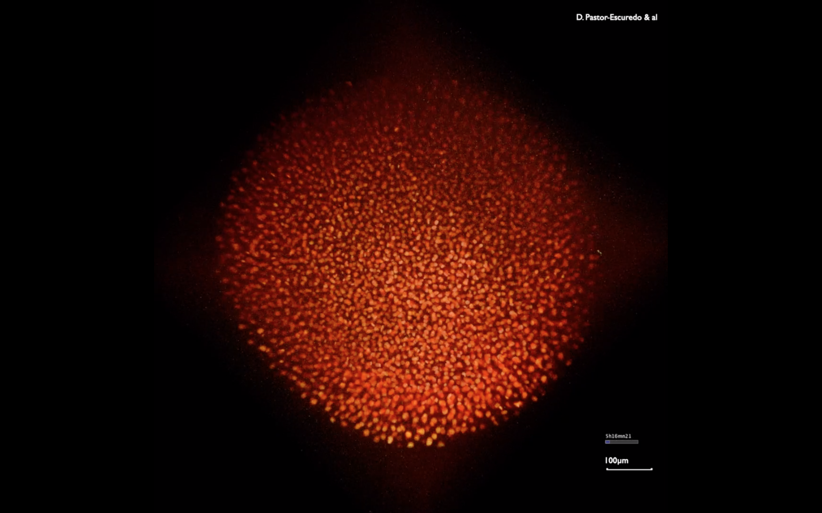
Supplementary Movie 2: 3D+time imaging of wildtype zebrafish gastrulation with marked gsc reporter expression
Rendering of raw data overlaying the two channels for cell nuclei (red) and gsc reporter expression (green) respectively (Mov-IT software). Embryo wt6. Nuclei are marked with H2B-mCherry and gsc reported is marked with eGFP. Embryo is imaged from the animal pole and observed first from the outside then from the inside. Scale bar 100 µm.
High-resolution movie available at: http://bioemergences.eu/kinematics/videos/MovieS2.mp4

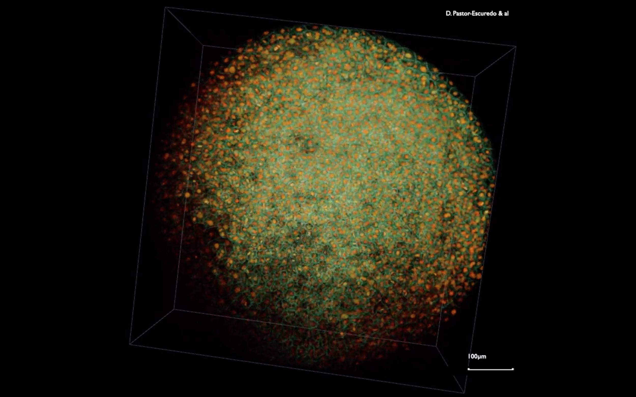
Supplementary Movie 3: 3D+time imaging of zoep^{tz57/tz57} mutant zebrafish gastrulation
Rendering of raw data overlaying the two channels for cell membranes (green) and nuclei (red) respectively (Mov-IT software). Embryo oep1. Nuclei are marked with H2B-mCherry and membranes are marked with eGFP-HRAS. Embryo is imaged from the animal pole and observed first from the outside then from the inside. Scale bar 100 µm.
High-resolution movie available at: http://bioemergences.eu/kinematics/videos/MovieS3.mp4

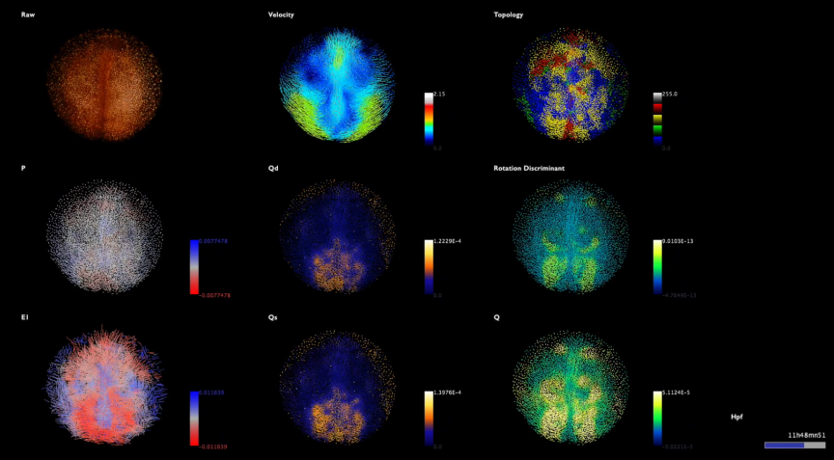
Supplementary Movie 4: Eulerian descriptors of wildtype embryo from animal pole (embryo wt1)
Instantaneous kinematics description from 5.5-14.5 hpf, embryo wt1 imaged from the animal pole, outside view then inside view. Raw data top left, descriptor indicated top left of each panel. Color code as in Fig. 2. Scale bar 100 µm. Temporal scale bottom right.
High-resolution movie available at: http://bioemergences.eu/kinematics/videos/MovieS4.mp4

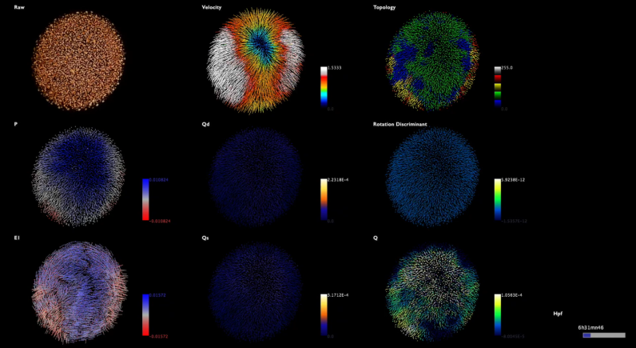
Supplementary Movie 5: Eulerian descriptors of wildtype embryo from animal pole (embryo wt2)
Instantaneous kinematics description from 5-13.1 hpf embryo wt2 imaged from the animal pole, outside view then inside view. Raw data top left, descriptor indicated top left of each panel. Color code as in Fig. 2. Scale bar 100µm. Temporal scale bottom right.
High-resolution movie available at: http://bioemergences.eu/kinematics/videos/MovieS5.mp4

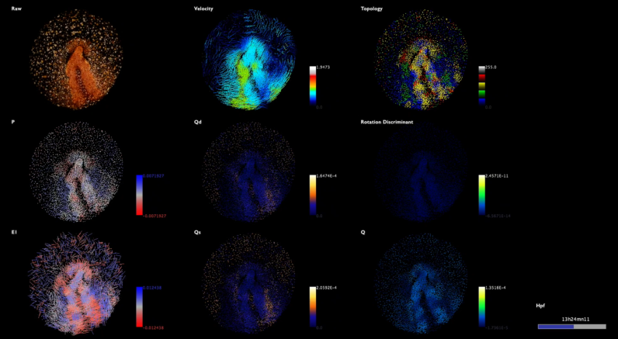
Supplementary Movie 6: Eulerian descriptors of wildtype embryo from animal pole (embryo wt3)
Instantaneous kinematics description from 6-14 hpf embryo wt3 imaged from the animal pole, outside view then inside view. Raw data top left, descriptor indicated top left of each panel. Color code as in Fig. 2. Scale bar 100µm. Temporal scale bottom right.
High-resolution movie available at: http://bioemergences.eu/kinematics/videos/MovieS6.mp4

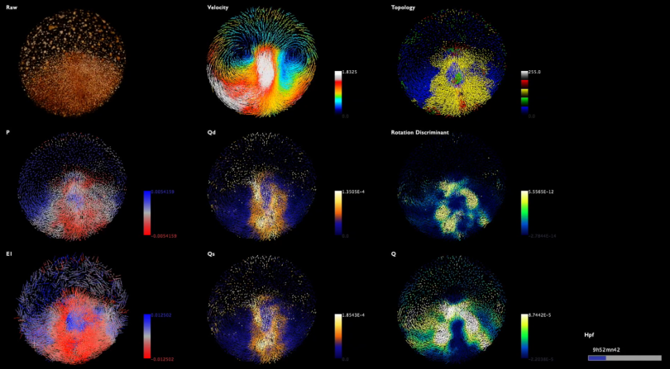
Supplementary Movie 7: Eulerian descriptors of wildtype embryo from animal pole (embryo wt4) Instantaneous kinematics description from 6.5-14.1 hpf embryo wt4 imaged from the animal pole, outside view then inside view. Raw data top left, descriptor indicated top left of each panel. Color code as in Fig. 2. Scale bar 100µm. Temporal scale bottom right.
High-resolution movie available at: http://bioemergences.eu/kinematics/videos/MovieS7.mp4

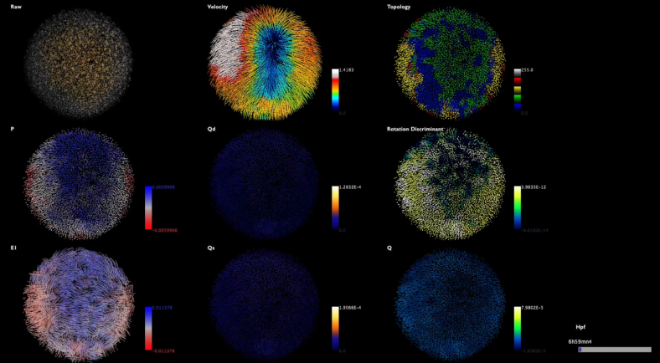
Supplementary Movie 8: Eulerian descriptors of wildtype embryo from animal pole (embryo wt5)
Instantaneous kinematics description from 6.5-14 hpf embryo wt5 imaged from the animal pole, outside view then inside view. Raw data top left, descriptor indicated top left of each panel. Color code as in Fig. 2. Scale bar 100 µm. Temporal scale bottom right.
High-resolution movie available at: http://bioemergences.eu/kinematics/videos/MovieS8.mp4

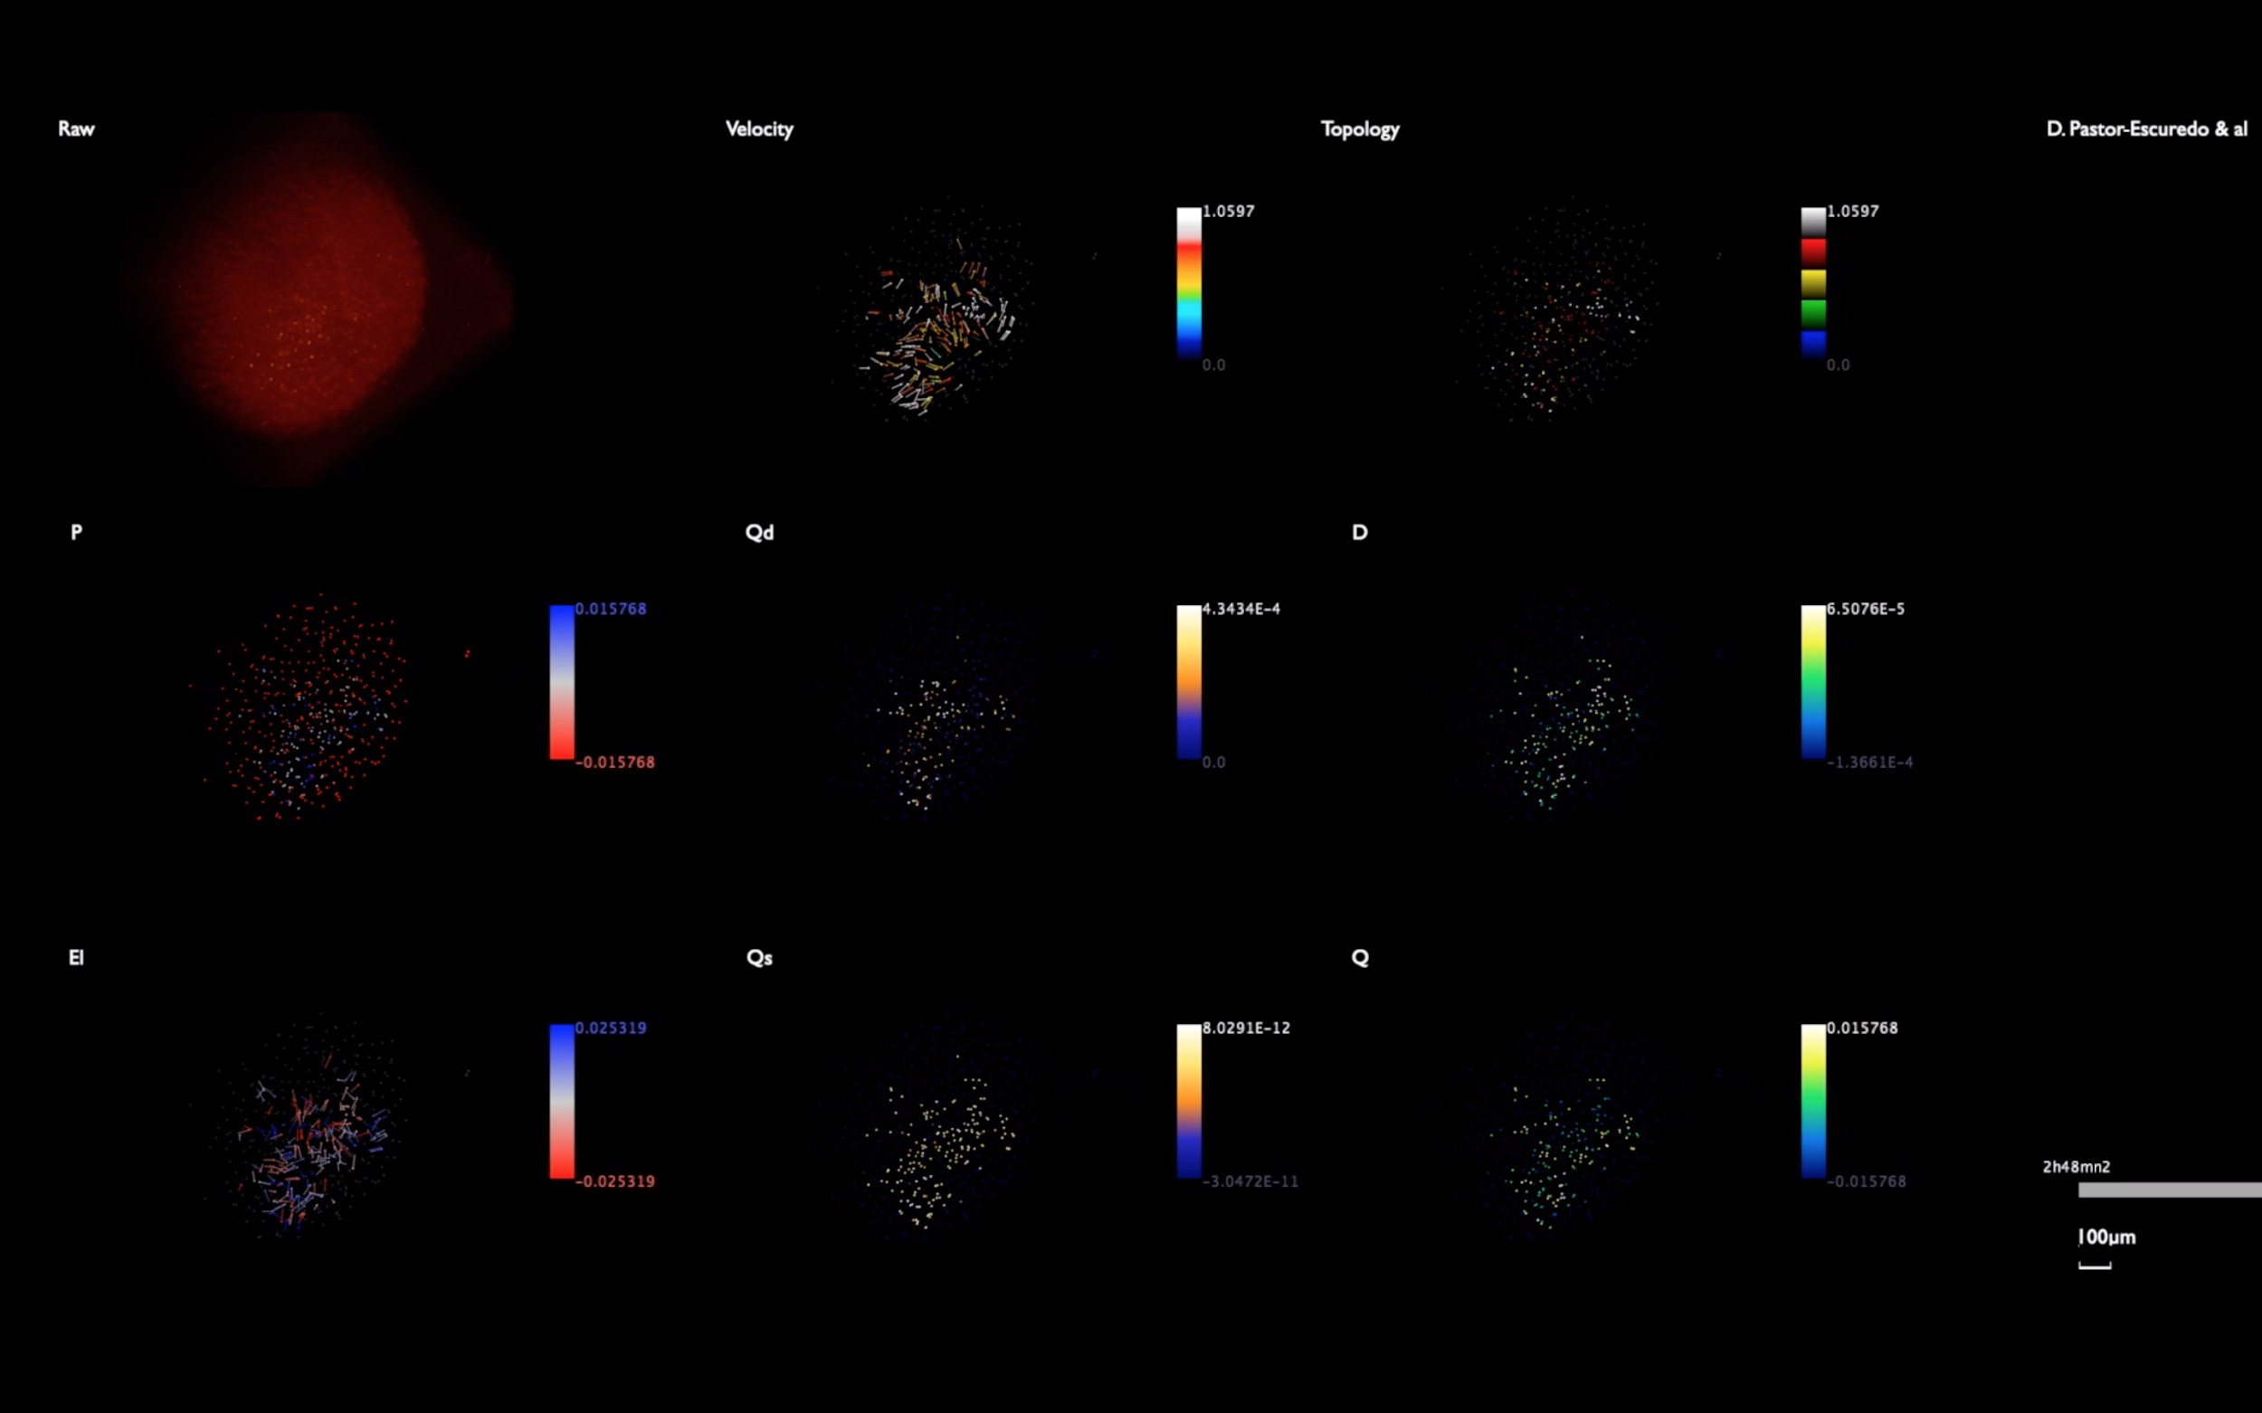
Supplementary Movie 9: Eulerian descriptors of wildtype embryo from animal pole (embryo wt6)
Instantaneous kinematics description from 2.8-11.8 hpf embryo wt6 imaged from the animal pole, outside view then inside view. Raw data top left, descriptor indicated top left of each panel. Color code as in Fig. 2. Scale bar 100 µm. Temporal scale bottom right.
High-resolution movie available at: http://bioemergences.eu/kinematics/videos/MovieS9.mp4

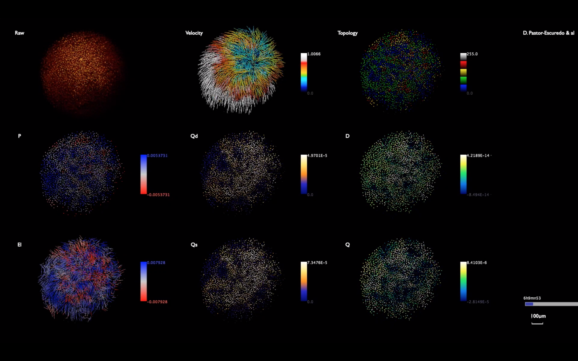
Supplementary Movie 10: Eulerian descriptors of zoep^{tz57/tz57} mutant embryo from animal pole (embryo oep1)
Instantaneous kinematics description from 4-14 hpf embryo oep1 imaged from the animal pole, outside view then inside view. Raw data top left, descriptor indicated top left of each panel. Color code as in Fig. 2. Scale bar 100 µm. Temporal scale bottom right.
High-resolution movie available at: http://bioemergences.eu/kinematics/videos/MovieS10.mp4

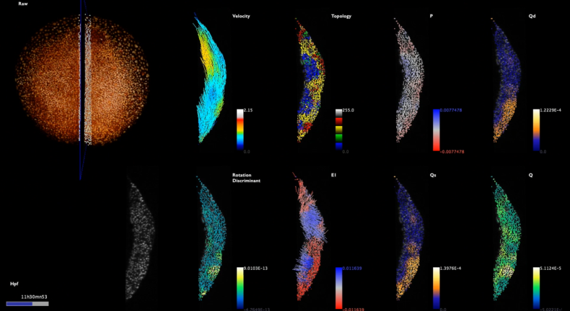
Supplementary Movie 11: Deformation rates at the midline (embryo wt1)
Instantaneous kinematics description from 5.5-14.7 hpf embryo wt1 imaged from the animal pole. Raw data top left, outside view then inside view. The midline is marked by an orthoslice (in black) and about 3-5 row of cells are selected (white) on each side of the midline for a lateral visualization (bottom left). Descriptors as in Fig. 3. indicated top right of each panel. Color code as in Fig. 2. Scale bar 100 µm. Temporal scale bottom right.
High-resolution movie available at: http://bioemergences.eu/kinematics/videos/MovieS11.mp4

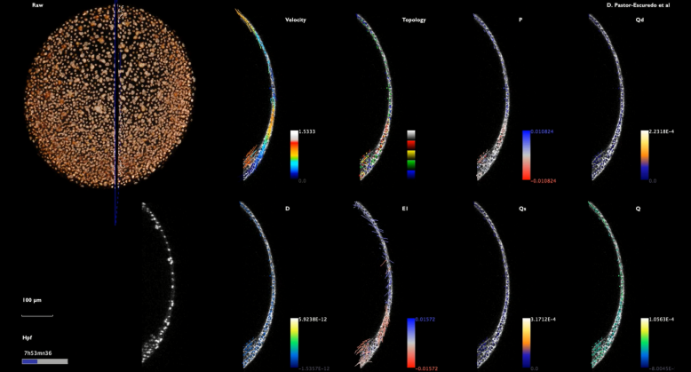
Supplementary Movie 12: Deformation rates at the midline (embryo wt2)
Same as Supplementary Movie 11 for embryo wt2. Time interval of Supplementary Movie 5.
High-resolution movie available at: http://bioemergences.eu/kinematics/videos/MovieS12.mp4

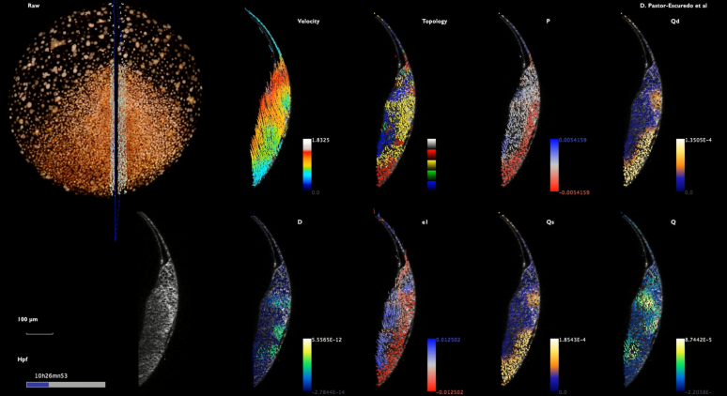
Supplementary Movie 13: Deformation rates at the midline (embryo wt3)
Same as Supplementary Movie 11 for embryo wt3. Time interval of Supplementary Movie 6.
High-resolution movie available at: http://bioemergences.eu/kinematics/videos/MovieS13.mp4

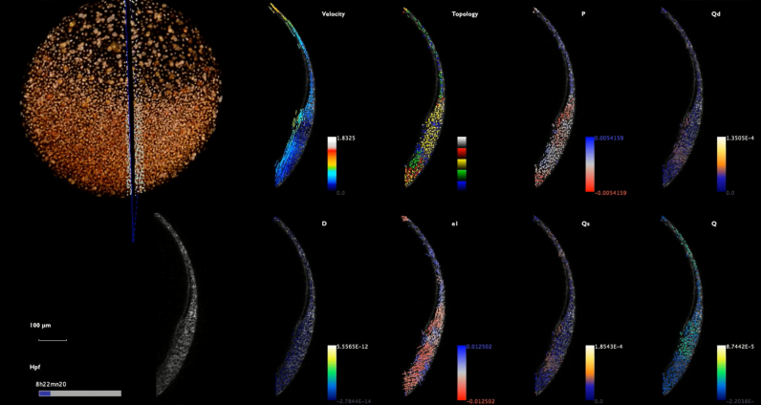

Supplementary Movie 14: Deformation rates at the midline (embryo wt4)
Same as Supplementary Movie 11 for embryo wt4. Time interval of Supplementary Movie 7.
High-resolution movie available at: http://bioemergences.eu/kinematics/videos/MovieS14.mp4

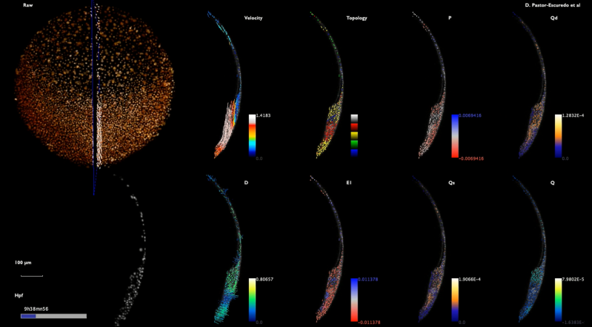
Supplementary Movie 15: Deformation rates at the midline (embryo wt5)
Same as Supplementary Movie 11 for embryo wt5. Time interval of Supplementary Movie 8.
High-resolution movie available at: http://bioemergences.eu/kinematics/videos/MovieS15.mp4

Supplementary Movie 16: Deformation rates at the midline (embryo oep1)
Same as Supplementary Movie 11 for embryo oep1. Time interval of Supplementary Movie 10.
High-resolution movie available at: http://bioemergences.eu/kinematics/videos/MovieS16.mp4

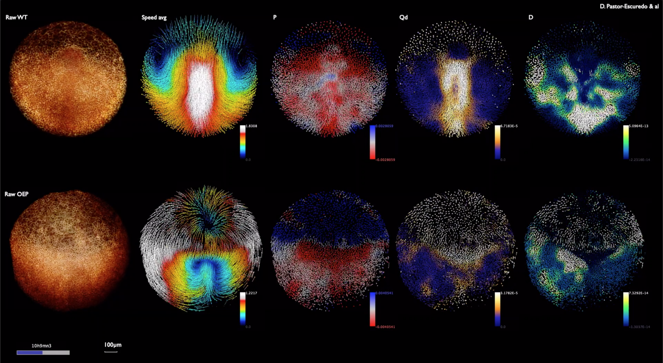
Supplementary Movie 17: Comparison Eulerian descriptors in wildtype and zoep^{tz57/tz57} mutant zebrafish (embryo wt1 vs oep1)
Instantaneous kinematics description from mid-gastrulation to early segmentation (8-13 hpf) embryo wt1 vs oep1, both imaged from the animal pole, outside view then inside view. Raw data top left, descriptor indicated top left of each panel. Color code as in Fig. 2. Scale bar 100 µm. Temporal scale bottom right.
High-resolution movie available at: http://bioemergences.eu/kinematics/videos/MovieS17.mp4

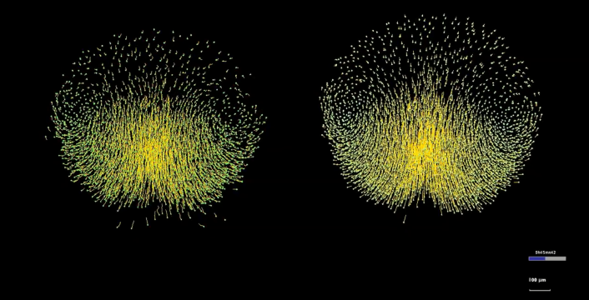
Supplementary Movie 18: Comparison between cell lineage and flow approximation of wildtype zebrafish
Embryo wt1 animal pole view (Mov-IT software). Displacements implicit in the digital cell lineage (left) compared to displacements in the flow field (right) after the temporal smoothing and the spatial regularization of the cell displacements. In the left panel, the cells that get into the imaged volume are excluded. The flow field is composed of complete trajectories resulting from the integration of the displacements. It produces an artifact, keeping in the field of view cells that normally moved out of it. It should be noted that this artifact is solved by working with a selection of cells that are kept in the imaged volume for the whole imaging sequence (shield selection as in Fig. 5).
High-resolution movie available at: http://bioemergences.eu/kinematics/videos/MovieS18.mp4

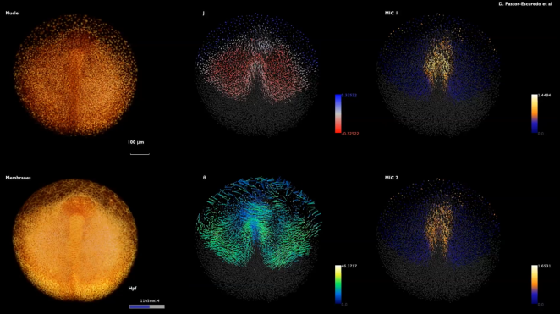
Supplementary Movie 19: Maps of cumulative descriptors of wildtype zebrafish
Cumulative descriptors displayed as maps from mid-gastrulation to early segmentation (7.55-14 hpf) embryo wt1 imaged from the animal pole. The cumulative descriptors are computed with $t_{ini}$=7.55 hpf. First view from the inside then outside then inside. Raw data nuclei top left, membranes bottom left. Descriptor indicated top left of each panel. Color code as in Fig. 3. Scale bar 100 µm. Temporal scale bottom right of the membrane raw data panel. As in Supplementary Movie 18, new cells that get into the field of view are not seen.
High-resolution movie available at: http://bioemergences.eu/kinematics/videos/MovieS19.mp4

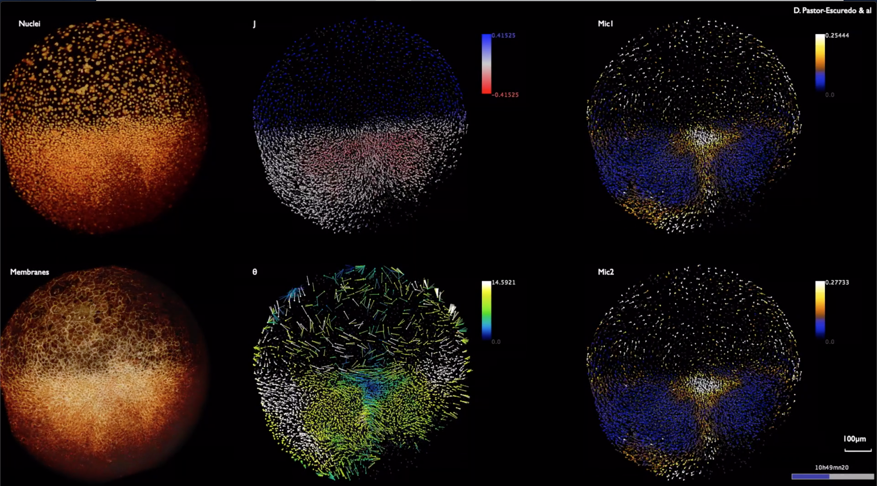
Supplementary Movie 20: Maps of cumulative descriptors of zoep^{tz57/tz57} mutant zebrafish
Cumulative descriptors displayed as maps from mid-gastrulation to early segmentation (8-14 hpf) embryo oep1 imaged from the animal pole. The cumulative descriptors are computed with $t_{ini}$=8 hpf. First view from the inside then outside then inside. Raw data nuclei top left, membranes bottom left. Descriptor indicated top left of each panel. Color code as in Fig. 3. Scale bar 100 µm. Temporal scale bottom right of the membrane raw data panel.
High-resolution movie available at: http://bioemergences.eu/kinematics/videos/MovieS20.mp4

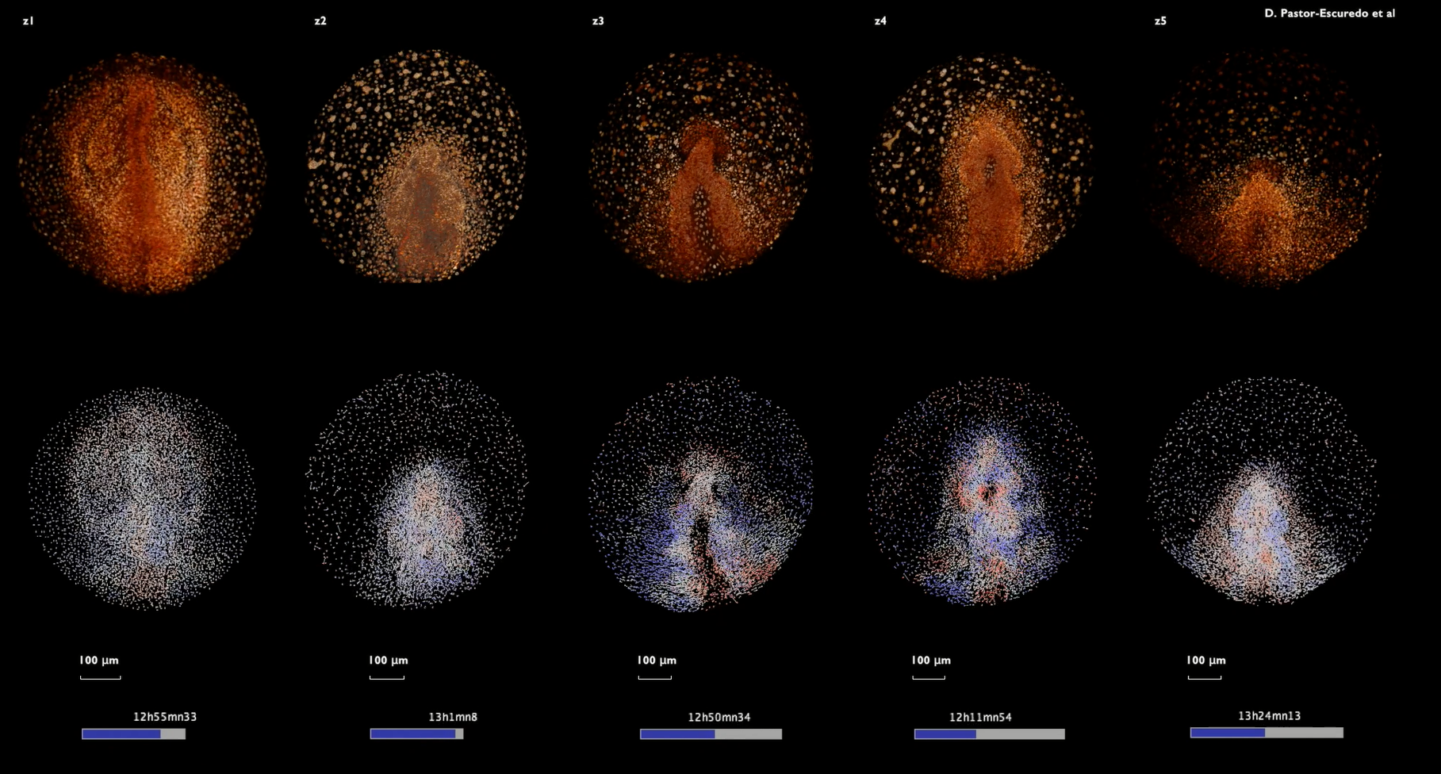
Supplementary Movie 21: Comparison of compression and expansion rates in a cohort of wildtype embryos
First row: 3D rendering of raw nuclei for wt1-wt5 (indicated top left of each column). Second row: descriptor $P$ (compression and expansion) with color code as in Fig. 2. Embryos have been positioned as in Supplementary Movie 1 and temporally aligned according to Fig. 4. View first from inside, then outside and inside. Scale bar 100 µm. Temporal scale bottom of each column.
High-resolution movie available at: http://bioemergences.eu/kinematics/videos/MovieS21.mp4

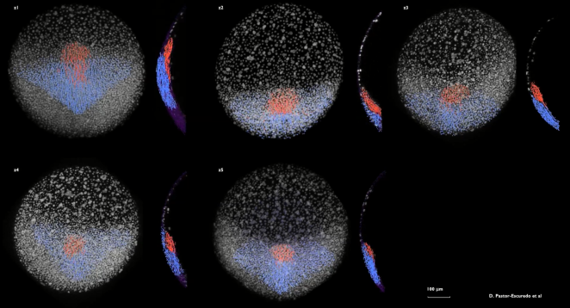
Supplementary Movie 22: Tailbud selection of germ layers in wildtype zebrafish embryo
Render of germ layers: epiblast (blue) and hypoblast (red). Selections of both populations have been done by the end of gastrulation for each dataset (tailbud selection as in Supplementary Fig. 8) and propagated through the trajectories along the whole interval of analysis (7-14 hpf). As the field of view and orientation are not exactly the same, the hypoblast appears at different time points in each movie. From left-right, up-down: wt1, wt2, wt3, wt4 and wt5.
High-resolution movie available at: http://bioemergences.eu/kinematics/videos/MovieS22.mp4

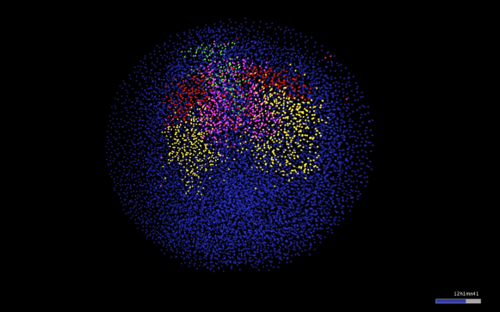
Supplementary Movie 23: Lagrangian Biomechanical Map of wildtype zebrafish (embryo wt1)
Spatio-temporal distribution of the mechanical domains (as in Fig. 5) from 8 to 13 hpf. Outside view of embryo wt1, animal pole, anterior to the top. The four biomechanical domains are obtained by clustering the selected cell population (shield selection as in Fig. 5) at 8 hpf into four domains according to the mechanical signature of the trajectories. Cells are labeled by 8 hpf according to their respective biomechanical domain and labels are propagated along the cell lineage. Visualization with Mov-IT software.
High-resolution movie available at: http://bioemergences.eu/kinematics/videos/MovieS23.mp4

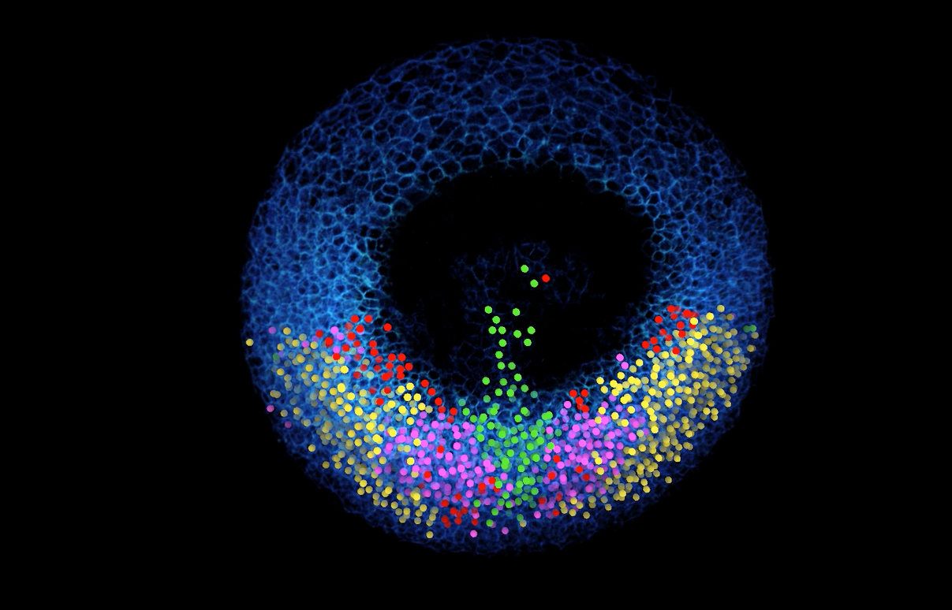
Supplementary Movie 24: Lagrangian Biomechanical Map section of wildtype zebrafish (embryo wt1)
Same as Supplementary Movie 23 but removing upper section down to 65 µm below the embryo surface.
High-resolution movie available at: http://bioemergences.eu/kinematics/videos/MovieS24.mp4

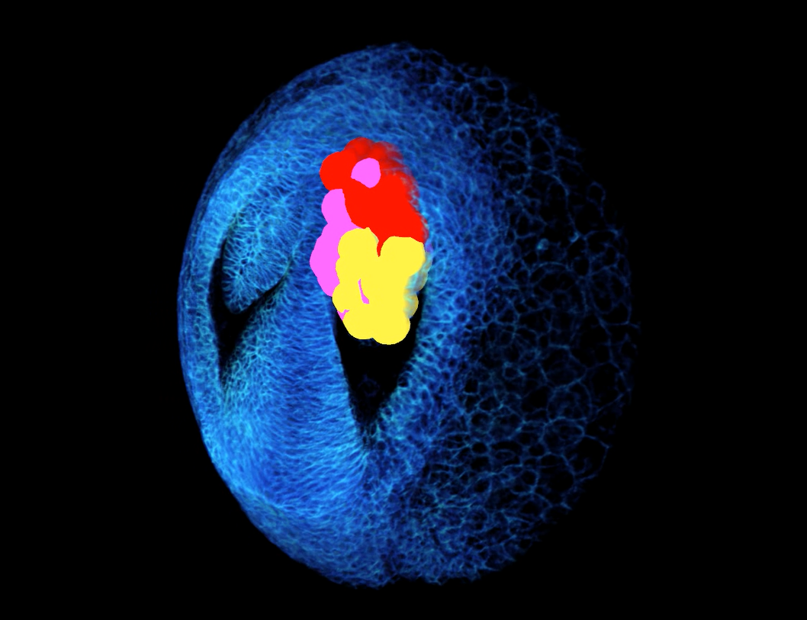

Supplementary Movie 25: Lagrangian Biomechanical Map of the eye vesicle of wildtype zebrafish (embryo wt1)
As in Supplementary Movie 23. Highlights the biomechanical domains in the eye vesicle by displaying the intersection of the Lagrangian Biomechanical Map and the eye vesicle. A sphere positioned at the detected nuclear center approximates the cell contours. Color code as in Fig. 5. Embryo wt1, anterior to the top, upper sections sequentially removed down to 65 µm below the embryo surface.
High-resolution movie available at: http://bioemergences.eu/kinematics/videos/MovieS25.mp4

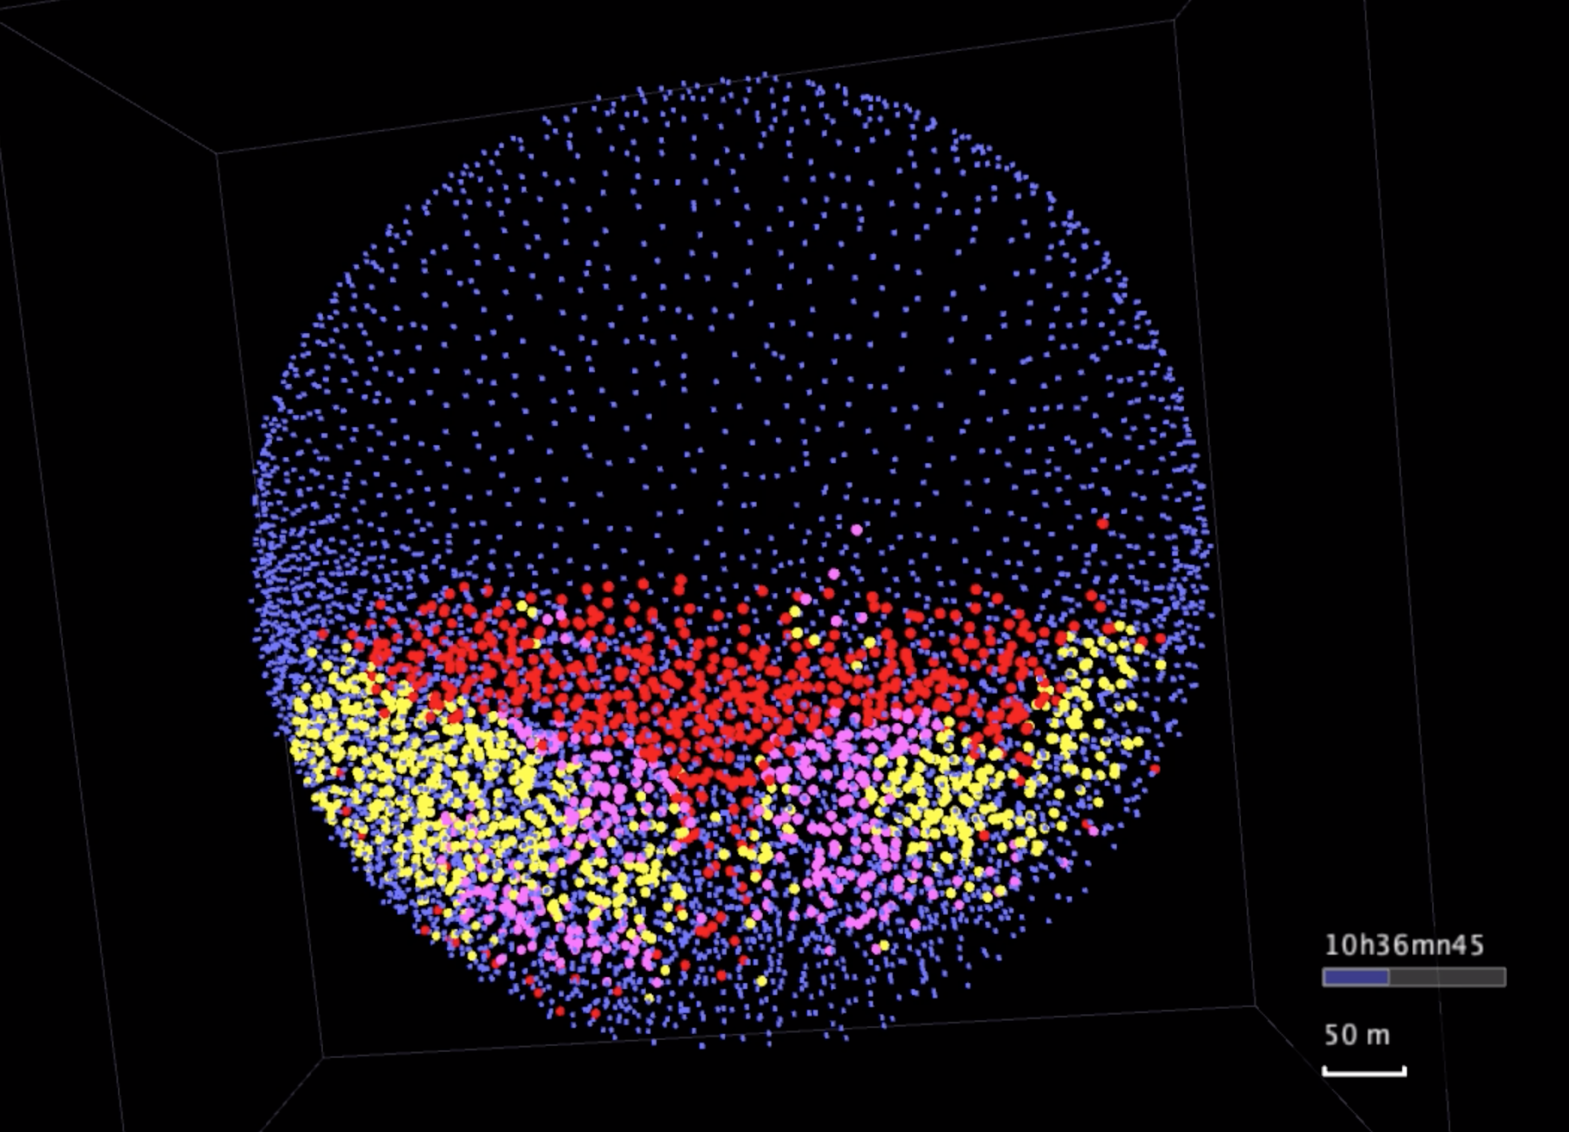
Supplementary Movie 26: Lagrangian Biomechanical Map of zoep^{tz57/tz57} mutant zebrafish (embryo oep1)
Spatio-temporal distribution of the mechanical domains (as in Fig. 5) from 8 to 13 hpf. Outside view of embryo oep1, animal pole, anterior to the top. The three biomechanical domains are obtained by clustering the selected cell population (shield selection as in Fig. 5) at 8 hpf into three domains according to the mechanical signature of the trajectories. Cells are labeled by 8 hpf according to their respective biomechanical domain and labels are propagated along the cell lineage. Visualization with Mov-IT software.
High-resolution movie available at: http://bioemergences.eu/kinematics/videos/MovieS26.mp4

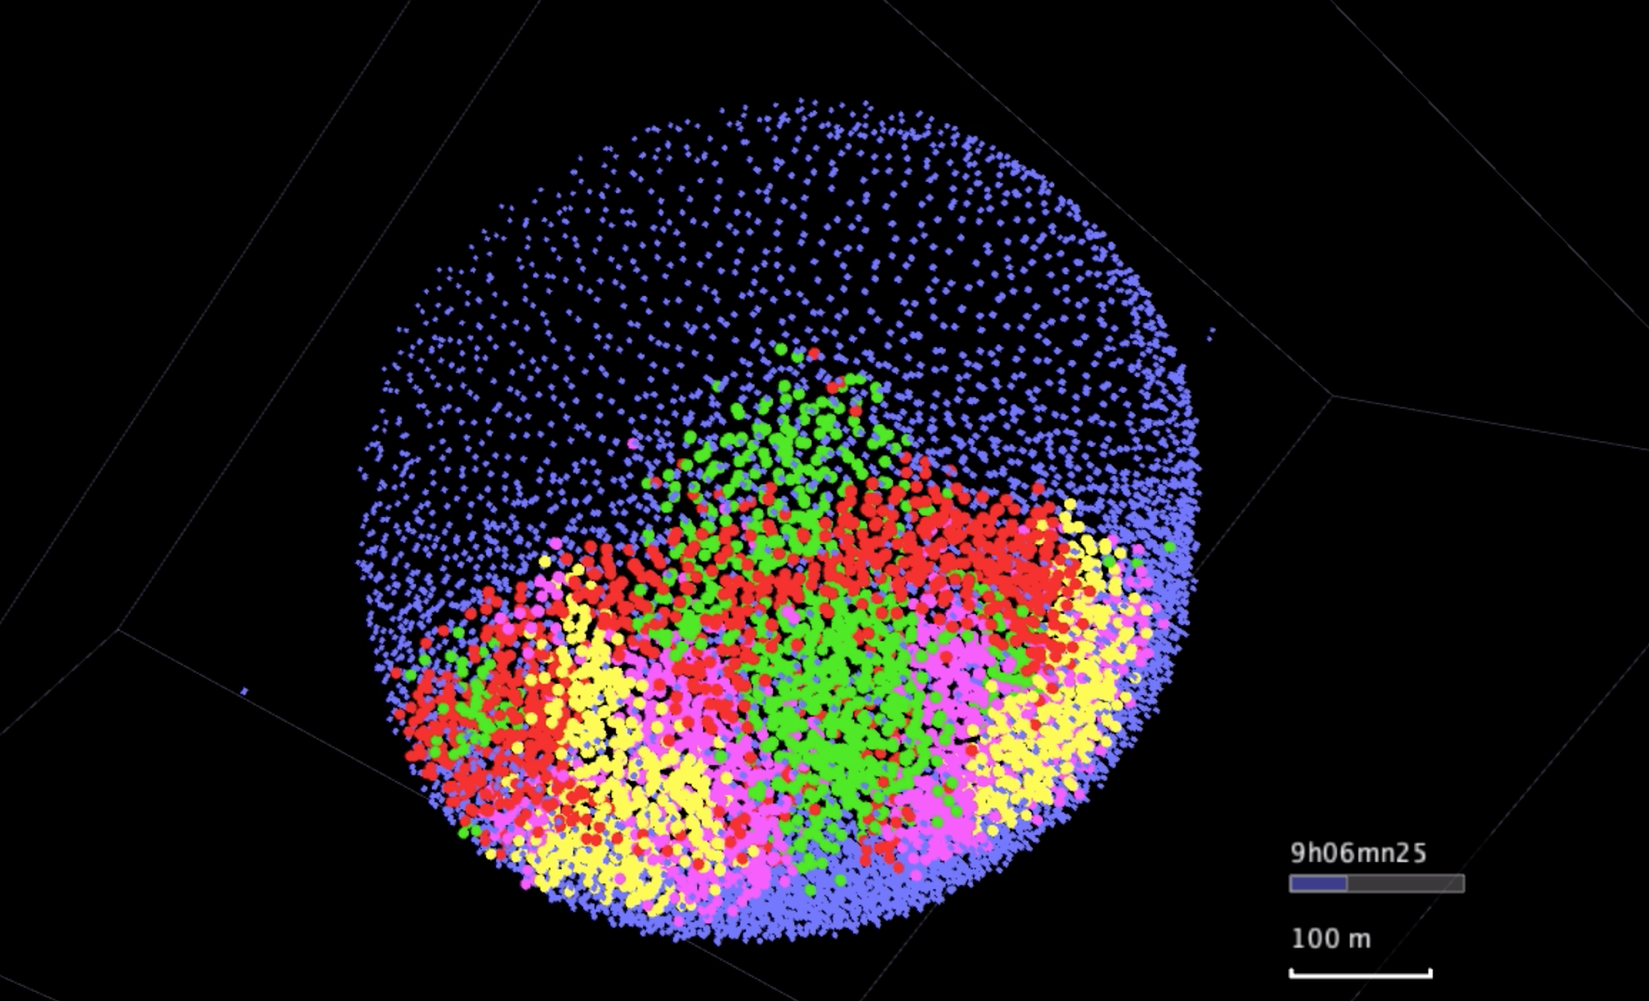
Supplementary Movie 27: Lagrangian Biomechanical Map of wildtype zebrafish (embryo wt6)
Spatio-temporal distribution of the mechanical domains (as in Fig. 6) from 8 to 10 hpf. Outside view of embryo wt6, animal pole, anterior to the top. The four biomechanical domains are obtained by clustering the selected cell population (shield selection as in Fig. 6) at 8 hpf into four domains according to the mechanical signature of the trajectories. Cells are labeled by 8 hpf according to their respective biomechanical domain and labels are propagated along the cell lineage. Visualization with Mov-IT software.
High-resolution movie available at: http://bioemergences.eu/kinematics/videos/MovieS27.mp4

Embryo |  | ID | Voxel | Voxel Size (µm³) | Timestep | Duration (hpf) | Tº (ºC) | Tº control
wt1 | 071226a |  | 512x512x120 | 1.37 | 2’33’’ | 5.5-15 | 26 | 21° room
wt2 | 140523aF |  | 512x512x177 | 1.26 | 2’28’’ | 5-13.8 | 26 | Okolab
wt3 | 141106aF |  | 512x512x148 | 1.38 | 2’24’’ | 6-18 | 26 | Okolab
wt4 | 141108aF |  | 512x512x174 | 1.38 | 2’26’’ | 6.5-20 | 28.6 | Okolab
wt5 | 141108a |  | 512x512x172 | 1.37 | 2’25’’ | 6.5-20 | 24.7 | Okolab
wt6 | 091021aF |  | 512x512x238 | 1.51 | 3’01’’ | 2.75-22.5 | 26 | 22º room
oep1 | 081018a |  | 512x512x171 | 1.31 | 2’31’’ | 4-22.2 | 26 | 22º room
oep2 | 081025a |  | 512x512x179 | 1.31 | 2’38’’ | 3.25-21.1 | 26 | 22º room
oep3 | 120914aF |  | 512x512x114 | 1.51 | 2’31’’ | 5.9-22-9 | 26 | 22º room
oep4 | 170315aF |  | 512x512x167 | 1.51 | 1’40’’ | 6-16.5 | 26 | Okolab
oep5 | 170321aF |  | 512x512x177 | 1.38 | 2’13’’ | 5-18.3 | 26 | Okolab

Supplementary Table 1. Image acquisition parameters
Recapitulates imaging conditions for the different specimens analyzed here. The ID column provides the identification specified in the BioEmergences database.
Database repository link: http://bioemergences.eu/kinematics/

$$P$$ | Volume change rate  $P>0$ expansion  $P<0$ compression | Expansion and compression of the tissue.  Cell nuclei centroids get further away or closer from a centroid taken as reference in consecutive steps.
$$D$$ | Rotation discriminant  $D>0$ rotation  $D<0$ no rotation | Measurement of infinitesimal rotation compared to linear deformation [29].  The centroids move around a reference centroid more than changing relative distances.
$$Q_{d}$$ | Distortion rate  defined positive | Deformation causing tissue rearrangements.  The constellation of centroids around a reference centroid changes shape without changing its enclosing volume.
$$δα$$ | Infinitesimal rotation angle | Measurement of the infinitesimal angle corresponding to the angular velocity ω
$$τ$$ | Topology (signs $P$ and $D$)  1 expansion / rotation  2 expansion / no rotation  3 compression / rotation  4 compression / no rotation | The combination of the signs of P and $D$ distinguishes the main topological configurations.
$$\{ε_{i}\}$$ | Strain rate components  direction and magnitude | Geometrical characterization (eigenvalues and eigenvectors) of the 3D strain rate $ε$.
$$\{d_{i}\}$$ | Distortion rate components  direction and magnitude | Geometrical characterization (eigenvalues and eigenvectors) of the 3D distortion rate$d$.
Supplementary Table 2. Instantaneous descriptors
Infinitesimal deformation formulation was used when the deformation occurred within an acquisition time step $Δt$ that was assumed small, then $Δt$ approximated as $δt$ was also assumed and descriptors were considered instantaneous. First column: descriptor name. Second column: expanded name and details of the descriptor values. Third column: short description of the descriptor. Scalar descriptors are defined as tensor invariants: $P$ for compression and expansion rate, $D$ for rotation discriminant, $τ$, which combines the sign of the previous two descriptors to define topology labels, $δα$ for infinitesimal rotation and $Q_{d}$, which describes the amount of distortion rate.

$$∆V$$ | $$J$$ | Volume Change  $∆V>1$ expansion  $∆V<1$ compression | Volume change regarding an initial state along ${}_{t_{ini}}t$.  The volume enclosing the centroids at $t$ grows or shrinks compared to the volume enclosing the centroids at $t_{ini}$ mapped through the trajectories.
$$∆α$$ | $$θ$$ | Finite rotation | The volume enclosing the centroids around a reference centroid describes a rotation compared to the mapped centroids at $t_{ini}$. Finite rotation in 3D can be characterized by and angle and axis of rotation (Euler theorem).
$$∆γ_{1}$$ | $$MIC1$$ | First distortion parameter | Descriptor of the isochoric -no volume change- deformation, of the region enclosing mapped points between two time steps, that changes linearly with the deformation along any dimension.
$$∆γ_{2}$$ | $$MIC2$$ | Second distortion parameter | Descriptor of the isochoric -no volume change- deformation, of region enclosing mapped points between two time steps, that changes with a geometric term when there are deformation components along more than one dimension.  $∆γ_{1}$ = $∆γ_{2}$ when there is only one component of deformation (planar distortion).
$\{c_{i}\}$/$\{b_{i}\}$ | $\{c_{i}\}$/$\{b_{i}\}$ | Finite deformation components | Geometrical characterization of the deformation of the volumes enclosing mapped centroids between any two time points in 3D.
$\{\tilde{c_{i}}\}$/$\{\tilde{b_{i}}\}$ | $\{\tilde{c_{i}}\}$/$\{\tilde{b_{i}}\}$ | Isochoric deformation components | Geometrical characterization of the distortion of the volumes enclosing mapped centroids between any two time points in 3D.

Supplementary Table 3. Finite time descriptors
Finite-time deformation descriptors for arbitrary intervals of time $[t_{ini},t]$. These descriptors describe deformation through time given an initial reference state at $t_{ini}$. First column: alias of the descriptor. Second column: descriptor name as introduced in mechanics notation. Second column: expanded name of the descriptor and details about the values. Third column: short description of the descriptor. $∆V$ is an alias for the compression and expansion descriptor in 3D, $∆α$for finite rotation around an axis of rotation, $∆γ_{1}$ and $∆γ_{2}$ for distortion of the tissue, obtained as the first and second invariants of the isochoric (not producing volume changes) deformation.

$$P$$ | $$P$$ | $tr\left(h\right)$ = $h_{1}{+ h}_{2}+h_{3}$
$$Q$$ | $$Q$$ | $$h_{1}h_{2}+h_{2}h_{3}+h_{3}h_{1}$$
$$D$$ | $$D$$ | $D^{3}$+${ PD}^{2}$+ Q$D+R=0$
$$Q_{s}$$ | $$Q_{s}$$ | $$ε_{1}ε_{2}+ε_{2}ε_{3}+ε_{3}ε_{1}$$
$$Q_{d}$$ | $$Q_{d}$$ | $$d_{1}d_{2}+d_{2}d_{3}+{d_{3}d}_{1}$$
$$δα$$ | $$ω$$
$$∆V$$ | $$J$$ | $$det\left(F\right)$$
$$∆γ_{1}$$ | $$MIC1$$ | $$\left(\tilde{C}\right) ={\tilde{c}}_{1}+{\tilde{c}}_{2}+{\tilde{c}}_{3}$$
$$∆γ_{2}$$ | $$MIC2$$ | $${\tilde{c}}_{1}{\tilde{c}}_{2}+{\tilde{c}}_{2}{\tilde{c}}_{3}+{\tilde{c}}_{3}{\tilde{c}}_{1}$$
$$∆α$$ | $$θ$$
Supplementary Table 4. Tensor invariants computation
Left: name of descriptor. Center: technical name of the invariant as defined in [28, 29], names may be similar or different. Right: mathematical definition of the descriptor. Given a tensor $A$ expressed as a diagonal matrix with eigenvalues $(a_{1}{, a}_{2},a_{3})$. The first invariant is defined as the trace of the tensor: $I_{1}={tr\left(A\right)=a}_{1}{+ a}_{2}+a_{3}$ (as $P$ and $∆γ_{1}$). The second invariant is defined as: $I_{2}=\frac{1}{2}\left({tr}^{2}\left(A\right)- tr\left(A^{2}\right)\right)=a_{1}a_{2}+a_{2}a_{3}+a_{3}a_{1}$ (as $Q_{s}$, $Q_{d}$ and $∆γ_{2}$). Third invariant is defined as the determinant:$I_{3}=detdet \left(A\right) = a_{1}a_{2}a_{3}$ (as $∆V$). The rotation discriminant $D$ is a descriptor that determines the limits in the presence of rotation (as described in 28). This rotation descriptor has been preferred over the rotation rate provided by the skew-symmetric part $Ω$ of the tensor $h$ (26) or the second invariant $Q$of $h$ used as vorticity descriptor in non-compressible fluids, as $D$ provides a univocal metric of rotation in compressible flows ($P≠0$). Interpretation of these invariants change according to the tensor and the temporal lengthscale of the deformation.

