Table S1 The top 10 institutions on RRS from 2003 to 2023.
Rank | Institution | Publication | Country
1 | Monash University | 137 | Australia
2 | Florey Institute of Neuroscience & Mental Health | 129 | Australia
3 | Austin Research Institute | 114 | Australia
4 | University of London | 113 | United Kingdom
5 | University of Melbourne | 87 | Australia
6 | University College London | 72 | United Kingdom
7 | Harvard University | 71 | United states
8 | RLUK- Research Libraries UK | 71 | United Kingdom
9 | University of New South Wales Sydney | 67 | Australia
10 | Pennsylvania Commonwealth System of Higher Education (PCSHE) | 60 | United states

Table S2 The top 10 authors on RRS from 2003 to 2023.
Rank | Author | Affiliations | Country | publications
1 | Jones, Daryl | Austin Research Institute, University of Melbourne | Australia | 56
2 | Bellomo, Rinaldo | University of Melbourne | Australia | 51
3 | Considine, Julie | Deakin University | Australia | 34
4 | Edelson, Dana P | University of Chicago | United states | 28
5 | Lopez-izquierdo, Raul | Hospital del Rio Hortega | Spain | 26
6 | Martin-rodriguez, Francisco | Universidad de Valladolid | Spain | 24
7 | Churpek, Matthew M | Univ Wisconsin Madison | United states | 23
8 | Smith, Gary B | Bournemouth University | United Kingdom | 23
9 | Currey, Judy | Deakin University | Australia | 22
10 | Kellett, John | Odense Univ Hosp | Denmark | 22
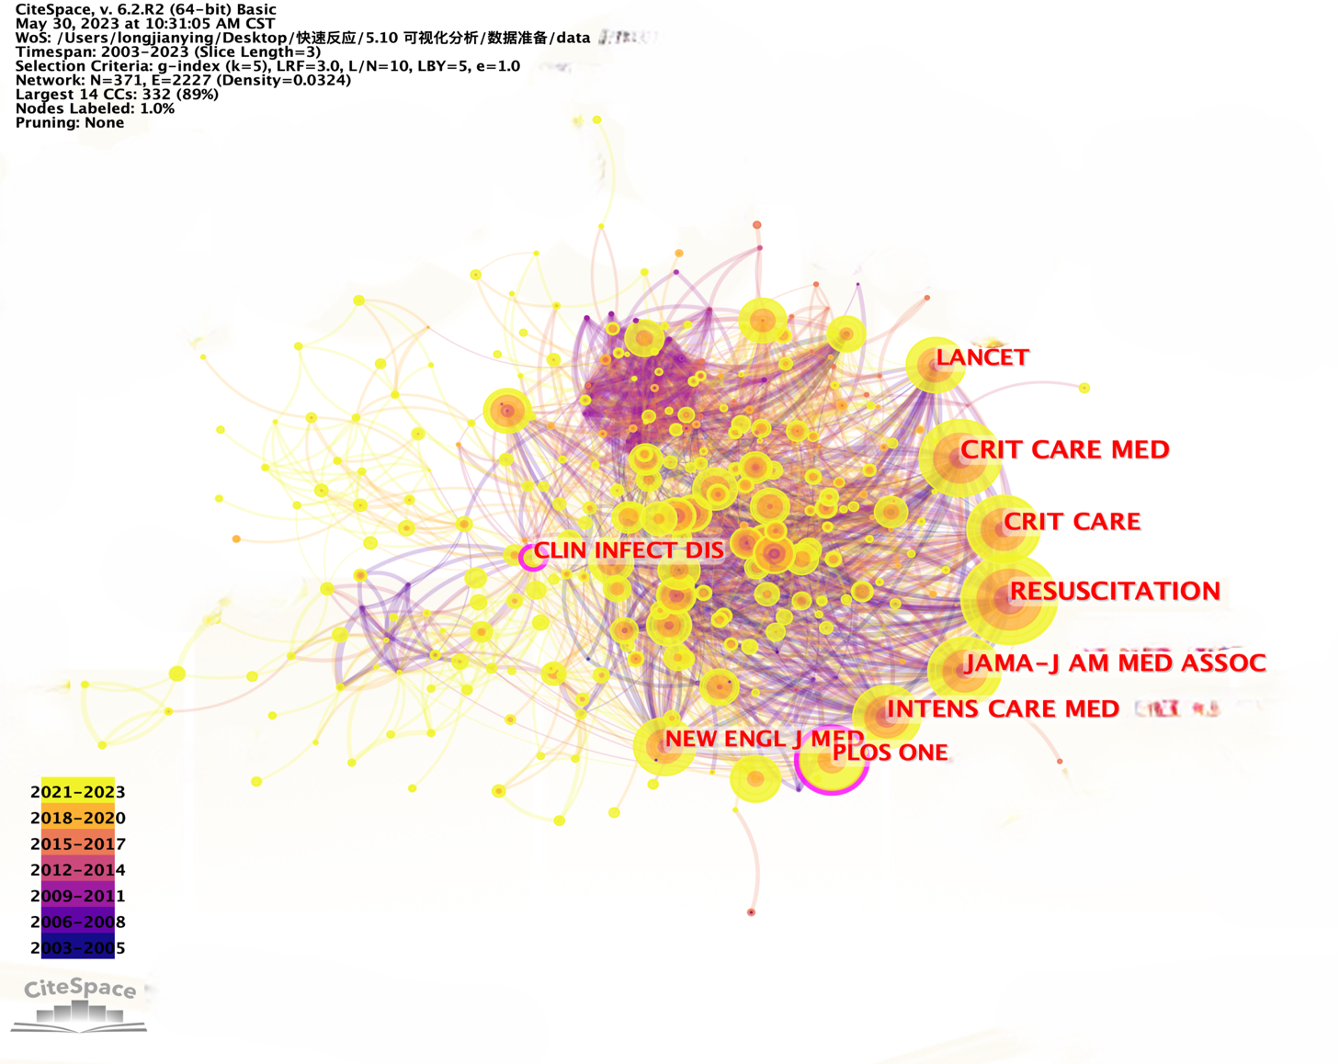
Figure S1 Distribution of cited journals

Table S3 The top 10 cited references on RRS from 2003 to 2023.
Rank | Title | Author | Journal | Year | Citations
1²² | European Resuscitation Council Guidelines for Resuscitation 2015 Section 3. Adult advanced life support | Soar, Jasmeet, et al | RESUSCITATION | 2015 | 1049
2¹⁴ | Introduction of the medical emergency team (MET) system: a cluster-randomised controlled trial | Hillman, K, et al | LANCET | 2005 | 932
3²³ | Scalable and accurate deep learning with electronic health records | Rajkomar, Alvin, et al | NPJ DIGITAL MEDICINE | 2018 | 902
4²⁴ | European Resuscitation Council Guidelines for Resuscitation 2010 Section 1 Executive summary | Nolan, Jerry P., et al | RESUSCITATION | 2010 | 834
5²⁵ | First documented rhythm and clinical outcome from in-hospital cardiac arrest among children and adults | Nadkarni, VM, et al | JAMA-JOURNAL OF THE AMERICAN MEDICAL ASSOCIATION | 2006 | 828
6²⁶ | European Resuscitation Council Guidelines for Resuscitation 2010 Section 4 Adult advanced life support | Deakin, Charles D., et al | RESUSCITATION | 2010 | 761
7²⁷ | Interprofessional education: effects on professional practice and health care outcomes | Reeves, S. | COCHRANE DATABASE OF SYSTEMATIC REVIEWS | 2008 | 728
8²⁸ | Normal ranges of heart rate and respiratory rate in children from birth to 18 years of age: a systematic review of observational studies | Fleming, Susannah | LANCET | 2011 | 689
9²⁹ | European Resuscitation Council Guidelines for Resuscitation 2005 - Section 4. Adult advanced life support | Nolan, JP | RESUSCITATION | 2005 | 616
10⁶ | Findings of the First Consensus Conference on Medical Emergency Teams | DeVita, Michael A. | CRITICAL CARE MEDICINE | 2006 | 554

