Supplemental Material
Supplemental methods
The calculations used to create the concentrated and diluted tobacco treatments are as follows:
Concentrated tobacco solution:
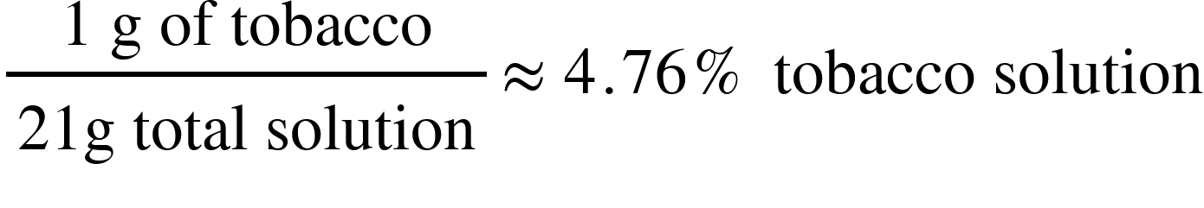
Diluted tobacco solution:
First step:
Second step:

Supplemental results
Fig. S1. Example of experimental methods including A) cotton after it was treated with the tobacco solution and B) 3rd instar larva in tube with cotton treatment.
A.
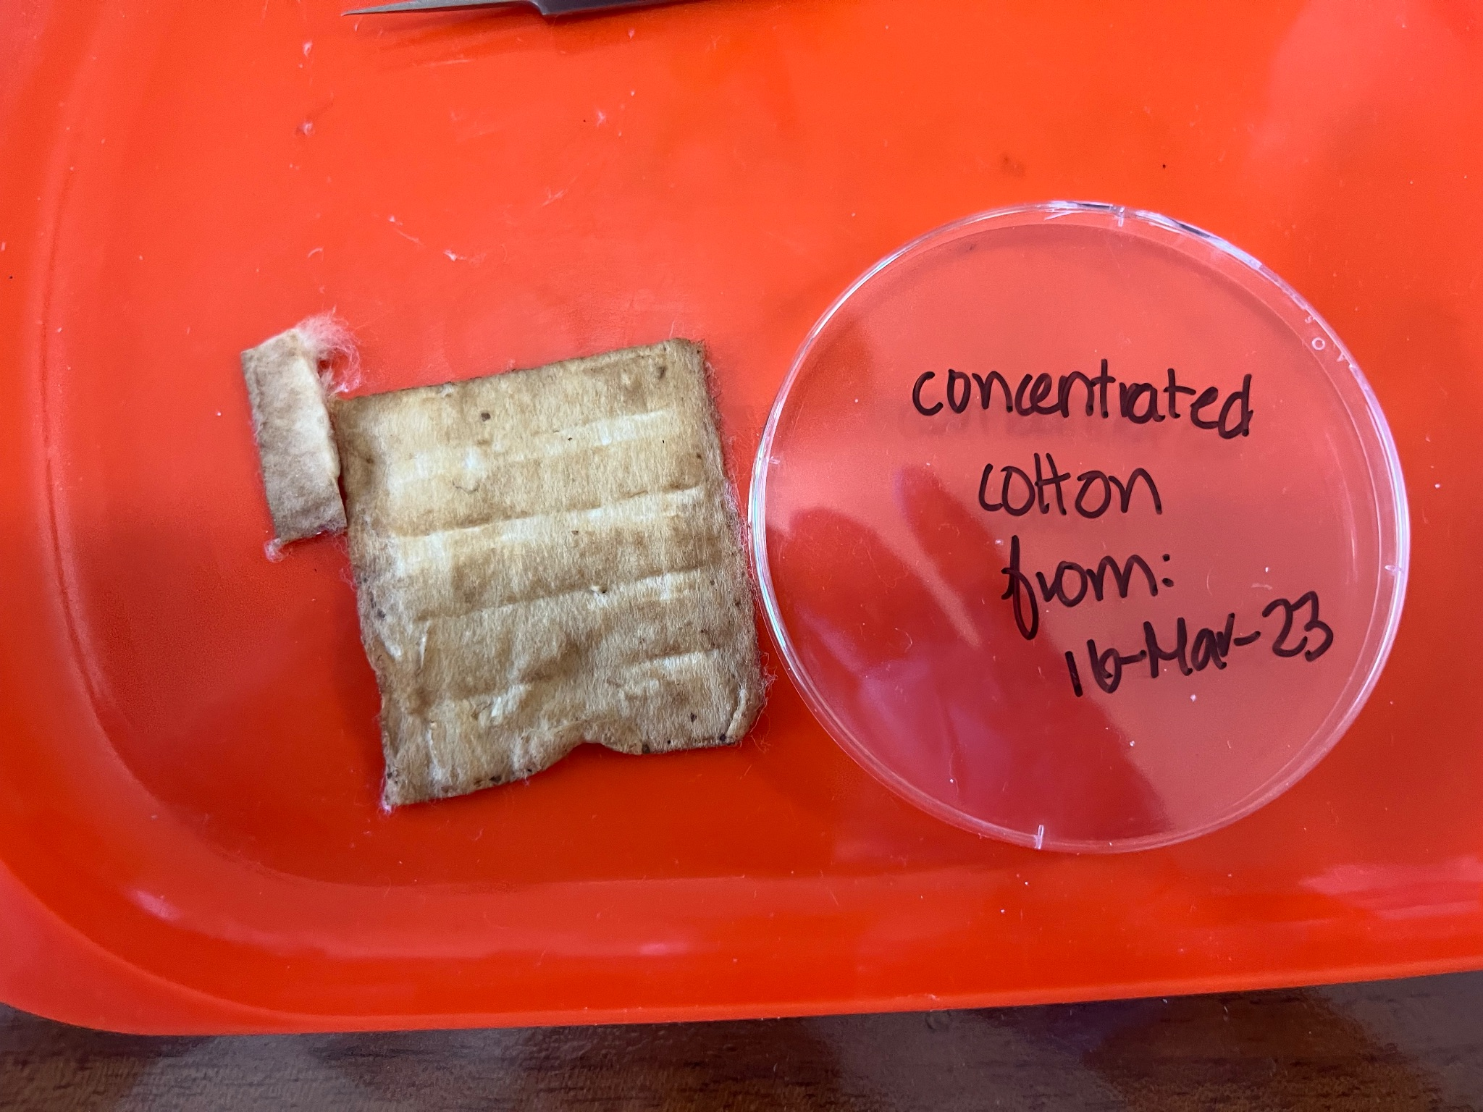
B.
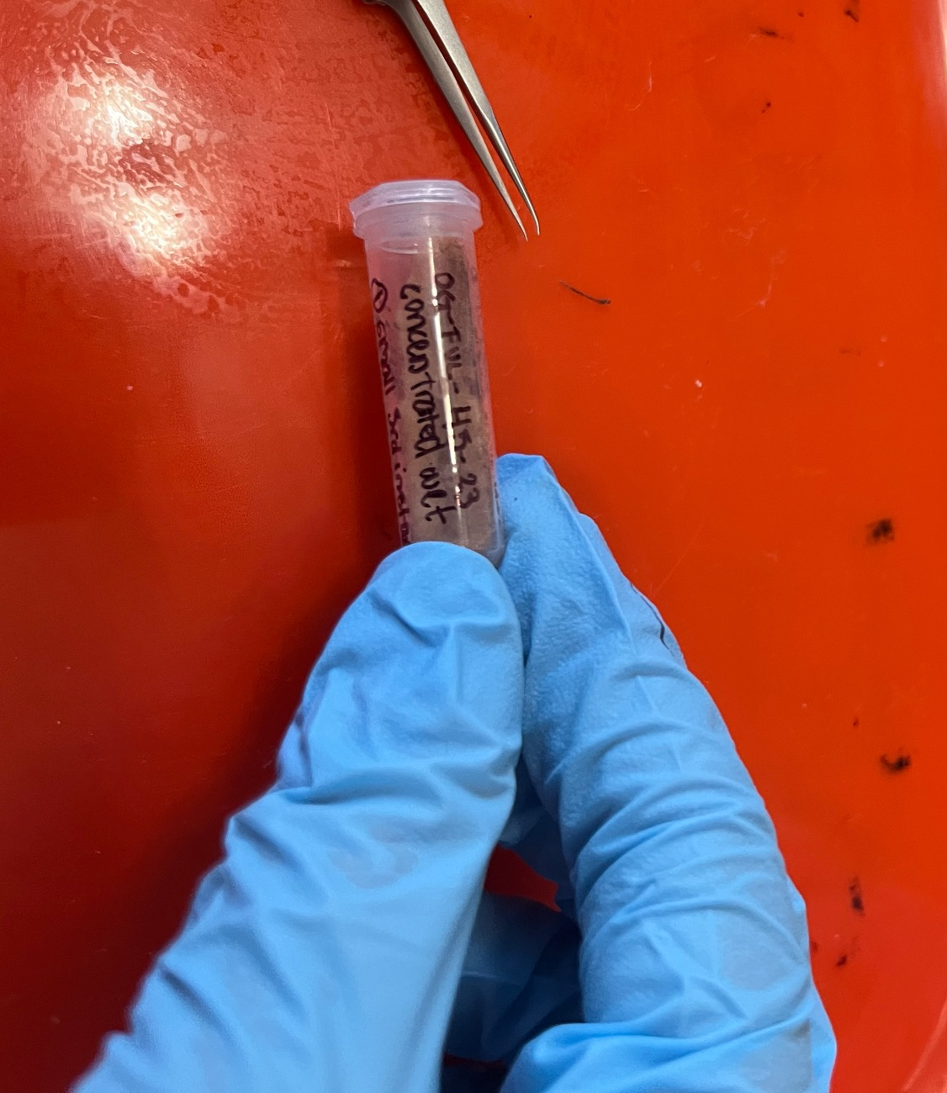

Fig. S2. Examples of non-deformed and deformed pupae. A and B) Non-deformed pupae have smooth abdominal segments and rounded posterior spiracles. C and D) Deformed pupae have rugged segments and shriveled spiricles.

A.
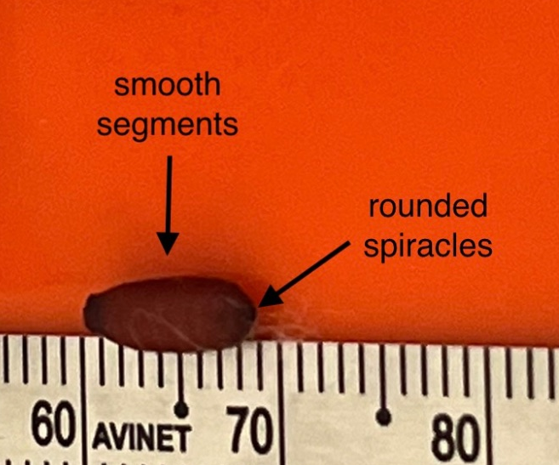
B.
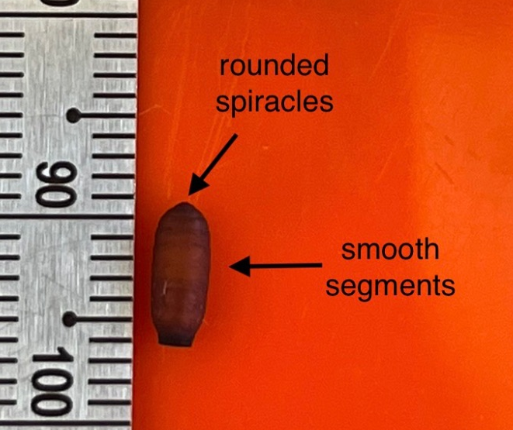

C.
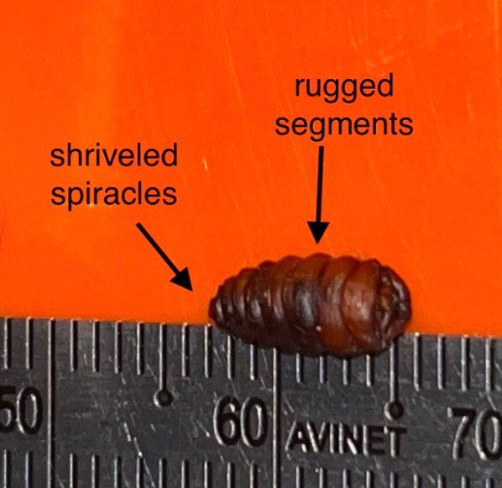
D.
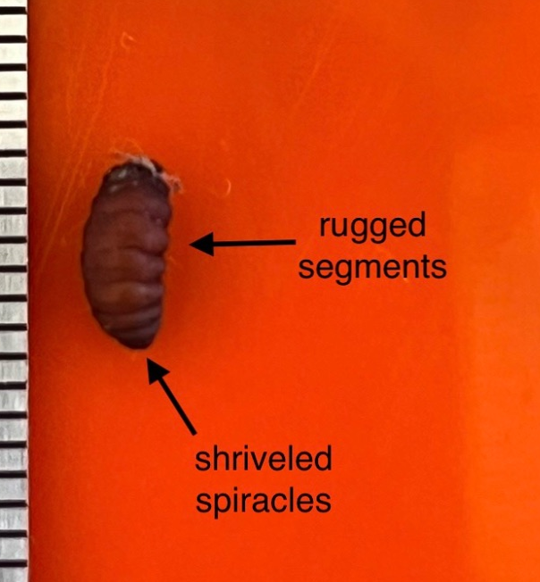

Supplemental Tables
Table S1. Sample sizes for the number of larvae from the nests of four bird species and three field sites (1 urban and 2 non-urban areas).
 | Urban | Non-urban
Host species | Puerto Baquerizo moreno | Opuntia Gardens | Puerto Chino
Small ground finch | 39 larvae / 4 nests | 160 larvae / 21 nests | 1 larva / 1 nest
Medium ground finch | 1 larva / 1 nest | 48 larvae / 3 nests | NA
Common cactus finch | NA | 61 larvae / 4 nests | NA
Total | 40 larvae / 5 nests | 270 larvae / 29 nests

Table S2. Sample sizes for the tobacco and moisture treatment across the urban and non-urban area.
 | Control |  | Diluted |  | Concentrated
 | Dry | Wet | Dry | Wet | Dry | Wet
Urban | 6 larvae/  2 nests | 5 larvae/  3 nests | 5 larvae/  3 nests | 7 larvae/  3 nests | 10 larvae/  5 nests | 7 larvae/  3 nests
Non-urban | 48 larvae/  18 nests | 43 larvae/  21 nests | 45 larvae/  19 nests | 43 larvae/  19 nests | 47 larvae/  19 nests | 41 larvae/  22 nests

Table S3. Measurements and sample sizes for male and female flies across tobacco and moisture treatments.
 | Control |  | Diluted |  | Concentrated
 | Dry | Wet | Dry | Wet | Dry | Wet
Mean (± SE) male head width (mm) | 2.81 ±  0.14 mm  (10 flies) | 2.67 ±  0.17 mm  (8 flies) | 2.54 ±  0.13 mm  (4 flies) | 2.75 ±  0.11mm  (8 flies) | 2.92 ±  0.22 mm  (3 flies) | NA
Mean (± SE) female head width (mm) | 2.80 ±  0.084 mm  (16 flies) | 2.74 ±  0.099 mm  (18 flies) | 2.93 ±  0.066 mm  (5 flies) | 3.09 ±  0.13 mm  (4 flies) | 2.78 ±  0.13 mm  (2 flies) | 3.20 ±  0.00 mm  (1 fly)
# of male and female flies | 12 males,  16 females | 10 males,  20 females | 4 males,  5 females | 10 males,  4 females | 3 males,  2 females | 0 males,  1 female

